

Effective Communication and Team working
Assignment term1 2018-2019

Types and models of Communication

Lecturer: Dr. Gulnar Ali
Student: Iulian Rotaru
Student ID: 1818626
Submitted on 29.08.2019

Table of content

1. Introduction……………………………………………………3
2. Types of communication………………………………………3
2.1. Verbal communication………………………………………...4
2.2. Nonverbal communication………………………………….....4
3. Models of Communication…………………………………….5
3.1. Shannon-Weaver model …………...…………………………..5
3.2. Berlos model of communication……………………………….6
3.3. Schramm model of communication……………………………8
4. Personal exp. In the work environment…………………………9
5. Conclusion…………………………………………………………9
6. Bibliography………………………………………………………10
7. In class Exercises………………………………………………11-13

- Introduction:

Solving complicated life situations but also work-related tasks, is made easier by collaboration and communication between individuals. Team work and communication sits at the very foundation of our society and helps on constant improvement and development of our life standards. Sharing and learning new aptitudes and ideas is made possible only by a well-developed communication skill of individuals combined with Team work, which will ensure the progress and success of any task or goal that a group of individuals work to complete or achieve.
Communication as an individual soft skill can be defined as the ability to speak clearly and intelligibly to be able to write and read well and to be a good listener in order to receive a message or provide a feedback (Last, 2007), and it does influence in a large extend the unity and capability of a team or group to work as cohesive single unit. As principle it can be defined as the process by which information is exchanged between people using a common language, signs or behavior (Webster, 2019).
Companies, in general, encourage the development of Communication and Team working skills, as several studies shows that good Communication and team working increase the productivity within the organization and improves relationships between employees (Jones, et al., 2007). Team working can be defined as a collaborated and coordinated action of a group of individuals working together to achieve a collective goal (Collins, 2012). Success rate it is increased and in most of the cases guaranteed in organizations who establish and encourage a good communication between team members and leadership, companies who don’t develop a good communication have the tendency to stumble in their progress and encounter more difficulties in their development program.

- Types of communication:

Communication as an action it is a complex process, people can communicate in many different forms, some people use sculpting or drawing as a mean of communication other people use music, but summarized, we use verbal and nonverbal communication as means to transfer information’s from one person to another. Body gesture or the ability to speak are natural means of communication used in general to show emotions and share stories, from gesture people also developed a complex language used by individuals with special disabilities. Whether is gesture, spoken or written communication, communication helps the society to constant improve and create new things and bring new ideas.
  - Verbal Communication:

Easiest way of communication come naturally, and it is acquired in the first years of an individual life, whether is verbal or nonverbal can be developed and improved during his entire life time.
Verbal communication can be defined as human interaction by using linguistic words or messages, academic use includes written and sometimes sign language which enables individuals to create a speech or share ideas particularly in face to face communications (Chandler & Munday, 2011).
The use of verbal communication in a clear and intelligible way helps groups to share stories, feelings and emotions with ease, and create strong relations between individuals.
  - Nonverbal communication:

Humans make use of nonverbal communication from the very first moments of their life. New born babies, do not posses a de ability to express emotions by speech but they do communicate by gesture, a frown face or a nice radiant face will show the emotions and in some extent the needs of a newborn.
Nonverbal communication can be defined as the features of communications who do not involve the aspects of verbal communication but relies on facial expressions and body gesture (Collins, 2012).
Sign language used by people with hearing or speaking disabilities is a well-known example of nonverbal communication, but it is also used in day to day communication by everyone. Adult people use the facial and body gesture to express feelings and emotions the same way new born babies do. The way we use our body language have a great impact in our daily interactions with people. The same as on new born case, adults show emotions using facial expressions, which can suggest happiness, sadness or boredom. Having a positive attitude towards a person or a task that you may encounter in work environment or daily life can make the difference between success and failure and it can help to avoid unpleasant situations.
- Models of communication:
Various studies have been made, looking for ways and models to follow to improve the communication process. Early telephone companies developed communication models that are applicable and can help to improve communication at personal or organizational level. Understanding theories like Shannon-Weaver, Schramm or Berlo will help to spot and solve issues in the communication chain. Transmitting information’s clear of external noise and receiving the information in an understandable fashion it is the essential factor who allows a good communication between message sender and message receiver.
3.1. Shannon-Weaver model:
Shannon-Weaver model of communication have been developed by Claude Elwood Shannon and Warren Weaver in 1948. Shannon was a mathematician from United States of America while Warren Weaver a scientist.
The theory was first stated in the article they published together which consists of two editions “A Mathematical Theory of Communication” (Wikipedia, 2019).
This theory works on a two-sided principle, Sender and Receiver. The sender is the person who delivers the message and chooses the channel and the receiver is the person who receives and decodes the message. By channel we understand the path or the mean that the sender has choose to deliver his message. According to Shannon-Weaver theory the message can be altered or stopped by the noise interfering with the message. The noise can be described as people or ambient interventions that the message may encounter on the transmitting channel. Once the message it is received by the receiver, the receiver sends a feedback to the sender which consists as an important action because it allows the sender the know if the message was properly received or it has been altered by the noise (Reuben & Steward, 2006).
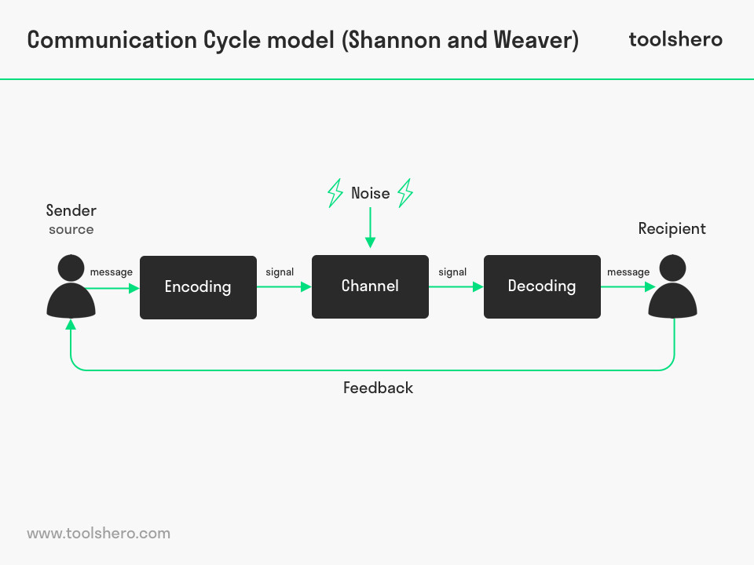
(Mulder, 2016)
3.2 Berlos model of communication:

David Berlo developed Berlos model of communication as an improvement to Shannon-Weaver model in 1960. He named his improved model SMCR model of communication which is an acronym for Sender-Message-Channel-Receiver.
The sender is seen as the source of the message and the person that starts the communication between sender and receiver. He added to the Shannon-Weaver theory a few factors who can influence the communication between source and receiver. He stated that the source can be influenced by the same types of noises as the receiver therefore, the message can be delivered already altered and not understandable by the receiver.
Example of influential elements:
- Social and the cultural ambient have an influence on the way the
sender and the receiver can understand the message.
- Structure can impact the way the message is received; a well-structured and comprehensive message will be easier to understand by the receiver.

- The code of the message or language that the message is received, it must be at the same level of understanding, both for receiver and sender.

- The channel or the means that the message is delivered and received, for a message to successful received it must be sent on route that it can reach in an understandable way the receiver.

- Type of elements that influence a face 2 face communication,
body gesture or voice tone can become noise who can alter or
interrupt the message to arrive or be understood by the receiver.

- The content of the message needs to be clear, comprehensive from the beginning to the end of the message.
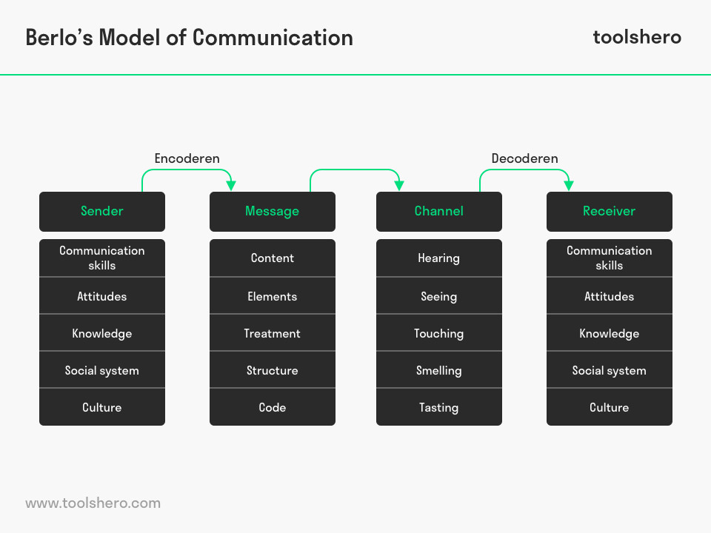 (Janse, 2018)

3.3 Schramm model of communication:

Wilber Schramm was an American journalist, writer and academician and had big influence in setting communication as subject of study in the United States (Wikipedia, 2019).He first suggested his theory of communication in 1954 and was inspired by Osgood Model who presented communication as a circular entity.
Schram theory suggest that an information has no use, unless it well structured and sent to the receiver. When the receiver is being delivered with the message his primary task will be to understand the message, making the encoding and decoding of the message the main factors of a successful delivery. If the receiver is not able to decode the message than the information sent in the message becomes useless (Juneja, 2015).
As an advantage Schramm model of communication is offering a two-way channel of communication, where the sender of the message will become receiver once the receiver of the initial message will return the feedback, becoming in this way the source of a new message. This enable the communication to be dynamic and adaptable to changing situations by ensuring a constant flow of information’s. On a down side Schramm model of communication does not offer any information about the noise that the sender or receiver may be influenced in properly receiving the message.
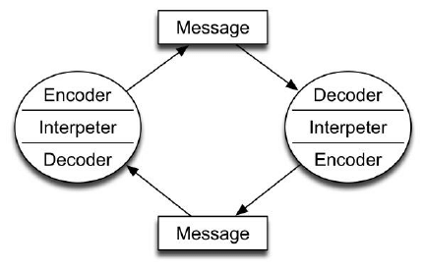 (judee, 2019)

- Personal experience in the work environment:

My name is Rotaru Iulian, I am working as a baker during the night shift at Percy Ingle. Applying Berlos theory, which I believe it does suit better to the environment that I work, I will try to analyze and draw a conclusion on how a situation encountered in my work environment can be improved and what cause it.
A short insight in the company, Percy Ingle is bakery which produces a wide range of cakes and breads. I estimate we are around 100 employees, all coming from different backgrounds and cultures. But most of the people with whom I directly work come from middle east. My manager is from a middle eastern country, my supervisors the same along with other 5 members of my team.
The issue that I often encountered during the work program is language barrier, as most of the workers do not speak English in an understandable way and can create confusion in understanding the tasks. Also
creates situations of miss communication between supervisors and workers which added with the tiredness of long hours of work, encourage the workers to leave unfinished tasks at the end of the program.
As a solution, I believe the communication between supervisors and workers can be improved, supervisors need to help the workers to understand exactly which their tasks are and lead the workers in a way that inspire them to complete their task until the end of working program.

5.Conclusion:
Understanding different models of communications opens the door to an effective communication skill, as all 3 models presented in this work offer solutions which can be applied in personal life and career environment. It is not easy to keep in mind these theories when an individual is under pressure, usually caused by personal situation or work ambient, but with practice applying these theories will lead to a better personal development and will improve the quality of a group who is working together towards the same goal.
6. Bibliography

Chandler, D. & Munday, R., 2011. A Dictionary of Media and Communication. 2 a cura di Oxford: Oxford University Press.
Collins, H., 2012. COLLINS ENGLISH DICTIONARY - COMPLETE & UNABRIDGED. 2012 a cura di Glasgow: WILLIAM COLLINS SONS & CO. LTD.
Janse, B., 2018. Berlo’s SMCR Model of Communication. [Online]
Available at: https://www.toolshero.com/communication-skills/berlo’s-smcr-model-of-communication/
[Consultato il giorno 29 8 2019].
Jones, A. et al., 2007. Effectiveness of teambuilding in organizations. Journal of management, 20(3).
judee, k. B., 2019. Schramm model of communication. [Online]
Available at: https://www.researchgate.net/figure/Schramm-Model-of-Communication_fig1_254051534
[Consultato il giorno 29 8 2019].
Juneja, P., 2015. Schramm’s Model of Communication. [Online]
Available at: https://www.managementstudyguide.com/schramm-model-of-communication.htm
[Consultato il giorno 29 8 2019].
Last, J. M., 2007. A Dictionary of Public Health. 1(ed) a cura di Oxford: Oxford University Press.
Mulder, P., 2016. Communication Cycle model by Shannon and Weaver. [Online]
Available at: https://www.toolshero.com/communication-skills/communication-cycle-shannon-weaver/
[Consultato il giorno 28 8 2019].
Reuben, B. D. & Steward, L. P., 2006. Communication of human Behavior. 5 a cura di Boston: Pearson.
Webster, M., 2019. merriam-webste. [Online]
Available at: https://www.merriam-webster.com/dictionary/communication
[Consultato il giorno 27 8 2019].
Wikipedia, 2019. Wikipedia. [Online]
Available at: https://en.wikipedia.org/wiki/Shannon–Weaver_model
[Consultato il giorno 28 8 2019].
Wikipedia, 2019. Wilbur Schramm. [Online]
Available at: https://en.wikipedia.org/wiki/Wilbur_Schramm
[Consultato il giorno 29 8 2019].

7. In class exercises:


