Module: Human Capital Management
Module code: LCMB7023

Assessment component 1:
Individual report

Student Name: Karankumar chaudhary
Student ID: 2538332
Table of Contents
TASK A: Socialisation, Identity & Business Activism 3
Evaluation of traditional onboarding versus strategic organisational socialisation 3
Designing a structured socialisation framework for Helios 4
Proposing mechanisms to cultivate 5
TASK B: Job Design 8
Innovative job design strategy using Job Characteristics Model, Job crafting theory, and Skills-based architecture or internal talent marketplaces 8
Way the design will stimulate intrinsic motivation and support innovation 10
TASK C: Reflective report 13
Introduction 13
Main Body 13
Conclusion 15
References 16

TASK A: Socialisation, Identity & Business Activism

Evaluation of traditional onboarding versus strategic organisational socialisation
Evaluation Criteria | Traditional Onboarding | Strategic Organisational Socialisation
Purpose and Strategic Focus | Attention to compliance, policies and IT set-up + role clarity in first few days. It has some level of readiness but is more about administration, with little cultural assimilation or commitment. | A continual process of pre-boarding to year one designed to build commitment, culture and learning. Helios (450 staff members in London, Berlin and Singapore) would benefit from better integration and having the ramp-up reduced from 8 months (CIPD, 2025a).
Van Maanen & Schein's Socialisation Theory | Uses mainly formal, collective and fixed tactics, being consistent but not very flexible and creative. Learners are passive learners at the workplace. | Implements serial mentoring, investiture and sequential strategies, allowing for transfer of skills and experienced personnel to guide inexperienced ones. This will help facilitate innovation and quick adaptation to changes at Helios.
Psychological Contract Theory | Establishes a transactional psychological contract around compensation, policies and expectations. Less than ideal post-induction support can lead to a drop in trust and turnover (CIPD, 2025b). | Establishes a psychological contract with others, mentoring and career development and ongoing feedback. This is essential to increase Helios' 54% employee engagement and decrease graduate attrition.
Identity Construction Theory | The staff member knows and understands their position, but does not feel as if he or she belongs to the organization, which results in a lower level of organizational citizenship behavior and emotional commitment. | Promotes identity development through mentoring, leadership interaction and collaboration. This is the case across Helios' 3 offices worldwide which boosts organisational belonging and cross-cultural teamwork (Deloitte, 2025a).
Table 1: Traditional onboarding versus strategic organisational socialisation

Designing a structured socialisation framework for Helios
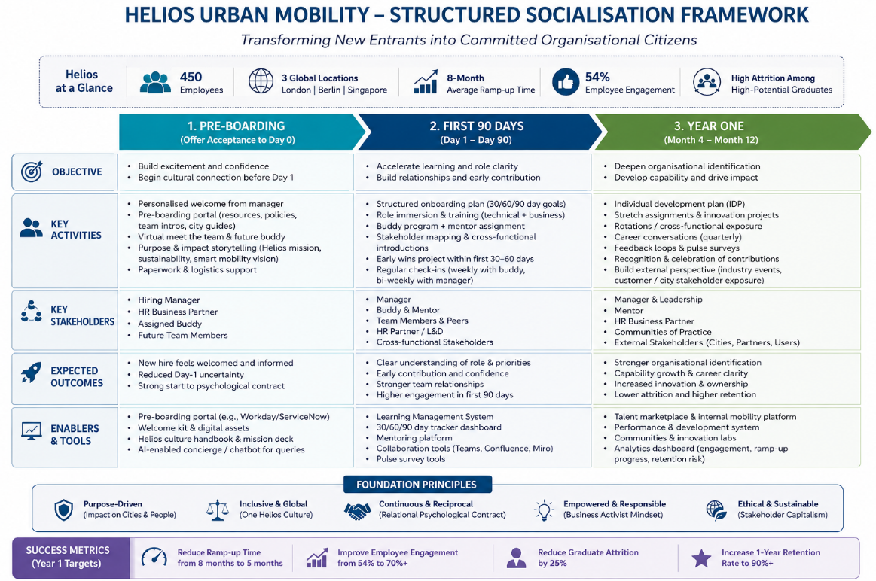
Fig 1: Structured socialisation framework
Source: (Self-Developed)
Proposed structured socialisation framework is justified as utilizing a strategic, continuous and evidence-based approach to employee integration, rather than relying on traditional onboarding activities that are based mainly on the administrative aspect of compliance. Helios Urban Mobility, a company with 450 employees in London, Berlin and Singapore, is using this framework to directly tackle its organisational challenges, including a 8-month average ramp-up period, 55% employee engagement and high attrition among high-potentials graduates, by incorporating learning, cultural integration and organisational commitment into the employee journey (Deloitte, 2025b). During the pre-boarding process, uncertainty before employees' entry is reduced through early communication, introduction of organisational values, mentorship and initial socialisation arrangements, which enhance the psychological contract, that is, through early trust and organisation support. The initial expectations of employees drives their commitment and reduces turn over intention, as per the Psychological Contract Theory.
The first 90 days are dedicated to structured learning, mentoring, role clarification and cross-functional collaboration and frequent feedback, consistent with Van Maanen and Schein's (1979) theory of organisational socialisation, specifically serial and investiture tactics. Serial mentoring allows for knowledge sharing within the organisation, it helps to remove the uncertainty while experienced mentors help transfer what they know to the new hires, while investiture helps to reinforce the new hires' knowledge and identity, thus fostering creativity and confidence (Deloitte, 2026a). In particular these approaches should be relevant for Helios, since collaboration between engineers, software developers, infrastructure analysts and city stakeholders is critical for the development of AI powered urban mobility solutions and knowledge sharing is a key element to innovate. The year one stage takes socialisation beyond induction, by incorporating career development planning, innovation projects, internal mobility, leadership development exposure and coaching on an ongoing basis, so that socialisation is no longer a single HR stage but a continuous strategic process. The stage also helps to strengthen the organisational identity through the employees' meaningful interactions, experiences and their connection with Helios' mission of providing sustainable smart mobility solutions (Deloitte, 2026b).
Organizational identity fosters organizational citizenship behaviors, teamwork and discretionary work, all of which are important to sustain competitive advantage in knowledge-based organizations. In addition, embedding analytics dashboards, pulse surveys and performance reviews across the model allows HR to measure engagement, learning progress and retention outcomes, which helps them make data-driven decisions and continuously improve.

Proposing mechanisms to cultivate
Organisational identification
Helios must enhance organisational identification through leadership communication that is based on purpose, mentoring across borders, employee resource groups and innovation communities throughout its employees in London, Berlin and Singapore. These mechanisms spur employees to make their values resonate with Helios' mission to provide sustainable mobility solutions with the assistance of AI (Edelman, 2025). The Identity Construction Theory holds that a sense of belonging and organisational citizenship behaviour is built through ongoing interaction and shared experiences. This is especially crucial in enhancing Helios' employee engagement score of 53.9% and to lower the rate of graduate attrition. As seen, highly engaged organisations see a 23% increase in profitability and an 18% increase in productivity, proving the business value of increased organisational identification.
Ethical professionalism
Ethical professionalism should be integrated by the requirement of AI ethical training, programmes on environmental, social and governance (ESG), establishing governance, whistleblowing mechanisms and ethical leadership development. Helios builds innovative infrastructure for city governments, and staff will need to navigate innovation while also maintaining responsibility for the data being managed, fairness, and sustainability of the algorithms. Ethical behaviour in performance appraisal helps to reinforce accountability and boost stakeholder trust (Gallup, 2025a). Ethical professionalism from a stakeholder point of view contributes to the legitimacy of the organisation and the creation of value over the long term. 79% feel businesses need to confront societal issues as well as business goals; there has been a shift in thinking, with ethical behavior no longer just about complying, but about it being a strategic capability (Gallup, 2025b).
The “business activist” mindset
Helios must foster a business activist mindset, through staff engagement in ESG innovation projects, smart city partnerships, and sustainability efforts and stakeholder engagement programmes. HR can add value to the business by aligning the interest of employees, customers, governments/communities, according to Ulrich's HR Business Partner evolution (Harvard Business Review, 2025). Helios needs to develop a business activist mindset to leverage innovation, ESG commitments and stakeholder engagement to realise long-term sustainable values in a market that is poised to grow by a factor of six to USD 4,719.8 billion by 2034. It is revealed that organisations with a purpose are much more likely to deliver innovation, workforce resiliency and long-term business performance (ILO, 2025).
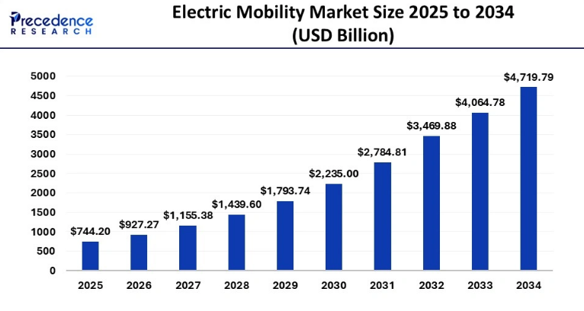
Fig 2: Electric Mobility Market
Source: (Precedence Research, 2025)

TASK B: Job Design

Innovative job design strategy using Job Characteristics Model, Job crafting theory, and Skills-based architecture or internal talent marketplaces
Introduction to the Proposed Job Design Strategy
Helios Urban Mobility must adopt an AI-driven Agile Job Design Strategy based on the JCM, JBT and Skills Based Architecture underpinned by an Internal Talent Marketplace. This is a way of changing the nature of jobs from "job description" to "skills based", to boost motivation, innovation and organisational agility. The roadmap targets Helios' challenges of an 8-month ramp-up for productivity, 53% engagement rate among employees, and high attrition rate with respect to graduates among its employees. The number of core skills that need to change among employees is estimated at 39% by 2030, and flexible job design and reskilling through continuous learning will be key to maintaining the competitiveness of the organization (LinkedIn Learning, 2025).
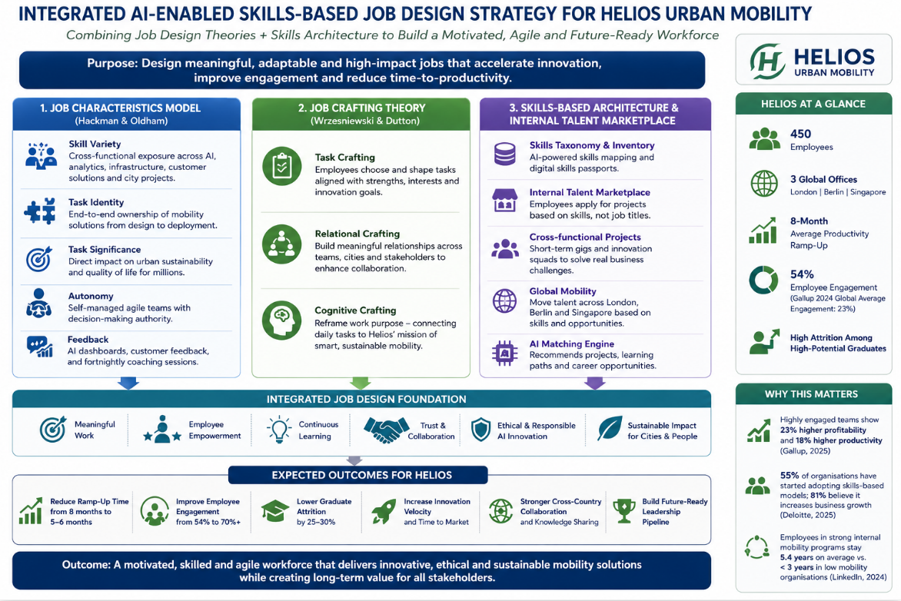
Fig 3: Job Design Strategy
Source: (Self-Developed)
Applying the Job Characteristics Model (Hackman & Oldham)
According to the Job Characteristics Model, to improve intrinsic motivation the job should be designed to increase skill variety, task identity, task significance, autonomy and feedback. Helios needs to restructure its roles to allow employees to undertake full AI-based mobility projects, move between engineering and analytics, and have constant access to feedback via the AI performance dashboard and agile coaching. More autonomy would enable employees to handle complex urban mobility problems, boost ownership and innovation (McKinsey & Company, 2025). 81% of executives agree that work is increasingly done across functional lines, underscoring a need for job designs that are more enriching and collaborative, rather than narrowly defined.
Applying Job Crafting Theory
Job Crafting Theory allows workers to engage in task, relational and cognitive modification to create more ownership and meaningfulness in their work. Helios should give staff the freedom to go on the innovation projects that are in their area of expertise, work together in London, Berlin and Singapore and link to the outcomes of sustainable urban mobility. This allows for flexibility in engagement that fosters ongoing learning and creativity. But job crafting should still be congruent with strategic goals using periodic coaching and performance evaluations.
Skills-Based Architecture and Internal Talent Marketplace
Helios needs to create a skills-based job structure with an AI-driven internal talent exchange marketplace, allowing staff to transfer from one project to another based on demonstrated skills instead of job descriptions. The workforce agility and innovation would be enhanced with digital skills passports, cross-functional assignments and global mobility programmes. This also facilitates the speed of deployment of specialist talent into Helios' international offices. Traditional role structures are no longer reflective of how modern organisations work, with 71% of employees already doing work outside of their job description, and 24% only doing the same work as another employee with the same job title (Microsoft, 2025).
Integrated Benefits for Helios Urban Mobility
The combination of the Job Characteristics Model, Job Crafting Theory, and a Skills-Based Architecture yields a very adaptable workforce that can adjust to the rapid changes in technology. The strategy would shorten Helios' 8-month productivity ramp-up, increase engagement to what it is now, build innovation and raise the retention rate of graduates through more autonomy and continuous learning and internal mobility. Moreover, companies that have an active internal mobility plan can expect to have staff stay for an average of 5.4 years; in companies with weak mobility procedures, the average staff member will stay only for less than three years, underscoring the long-term benefits of flexible talent deployment and skills-first strategies (MIT Sloan Management Review, 2025).

Way the design will stimulate intrinsic motivation and support innovation
The proposed AI enabled Skills Based Agile Job Design Strategy will help to keep employees motivated, nurture innovation through meaningful work, employee autonomy, continuous learning, and flexible career paths. Helios Urban Mobility will benefit from the implementation of the Job Characteristics Model (Hackman & Oldham), which will increase the skill variety of workers by being involved in different cross-functional AI, engineering and smart-city projects, as well as the task identity, which will allow workers to have a role in the complete mobility solution instead of just in one of its parts (OECD, 2025). Helios must respond to the rapid evolution of the smart mobility market and come up with an agile, skills-based job design to boost their intrinsic motivation and continuous learning & innovation to stay competitive in the smart cities market, which is expected to reach USD 2,242.44 billion by 2030 at a CAGR of 19.1% from USD 939.99 billion in 2025. These are all conducive to employees being intrinsically motivated because work becomes meaningful, responsible and rewarding.
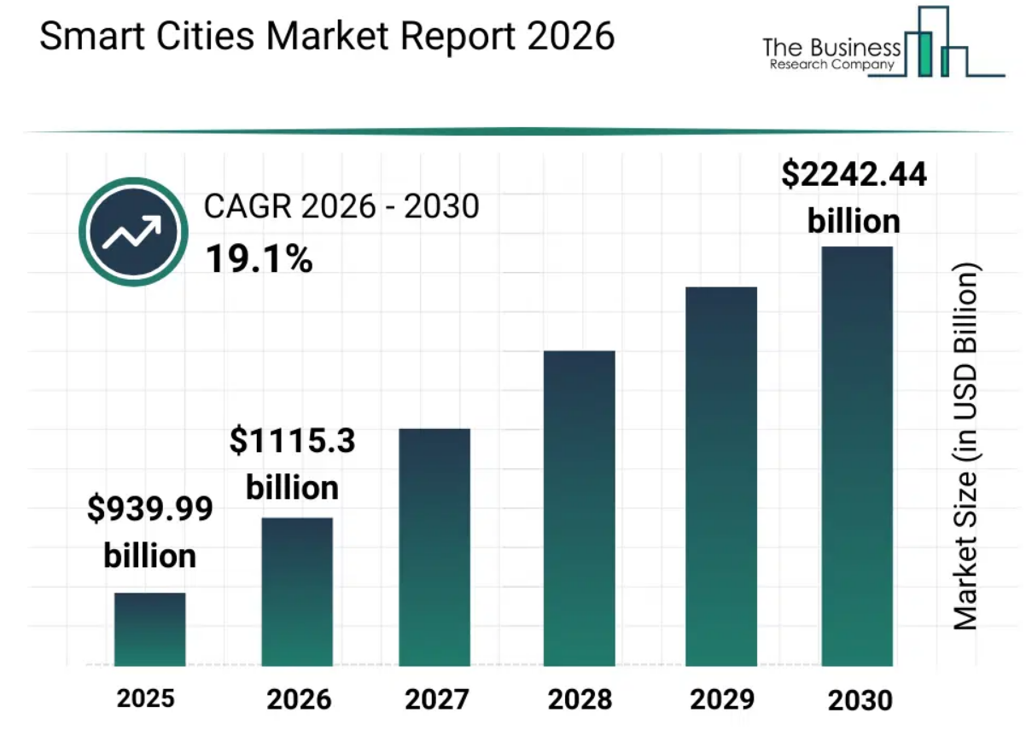
Fig 4: Smart Cities Market
Source: (The Business Research Company, 2026)
The incorporation of Job Crafting Theory also helps to foster intrinsic motivation by enabling employees to customize parts of their jobs based on their strengths, interests and career goals. Employee’s gets opportunities to pick innovation projects to work on, connect with other employees across London, Berlin, and Singapore, and think of their work as part of the process of driving sustainable mobility, not just as a technical task. Such flexibility fosters greater psychological ownership, innovativeness and involvement from employees and promotes them to actively pursue constant improvement (SHRM, 2025). The need to upskill the workforce to meet rapidly changing skill needs is growing in significance, with 85% of employers planning to focus workforce upskilling on this issue, reflecting the need for flexible and employee-centred work design.
Employees can also transition between projects via the Skills Based Architecture and Internal Talent Marketplace, which allows staff to flow based on skills, not just job titles. This ensures a team of AI engineers, software developers, urban planners, and data analysts share a common understanding of the project, making it easier for them to work together and solve problems quickly. Diverse projects also bring in new technical skills for employees and create innovative answers to complex urban mobility challenges. New jobs will grow at the rate of 170 million in the next five years around the world because of technological change, further emphasizing the need to equip organisations with flexible and innovation-driven workforces (SHRM, 2026a).

TASK C: Reflective report

Introduction
The role of HR is evolving as a result of digital transformation, and it is essential for HR professionals to balance AI-driven decision-making with critical human judgment and make informed, ethical choices based on data. This reflective report explores how AI should complement, and not replace, human decision making and explains a plan for developing personal capabilities to improve employability in the future, specifically: Data Literacy, AI Augmentation Applications in HR, Strategic Influencing Skills and Global Mobility Awareness.

Main Body
Driscoll (2007) The What Model
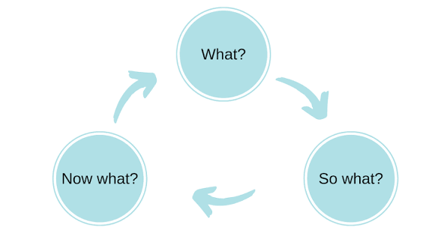
Fig 5: The What Model
Source: (Reflective Writing Tips, 2021)
Using AI as a Decision-Support Tool without Eroding Critical Human Judgement
What?
In HR, AI is proving to be a valuable decision-making aid, thanks to its ability to process data quickly to aid in recruitment and workforce forecasting and analytics. In the course of my studies, I've leveraged AI for structuring information, spotting trends and assisting in data-driven choices. I do understand, though, that HR decisions are not just about algorithms, but about ethics, culture and wellbeing in the organisation.
So What?
This has been my experience and I want to see AI complement, not supplant, human judgment. Relying too heavily on AI can lead to automation bias, a lack of consideration for the context, and potentially biased results if the data provided are flawed or biased (United Nations Global Compact, 2025). Hence, HR experts should always analyse AI-generated insights with a critical eye, taking into account ethical, legal and organisational considerations as well, prior to making any decision.
Now What?
Going forward, I will use AI to be more efficient and engage in critical thinking, using a variety of sources of evidence and engaging stakeholders. I will also continue to develop my knowledge and understanding of AI Governance, HR Analytics and ethical decision-making for the effective use of technology to drive HR practice responsibly and in balance.
Personal Capability Development Plan
What?
Looking at what I can do today, I am aware that HR professionals from the future need more than just traditional HR knowledge. To stay relevant in the job market, I am required to enhance and embed my data literacy skills, AI tools for HR and strategic influencing and global mobility awareness to be able to address digital transformation effectively and the challenges related to the international workforce.
So What?
These skills will help me to better understand the workforce, to apply AI responsibly, to impact the actions of the organization and to work in multicultural teams. These skills will also help me to develop my confidence, flexibility and contribution to HR strategic plans in technology intensive environments.
Now What?
To do so, I shall undertake professional training on HR analytics, how to apply Power BI and AI, as well as improve my communication and stakeholder management skills, with hands-on projects, and also enhance my understanding of international HRM and cross-cultural leadership (World Economic Forum, 2025). To equip myself with the ability to work as a digitally knowledgeable and globally competitive HR professional, I will have to undergo continuous learning and attain professional certifications.

Conclusion
In summary, it underscores the importance of human critical thinking in making responsible HR decisions, and that the power of AI must be complemented by human judgment. As I continue to practice, develop, and evolve data literacy, AI capability, strategic influencing, and global mobility awareness, I will be better positioned to be effective and remain relevant in the changing HR landscape and in an increasingly digital and global world.

References
Chartered Institute of Personnel and Development (CIPD) (2025a) AI and technology factsheet. Available at: https://www.cipd.org/uk/knowledge/factsheets/ai-technology/
Chartered Institute of Personnel and Development (CIPD) (2025b) Induction factsheet. Available at: https://www.cipd.org/uk/knowledge/factsheets/induction-factsheet/
Deloitte (2025a) Creating value with skills. Available at: https://www.deloitte.com/us/en/insights/topics/talent/creating-value-with-skills.html
Deloitte (2025b) The future of work. Available at: https://www.deloitte.com/global/en/services/consulting/collections/future-of-work.html
Deloitte (2026a) 2026 Global Human Capital Trends. Available at: https://www.deloitte.com/us/en/insights/topics/talent/human-capital-trends.html
Deloitte (2026b) The State of AI in the Enterprise 2026. Available at: https://www.deloitte.com/us/en/what-we-do/capabilities/applied-artificial-intelligence/content/state-of-ai-in-the-enterprise.html
Edelman (2025) 2025 Edelman Trust Barometer. Available at: https://www.edelman.com/trust/trust-barometer
Gallup (2025a) Workplace insights. Available at: https://www.gallup.com/workplace/insights
Gallup (2025b) Workplace. Available at: https://www.gallup.com/workplace
Harvard Business Review (2025) Harvard Business Review. Available at: https://hbr.org
International Labour Organization (ILO) (2025) Future of work. Available at: https://www.ilo.org/global/topics/future-of-work
LinkedIn Learning (2025) Workplace Learning Report. Available at: https://learning.linkedin.com/resources/workplace-learning-report
McKinsey & Company (2025) People and Organizational Performance. Available at: https://www.mckinsey.com/capabilities/people-and-organizational-performance
Microsoft (2025) Microsoft WorkLab. Available at: https://www.microsoft.com/worklab
MIT Sloan Management Review (2025) Ideas Made to Matter. Available at: https://mitsloan.mit.edu/ideas-made-to-matter
Organisation for Economic Co-operation and Development (OECD) (2025) Future of work. Available at: https://www.oecd.org/en/topics/future-of-work.html
Precedence Research (2025) Electric mobility market size, share and trends 2025–2034. Available at: https://www.precedenceresearch.com/electric-mobility-market
Reflective Writing Tips (2021) Models of reflection. Available at: https://www.reflectivewriting.tips/wp-content/uploads/2021/07/Models-of-Reflection.pdf
Society for Human Resource Management (SHRM) (2025) Future of Jobs Report 2025: Deep Dive. Available at: https://www.shrm.org/topics-tools/flagships/ai-hi/future-of-jobs-report-2025-deep-dive
Society for Human Resource Management (SHRM) (2026a) The State of AI in HR 2026. Available at: https://www.shrm.org/in/topics-tools/research/state-of-ai-hr-2026
The Business Research Company (2026) Smart cities market report 2026. Available at: https://www.thebusinessresearchcompany.com/report/smart-cities-global-market-report
United Nations Global Compact (2025) United Nations Global Compact. Available at: https://unglobalcompact.org
World Economic Forum (2025) Future of Jobs Report 2025. Available at: https://www.weforum.org/reports/the-future-of-jobs-report-2025

