Epic, Religion and Philosophy: Spenser and Milton
Milton’s Paradise Lost (2)

The Body & Soul, Sexual Difference, Sexuality, Appetite, Chastity, & Temperance

Milton’s God is a father and mother figure: ‘He guides the birth of Eve from Adam’s side, as if he were a benevolent and kind surgeon or obstetrician, and he must be both father and mother to the first two humans he has created, nurturing them, providing a home, warning them to avoid danger.’ In Book III, a prescient Fatherly God might sound very much like an authoritarian father faced by rebellious adolescent children. Perhaps Alexander Pope was correct to infer in the eighteenth century that He sounds like a schoolmaster at times, but Milton’s God is not a tyrant.
‘Eve has been created for Adam at his request, as his helpmeet – his fitting and suitable companion, close to equal to him in her intellectual capacity though softer and more inclined to domesticity.’ Adam is defined by contrast in terms of his masculine strength and authority. Paradise Lost undoubtedly re-inscribes a patriarchal system but Eve is far from being disparaged as lightweight, and we should beware drawing too clear a division between domestic and public in Paradise Lost, lest we miss the figuration of the political in the domestic. It has been argued, for example, that the well-regulated eating of Adam and Eve implies criticism of excessive consumption at the Stuart court of King Charles II.
Eve becomes the daughter of God and man. On many occasions she reiterates her understanding of herself, of her being derived from Adam. Whereas Adam is described as being created by God in God’s own image; Eve is described as having been made in Adam’s image. This idea we find also in Tetrachordon, one of Milton’s Divorce Tracts, where Milton claims that the idea is St Paul’s in 1 Corinthians 11. Yet when Eve sees her reflection in the water thereby gaining a psychological sense of herself through her (mis)recognition of herself in her reflected image, we recognise that she does not thereby identify herself as a projection of Adam (IV. 440-91).
In descriptions of Eden it is evident that Milton is acutely aware of the natural world and curious about the nature and habits of plants, insects, and other animals, in philosophical and natural-historical ways that connect his work with that of the natural philosophical and literary circle surrounding Richard Lovelace, which included Milton’s friend, Andrew Marvell. There is an ideal order in this garden which expresses its divine origins and its connectedness to the cosmos and to heaven. The Archangel Raphael explains to Adam the analogy between earth and heaven, a common idea at the time, but here presented with a difference which is due to Milton’s monism.
Milton’s monism and his belief in creation ex deo combine to create a perspective on creation in which body and spirit are essentially of the same substance, more or less gross or rarefied, at different points on a spectrum that stretches from God to minerals. In Book V, for example, Raphael explains to Adam that God is the material cause of the world and that it is framed out of an original matter that is intrinsically good (V. 468-543). It is an argument that is echoed in De Doctrina Christiana, Bk 1, Ch. 7, where its author argues strongly against creation out of nothing.
According to Michael Schoenfeldt in Bodies and Selves in Early Modern England, one way in which this is more poetically envisaged in Paradise Lost is as a ‘Great Chain of Digestion and Secretion’, in which the grosser feeds the purer. As Raphael explains to Adam when accepting his and Eve’s invitation to partake of the food placed before him in Paradise, angels digest corporeal food turning it into the incorporeal substance of which they are made, whereas when humans digest they turn their food into their own flesh by a process of concoction into chyle and digestion or distribution of this through the veins to feed the body’s members. Some is turned in the liver into natural spirit which distributed along with chyle in the veins gives the members growth and nutrition. In the heart the same blood and natural spirit is concocted with air to produce vital spirit which distributed by the arteries gives the body life (V. 484). Arterial blood and vital spirit entering the brain is turned into animal spirit which enables the brain to co-ordinate movement and sensory perception (V. 484), linking the imaginative and intellectual faculties of the soul with the body’s rarefication of food into spirit. In this model sensuousness is combined with epistemology as discerning touch and taste turn food into the spirit necessary for reasoning and knowing.
Angelic digestion leads to perspiration as opposed to mortal defecation but these are differences on a spectrum; they do not articulate discontinuities between physical, material substance and spirit. Indeed Milton is deeply committed to the material basis of spiritual reality without reducing spirit to matter. Creation ex deo means that the universe was created out of God’s own self, his own substance, and in Paradise Lost this is imagined as involving digestive processes. There is a suggestion that Hell is the excrement, although it was created for the purposes of confining the fallen angels before God embarks upon Creation. In his Divine Comedy, Danté had located Hell in the centre of the Earth itself, but Milton, in adopting the other alternative provided by theological tradition, remarks (in the argument to Book I) that Hell is ‘described here not in the center (for Heaven and Earth may be supposed as not yet made, certainly not yet accursed), but in a place of utter darkness, fitliest called Chaos’. In De Doctrina Christiana, Bk 1, Ch. 33, this location is defended on the same grounds, and with reference to the opinion of Chrysostom and Luther. But why would a monist universe in which all matter comes from God require a digestive process that separates nutrition from dross anyway? Schoenfeldt proposes that in Raphael, Milton suggests that the monist picture is correct so long as what is created does not become depraved from the good. The depravity of Satan and the rebellious angels necessitated the creation of Hell.
By contrast, the Garden of Eden before the Fall is in some sense an image of the physical face of God, a localisation of the divine presence, and for the first humans their physical separation, their expulsion from the Garden is spiritual alienation from God, or at least from any sense of the familiarity of God’s presence or that of angels in the Garden. There are reassurances from the Archangel Michael to Adam, that ‘wilt thou not be loath / To leave this Paradise, but shalt possess / A paradise within thee, happier farr.’ (XII. 585-87) The extradiegetic narrator also indicates that Adam and Eve retain ‘Providence’ as ‘thir guide’ (XII. 647).
The instances of eating and the many uses of the concept and imagery of eating in Paradise Lost relate thematically to the central most significant event of the epic – the eating of the fruit of the tree of knowledge of good and evil firstly by Eve and then Adam. As Schoenfeldt says, the scenario of temptation in Paradise Lost is ‘trial by food’. Each time Milton repeats an image of eating or of food he has used before, the repetition is incremental: it will add a new level of meaning. Centrally concerned with the nature of this sinful transgression, the epic develops the theme in its relation to temperance, the virtue that subjects appetite to discipline. Eating is a complicated moral action that requires regulation through continence and temperance. Throughout Milton’s earlier plans for tragedies in the 1640s there may be discerned a persistent interest in chaste or temperate living. And in Paradise Lost, when Milton rejects the militarism of the ancient epic with epic virtues of outward, glory-seeking, active anger and aggressive boldness, he replaces this with a heroism that is ‘quiet, passive, noble, intensely private’, ‘solitary’, - the ‘one just man’ (XI. 890), like Noah, remaining faithful to God even when utterly alone in faith. This individual embodies ‘the better fortitude / Of Patience and Heroic Martyrdom’ (IX. 32), accompanied by Christian virtues of ‘Temperance and Love’ (XII. 583). This is perhaps why when Adam and Eve are tempted by Satan in the serpent, for in the end they must each alone make the painful choice to disobey one simple, clear, and arguably easy to obey command – not to eat of that one fruit.
Temperance is the virtue that subjects appetite to discipline. But because of the monist world of Paradise Lost, ethical matters are not distinctly different from physiological processes. Temperance is not to be understood merely as the rational soul subjecting appetite to discipline through the exercise of the will. Schoenfeldt goes so far as to argue that the trial of morality or virtue in Paradise Lost corresponds to the process of digestion of food. So just as the ingestion, concoction and digestion of food produces nutriment through a process of refinement which discards the dross as excrement, the trial of what appears to be virtue purifies true virtue and reveals the mere appearance of virtue for what it is.
While for human beings eating is a complicated moral action that requires regulation through continence and temperance, this does not seem to be so for angels who consume freely without physiological or ethical recriminations. But equally the consumption of food by Adam and Eve before they are expelled from Eden is an appropriate response to God’s plenitude. Although there is sensuousness and appetite in Eden the enjoyment of these is not sinful; it is measured, chaste, and temperate, as is evident in the description of Adam’s passion on first seeing Eve (VIII. 521-33).
Milton’s monism makes accounts of angels’ sexuality relevant to humans: (VIII. 614-29). Adam and Eve’s wedded life in Paradise is described as innocent. Their embrace of sensual pleasure is without shame. Eve in this context may be imagined as a goddess of love, like Venus, like the beloveds of many love lyrics and sonnet sequences, without this being perceived as inappropriate. Milton is happy to use pagan symbols of Eros in wedded love and Eden is an accommodating, alluring, and secure place for love. This is not Marvell’s witty horticultural seclusion from female sexuality, but like Marvell’s ‘Garden’ the one in Paradise Lost combines the idea of Eden with the Classical myth of Arcadia and the Golden Age, in which humanity lived in harmony with nature and with their own appetites.
But we may well ask whether Eden would be Eden without temptation. In a poem entitled ‘Twickenham Garden’, John Donne had written with characteristic wit, ‘And that this place may thoroughly be thought / True Paradise, I have the serpent brought.’ As soon as Eden is described in Paradise Lost the reader senses threat, perhaps from beyond the garden, beyond Paradise, a vast beyond that is described as much wilder. Like Marvell’s gardens, Milton’s Garden of Eden articulates both terms in the dichotomy of Art and Nature. The Garden is cultivated and pruned. Pruning and tying in are moral as well as horticultural acts. Likewise the stars shine at night to keep night at bay, lest total darkness should by night regain her ancient possession.
When Satan first steals into the Garden he approaches Eve asleep, when her reason is subdued and she is less able to filter impressions through her ear. Satan’s insinuation sows a seed for the generation of the idea of transgression, which then becomes easier to accept when awake. So on the morning that Eve will be tempted by the serpent, she proposes to Adam that they set about their daily tasks in the garden by going their separate ways for once in order better to accomplish the challenge to their husbandry posed by the garden’s rapid growth (IX. 205-411). But does the growth of the garden suddenly seem or even become more rampant precisely because Eve’s inclination exposes her alone to the danger of temptation? As she sets out to tie in the roses, Eve is described as a flower ironically unsupported by her prop or frame who is Adam (IX. 432-33). The artist John Martin’s illustration of the garden in which Eve is depicted discoursing with the serpent (see below), presents a scene that is verdant and beautiful, distantly illuminated, yet simultaneously menacing, with deep shadows and twisted branches, for here, in this scene, evil has entered into Paradise itself. In a small pool of distant light stands an angel, apparently watching Eve’s temptation, unwilling to intervene because Eve is, and must remain, free – either to resist or to fall.
But even though Satan has entered the Garden, temptation in Eden does not imply loss of innocence provided it is successfully resisted. Eve, however, unwisely assured of her ability to resist, is described as like a rich and complacent burgher who within the walls of his estate falsely believes he is secure and safe. In Book IV of Paradise Lost, Satan suffers tremendously from desire of Eve and when, in Book IX, he tempts her to taste of the fruit of the tree of knowledge of good and evil, he acts as a courtly wooer, a love poet of the Caroline court. His arguments are rhetorically sinuous, a description that also fits the narrator’s description of Eve’s hair, suggesting to some critics that in her physical description the reader sees Eve’s own sinfulness, or at least her weakness. But we must remember that the focaliser of this passage is Satan; it is he who is seeing Eve.
Satan presents himself persuasively in terms that make sense to Eve in the monist world of Eden, as one who has changed his diet so that the serpent may reason and speak with her. She is thereby the more easily deceived. In the event, the fruit results in self-consuming erotic desire through physiological over-heating. Paradise Lost is a work about how knowledge of good was bought dearly by knowing evil (IV. 222), before which was innocence but after which there can be no innocence, only a strenuous virtue that must resist the temptation to do evil.

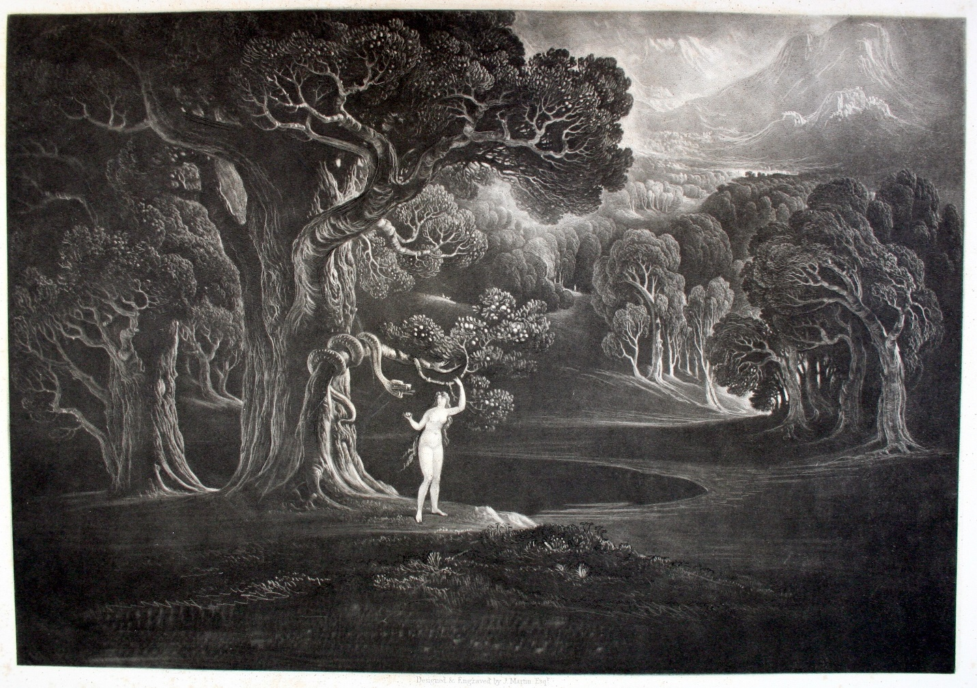
The Paradise Lost of Milton; with illustrations, designed and engraved by John Martin (London: Septimus Prowett, 1827) PHI 00556

In their creation God has given to Adam and Eve ‘the potential to fall or the liability (in the legal sense) that they might fall:’

Eve may be inclined toward the vanity that will make her susceptible to the Serpent’s flattery, and Adam might be inclined toward worshiping his wife’s exterior beauty more than admiring her inner virtue [a mistake that is made time and again in Renaissance love lyrics]. Such inherent human faults might incline them toward making mistakes, but when they choose to disobey God’s one commandment, their sin includes every sin from greed and envy to lust and murderousness. In one act, they murder the human race at its genetic beginning, but that they do so is not God’s fault. He made them free to choose: otherwise they would have been puppets.

Adam and Eve’s subsequent expulsion from the Garden of Eden, according Schoenfeldt, is of physiological as well as moral necessity. They are excreted from Paradise as though from a sickening body.

Roy Flannagan, John Milton: A Short Introduction (Oxford: Blackwell, 2002), p. 82.
Flannagan, John Milton, p. 81.
Laura Knoppers, ‘“No fear lest dinner cool”: Milton’s Housewives and the Politics of Eden’, unpublished paper, Ninth International Milton Symposium, 7-11 July 2008.
See Annabel Patterson, ed., John Milton, Longman Critical Readers (London and New York: Longman, 1992), p. 9, on the explanatory power in the doctrine of monism, or the unity of body and soul, to generate an account of Milton’s thought that is simultaneously materialist and ethico-religious.
Michael Schoenfeldt, Bodies and Selves in Early Modern England: Physiology and Inwardness in Spenser, Shakespeare, Herbert, and Milton (Cambridge: Cambridge University Press, 1999), p. 139.
Schoenfeldt, Bodies and Selves in Early Modern England. A chapter on Milton discusses his ethics of appetite, trial and temptation, especially in Paradise Lost.
Flannagan, John Milton, p. 81.
Nina Pollari, ‘“… at the ear of Eve”: Hearing, Gender, and the Physiology of the Fall in John Milton’s Paradise Lost’, unpublished paper, Ninth International Milton Symposium, 7-11 July 2008.
Schoenfeldt, Bodies and Selves in Early Modern England, p. 147.
Flannagan, John Milton, pp. 81-82.

