

Postgraduate/Distance Learning
Assignment coversheet & feedback form

THIS SHEET MUST BE THE FIRST PAGE OF THE ASSIGNMENT YOU ARE SUBMITTING (DO NOT SEND AS A SEPARATE FILE)

For completion by the student:
Student Name: Inga Thornell

Student University Email: 30001070@student.uwtsd.ac.uk
Module code: HPCA7028  Module title: Sacred Skies | Student ID number:  30001070 |  |  | Educational support needs:  No
Assignment title: An Exploration of the Cultural Significance of a Sky Myth

Assignment due date: March 31, 2022
This assignment is for the 1st 2nd 3rd (4th ) 5th 6th module of the degree
I confirm that this is my original work and that I have adhered to the University policy on plagiarism.
Signed …………Inga D Thornell…………………………………………………
Email submission: if you are submitting this form via email, please tick this box X
(as a substitute for your signature) to confirm that you agree to the above declaration.
Assignment Mark
1st Marker’s Provisional mark
2nd Marker’s/Moderator’s provisional mark
External Examiner’s mark (if relevant)
Final Mark

NB. All marks are provisional until confirmed by the Final Examination Board.

ALL COMMENTS ARE ON THE PDF OF YOUR PAPER IN TURNITIN

For completion by Marker 1 :
Comments:

Marker’s signature: |  |  | Date:
For completion by Marker 2/Moderator:

Comments:

Marker’s Signature: |  | Date:
External Examiner’s comments (if relevant)

External Examiner’s Signature: |  | Date:

An Exploration of the Cultural Significance of a Sky Myth

The Orion Story

When Calypso was directed by Zeus, via Hermes, to release Odysseus from her island, Ogygia, she helped him build and provision a raft. She called forth a ‘kindly warm wind in his favor’ and he set sail. Homer/T.E. Lawrence described the scene this way:

The delighted Odysseus spread wide his sail to this fair breeze and sat down by the stem oar, most skillfully steering. Nor did sleep once take possession of his eyelids, so continually he kept gazing on the Pleiades, directions or on Arcturus that goes down so late, or on the Great Bear (they call it also Wain) which revolves in constant narrow watch upon Orion and alone of stars will never enter the bath of ocean. Goddess Calypso had exhorted him to keep this star always on his left while he voyaged, as he did for seventeen days; and on the eighteenth day the loom of the nearest mountain top of the Phaeacian land rose up into his sight.

This paper will not deal with Homer as a historical figure, the various schools of thought about authorship vs oral history but will instead focus on the sky story within the text. Homer (c 750 BC) mentioned the constellation of Orion and explained it in relation to the Great Bear, Ursa Major. He describes the Great Bear, Ursa Major, ‘revolving’ in its circumpolar position as it ‘keeps watch’ on the stars at the horizon. Homer describes Odysseus, like the Great bear, unsleeping and keeping watch on the stars of the horizon, (see Figures 1 and 2). Orion is visible at night in the Northern hemisphere from December to March.

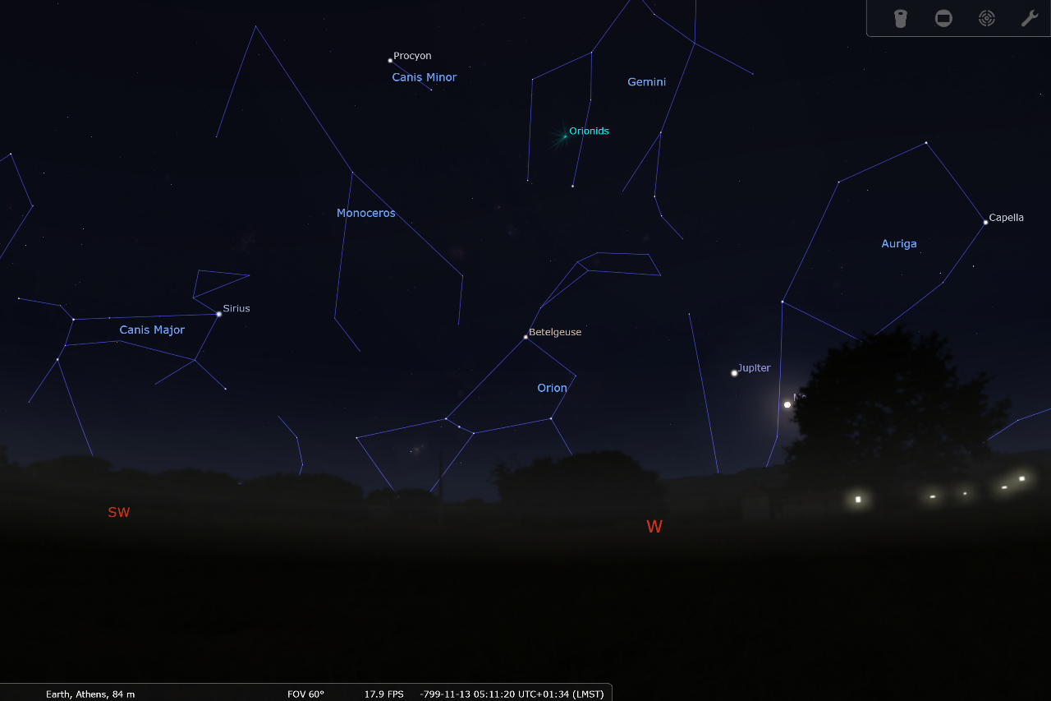
Figure 1 Orion and related constellations, Athens, 800 BC, Western horizon in November. Photo: Stellarium, version 0.21.3.

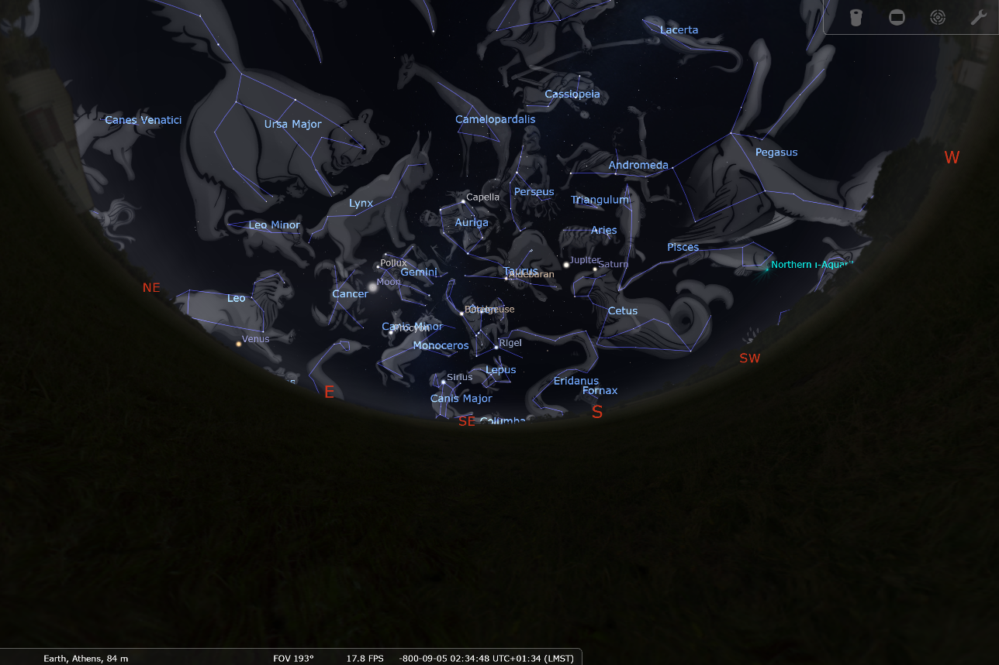
Figure 2 Constellations (Greek depictions view), time and place Athens, 800 BC, Orion is SE, above the horizon. Photo: Stellarium, version 0.21.3.

In referring to the Great Bear, Homer notes that it is also called the wain, revealing his familiarity with Mesopotamian constellations. Wain is a Greek translation of the name for the Mesopotamian wagon constellation described in the Three Stars Each and the Enuma Anu Enlil. The Mesopotamians organized constellations into different star paths each accorded to a deity. Cultural Astronomer and Astrologer, Bernadette Brady discusses these star paths in terms of, groups of stars on pathways or lines which were defined by the horizon calendar events. Modern renderings of these constellations typically depict them as chariots or war wagons, but Susanne Hoffman, an astronomer, physicist and historian of science who has done extensive research comparing the Mesopotamian and Greek constellations, describes the wagons in relation to other constellations, the Great Bull of Heaven, Orion, and Canis Minor, and offers a different view. She describes the Wagon(s) based on their relation to other Mesopotamian ‘agricultural images’ in the constellations; the shepherd, the bull, the crook, as ‘clearly an attribute for the god of agriculture (Enlil) and not a chariot for war.’ (See figure 3). In discussing the wagon, Gavin White, a non-academic researcher who has written three books on Mesopotamian star-lore, relates Ursa Major, and its counterpart, Ursa Minor, the wagon of heaven, to the funeral beliefs of the Mesopotamians. He depicts them as biers, Ursa Major transporting the deceased to the burial ground and Ursa Minor onward to the realm of shades. This is illustrative of the soul’s ascent, the idea of eternity, related to the circumpolar stars, a belief ascribed to both Egyptian and Mesopotamian cultures, though expressed in different ways. This sky view of eternity was not adopted by the Greeks of Homer’s time, whose dead entered the underworld to exist as shades. Orion contains the same stars as the Mesopotamian True Shepherd of Anu and Sirius is the tip of the Arrow constellation pointing to Orion’s belt, and signaling by its heliacal rising, the approximate time of the Summer Solstice., Hoffman describes Orion, ‘Since the True Shepherd of Anu (Greek Orion, the hunter) is in the ‘path of the moon’ it can be touched or eclipsed by the moon,’ clearly placing it in a separate, lower, star path from Ursa Major.

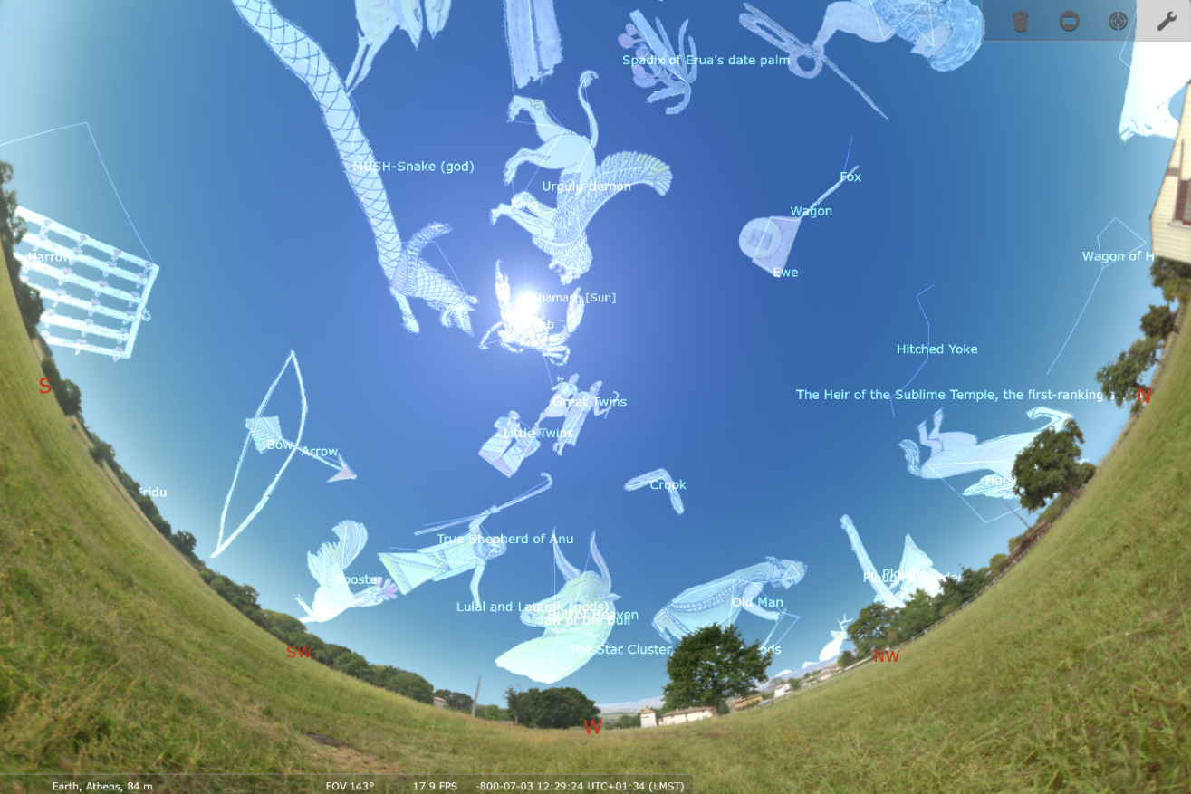
Figure 3, Constellations, same as fig. 2 but in the Babylonian starlore view. Time and place Athens, 800 BCE, photo: Stellarium, version 0.21.3

Other Orion mentions in Homer
Homer mentions Orion as a mythical character when Odysseus encounters him in the Underworld but does not connect the story with the constellation, seasonal imagery, or direction Odysseus relates, ‘I next caught sight of Orion, that huge hunter, rounding up on the fields of asphodel those wild beasts the man in life cut down on the lonely mountain-slopes, brandishing in his hands the bronze-studded club that time can never shatter.’ Orion, is mentioned alongside other heroic characters, Ajax, Heracles, Sisyphus, and Tantalus. Homer/Odysseus speaks of them as cultural symbols referring to both historical figures and characters from the Iliad. In the Iliad, placed chronologically before the Odyssey and generally believed to have been written earlier, Homer references these star groups when describing the shield Hephaestus forges for Achilles, ‘On it he showed the earth, sea, sky, the tireless sun and the full moon, and all the constellations that crown the heavens, the Pleiades, Hyades, great Orion, and the Bear, that men also call the Wain, that circles round in its place, never bathing in Ocean’s stream, while gazing warily at Orion.’ Again, Homer repeats the reference to the Mesopotamian wagon, characterizes it as circumpolar, and differentiates it as a different star path from the Pleiades, Hyades and Orion. Also in the Iliad, Homer likens Achilles to the star Sirius, ‘Him, as he blazing shot across the field, The careful eyes of Priam first beheld. Not half so dreadful rises to the sight, Through the thick gloom of some tempestuous night, Orion's dog (the year when autumn weighs), And o'er the feebler stars exerts his rays; Terrific glory! for his burning breath taints the red air with fevers, plagues, and death. So flamed his fiery mail.’ He associates Sirius with Orion, and with autumn. This would imply the time of year it is visible in the night sky rather than the solstice when it was heliacally rising, (see figure 4), but Efstratios, Theodossiou quotes Allen to address the lack of a word for autumn in Greek before the 5th century BC, correcting it to the late summer, and referring the epithet Autumn star to Sirius. The meanings Homer ascribes to it are those related to its name, ‘The original Greek name, ‘Seirios’, meant sparking, shining, flamboyant or burning.’ These terms are used as epithets for Sirius in The Orphic Argonautics, written in 6th century BC. In the Iliad, Homer also refers to Sirius, describing Sirius as Orion’s dog, and says, ‘though it is the brightest of all stars it bodes no good bringing much fever, as it does, to us poor mortals. Anonymous of 379 refers to, ‘those born when Sirius is rising’ saying that if nocturnal, it will ‘make those fit to rule,’ if diurnal, ‘those who are insolent, coarse, precipitate, and when culminating, ‘those who are eloquent and merciful, but they do not always come to a good end.’ In the Odyssey, Sirius is the faithful dog, who followed Orion even after his death, foreshadowing Odysseus’ own return to Ithaca when his faithful dog, Argos, is the first to recognize him. He does not use any of the negative effects of Sirius as in the previous passages.

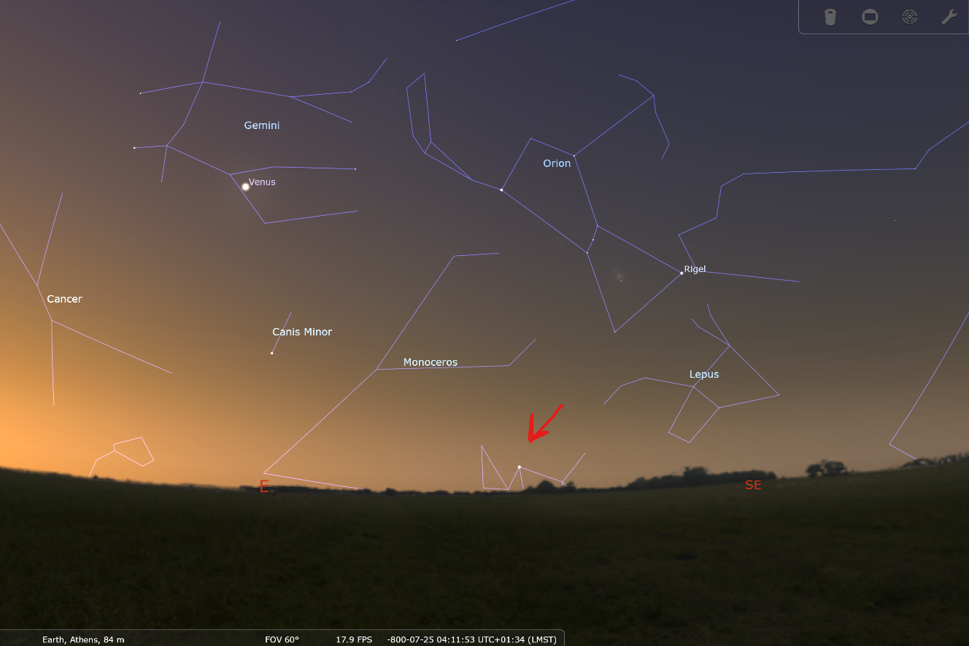
Figure 4 Sirius rising with the Sun, July 25, 800 BC, Athens, (Arrow points to Sirius, Sun is just about to rise), Photo: Stellarium version 0.21.3.

The Cultural significance of Homer

To understand the cultural of Homer we would first need to define culture, Tylor’s foundational theory is that ‘Culture, or Civilisation, taken in its wide ethnographic sense, is that complex whole which includes knowledge, belief, art, morals, law, custom, and any other capabilities and habits acquired by man as a member of society.’ Raymond Williams discusses culture in terms of education (including religion), the particular life of a people or group, and with art. The Odyssey gives us many examples of Hellenic knowledge, beliefs, morals, religion and customs. Homer portrayed the Hellenes as a people with a shared culture, language, and gods, who participated in the social rituals associated with hospitality (xenia) and fame (kleos). Historian and philologist, Christoph Ulf cautions against assuming that a ‘nation’ is a primordial entity and describes this idea as arising from late 18th century Romantic thought. He argues that, ‘more recent scholarship has been able to show - particularly by means of an analysis of the peoples of the so-called European migrations - that ..nations, emerge only under certain demographic conditions and with the aid of fictive stories of origin so that, as a distinct political unit, they may advance their claims to power more successfully.’ He draws the conclusion that the works of Homer and Hesiod were composed in a milieu, ‘in which states had just begun to form.’ Margo Kitts, a professor of near-Eastern religion and classical studies, affirms that epics of Homer and the writings of Hesiod both were written or continued to evolve during a ‘watershed for a pan-hellenic identity’ which arose from ‘rising populations and intensified networks of communication and trade among emerging city-states all around the Mediterranean Sea.’ She describes the cultural impact of shared institutions in the creation of a ‘people,’ saying, ‘the Delphic oracle, Olympian games, and poetry competitions enhanced this panhellenic identity, variegated locally by the adoption of eponymous heroes by some city-states. Panhellenic poetic and athletic competitions were conceived as devotional rituals for the gods.’ The conflict in the epics occurs because of erroneous behavior. In the Iliad it arises over the leader, Agamemnon’s, handling of a plague brought by Apollo after Agamemnon claimed the daughter of a priest as spoils. He handled it by returning his spoils, Chryseis, to the priest but then taking Achilles’ spoils, Briseis as his own. He is finally forced by the circumstances of the war and his immanent defeat to admit he was wrong, to return Briseis to Achilles and to ask for his help. In the Odyssey, Penelope and Telemachus, Odysseus’ wife and son are unable to declare him dead and hold the proper funeral rites for him because he was missing, and they didn’t know whether to treat him as a hero or as a victim of shipwreck. Odysseus had the promise of a speedy voyage home, in the gift of the pouch of winds offered by Aeolus, but this is prevented by the folly of his men in opening the gift. Telemachus, Odysseus’ son, also undertakes a journey of initiation advised by Athena. The funerary rituals, including cremation, providing coins for the dead, erecting a mound, and games, are discussed at length in both works. Penelope’s suiters violate the conventions of xenia, hospitality, her status as a widow, and threaten her son. Homer contrasts this with a positive example of xenia in the Phaeacians, who cared for the ship-wrecked Odysseus and sent him on his way with gifts. Both stories show the proper way of dealing with conflict, according to Homer, and the importance of moral leadership.

Aratus, a Greek poet of the 3rd century BC, wrote about navigation in his work, Phaenomea, ‘It is by Helice [Ursa Major] that the Achaeans on the sea divine which way to steer their ships, but in the other the Phoenicians put their trust when they cross the sea. But Helice, appearing large at earliest night, is bright and easy to mark; but the other [Ursa minor] is small, yet better for sailors: for in a smaller orbit wheel all her stars. By her guidance, then, the men of Sidon steer the straightest course.’ Homer’s active dates are circa (750 AD - 651 BC) while Hesiod’s are circa (750 and 650 BC), making them contemporaries. Hesiod uses the constellations to establish a rough annual calendar based on the stars in Works and Days:

But when Orion and Sirius are come into midheaven, and rosy-fingered Dawn sees Arcturus, then cut off all the grape-clusters, Perses, and bring them home. Show them to the sun ten days and ten nights: then cover them over for five, and on the sixth day draw off into vessels the gifts of joyful Dionysus. But when the Pleiades and Hyades and strong Orion begin to set, then remember to plough in season: and so the completed year will fitly pass beneath the earth. But if desire for uncomfortable sea-faring seize you when the Pleiades plunge into the misty sea to escape Orion's rude strength, then truly gales of all kinds rage.

The geography of ancient Hellas was mountainous, travel across the land was difficult but Greece has one of the longest coastlines in Europe, following only Norway and Greenland. Homer describes the organization of society as agricultural, households farm, weave, and trade long distance in an extensive maritime network. (See Figure 5) The maritime trade routes coordinated with land routes from the east that reached the sea via Troy and other cities along the coast. These trade routes facilitated the exchange of ideas as well as goods. Homer’s mentions of the wain when he describes Ursa Major is evidence of this, as is Hesiod’s work. Hesiod says his father was from Cyme, an Aeolian city in Aeolis (Asia Minor) located on the coastline. The location of Cyme and its access to the East could explain his interest in and access to ideas from Mesopotamian astronomy from his father’s stories. Scholars, including Classicist and philologist, Martin L West have noted many passages from the Mesopotamian Gilgamesh Epic that parallel the events or language of Homer’s epics.
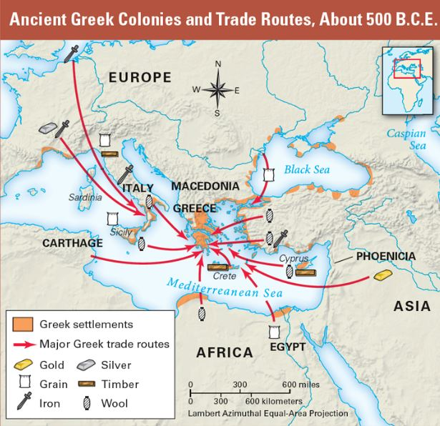
Figure 4 Major Greek trade routes, map credit: http://bakkeac.weebly.com/greece.html

Conclusion

Several points that Archeoastronomers have determined were typical of early civilizations are observation of the moon’s phases, solstices and heliacal risings. Michael Rappengluck, Cofounder and secretary of the Society for Archaeoastronomy (Germany), describes the methods ancient pilgrims and traders might have navigated by story-tracks or story maps. This idea brings Brady’s Mesopotamian star paths back to the earth, encoding the constellation stories with astronomical data, waypoints, and history creating a narrative map. The descriptions of ship building and handling in the Odyssey are long and detailed, Homer and his listeners were clearly familiar with sailing and navigation and saw their mastery as part of their cultural heritage. Sandra Tinaj describes heritage as tangible and intangible structures, inherited from the past, maintained in the present and worthy to be preserved and protected for future generations. It is a selected, common wealth that belongs to a community. For Odysseus these constellations are a way of placing himself in the world, Orion and the circumpolar stars are tools he can use to return home or as Rappengluck explains, the stars combined with stories are a way of domesticating space and time.

Figures
Figure 1 Orion and related constellations, Athens, 800 BC, Western horizon in November. Photo: Stellarium, version 0.21.3. 2
Figure 2 Constellations (Greek depictions view), time and place Athens, 800 BC, Orion is SE, above the horizon. Photo: Stellarium, version 0.21.3. 2
Figure 3, Constellations, same as fig. 2 but in the Babylonian starlore view. Time and place Athens, 800 BCE, photo: Stellarium, version 0.21.3 4
Figure 4 Major Greek trade routes, map credit: http://bakkeac.weebly.com/greece.html 9

Bibliography

1 Anonymous of 379, The Treatise on the Bright Fixed Stars. trans. Robert and Schmidt Hand, Robert (1993).
2 Bernadette Brady, 'Star-Paths, Stones and Horizon Astronomy', in SEAC 2011 Stars and Stones: Voyages in Archaeoastronomy and Cultural Astronomy, ed. by F. Pimenta, N. Ribeiro, F. Silva, N. Campion, A. Joaquinito and L. Tirapicos (2015), pp. 58-62.
3 Robert Fagles, The Odyssey: Translation Robert Fagles (Penguin Classic: 2006).
4 Hesiod, Theogony. Works and Days. Testimonia. trans. H.G. EVELYN-WHITE. ed. by Loeb Classical (Cambridge Massachusetts: HARVARD UNIV Press, 2018).
5 ———, 'Works and Days'.
6 Susanne M. Hoffman, 'Drawing Babylonian Constellations', (2018).
7 Homer, and Richmond Lattimore, The Odyssey of Homer (New York: Harper & Row, 1999).
8 Homer, and Richmond Alexander Lattimore, The Iliad ([Chicago]: University of Chicago Press, 1962), p. 526 p.
9 Homer, and T. E. Lawrence, The Odyssey (1935).
10 translated by Kline A. S. Homer, 'Homer - the Iliad', (2022).
11 'The Iliad of Homer. Translated by Mr Pope. [with Notes Partly by W. Broome.] (an Essay on the Life, Writings and Learning of Homer. [by T. Parnell].) F.P Collection Item', The British Library.
12 Margo Kitts, 'What's Religious About the Iliad?', Religion Compass, 7 (2013), 225-33.
13 Natural History Magazine, 'Sirius Matters', Natural History, Aug 1994 1994, p. 24.
14 Sen Nag Oishimaya, 'Countries in Europe with the Longest Coastline', World Facts, (2018) <https://www.worldatlas.com/articles/countries-in-europe-with-the-longest-coastline.html>2022].
15 Beaulieu Paul-Alain, Frahm Eckart, Horowitz Wayne, and Steele John, 'Chapter 3: The Expanded Version', Transactions of the American Philosophical Society, 107 (2017), 35-62.
16 Michael Rappengluck, 'Seac 2011 Stars and Stones: Voyages in Archaeoastronomy and Cultural Astronomy : Proceedings of the Seac 2011 Conference', ed. by Meeting Pimenta Fernando Ribeiro Nuno Silva Fabio Campion Nicholas Joaquinito Anabela Tirapicos Lu s European Society for Astronomy in Culture (2011).
17 Efstratios Theodosiou, Milan Dimitrijevic, Vassilios Manimanis, and P. Z. Mantarakis, 'Sirius in Ancient Greek and Roman Literature', Publications of the Astronomical Observatory of Belgrade-Πyбл. Aстр. Друш. "Pyђeр Бошковиђ", 10 (2011), 605-8628.
18 Sandra Tinaj, and Anđela Jakšić Stojanović, 'Cultural Heritage', (2021).
19 Edward B. Tylor, Primitive Culture, Etc. (Sixth Edition.) (2 vol. John Murray: London; printed in U.S.A., 1920), p. 8º.
20 Christoph Ulf, 'The World of Homer and Hesiod', in A Companion to Archaic Greece (2009), pp. 81-99.
21 M. L. West, The Making of the Odyssey (Oxford: Oxford University Press, 2015).
22 Gavin White, Babylonian Star-Lore. An Illustrated Guide to the Star-Lore and Constellations of Ancient Babylonia (London, UK: SOLARIA PUBLICATIONS, 2014).
23 Raymond Williams, Keywords : A Vocabulary of Culture and Society (London: Fontana Press, 1985).

Homer and T. E. Lawrence, The Odyssey, (1935), p. 77.
Homer and Lawrence, p. 77.
Natural History Magazine, 'Sirius Matters', in Natural History, (New York: Natural History Magazine, Inc., 1994), p. 24.
Beaulieu Paul-Alain and others, 'Chapter 3: The Expanded Version', Transactions of the American Philosophical Society, 107 (2017), 35.
Bernadette Brady, 'Star-Paths, Stones and Horizon Astronomy', in SEAC 2011 Stars and Stones: Voyages in Archaeoastronomy and Cultural Astronomy, ed. by F. Pimenta, et al. (2015), pp. 58-62.
Brady, p. 3.
Susanne M. Hoffman, 'Drawing Babylonian Constellations', (2018), (p. map).
Gavin White, Babylonian Star-Lore. An Illustrated Guide to the Star-Lore and Constellations of Ancient Babylonia, (London, UK: SOLARIA PUBLICATIONS, 2014), p. 38.
Hoffman, p. map.
Natural History Magazine, p. Soltice page.
Hoffman, p. map.
Robert Fagles, The Odyssey: Translation Robert Fagles, (Penguin Classic, 2006), p. 193.
Homer and Richmond Alexander Lattimore, The Iliad, ([Chicago]: University of Chicago Press, 1962), p. book iixx.
translated by Kline A. S. Homer, 'Homer - the Iliad', (2022), (p. 449.).
Efstratios Theodosiou and others, 'Sirius in Ancient Greek and Roman Literature', Publications of the Astronomical Observatory of Belgrade-Πyбл. Aстр. Друш. "Pyђeр Бошковиђ", 10 (2011), 181; Theodosiou and others
Theodosiou and others p. 180.
Theodosiou and others p. 180.
'The Iliad of Homer. Translated by Mr Pope. [with Notes Partly by W. Broome.] (an Essay on the Life, Writings and Learning of Homer. [by T. Parnell].) F.P Collection Item', The British Library, 19xx.
Anonymous of 379, The Treatise on the Bright Fixed Stars, (1993), p. 6.
Homer and Richmond Lattimore, The Odyssey of Homer, (New York: Harper & Row, 1999), p. xvii.292.
Edward B. Tylor, Primitive Culture, Etc. (Sixth Edition.), (2 vol. John Murray: London; printed in U.S.A., 1920), p. 1.
Raymond Williams, Keywords : A Vocabulary of Culture and Society, (London: Fontana Press, 1985), pp. 12, 87, 90.
Christoph Ulf, 'The World of Homer and Hesiod', in A Companion to Archaic Greece, (2009), pp. 81-99 (p. 82).
Ulf, p. 83.
Ulf, p. 83.
Margo Kitts, 'What's Religious About the Iliad?', Religion Compass, 7 (2013), 2.
Kitts, p. 2.
Ulf, p. 84.
Hesiod, Theogony. Works and Days. Testimonia, (Cambridge Massachusetts: HARVARD UNIV Press, 2018), pp. lines 610-25.
Sen Nag Oishimaya, 'Countries in Europe with the Longest Coastline', (World Facts, 2018).
Hesiod, 'Works and Days', lines 631-4.
M. L. West, The Making of the Odyssey, (Oxford: Oxford University Press, 2015), p. 402.
Michael Rappengluck, 'Seac 2011 Stars and Stones: Voyages in Archaeoastronomy and Cultural Astronomy : Proceedings of the Seac 2011 Conference', ed. by Meeting Pimenta Fernando Ribeiro Nuno Silva Fabio Campion Nicholas Joaquinito Anabela Tirapicos Lu s European Society for Astronomy in Culture (2011), (p. 19).
Brady, p. 3.
Sandra Tinaj and Anđela Jakšić Stojanović, 'Cultural Heritage', (2021), (p. abstract).
Rappengluck, p. 19.

