Name: Garett Talbot
Student number: 1803311
BA course title: automotive design 90 credit
Word count: 1423
Tutors name: Julia lockheart
Introduction
Since the inventions of the automobile people have wanted speed and the best way to do so was by making you vehicle lighter. Enter the motorized bicycle but the invention of a motor bike brought more than just speed it brought an entire culture with it. In this exhibition you will see the different worlds that this invention has brought to be from high revving super bikes to the gentle tick over of a trials bike
Location
The location of my exhibit will be the Mission Gallery because it is a well-known contemporary art gallery used by many different artists over time formerly St Nicholas church for seamen, the mission gallery was designed by Benjamin Bucknall and built in 1886 Mission Gallery is housed in a Grade II listed building which began its existence in 1977 and is voluntary run by artists [1]all the bikes in the gallery will be placed next to each other in a line up side by side

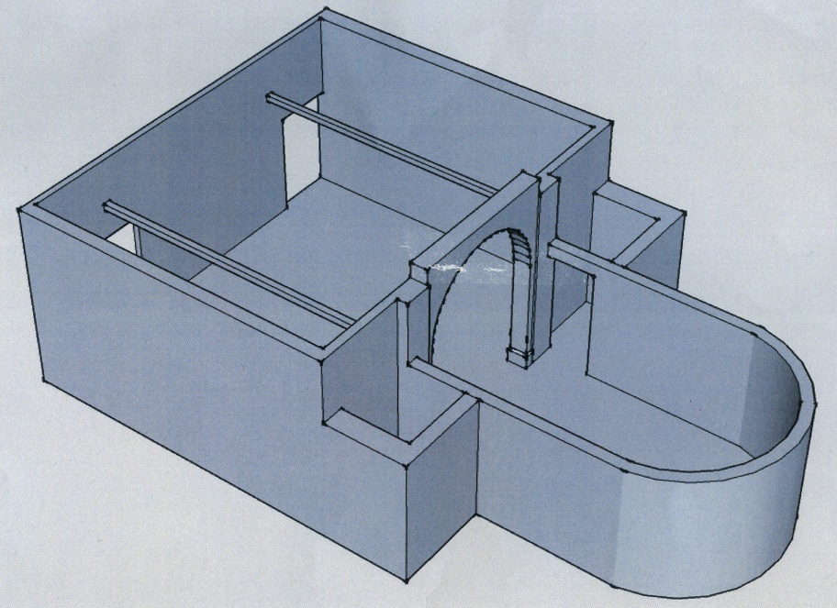Fig.1
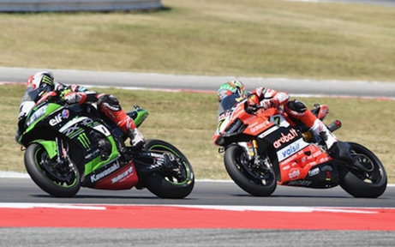
Exhibit one superbikes: in the first part of my exhibition there will be a super bike also known as a road bike which are the most commonly seen and used bikes they are road legal and require a license to ride on the road the bikes them self’s can vary from 50cc to over a 1000cc which is the size and power of the engine. These bikes have been around for nearly 50 years .superbikes were designed to go faster than any other bike on the road. In the process of this a culture was born full of
Fig.2
Adrenalin junkies and bike lovers. The first ever bike to carry the ‘super’ prefix was
The Honda CB750. Which was made in 1969 it was manufactured in Japan it was their first attempt and making a bike to appeal to the American market. [2] Super bikes are raced on tracks all around the world and have become one of the biggest sports worldwide. But they also come with the harsh reality of danger and death since the birth of the super bike there have been riders who have lost their lives and their limbs to this sport. Riding a super bike can be one of the most dangerous bikes you could choose to ride but one of the most exhilarating to say the least. Noting comperes to 200mph winds in your face with just a motor between your legs
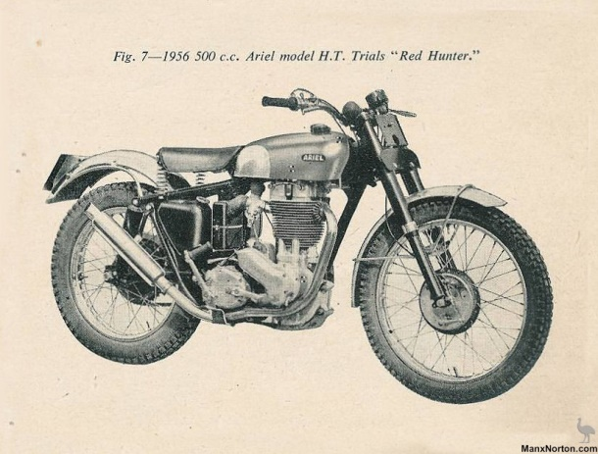
Exhibit two trials bikes: trials bikes unlike super bikes or any other bikes in the exhibition. A trials bike does not involve speed. Trials bikes have the ability to go fast and be fast but they are made for slow and precise actions unlike the rest they are the only bike in the bike world that can almost go over and traverse any surface they are designed for this purpose. The look for a trials bike is unlike any other they do not have a seat which causes the body of the bike to have a huge dip in the middle making the look and style of the trials bike very unique. The sport itself has an unknown time of origin because trials started with ordinary road bikes which had knobble tires put on them the first record of a trial style event was in 1910 which consisted of a hill climb which is very simple and straight forward event. By the 1960s trials became more specialized and the bikes improved with the sport a huge milestone accrued in the 1960s. When Sammy miller lighted his factory Ariel HT5 and changed the steering head angle resulting in a bike which went over obstacles better and turned tighter then another bikes. After this accrued other manufactures started to work on their own bikes and over time the sports became bigger and evolved. Into what you see today from indoor trials to 6 day trials events which happen all over the world. Trials is a unique motorcycle sports which its own unique history like no other [3]
Fig.3
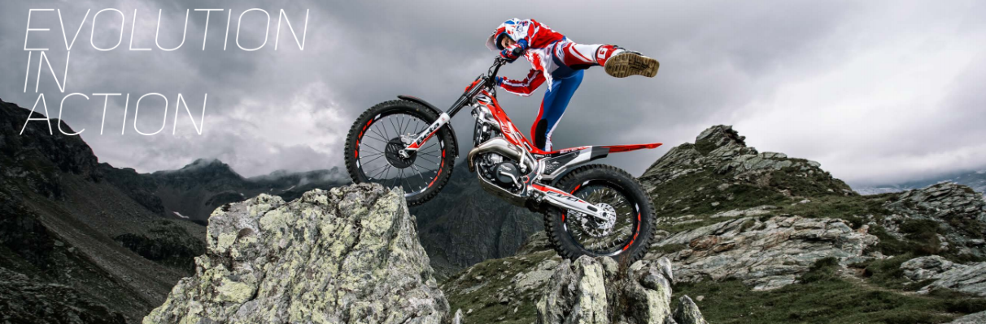Fig.4

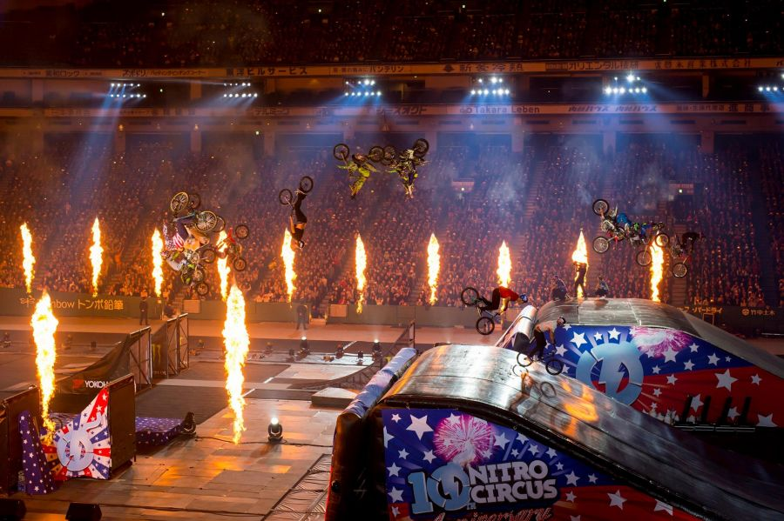
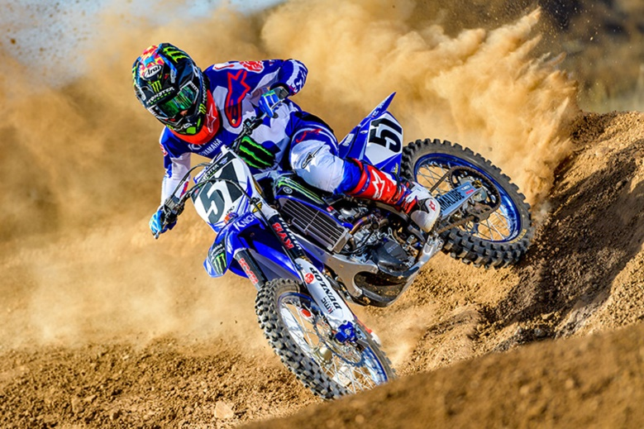
Exhibit three motocross: Motocross’s bike/ dirt bikes are probably the most dangerous bike out of all of the motorbikes in this exhibit. Motocross consist of high speed big jumps round a track over a certain amount of laps to see who come first out of a group from 15 to 50 the origins of the sports began in the UK in the early 1900s. Motorcycle clubs would hold time trials over time these events became “scrambles” the first ever official scramble was in Camberley, Surry in 1924. Over the years the sport became bigger and bigger in the 1970s the sport exploded when it became popular in America the first stadium motocross race took place in Los Angeles Coliseum. Motocross is a worldwide sport and one of the extremist to this day. Between 2001 and 2004 an estimated 500,000 people were in dirt bike accents just showing you how dangerous a dirt bike can be let alone under pressure and in a race of up to 50 people so motocross is one of the most exhilarating and the most dangerous. Motocross bikes are now used in a variety of different events now like freestyle motocross where bikes are jumped over huge distances and tricks are performed in midair which requires a lot of training and can be very dangerous there are versus other events which have been invented over time like straight rhythm, supercross and others over all motocross is an adrenalin filled sport and unlike the rest its hard and fun not something for the faint hearted. [4]
Fig.5
Fig.6
Fig.6
Fig.5
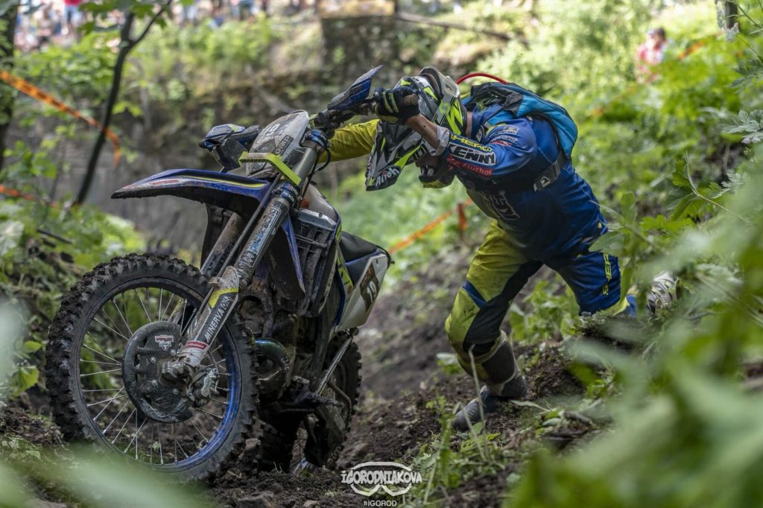
Exhibit four enduro: out of all of the bikes in this exhibition the sport enduro and the enduro bike and the definition of their names. Being an enduro rider is one of the hardest and most taxing things you could choose to do because of the hours required to be on the bike and the difficulty of the races. Like trials there is not really a known origin for because it has evolved from people taking their normal road bikes down drift tracks and just having fun after years of this people decided to create events and hold them in different countries and compete to see who the best is. One of the oldest recorded enduro events is the ISDE (international six day enduro). The ISDE was first held in 1913 in Carlisle, England. The early events were a test of true machine, rider skill, and reliability. Over the years the race has been held in 32 different countries for example Australia, Brazil, New Zealand and Chile .The enduro its self is a six day and upward of 1250 kilometers a motorcycle rider must contend with strict rules about restrictions on mechanical replacements , time allowances and much carry out their own track side repairs. Making this sport one of the hardest your could ever do on a motorcycle because of the shire endurance needed and the mental strength to carry on going when it’s just you and a bike miles away from anyone or any help. That’s why enduro is one the hardest sports to ever compete in.[5]
Fig.7
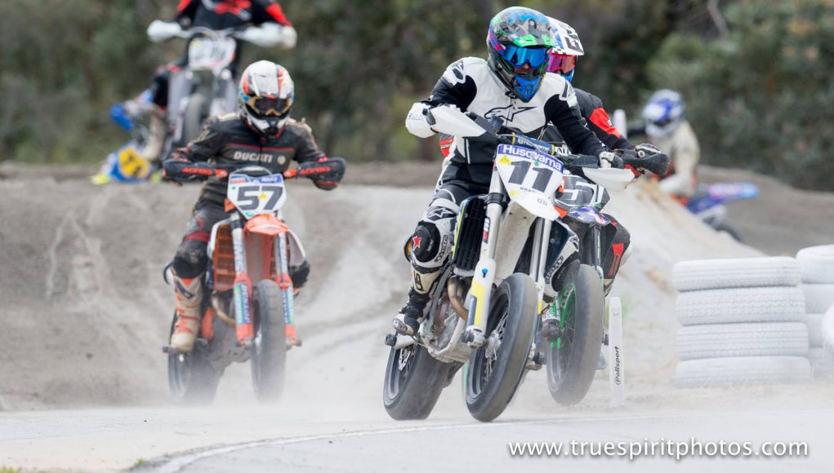
Exhibition five supermoto: supermoto / supermoto bikes are cross between motocross and super bikes being a hybrid of the two this bike. Sport its self is very entire because it requires bikes to race on tarmac and on dirt making it a very entertaining sport to watch and be a part of. Prior to the 1990s, supermoto bikes (also known as Supermotards), in 1991, the Italian manufacturer Gilera released their ‘Nordwest’ model, the first ever production supermoto motorcycle after this it didn’t take long for other manufactures round euro to start doing the same one by one they were all producing supermoto bikes. At this time the manufactures had not considered road bikes but after this it became a huge part of their focus. This sport is a very young one but very unique because of its hybrid style.[6]

Fig8
Conclusion
As you can see the invention of the motorcycle and bought so many different people together to create huge sports and cultures. To some people a motorbike is more than just a metal frame with an engine in it. It is life, motorbikes bring happiness they being people from all over the globe with different cultures and different passions together to celebrate the same thing they all love. It shows you now one invention made for one purpose can evolve and become something bigger than itself. Creating joy and love.

Bibliography:
- https://www.eventbrite.co.uk/o/mission-gallery-6394656435

- https://en.wikipedia.org/wiki/Mission_Gallery
2. https://www.bikesure.co.uk/bikesureblog/2016/12/a-brief-history-of-superbikes.html
- https://trials.com.au/moto-trials/history
- https://www.cornmarketinsurance.co.uk/a-brief-history-of-motocross-racing/
- https://ultimatemotorcycling.com/2010/11/06/isde-enduro-history/
- https://www.supermotoasia.com/2017/08/15/brief-history-supermoto-bikes/
Images:
Fig1: https://moodle.uwtsd.ac.uk/mod/folder/view.php?id=179942
Fig2:https://www.google.com/search?q=super+bikes&rlz=1C1GGGE_enSK398GB847&source=lnms&tbm=isch&sa=X&ved=0ahUKEwiqz4zd6YbiAhUvSxUIHXDAAMYQ_AUIDigB&biw=959&bih=932#imgrc=qEJpIMyWMak9XM:
Fig3: https://cybermotorcycle.com/gallery/ariel-ht5/images/Ariel-1956-HT5-Red-Hunter.jpg
Fig4:https://www.google.com/search?rlz=1C1GGGE_enSK398GB847&biw=958&bih=959&tbm=isch&sa=1&ei=hjHQXJbZBY2Y1fAPl8GMmAo&q=trials+bike+in+action&oq=trials+bike+in+action&gs_l=img.3...1921.3806..3950...0.0..0.46.398.10......0....1..gws-wiz-img.......0j0i8i30j0i24.T9gJ3FHV8GE#imgrc=PpOaAW5FZR6uyM
Fig5:https://www.google.com/search?rlz=1C1GGGE_enSK398GB847&biw=963&bih=959&tbm=isch&sa=1&ei=AjTQXPDzN86G1fAPkfigkAE&q=motocorss&oq=motocorss&gs_l=img.3..0i10i24l6.3153222.3159026..3159675...0.0..0.51.402.9......0....1..gws-wiz-img.....0..0j0i67j0i5i30j0i24j0i30.ts2egNZhDk8#imgdii=U1iB75SG19qQ6M:&imgrc=cJxwot6X8hctvM:
Fig6: https://www.kelownanow.com/files/files/images/nitro%204.jpg
Fig7: https://slingfast.com/en/
Fig8: https://www.mcnews.com.au/moto-wrap-ama-endurocross-supermoto-baja-1000/

