Owen Evans (2011680)
University of Wales Trinity St. David
Design of a specialist automatic control system
Control & Automation - ACMA5001

Table of Contents

1. Introduction 2
2. Methodology 3
2.1 Water Management 3
2.1.1 Water Quality 3
2.1.2 Valves 5
2.2 Variables 6
2.2.1 Water Quality 6
2.2.2 Temperature 7
2.2.3 Light 7
2.2.4 pH 7
2.2.5 Ammonia/Nitrite 7
2.2.6 Phosphate 8
2.2.7 Nitrate 8
2.2.8 Consumables 8
2.3 Control System 9
2.4 Data Storage 11
2.5 Non-automated Processes 11
3. Conclusion 13
4. References 14
5. Appendix: Water Cycle Scripts 15

Introduction

As environmental changes caused by human activity start to change the world’s ecosystem, specialist breeding projects are required to ensure the survival of ‘at risk’ species. These projects attempt to recreate the animal’s natural environment, often with complex bespoke requirements for the species ‘at risk’. To maintain the artificial environment, the variable parameters of the habitat must be defined, measured, adjusted, and controlled in real time to bring the environment back to the nominal conditions for any deviation beyond acceptable limits. Doing so would require frequent and constant human intervention into the environment to test, and potentially adjustment of each variable through various corrective actions. This report explores the possibilities for automation of the maintenance of the artificial habit for different species of endangered marine animals. Furthermore, the report explores the data storage and reporting options.

Methodology

Water Management

2.1.1 Water Quality

Tap water is unsuitable for direct use in a fish tank as it contains a mixture of metals and minerals, both naturally occurring and added as part of the water treatment and distribution process. The composition varies across geographical regions and seasonal shifts, as water companies change the additive mix to inhibit bacterial and fungal growth during the warmer Summer months (Water Inspectorate, 2021).
To counter this, the water must first be treated in a secondary tank, prior to flowing into the main tank. The preferred process is ‘Reverse Osmosis’ (RO) for the following reasons (Gay, 2005):
- It provides a consistent base water quality regardless of input water composition
- It does not require water testing
- It aids automation as pH conditioning substances (‘buffers’) composition will remain constant
- It allows the buffer amount to remain constant, set by volume of treatment tank
- It enables re-use of wastewater for other purposes
A suggested ‘Water Flow System’ from supply to drain, passing through both the treatment and the main tank is shown in Figure 1.

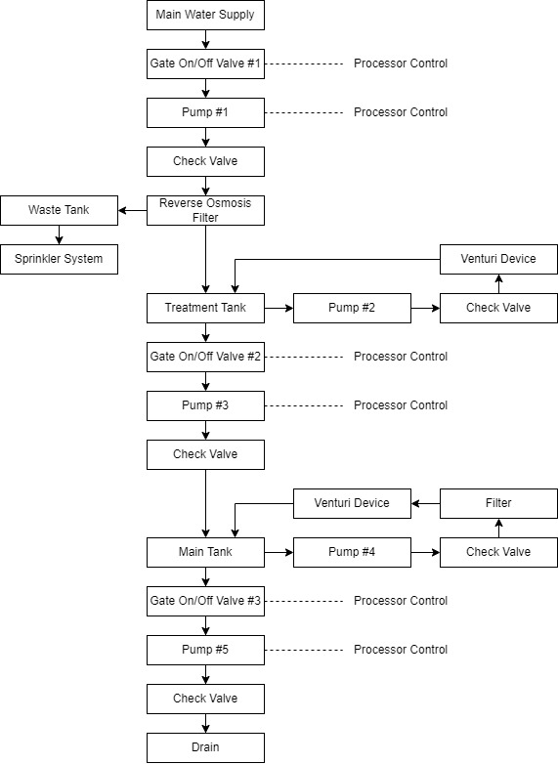
Figure 1 - Water Flow Diagram

All pumps are fitted with a ‘check valve’, which acts as a one-way valve allowing full fluid flow into the system, but prevents the backwards flow of water into the pump once it is switched off (Parr, 2011). Each tank also contains a ‘Venturi Device’ to spoil the airflow from the pump, reducing the pressure of the water and improving oxygenation, to a higher degree than other types of end effector (Emiroglu and Baylar, 2010).

2.1.2 Valves

The control for the water flow would be provided by the ‘Gate On/Off’ valves, as shown in Figure 1. Gate valves are suitable as they can be activated by an electrical signal to an actuator to provide an ‘open/closed’ response. To power the actuators to close the gates, a pneumatic system would be required comprising of the following key components (‘Basic Pneumatic Circuits’, 2021).
- Intake filter
- Compressor
- Cooler
- Separator
- Receiver
- Pressure Switch
- Secondary Air Treatment
- Motor Control Centre
- Valves/Actuator
The valves would be in a ‘normally closed’ position, requiring an input to activate. This configuration also acts as a safety control, returning the valve to a closed state and preventing the flow of water through the gate and into the tanks in the case of power loss to the system. An example of the schematic for the valve is shown in Figure 2.

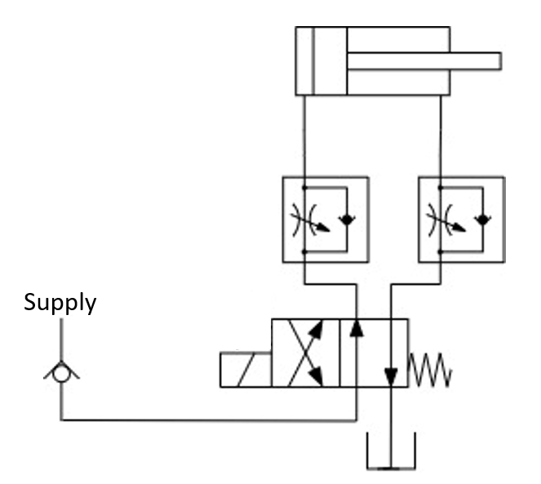
Figure 2 - Gate valve schematic

Once the solenoid is activated, the air into the actuator flows through ‘Unidirectional Flow Regulators’, which ensure maximum flow into the actuator but control the exhaust phase. This approach lessens the speed of the actuation, preventing system wear and providing control to gradually reduce the flow to a stop. Using a pneumatic approach, the electrical control part of the valve can be kept isolated from the water, allowing the pneumatic section of the system to operate from a submerged position.
Although the actuation could be carried out by a hydraulic system, this approach would not be suitable for the following reasons (Ilango and Soundararajan, 2013):
- Hydraulic system requires/provides excessive power in comparison to the pneumatic solution
- Hydraulics require purchase, storage and control of a separate fluid medium
- Fluids are generally oil-based, so any leaks would be toxic to marine species
- Expensive to setup and maintain
Hydraulic systems would be better suited to other functions within the building, separated from the aquarium, such as lifts, heavy security doors, hoists, forklifts and cranes.
The activation of these valves would be controlled through an input signal from a Programmable Logic Controller (PLC).

2.2 Variables

To automate the process, the variables to be controlled in maintaining a healthy environment for the fish must first be determined. Measurement devices would then be required to provide real-time data for each variable identified, with thresholds clearly established for corrective actions to take place. Finally, the desired action required for each threshold violation should be clearly stipulated to enable design of the automation process.
The thresholds are required to create acceptable limits where no corrective action is undertaken for any of the parameters. Acceptable limits are essential to:
- Allow for the accuracy of the measurement device to be compensated for
- Prevent competing corrective actions at threshold conditions
- Reduce power consumption by limiting corrective actions only to times when they are required
The variables relating to salt/saline are only applicable to salt water marine environments.
All submerged equipment must be waterproof to IP68 specifications (CEI, 2001) and all measurement equipment would have to be controlled and calibrated periodically in accordance with ISO 9001:2015 (ISO, 2015). Any sensors chosen for use within the system must have a measurement resolution and accuracy band that would not exceed the control limits specified to prevent erroneous non-conformances to the stipulated parameters.

2.2.1 Water Quality

To maintain a healthy water environment and encourage the removal of contaminated water, a monthly cycle replacing 25% of the water should be carried out (Gay, 2005). The cycle would be co-ordinated through a monthly timer, which activates it in line with ‘Appendix 1’. Water level sensors in both tanks would monitor each tank independently and control water top-ups using ‘Appendix 1’. Water quality will also be maintained through a pump and filter section within the main tank. If both level sensors detect a low level, an alert would be sent to the operator.
The RO filter will require the filter media to be replaced every 4500 litres. The timing will be controlled by measurement of the count of water in and out of the system using the treatment tank water float. All other filters will require a monthly service, with a notification scheduled and sent to the operator.

Temperature

Water temperature should be set for the natural environment of the fish, varying only within an acceptable range. As fish can suffer from ‘cold water shock’, it is important that any water added into the main tank from the treatment tank is prepared to a similar temperature (Donaldson et al., 2008). For this configuration, the water temperature regulation would require two independent systems, one for each tank.
The temperature would be controlled at a nominal value with a +/-2ºC using a water thermometer. Temperatures above the upper limit would activate a cooling fan whilst temperatures under the lower limit would activate a heater.

2.2.3 Light

The natural bodily functions of fish follow a circadian day-night cycle (Trajano, Ueno and Menna-Barreto, 2012). As such, the main tank system hosts two fluorescent tubes of different hues to mimic the cycle, controlled by a timer. A Lux meter with a wide tolerance band under the lights would monitor the light intensity and provide a warning to the controller if a fluorescent tube is not functioning.

pH

Fish have adapted to the water conditions of their local environment, including its pH level. Changes to the pH could prove toxic and result in increased mortality of the fish (Sampaio et al., 2019). Variation in the pH of the water can be caused by a build up of waste materials produced by the organisms (Gay, 2005). To detect changes, a pH sensor is required, set to a nominal value for the species of fish, with a +/- 1pH threshold. If a reading passes wither the upper or lower threshold, the corrective action is to trigger a partial water change through the activation of the ‘Appendix 1’.

Ammonia/Nitrite

Ammonia/Nitrite build up can be toxic to fish at any value above zero. It can be caused by a lack of good bacteria in filter system, overfeeding, poor filtration, too high fish concentration per unit volume or rotting dead fish (Medeiros et al., 2016). A sensor would be required to detect the presence of Ammonia/Nitrite, with a threshold of >1ppm. As the causes vary, a complex response would be required as shown below:
- 10% water change in accordance with ‘Appendix 1’
- Suspend feeding cycle for 2 days
- Suspend filter cleaning to retain good bacteria
- Signal to operator to clean tank to remove uneaten food/dead fish

Phosphate

Phosphate exposure can also be toxic to marine species at concentrations exceeding 2mg/l (Reid, Contreras Macbeath and Csatádi, 2013) and can be caused by unfiltered water, excess fish food or fish waste. A phosphate sensor in the system with a threshold of 1mg/l would be required. The corrective actions would be the same as the ones for Ammonia/Nitrite contamination, with the exception that a notification would be sent to the operator to carry out filter maintenance.

Nitrate

Insufficient filtration and poor water quality can allow nitrate levels to climb over time above the acceptable limit of >10ppm (Furukawa et al., 2016). Although the water quality process will reduce the risk of nitrate build up, a sensor to detect nitrate with a >10ppm threshold would provide a safety net. If the nitrate levels exceed the limit, the actions below would be applied:

- 10% water change in accordance with ‘Appendix 1’
- Signal to operator to clean tank substrate
- Signal to operator to carry out filter maintenance

Consumables

The system needs to incorporate dispensing of consumables into the water as they are required. The consumables are shown in Table 1.

Consumable | Tank |  | Initiation
Consumable | Treatment | Main | Initiation
Buffer | X |  | Activated as part of the 'Water Cycle Script'
Salt | X |  | Activated as part of the 'Water Cycle Script'
Food |  | X | Set to activate a 8 hour intervals
Table 1 - Consumable requirements

All consumables will be delivered through the activation of a servo motor attached to a transparent dispensing tube. When required, the signal from the PLC will trigger the motor and dispense a single portion of the consumable. The dispensing tube requires an optical transmitter/receiver at the base, which would detect the laser and send a signal to the PLC, which sends an alert to the operator requesting replenishment of the consumable as it runs out.
The buffer effect and surplus food are already measured and controlled within the other variables previously discussed. The saline content should be measured in the main tank, to a salinity level of 1.012 to 1.024 Specific Gravity, triggering a water change in accordance with ‘Appendix 1’ for any deviation outside of the threshold (Gay, 2005).

Control System

The system is comprised of a mixture of analogue and digital components. All analogue signals will need to pass through an ‘Analogue-to-Digital’ converter to produce an output that can be received and utilised by the PLC. The categorisation of the components is shown below:
- Analogue Components
- Water Temperature Sensors
- Water Float Sensors
- pH Sensor
- Ammonia Monitor
- Phosphate Hydrocycle
- Nitrate Sensor
- Saline Sensor
- Lux Meter

- Digital Components
- Microcontroller Outputs
- All Consumable (Feed/Buffer/Salt) Dispensers
By connecting the PLC to a PC via a communication port, the PLC can be programmed to the thresholds defined for each sensor to trigger the appropriate response. This allows the same system to be used for multiple artificial environments. The system would include a physical board which would alert the operator through an audible alarm, coupled with an LED dashboard to illustrate the action to take. The system would also control timer circuits to set the scheduled maintenance actions. Figure 3 demonstrates the connectivity of the whole system.
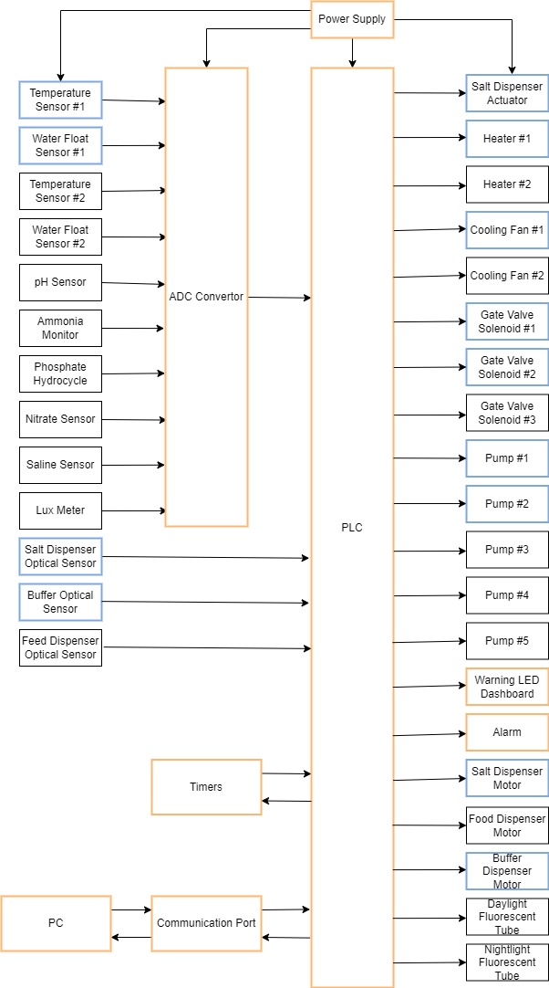
Figure 3 - Example Block Diagram of an Automated Response System. The treatment tank specific components are in blue boxes, the main tank specific components in black boxes and the control components affecting both tanks in orange boxes

Data Storage

It is possible to set the PC to periodically interrogate the PLC to extract the data for all the variables and store it in an SQL database. The frequency of the data collection would have to be determined so the data provides enough resolution to identify trends, whilst also considering the financial implications of excessive data storage. Once the data is stored in the database, dashboards can then be created using data visualisation software (such as Power BI or Birst) to provide a user-friendly interface to demonstrate the conditions in the tank within any period. The dashboards can then be hosted on a server, allowing any device to connect to the webpage and view the data, provided the user has the correct privileges.
Such a system offers the following advantages:
- Allowing remote observation of conditions within the tank
- Ability to place displays near the aquarium/online for educational purposes
- Ability to supplement the operator dashboard with a wireless device to monitor environment
- Development of push notifications for operator actions
- Transmission of action scripts and checklists to operators to aid scheduled or incident-based responses, replacing Standard Operating Procedures (SOP)

Keeping historical records that can be reviewed will also help in the identification of seasonal shifts or other potential parameters’ trends in the tank environment. This could allow understanding of potential causality between the parameters’ values and the different conditions within the tank. The data can also provide indications of when a corrective action is needed, based on parameter drift from the nominal condition, rather than relying on the threshold to be breached before any identification of an issue is provided. It can also assess power usage of the system and enable other facilities to understand the requirements for their own systems.

Non-automated Processes

Whilst this report has demonstrated that it is possible to automate a considerable part of the day-to-day running of a marine environment, there are several parameters that cannot be automated. Although some of these activities could be scheduled using timers in the control of the system, or have detection built into the system, they would require a manual intervention to complete the task. These tasks include the following.
- Replenishment of consumables (food/salt/buffer)
- Filter maintenance
- Light bulb replacement
- Sensor/test equipment maintenance
- Cleaning of the substrate on tank floor
- Glass cleaning from algae and other impurities
- Measurement equipment calibration

Other tasks that cannot be automated or scheduled rely on the constant monitoring of the environment to understand whether human intervention is required or not. These tasks include individual fish health check and faulty equipment replacement.

Conclusion

This report has shown that by aligning a water flow strategy and an environmental monitoring plan with a robust control system, it is possible to maximise the automation potential of an aquarium. There will still be a need for human intervention for certain activities, however these are reduced to scheduled maintenance of the equipment and refilling of consumables, rather than testing and correction of environmental conditions. This solution also removes the requirement for laborious record keeping and specialist knowledge of environmental manipulation as a prerequisite for the operator. The proposal can be adapted for use across a range of environmental conditions for different fish species and their requirements.

References

‘Basic Pneumatic Circuits’ (2021) NASA Tech Briefs, (8), pp. 6A-10A.
CEI (2001) ‘IEC 60529’.
Donaldson, M. R. et al. (2008) ‘Cold shock and fish’, Journal of Fish Biology, 73(7), pp. 1491–1530. doi: 10.1111/J.1095-8649.2008.02061.X.
Emiroglu, M. E. and Baylar, A. (2010) ‘Study of the influence of air holes along length of convergent-divergent passage of a venturi device on aeration’, https://doi.org/10.1080/00221680309499996, 41(5), pp. 513–520. doi: 10.1080/00221680309499996.
Furukawa, A. et al. (2016) ‘Development of a DHS-USB recirculating system to remove nitrogen from a marine fish aquarium’, Aquacultural Engineering, 74, pp. 174–179. doi: 10.1016/J.AQUAENG.2016.08.004.
Gay, J. (2005) The Perfect Aquarium. Octopus Publishing Group Ltd.
Ilango, S. and Soundararajan, V. (2013) Introduction to hydraulics and pneumatics. PHI-Learning.
ISO (2015) ‘Quality management systems-Requirements’. Available at: www.iso.org (Accessed: 31 March 2022).
Medeiros, R. S. et al. (2016) ‘Ammonia and nitrite toxicity to false clownfish Amphiprion ocellaris’, Aquaculture International, 24(4), pp. 985–993. doi: 10.1007/S10499-015-9965-9.
Parr, A. (2011) Hydraulics and pneumatics a technician’s and engineer’s guide. Elsevier Science.
Reid, G. M., Contreras Macbeath, T. and Csatádi, K. (2013) ‘Global challenges in freshwater-fish conservation related to public aquariums and the aquarium industry’, International Zoo Yearbook, 47(1), pp. 6–45. doi: 10.1111/IZY.12020.
Sampaio, F. D. F. et al. (2019) ‘Water acidification causes death of marine ornamental fish (Perciformes: Pomacentridae) during transport: Contributing to the conservation of wild populations’, Zoologia, 36. doi: 10.3897/ZOOLOGIA.36.E25083.
Trajano, E., Ueno, J. C. H. and Menna-Barreto, L. (2012) ‘Evolution of time-control mechanisms in subterranean organisms: Cave fishes under light-dark cycles (Teleostei: Siluriformes, Characiformes)’, Biological Rhythm Research, 43(2), pp. 191–203. doi: 10.1080/09291016.2011.560051.
Water Inspectorate, D. (2021) ‘The Chief Inspector’s report for drinking water in Wales’. Available at: www.dwi.gov.uk (Accessed: 31 March 2022).

Appendix: Water Cycle Scripts

Appendix 1

