Project Proposal
Language Teaching App Evaluation
Rhiannon Thomas
BSc Computer Games Development
Supervisor: Gordon Dickers
4000 Words

Tables of Contents

Contents | Page Number
Introduction | 1
Background Literature | 1
Aims and Objectives | 6
Expected outcomes/deliverables | 6
Research Methodology | 7
Data Collection | 10
Risks | 11
Data Analysis | 11
Resources | 12
Conclusion | 12

Tables of Figures

Figure Number | Page Number
Figure 2.1 | 4
Figure 2.2 | 4
Figure 2.3 | 4
Figure 2.4 | 4
Figure 5.1 | 7

Introduction
A Project Proposal has been required to be produced to introduce and justify the chosen research. This will include Background Literature, Aims and Objectives, Research Methodology, Development Methodology, Risks, Analysis Deliverables, Physical Resources, Human Resources, References and Bibliography.

The project that has been chosen is called “Language Teaching App Evaluation” which is a Survey type of Project. The aim is to investigate a subset of existing language teaching software applications and to evaluate those identifying strengths, weaknesses and approaches. A small study must be created to compare the effectiveness of two leading applications.

Background Literature
Language Learning Applications have been used by many people all around the world to educate them and help them learn a new language. Language Learning Apps can be used on different types of devices such as mobile phones, computers and other devices. What is a Language Learning App? It is an educational application which allows users to learn different types of languages.

Teaching Methods
There are many different types of ways to be able to teach users languages. Many language learning applications have different ways of teaching users such as Duolingo which is created by native speakers which empowers communities and language passionates to get involved [1], it also has gamified elements to make language learning more fun and effective [2] and all skills are developed which are Reading, Writing, Listening and Speaking [3]. Another example is HelloTalk which takes a completely different teaching approach where learners can fine native speakers and converse using a private chat with voice and text messages [1], this application uses the Language Exchange teaching mechanism which works on the basis that both participants in the conversation gives a little bit of their language skills to each other [4].

Duolingo:  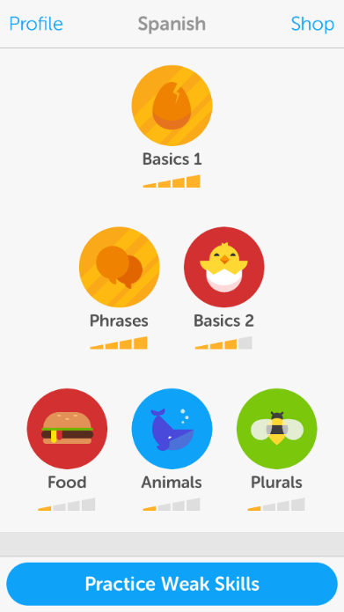  2.1 DuoLingo, Fluent in 3 Months, https://www.fluentin3months.com/duolingo/ | HelloTalk:  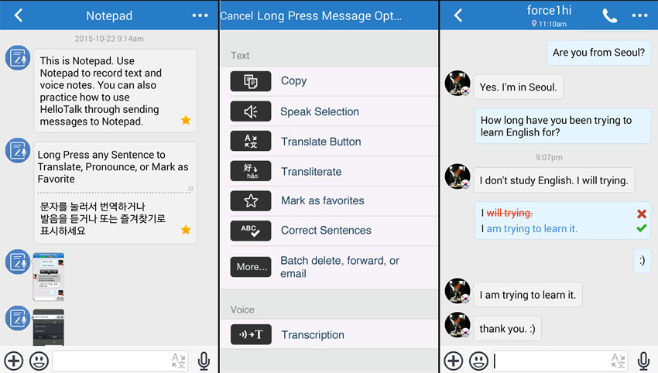  2.2 HelloTalk, Lingholic, https://www.lingholic.com/hellotalk-one-of-the-most-comprehensive-language-exchange-apps/

There are many more different teaching methods which is used to create a language learning application. For example, Memrise which focuses on repetition and memorisations to boost up users’ language skills [5]. However, Lea Knows is more like Google Translate which allows you to translate a sentence into the translator and allows the user to save every translation into a flash card [5].

Memrise:  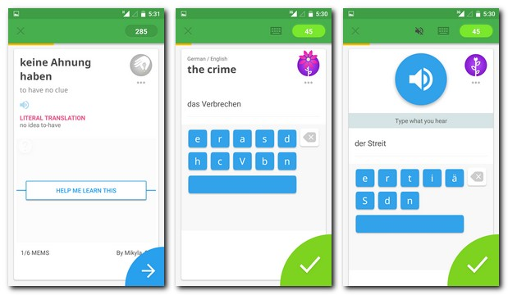  2.3 Memrise, Tellwut, https://www.tellwut.com/surveys/technology/111014-memrise-app.html | Lea Knows:    2.4 Lea Knows, FluentLanguage, http://fluentlanguage.co.uk/blog/language-tools-winter

Motivational Theories
Motivation simulates a desire and energy in people to be continuously interested and committed to a job, role or subject, or to try to attain a goal [6]. Unfortunately, many people lack motivation due to laziness and can be a major problem, especially when the goal is needed to be achieved. Most lack of motivation comes from the subconscious mental strategies, many of which are intended to motivate people [7].

Language learning applications is an educational app which people may lack motivation to use the app. When the term “Educational” is used, people may neglect the idea of learning a new language. Theoretical tools are needed to analyse situations like these, as well as a multidisciplinary approach to research to inform educationalist around the globe about significant role of languages in education and educational languages [8]. Cognitive theories of motivation focus on the instrumental role of mental structures, beliefs and information-processing mechanisms in shaping individual behaviour and action, motivation is viewed as located within the individual, though naturally the individual’s cognitions and perceptions may be influenced by various social and environmental factors [9].

There are many ways of overcoming this problem such as, interact with the audience, Engage and stimulate self-study and challenge users and making learning fun [10]. In this case, the language learning application must have many features which can motivate people to learn a language. These Include:

Gamification
Gamification is the process of taking something that already exists and integrating game mechanism into it to motivate users [11]. This will help stimulate the users brain, to make the user play the game however in a simple format by using game mechanics. There should be a goals and achievements to help with self-actualization. This is a major component in a Language learning application, as it is one of Maslow’s hierarchy of needs. Self-actualization can be thought of as the full realization of one’s creative, intellectual or social potential [12]. Gamifying language learning apps can also make the app fun and enjoyable to play.

Interactive Features
Interactive features are all the automated menus which allows users to easily find what they require on the application [13]. Language Learning apps must have interactive features such as, audio, text, images and menus, if the product is difficult to use then the user will not use the application due to confusion or simply too difficult to manage.

Mobile Learning
The widespread ownership of mobile phones and other portable and wireless devices has been dramatically changing our learning, communicating and life styles. Use of these mobile technologies turns out to be well aligned with educational goals such as extending learning opportunities, improving achievement, differentiation of learning needs, goals and learning styles and deliver authentic learning materials to users who would otherwise have no access to them [14]. Technology has ushered a new era of teaching and learning. It makes learning engaging, flexible and heuristic. Researchers have investigated innovative approaches of integrating computer-assisted programs in language-learning [15]. With mobile learning, users will be empowered since they can learn whenever and wherever they want [16].

As Mobile Learning has become more pervasive, however, expressions of uncertainty, concern and scepticism have also emerged. The growing lists of concerns include commercialization of teaching; lack of face-time between students and teachers; techno-centric models prioritized over face-to-face culture; devaluation of oral discourse/discussion practices; centralization of decision-making and service provision; concerns that complex and deep learning cannot be satisfactorily achieved without real-time classroom experience [17].

Educational Psychology
Educational Psychology is the study of how people learn [18]. Educational psychologists focus on not only studying how individuals learn but the best ways to apply different teaching methods and affecting educational outcomes using different tailored lessons and teaching styles [19]. Epistemology is the study of the nature and scope of knowledge and justified belief [20]. A growing area of interest for psychologists and educators is that of personal epistemological development and epistemological beliefs: how individuals come to know, the theories and beliefs they hold about knowing and the way such epistemological premises are part of and influenced on the cognitive processes of thinking and reasoning [21].

Cognitive Thinking
Cognitive thinking refers to the use of mental activities and skills to perform tasks such as learning, reasoning, understanding, remembering and paying attention [22]. There are many cognitive skills to consider which are Attention/Sustained, Attention/Selective, Attention/Divided, Memory/Long-Term, Memory/Working, Logic & Reasoning, Auditory Processing, Visual Processing and Processing Speed [23].

Cognitive thinking must be considered in Language Learning applications, so the app can be effective for users. This is the reason why Language Learning apps have images, audio, text and memory-based mechanisms so the user will be able to learn a language through cognitive thinking.

Investigation
The project requires two individual Language Learning Applications to evaluate. The two chose Language Learning Applications are DuoLingo and HelloTalk, this is because both apps take a completely different teaching approach to users to learn a new language.

Aim and Objects
In this section the Aim and Objectives will be identified. The SMART approach will be used whilst creating the Aims and Objective.

Aim
The aim of the project is to evaluate two Language Learning Applications.

Objectives
- Research must be taken to critically evaluate two Language Learning Applications
- Development of Prototype
- Learning a new Language
- Create a Survey

Expected outcomes/deliverables
At the end of the project there must be two chosen Language Learning applications which have been researched and critically analysed. Also, a development of a prototype must be required. Finally, a survey must be created and given to people after they have used the prototype, so the feedback can be critically analysed and evaluated.

Research Methodology
This section will be purely based on Research and Development methods for project. Contemplating any ethical and legal issues will be required to connect with the project as well as risks and limitations that may occur and the steps that can be taken to prevent them. Also, the method of how to analyse the data of the results of the product.

Agile Model
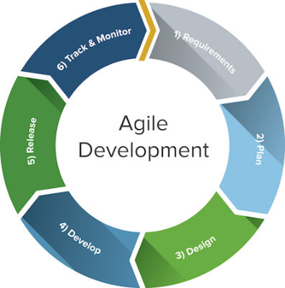
This is the model that is going to be used for the software development. This will be needed when a Language Learning App prototype will be created, below is the step by step process of creating the system using the agile method:

5.1 Agile Model, Smartsheet, https://www.smartsheet.com/agile-vs-scrum-vs-waterfall-vs-kanban

Requirements
During the first steps of this development life cycle the requirements must be identified to create the project. These requirements can be functional and non-functional requirements. In this project a prototype of a Language Learning App will be created, this will include many requirements such as Equipment, Programming Software and Time Constraints. If the requirements are not identified at the start, then this can cause major problems through the development process.

Plan
Once the requirements have been identified, a plan is required on how to carry out this project. This can be done using flow diagrams or UML to demonstrate how the features should function. Planning to create a prototype will be needed, this will show the layout of what features will be included in the prototype and what the features will do.

Design
Once the plan has been created, a design is required on how the project will look like. Designing the user interface will be needed to know what the product will look like. In this case, designing the Language Learning App prototype will be required to create a good and effective user interface.

Develop
Once the design has been created, the development process can start. This will be the part where the iteration will proceed, and the Language Learning app will be developed. In this case, this is the part where coding will be involved to create a functional prototype application, there will be programming software required to do this step. The app will be created in Visual Studio using C++ Language.

Release
Once the development process is done, the release of the system can start. This part will be made into subsections which include Testing, User Documentation and Release of the system. Testing will be required to find any errors or bugs when using the system, if any errors are encountered then it must be fixed straight away. User Documentation will be required as a user guide to help users on how to use the system and what the system does. Lastly, the system can the be released to the public.

Track & Monitor
Once the application has been released, the track and monitor phase can start. This will track and monitor the Language Learning prototype application. This will then lead to the retirement phase where the system will be removed from the production release.

Research
In this section there will be different categorized research purpose which will be evaluated and credibility testing.

Exploratory Research
This will be where the problem of using Language Learning Apps is identified. Data and resources will be collected to clarify the problem, this will be done by taking critical research into existing Language Learning Apps. Exploratory research intends merely to explore the research questions and does not intend to offer final and conclusive solutions to the existing problem [24].

Descriptive Research
This will provide a better understanding of the problem of using Language Learning Apps. This is where action will be taken into critically evaluating the problem. Descriptive studies may be characterised as an attempt to determine, describe or identify what the problem is, while analytical research attempts to establish why it is that way or how came to be [25].

Explanatory Research
This is where the recognition of cause and effective relationships. A central goal of most research is the identification of casual relationships or demonstrating that an independent variable influences the dependent variable of interest. The three criteria for establishing cause and effect is association, time ordering and non-spuriousness [26].

Primary Research
This is the research method that will be used in the project. This method involved the collection of original data by the researcher to address a specific problem. This is where critical research will be taken to collect data from the Language Learning app evaluation and addressing the problem with Language Learning apps.

Qualitive Research
This is the research method that involved the collection of soft data that are open to interpretation. This is where the data is collected and critically analysed and evaluated using facts and opinions to create an argument between both Language Learning Apps and how they are effective to the human brain.

Longitudinal Research
A longitudinal study is an observational research method in which data is gathered for the same subject repeatedly over a period [27]. This will be the study of the psychological effects of using Language Learning Apps, this is where research will be taken to examine the brain and knowledge of users that use Language Learning Apps and how education stimulates the brain.

Reliability
This is where Reliability is identified:

Will the Research give the same result if run a second time?
The research will not give out the same result if run a second time, this is because evaluating two different Language Learning Apps will result in different opinions. There are many different topics to talk about when critically evaluating two individual language learning apps such as, advanced technologies, psychological effects and different teaching methodology. Also, when users use the prototype that will be created they will also have different opinions and diverse types of feedback will be made.

Validity
This is where Validity is identified:

Is this an appropriate way to research the topic?
This is an appropriate way to research the topic because Language Learning Apps are mainly about how the system works, how effective a language learning app can be for the user and the psychology behind the learning and teaching methodology.

Are you asking the right questions?
There are many ways to ask questions behind Language Learning Apps, such as, how does Language Learning apps work? How can users be motivated to learn an educational app? What are the views on mobile learning? These are all the research that has been made and will be critically analysed and evaluated in the project.

Are you asking the right people?
The people who are going to be filling out the survey will be people of different ages; Language Learning apps must be suitable to all ages. There might problems due to older people may find the app “childish” and young people may possibly be uninterested in the app because its “too formal”, its complicated to find the correct balance between the ages.

Generalisability
This is where Generalisability is identified:

Do the results apply globally? Locally? To the same business sector?
The results from the survey will be applied globally. This is because people should know the effects on what Language Learning apps have in a phycological way. People should be aware of there major difference of opinions that will be made and then compare them with others around the world.

Methodology
This is where three methodologies will be chosen from the “Research Wall”. A philosophy, an approach and three strategies will be selected for the project.

Philosophy
The Phenomenology approach will be used for the project. This philosophy uses knowledge which is a social phenomenon that can only be understood subjectively, and subjective data is collected and examined to understand thoughts, feelings and ideas. This philosophy is chosen because the project requires a critical evaluation of two individual Language Learning Applications, an opinion will be created which will neither be subjectively wrong or right.

Approach
The inductive approach will be used for the project. This approach involves collecting data, analysing it and then developing a theory. Induction emphasises gaining an understanding of the meaning humans attach to events, a close understanding of the research context, the collection of qualitive data, a more flexible structure to permit changes of research emphasis as the research progresses, a realisation that the researcher is part of the research process and less concern with the need to generalise. This approach is chosen because the project will need gather data and try and generate a theory from it, the data I will be gathering will be research about the two language learning apps and then critically evaluating them both.

Strategies
The three strategies that will be used for the project will be Document Review, Case Study and Survey. The document review has been chosen because the project requires a literature review. A case study has been chosen because two Language Learning apps must be chosen for investigation and evaluation. Also, Survey has been chosen because the project requires a creation of a survey that must be handed out to people to find out their views on Language Learning apps. The data that will be collected will then be critically analysed and evaluated for the result.

Data Collection
The data collection that will be used document review, questionnaire and surveys. A document review will be used to perform a literature review about two Language Learning Apps and performing critical research and evaluation into the chosen Language Learning Apps. A questionnaire will be used so after users have finished using the Language Learning app prototype they will fill out a questionnaire about how good and knowledgeable it is and what affects it had on the users. Also, a survey will be created to find out what views people have on Language Learning Apps, what affect does the Language Learning app have on them, how they learn through the app and what makes Language Learning apps fun.

Risks
There will be many risks involved in this project such as limitations, ethical issues and legal issues that must be dealt with.

Limitations
There will be limitations to this project such as the word count, the Language Learning app prototype will be limited to a certain number of features and the survey will be limited to an amount of questions.

Ethical Issues
There will be ethical issues that will be encountered during the project such as choosing which language to use in the Language Learning app prototype, choosing which theme to use for the app and what audience the app will be aimed at (Young audiences, older audiences).

Legal Issues
There will be Legal issues that will be encountered during the project such as, the prototype app must be different from any other existing applications and the research that will be made about the two language learning apps must be my own research and not copied from other researchers’ findings.

Data Analysis
Data will be analysed by user testing, content analysis and data collection. Data analysis is needed to evaluate the results at the end of the project.

User Testing
There will be people that will test the Language Learning App prototype before releasing it to the public. This will be required so that the users can spot any problems or errors that may be in the prototype.

Content Analysis
Content analysis is a widely used qualitative research technique. This technique will be used in the project to summaries and evaluate two individual Language Learning applications, a conclusion will also be included at the end of the research to finalise the data and opinions will be concluded and evaluated.

Data Collection
Data collection will be used in this project to collect data from others and then critically analyse the data. In this case, research of two language learning apps will be collected and analysed and using the surveys to collect data to analyse. Every information that will be collected will be critically analysed and evaluated. This includes questionnaires, surveys and research of two language learning apps.

Resources
There will be many resources needing during the creation of the project such as:

Computer Systems
Computer Systems will be needed so the Language Learning app prototype can be created. Also, a computer system will be used to design and create questionnaires and surveys which will then be printed off and given to individuals after using the prototype. Computer systems will also be used to research and investigate two individual language learning applications.

Programming Software
Programming software will be needed to develop the Language Learning App prototype. The package that will be used is Visual Studio and the chosen language is C++.

Access to Journals
Access to journals will be required when researching about two individual language learning apps to evaluate them. Research can be done by going to the library and finding journals about Language Learning apps or looking online for journals.

Mobile Phone
A mobile phone will be required so people can use the Language Learning App prototype. The language learning app will be used on mobile phones, to do this the app will be downloaded from the computer onto the device.

Conclusion
To conclude, background literature has been made and critically analysed by using many websites and online journals. The aims and objectives has been outlined using the SMART approach, these aims and objectives will be used for the project. Also, the deliverables have been clearly stated so that people will know exactly what the result will be when the project is finished. Research and Development methods have been made to identify and justify the research methods that will be used to gather data, data collection has been identified, the risks have been identified and how the data is going to be analysed has been explained. Lastly, resources and planning has been made to show what resources will be required to create the project.

References

[1] | M. KRZEMIŃSKA, "10 best language learning apps," [Online]. Available: https://www.lingualift.com/blog/best-language-learning-apps/.
[2] | "What is Duolingo?," Duolingo, 6 September 2017. [Online]. Available: https://support.duolingo.com/hc/en-us/articles/204829090-What-is-Duolingo-.
[3] | thediscoverer, "Best features on duolingo," Duolingo, [Online]. Available: https://www.duolingo.com/comment/845614/Best-features-on-duolingo.
[4] | "A Complete Review of the HelloTalk Language Exchange App," Fluent Language, 22 October 2015. [Online]. Available: http://fluentlanguage.co.uk/blog/hellotalk-language-exchange-app-review.
[5] | D. Preston, "The best language learning apps," Tech Advisor, 19 February 2018. [Online]. Available: https://www.techadvisor.co.uk/feature/software/best-language-learning-apps-3655778/.
[6] | "Motivation," Business Dictionary, [Online]. Available: http://www.businessdictionary.com/definition/motivation.html.
[7] | M. Burndrant, "Lack of Motivation? Here are Seven Causes and Seven Cures," Inlpcenter, [Online]. Available: https://inlpcenter.org/lack-of-motivation-here-are-seven-causes-and-seven-cures/.
[8] | J. Li, "Attitudes, Orientations, and Motivations in Language Learning: Advances in Theory,," Language Awareness, p. 199, 2005.
[9] | Z. D. a. E. Ushioda, Taching and Researching Motivation, Great Britain: Pearson Education Limited, 2011.
[10] | M. Treser, "10 Practical Tips To Motivate People To Learn," eLearning Industry, 11 November 2016. [Online]. Available: https://elearningindustry.com/10-practical-tips-motivate-people-to-learn.
[11] | "What Is Gamification?," Bunchball, [Online]. Available: https://www.bunchball.com/gamification.
[12] | "Self-Actualization: Definition & Examples," Positive Psychology Program, 2017 13 November. [Online]. Available: https://positivepsychologyprogram.com/self-actualization/.
[13] | "What is Interactive Features," IGI Global, [Online]. Available: https://www.igi-global.com/dictionary/interactive-features/54053.
[14] | H. Gue, Analysing and Evaluating Current Mobile Applications for Learning English Speaking, p. 12.
[15] | X. Chen, "Evaluating Language-learning Mobile Apps for," Journal of Educational Technology Development and Exchange.
[16] | M. Ally, Mobile Learning, Edmonton: AU Press, Athabasca University, 2009.
[17] | T. Anderson, The Theory and Practise of Online Learning, Edmonton: AU Press, Athabasca University, 2008.
[18] | "What Is Educational Psychology?," Reference, [Online]. Available: https://www.reference.com/education/educational-psychology-b082ee41458f152d?aq=educational+psychology&qo=cdpArticles.
[19] | "What Is the Importance of Educational Psychology In the Classroom?," Reference, [Online]. Available: https://www.reference.com/world-view/importance-educational-psychology-fa1e25236dc7c0d2?aq=educational+psychology&qo=cdpArticles#.
[20] | "The basics of Philosophy," Philosophy Basics, [Online]. Available: https://www.philosophybasics.com/branch_epistemology.html.
[21] | B. H. a. P. R. Pintrich, "The Development of Epistemological Theories:," Review of Educational Research , vol. 67, 1997.
[22] | "Define Cognitive Thinking," LearningRx, [Online]. Available: https://www.learningrx.com/define-cognitive-thinking-faq.htm.
[23] | "What Are Cognitive Skills, Anyway?," LearningRx, [Online]. Available: https://www.learningrx.com/brain-training-101/what-are-cognitive-skills/.
[24] | " Exploratory Research," Research Methodology, [Online]. Available: https://research-methodology.net/research-methodology/research-design/exploratory-research/.
[25] | "Descriptive Research," Research Methodology, [Online]. Available: https://research-methodology.net/descriptive-research/.
[26] | "Establishing Cause and Effect," Statistics Solutions, [Online]. Available: https://www.statisticssolutions.com/establishing-cause-and-effect/.
[27] | M. Rouse, "longitudinal study," WhatIs, [Online]. Available: https://whatis.techtarget.com/definition/longitudinal-study.

