University of Wales Trinity Saint David
School of Engineering


Technical Report Writing
Academic Skills
ACHA4005

Motorsport Engineering
Catriona Burn
November 2022
2203239

Contents
- Introduction
- Background
- Downforce and Bodywork
    - Figure 1
- Wing
  - Front
    - Figure 2
  - Rear
    - Figure 3
- Future development
- Conclusion
- References

- Introduction
In the early years of motorsport, race cars relied on their engines to give them speed, but more recently horsepower is not enough to compete and the focus has been on the aerodynamics and how to make improvements. Aerodynamics is the phenomenon of manipulating air to flow around a body/vehicle to create a “path” through the air, using downforce to reduce the drag given off. Downforce is created to assist with stability and speed when the car is taking corners. Throughout the years, changes have been made to the bodywork of race cars to develop ways to improve and generate a larger downforce. The main focus of this report is recent changes, comparing the 2021 model with the 2022 model.

- Background
Most recently, in 2022, the regulations in Formula one were changed to improve slipstream. The use of ground effect was brought back after nearly 40 years in attempt to decrease the ‘dirty air’ and allow closer racing (which also assists with overtaking). There are many different elements of the car that contribute to the aerodynamics of it, i.e. front and rear wing, flooring (venturi tunnels, diffuser) and the overall body shape.

- Downforce and Bodywork
The Aerodynamic force mainly focused on in motorsport is downforce. In previous Formula One models this was created by forcing air over the car, but in doing this there was a wake of ‘dirty air’ given off the rear wing. This made it difficult for following cars to drive near and overtake. The new rules meant that downforce was to be created in a more efficient way, using ground effect. Ground effect is a more beneficial way of aerodynamics, encouraging cleaner racing and making overtaking easier.
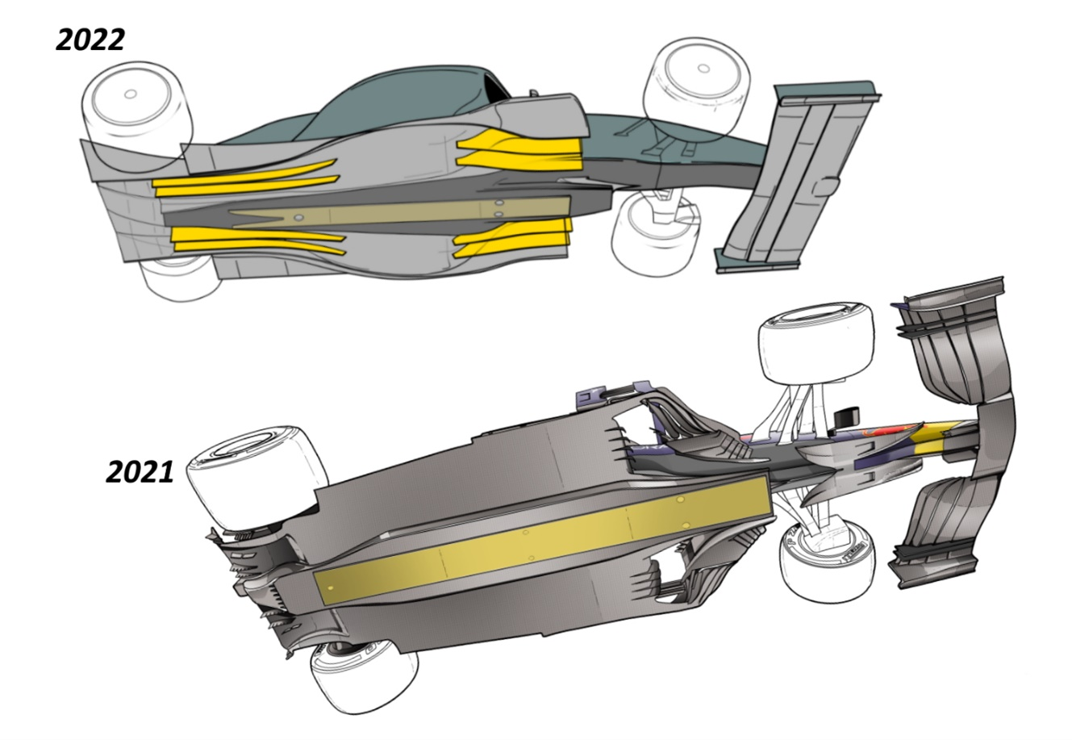
[Figure 1] The Race (Gary Anderson, 2022)
The flooring of a race car is a huge factor when it comes to the aerodynamics. Figure 1 shows the comparison of 2021 vs 2022 flooring. In 2022, venturi tunnels and diffusers were introduced for better downforce.
The venturi tunnels are on the underside of the car and allow the air to pass under it to act as a vacuum. This pulls the car down towards the track by causing low pressure. This low pressure is due to Bernoulli’s principle. Bernoulli’s Principle states that velocity of a fluid is inversely proportional to its pressure. So when we have an increase in the velocity of the air that is passing under the car, the pressure of it will decrease, pulling the car down.
The rear flooring, aka the diffuser, also assists with the decrease in pressure, producing a strong ground effect. When it comes to competitive racing, it is more effective than over car airflow that was used in prior years. But a downside, that even the championship winning race teams (i.e. Ferrari and Mercedes) have struggled with, is porpoising. Porpoising (a ‘bouncing’ effect) is created by the car getting too close to the ground and the airflow being almost ‘cut off’ and the car springing up. McLaren have found a solution by engineering a slot in the side of the bodywork, aiming to reduce the vacuum effect, but it has caused them a slight loss of downforce.
Another part of the bodywork that has been reintroduced to improve the aerodynamics of the cars is over-wheel winglets. They send the wake of airflow through the wheels instead of around them, while also directing wake away from rear wing.

- Wings
In the same way that aircrafts use wings to generate lift and take off, Formula one cars use their wings to force them towards the ground. In an act of forcing the air to accelerate under the wing to create low pressure below and high pressure above, sucking the car towards the ground. Both the front and rear wing play a part in the ground effect that keeps the car as close to the track as is possible.
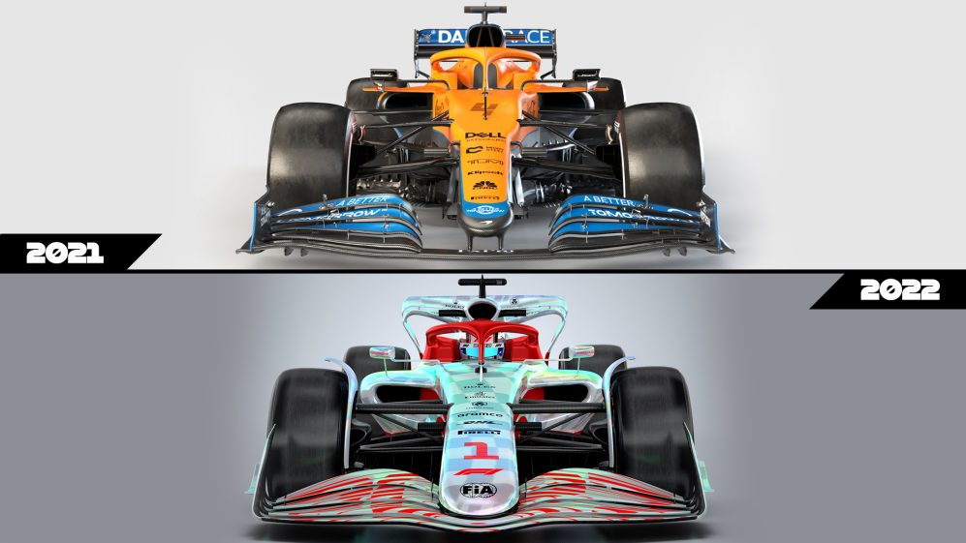
  - Front wing
[Figure 2] Front wing comparison (Formula One, 2022)
The front wing creates 25% of the total downforce of a car, meaning it is a hugely important component of the car. Following the new regulations, there were some significant changes made to the design of the front wing in attempt to improve the competitive racing and reduce turbulence. As shown in figure 2, the 2021 model has a 250mm gap between the nose and where the wing starts. This was used to create vortices that increased airflow and pushed the behind car further away, known as the y250 vortex. This was banned for the 2022 model to help with the flow of clean air. The new design helps direct the airflow away from the centre of the vehicle and decrease the air resistance and pressure on the nose.
Other changes to the front wing are the size of the endplates, and the overlap and number of wing elements. When endplates aren’t used, the wheels create a vortices low to the ground, producing a low pressure area. This causes turbulence to be generated, which is responsible for increase in drag. The endplates on the 2022 model are smaller and not as low to ground. This is to limit the disruption of airflow and increase the downforce produced by the front wing. Increasing the overlap of the elements produces a larger force of air that rushes into the gaps (the smaller the gaps, the larger the force), thus also helping with downforce.

  - Rear wing
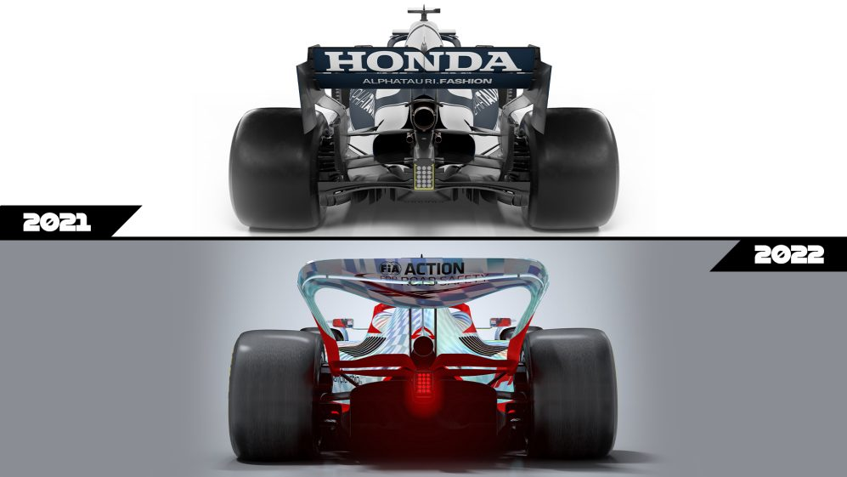
[Figure 3] Rear wing comparison (Formula One, 2022)
The rear wing is another very important component of a formula one car. There are very few similarities between the 2021 and the 2022 model, as shown in figure 3. Its main design purpose is to drag the wake from the body of the car up and over the wing, rather than into it, to remove turbulent air. From the point of view of the driver behind, this makes following and overtaking a whole lot easier. One of the aspects kept from the rear wing of the 2021 model is the DRS (drag reduction system). DRS is activated in very few parts of each circuit and only on long straights. It works by lifting the rear wing, which reduces drag and angle of attack, and creating a slip stream of ‘clean air’ for the car behind. Similarly to the front wing, the endplates on the rear wing are in place to decrease vortices. They also increase the airflow from the diffuser which helps with its power and produces more downforce.

- Future developments
The main focus of the future is fuel, but over the next few years aero will play a big part in an attempt to decrease fuel consumptions, while we find an alternative. The plan for the next generation of Formula One cars, introduced in 2026, is to make use of ‘active aerodynamics’ to decrease drag. Drag is a huge factor when it comes to why the race cars carry so much fuel, so if we reduce drag, we reduce the amount of fuel necessary per race. This will mean we can decrease the size of the fuel tanks which will have less weight, thus giving an increase in speed.

- Conclusion
Aerodynamics has come a long way since motorsport started and even in the past year a lot of improvements have been made, but there is still a long way to go in terms of engineering. The main aim of the new regulations was to make for a better race. To improve the overall aerodynamics while also reducing the wake coming off the back of the car that then hits the car following. Each part of a Formula One car plays a huge part in the aero of it, every part is there for a purpose. There are many more experiments and tests to be carried out to find ways to improve aerodynamics, especially with modern day technology, there will always be improvements to be made.
- References
(Ogawa et al., 2009; Petkar, Kolgiri and Ragit, 2014; Raheem, Sapit and Mohammed, 2019; Martins, Correia and Silva, 2021; Raj, Tharakaram and Prakash, 2022)

