Hyperfort: Bring Your Own Device Policy

Table of contents:
- Abstract
- Introduction
- Research and findings
- Potential benefits of BYOD
- Issues with BYOD
- Implementation throughout the company
- Revised Network Design
  - Mobile Device Management
  - New Network Explanation
- Conclusion
- Bibliography
- Appendix

- Abstract
This report will cover the proposed bring your own device (BYOD) scheme for Hyper-Fort. This will provide staff with access to utilise their own devices within and outside of work to access corporate data securely with the aim to increase productivity and employee comfort adapting to new technology. It will also allow guests to utilise their own network separate from the corporate one in order to provide internet connectivity and controlled access to data. The author assumes that the reader will have a good knowledge of technical terminology as well as networking.

- Introduction
Throughout this report, the author will be discussing their research and findings from reviewing other company’s data on the implementation of their BYOD policies. This will include how staff received it and the benefits to their working lifestyle, the potential dangers to proprietary information including the corporate network as well as the user, device and security policies top support the new BYOD scheme. Alongside this information, there will also be the proposed network structure for Hyper-Fort.

- Research and Findings
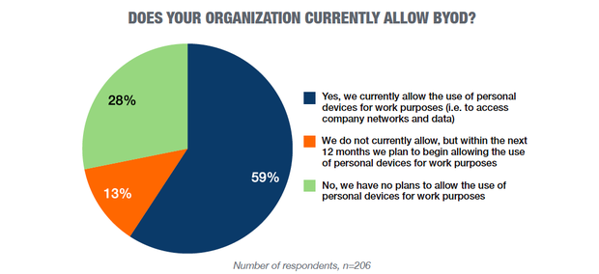
BYOD was a term first introduced in 2009 and started to gain traction in 2010. [1] Since then it has been a growing alternative to providing users with corporate equipment, see figure 1. This is due to more people becoming integrated with IT, in and outside of work, with an increase in people acquiring newer and more powerful technology as it becomes more commercially available, with a report averaging users to replace their own devices every 22 months [2] which is a good increase on the recommended standard to 3-5 years for corporate issued devices. [3]
Figure 1: BYOD usage rates 2016 [22]

However, even though implementing may seem like a win-win situation for both employers and employees, it does come with its risks, the major concern being to security. Allowing employees to integrate their work and personal devices into one can allow their online insecurity to effect the business’ some of the major risks are identified in a survey conducted by Information Magazine it showed the main concerns as malicious Wi-Fi and malware involved breaches of data, and insufficient countermeasures and management capabilities [4] for BYOD devices. It is also shown that on average BYOD compliance with policy is far lower than on corporate issued devices [5] further adding to security concerns. These security risks can be controlled with specific rues being applied to the devices that users possess and restricting their means to access the data. This could be things as making sure there are no vulnerable applications present on the device as well as restricted apps such as games. It could also include instructing users of stringent security policies for their devices such as having regularly-changed, complex passwords and maintaining up to date anti-virus. You may also restrict users access to proprietary and sensitive data when working away from the campus and using VPN to connect to the organisational network. Another implementation could be to allocate users a virtual workspace to work on through a remote desktop window and remove user’s ability to transfer data from that RDP session to their own machine, greatly reducing the risk of data leakage [6] and address users concerns of how their work and personal usage will be divided.
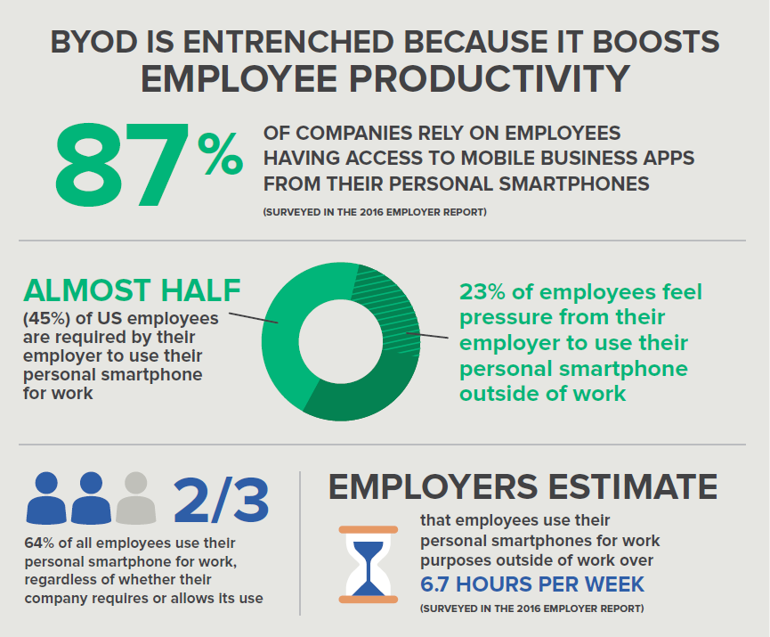
Through the research, that the author has undertaken it has been found that BYOD schemes do not universally increase productivity and a report stated that “In contrast to controlling aspect, negative outcomes will be returned and then decrease productivity and morale.” Chunxiao Lin et al [7] Showing that if implementation is not completed properly and under well managed circumstances it has been shown to decrease productivity which from then would be costly financially and time wise to rectify. On the point of productivity, if implementation does go through successfully there are many increases to employee satisfaction and productivity to be seen. A Frost and Sullivan Report detailed that introducing just smartphones into the workplace allowed users to achieve an extra 58 minutes of working time per day due to the increase in mobility for them, as well as an overall 37% increase in productivity [8] if combined with other technologies as well could see further improvements on productivity.
Figure 2: BYOD benefits and average statistics [23]

- Potential Benefits of BYOD

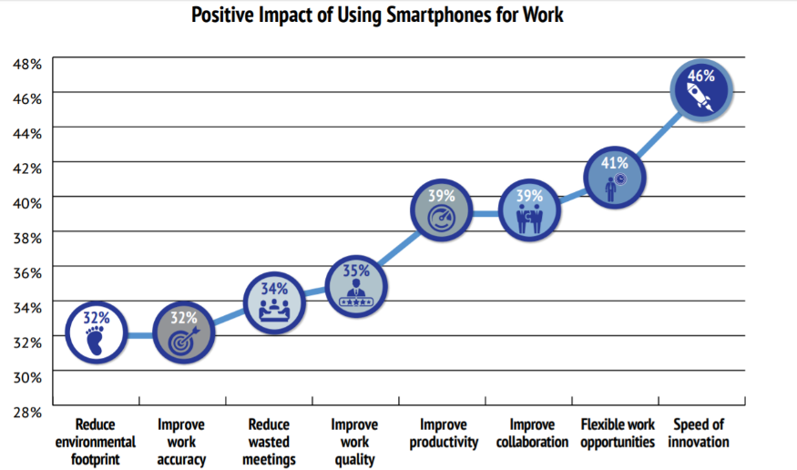
BYOD, if adopted properly as discussed previously can greatly increase working efficiency of staff. It can also increase employee happiness at work, due to them being more comfortable and experienced working from their own device.[9] Despite the cost once the changes to infrastructure and policy are complete it will then begin to save money as expenses on computer equipment. As a result, IT support will decrease from employees providing their own devices due to most users having a good deal of familiarity with their own device. This will provide a benefit the organisation assuming they will provide a reasonable quality of system management knowing it is their own device, lowering the workload of the IT support teams.[10][11] From the employees standpoint it has shown a decrease in employee turnover due to more amenities being available to employees. [2] As aforementioned, there are also increases in productivity reported from implementation of BYOD but there are also improvements in other areas within the workplace that have been gained from BYOD, as you can see from figure 3. On top of this working in this way will allow more flexible working hours as well as providing more opportunities for employees to work whilst commuting and can be especially effective with employees who are non-office based. [12] Additionally it should create more opportunities for increasingly mobile job roles.
Figure 3: Impact of smartphones on work [8]

- Issues with BYOD
BYOD by essence allows users to bring their personally procured devices into the business to complete their work. As this is the case, there is a good risk that the devices they will bring will be unsecure or infected with malware.[4] This poses a major risk to Hyper-Fort and management and mitigation of these risks will be the main ordeal to overcome when adopting this scheme. Other risks include the Software and Applications already being present on the Employees’ device posing an unfortunate risk to security as they may be able to monitor activity on the device and in these circumstances will include corporate data. In order to circumvent this Mobile device management (MDM) software companies have created ways around this, including but not limited to, phone encryption of particular workspaces, virtual working environments and integration of VPN technology.[13] There may also be complaints from staff who may not want to bring their devices to work, this could possibly from the additional wear and tear to their devices during transportation and by working on the device. There may also be complaints as the users will want to maintain their digital privacy and have concerns as to how their data is handled [14] this will be discussed later within the policies section, see appendix. The concerns from the business’ perspective are how their corporate data is being used on these devices as it poses challenge for being able to manage and track corporate data on employee owned devices. [15] MDM systems for companies are available, providing unique ways of tracking and risk management for the companies allowing BYOD, it will provide a good level of detail and control for the business. This however begins to infringe onto the employees privacy and getting a careful balance of corporate control and anonymity for the employees is crucial.[16]

- Implementation throughout the company
Implementation throughout the business should be a carefully handled process as the risk it poses is very high to Hyper-Fort. As the company already works 95% using wireless connections there should little changes to the hardware side of the network. The major challenges will be how employees will adopt the revised policies and how they maintain their compliance with these. From here it would be best to assess how many employees will have compatible devices to provide themselves and then how many will have to be procured and provided to staff to get an estimate for costs. As users may not be familiar with basic device management it would be advantageous to begin educating employees on basic IT management, this should decrease the IT support staff’s workload during and after the changeover period as well as providing a potential increase to compliance with device policies. Rollouts should then proceed, these should be staggered in order to reduce risk and in order to iron out problems during operation [17] these will bring the personal devices into operation. It will involve the IT staff working though checking the devices compliance with policies and will include; Making sure operating systems are of a suitable standard, this will be Windows 10 v1709 or higher for windows devices with all relevant security patches, or under special circumstance MACOS 10.14 Mojave or higher and up to date Linux systems. Reviewing the currently installed applications for any vulnerable ones. Adding on the required applications (including VPN client to local machine) for that employee as detailed by the rollout specification, this will include enterprise standard Anti-virus, assuming there is already one in Hyper-Fort’s possession, then the anti-virus and system will be updated and checked to make sure it is operational and suitable for use. From here the device will be issued back to the user with specific instructions for the complexity of passwords applied, a maintenance schedule with instructions, as well as helpdesk contact information.

- Proposed Network Redesign

  - Mobile Device Management

For management of mobile devices, the author has selected to use Microsoft Intune. This choice was made due to the wide variety of features available within the platform including remote wipe and locking, support for all major device brands and granular application control. On top of these features as this is a Microsoft product it should integrate very well into a windows-based workplace and as the author is assuming they operate using 365 cloud services, Intune should function optimally. With granular application control it becomes possible to limit access to corporate resources when attempting to access from an un-enrolled device. [18] Within the management portal you may configure device policies and access all the security features, reports and statistics. Although the software does not allow for generation of customised reports. [19] With all of this it also allows user device registration should it be permitted, the author proposes that this be permitted but the registration page be only accessible on the corporate, staff network for security threat mitigation.

  - New network Explanation

For this section please refer to the packet tracer diagram for a visual representation of the network discussed.

As the end user devices are primarily wireless based, the author has proposed a network design that involves two groups of access points, one for staff and another for guests. This system will use 2 VLANs (Virtual Local Area Networks) to allow for easy management of both security and access if properly configured. Using a VLAN system will reduce workloads of network administrators, decreases security threats and allows you to very simply manage staff and guest’s access to corporate data. [20] If implemented correctly using this to divide up the different access points will be especially helpful as the author proposes to severely limit the guest networks access to just web whereby this information will also be cached for security purposes. Both the access point are secured using WPA2-PSK, currently the most secure protection, [21] and each form of access point, staff or guest, will run from its own switch with the guest APs (Access Points) running from SW2 and staff from SW1.

For the wired side of the network, this has been limited to the core services; servers, switches, routers, firewall, etc. for this system there are presently 5 servers each with their own services that have been shown within the simulation to function but this is under the assumption Hyper-Fort will be configuring all infrastructure equipment. DHCP01 is a server simply just for DHCP and NTP use using DHCP to configure both VLANs and has connections running to both SW1 + 2. It uses a class C IP addressing but the limitations of this are mitigated due to the use of VLANs. The server DNS01 will then also host DNS as well as email services and HTTP services. The server DNS01 will then additionally used to host the staff intranet. FIL01 will be used for AAA (authentication, authorisation and accounting) for security as well as FTP this is what employees will also use as a storage serve so this must be fitted with high capacity drives for this reason and is also the reason it runs the FTP and AAA services. FIL01 server will also run the SYSLOG service for monitoring of activity for the same reason. The VPN server then will govern users working remotely and allow for connections into the network through it. The VPN server itself will sit within a DMZ and for this reason will also host web services this is assuming firewalls have been configured correctly to allow for an effective DMZ as this is not shown within the packet tracer diagram. RDP01 will be the server that the virtual working environment will be hosted on and will not run any other server services.

In terms of physical security for the core services the proposed server room contains a mantrap system with 2 RFID card scanner on both doors to limit access to personnel. Within the mantrap is a CCTV camera in order to capture any people attempting to gain unauthorised access to the server room. The author assumes these have been configured by Hyper-Fort staff. Housed also within the server room will be temperature, humidity, smoke and water sensors that will alert the currently on call networks administrator of any fault as well as CCTV present within the server room itself. These too must be configured by Hyper-Fort staff as configuration is not present within the diagram.

The cloud present within the diagram is to simulate the connection to cloud services as the author assumes all publicly visible websites will be hosted by a 3rd party provider as well as to simulate the incoming and outgoing connections to office 365.

In terms of security the network diagram demonstrates the practises that should be taken. Firstly, all unused ports on switches have been disabled to prevent unauthorised access. Secondly all switches then have passwords set on both console ports and when first accessing the CLI (command line interface), these passwords are also encrypted to prevent them being viewable when running the show run command. For redundancy purposes all servers have been fitted with connections to SW2 as a failover measure.

- Conclusion

In conclusion, comparing the potential productivity and financial benefits to the security risks of BYOD the author would advise Hyper-Fort to adopt a BYOD scheme. As the service of BYOD has been developed highly over the last decade with many management and security solutions being updated regularly with new features and more companies adopting these structures it would be highly recommended to implement BYOD. Although this may increase the potential for security and data breaches if the solutions for the network and policies the author has proposed are implemented, they believe this will mitigate these enough to more than justify the change, especially with the benefits considered.

- Bibliography

[1] James Laird, “A Brief History of BYOD and Why it Doesn’t Actually Exist Anymore | Lifehacker UK,” LifeHacker, 2014. [Online]. Available: http://www.lifehacker.co.uk/2014/11/07/brief-history-byod-doesnt-actually-exist-anymore. [Accessed: 02-Jan-2019].
[2] Ilan Paretsky, “How Much Does BYOD Really Save Your Company? - DZone Agile,” Dzone, 2018. [Online]. Available: https://dzone.com/articles/how-much-does-byod-really-save-your-company. [Accessed: 02-Jan-2019].
[3] Caleb Pruitt, “How Often Should Your Company Replace Its Computers – Beacon ITS Blog,” Beacon IT Services, 2017. [Online]. Available: http://www.beaconitservices.com/blog/2017/04/replacing-your-computers/. [Accessed: 02-Jan-2019].
[4] “Security Issues May Hamper BYOD Adoption: EBSCOhost,” Inf. Manag. J., vol. 50, no. 4, pp. 12–12, 2016.
[5] Simple MDM, “The Challenges Of A Bring Your Own Device (BYOD) Policy | SimpleMDM,” Simple MDM, 2017. [Online]. Available: https://simplemdm.com/2017/01/05/challenges-of-bring-your-own-device-byod-policy/. [Accessed: 06-Jan-2019].
[6] Trapp Technology, “Top 5 Benefits of Remote Desktop Connection,” Trapp Technology, 2016. [Online]. Available: https://trapptechnology.com/top-5-benefits-remote-desktop-connection/. [Accessed: 10-Jan-2019].
[7] C. Yin, L. Liu, and L. Liu, “Association for Information Systems AIS Electronic Library (AISeL) BYOD IMPLEMENTATION: UNDERSTANDING ORGANIZATIONAL PERFORMANCE THROUGH A GIFT PERSPECTIVE.”
[8] Frost & Sullivan, “The Smartphone Productivity Effect : Quantifying the Productivity Gains of Smartphones in the Enterprise,” 2016.
[9] Marine Klein, “What is BYOD (bring your own device) and why is it important?,” Commusoft, 2017. [Online]. Available: https://blog.commusoft.co.uk/business/what-is-byod-and-why-is-it-important. [Accessed: 05-Jan-2019].
[10] Craig Borowski, “BYOD’s Effect on the IT Help Desk Burden,” Software Advice, 2014. [Online]. Available: https://www.softwareadvice.com/crm/industryview/byod-help-desk-burden-2014/. [Accessed: 05-Jan-2019].
[11] Josh Bouk, “What Are the Benefits of BYOD?,” Cass Information Systems, 2018. [Online]. Available: https://www.casstelecom.com/blog/what-are-the-benefits-of-byod. [Accessed: 05-Jan-2019].
[12] Chas Moloney, “Could organisations be doing more to implement BYOD policies in the workplace? | ITProPortal,” IT Pro Portal, 2017. [Online]. Available: https://www.itproportal.com/features/could-organisations-be-doing-more-to-implement-byod-policies-in-the-workplace/. [Accessed: 07-Jan-2019].
[13] Christine Horton, “Is BYOD Good or Bad for Your Business?,” Tom’s Hardware, 2018. [Online]. Available: https://www.tomshardware.co.uk/byod-pros-and-cons,review-34553.html. [Accessed: 02-Jan-2019].
[14] Maria Korolov, “BYOD can pose privacy risks to employees | CSO Online,” 2016. [Online]. Available: https://www.csoonline.com/article/3086823/mobile-security/byod-can-pose-privacy-risks-to-employees.html. [Accessed: 02-Jan-2019].
[15] Jeff Pochepan, “Employees Working On Their Personal Devices? Here’s How You Can Protect Your Business Data. | Inc.com,” 2018. [Online]. Available: https://www.inc.com/jeff-pochepan/employees-working-on-their-personal-devices-heres-how-you-can-protect-your-business-data.html. [Accessed: 02-Jan-2019].
[16] Steve Cassidy, “Mobile device management - ProQuest,” PC PRO, 2015. [Online]. Available: https://search-proquest-com.ezproxy.uwtsd.ac.uk/docview/1625413987/abstract/3B1E3D35D08F4656PQ/1?accountid=130472. [Accessed: 02-Jan-2019].
[17] Carol Finch, “The Advantages of a Staggered Rollout Plan | Techwalla.com,” Techwalla. [Online]. Available: https://www.techwalla.com/articles/the-advantages-of-a-staggered-rollout-plan. [Accessed: 04-Jan-2019].
[18] Gary Utley, “The 7 Top Microsoft Intune Features - CWPS,” CWPS, 2018. [Online]. Available: https://www.cwps.com/blog/top-microsoft-intune-features. [Accessed: 10-Jan-2019].
[19] Paul Ferrill, “Microsoft Intune - Review 2017 - PCMag UK,” PC Mag, 2017. [Online]. Available: https://uk.pcmag.com/cloud-services/76023/microsoft-intune. [Accessed: 10-Jan-2019].
[20] Jim Herbst, “VLANs: 5 Types and Benefits - Summit Information Resources,” Summit IR, 2017. [Online]. Available: https://www.summitir.com/2017/08/30/vlans-types-benefits/. [Accessed: 10-Jan-2019].
[21] Chris Hoffman, “Wi-Fi Security: Should You Use WPA2-AES, WPA2-TKIP, or Both?,” How-To-Geek, 2017. [Online]. Available: https://www.howtogeek.com/204697/wi-fi-security-should-you-use-wpa2-aes-wpa2-tkip-or-both/. [Accessed: 10-Jan-2019].
[22] Tech Pro Research, “BYOD, IoT and wearables thriving in the enterprise - Tech Pro Research,” TechProReasearch, 2016. [Online]. Available: http://www.techproresearch.com/article/byod-iot-and-wearables-thriving-in-the-enterprise/. [Accessed: 06-Jan-2019].
[23] EZ Computer Solutions, “The Pros &amp; Cons Of BYOD In The Workplace | EZSolution,” EZ Computer Solutions, 2017. [Online]. Available: https://www.ezcomputersolutions.com/blog/the-pros-cons-of-byod/. [Accessed: 05-Jan-2019].

10 . Appendix

Policies

- End User BYOD Policy
Scope
This Policy applies to all Hyper-Fort Staff using computer equipment of any sort.

Your Duty
With each device, there is a mandatory maintenance schedule within which will be detailed how regularly operating system, Anti-Virus and software must be updated. As standard anti virus must be updated at least once per week. This is done to upkeep maximum security in the event that automatic updates should fail.

If you suspect there is malicious software present on your machine or there has been a breach of data you must immediately disconnect your device from the Hyper-Fort network and proceed to contact local IT team as soon as possible for how to move forward. Likewise if your device is lost or has been stolen you must immediately contact a member of the IT team.

Acceptable use of systems within work time does not include access to social media or video/audio streaming services and accessing any sites like these or malicious sites through the virtual working environment or local machine is not acceptable. These rules also apply to personal email services and cloud storage services and any employee found to be storing or transmitting corporate data via these platform will be face up to and including termination of employment.

It is the duty of all onsite staff to maintain the physical security, all personnel present onsite, visitor or staff, are always required to have an identification card and if you see anyone without one it is your duty to question them as to why they’re here. This also applies to all doors within the campus, RFID scanners activated by identification cards protect all doors, and doors must be closed securely and made sure to be making contact with the magnetic locks. Additionally to this all computers must not be unlocked whilst unattended.

Variant operating systems
In the case of non standard operating systems, MACOS and Linux, system updates must be completed twice as regularly as these cannot be managed as strictly.

Personal Data
In order to maintain maximum security devices are monitored using a Mobile Device Management (MDM) software. This software includes many features for monitoring as well as countermeasures for theft, loss, damage and employment termination. These include the ability to track, lock and wipe your device. These countermeasures will only be used where necessary and IT teams will make every effort to contact you prior to this being done. In the event of loss of personal data Hyper-Fort does not hold responsibility for any of your personal data and it is considered your duty to make sure personal data is backed up appropriately.

In the event of employment termination, you would be expected to return the device to IT support teams for corporate decommissioning. This will involve formatting the device and returning it with the same operating system, prior to this you are expected to have backed up all personal data, but not corporate data, from the device as it will be lost. Failure to bring the device to IT teams prior to leaving employment will result in either the device being locked or wiped and then potentially reclaimed should it have been issued by Hyper-Fort.

Working within the organisational network
If you are working within the Hyper-Fort campus you are expected to work solely through the provided remote desktop session. Within this, you will not have privileges to transfer data of any sort between the device and remote server or vice versa, any unauthorised data transfer between the two is a breach of corporate policy pending disciplinary. To request this ability permanently or on a temporary basis please contact IT support helpdesk.

Working outside the organisational network
If you are working out of a corporate site or from home, there are additional steps that must be taken. Firstly, you must ascertain whether the Wi-Fi connection you will be operating from is secure and password protected, open networks are to be considered unsecure and not to be used. From here you will then connect into the organisational network using the installed VPN client and the credentials issued to you. You are only to use your credentials to connect with the VPN client. From here you will proceed to use the remote desktop session as normal to complete any work. When working over a VPN connection your access to sensitive and proprietary data will be restricted to none-minimal. Higher access to this information over VPN can only be requested on a temporary basis of 10 hours maximum and can be done by contacting the IT support helpdesk 2+ days before you intend to be working offsite.

- Device Policy
Minimum Specification for Personal Devices
Laptops:
CPU: Intel dual core 2.0GHz or higher, AMD Phenom 2 x3 or higher. Must be 64-bit compatible.
Memory: 4GB DDR3 1600MHz or higher
Storage: 250GB+ HDD or 128GB+ SSD
Operating System: Windows 10 1709 or higher compatible, MACOS 10.14 Mojave or higher compatible, please contact IT support for information on Linux compatibility.
Smartphone/Tablets:
Android:
Memory: 1GB+
Operating System: Android Oreo 8.0-8.1 or higher
Apple:
Memory: 2GB+
Operating System: IOS 12.1+

These minimum specifications have been provided to maximise compatibility throughout the network and prevent cases where users will have to update devices shortly after bringing them into the corporate environment. As well as to make sure devices will work as intended for working through the remote desktop sessions. Mobile devices must be able to function on supported operating system versions in order for anti-virus to function as intended.

Device security
Devices must comply with the following standards to adhere to Hyper-Fort’s security terms.
- Have complex passwords set on the device, 8+ characters with 2+ numbers, 1+ special characters and 1+ capital letters.
- Must be registered to the MDM software and communicate at all times where possible
- Device must not knowingly contain malicious programs or code and if it does it must be reported to a member of IT support as soon as possible.
- There must be a screen timeout set on the device a maximum of 15 minutes.
- Device password must not be the same password used to access VPN or corporate network account
- Devices must not store or transfer illegal material or proprietary information from another company
Any damage to the device is the responsibility of the owner to repair should it not be caused by Hyper-Fort.

  - Security Policy
Scope
This policy applies to all computer equipment operating on the Hyper-Fort network

Information Security
These policies are to be adher]ed to at all times in order to maintain data integrity and confidentiality.
- All work data must be kept within a secure environment, either through the corporate remote desktop session or onto one of the provided file servers, and should not be stored on any local machine hard drives as these are not backed up.
- Data must not be transferred from virtual working environment onto local machine or vice versa, without authorisation.
- All devices attempting to access Hyper-Fort data, network or virtual working environment must be registered onto MDM software.
- Any data containing PII (personally identifiable information), proprietary or client data is to be treated as sensitive and will not be accessible over a VPN connection unless a request has been put forth with applicable reason 2+ days prior to accessing over VPN.
- All laptop and desktop devices must have their hard drives encrypted using Bitlocker drive encryption with an 8-20 character password in-built in Windows 10 pro version and up, if you are using a variant OS please contact IT support helpdesk to get alternative encryption software installed.
- Unauthorised use of 3rd party cloud backup services other than the services provided is prohibited on the corporate network and should never be used for storing work data.
- All sensitive or proprietary data should have three copies with one stored on a secure, encrypted medium, another stored on a file server that is backed up at least 3 times weekly and the last on the cloud service provided by Hyper-Fort.

marking criteria and Student FEEDBACK

This section details the assessment criteria. The extent to which these are demonstrated by you determines your mark. The marks available for each criterion are shown. Lecturers will use the space provided to comment on the achievement of the task(s), including those areas in which you have performed well and areas that would benefit from development/improvement.

Common Assessment Criteria Applied (Assignment 1) | Marks available | Marks  awarded
1. Research-informed Literature
Extent of research and/or own reading, selection of credible sources, application of appropriate referencing conventions.
Good lietrature research. Some sections could use a broader range of sources. (Grade mark: 73.33%) | 15 | 11
2. Knowledge and Understanding of Subject
Extent of knowledge and understanding of concepts and underlying principles associated with the discipline.
Clearly demonstrated a high level of knowledge and understanding of technical aspects of the work. (Grade mark: 86.67%) | 15 | 13
3. Analysis
Analysis, evaluation and synthesis; logic, argument and judgement; analytical reflection; organisation of ideas and evidence
The chosen method is discussed and some justifications are offered as to why it would be an appropriate impelmentatin. However, this could be improved if justifications could be cross referenced to appropriate literature and also if a comparison was made with other available solutions. (Grade mark: 62.50%) | 40 | 25
4. Practical Application and Deployment
Deployment of methods, materials, tools and techniques; application of concepts; formulation of innovative and creative solutions to solve problems.
Hierarchical architecture was not fully demonstrated. Good level of security config is observed in PT submission. Good demonstration of connections between ISP and Cloud storage, as well as VPN line to telecommuters. Intuitive implementation of IoT sensors throughout the design. Could be improved by adding redundancy both internally and externally. (Grade mark: 80.00%) | 20 | 16
5. Skills for Professional Practice
Attributes in professional practice: individual and collaborative working; deployment of appropriate media; presentation and organisation.
Generally, good overall presentation of the document. There is still room for improvement in some areas (i.e. having a main cover page, table of contents formatting and etc.). Please refer to more comments on presentation embedded within the report. (Grade mark: 50.00%) | 10 | 5

Assignment Mark (Assessment marks are subject to ratification at the Exam Board. These comments and marks are to give feedback on module work and are for guidance only until they are confirmed. ) | Late Submission Penalties (tick if appropriate) |  | 70%
 | Up to four weeks late |  | 70%
 | First Attempt? |  | 70%

