

Table of Contents

1. Introduction 3
2. The Marketing Process 3
3. The SWOT analysis 5
3.1 Strengths 5
3.2. Weakness 6
3.3. Opportunities 6
3.4. Threats 7
4. Advantage and Disadvantage of a SWOT analysis 8
5. Recommendations 9
6. Conclusion 9
7. References 10

1. Introduction

Aldi (UK) Ltd
Aldi (UK) Ltd is a discount supermarket chain with its headquarter in Essen, Germany. Aldi’s opened its first store in UK’s in 1990 (Aldi, 2024). Originally Aldi was started in 1946 when two brothers Karl and Theo Albrecht took over their mother’s small grocery store (The Strategy Story, 2023). Today, Aldi UK is fourth largest grocery retailers in Britain. They now have over 1000 stores and planning to open more stores in the near future (Davey, 2025).

The purpose of this report is the situational analysis of the market, operational and regulatory factors impacting Aldi UK Ltd overall success using the SWOT analysis in order to inform the company’s strategic decision maker.

2. The Marketing Process

The marketing process is a structured method that guides how business introduce a product or service to the market. It involves key action such as studying the market, choosing a target audience, developing market strategies, delivering value, and measuring performance (Khushboo, 2025). One widely used framework that supports this process is the SOSTAC model, developed by UK-based marketer PR Smith in the 1990s. SOSTAC stands for Situation Analysis, Objectives, Strategy, Tactics, Action, and Control. It provides a comprehensive structure for creating, implementing, and managing effective marketing plans (Chaffey, 2022).
The SOSTAC framework is illustrated in the diagram below:

(Chaffey, 2023) Diagram created by Learner.

There are four key critical resources (4Ms) required for the SOSTAC to be effective. They are illustrated in the matrix below;
.
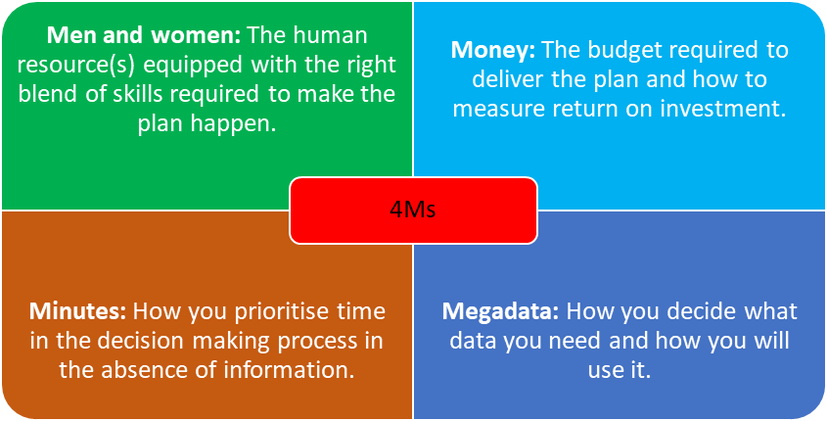(VCMO, 2024) Diagram created by Learner.

3. The SWOT analysis

A SWOT analysis is a strategic planning method that enables companies or organisations recognise the internal factors, that is the strengths and weakness, and the external factors, which are the opportunities and threats impacting them. By analysing these four factors, they gain valuable insights into the company’s current position and future potential (Peterdy, 2024).

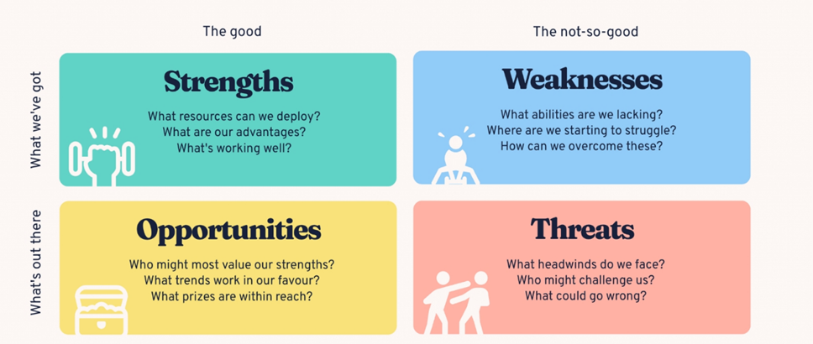
(Bitesize, 2024)

3.1 Strengths

Aldi’s strengths lies in its strong brand presence, attractive prices for private label items, and efficient product control. As a leading discount grocer, Aldi attracts cost-conscious customers through trusted private-label brands that are affordable quality alternatives to national names. Its low prices are possible because of the no-frills approach and low costs which stem from effective cost management aligned with its competitive and growth strategies (Sherman, 2024). Additionally, Aldi’s tight control over product selection ensures a streamlined, high-quality assortment that supports brand consistency and customer satisfaction. A 2023 YouGov survey revealed Aldi as the UK most popular supermarket due to customer satisfaction (Walters,2024). These strengths enable Aldi to maintain market stability and deliver on its mission and vision to provide affordable groceries that meet consumer needs, reinforcing its position in the highly competitive retail sector (Sherman, 2024b).

3.2. Weakness

Aldi’s weaknesses include thin profit margins, limited market presence, restricted e-commerce operations, and an easily imitable business model. Its low pricing strategy limits flexibility and profitability, making it vulnerable to market fluctuations (Evans, 2024b). Compared to major competitors, Aldi’s smaller market reach and underdeveloped online sales reduce its accessibility and growth potential. Additionally, the company’s simple, low-cost model focused on private label products and affordability, can be easily replicated by rivals targeting similar consumer segments. Also, Aldi’s no-frills approach, basic store’s setup and lean staffing help keep prices low but sometimes, shopping there may not be the best experience. Long checkout queues, and slow restocking during busy shopping times, may lead to customer frustration and less satisfaction. Furthermore, the limited product range means not everything some customers need may be available in one store, this may result in some customer to shop at competitors that offers more selections. (Sherman, 2024c).

3.3. Opportunities

Aldi can strengthen its market position through strategic expansion, innovation, and developing e-commerce capabilities that will attract new customers and align with shifting shopping habits. Broadening its product range, especially with health-focused, organic, and specialty items that can meet diverse consumer needs. More emphasis on sustainability and partnerships with local producers can enhance brand reputation and supply chain resilience. Also adapting vertical integration offers the chance to improve supply chain efficiency and cost control by developing in-house production for select food products. By pursuing these opportunities, Aldi can enhance its competitive edge, increase market share, and strengthen its business capabilities (Evans, 2024a). Aligning these initiatives with its growth strategies may help the company adapt to industry trends and effectively compete in the global retail landscape.

3.4. Threats

Aldi faces intense competition from other discount chains, supermarkets, and online retailers, which may lead to price wars that can reduce profit margins and challenge its low-cost model (Stacey & Stafford, 2025). Shifting consumer preferences and rapid e-commerce growth require continual adaptation. and failure to expand product offerings or improve online services could reduce Aldi’s relevance and market share. Additionally, supply chain disruptions, regulatory shifts, and currency fluctuations can raise costs and affect product availability. Like all other major retailers, Aldi could face data breaches and cyberattacks. If they don't handle these well, they could lose money, damage their reputation, and lose customers' trust.

4. Advantage and Disadvantage of a SWOT analysis

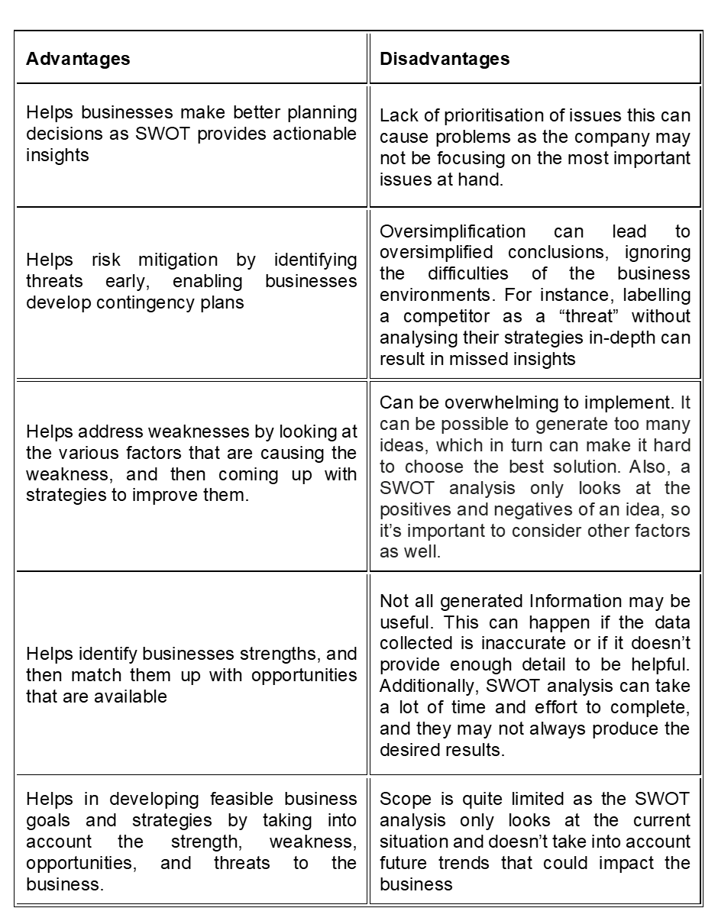

(Prasanna,2022).

5. Recommendations

The following are recommendations for Aldi based on the strategic elements taken into account in this SWOT analysis:
- Diversify the company to increase revenue sources and lower risk exposure in the retail market. This is for controlling the impact of retail rivals.
- Vertically integrate to improve corporate control over goods production operations and stabilise Aldi's supply chain. This will improve competitive advantage.
- Expand online activities to boost online sales income. This is because of the weakness caused by the limited e-commerce operations and the associated e-commerce corresponding opportunity.

6. Conclusion

Overall, Aldi UK remains strategically well positioned within the British grocery sector through its disciplined low-cost model, strong brand equity, and continued investment in store expansion and sustainability. The company’s operational efficiency and value proposition continue to attract a growing share of price-conscious consumers, particularly during ongoing economic pressures. To maintain growth and resilience, Aldi should balance expansion with profitability, invest in digital opportunities, and leverage sustainability to strengthen brand trust. Aligning these strategies with evolving consumer and regulatory trends will help secure Aldi’s long-term leadership in the UK discount retail sector.

7. References

Aldi (2024). About Aldi - ALDI UK. [online] Aldi.co.uk. Available at: https://www.aldi.co.uk/corporate/about [Accessed 14 Oct. 2025].
Bitesize (2024). How to Do a SWOT Analysis [with Examples & templates]. [online] BiteSize Learning. Available at: https://www.bitesizelearning.co.uk/resources/swot-analysis-explained-examples-templates [Accessed 15 Oct. 2025].
Chaffey, D. (2022). SOSTAC Marketing Plan Model Definition - What is? | Digital Marketing Glossary. [online] Dr Dave Chaffey : Digital Insights. Available at: https://www.davechaffey.com/digital-marketing-glossary/sostac-marketing-plan-model/ [Accessed 17 Oct. 2025].
Davey, J. (2025). Aldi UK to ramp up store expansion despite profit fall. Reuters. [online] 15 Sep. Available at: https://www.reuters.com/business/retail-consumer/aldi-uk-ramp-up-store-expansion-despite-profit-fall-2025-09-15/ [Accessed 14 Oct. 2025].
Evans, L. (2024a). Aldi Five Forces Analysis & Recommendations (Porter’s Model). [online] Panmore Institute. Available at: https://panmore.com/aldi-five-forces-analysis-recommendations-porters-case-study [Accessed 27 Oct. 2025].
Evans, L. (2024b). Aldi’s Marketing Mix (4P) Analysis. [online] Panmore Institute. Available at: https://panmore.com/aldi-marketing-mix-4p-4ps-strategy-analysis-case-study [Accessed 27 Oct. 2025].
Khushboo (2025). Marketing Process, Definition, Examples, 5 Steps & Importance. [online] PW Skills Blog. Available at: https://pwskills.com/blog/marketing-process/ [Accessed 18 Oct. 2025].
Peterdy, K. (2024). SWOT analysis. [online] Corporate Finance Institute. Available at: https://corporatefinanceinstitute.com/resources/management/swot-analysis/ [Accessed 7 Nov. 2025].
Prasanna (2022). Advantages And Disadvantages Of SWOT Analysis | Benefits, Limitations, What are the Advantages And Disadvantages Of Swot Analysis? [online] CBSE Library. Available at: https://cbselibrary.com/advantages-and-disadvantages-of-swot-analysis/ [Accessed 20 Oct. 2025].
Sherman, M. (2024). Aldi’s Generic Competitive Strategy & Growth Strategies. [online] Panmore Institute. Available at: https://panmore.com/aldi-generic-competitive-strategy-intensive-growth-strategies-case-study [Accessed 27 Oct. 2025].
Sherman, M. (2024c). Aldi SWOT Analysis & Recommendations. [online] Panmore Institute. Available at: https://panmore.com/aldi-swot-analysis-recommendations-case-study [Accessed 10 Nov. 2025].
Sherman, M. (2024b). Aldi’s Mission, Vision, Purpose & Core Values. [online] Panmore Institute. Available at: https://panmore.com/aldi-mission-vision-purpose-core-values [Accessed 27 Oct. 2025].
Stacey, S. and Stafford, P. (2025). Asda price cuts hit shares of supermarket rivals. [online] @FinancialTimes. Available at: https://www.ft.com/content/d5aa7477-325e-42c4-9512-4280fdd9a0db?utm_source [Accessed 20 Oct. 2025].
The Strategy Story (2023). Aldi PESTEL Analysis - The Strategy Story. [online] The Strategy Story. Available at: https://thestrategystory.com/blog/aldi-pestel-analysis/ [Accessed 14 Oct. 2025].
VCMO (2024). What is SOSTAC® | VCMO. [online] www.vcmo.uk. Available at: https://www.vcmo.uk/resources/glossary/what-is-sostac [Accessed 18 Oct. 2025].
Walters, A. (2024). ALDI NAMED BRITAIN’S FAVOURITE SUPERMARKET. [online] ALDI UK Press Office. Available at: https://www.aldipresscentre.co.uk/business-news/aldi-named-britains-favourite-supermarket-2/ [Accessed 19 Oct. 2025].

