

Name: Jay Shaileshbhai Patel
Student ID: 2529400
Lecturer name: Piyumika gamage

Module: International Marketing: Principles and Practices
Module code: LCMB7026
Assignment Title: Assessment component 1: Individual report
Word count (or equivalent): 5000 words (± 10%)

Company: Cadbury
Host Countries: India and USA

Table of Contents
Introduction 3
Section 1 3
1.1 Comparative analysis of the market in India and USA 3
1.1.1 Macro-environments of India and USA (PESTLE) 3
1.1.2 Cultural factors in India and USA (Hofstede framework) 10
1.2 Comparative analysis of STP and 7Ps marketing mix strategies 12
1.2.1 STP 12
1.2.2 7Ps marketing mix 16
1.3 Analysis of the market entry strategy in India 18
1.4 Ethical issues related to Cadbury’s marketing mix in India 20
1.5 Recommendations 21
Section 2 23
2.1 Reflective account of the process (Gibbs reflective cycle) 23
References 28

Introduction
This report compares and contrasts the international marketing of Cadbury in India and the USA. It contrasts the two markets using PESTEL analysis and that provided by Hofstede in its cultural frameworks and then contrasts STP analysis and the 7P marketing mix. It also analyses the strategy of market entry used by Cadbury in India, ethical concerns and strategies, and the analysis is enhanced with the correct market figures and evidence.

Section 1

1.1 Comparative analysis of the market in India and USA

1.1.1 Macro-environments of India and USA (PESTLE)
Factors | Analysis of India
Political | - India has been stable politically and the policies are favouring foreign direct investment (FDI) in food processing industry.  - The government is opening 100% FDI under the automatic path on food processing and multinational competitors like Cadbury are encouraged to increase manufacturing and distribution (Aujla, 2022).  - The manufacturing efficiency and supply chain networks have been reinforced with the help of national programs, including Make in India, and the creation of better logistics infrastructure (DPIIT, 2025).
Economic | - As per the provided GDP data, economic growth rose from 6.5% in 2024-25 to an estimated 7.4% in 2025-26, following 9.2% in 2023-24 (Dailypioneer, 2026).  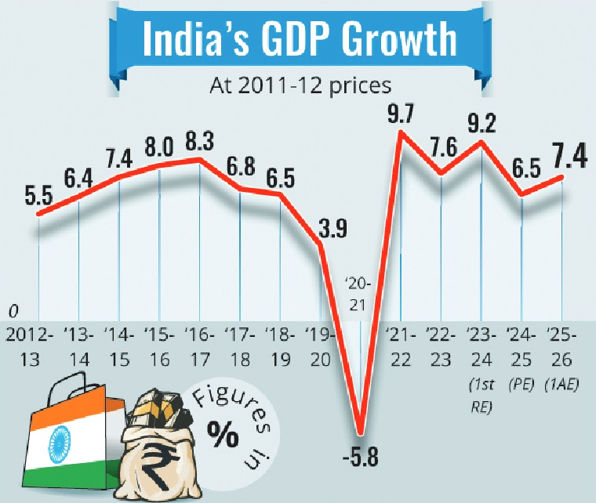  Figure 1: GDP growth of India  (Source: Dailypioneer, 2026)  - The disposable income is on the rise and the population in the middle class is also over 400 million people (MOSPI, 2025).  - India has a nominal GDP of more than INR 330 trillion, which offers high opportunities to high-end and regular chocolate products (RBI, 2025).
Social | - India is a country of over 1.47 billion, with approximately 65% of the population coming out to be below 35 years (Worldometers, 2026a).  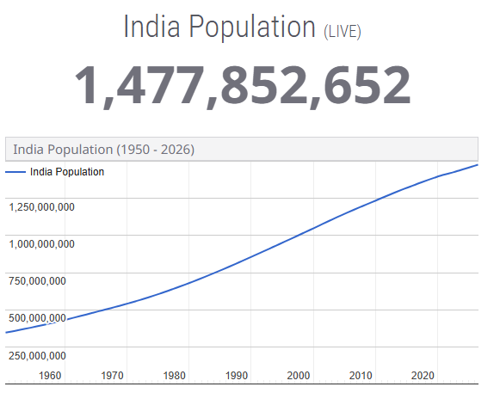  Figure 2: India population  (Source: Worldometers, 2026a)  - Festivals like Diwali and Raksha Bandhan are being trendily celebrated with Chocolates rather than the traditional sweets.  - Urbanisation, evolving lifestyles and increased health consciousness have resulted in a demand for high-quality, sugar-cut, and gifting chocolate products as a boon to product diversification at Cadbury (UN Population Division, 2025).
Technological | - The market data of Indian IT services illustrates that the market will expand by an average of almost US$230 billion in 2033, starting with a figure of about US$52 billion in the year 2021 (Grandviewresearch, 2026a).  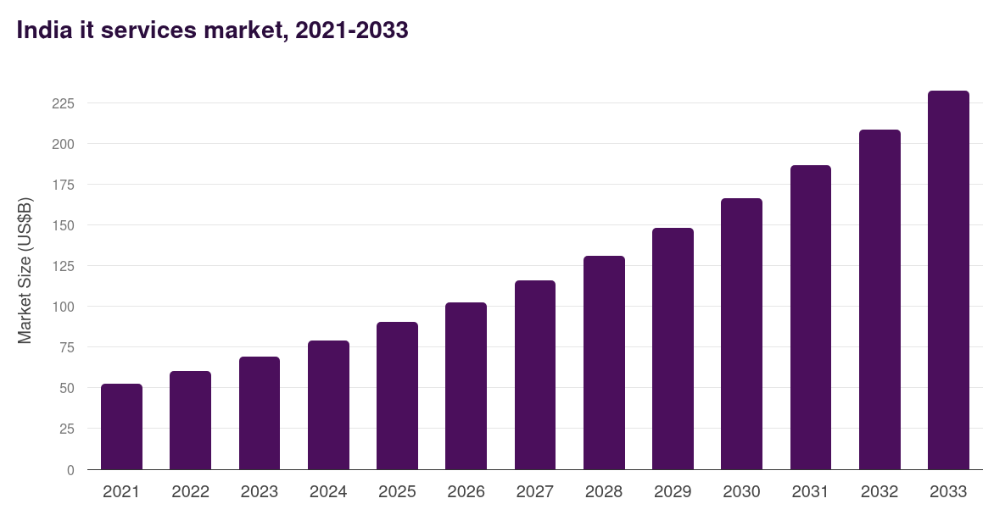  Figure 3: IT market of India  (Source: Grandviewresearch, 2026a)  - Expanding e-commerce and retailing benefits will be AI-enabled, online payments via UPI and data analytics, providing Cadbury an opportunity to enhance online sales, personalised promotions and optimised supply chain (IBEF, 2025).
Legal | - Cadbury will have to abide by laws set by the “Food Safety and Standards Authority of India (FSSAI)” with regard to food safety, ingredient labelling, nutritional labelling and advertising (FSSAI, 2025).
Environmental | - Plastic waste management policies and climate commitments have empowered India to enhance sustainability policies.  - Consumers are becoming more demanding of chicken food packs that are recyclable and responsibly sourced cocoa.  - By investing in sustainable and renewable energy and renewable sourcing practices, Mondelez International, the parent company of Cadbury, can enhance its competitive advantages by investing in sustainable packaging, which goes in line with the environmental goals of India (KR, 2022).
Table 1: PESTLE analysis of India
(Source: Self-created)

Factors | Analysis of USA
Political | - The USA offers both a politically and business stable environment with good protection of intellectual assets and open trade rules.  - Food safety and labelling standards set by the “Food and Drug Administration (FDA)” assist in helping multinational companies like Cadbury keep product quality and trust of consumers (FDA, 2025).  - These types of long-term business development are also promoted by government support of innovation and investment (FDA, 2025).
Economic | - The USA is the biggest economy in the world with a GDP of more than US$32.38 trillion (Worldometers, 2026b).  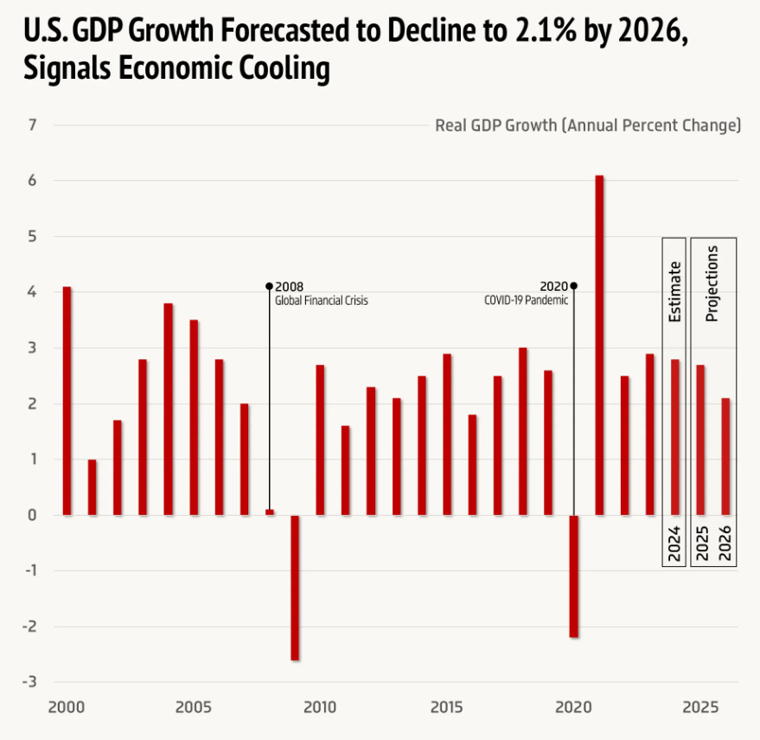  Figure 4: US GDP decline  (Source: Voronoiapp, 2026)  - Based on the given GDP statistics, the anticipated economic growth will be 2.8% in 2024 and 2.7% in 2025, and it is predicted to decelerate to 2.1% in 2026 (Voronoiapp, 2026).  - Despite the moderation of growth, consumer high purchasing power and premium chocolate demand remain a good opportunity for Cadbury in the chocolate market (U.S. Bureau of Economic Analysis, 2025).
Social | - The USA is a highly urbanised country that has a population of around 349.2 million, with heterogeneous consumer preferences (Worldometers, 2026c).  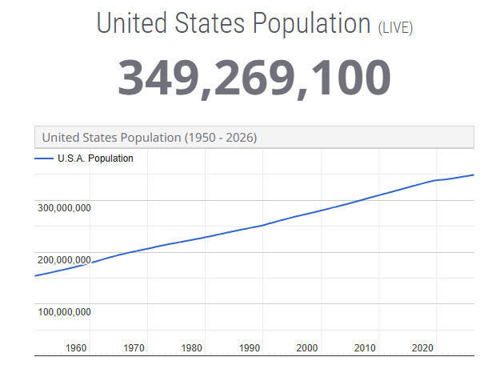  Figure 5: USA population  (Source: Worldometers, 2026c)  - The shift towards higher demand for high-quality, organic and low-sugar chocolates is a sign of the growing level of health consciousness.  - Huge sales of chocolate are also contributed by seasonal occasions like Halloween, Christmas and Easter in the entire country (U.S. Census Bureau, 2025).
Technological | - According to the market statistics given, the education technology market in the U.S. is projected to increase by approximately to roughly US$90 billion by the year 2030, as compared to the current market of about US$21 billion (Grandviewresearch, 2026b).  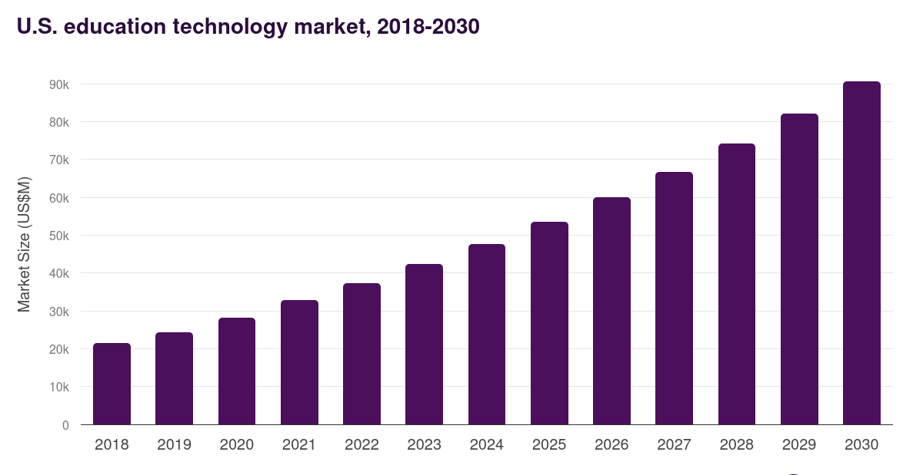  Figure 6: USA tech market  (Source: Grandviewresearch, 2026b)  - Cadbury can enhance its interactions with customers, tailored marketing and omnichannel retail via advanced AI.
Legal | - Cadbury needs to adhere to the FDA laws, the Nutrition Labelling and Nutrition Education Act, consumer laws, and trademark law (Bollinger et al. 2022).
Environmental | - The USA has enhanced sustainability programs concerning carbon emissions, recyclable packaging and responsible sourcing (EPA, 2026).  - Cadbury is making investments in sustainable cocoa sourcing, recyclable packaging and low-carbon manufacturing to make its brands stronger.
Table 2: PESTLE analysis of USA
(Source: Self-created)

Comparison and contrast of the macro-environments of India and USA
According to RBI (2025), there is a better growth opportunity in India, where the growth in GDP is estimated to be 7.4% in the year 2025-26, a population of 1.47 billion, and growing digital commerce. Nonetheless, price sensitivity, the complexity of regulations and infrastructure gaps are weaknesses. Bollinger et al. (2022) argued that the USA offers a higher level of political and economic stability that is backed by a GDP of over US$32.38 trillion, better purchasing power and technological progress, but lower estimated growth of 2.1% in 2026 stifles expansion rates. Most importantly, Li (2023) stated that the young demographic population and high rate of digitalisation of India present Cadbury with higher long-term volume opportunity, but the USA presents higher value premium consumption. However, Voronoiapp (2026) argued that more stringent regulation and growing health consciousness in both markets pose great risks and Cadbury must be able to strike a balance between growth and responsible product innovation.

1.1.2 Cultural factors in India and USA (Hofstede framework)
The cultural dimensions can clarify the effects of the national culture on consumer behaviour and marketing decisions. When looking at the differences in culture as is witnessed in the comparison between India and the USA, it is evident that Cadbury must make changes to its international marketing strategy. According to Mondelez International (2025), the power distance dynamic in India supports the idea of family-based purchasing, in which Cadbury can make their emotional campaigns much more crucial than individualistic advertising. Nevertheless, Chattopadhyay et al. (2023) argued that this opportunity might be slowly eroded by the growing urbanisation and Gen Z consumers, and Cadbury will have to strike a balance between traditional communication and the digitalisation of the message. In turn, Cadbury encourages activities that are based on family themes like “Kuch Meetha Ho Jaaye” that link chocolate to Indian festivities and familial events. India is one of the biggest markets for Cadbury, with the brand controlling about 70% of the organised chocolate market with solid emotional advertising and a vast network of retailers (Mondelez International, 2025).
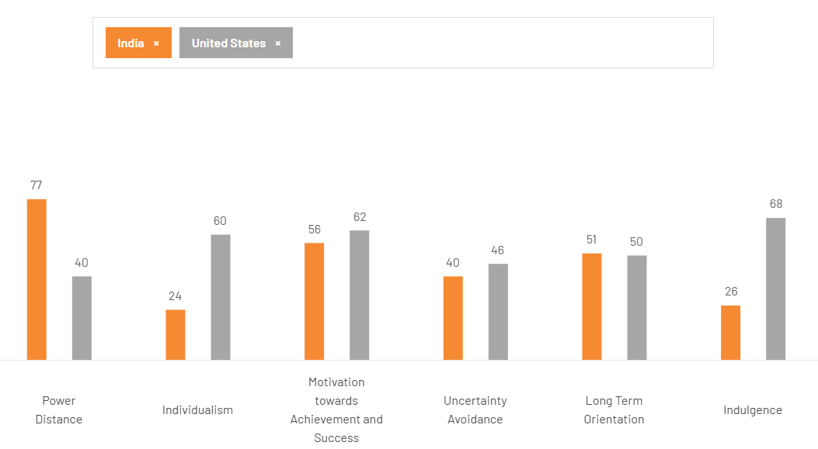
Figure 7: Hofstede’s cultural factors of India and USA
(Source: Theculturefactor, 2026)
The score of the USA in Individualism (60%) is significantly higher than the score of India (24%), indicating that people are fond of making personal decisions and being independent. Cadbury then places its products around the enjoyment of individuals, a premium and consuming its products during seasons like Easter and Halloween. In the USA, the Indulgence score (68%) is also higher than it is in India (26%), which shows that the USA has higher demands on self-reward and buying impulsions (Theculturefactor, 2026). Moreover, Li (2023) stated that the USA is a little higher on Masculinity (62) and Uncertainty Avoidance (46%) than India (56% and 40%), respectively, which means they prefer consistency in their products and effective brand communication. In the meantime, Bollinger et al. (2022) argued that the scores of Long-Term Orientation are similar in both countries (India-51%, USA-50%), which provides Cadbury with an opportunity to continue making long-term investments in the brands in both markets and adjust product offerings and advertising messages to local cultural values. Though Hofstede offers a much-needed model, it assumes that every country has a uniform culture and thus cannot serve as a complete explanation of the differences between urban and rural consumers of India, which is a major limitation (Mondelez International, 2025).

1.2 Comparative analysis of STP and 7Ps marketing mix strategies

1.2.1 STP
Segmentation
In both the USA and India, Cadbury uses a differentiation segmentation approach in order to address consumer needs, income levels and purchasing behaviour. Whereas the brand is integrated with a consistent global identity, size, flavours, pricing and promotional activities of products are modified to suit local market attributes. India concerns itself with the philosophy of affordability and festive consumption, whereas the USA tends to be more concerned with premium products, gifting by season and personal consumption.

Segmentation Variables | India | USA
Geographic | The metropolitan cities, Tier-2 cities and Tier-3 cities and rural markets using over 6 million retail outlets. | Distribution nationwide via supermarkets, convenience stores, pharmacies and online stores.
Demographic | Children, adolescents, young adults and families between ages 5 to 55 years. Good client base in the middle-income segments (Manikandan and Sarguna, 2024). | Adult and premium youthful users with medium to high household income of children, adults and premium consumers aged 18 to 60 years of age (Chattopadhyay et al. 2023).
Income | Prices of the product range between approximately INR 10 and gift packs on the higher end priced above INR 1,000 (Davvetas and Biraglia, 2022). | Gift boxes are available at a premium price and chocolate bars range between about US$2 and higher, with the gift boxes costing more than the premium (Pramodini et al. 2026).
Psychographic | Family gifting, emotional connections (and value-conscious consumer) and festival celebrations. | Premium lifestyle, self-reward, seasonal nurturing and convenient shoppers.
Behavioural | Periodic purchases, gift giving due to festivities, impulse buying and consumption by the family. | Premium gifting, Brand-loyal consumers, impulse purchases and holiday purchases.
Table 3: Segmentation of Cadbury in India and USA
(Source: Self-created)
The market for confectionery in India is still growing due to the increased disposable income and the growth of organised retail. By 2029, the Indian market for chocolate confectionery will reach greater than US$5.6 billion, with the help of further urbanisation and the need to consume high-quality chocolate (Mordor Intelligence, 2025). The USA is a mature confectionery market that has a higher purchasing power and demand for high-quality chocolates. An increase in demand and seasonality during Halloween, Easter and Christmas are likely to propel the U.S. chocolate confectionery market to over US$33 billion by 2029 (Grand View Research, 2025c). As a result, Cadbury is able to expand its premium products and retain the value products via the supermarkets and online retailers.

According to Mordor Intelligence (2025), differentiation in segmentation provides Cadbury with a huge competitive edge both in the USA and India. The combination of affordable products and family-based consumption and festive gift-giving enables it to target a range of income groups in India, where it targets a price point as low as INR10. In the USA, Cadbury can use medium-to-high household incomes as the distinguishing aspect of the consumer target age (18- 60-year-olds) thanks to the premium products, seasonal gifts, and personal usage. This balance between premiumisation and affordability enhances the coverage in the market.

Nonetheless, Pramodini et al. (2026) argued that multi-segment strategies present threats of brand dilution and more and more complex marketing. Price sensitivity within India is high, which reduces the adoption of premium products, whereas the USA has a mature market, so the level of competition among premium consumers is high. As stated by Chattopadhyay et al. (2023), the segmentation will be narrowed in the future to include health-conscious, digitally active and premium consumers. The strategies to address the challenges that Cadbury can develop include low-sugar chocolate, customised online messages, environmentally friendly packaging and data-driven segmentation. The increasing disposable income and urbanisation of India and the need for high-quality and seasonal confectionery in the USA present the chance to launch a targeted market.

Targeting
The multi-segmentation targeting strategy utilised by Cadbury varies in India compared to the USA based on the buying behaviour and cultural preferences of consumers. In India, the major target market is children, young adults and middle-income families who want to consume chocolates for daily consumption and during festivals or occasions (Powers et al. 2023). The promotional campaigns will aim at enhancing the emotional attachment with family celebrations and other social events. The growth in retail in India is also a way for Cadbury to access consumers in both urban and semi-urban areas via traditional retailers, supermarkets and online shopping platforms. Conversely, the strategy of Cadbury in the USA lays more emphasis on the market segment of adults, i.e., those who buy premium chocolate and those who give out gifts at seasons. Premium chocolates have a greater value since, during festivals, American consumers are likely to pay more for branded confectionery. Premium chocolate remains sold online through online grocery shopping of groceries. The National Confectioners Association (2025) reveals that confectionery sales in the United States reached more than US$54 billion in 2024, and the share of seasonal products in the annual purchases of chocolate reached a significant level.

Positioning
Cadbury creates a high-quality brand, which promises good emotional value and a competitive high price, positioning itself in a different manner in India and in the USA.
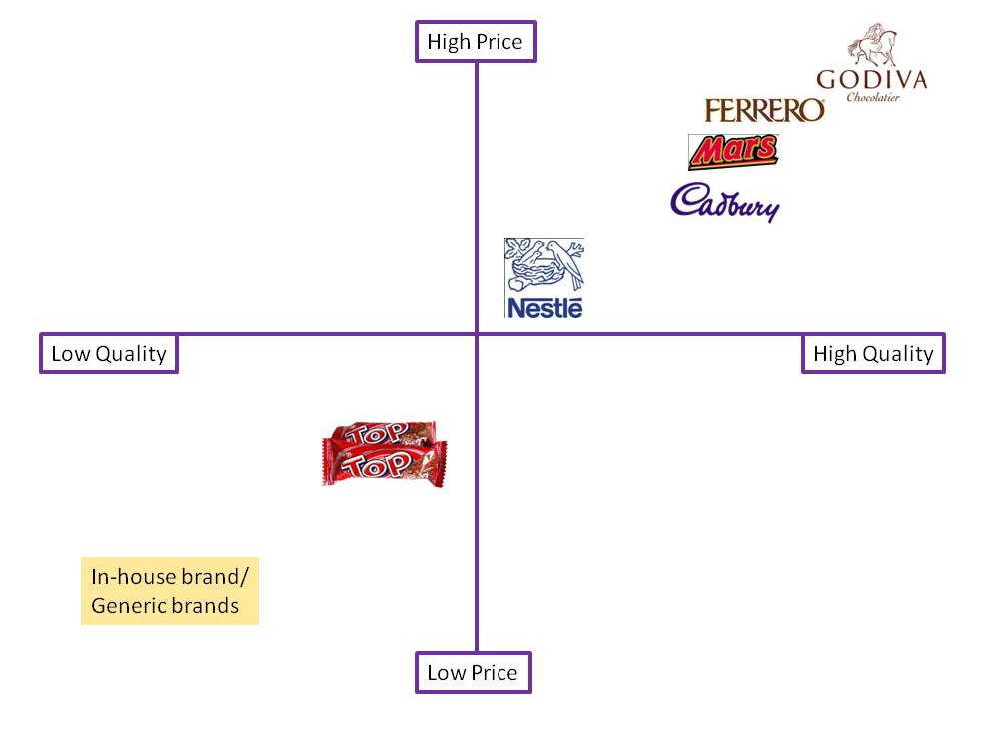
Figure 8: Positioning map of Cadbury
(Source: Thecadburychocolatier, 2026)
The positioning map provided above demonstrates that Cadbury was in the high-quality and rather expensive section of the confectionery market. The Cadbury brand lies lower than other luxury chocolate brands like Godiva and Ferrero, but higher than mass-market and generic chocolate brands in their perceived quality (Thecadburychocolatier, 2026). Many of the brands that Cadbury uses, such as its closer brand heritage, richer chocolate flavour and emotional brand identity, place Cadbury more at the end of the premium segment than Nestle. The low-end local brands are mostly competing on price but not quality, whereas the high-end luxury brands are based on exclusivity instead of the mass market (Mourya, 2026).

In India, Cadbury's positioning is based on a combination of high quality and affordable goods, which gives consumers the ability to buy not only low-priced products, but also gift boxes of high quality, under an exclusive brand. This twofold strategy has increased the leadership of Cadbury in various consumer groups (Amiri et al. 2023). Cadbury in the USA is better positioned in terms of genuine chocolate quality, high-end gifting and seasonal consumption to compete in the mature confectionery industry.
In the end, Cadbury has managed to sustain a globally consistent image of premium without compromising its segmentation, targeting and positioning practices to the local market expectations. This global and local responsiveness balance enhances competitiveness in both India and the USA.

1.2.2 7Ps marketing mix
Cadbury uses a global brand strategy, eliciting standardisation and adjusting the aspects of its market mix to adapt to India and the USA market choices. The product adaptation increases profitability due to increased numbers of customers in both India and the USA. The balance will help the company to enhance customer satisfaction and competitive edge in both markets.
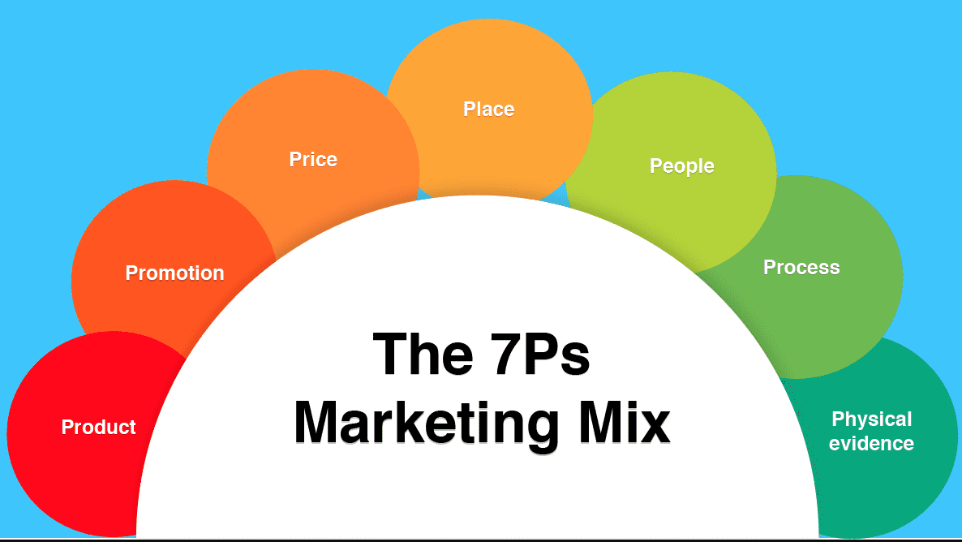
Figure 9: 7Ps marketing mix
(Source: Kilipiri et al. 2023)
Product
In India, Cadbury has a wide product range of Dairy Milk, Silk, Bournville, 5 Star and Celebrations, and in the USA, they sell predominantly Dairy Milk, Caramello and Easter and Halloween speciality products. The company also releases festive gift packs and local flavours on a regular basis in India according to the taste of the consumers (Kilipiri et al. 2023).

Price
Cadbury works under a value-based pricing strategy, as the brand is also affordable to various income brackets in India, with products costing in the range of INR 10 to luxury gift packs priced in the range of over INR 1,500. The retail price of the regular chocolate bars in the USA tends to be between US$2 and US$5, whereas luxury seasonal gift boxes are over US$50 (Salunkhe et al. 2023). The different pricing structure enables Cadbury to cater to the mass-market and premium consumers.

Place
Distribution policies vary with respect to market maturity. Mondelēz reaches its consumers in India in about 3 million traditional retail outlets, and 20% of the total sales come from modern trade and e-commerce outlets (Dong et al. 2022). In the USA, Cadbury products are offered in most supermarkets and other convenience stores as well as warehouse clubs and electronic stores such as Walmart, Target and Amazon, which guarantees a wide national coverage.

Promotion
The local culture is reflected in the promotion strategies, as India is adaptable to emotional campaigns in connection with such festivals as Diwali, Raksha Bandhan and Valentine's Day, whereas the USA is set on seasonal campaigns like Halloween, Easter and Christmas (Vieito et al. 2024).

People
Cadbury makes investments in employee competency, retail relationships, and customer experience to enhance brand experience. The sales teams are constantly trained to ensure quality of merchandising and customer relations both in the physical and online sales methods.

Process
The company applies modern digital technologies, demand forecasting with the help of AI and integrated supply chain management to enhance inventory management and optimise deliveries. Customisation of marketing and usage of digital sales systems also complement customer experience and performance in the market (Duro et al. 2022).
Physical Evidence
Cadbury also has uniform purple wrappings, universally recognisable logos and high-quality product packaging. Vibrant festive gift boxes, contemporary retail shelves and branded cooling units reinforce the brand image and build brand perceptions of product quality in both India and the USA (Uner et al. 2023).

1.3 Analysis of the market entry strategy in India
The decision to choose India as the preferred international market has been due to its huge population, increasing disposable income and booming confectionery industry. Cadbury came to India in 1948 and has evolved to be no longer an imported chocolate maker but one of the most popular brands of confectionery in the country. The result of its market entry strategy is its success in the long term, as today, one of the three largest markets of Cadbury is in India.

Cadbury has taken the approach of a wholly owned subsidiary, which currently works under Mondelez India Foods Private Limited. The company developed regional manufacturing, distribution and marketing as opposed to licensing or franchising. This became more effective as Cadbury had more control over the quality of their products, pricing, branding and supply chain management. The local production also decreased the importation duties and transportation expenses, and the company was able to sell chocolates at reasonable prices and profit. Within the last 75 years, Mondelez India has increased its manufacturing capacity and product line-up as consumer tastes and preferences transformed (Mondelez International, 2025).

India was a good market pick that was anchored by solid market fundamentals. India is among the most dynamic consumer markets in the world, as household income is increasing and urbanisation has been happening at high rates, creating favourable conditions for confectionery products in India. “India Brand Equity Foundation (IBEF)” forecasts that the Indian food processing sector will attain a figure of about US$700 billion in the year 2030 with the support of the growing consumption of food and drugs, the growth of organised retail outlets, as well as government funding (IBEF, 2025).

Cadbury's market entry was also based on localisation compared to merely presenting products so designed that they appealed to Western consumers. The firm tailored the size, flavour, packaging and prices of products to the purchasing behaviour in India. Small packs of chocolate costing approximately INR 10 helped Cadbury to scoop the low- and middle-income segments of the market, and the high-end segments with products like Cadbury Silk, Bournville and gift boxes like Celebrations were aimed at the higher-income markets (Umar et al. 2022). This multi-price plan made the market more penetrative among various income groups and enhanced brand accessibility.
Other key success factors have been distribution, as Cadbury established a large supply network throughout the big cities, the small towns and the rural regions. The company integrates traditional neighbourhood shops, supermarket shops, convenience shops and online stores to optimise product availability. This extensive distribution network makes Cadbury products available to various consumer groups (Golovko et al. 2023). An ever-increasing investment in production and logistics has also enhanced the availability of the products and efficiency in the functioning throughout India.

Joint venture, licensing, exporting and franchising also help to improve the market operations of Cadbury in India. Due to its high population, India is suitable for exporting, licensing and doing joint ventures with Cadbury (IBEF, 2025). Localisation of marketing has also been one of the strategies that have enhanced Cadbury in its entry operations within the market. Rather than selling chocolate as a child product only, Cadbury has managed to sell chocolate as a family product to celebrate and offer as presents and during festivals. Diwali, Raksha Bandhan, Valentine's Day, and wedding campaigns that were associated with similar festivals brought great emotions to Indian consumers (Invest India, 2025). This localisation approach facilitated the spread of chocolate consumption beyond normal times and heightened buying rates. The new products and limited edition products that were launched in recent campaigns are still present and are aligned to local consumerism and seasonal demand.

Cadbury has also benefited through strategic alliances to enhance its long-term growth. Collaborations have helped Mondelez to increase its production capacity and diversify its products by relying on its current production and distribution facilities in India. Indicatively, alliances with the production and distribution of foreign brands within the country are a show of trust in the emerging consumer base in India and enhance efficiency in production.

In the end, the introduction of Cadbury in India in the form of a wholly owned subsidiary with the help of localisation, local production, and a wide network of distributors has proven to be successful. The strategy has helped the company to develop a good brand equity, gain wide market penetration and react positively to evolving consumer tastes. Together with the growing consumer economy of India and the ongoing investment in innovation, the market entry strategy will offer Cadbury a long-term platform for the growth of its business in one of its most significant business markets across the globe.

1.4 Ethical issues related to Cadbury’s marketing mix in India
Cadbury has emerged to gain a good market base within India, but various ethical concerns have been attached to its marketing mix. Such problems are connected to product responsibility, promotion, price, sustainability and consumer welfare. Such concerns should be evaluated to help enhance trust between business entities and customers in the long-term and the brand image, which can be achieved through ethical practices in business.

Marketing high sugar products is one of the ethical concerns. Sweetened snacks, especially chocolate products, enjoy child popularity, and the younger generation might tend to develop obesity, diabetes and tooth decay due to the frequent regular use of sugary snacks. Most of the Cadbury ads establish a feeling of association with the festivities, festivals and family gatherings. As effective as any such campaigns may be in ensuring that consumers are more engaged, it may as well lead to over-consumption of confectionery products (Yang et al. 2023). The company should, therefore, take a moral obligation to ensure well-balanced consumption and give up-to-date nutritional information to the consumers.

The other ethical issue is associated with targeting the marketing towards children. Catchy packaging, appealing product designs and TV/internet advertisements can have an enormous impact on youthful consumers who are not fully aware of the health impacts of over-indulgence in sugar consumption. In ethical marketing, businesses should make sure that their promotional information is presented in a responsible manner that does not take advantage of the underdeveloped level of decision-making in children (Pereira et al. 2022). Marketing should be made more responsible with increased focus on parental awareness and enhancing healthier dietary habits.

Pricing also poses some ethical dilemmas, as Cadbury has a variety of products at various prices to target a diverse market. Although the low cost of the products can enhance accessibility, the price can often be increased due to inflation or rising costs of raw materials and decrease the affordability of lower-income households (Khanom, 2023). Businesses are not supposed to be secretive in terms of their pricing, and it is better to avoid packages being deceptive, which may end up confusing customers about the value of products. Another issue of ethical concern is environmental sustainability, as the manufacture of chocolate is greatly reliant on cocoa production, packaging materials and transportation. Concerned consumers are insisting that companies minimise plastic waste, decrease both carbon emissions and use ethically sourced cocoa (Li, 2023). Sustainable sourcing and environmentally responsible manufacturing processes, as well as recyclable packaging, need to be increased continuously in ethical business practice.

1.5 Recommendations
Cadbury needs to enhance its global marketing initiative by combining global uniformity of the brand with local market competencies. The likes of consumers vary among countries, and mitigating localisation of products, product flavours, packaging and marketing campaigns will enhance customer satisfaction in their respective markets and competitiveness (Aswathy et al. 2024). Given other international markets, there should also be the development of seasonal products and culturally specific campaigns. The firm needs to increase its control in digital marketing and AI to engage customers better, as Cadbury can utilise AI-based consumer behaviour insights, targeted advertising and data analytics to gain a better insight into evolving purchasing behaviour and provide more targeted promotional campaigns. Increased utilisation of e-commerce sites and apps will also enhance customer convenience and boost sales via the internet.

By removing sugar, bringing out more portion-controlled packages and increasing products made using natural ingredients, Cadbury needs to speed up the process of developing healthier chocolate products (Khanom, 2023). The increasing health consciousness in markets around the world necessitates product innovation in its bid to attract new consumers and retain the already existing consumers. Other sustainability areas that the company needs to enhance to make its company more sustainable include enhanced recyclable packaging, minimising carbon emissions and promoting responsible sourcing of cocoa. Honest and transparent communication of environmental initiatives will enhance consumer trust and enhance Cadbury's international brand name (Aswathy et al. 2024).

Lastly, Cadbury needs to expand its reach in emerging markets, especially by increased distribution of its retail outlets, joint ventures and local manufacturing where suitable. Market research should be carried out regularly to discern evolving needs of the consumers and competitive trends.

Section 2

2.1 Reflective account of the process (Gibbs reflective cycle)
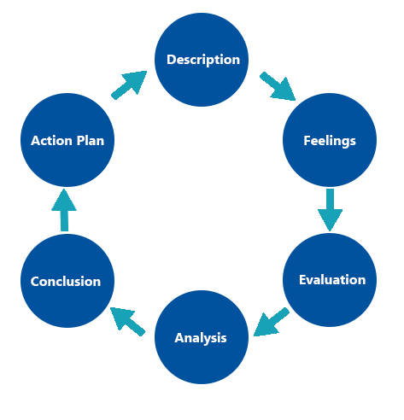
Figure 10: Gibbs Reflective Cycle
(Source: Aneeis Hashim et al. 2023)
Description
In this evaluation, a comparative analysis of India and the United States of Cadbury international marketing strategies had to be done. The report contained the PESTLE analysis and cultural structures by Hofstede, STP, marketing mix (7Ps), market entry approach, ethical concerns and suggestions (Aneeis Hashim et al. 2023). In the process of preparing this report, I used company-reports, government-publications, industry-reports and academic-resources as sources of information. The country I chose to conduct the market entry analysis in is India, as it is one of the most important foreign markets of Cadbury.

Feelings
When starting this assessment, I was certain, as I was already acquainted with Cadbury as a world-renowned brand. Nevertheless, I also learnt that it would take a lot of research and critical thinking to make a specific comparison of two countries. At first, locating new and valid data was not an easy task since numerous available sources on the internet showed varied market statistics. I had the issue of choosing the correct information that would enhance the quality of the report.
As I continued the research, my confidence was building up. I also felt more normal searching government reports, company reports and well-known sources of market research rather than relying on general websites. I also liked to get to know the differences in the international marketing strategies by different countries. The topic became interesting due to the understanding that Cadbury modifies its products, pricing and promotional activities based on the local culture.

Evaluation
I think that there are a number of research process issues that were successful. In my opinion, the report was able to draw comparisons on the business situation in India and the United States based on the well-known marketing frameworks. The use of the PESTLE analysis and the dimensions provided by Hofstede helped to understand why Cadbury employs varying marketing strategies in various countries (Khanom, 2023). The analysis of STP and 7Ps marketing mix also showed how the company tailors its products and promotion activities to the local consumer requirements.

The other advantage was that there were recent statistics and examples of companies used. Gathering the latest market intelligence enhanced the topicality of the report and made the discussion more relevant as it was based on practical evidence and not on theory alone. The market entry analysis also aided in determining why India would continue to be a significant international market for Cadbury and how localisation would help achieve long-term business success. But the preparation of the report was faced with some challenges as well. Locating up-to-date information about the industry was time-consuming since some data could be located only by commercial reports or other online databases.

Analysis
The evaluation helped me greatly to learn about international marketing. I primarily focused on marketing as promoting products and advertising before doing the report. In this study, I realised that international marketing involves businesses knowing the political circumstances, economic performance, culture, law and consumer behaviours prior to venturing into foreign markets. The case study of the comparison between India and the United States was a clear illustration that not all markets can be treated by using a single global marketing program. Countries have a huge variation in terms of consumer expectations, buying behaviour and cultural values. India, as an example, Cadbury pursues emotional family-based advertising because it has been effective there, whereas premium positioning and seasonal marketing are more effective in the United States (Salunkhe et al. 2023). This made me realise that global firms attain competitive advantage through balancing global uniformity with local customisation.

It also enhanced my skills in research and analysis in the report. I also understood how to check the credibility of various sources of information and juxtapose statistical evidence to make conclusions. Instead of just delivering information, I was made more conscious of the significance of analysing why some marketing strategies can work successfully in some business setups.

Conclusion
On the whole, this assessment was a good learning experience. By using the application of academic theories to the operations of Cadbury in India and the United States, I was able to develop a greater insight into the international marketing practices to use. The research helped me enhance my confidence when it comes to gathering sound information, studying the business environment and interpreting the market trends in the existing market. Though I had a few problems with finding new and consistent data, this gave me some skills in critical thinking and research. Now I understand the necessity to choose legitimate sources of information, to analyse evidence and justify business decisions using up-to-date information.

Action Plan
Improvement Area | Action to be Taken | Expected Outcome | Timeframe
Research Skills | In future assignments, use greater quantities of peer-reviewed journal articles, government publications and company annual reports at the beginning. | Enhance the quality, reliability and credibility of the research findings. | 1 month
Critical Analysis | Refer to a variety of theories, perspectives and market observations prior to making conclusions rather than basing on a single source. | Develop more balanced, evidence-based and analytical discussions. | 2 months
Data Analysis Skills | Train on how to read market reports, business statistics and consumer data with the use of real business databases. | Gain a greater ability to discern and make better business recommendations. | 3 months
Academic Writing | Enhance report organization, sense of logic, and scholarly writing through revising lecturer feedback and carefully proofreading every assignment. | Write more coherent, professional and well-structured academic reports. | 5 months
Digital Marketing Knowledge | Continually keep abreast of advances in the fields of AI, digital marketing, consumer behaviour and the international business landscape using professional business articles. | Earn current knowledge which can be used in academic and professional work. | 7 months
Time Management | Before doing any assessment, make a study schedule that has definite milestones to research, write, edit and reference before handing in the assignment. | Avoid pressure and increase the quality of assignments at the last minute. | 8 months
Table 4: Action Plan
(Source: Self-created)

References
Amiri, A.M., Kushwaha, B.P. and Singh, R., (2023). Visualisation of global research trends and future research directions of digital marketing in small and medium enterprises using bibliometric analysis. Journal of Small Business and Enterprise Development, 30(3), pp.621-641. DOI: https://doi.org/10.1108/JSBED-04-2022-0206
Aneeis Hashim, S.N., Yaacob, A., Suryani, I., Mohd Asraf, R., Bahador, Z. and Supian, N., (2023). Exploring the Use of Gibbs’ Reflective Model in enhancing in-Service ESL teachers’ reflective writing. Arab World English Journal (AWEJ) Volume, 14. DOI: https://dx.doi.org/10.2139/ssrn.4497558
Aswathy, T., Rajan, S.A., Chitra, N. and Soumya, V.I., (2024). Food Safety Standards Authority of India (FSSAI): A multifaceted approach towards food safety. Agritechpublication. com, pp.1-4. DOI: https://www.academia.edu/download/118328389/FSSAI_Sept_2024._Aswathy_S._Anu_Raja.pdf
Aujla, D.S., (2022). An Analysis of the Marketing Strategies of Cadbury. Marketing Mastery: Strategies for Captivating Audiences, p.43.
Bollinger, B., Liebman, E., Hammond, D., Hobin, E. and Sacco, J., (2022). Educational campaigns for product labels: Evidence from on-shelf nutritional labeling. Journal of Marketing Research, 59(1), pp.153-172. DOI: https://doi.org/10.1177/0022243720981975
Chattopadhyay, A., Ali, S.S., Chakraborty, S., Acharjee, S., Roy, A., Pal, S. and Chittilapilly, S.V., (2023). Cultural Adoption Through Advertisements: International and Indian Scenarios. Journal homepage: www. ijrpr. com ISSN, 2582, p.7421. DOI: https://doi.org/10.55248/gengpi.2023.4215
Dailypioneer (2026) GDP growth of India in FY2026. Available at: https://dailypioneer.com/news/india-s-gdp-to-grow-at-7-4-in-fy26 (Accessed: 27 July 2026).
Davvetas, V. and Biraglia, A., (2022). The “indie” premium: how independent firms create product value across cultures. International Marketing Review, 39(6), pp.1353-1389. DOI: https://doi.org/10.1108/IMR-04-2021-0157
Department for Promotion of Industry and Internal Trade (DPIIT) (2025) FDI Policy. Available at: https://dpiit.gov.in/ (Accessed: 27 July 2026).
Dong, Z.Y., Yang, J., Yu, L., Daiyan, R. and Amal, R., (2022). A green hydrogen credit framework for international green hydrogen trading towards a carbon neutral future. International Journal of Hydrogen Energy, 47(2), pp.728-734. DOI: https://doi.org/10.1016/j.ijhydene.2021.10.084
Duro, J.A., Osorio, A., Perez-Laborda, A. and Fernandez-Fernandez, M., (2022). Measuring tourism markets vulnerability across destinations using composite indexes. Journal of Destination Marketing & Management, 25, p.100731. DOI: https://doi.org/10.1016/j.jdmm.2022.100731
Food and Drug Administration (FDA) (2025) Food Guidance and Regulation. Available at: https://www.fda.gov/ (Accessed: 27 July 2026).
Food Safety and Standards Authority of India (FSSAI) (2025) Food Safety Regulations. Available at: https://www.fssai.gov.in/ (Accessed: 27 July 2026).
Golovko, E., Lopes-Bento, C. and Sofka, W., (2023). Learning by exporting for marketing innovation. Industry and Innovation, 30(5), pp.607-635. DOI: https://doi.org/10.1080/13662716.2022.2161874
Grand View Research (2025c) U.S. Chocolate Confectionery Market Size Report. Available at: https://www.grandviewresearch.com/ (Accessed: 27 July 2026).
Grandviewresearch (2026a) Indian IT market. Available at: https://www.grandviewresearch.com/horizon/outlook/it-services-market/india (Accessed: 27 July 2026).
Grandviewresearch (2026b) USA tech market in 2026. Available at: https://www.grandviewresearch.com/horizon/outlook/education-technology-market/united-states (Accessed: 27 July 2026).
India Brand Equity Foundation (IBEF) (2025) Food Processing Industry in India. Available at: https://www.ibef.org/industry/food-processing (Accessed: 27 July 2026).
India Brand Equity Foundation (IBEF) (2025) IT and BPM Industry in India. Available at: https://www.ibef.org/industry/information-technology-india (Accessed: 27 July 2026).
Invest India (2025) Food Processing Sector. Available at: https://www.investindia.gov.in/sector/food-processing (Accessed: 27 July 2026).
Khanom, M.T., (2023). Using social media marketing in the digital era: A necessity or a choice. International Journal of Research in Business and Social Science (2147-4478), 12(3), pp.88-98. DOI: 10.20525/ijrbs.v12i3.2507
Kilipiri, E., Papaioannou, E. and Kotzaivazoglou, I., (2023). Social media and influencer marketing for promoting sustainable tourism destinations: The Instagram case. Sustainability, 15(8), p.6374. DOI: https://doi.org/10.3390/su15086374
KR, S., (2022). Would Mondelez branch out into plant-based products in India?. The CASE Journal, 18(6), pp.1016-1036. DOI: https://doi.org/10.1108/TCJ-01-2022-0006
Li, C., (2023). Cultural friction in international joint ventures: whose cultural distance affects market reactions?. Journal of Management, 49(7), pp.2288-2317. DOI: https://doi.org/10.1177/01492063221104030
Manikandan, M. and Sarguna, G., (2024). A comparative analysis of Cadbury dairy milk and Cadbury 5 star using the BCG matrix framework. INTERNATIONAL JOURNAL OF RESEARCH IN MARKETING, 6(2), pp.238-243. DOI: https://doi.org/10.33545/26633329.2024.v6.i2c.198
Ministry of Statistics and Programme Implementation (MOSPI) (2025) National Accounts Statistics. Available at: https://mospi.gov.in/ (Accessed: 27 July 2026).
Mondelez International (2025) Annual Report 2024. Available at: https://www.mondelezinternational.com/investors/financial-information/annual-reports/ (Accessed: 27 July 2026).
Mordor Intelligence (2025) India Chocolate Market - Growth, Trends, Forecast (2025–2030). Available at: https://www.mordorintelligence.com/ (Accessed: 27 July 2026).
Mourya, P., (2026). Influencer Marketing in India: Dynamics, Consumer Behaviour, and the Evolving Digital Ecosystem. Minnesota Journal of Business Law and Entrepreneurship, (2), pp.2859-2867. DOI: https://kommerstad.org/journal/article/download/516/399
National Confectioners Association (2025) State of Treating Report. Available at: https://candyusa.com/ (Accessed: 27 July 2026).
Pereira, C.S., Durão, N., Moreira, F. and Veloso, B., (2022). The importance of digital transformation in international business. Sustainability, 14(2), p.834. DOI: https://doi.org/10.3390/su14020834
Powers, G., Johnson, J.P. and Killian, G., (2023). To tell or not to tell: The effects of disclosing deepfake video on US and Indian consumers’ purchase intention. Journal of Interactive Advertising, 23(4), pp.339-355. DOI: https://doi.org/10.1080/15252019.2023.2260399
Pramodini, S., Prajna, M. and Aithal, P.S., (2026). The Sweet Revolution: The Rise of the Chocolate Industry in India. Poornaprajna International Journal of Teaching & Research Case Studies (PIJTRCS), 3(1), pp.59-102. DOI: https://doi.org/10.64818/
Reserve Bank of India (RBI) (2025) Annual Report 2024–25. Available at: https://www.rbi.org.in/ (Accessed: 27 July 2026).
Salunkhe, U., Rajan, B. and Kumar, V., (2023). Understanding firm survival in a global crisis. International Marketing Review, 40(5), pp.829-868. DOI: https://doi.org/10.1108/IMR-05-2021-0175
Thecadburychocolatier (2026) Brand positioning of Cadbury. Available at: https://thecadburychocolatier.wordpress.com/cadbury-brand-positioning/ (Accessed: 27 July 2026).
Theculturefactor (2026) India and USA cultural factors. Available at: https://www.theculturefactor.com/country-comparison-tool?countries=india%2Cunited+states (Accessed: 27 July 2026).
U.S. Bureau of Economic Analysis (2025) National Economic Accounts. Available at: https://www.bea.gov/ (Accessed: 27 July 2026).
U.S. Census Bureau (2025) U.S. Population Clock. Available at: https://www.census.gov/ (Accessed: 27 July 2026).
U.S. Environmental Protection Agency (EPA) (2025) Sustainable Materials Management. Available at: https://www.epa.gov/ (Accessed: 27 July 2026).
Umar, Z., Polat, O., Choi, S.Y. and Teplova, T., (2022). The impact of the Russia-Ukraine conflict on the connectedness of financial markets. Finance Research Letters, 48, p.102976. DOI: https://doi.org/10.1016/j.frl.2022.102976
Uner, M.M., Karatepe, O.M., Cavusgil, S.T. and Kucukergin, K.G., (2023). Does a highly standardized international advertising campaign contribute to the enhancement of destination image? Evidence from Turkey. Journal of Hospitality and Tourism Insights, 6(3), pp.1169-1187. DOI: https://doi.org/10.1108/JHTI-04-2022-0141
Vieito, J.P., Espinosa, C., Wong, W.K., Batmunkh, M.U., Choijil, E. and Hussien, M., (2024). Herding behavior in integrated financial markets: the case of MILA. International Journal of Emerging Markets, 19(11), pp.3801-3827. DOI: https://doi.org/10.1108/IJOEM-08-2021-1202
Voronoiapp (2026) USA GDP decline. Available at: https://www.voronoiapp.com/economy/-US-GDP-Growth-Forecasted-to-Decline-to-21-by-2026-Signals-Economic-Cooling-3776 (Accessed: 27 July 2026).
Worldometers (2026a) Current population of India. Available at: https://www.worldometers.info/world-population/india-population/ (Accessed: 27 July 2026).
Worldometers (2026b) USA GDP 2026. Available at: https://www.worldometers.info/gdp/us-gdp/ (Accessed: 27 July 2026).
Worldometers (2026c) USA population 2026. Available at: https://www.worldometers.info/world-population/us-population/ (Accessed: 27 July 2026).
Yang, C., Chen, L. and Mo, B., (2023). The spillover effect of international monetary policy on China's financial market. Quantitative Finance and Economics, 7(4), p.508. DOI: http://www.aimspress.com/journal/QFE

