

Methods and Search Strategy Academic Poster

Student name: Sharmin Moqsuda Ahmed
Student ID: 2232368

Module name: Independent Project
Module code: BMHP6020

Assessing the Impact of Environmental Factors on Asthma in Children and Teenagers in England
01 Introduction and Research Aim  This methodology chapter outlines how secondary research methods were applied to investigate the link between environmental exposures and asthma outcomes among children and teenagers in England. The aim is to identify major contributing environmental risk factors and inform policy development for prevention and control strategies. | 02 Search Strategy  A search strategy in secondary research refers to a systematic plan to locate and select relevant sources from academic and grey literatureInvalid source specified.. My search strategy used Boolean operators, filters, and key terms (e.g., “childhood asthma”, “air pollution UK”, “housing and asthma”, “climate change and respiratory health”) to retrieve relevant and credible literature from PubMed, Google Scholar, and NHS databases.
03 Searching for Information  Step-by-step process:  - Initial scoping search to identify keywords and trends.  - Search conducted using terms such as: “asthma in children UK”, “environmental risk asthma England”, “indoor air quality and asthma”.  - Filters applied: English language, UK-based studies, publication years 2014–2024.  - Used government databases (e.g., DEFRA, NHS Digital) for national data.  - Selected peer-reviewed articles and reports that were accessible in full.  This strategy ensured a focused review of up-to-date and relevant literature on asthma and environmental health. | 04 Picture / Graph / Visual Aid / Statistics  The chart displays asthma mortality rates per 100,000 young people in the UK (ages 10–14, 15–19, 20–24) from 1998 to 2019, revealing several key trends.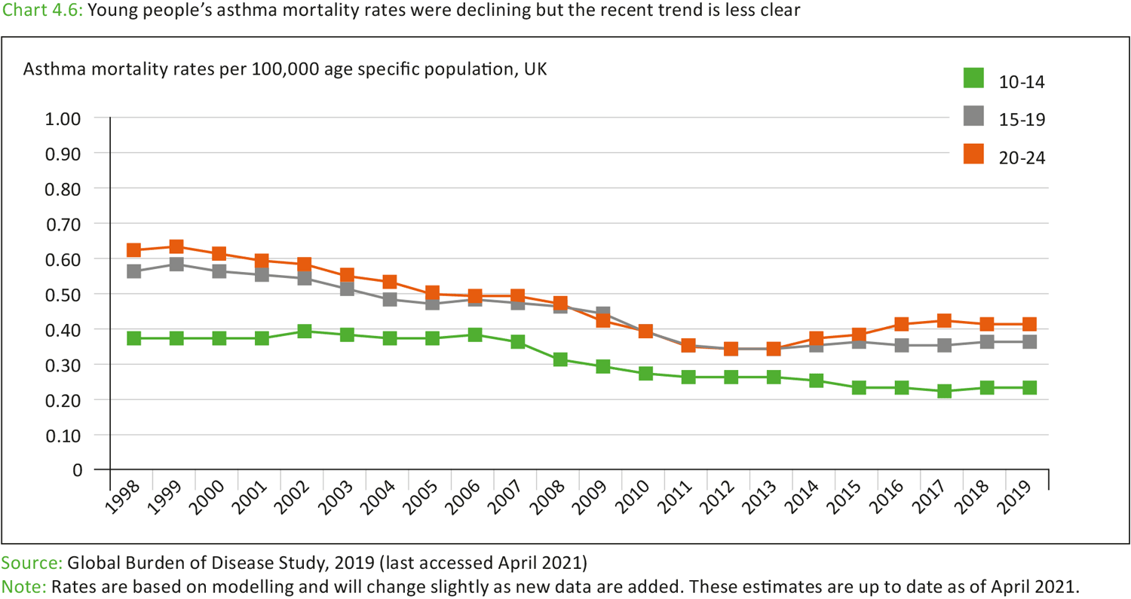
05 Research Validation and Analysis
In secondary research, validation refers to ensuring data is credible, reliable, and derived from trustworthy sourcesInvalid source specified.. I prioritised peer-reviewed journals and government datasets. A thematic analysis approach was used to identify recurring topics such as:
- Outdoor air pollution (NO₂, PM₂.₅)
- Damp or mould in housing
- Socioeconomic disparities in exposure
The themes will be explored in-depth in the dissertation findings.
06 Inclusion Criteria  - Published in the last 10 years  - UK-specific or England-focused studies  - Population: children (0–11) and teenagers (12–18)  - Access to full text online | 07 Exclusion Criteria  - Studies outside the UK context  - Adults or elderly populations  - Non-peer-reviewed blogs or forums  - Sources older than 2014 (except seminal works)
08 Ethical Considerations
Ethics in secondary research involves using data responsibly, avoiding plagiarism, and giving proper attribution (Bhaskar & Ola, 2024). This research upholds ethical standards by ensuring respect for intellectual property through accurate citation and referencing to avoid plagiarism. All sources used are properly credited following the Harvard style. Privacy and confidentiality are maintained by excluding any data with identifiable or sensitive personal information. Data integrity is prioritised by selecting only reliable, peer-reviewed, and valid sources. The study complies with legal regulations, including the General Data Protection Regulation (GDPR), governing the use of secondary data.

References
Bhaskar, R. & Ola, M., 2024. Publication Misconduct, Plagiarism, and Research Integrity. In: Principles of Research Methodology and Ethics in Pharmaceutical Sciences. s.l.:CRC Press, pp. 271-310.
Coleman, P., 2022. Validity and reliability within qualitative research for the caring sciences. International Journal of Caring Sciences, 14(3), pp. 2041-2045.
University of Staffordshire, 2024. Information Literacy Guide. [Online]
Available at: https://libguides.staffs.ac.uk/c.php?g=714324&p=5170627#:~:text=In%20an%20academic%20university%20context,a%20particular%20field%20of%20study.
[Accessed 25 June 2025].
Youth Health Data, 2021. Asthma. [Online]
Available at: https://ayph-youthhealthdata.org.uk/key-data/physical-health-conditions/asthma/
[Accessed 25 June 2025].

Submission Notes – Please Delete Before Submission

- The Academic Methodology Poster is worth 15% of your final grade for BMHP6020 Independent Project.
- Your poster should be no more than 2 pages in length and between 300 - 500 words approximately.
- All information should be cited using the UWTSD Harvard Referencing Guidelines from Cite them Right.
- Try not to include too much information as you will be able to explain concepts further within your main dissertation.
- Use visuals and colours to make your poster engaging to the audience.
- Ensure your poster is clear and consistent in style.
- Convey the information in an appealing way which can be understood by any audience.
- Use the headings within this guidance to ensure you include all the information for successful completion of this element.

