Cardiovascular disease is a type of disease in which is associated with the heart or blood vessels, this can be a build-up fatty deposits in the arteries and blood clot (NHS, 2018).
There are different types of cardiovascular diseases such as coronary heart disease, peripheral arterial disease, aortic disease, strokes, and Transient Ischaemic Attack (NHS, 2018).

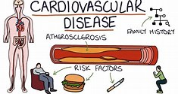
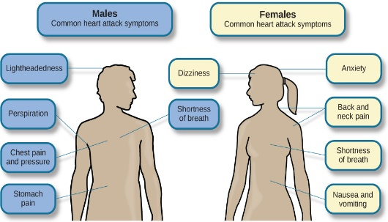
Symptoms
Depends on the type of heart condition.
CARDIOVASCULAR DISEASE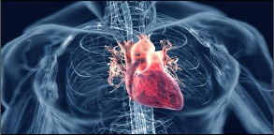

Causes

CVD is a one of the main diseases that causes death and disability in the UK.
Causes of CVD are high blood pressure, smoking, high cholesterol, diabetes, inactivity, overweight, obese, family history, ethnic background (NHS, 2018).

Lifestyle / Risk factors
Lifestyle changes such as eating healthy, staying active, understanding the risk factors (NICE, 2020).

Treatment
Ablation, coronary bypass surgery, cardioversion, heart transplant, Implantable Cardioverter Defibrillator, Transcatheter Aortic Valve Implantation, statins and coronary angioplasty and stent (bhf, 2020).

Medication
Medication can be in the form of tablets, aerosol spray or self-adhesive patch, which can be prescribed by GP or pharmacist to maintain a safe and effective practice.
CVD is mostly associated with health inequalities because those from the poorest communities tend to be affected (GOV.UK, 2019).
References
- British Heart Foundation. 2020. Treatments For Heart And Circulatory Conditions. [online] Available at: <https://www.bhf.org.uk/informationsupport/treatments> [Accessed 13 November 2020].
- England, N., 2018. NHS England » Cardiovascular Disease (CVD). [online] England.nhs.uk. Available at: <https://www.england.nhs.uk/ourwork/clinical-policy/cvd/> [Accessed 26 October 2020].
- Mayo Clinic. 2018. Heart Disease - Symptoms And Causes. [online] Available at: <https://www.mayoclinic.org/diseases-conditions/heart-disease/symptoms-causes/syc-20353118#:~:text=Symptoms%20of%20heart%20disease%20in%20your%20blood%20vessels,as%20shortness%20of%20breath%2C%20nausea%20and%20extreme%20fatigue.> [Accessed 13 November 2020].
- nhs.uk. 2018. Cardiovascular Disease. [online] Available at: <https://www.nhs.uk/conditions/Cardiovascular-disease/> [Accessed 26 October 2020].
- Pathways.nice. 2020. Lifestyle Changes For Preventing Cardiovascular Disease. [online] Available at: <https://pathways.nice.org.uk/pathways/cardiovascular-disease-prevention/lifestyle-changes-for-preventing-cardiovascular-disease> [Accessed 13 November 2020].
- Public Health England, 2019. Health Matters: Preventing Cardiovascular Disease. England: GOV.UK.

