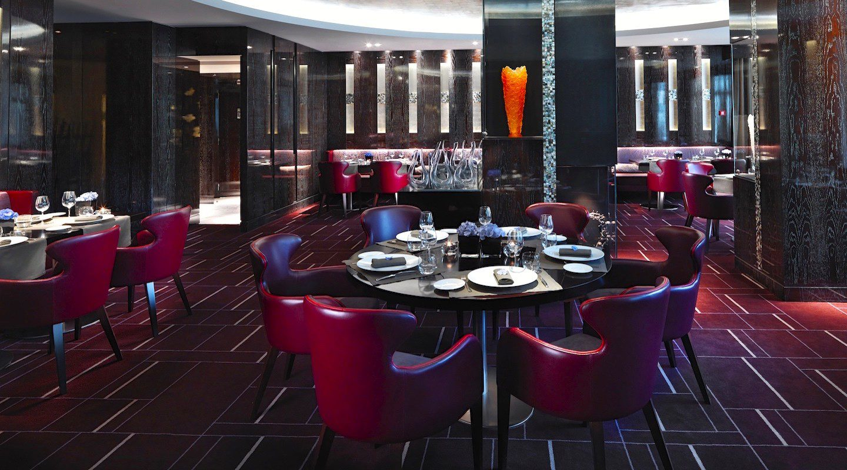

Managing Enterprise in 21st Century

Business Plan

  - certificate of higher education in: skills for
  - the work place
Samsul Islam | Student ID: 1914178 | Module: BMSW 4006

Lecturer: Melanie Squire

Contents
Company Concept 2
Company Name 2
Mission Statement 2
Business Aims 2
Business Objectives 3
Legal Identities 3
Marketing and PR Plan/Strategies 4
Pricing Strategy 5
7 P’s 5
Marketing Samples 7
Physical Location 7
Human Rescores 7
Source of Finance 8
Cash Flow Forecast 8
Appendices 9
Swot analysis 9
References 10

Company Concept

The company to be built and developed is going to be an Indian restaurant. The desire of a restaurant has many benefits. After working in some restaurant, I have decided I wanted my own business in the food industry. There are very, very few authentic Indian restaurants and therefore I would like to take advantage of this gap in the market.

Company Name

Curry Quarters Kitchen & Bar

I came up with the name to keep it catchy and make people feel welcomed and invited.

Mission Statement

The restaurant will provide an interesting selection of authentic Indian cuisine. A good selection of beverages that complements or enhances the quality of the food. Provide an exceptional variety of desserts made inhouse and unavailable by others. Will have a great team that can help improve the dining experience for all customers.

Business Aims

Curry Quarters will be an inspiring restaurant. Combining a beautiful atmosphere with excellent and interesting choices of food. The mission statement is not only to have a great and interesting selections off food and beverages but also to offer, an efficient and superior service as customer satisfaction will be number one priority. Curry Quarters will become the restaurant of choice for mature and adult crowd, couples and singles, young and old, male or female.
Also: -
- Employees welfare, participation, and training is equally important to success.

- Everyone will be treated fairly and with utmost respect

The concept combines variety, ambiance, entertainment and a superior team to create a sense of ‘place’ in order to reach the set goals of overall value in the dining and entertainment experience. The business also offers a rewarding place for employees and fair profits for investors.

Business Objectives

The Curry Quarters restaurant will and provide delicacies which will be unavailable elsewhere. Fresh produces and ingredients will only be used. Research prime locations and completions. Build a team of experienced servers and cooks and also train them to better their skills to create a more superior team of staff. Keep records of products made that would be used to create the delicacies served. Keep a high-level cleanliness and provide proof for the public by having food and hygiene do regular inspections and provide an excellent score of rating. Create a PR and marketing plan that would target every household near and far for every individual that loves a good Indian curry, also entice new people who have never tried Indian cuisine’s before. Create an effective and fair price for consumers. By filling up the seats consistently and giving investors and partners a good share of profit.

Legal Identities

The Curry Quarters restaurant will be a limited company with a maximum of five investors and partners. The reasons for this are partners will provide a level of commitment as much as the founder and also, will have many skills the founder may not have, for example, a level of creativity for food awareness of beverages that complement the dishes and provide input to grow the business. Investors will be bought along to provide necessary funds to market and expand the business and provide valuable information how to do so.

Marketing and PR Plan/Strategies

The target market will be the general public, all types ethnics but mainly the British ethnics as many in the UK love a good curry. The popularity of curry started in 1733 and has grown in 1784 in London’s Piccadilly said by Mukarjee D (2020). First thing is to choose a catchy name that’s easily remembered. Therefore, the name of the restaurant will be called the Curry Quarters. By advertising the restaurant whilst the location (premises) is having its work carried out, this will create anticipation for all the regulars that pass by the area and further people giving word of mouth in the area and nearby boroughs. Furthermore, create a Facebook page and speak to all the people I know (approximately 10,000 + people) to spread the word in the area’s they know and all the people they know and ask them to spread the word. This will create a chain affect as this restaurant should be the desired place for all near and far. People from other cities should want to travel to visit here. Also share this with Twitter, Instagram and Pinterest. This will allow people to see the design of the business and what is being offered. A website will be created to allow people be redirected from social media sites and people looking up the business. The website will have the design of the restaurant so people can feel excited and understand why this will be the restaurant to go to. There will be two restaurants straight away as this will let the restaurant grow its brand. The brand name Curry Quarters will try to grab all people’s attention. Offering fresh ingredients, cooking to order and never any frozen or store-bought items. The restaurants policy will be to guarantee all customers will have a satisfying experience when it comes to fine dining and will utilize a great team of cooks and servers making sure the policy is upheld. The restaurant will offer a fabulous dining experience along with a takeaway service to maximize its clienteles. TripAdvisor and Yell will also be utilized to provide feedback for the restaurant, the restaurant staff (team) members and most importantly the customers that visit the establishment and the people looking up the restaurant for positive feedback and reasons to visit. Other services will also be available as people like to dine at home so companies like Just eat, Uber eats and Deliveroo will be available for those comfortable using these established giants of the food industry. The restaurant will have the Maximum Food Hygiene Rating which is five due to the commitment the groups or teams put in place of the restaurant. By doing so the brand Curry Quarters will prove to existing customers to come back and new customers a unmistakable reason to visit the Food Quarters over and over for many years. Classic items will be available to all that have a love for their favorite dishes however, the restaurant will provide exclusive dishes unavailable by other which would make this establishment stand out than over other competitor. Offering a seasonal menu and curtain beverages throughout the year. The business will provide a superior service and the restaurant will be able to accompany elderly who love their curries, new generation looking for the hottest place in the city, people wanting parties for an occasion and people looking for a romantic night out wanting some lone time and privacy.

Pricing Strategy

The prices will be based on cost of groceries, produces, butchery and beverages. according to Shaw (2015) the average brit spends approximately £340.00 annually on dining out and takeaways. The average meal for one said is close to the ten pounds mark for an average takeaway. A dining in already established restaurants would cost minimum of thirteen pounds including a soft drink or a small beer. It would cost a minimum of twenty pounds for a glass of wine and if chosen from the menus more exclusive range of dishes. Therefore, the restaurant to be available to all will cost the average consumer fifteen pounds and for a more exclusive dishes and beverages would cost approximately twenty-two to thirty pounds. The restaurant will offer a range of promotional offers to the public occasionally so those that may find it too expensive would feel that they average person is well looked after making them come back and by offering a superior service wanting all customers to come back. Two business partners will be head of leading the restaurant.

7 P’s

The 7Ps helps companies to review and define key issues that affect the marketing of its products and services and is often now referred to as the 7Ps framework for the digital marketing mix (Hanlon A, 2020).

- Product
The restaurant will serve fresh ingredient only and quality in house sourced and handpicked. Variety of exclusive dishes as well as traditional favorites such as Chicken Tikka Masala or/and Chicken Korma. Customers are also paying for the service provided which will be to a high standard.
- Price
The customers will undoubtably pay slightly higher than the competition however, the quality and service will far superior. Average cost will be approximately £17 per person. This figure is based so all customers can enjoy a great evening and feel the price is fair as they received much more during their visit.
- Place
The restaurant will be situated in one of London’s popular high streets as well as Cardiff’s city center in Wales. Also Just eat and Deliveroo will be aboard to help do deliveries up to a five miles radius.
- Promotion
Loyalty cards will be given to customers via opening by posting to all local areas with five miles and carried out throughout the course the running establishment. These cards will be stamped and upon completion will be a very generous award such as a free 4 course meal for 1 including 1 beverage such a 660ml bottle of cobra. Flyers will be handed out once a year with offers to draw in new consumers and provide a bonus for existing customers. The company that gathers feedback by monitoring all online activities such as social media sites will allow the business to develop intuitive ways for promotional offers and messages given by the restaurant acknowledging there feedback and importance of their customers.
- People
The two restaurants will together have approximately fifty staff members which will include managers who supervise the establishments giving feedback that’s necessary. Trip Advisor for feedback. Just eat and Deliveroo doing the delivery service. Facebook taking customer comments and experience as well as Twitter and Instagram. The business will also utilize a company to monitor the online activities such as Facebook gathering further feedback. The restaurant will cater for elderly, couples, groups and will also hold events.
- Process
Servers will take orders via a E.P.O.S and also use devices given from Just eat and Deliveroo as well as using the vehicles and staff they both have at their disposal.
- Physical
The two buildings will be designed to a most luxurious atmosphere and equipment’s like the chairs and tables and crockery that the customers will be utilizing along with all dishes the food will be served in. lighting will be used to organize the mood in the restaurant such as green is a colour for welcoming or red for passion, energy and ambition. Service and presentation of the food will be considered served with the utmost care and attention to detail (Empowered, 2020).

Marketing Samples

Flyers, business cards social media profiles, vouchers, loyalty cards, Deliveroo, Just eat and website were used to market the business.

Physical Location

First Location of the restaurant will be inside Wales capital Cardiff. Centre of Cardiff has many restaurants already however in trying to separate away from all these but still be in a prime location, Penarth Road has been chosen as its on a popular road overlooking the beautiful Embankment and some of Cardiff’s features in the view such as, the Cardiff’s Millennium Stadium and Cardiff Bays and town centers tall building and water activities on the Embankment itself.

Second location is in East London again, overlooking the embankment and Canary Wharf’s stunning advanced layout and building structures. Here there is a heavy traffic flow of pedestrians and always talks if something new is being developed. On of the best places to go. The restraint will reside on the third top floor of the Shard.

Both these locations will have ample access and a car park for all those traveling in vehicles.

Human Rescores

The business will 6 full time highly experienced waiters/managers who will be offered an annual salary of 23,000.00 per annum to provide an excellent level performance training new employee’s and also providing a level of service themselves. ten full time cooks will also be required with a salary of up to 28000.00 – 30,000,00. Ten front staff (waiters/waitresses rotary shifts, part-time) on 17,280.00 annum. A further 7 kitchen staff (porters, clears, rotary shift, part time cooks) on 17,280.00 per annum. The managers selected by the founders would be trained professionals that can carry out interviews, explain the job and priorities, treat them to be part of an organisation and carry out incentives.

Source of Finance

To set up this business the required sum would cost approximately 350,000.00. it would also take seven months to set up the desired premises. The funding for the project would be raised from three investors, the two founds and a business loan from the bank. Further investment if needed would be bought forward by the three investors. Initial investments from all investors are repayable in three years.

Cash Flow Forecast

This forecast has been done based on an annum. These are projected figures of what the business is capable of making.

Borrowed/loaned = £350,000.00
Gross Profit = £1,200,000.00
Salaries = £630,960.00
Bills Including Rent, Gas, Electric etc. = 150,000.00
Tax and Vat = 275,880.80
Net Profit = £143,159.20

Appendices

Swot analysis

Strength | Weakness | Opportunities | Threats
Location (Beautiful  Scenery) |  | Built up Area
 | Open 5.30pm till 10.30 pm |  | Competitors
Qualified and Trained
Staff (superior Team)
 |  | Cars passing continuously
Competitive Pricing |  |  | New Restaurants
 | Can seat only 120  People | Views attracting attention
Promotional Offers
New  Catering for All  Quality Produces  Parking Facilities |  | Pedestrian Foot  Flow

References

Empowered. (2020). Understanding the Meaning of Colors in Color Psychology. Available: https://www.empower-yourself-with-color-psychology.com/meaning-of-colors.html#:~:text=Red%20is%20the%20color%20of,of%20anger%20and%20sexual%20passion.&text=Orange%20is%20the%20color%20of%20social%20co. Last accessed 07/12/2020.

Hanlon A. (2020). How to use the 7Ps Marketing Mix. Available: https://www.smartinsights.com/marketing-planning/marketing-models/how-to-use-the-7ps-marketing-mix/. Last accessed 07/12/2020.

Mukherjee D. (2020). The British Curry. Available: https://www.historic-uk.com/CultureUK/The-British-Curry/. Last accessed 07/12/2020.

Shaw V, ET AL. (2015). Brits spend £340 a year on CURRY - find the spice at a cheaper price during National Curry Week. Available: https://www.mirror.co.uk/money/brits-spend-340-year-curry-6623400. Last accessed 07/12/2020.

