Steph Kiefer
2215879

1) Explain and discuss the concepts of health, health-related fitness, and their relation to socio-economic status.
2) Discuss the association between physical activity and socio-economic status: is there any evidence that link them together?

This essay will be looking at the definitions of “health” and “health-related fitness”, and how measures of the population health, such as life-expectancy and disease prevalence, are linked to socio-economic status. It will also address the issue of physical activity, its impact on health, and levels of participations, amongst disadvantaged communities in comparison to less deprived areas.

The definition of health is the first fundamental definition stated in the constitution of the World Health Organisation (WHO, 1948). It declares that “Health is a complete physical, mental and social well-being and not merely the absence of disease or infirmity” (WHO, 1948).
Health is a complex subject to define. Well-being, as a component of health itself, is difficult to assess, being very subjective to each individual. The most accurate way to measure well-being is with self-reports and quality of life questionnaires (WHO, 2012).
A multitude of factors are necessary to determine whether a person is healthy or not. Factors such as genetic, behavioural, social, and environmental, are involved, as shown in “The Social Model of Health” Diagram (Dahlgren and Whitehead, 1991). For example, hereditary conditions can influence someone’s health, their decision to smoke or not, where they live and their social réseau will also have an impact on their health (Fig. 1).

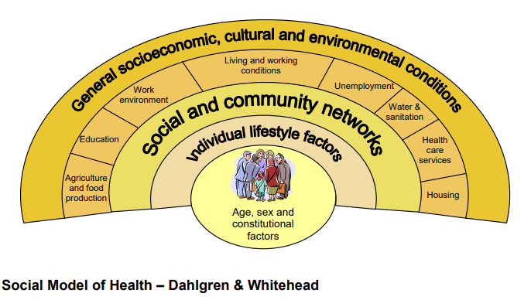
Fig. 1

Health-related fitness is a component of physical fitness which is composed of five elements: cardio-respiratory fitness, muscular strength, muscular endurance, body composition and flexibility (Caspersen et al., 1985).
Cardio-respiratory fitness is linked to lower levels of not only cardio-vascular diseases but also certain cancers and type 2 diabetes, as well as a better-quality and longer life (Kaminsky, Arena et al. 2019).
In 2015, Volaklis et al. published a review showing the link between muscular strength and all-cause and cause-specific mortality risk. This review confirms findings published in 2012 stating that muscular fitness is related to improved health condition (Kell et al., 2012).
Body composition is the proportion of fat, bone, and muscle in the body. It is connected to cardiovascular diseases, cancers, diabetes, osteoporosis, and osteoarthritis (Bayles and Swank, 2018). Measuring body composition ranges from simple methods which are not always reliable (BMI for example) to more complex processes which are more accurate but expensive such as MRI and CT scans (Muller et al., 2002).
As regards to flexibility, its definition and the part it plays in measuring health-related fitness has been challenged by a few (Nuzzo, 2019; Holt et al., 2008). However, the American College of Sports and Medicine recommends flexibility training exercises for all parts of the body on at least two days a week in order to maintain a good range of movement, which will help with mobility in ageing (ACSM, 1998; Garber, Blissmer et al. 2011).
In the UK, some of the most important measures of health are life-expectancy and disease prevalence. Life expectancy refers to how long citizens can live up to as an average calculated according to the amount of people and deaths in the country (Office for National Statistics, 2021). According to the most recent data from Public Health Wales, the life expectancy for men is 78 years and for women 82 years (PHW, 2022). However, the same report states that healthy life expectancy for men and women in 2018 to 2020 was respectively 61 and 62 years, and for women, life expectancy was at its lowest since the records began in 2011. Public Health Wales Observatory calls attention to the fact that for the most deprived areas of Wales, life expectancy is lower, which shows a growth in health inequality due to socio-economic factors. In a report published in 2020 by the Welsh Government, based on the results from the national Survey for Wales, it is highlighted that women and adults aged between 45 and 54 are more likely to live in poverty than men and those age 75 and over. Additionally, people with little to no qualification are also more likely to live in poverty than higher educated people, as well as those living with an illness or condition incapacitating them on a daily basis. People who are generally unhappy, living in social accommodation, with no access to internet, and no vehicle, are also more likely to live in poverty (Welsh Government, 2020). This information links to a Public Health Wales data published in 2022 regarding premature mortality (death before the age of 75), which shows higher rates in most deprived areas compared to least deprived areas (Public Health Wales, 2022). The prevalence of behavioural risks factors (such as smoking and a lack of adequate nourishment) are shown to be more prominent in disadvantaged areas as opposed to less disadvantaged areas. Higher levels of poverty impact on access to healthcare, due to lack of transport or illiteracy for example, which in consequence means a later diagnosis of potential disease, which can cause premature death compared to less deprived areas (PHW, 2022). Furthermore, children under the age of 5 are twice more likely to die prematurely in poorer communities than in wealthier ones (PHW, 2022).
Disease prevalence is the measure of existing cases of a disease at one point in time and is expressed as a proportion (Coggon, Rose and Barker, 2003). In the Office for National Statistics most recent data (ONS, 2022), the most common cause of death in Wales is Dementia and Alzheimer’s disease, closely followed by coronary heart diseases (108 and 107.2 deaths respectively per 100 000 people). Chronic lower respiratory diseases, cerebrovascular diseases and lung cancer are also in the top 5 of the leading causes of death (Fig. 2).
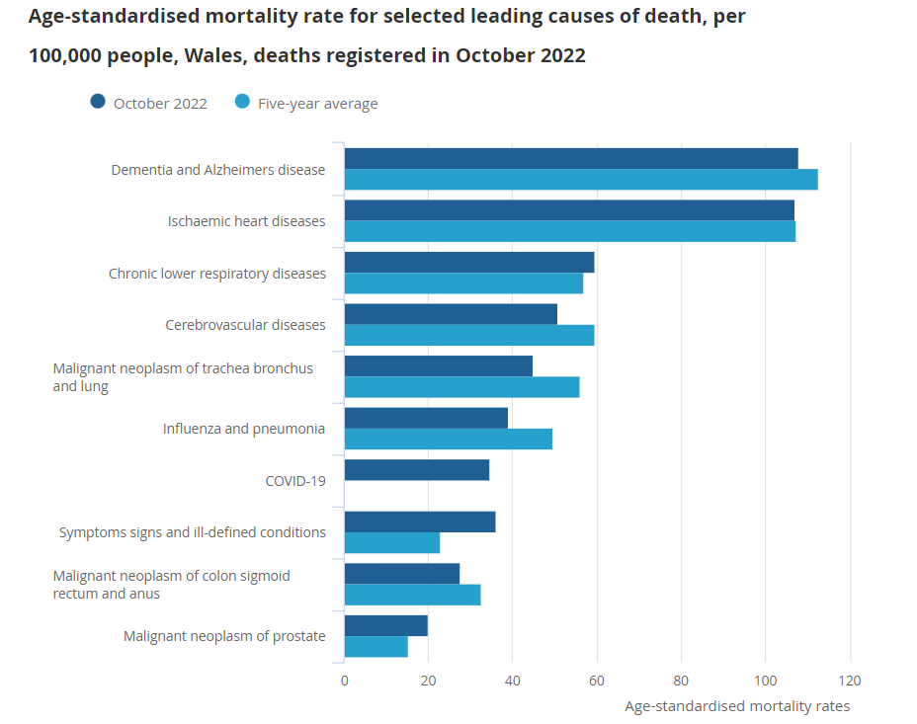
Fig. 2, Monthly mortality analysis (ONS, 2022).

In 2017-2018, the National Survey for Wales compared health states between the most deprived and the least deprived quintiles: the results clearly show a big gap between the two, in favour of the least deprived quintile (Welsh Government, 2019). The theory that the most deprived areas are suffering from lower quality of life and health outcomes is further supported by the Welsh Index of Multiple Deprivation which shows that rates of chronic conditions are higher in the Lower Layer Super Output Areas (LSOAs) which have been in the top 50 most deprived areas since 2005, compared to those who have never been in the top 50 (22% compared to 14%). Similarly, single births weighing less than 2.5 kg were over 8% compared to 5.5 % for the average for Wales. Moreover, the rate of children aged 4-5 with obesity is 15% in the LSOAs within the top 50 most deprived areas compared to 12% in the areas which have never ranked in those top 50 (Government Wales, 2022). Therefore, it is a major priority to improve living conditions for the least advantaged people in order to promote better health outcome in those communities (Fig.3; PHW, 2022). Public Health Wales have come up with 12-year plan to improve health for everyone in Wales (Fig.4; PHW, 2022).

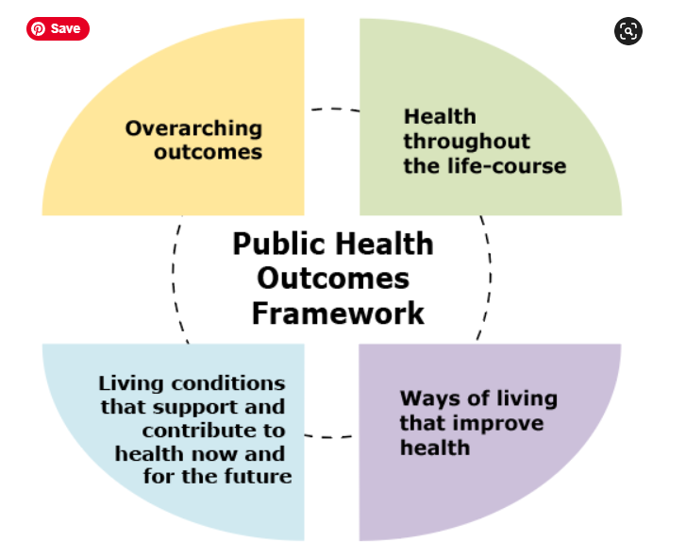
Fig. 3 (Public Health Wales, 2022)

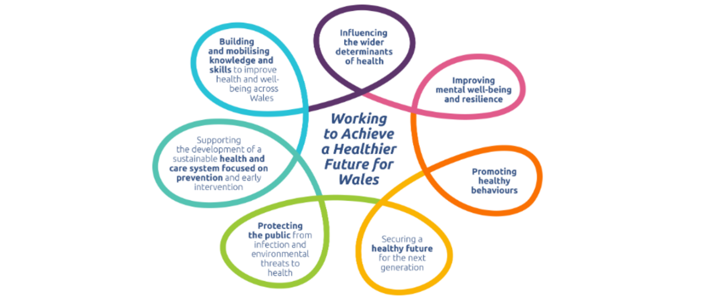
Fig.4 (Public Health Wales 2022)

“Physical activity is defined as any bodily movement produced by skeletal muscle that requires energy expenditure” (WHO, 2018). Physical activity is promoted in the prevention of non-communicable diseases such as heart diseases, diabetes and some cancers, and as a preventative to hypertension, obesity and mental-health problems. Consequently, the World Health Organisation recommends a minimum of 150 minutes of moderate or 75 minutes of intensive exercise per week, in combination with some strength exercises, in order to maintain good health (WHO, 2020). The UK Chief Medical Officers Physical Activity Guidelines also highlights the importance of minimising sedentary time and encourages people to be physically active as much as possible (Department of Health and Social Care, 2019). Less physically active people are more likely to suffer from cardiovascular diseases, cancer and diabetes, which cost the UK’s NHS around £8.2 billion per year in 2010 (Weiler and Stamatakis, 2010).
The Physical Activity Systems Map (Fig.5, Rutter et al., 2019) shows the complexity of the various factors involved in the participation and maintenance of physical activity.
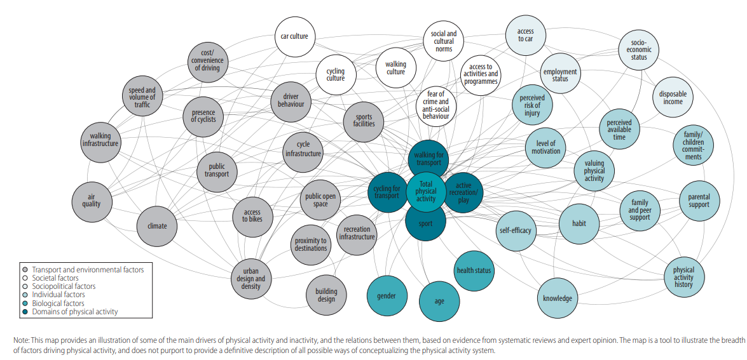
Fig. 5: “An initial physical activity system map” (Rutter et al., 2019).

Gidlow et al. (2006) found that higher income and higher educated households have higher levels of physical activity. A paper published in 2014 by Farrell et al. concurs that lower income households in England are over 30% more likely to be inactive compared to less than 10% in higher income households. Additionally, inactivity levels are higher at a young age in lower income settings and increases as the population gets older. Regarding levels of education, the same paper presents the evidence that people without qualifications are 3 times more likely to be inactive in comparison to people with qualifications and higher education (Farrell et al., 2014). Furthermore, a 2007 study on older British women shows that socioeconomic conditions affect levels of activity in agreement with the previously mentioned papers (Hillsdon et al., 2007). In Wales, looking at healthy lifestyle behaviours such as not smoking, not drinking excessive amounts of alcohol, eating at least 5 portions of fruit and vegetables per day, being physically active according to the guidelines for health and maintaining a healthy weight, it again appears that the most deprived areas follow less than 2 of these behaviours (National Survey for Wales, 2019-2020). Similarly, the amount of people following the 150 minutes of physical activity per week guidelines were higher (60%) in the least deprived areas compared to the most deprived areas (less than 50%), and the amount of people being physically inactive were higher (over 40%) in the most deprived areas compared to the least deprived areas (25%). A 2019 study of Black and Minority ethnic groups in the UK shows that language and culture can be a barrier to participation in physical activity, especially for women (Ige-Elegbede et al., 2019). South Asian communities in the UK tend to discourage women to take part in physical exercise, due to their religious beliefs, cultural habits and household responsibilities. Moreover, lack of childcare and suitable and safe exercising environments, as well as financial and linguistic barriers, prevent women from Asian communities from taking part in physical exercise. Further research, however, is needed to assess barriers to exercise in Black African minorities. A 2022 review by Pearson et al. on the relation between socioeconomic status and physical activity and sedentary behaviour in UK youth shows that outcomes are not very straight forward, therefore an improvement in measures of studies would be useful to produce clearer results (Pearson et al., 2022).
The World Health Organisation also came up with a global action plan on physical activity for 2018 to 2030 in order to encourage people to be more active as a health benefit.
Health inequalities in the UK are still existing now. Sir Michael Marmot wrote the “Fair Society, Healthy Lives” review in 2010 with the aim to create positive changes across England in terms of health inequalities (Marmot, 2010). Evidently, inequalities are still existing in the UK, as a review published by the Welsh government in 2021 shows (Welsh Government, 2021). The impact of socio-economic status goes further than health and physical inactivity and needs attending to urgently in order to prevent further gaps in inequalities between affluent and disadvantaged communities. Unfortunately, the Covid-19 pandemic has slowed any progress, if not aggravated the situation in some cases.

Reference List

Coggon, D., Rose, G., Barker, D.J.P. (2003) Epidemiology for the uninitiated. 5th edn. London: BJM Books. Chapter 2
Garber, C.E., BLISSMER, B., DESCHENES, M.R., FRANKLIN, B.A., LAMONTE, M.J., LEE, I.-., NIEMAN, D.C. and SWAIN, D.P., 2011. American College of Sports Medicine position stand. Quantity and quality of exercise for developing and maintaining cardiorespiratory, musculoskeletal, and neuromotor fitness in apparently healthy adults: guidance for prescribing exercise. Medicine and Science in Sports and Exercise, 43(7), pp. 1334-1359.
Holt, L.E., Pelham, T.W. and Holt, J. (2008) Flexibility: A Concise Guide. Totowa: Humana Press.
KAMINSKY, L.A., ARENA, R., ELLINGSEN, Ø, HARBER, M.P., MYERS, J., OZEMEK, C. and ROSS, R., 2019. Cardiorespiratory fitness and cardiovascular disease - The past, present, and future. Progress in cardiovascular diseases, 62(2), pp. 86-93.

Nuzzo, J.L. (2019) 'The Case for Retiring Flexibility as a Component of Physical Fitness', Sports Medicine, 50, pp 853-870. Available at: https://doi.org/10.1007/s40279-019-01248-w

