

Assessment 1 – Reading Task Template
PART 1: Upload your photo of your A3 in-class notes here:
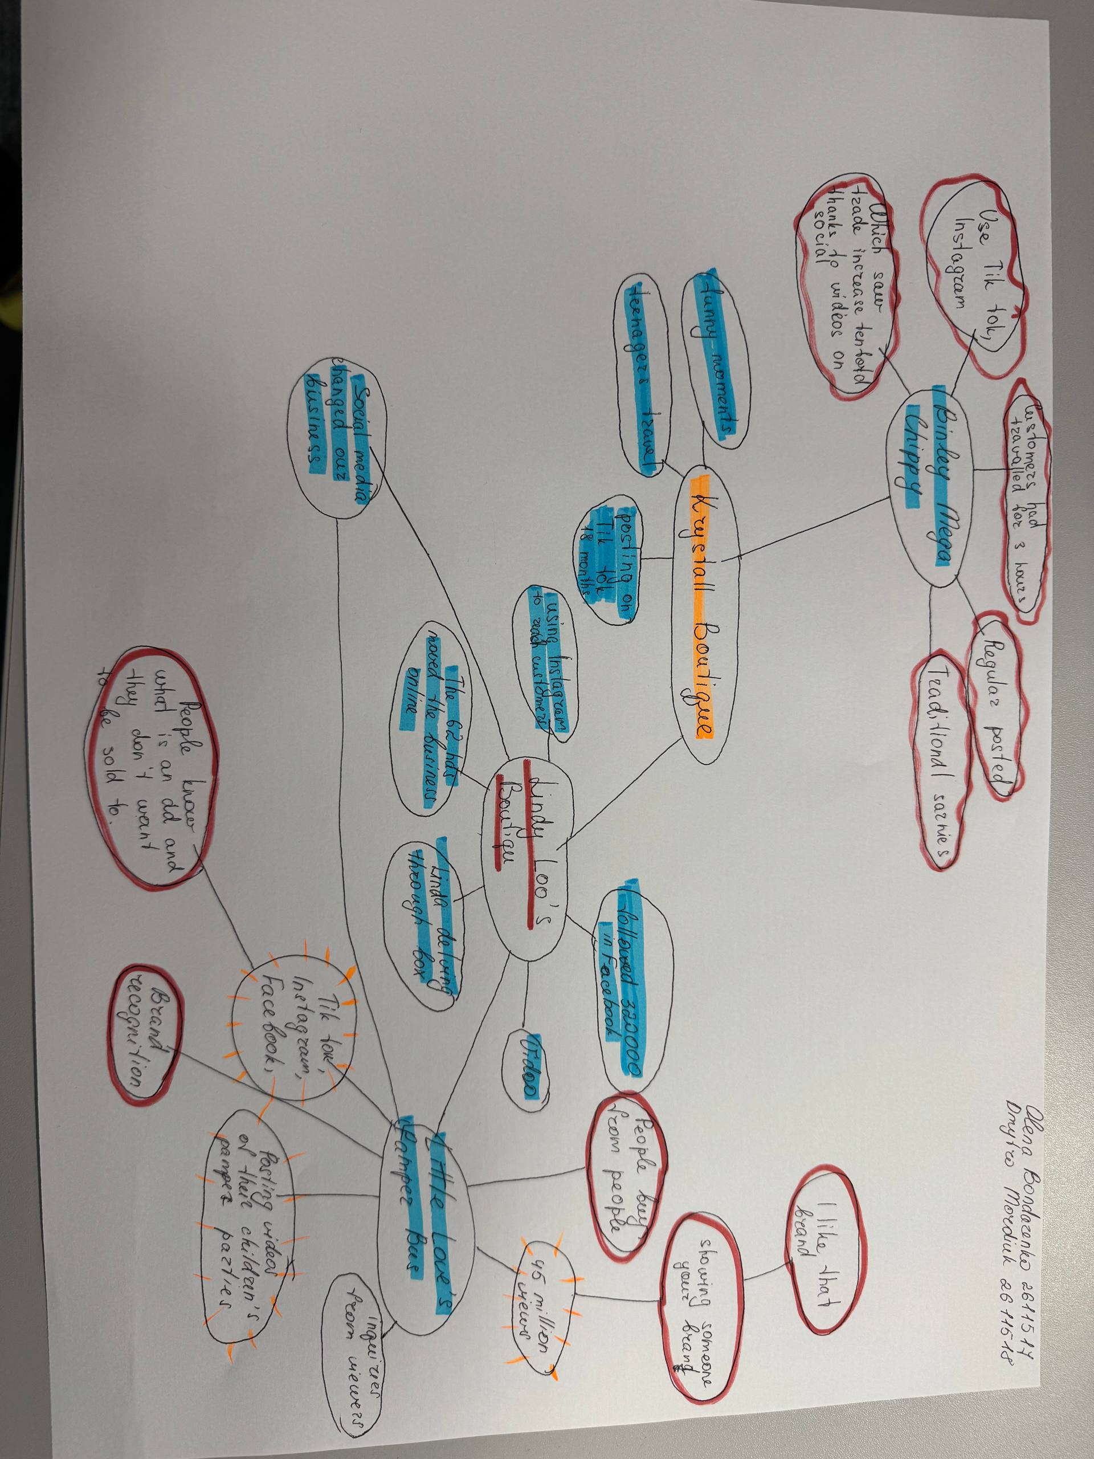

PART 2:
- Answer every question below in 1-3 full sentences.
- Use your own words. Do not use generative AI to answer these questions.
- Include a specific detail from the text when asked.
REMINDER
- The main idea is the overall message of the whole text.
- A key point helps to explain the main idea.
- A specific detail or example from the text shows that the key point is true.

- What is the main idea of the whole text?
I think the main idea of the text is the use of social networks

- What is one key point that supports the main idea, and which specific example from the text shows this?
Actively maintaining your own page and tracking the audience

- What is a different key point that supports the main idea, and which specific example from the text shows this?
“If you post it, they will come: The businesses turning likes into livelihoods”

- Which part of the text do you think is most important, and why?
I think the second part is more important because we are told about interaction with the audience and regular use of social media

Reflection:
- What did you find difficult in this task (including in-class components), and why was it difficult?
We faced difficulties, as different ideas and everyone chose different important.

- What helped you with this difficulty, and how did it help you?
After discussions and debates, we chose the most important

