
APPENDIX GA36d
LEVEL 7 ASSESSMENT SPECIFICATION

Student name: | ARTIBEN RUPESHKUMAR SHAILAR | Student ID number: | 2532580
Programme: | Master of Business Administration
Module: | Marketing Management
Module code: | LCMB7024 | Contribution to Overall Module  Assessment (%): | 50%
Lecturer: | Laila Maazouz | Internal Verifier: | Vasilios Tavlaridis  Hoang Nguyen
Assignment Title: | Assessment component 2: Marketing Strategies Portfolio | Word count (or equivalent): | 2,500 (± 10%)
 | Poster (element 1) submission:
 | 5th April 2026
Submission deadline: | Presentation in week 9 & 10  Portfolio (all elements) | Return date of provisional marks & written feedback: | 29th May 2026
 | submission:
 | 01st May 2026 by 2:00PM
Submission method: | All written assessments, where practical and possible, must be submitted via Turnitin unless otherwise instructed by the Lecturer. (Please DO NOT put this assessment specification into Turnitin or it will match many similarities with other students’ submissions.)  Alternative submission method (if applicable):  Late submission of the assessment will result in a late penalty mark:.  Work which is submitted up to 1 week late will be capped at 50% for the first attempt and will be awarded a mark of 0% for re-assessment. Late submission penalties may be lifted only if there is an approved extenuating circumstances claim.  Work submitted more than 1 week late will be considered as a non-submission and will not be marked. The work may be considered as a submission for reassessment if offered by an Examining Board or if there is an approved extenuating circumstances claim.

Academic honesty / referencing: | Academic honesty is required. In the main body of your submission you must give credit to authors on whose research and ideas your work is based. Append to your submission a reference list that indicates the books, articles, etc. that you have used, cited or quoted in order to complete this assessment.



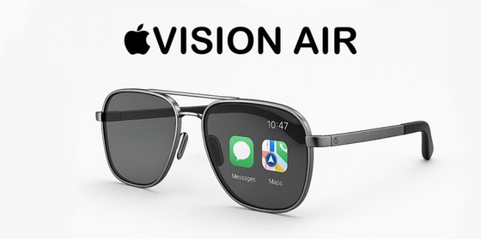
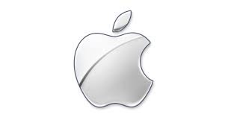





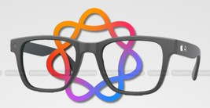

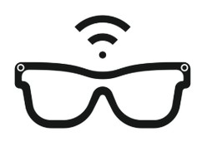


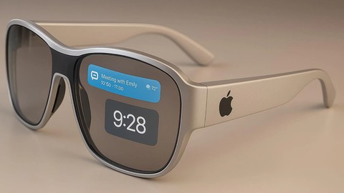
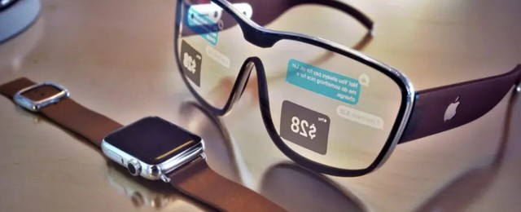
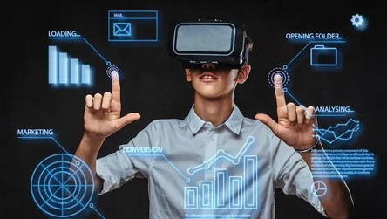
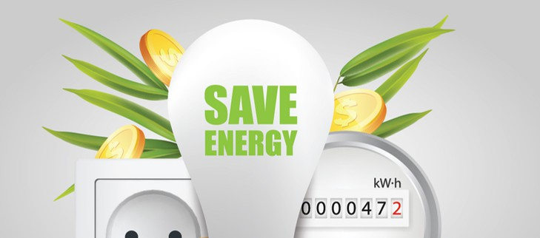
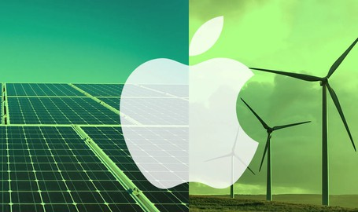
APPLE SMART GLASSES
The Future of Wearable Technology
Apple Smart Glasses
Apple Smart Glasses are a new wearable device that uses augmented reality. Users can see messages, directions, and information without using their hands. The glasses connect easily with iPhone and other Apple devices (Perry, 2021).
Key Features
Shows messages and notifications
Gives easy directions and maps
Lets you enjoy music and
videos
Smart AI helps with daily tasks
Connects smoothly with iPhone and other Apple devices
About Apple
Apple is a big technology company known all over the world. It makes smart and stylish products like the iPhone, Apple Watch, and Mac. Apple is famous for creating new ideas and easy-to-use devices. All its products work together smoothly, making life easier and more connected for people every day (Apple, 2022).
Why This Product?
More people are using smart wearable devices today
People want easy and hands-free technology Augmented reality is becoming popular Modern lifestyles depend on digital and smart solutions
Users look for fast, simple, and connected experiences (Lin, 2025)
Key Message
Apple
Smart
Glasses
offer
a
smart,
innovative, and sustainable solution that improves daily life while creating strong
future growth opportunities (Apple, 2022).

References
Apple (2022). Apple services enrich peoples’ lives throughout the year. [online] Apple Newsroom. Available at: Apple Smart Glasses offer a smart, innovative, and sustainable solution that improves daily life while creating strong future growth opportunities (Apple, 2022)..
Caminade, J. and Borck, J. (2023). The Continued Growth and Resilience of Apple’s App Store Ecosystem. [online] Apple, pp.1–32. Available at: Apple Smart Glasses offer a smart, innovative, and sustainable solution that improves daily life while creating strong future growth opportunities (Apple, 2022)..
Lakhouit, A. (2025). Revolutionizing urban solid waste management with AI and IoT: A review of smart solutions for waste collection, sorting, and recycling. Results in Engineering, [online] 25, p.104018. doi: Apple Smart Glasses offer a smart, innovative, and sustainable solution that improves daily life while creating strong future growth opportunities (Apple, 2022)..
Lin, W. (2025). Augmented Reality Smart Glasses: Current Challenges and Future Innovations in Wearable Technology. Theoretical and Natural Science, [online] 83, pp.209–215. doi: Apple Smart Glasses offer a smart, innovative, and sustainable solution that improves daily life while creating strong future growth opportunities (Apple, 2022)..
Perry, T.S. (2021). Look Out for Apple’s AR Glasses: With head-up displays, cameras, inertial sensors, and lidar on board, Apple’s augmented-reality glasses could redefine wearables. IEEE Spectrum, 58(1), pp.26–54. doi: Apple Smart Glasses offer a smart, innovative, and sustainable solution that improves daily life while creating strong future growth opportunities (Apple, 2022)..
Value for Customers
Value Proposition
Easy and smooth user experience
Makes daily life more smart and convenient Saves time with hands-free technology
Value for Investors
Creates new income opportunities Strengthens Apple’s product ecosystem
High growth potential in future markets (Caminade and Borck, 2023)
Sustainability Impact
Uses energy-saving technology to reduce power use
Helps replace multiple devices with one
smart product
Reduces electronic
recycling
waste
and supports
Supports Apple’s goal of becoming carbon
neutral (Lakhouit, 2025).

