Circuit Design and Analysis

Formal Report

Student: Adam McGowan

Lecture: Steve Mosey

Contents
Introduction 4
Method Math Equations: 5
Results 8
2KHz Noise Graph 8
9KHz Signal Graph 9
155KHz Noise Graph 10
Three Frequencies 11
Circuit Diagram of Active Filter 13
Discussions 14
Conclusions 15
References 16

Figure 1 - This is the 2KHz with a dB of -53.6 dB 8
Figure 2 - This is the 9KHz Signal with a dB of -475m dB 9
Figure 3 - This is the 155KHz Noise with dB -32.8 10
Figure 4 - The Three Frequencies 11
Figure 5 - Circuit Diagram Active Filter 13

Introduction

This report is about investigating an active filter using a student Number which is 1550902, they were split into frequencies to work alongside a Low pass filter which was 2KHz noise, High pass filter which was 155KHz noise and an 9KHz signal, there was a band pass filter used in the investigation as it went along. To find out more about these active filters was to do an experiment by creating a simulate on proteus8.7, after creating the circuit design on proteus8.7 the two noise frequencies the 2KHz and 155KHz were put into a signal generator, while the 9KHz was a sine wave. There were frequency graphs used to measure the low pass 2KHz, high pass 155KHz and to find the gain of the 9KHz. To do that there had to be a gain that the noise will not work if they are near the -30dB and had to be more than -30dB, which the 2KHz gain came to -53.6dB and the 155KHz had -32.8dB which they are both over -30dB which is very good. The 9KHz the signal had to be above -3dB or 0dB and the value of the 9KHz came to -475mdB which is near 0dB and that is good. The three frequencies were showing vin and OUT of a filtered signal and not filtered signal. Vin was the not filtered signal showing three frequencies of a low, high and a naked eye and high frequency. The red frequency is the OUT that is filtered, but the green and red frequencies are out of phase from each other’s.

Method Math Equations:
High Pass Filter = 115KHz (Noise)
Low Pass Filter = 2KHz (Noise)
Frequency Signal = 9KHz
R = Resistance/Resistor
C = Capacitor
f = Frequency
$$FLP=\frac{1}{2*pi*R1*C1}$$
This is the Frequency of Low Pass (FLP) Equation. This is how the math is worked out to find the answer for Low Pass. To do this the R1 (Resistor) is a mystery, and the only way to work it out is by giving C1(Capacitor) a value.
$$R1=\frac{1}{2*pi*f*C1}$$
The Value of ( f ) is the frequency that would be closer to 9KHz signal by decrease or increase. The decrease of 9KHz to find the Low Pass Filter is now 8500Hz (8.5KHz) and this is put into an Equation.
The value for (C1) was set to 10nF to be used as a value in the equation below.
$$R1=\frac{1}{2*pi*8500*10*{10}^{-6}}$$
The capacitor (C1) was given a value at a random value, for the Low Pass, It had to be a Low value capacitor to work as a high capacitor is too big.

$R1=1.872$ resistance
The resistor value (R1) what is shown above, 1.872 resistance. Then rounded R1 resistor to a better value which is shown below.
$R1=1.9k$ resistance

After solving the equation and getting the value of the resistor (R1), the value is then put into Proteus 8.7 software, this is the resistor that is used for the Low Pass Filter.

$$FHP=\frac{1}{2*pi*R2*C2}$$
Then the same is done for Frequency High Pass (FHP), the same equation is used just as for the Low Pass. The only difference is the capacitor (C2) value it very high as it shown above.
$$R2=\frac{1}{2*pi*f*C2}$$
From above where the ( f ) that stands for frequency is used in the equation as (R2) is need to be found.
$$R2=\frac{1}{2*pi*16000*20*{10}^{-12}}$$
The value of (C2) was set to 20pF this had to be higher than the low pass value and was used in the equation above. Then the frequency of 16KHz which is 7000Hz gap from the signal that is 9KHz is used in the equation to get the value of (R2).
After doing the calculations from the equation for (R2), the values answer found.
$R2=497359$ resistance
Then again with R2 resistor is rounded to a better value.
$R2=500k$ resistance
Both equations are completed, and all values are found and answered.
The next thing was to find if the values that were found give the possible closest frequency answer from the ones that were given in the first place. More equations are used, the following order is to put the resistor value back into the equation. To do this the ( f ) frequency is replaced with (R1) resistance, this is shown below in the equation.
$$\text{F}=\frac{1}{2*pi*R1*C1}$$
As (R1) is 1900 resistance is placed back in the equation this should give an answer of the frequency what was started with to get (R1) in the commencement of the Low Pass.
$$F=\frac{1}{2*pi*1900*10*{10}^{-6}}$$
This shows that the frequency is closer to the frequency that was started off with 8.5KHz in the beginning.
$F=8.376Hz$ Rounded to $F=8380Hz$

The equation is once yet again used to find the frequency that was started off with.
$$\text{F}=\frac{1}{2*pi*R2*C2}$$
As (R2) is 500k resistance, the equation showing the math calculations as it the same as the High Pass.
$$\text{F}=\frac{1}{2*pi*500000*20*{10}^{-12}}$$
The frequency answer is given at the very contiguous it could be. This is almost the same as the 16KHz, but not far off.
$F=15915Hz$ Rounded to $F=15920Hz$

Results

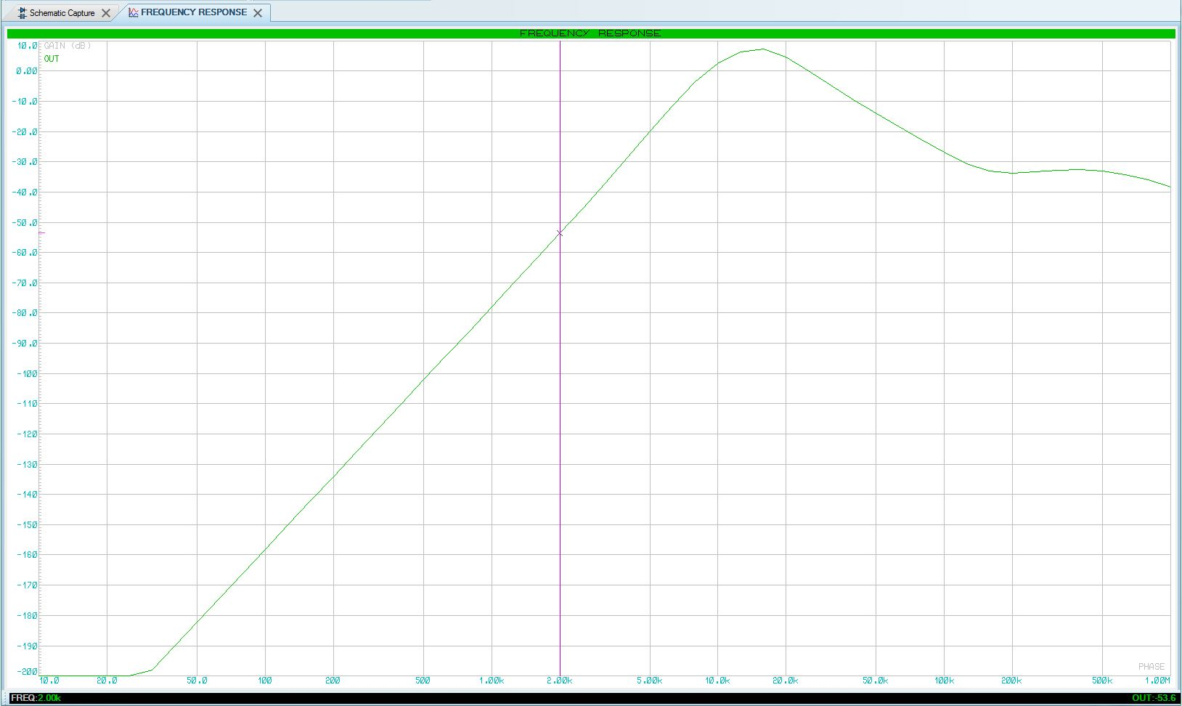
2KHz Noise Graph
Figure 1 - This is the 2KHz with a dB of -53.6 dB
The frequency is shown on the bottom going from 10Hz to 1MHz. The measurements are taken between 2KHz to 155KHz for noise, but the signal is at 9KHz.
On this graph above is showing where the 2KHz is pinged by a purple line this is where the frequency and its gain is.

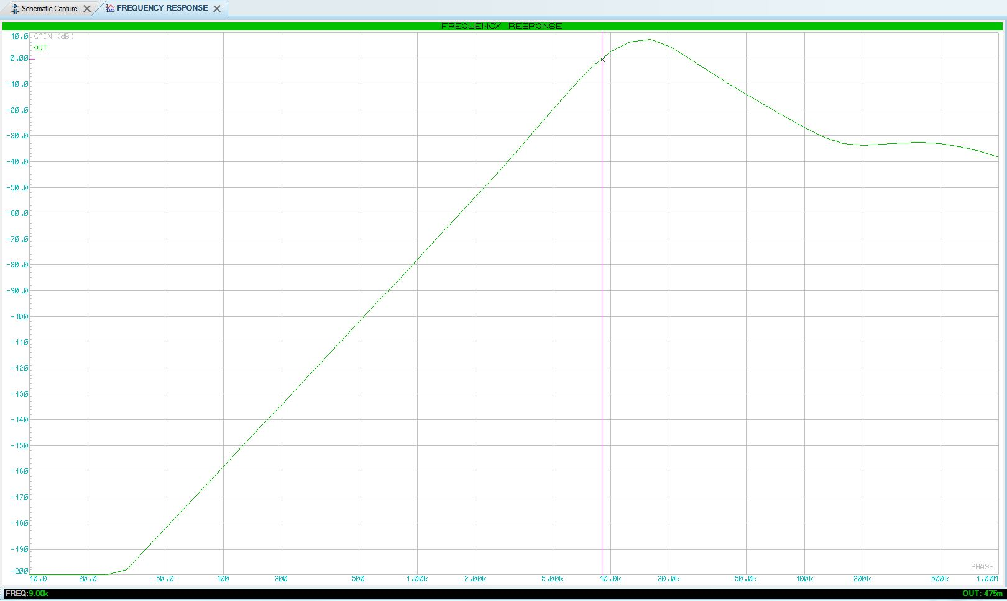

9KHz Signal Graph
Figure 2 - This is the 9KHz Signal with a dB of -475m dB
As above this frequency is the 9KHz signal which is pinged by the purple line. With a slope of decades at -475mdB, which is very close to 0dB and this shows that the signal is working.

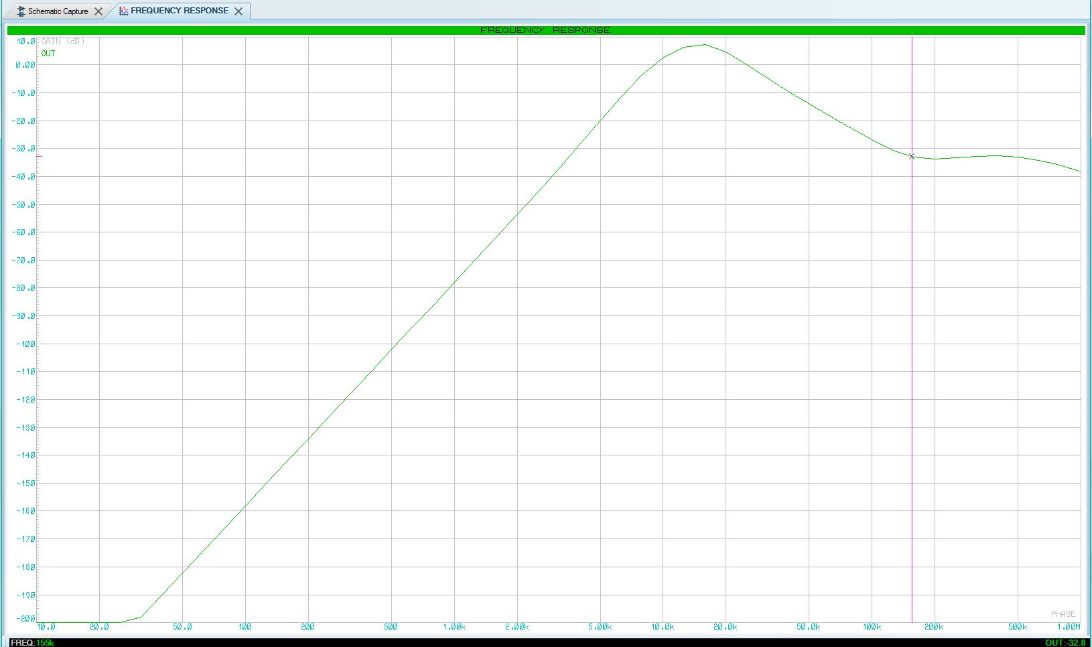
155KHz Noise Graph
Figure 3 - This is the 155KHz Noise with dB -32.8
Here is the 155KHz noise which is the Low Pass where the purple line is pinging at showing where the 155KHz is taking place.

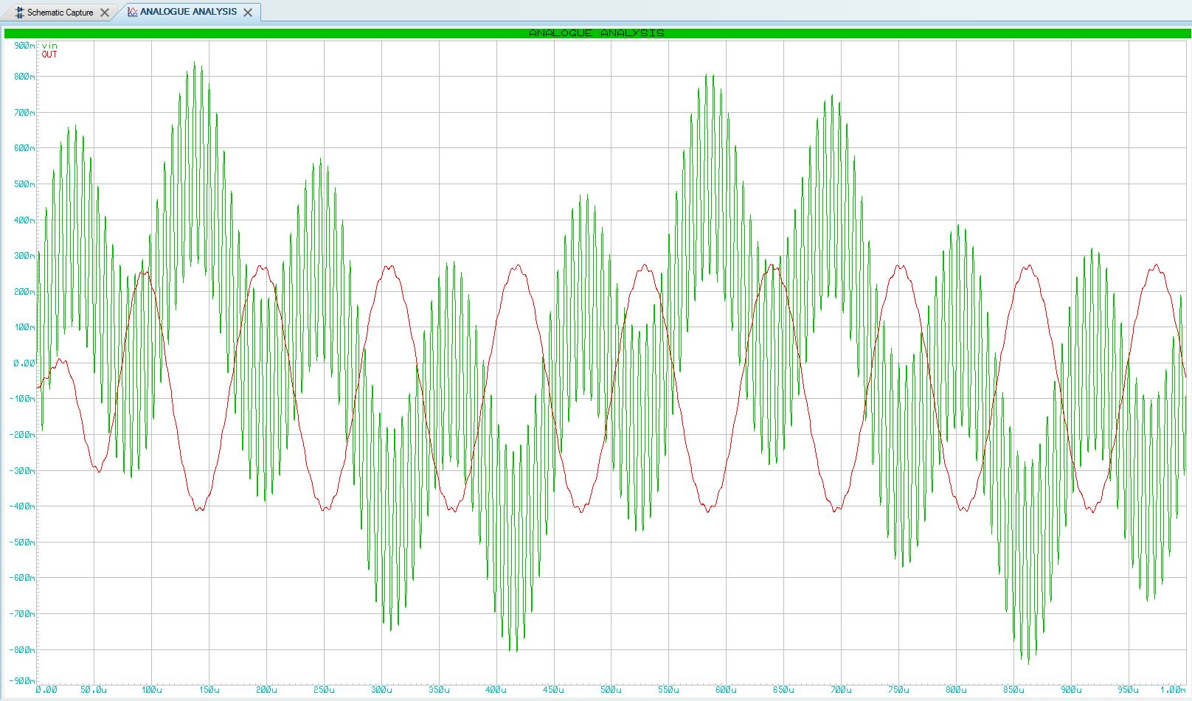
Three Frequencies
Figure 4 - The Three Frequencies

Here on this graph is showing three frequencies, there is a low frequency which is only visible by following the top of the green peaks of the frequency which is showing three of the green peaks on the left side is up as it comes down to one green peak in centre left is down, and it starts rising again with three green peaks in centre right going up and then comes back down again with two green peaks on the right. This is showing the low frequency.
“Its principle of operation and frequency response is exactly the same as those for the previously seen passive filter, the only difference this time is that it uses an op-amp for amplification and gain control.” [1]
The next frequency is the one in green that can be visible by naked eye that looks like a sine wave this is the frequency that hasn’t been filtered yet and had a number of cycles of 18.
The last frequency that is the same again in green, is very small as they are very close. Those are high frequencies that makes the large frequency appear to naked eye.
These frequencies are the noise and signal all in one, is they are called on the graph (Vin) and is not filtered, this means they have noise in there and it a useless frequency.
The red frequency that can be seen is out of phase with the green frequency as it called (OUT), this frequency is filtered, this means it has no noise and is useful to be used.

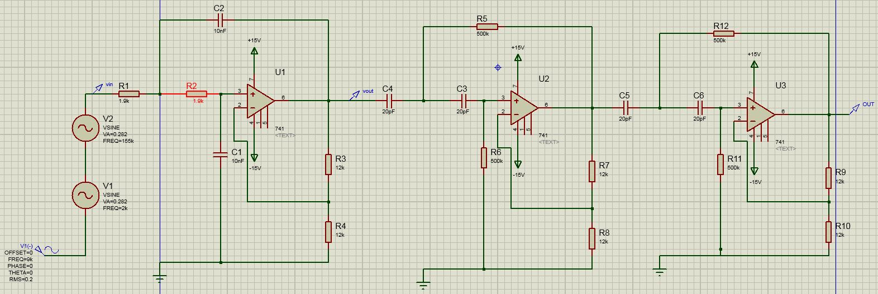
Circuit Diagram of Active Filter
Figure 5 - Circuit Diagram Active Filter

Here is a circuit design diagram of an active filter this is an analogy circuit using active components. On the left side where the two resistors are 1.9k, that is a low pass filter with a capacitor set to 10nF. The low pass filter, filters out unwanted frequencies. “Amplifiers included in a filter design can be used to improve the cost, performance and predictability of a filter.” [2]
The two on the other side are the same, this is because they are Active High Pass Filters, and they have the same resistor of 500k and 20pF capacitors.
The Gain are set to 12k resistor as that holds the dB steady at the right amplitude so that the peak of the Active Band Pass gives the right dB for the Active Filter Op Amp when it cut’s off at -3dB or 0.707(70%). “This type of active band pass design produces a “tuned” circuit based around a negative feedback active filter giving it a high “Q-factor” (up to 25) amplitude response and steep roll-off on either side of its centre frequency.” [3]

Discussions
The Picture diagram shown where the purple line pinged at in the 2KHz graph Noise with a slope of decade at -53.6dB. This is measuring the High Pass noise as it can be seen the graph. The slope in decades of -53.6dB is a good sign as there is no noise, it is way pass the -30dB where the noise would produce background and disrupt the signal. “The frequency response of the circuit is the same as that of the passive filter, except that the amplitude of the signal is increased by the gain of the amplifier” [4]
The graph shown in the 155KHz shows where the 155KHz is pinged at, as there a line in purple that taking it readings, there is a slope decade of -32.8dB which is very close to -30dB. This is acceptable as there no noise, when taking this reading as it is coming down it can be seen at 155KHz that there a little rise back up. The gap between the 155KHz and 9KHz is 146KHz, to which is a colossal gap.
The 9KHz is pinged by purple line in the graph, because it is closer to the 2KHz noise there a small gap between the both. The signal has a slope in decades of -475m dB which is not far off from 0 dB, If the signal went under the slope of 0 dB into no more than the cut-off -3 dB, this would clutter up the signal and that it won’t work. If the signal went no more than 15dB it would be OK, any higher it would stop working properly.

Conclusions

Active filter investigating about the low pass, high pass and band pass of the student number. There were numbers of errors and lack of understanding towards this report. The circuit that was designed on proteus8.7 took some time to understand and how to work through it and investigate through it. The methods were understandable and what had to be done to achieve the results on the graph and the right noise and signal to make the active filter work. There was no best part in writing this report as it was very hard to understand. The problem was trying to write abstract, brief, problem statement. This was very confusing and frustrating! In the end I left it out and added the content in as it a lot easier and very understanding. A figure was added to include the pictures. The lack of words of writing 2500 as lack of knowledge of understanding an active filter. I wasn’t too sure what I was doing in this investigation as it was hard to understand what was needed to be done or follow instructions.

References

[1] | “Active Low Pass Filter,” Electronics Tutorials, [Online]. Available: https://www.electronics-tutorials.ws/filter/filter_5.html. [Accessed 8 2 2018].
[2] | “Active filter,” WikipediA, [Online]. Available: https://en.wikipedia.org/wiki/Active_filter. [Accessed 8 2 2018].
[3] | “Active Band Pass,” Electronics Tutorials, [Online]. Available: https://www.electronics-tutorials.ws/filter/filter_7.html. [Accessed 8 Feburary 2018].
[4] | “Active High Pass Filter,” Electronics Tutorials, [Online]. Available: https://www.electronics-tutorials.ws/filter/filter_6.html. [Accessed 8 Feburary 2018].

