Pretty Prejudice.

Sarah Mason

Qualification: CIPD Diploma in Applied Human Resources

Module Name:

Word Count:

2687

Student Name: Sarah Mason
Student Number: 2005783
CIPD Membership Number: 55991280

By signing below, I confirm that the work/evidence presented is my own, unaided work. I understand the regulations pertaining to candidate malpractice and the action that may be taken as a result.

Signed: Sarah Mason
Date: 28/03/2021

Statement
Reliable secondary data sources were analysed to understand the thinking and trends relating to homeworking during the pandemic and going forward. Primary data in the form of questionnaires undertaken within the business and Facebook, details of which can be found in the report. The primary research mirrored and added to the secondary research.

Contents

- Introduction ……………………………………………………………………………………………………………………………….

- Literature Review ……………………………………………………………………………………………………………………….

- Introduction and aim ………………………………………………………………………………………………………………….

- What is pretty prejudice? ……………………………………………………………………………………………………………

- Good looks vs Competency …………………………………………………………………………………………………………

- Unconscious bias …………………………………………………………………………………………………………………………

- Tattoos at work- Are they still an issue?...........................................................................................

- Does having your hair dyed effect you from having a job?..............................................................

- Methodology……………………………………………………………………………………………………………………………….

- Findings……………………………………………………………………………………………………………………………………….

- Conclusion…………………………………………………………………………………………………………………………………...

- Survey …………………………………………………………………………………………………………………………………………

- References ………………………………………………………………………………………………………………………………….

Introduction

Even in the rich and liberal world, there are mainly biases at play in the workplace, which account for the unmeritocratic or unfair advantage that sone groups have over others, irrespective of their actual talent or potential: sexism, racism, and ageism to name a few (Tomas Chamorro).
One of the most prominent bias is hardly ever discussed or acknowledged. Beauty bias also known as ‘lookism’. Literature reviews summarise that physically attractive individuals are more likely to be interviewed for jobs and hired, they are more likely to advance with their careers and gain frequent promotions, they can even earn higher wages than unattractive individuals.
Common manifest of appearance discrimination may include bias against obesity, oddly dressed or tattooed candidates or any people that do not fit a society’s aesthetics criteria.

Aim

The aim is to critically analysis the impact of ‘pretty prejudice’ and ‘unconscious bias in the workplace.

Objective

- To critically analysis ‘pretty prejudice’ in the workplace
- To critically analysis the impact of unconscious bias in the workplace
- To look at hair colour and tattoos in the workplace
(Teksystems)

The literature review was gained from a number of reliable sources, they were analysed, and a number of key themes became apparent.

What is ‘pretty prejudice?’

While of course there can be some definite perks, it turns out that the bubble of beauty can make a certain aspect of life much more difficult.
Attractive women came together in their masses via social media site reddit, to voice their negative experiences, with stories where your attractiveness has an actual advantage.
The most common responses, being ‘not being taken seriously at work’, a place where many women found to be fuelled by implicit sexual prejudices. A fairly young worker was told by HR, that she did not have chance because older male co-workers will not take her seriously and could get distracted. A ladies husband said about his wife bad experience, stating ‘it sounds like in my wife’s workplace, they just see her as another ‘dumb blonde’ trying to make it in a man’s world (information technology), but in reality, she ran circles around them and knew the systems better than anyone (Reddit) (young 2019).
Is there a term that denotes such prejudice against ‘ugly’ people or favouritism towards beautiful people much like ‘racism’ has come to denote, prejudice directed against someone of a different race?
Lookism is often used to denote appearance-based discrimination. Lookism is a term used to refer to the positive stereotypes, prejudice and preferential treatment given to physically attractive people, or more generally to people whose appearance matches cultural pretences. Some say that lookism does not seem obvious although it does follow the same pattern as sexism, racism, and ageism etc.

Beauty bias is the favourable treatment that individuals receive when they are deemed more attractive, regardless of whether this happens unconsciously. Some individuals and employers admit to preferring to work with others on the basis of their high level of attractiveness. There are some exceptions in the Chinese navy, ‘good looks’ are an official requirement, apparently as they represent the nation with their best image. Abercrombie and Finch was forced into a million-dollar settlement for hiring attractive assistants, it was not banned from stating attractiveness standards in its recruitment policies, so long as it recruited diverse but good-looking candidates (Harvard).
So, what does science actually tell us?
Pro attractiveness already exists in education, studies have shown that physically attractive students tend to obtain higher grades at universities because they are deemed as more conscientious and intelligent, even when they are not. This is consistent with the ‘halo effect’, whereby attractive people are generally perceived as being more sociable, healthy, successful, and talented (Reiners 2021).
Beauty bias transfers into the workplace where scientific studies show that attractive people are more likely to get hired, researchers sent 11,000 CVs to various job openings including identical CVs accompanied by a picture of different levels of attractiveness. Attractive men and women were more likely to get a call for an interview, than unattractive candidates. At times it would be hard to determine if appearances should be treated as a bias factor, especially when it is determined on perception of an individual (Chamotrro-Premuzic).

Good looks V Competency
Analysis revealed that while there is no competency difference perceived between the attractive and unattractive female candidates. Attractive males were seen as much more competent than unattractive males. The participants that were to cooperate with the candidate felt that they preferred the attractive male candidate as they believed he would have more positive impact on their own success. Controversy the participants that were expected to compete with the candidate showed a greater preference for the unattractive male as they saw him as being less capable and therefore more instrumental to their success.
In these studies when it came to female candidate’s attractiveness had no significant impact on results (Stefan Thavis Professor of behaviour).
A Times article commented that ‘women with above average looks reportedly made 8% more, while below average looking women had a 4% penalisation. While an attractive male earned 4% more and men that fell below average on the looks scale were docked 13%.
It did not come as a surprise it was found that almost three quarters of working women at that tie believed ‘appearance and youthful looks’ are important in hiring and promotion and at least one in five already had cosmetic surgery or were considering it.
(Julie Baird – New York Times)

Unconscious bias
According to Forbes the human brain unconsciously processes 11 million pieces of information per second compared to 40 million processed consciously. With such a significant number of decisions being processed are reached without being consciously aware, it is vital for organisations to become aware of the risks associated with this in the day to day running of a business and educate people in order to develop and maintain a truly inclusive and high performing culture (Forbes).
Unconscious bias or implicit bias refers to the thought made between different qualities, social categories such as race, gender or disability and judgement that are made without conscious awareness (Maggie Mauara).
Every time we decide, our background, life experiences and culture values all impact our reasoning. Overtime the human brain has developed an ability to use these experiences to create short cuts and enable us to navigate all the information we are exposed to daily. (Allegis Group 2020).
Discrimination is pervasive within our society and is therefore highly prevalent within the workplace, affecting a number of business decisions#. In the workplace it can take the form of social stereo typing, resulting in biases that affect decisions such as recruitment, hiring, promotion, job advancement opportunities, retention, and evaluations.
There have been moves to use more finite methods to challenge individuals unconscious bias, such as the implicit association test, as unconscious biases have been acknowledge as being more detrimental to businesses than conscious bias. Unconscious biases are those that occur automatically, triggered by our brain making quick judgements or socially accepted norms while disregarding any level of rationality good judgement.
Unconscious bias in the workplace can result in the same negative consequences as conscious bias and discrimination. According to the equal employment opportunity commission, if unconscious bias is rampant in a workplace, it can result in discriminatory treatment or practices, negative business culture and lack of workforce diversity. Driving diversity in the workplace should be an important focus for management and HR departments for both business development and legal reasons, Business with highly diverse workforce have been proven to work more effectively and perform better than competitors that are lacking in diversity.
From a legal perspective, employers need to ensure that all business practises comply with fair work ombudsman guidelines around discrimination (Rolf Howard Managing Partner Owen Hodge Lawyers 2017).
Employees who experience prejudice actively disengage and reduce contribution. A study evaluated 3,750 employees, consisting of pf men, women, causcians, Asians, Hispanics, and African Americans, they were between the ages of 21 and 65, and they were employed in white collared occupations, of those that reported workplace bias:
- 33% feel alienated
- 34% Withhold ideas and solutions
- 80% would not refer people to their employer
Overtime, feelings of isolation, alienation and withholding take a toll on the persons stress and hormones result in:
- Low or no emotional engagement
- Increased stress related illness
- Increased accidents and absenteeism
- Above average employee turnover
Something to consider it can take the brain 3 to 4 hours to rid of the stress hormones. Each time an employee feels discriminated against or experience unconscious bias, these emotions resurface on the downside, employees do not have the capacity to do their best work, or they may not have the ability to work at all (Forbes) (Impact Group HR).

Tattoos at work – Are they still an issue?

Having visible tattoos at work has long been frowned upon in certain professions such as law, healthcare, and finance (BBC news 2019).
Debbie Darling who runs her own Marketing and PR agency, says her body art has been nothing but a bonus in her career, she has 15 tattoos, including a half sleeve on her arms, tattoos on her lower arms and one on the edge of her hand.
“I work with construction industry, where people can be sensible, but what I find is they are usually very impressed with the detail in my tattoos. The older guys who you might think would be stuffy are as interested as the younger ones” (Debbie Darling BBC News).
In 2018 London Metropolitan Police partially relaxed a ban on recruiting candidates with body art saying tattoos can be considered on a ‘cases by cases basis’.
The met commissioner Cressida Dick said the policy had been deterring new applicants – 10% of whom were rejected because they had tattoos (Danial Thomas 2019).
Kayleigh Preach was so determined to become a successful tattoo artist that on her first day she got the word ‘cursed’ etched over her eye. She thought her tattooed face would put off employers and leave her with no choice but to pursue her ambition.
Kayleigh is now aged 26 and has 60% of her body tattooed and so far, her risk has paid off. She gets asked about her face tattoo a lot; however, Kayleigh feels that people view throat and face tattoos as more extreme (Kayleigh Preach 2019).
The data on tattoo appearance in the workplace doesn’t give us a clear cur answer about whether tattoos are frowned upon or generally accepted. In some ways that’s a good sign, because it shows that we’ve made a lot of progress from the days when people with tattoos could only hope to work as truckers or bouncers. However, it also means we haven’t yet fully accepted that having tattoos, especially those you can’t hide easily, could make it harder for someone to gey a job.
When hiring staff foe customer facing areas, they try to avoid anyone who might make customers uncomfortable or come across as unprofessional, ultimately whether or not your tattoo is frowned upon by employers and it affects your job prospects really depends on the individual prejudices, or their assumptions about their customers prejudices (The Job network).

Does having your hair dyed affect your chances of getting a Job?

The colour of your hair should not really matter to a prospective employer however it really does. Its not that they don’t want you to dye your hair, it’s that they don’t want your hair to be something out of this world working for them. There are some companies who will say that the person who they are looking for in a prospective employee should not have wild hair, as this makes the company itself look bad. If you apply for a job flipping burgers, they will most likely not mind what your hair colour is but if you are applying for a job as an Estate Agent, they most likely will not want you to have dyed hair that is orange, blue or purple (Og barber School).
Studies show that how much someone is paid can sometimes be affected by how they look. We have all heard of the term ‘blonde bimbo’, but in 2010 study by Queensland University of technology, it shows that blondes earn up to seven percent more than other hair colours, maybe not so much blonde bimbo, more blonde goddess.
Research also shows that being a blonde male has no impact on wage rates compared to brunette males, highly educated or not.
A survey from National Association of Colleges and Employers complied annually shows opinions are based highly on candidate’s appearance. The important attributes that affect employers’ opinions include:
- Non-traditional interview outfit – 73%
- Handshakes – 74%
- Unusual hair colour – 73%
- Unusual hair styles – 64%
- Body piercing – 72%
- Obvious tattoos – 69%
These statistics show just how effective your appearance can be, and with unusual hair colour at 73% the hair colour you choose could have a negative effect on your success at the job interview stage (Lyndsey Jackson).

Methodology

Primary research was undertaken by utilising a quantitative questionnaire and qualitive interviews (Raimo Streeferk 2021). Ethical implications were considered throughout the various stages of the research. In order to gather as many opinions as a possible in the timeframe, a multiple-choice questionnaire was sent electronically via survey monkey, enabling respondents to remain anonymous and also decline responding. The method of data collection was reliable, although the validity was reduced due to the limited responses. The questionnaire results were analysed by survey monkey and then along with the interviews findings and secondary research was analysed to identify a theme and areas of development.

Findings

I have analysed the questionnaire results and it finds that 66.7% of participants do not think that if they were to employ a candidate with visible tattoos it would not give their business a bad reputation. The findings interestingly 13.3% would deem arm tattoo as unsuitable, 20% deemed hand tattoos as unsuitable but only 6.7% deemed a full sleeve as unsuitable. These findings could be down to the limited amount responses. A huge 93.3% of responses state that they would employ a candidate with non-natural colour hair.
“it’s a form of expression and people have the right to express themselves. Hair colour, tattoos do not convey values and ethics; they are conveyed by how you behave.”
Most of the responses state that more senior roles, tattoos, or non-conventional hair colour would be unsuitable.

Conclusion
My conclusion would be that still to this day everyone has unconscious biases. Even though as Human Resource professionals and key senior leaders we receive EDI training sessions and understand what is deemed as acceptable, our unconscious bias in many cases will not allow us to employ the non-conventual candidate. However, does tattoos or hair colour actually prevent an individual from doing an excellent job, as previously stated that is conveyed by behaviours.
There are many jobs out there that hair colour and tattoos would not be discriminated against, CEO for instance, if you own your own company then who tells you how to look?
I recommend that we stop and think carefully if the person that is sat in front of you is the right person for the role, then appearance in anyway should not stop you from employing them. You are employing the person and it could prove to be the right choice, imaging how many great people we could have turned away because of this? We are in 2021 after all.
Survey

Pretty Prejudice
Disclaimer
The purpose of this research project is to look at the biases of pretty prejudice, with tattoos and non-natural hair colour in mind.
This is a research project being conducted by Sarah Mason at University of Wales, Trinity Saint David.
Your participation in this research study is voluntary. You may choose not to participate. if you decide to participate in this research survey, you may withdraw at any time.
The procedure involves filling an online survey that will take approximately 5 minutes, your response will be confidential, and we do not collect identifying information such as your name, email address or IP address.
All data is stored in a password protected electronic format. To help protect your confidentiality, the survey will not contain information that will personally identify you.
The results of this study will be used for scholarly purposes only and may be shared with an academic tutor at the University of Wales, Trinity Saint David.
All data will be destroyed at the end of the investigation.
If you have any questions about the research study, please contact Sarah Mason on sarahmason0@outlook.co.uk
This research has been reviewed according to the University of Wales, Trinity Saint David procedures for research, involving human subjects
Thank you for your time and consideration.

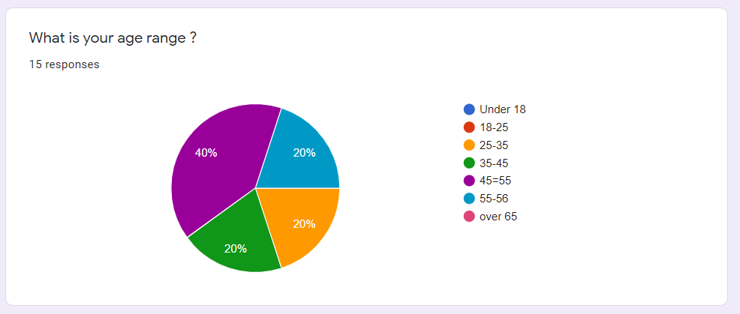

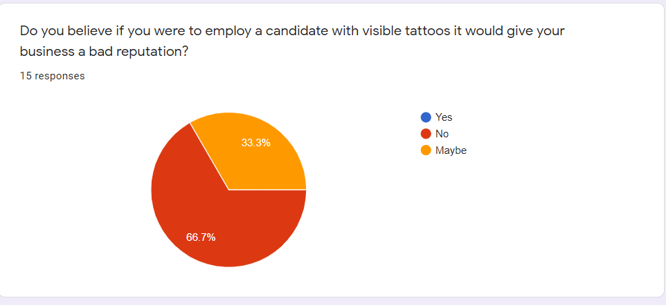

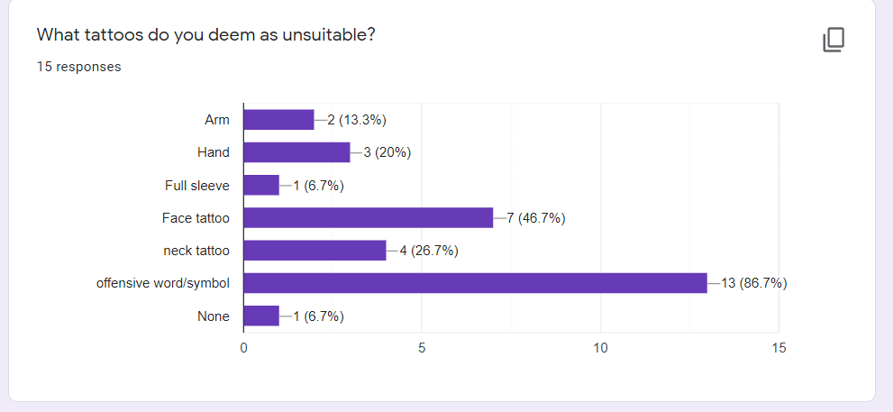

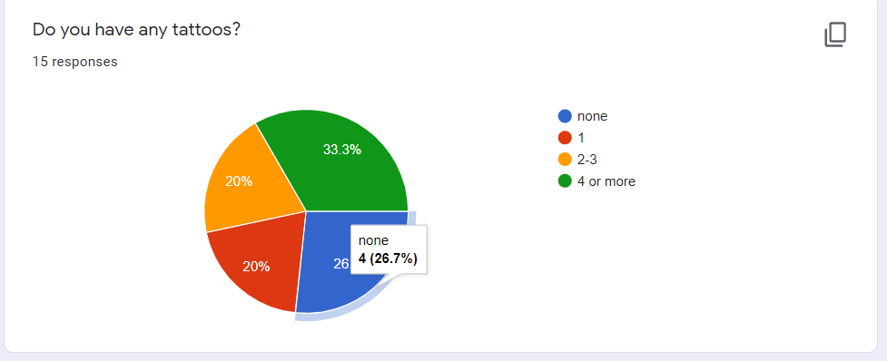

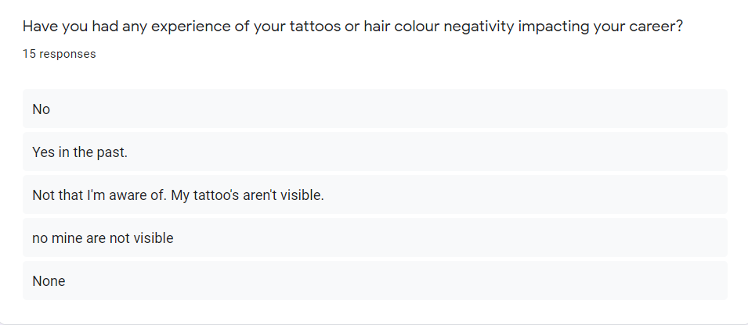

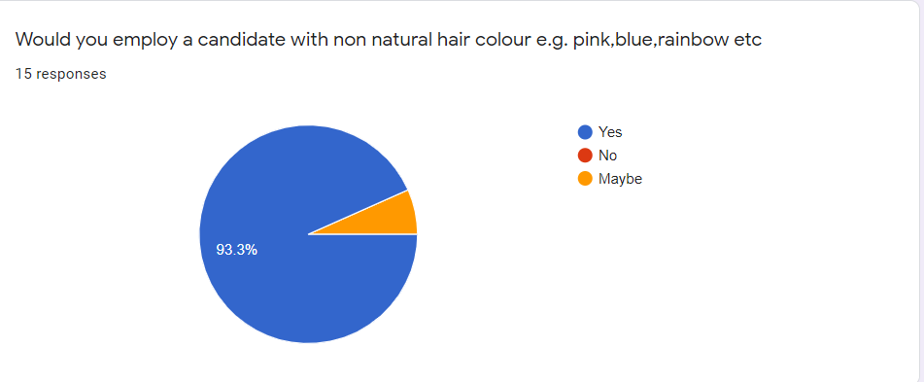

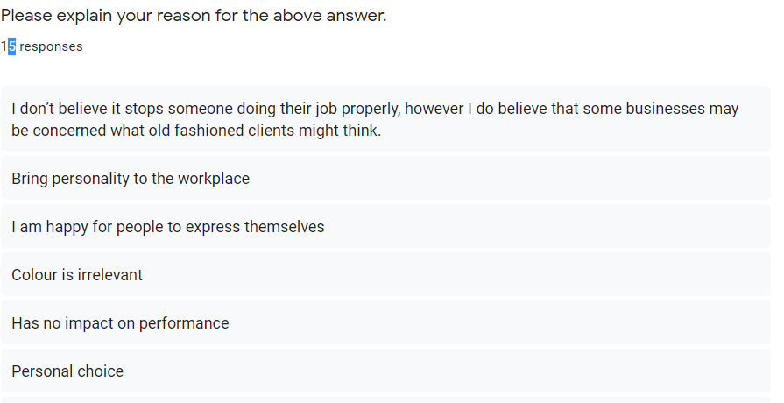

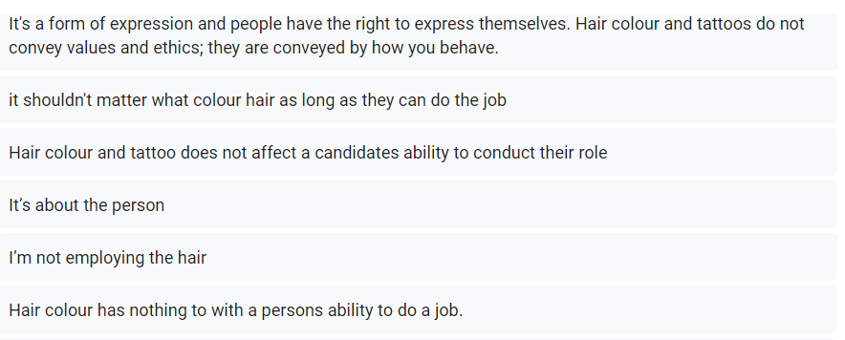
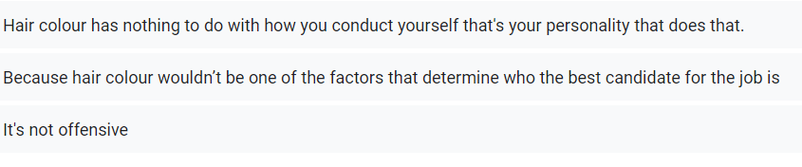

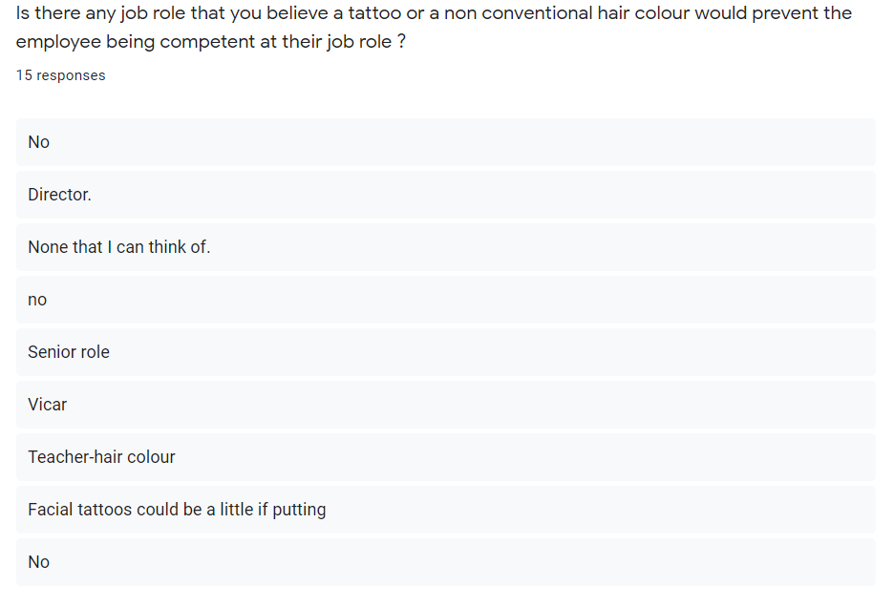
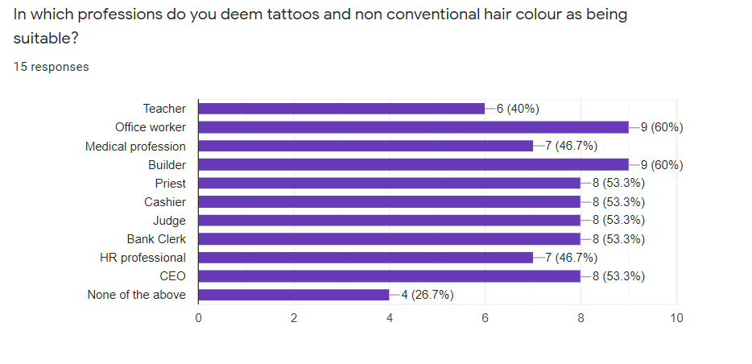

References

Rolf Howard, Managing Partner, Owen Hodge Lawyers 2017 online at:
https://www.hcamag.com/au/news/general/the-danger-of-unconscious-bias-in-hr-decisions-and-how-to-overcome-it/
Contribution by Anadri Chisolm-Noel.
Anadri is a Senior Leadership Development Coach at IMPACT Group with expertise in talent management, organizational development, and employee engagement online at :

https://www.impactgrouphr.com/insights/unconscious-bias
Kayleigh Peach found at:
https://www.bbc.co.uk/news/uk-england-47231027
Tattoos are frowned upon in the workplace found at:
https://www.thejobnetwork.com/tattoos-in-the-workplace-accepted/
Does having your hair done effect you getting a job? Found at:
http://ogbarberschool.com/does-having-your-hair-dyed-affect-your-chances-of-getting-a-job/
Lyndsay Jackson article author found at:
https://www.careeraddict.com/can-your-hair-colour-affect-your-job
Sheiresa ngo article author found at:
https://www.cheatsheet.com/money-career/best-jobs-dont-mind-visible-tattoos.html/
Reddit online
https://www.reddit.com/r/jobs/comments/4fxnlk/am_i_biased_or_do_attractive_people_especially/
Protected characteristics
https://www.equalityhumanrights.com/en/equality-act/protected-characteristics
Harvard business review
https://hbr.org/2019/10/attractive-people-get-unfair-advantages-at-work-ai-can-help
Tomas Chamorro-Premuzic 2019
https://hbr.org/2019/10/attractive-people-get-unfair-advantages-at-work-ai-can-help
Stefan Thavis Professor of behaviour
https://knowledge.insead.edu/search/site/stefan%20thavis?scope=all
Julia Baird New York Times
https://abovethelaw.com/2017/04/pretty-people-always-win-beauty-bias-in-the-workplace/
Richard B. Cohen 2017
https://abovethelaw.com/2017/04/pretty-people-always-win-beauty-bias-in-the-workplace/
Forbes
https://www.forbes.com/sites/pragyaagarwaleurope/2018/12/03/unconscious-bias-how-it-affects-us-more-than-we-know/?sh=828e2766e13e
Allegis group 2020
www.allegisgroup.com
Raimo Streefkerk 2021 Qualitative and quantitative 2021
https://www.scribbr.com/methodology/qualitative-quantitative-research/
Daniel Thomas BBC UK
https://www.bbc.co.uk/news/business-48620528
The job Network
https://www.thejobnetwork.com/tattoos-in-the-workplace-accepted/
https://www.teksystems.com/en-cn/insights/article/unconscious-bias-in-the-workplace
https://english.stackexchange.com/questions/102322/term-to-represent-prejudice-against-ugly-people-or-favouritism-towards-beauti
Harvard Business review
https://talent360.co.za/employers/how-ai-can-help-eliminate-the-beauty-bias-in-hiring/
Maggie Mzumara 2021
https://talent360.co.za/employers/how-ai-can-help-eliminate-the-beauty-bias-in-hiring/

