Module name: Hotel Placement Research Project
Assignment Type: Report
Student name: Iulian Petrut Petrache
Student ID: 2025332
Lecturer: Ka Po Chong

Abstract
Maldrone Hotel of trying to adopt sustainable infrastructure in the company which can help the brand reduce its carbon emissions. The brand is facing problems related to workforce management and monitoring which is creating hurdles for the company. The brand is trying to implement strategies to overcome the barriers. The Maldrone Hotel Newcastle is facing difficulties in implementing sustainable practices which further helps them to grow in the long way. Sustainable development will help this company to boost its growth and also increase its brand recognition. Hence, to implement sustainability, this organisation can introduce experts who have knowledge regarding advanced technology. Furthermore, the strategies that can be used to overcome the obstacles or barriers are discussed and analysed. A methodology has been included by stating the way of the research. A SWOT and PESTLE analysis has also been conducted here to understand the position of the aforesaid hotel. Furthermore, a reflection on the placement journey has been provided here.
Contents
Introduction 4
Aims 5
Objectives 5
Literature Review 6
Methodology 10
Case Study Discussion 13
Maldron Hotels Overview 13
Competition Analysis 14
SWOT Analysis 16
PESTLE Analysis 18
Theme 21
Conclusion 32
Recommendations 33
Reflection on the Placement Experience 35
References 38

Introduction
Maldrone Hotel is considered to be one of the most popular and finest hotels in the UK. This company has decided to adopt sustainable technology to improve the functioning of the business. Sustainability is a concept that focuses on the environment, economy and society. The hospitality industry is one of the most employment-generating sectors but it is also considered to be one of the highest carbon-emitting sectors in the world (Inkson and Minnaert, 2022). The hospitality sector often causes massive destruction of natural flora and fauna. It creates harmful impacts on both the economy and the local population of the host country. The concept of sustainability motivates companies to adopt eco-friendly business models that can help the companies gain economic benefits without harming the local environment and society. Maldrone company has decided to adopt sustainable business to mitigate the risk of climate change and global warming. Critical thinking is important to develop and implement a plan (Cottrel, 2011). It becomes important for any business to develop a skilled workforce that can support the company in implementing a sustainable business model. The company is facing problems in managing its workforce and providing them with skills that can help the company implement a sustainable business model. Apart from that there is a lack of a proper monitoring system to monitor the implementation of the sustainable business model which is impacting the sustainable business. This report focuses on the issues that the company is facing in implementing the sustainable business model.

Aims
To understand the problems which the Maldrone Hotel New Castle is facing while implementing a sustainable business management strategy.

Objectives
To investigate the role of sustainability in improving the business operations of the hospitality industry companies.
To analyse the barriers that businesses in the hospitality industry are facing to implement sustainable business policies.
To evaluate the strategies that can help companies in the hospitality industry overcome the barriers related to sustainable business practices.

Literature Review
1. To investigate the role of sustainability in improving the business operations of the Maldron Hotel Newcastle
Improving business management in the long run: According to Denscombe (2010), sustainable business practices are the crucial step to improve overall business management in a superior way. There are many multinational industries which take part in this case to enhance their growth in the long term. This improvement can be done through various steps such as reducing the expenses which are related to the operational management system. For instance, this industry can practise waste management, recycling processes along eco-friendly transportation which allow them to grow their annual income structure. Apart from that, these kinds of strategies also help them to foster a positive environment which is most demanding in modern times. On the other hand, this initiative helps this company to make a firmed decision for further development purposes in this competitive marketing background.
Increasing brand reputation by engaging with the local community: Community engagement plays a significant role in the case of upbringing the brand reputation which further contributes to the growth of the annual income. The local community takes an integral role in promoting sustainable practices in an industry in several ways. According to Saunders et al. (2012), local suppliers can be involved in sustainable development which further induces a brand recognition of this company. Apart from that, some initiatives such as starting a clean-up event with the community members make the overall society stay garbage-free and also promote eco-friendly activity. All these strategies help the company to develop their brand reputation positively which attracts a large number of customers.
2. To analyse the barriers that the company is facing to implement sustainable business policies
Lack of expertise: The Maldron Hotel is facing some issues regarding the implementation of sustainable business practices which includes a lack of experts that can analyse and monitor the whole process. In simple terms, this industry does not have staff who have the proper technological knowledge to implement the whole procedure. In the case of establishing advanced technology for a streamlined experience, there will be a requirement for the workers who have that particular knowledge to examine the whole process effectively. In addition to this, there is a requirement for training and development programs to mitigate the issues regarding the implementation of sustainable practices. According to Collis and Hussey (2014), it is very difficult to initiate sustainability in the hospitality industry without having the proper technological knowledge and equipment that are essential for this purpose.
High expenses: Sustainable business practices demand a high investment which is vital to implement this kind of strategy. There is a lot of equipment which is related to saving energy and those kinds of instruments are highly expensive. For this reason, many industries are unable to implement these kinds of apparatus in their company to support sustainability. Apart from that, renewable energy implementation also demands a huge amount of money which is a barrier for promoting a sustainable business practice. In that regard, many organisations fail to embrace this kind of advanced techniques in their business field due to high expenses.

3. To evaluate the strategies that can help the company to overcome the barriers.
According to Bux et. al. (2020), the acknowledging of numerous problems and the strategies used to overcome the cruciality of implementing sustainable manufacturing to be successful. Many researchers and practitioners have reported numerous ways to eliminate the problems of manufacturing sustainability. The research study being conducted shows efforts that have been made to highlight the alternative solutions to the barriers or even lessen their negative effects. A total of thirteen options have been found and the F-TOPSIS rank has been used based on the approach to the literature and the opinions of experts. Therefore, based on the identified barrier strategies of various kinds are selected in a manner which eliminates the maximum possibility of the barriers in quantity.
Financial policies and incentives: According to Samanlioglu et. al., (2020) after following the strategy of the F-TOPSIS out of its thirteen strategies. The government should be taking the initiative to provide financial incentives to motivate manufacturing in SMEs sustainably. The one major challenge in the industries to implement sustainable manufacturing is the lack of funds. Hence, incentives should be provided specifically to micro and small-scale companies to improve their technologies for the production of sustainability.
Skill enhancement and improvement of knowledge in workers and society members: this category of strategy aims to conduct training programs for SMEs in both existing and new workers. Further, according to Peterson et. al., (2021), conducts awareness programs to educate societal members in regards to the importance of sustainable manufacturing. The manufacturing industry of today’s time is adapting smart techniques for manufacturing that is renowned for its skilled workforce. The complexities found in today’s factories are responsible for both new and existing employees who are recommended to upgrade their skills to affect production. The design modifications and product efficiency led to the manufacturing of sustainability. Therefore, organisations are concerned with the increased awareness and knowledge that is related to sustainable manufacturing.
Government promotions and regulation: this category of strategies is assumed for the company Maldrone Hotel to assist in the formulation of various policies by the government for motivating the sustainability efforts within SME manufacturing. The form is taken as tax breaks or holidays, accessing the newest sustainability and eco-friendly technologies, waste management, and recycling regulations infrastructure supports. Motivating the creation of intellectual properties for sustainable products, processing innovation and eco-friendliness.
Investment in research and development facilities: This category plan is intended to support the establishment of research facilities within Maldrone Hotel for creating and inventing new products and goods. This plan also includes the establishment of research facilities for energy use management, reduced use of materials and more. The investment in research and development is vital as it provides insightful knowledge and helps in the enhancement of present processes for which efficiency is increased and costs are decreased. Therefore, the additional allowance of SMEs to create innovative, goods sustainable and services that assist them in competing in rough markets.

Methodology
A case study methodology is a strategy of research that sheds light on understanding, exploring, and discussing complex instances within the setting of real-life evidence. This particular methodology is helpful in understanding the way the particular research on the case study has been conducted. Researchers use several methods of data collection in order to gather necessary information. The benefit of case study methodology is it helps to identify complex phenomena in details, which leads to providing practical insights. However, potential bias in the method of data collection can be a notable limitation of this process. The benefits and limitations of this method are stated below (Greetham, 2014).
Benefits
a. This particular method helps to understand the scenario from the perspective of another person. The assistance of new perspectives helps in resolving the issues rapidly.
b. This method allows the researcher to build decision-making skills effectively.
c. Collaboration with other people regarding the study helps to enhance the knowledge of the researcher, which is beneficial in completing the study in an effective and diversified manner.
Limitations
a. Researcher bias is one of the limitations of this method, which can negatively impact the outcome of the study.
b. This method can be time-consuming as the process of data collection can be long and intensive.
c. There are chances of ethical issues in the research method. Errors of judgement or memory can also be a limitation of this particular method (Veal, 2006).
Here the overview of the research onion method will be discussed, which has been used to collect data effectively. This method helps the researcher to collect data without bias and conduct the research with authentic data.
Research design: This framework depicts the different techniques or processes that are utilised in order to conduct the study. Here the researcher has conducted this study by following an explanatory research design. It is useful in exploring several theories that were not tapped extensively. The implementation of the aforesaid design indicates that the researcher has created a cause-and-effect relationship between different studies variables.
Research method: The processes that are used in research to collect and evaluate data are known as research methods. Here a mixed method has been used in which interviews, different journals, articles, and so on have been utilised in order to collect information related to the study. This has helped the researcher to gather effective and authentic knowledge regarding the research topic and fulfil the objectives efficiently.
Data collection: The use of both primary and secondary data can be found here, which depicts the collection of both first-hand information and data from the journals. Here, an interview has been conducted in order to understand the perspectives of the intended population. Along with that, the use of several articles and journals was beneficial in understanding the topic of the study significantly (Grbich, 2006).
Sampling: The procedure of choosing a particular fragment of people from a large population who are intended to be interviewed or studied is known as sampling method. Here the researcher has used a simple random sampling method, as it ensures that the individuals representing the particular population have an equal probability of getting selected. With the assistance of this method, the researcher was able to eliminate biases.
Ethical consideration: It is important for the researcher to maintain a moral code of conduct while conducting the data for the research. Therefore, maintaining moral and ethical practices is an integral aspect of the research. The researcher has ensured that anonymity and confidentiality have been maintained throughout the research. Along with that, the researcher has also ensured voluntary participation in the process of interview. The participants were also distributed consent forms in order to maintain the ethical approach of the research (Diamantopoulos and Schlegelmilch, 2002).

Case Study Discussion

Maldron Hotels Overview

Source: (Maldronhotel, 2024)
Maldron company owns one of the largest hotel chains in the UK and it has branches in 12 locations in the UK ( (Maldronhotel, 2024). The brand is known for its premium quality services and Luxury services. Maldrone company has gained popularity over a short period among the customers. The hotels of this company are situated in some of the most exotic locations in the UK. The branches of the company are located in London, Glasgow, Dublin, Belfast, Cork, Derry, Galway, Laois, Limerick, New Castle and Wexford. This brand is owned by the Dalata group of hotels which is headed by Dermot Crowley. It follows a hierarchical business structure and transformative leadership approach to govern the company. The company follows the business culture of the UK. It focuses on politeness, humility, discipline and punctuality to maintain its business model. The main vision of the company is to provide premium quality services to customers. The brand has shifted its focus to the sustainable business management model to reduce the risk of climate change and global warming. The brand is promoting green tourism among tourists. It has adopted green infrastructure to reduce carbon emission and most of the buildings of the company are less than 15 years old. It has adopted the BREEM framework to measure the effectiveness of its sustainability strategy (Bregroup, 2024). It has implemented several sustainability projects to reduce its carbon footprint. It has also worked on the energy management strategy to reduce the environmental impact. BREEM framework supports the Property investors to determine the sustainable functioning of their assets. It helps to set benchmarks for the companies and provide validation to the asset data of the company. The company has recruited more than 5500 people (Careers portal, 2023). The leadership of the company motivates the employees to enhance their work efficiency and productivity. It has emphasised the training of the staff to increase the productivity of the entire workforce. The company organises training sessions to make their workforce more competent. However, the brand is facing skill gap issues which are impacting the sustainable business model. Sustainable technologies are sensitive and can be only managed through skills expertise knowledge. Lack of skills in the workforce creates difficulties for the companies to maintain sustainability in the organisations. There is a lack of proper monitoring and implementation of the planning which is creating barriers for the company. Maldron Hotel has witnessed a significant rise in its revenues which almost reached 607 million Euros in 2023 (Businesspost, 2023). Despite the growth of the revenue the profit of the company is still reducing each year. The company is struggling to implement a sustainable management plan on the ground and to develop an effective monitoring system. There are other competitors like Ritz Carlton and Marriott International which have implemented the sustainability strategy much more than the Maldron hotels.

Competition Analysis
Competitors- The hospitality industry is considered to be one of the most competitive sectors in the world (Valeri and Baggio, 2021). It follows a monopolistic competition structure in which the market competition is less in comparison to the sectors. Most of the hospitality company sells somewhat similar types of products to the customers. It creates high competition among the companies to highlight their products in front of large audiences. The hospitality industry of the UK is also highly competitive where companies like Ritz Carlton and Marriott International give Maldron hotels. Marriott International is one of the most popular companies in the UK. More than 14% of customers in the UK like to book Marriott for their stay. Ritz Carlton is another popular hotel in the UK which is known for its premium hospitality services.
Power of Buyers- The power of the buyers depends on the availability of the products and the services. The power of the buyers increases when there are plenty of options of products and services available in the market for the customers. The power of buyers decreases when there are fewer products or service options available in the market and it gives better negotiation power to the companies (Streimikiene et al., 2021). There are plenty of hotel options available for the customers and it increases the negotiation power for the tourists. The company can face difficulties in attracting the attention of the customers.
Power of Suppliers- The power of suppliers depends on the number of companies available to collaborate with the suppliers. The power of suppliers increases when there are less number of suppliers available to supply specific goods to the company (Mooney, 2020). The number of suppliers decreases when there are more suppliers available for the companies to negotiate. There are plenty of hospitality companies available in the UK but there are fewer suppliers. It increases the power of suppliers to negotiate with the company. It is a serious challenge for companies like Maldron.
The threat of Substitute- The tourism sector is highly competitive and the threat of substitutes always remains very high in the tourism sector. There are plenty of companies in the UK which are working to promote the ecotourism model like Maldron. The rival companies of the Maldron are adopting sustainable business models and sustainable technologies to reduce their carbon footprint. They are creating ecotourism business models and eco-tourism packages at affordable price ranges for the tourists of the UK. It is a serious threat to the companies like Maldron Hotels and it can impact the revenues of the company.
Threat of New Entrance- The tourism sector of the UK follows monopolistic competition which allows new companies to establish themselves in the market. The tourism sector of the UK has witnessed a boom after the Covid-19 pandemic. It has created opportunities for new companies to expand their business in the UK. The tourism sector is rising by a 1.2% rate. It has increased the threat of new entrants for the companies like Maldrone which is working hard to implement its sustainable business model.

SWOT Analysis
A SWOT analysis is known as a strategic management tool or framework that assists the decision-makers and organisations evaluate the weaknesses and strengths, which allows them to find various new opportunities and mitigate the threats. A detailed SWOT analysis of Maldron Hotel Newcastle will be discussed here to understand its position in the market.
Strengths | Weaknesses
Prime location: The alluring location of Maldron Hotel is able to attract many individuals to provide the experience of a quiet retreat.  Friendly staff: The value of the aforesaid hotel is enhanced due to the friendly behaviour and assistance of the staff. Along with that, cleanliness, as well as modern comforts, are another notable aspect of this hotel (Aleksandrovna, 2020). | Lack of monitoring system: Despite the attractive location and friendly workforce, this particular hotel lacks monitoring features in the context of maintaining a sustainable business model. As a result, the process of sustainable integration gets hampered.  Scarcity of skilled workforce: The implementation sustainable business model requires the presence of a skilled workforce. However, the workforce of the aforesaid hotel lacks the knowledge and skills regarding the proper implementation of the sustainability model, which can be an issue for the business.
Opportunities | Threats
Scope of sustainability: The respective hotel is planning to improve the practices and processes of reducing harmful impacts on the environment. ‘Living Green’ movement and accreditation by Green Tourism will allow the respective business to achieve sustainability in its business operations (maldronhotels, 2024).  Growth opportunities: Better services provided by the hotel and positive reviews from the customers are beneficial for the respective hotel to grab the attention of more customers. The sustainability approach will also allow the aforesaid hotel to attract more customers who prefer sustainability and eco-friendliness. The availability of funds can also be used to integrate innovative technologies and implement sustainable features in the business. | Competition: There are several hotels in the surrounding location that offer equal services and sustainability to the customers. Therefore, the hotel can face competitive threats in the market due to the lack of a monitoring system.  Losing customers: The absence of a skilled and knowledgeable workforce in the context of sustainability implementation can lead the hotel to face the loss of customers. The fall in the overall profit of the business can be a notable threat to the existence of the business in the market (Davies and Kolaczkowski, 2022).

PESTLE Analysis
This framework is effective in understanding the way external factors and activities affect the businesses of an industry. The PESTLE analysis of Maldron Hotel Newcastle will help to understand the changes and overall effects of political, economic, social, technological, environmental, and legal factors on the businesses of the hotel industry.
Political: The decisions and actions of local government affect the hotel and hospitality industry in an effective manner. The outbreak of the pandemic, Brexit, and the Russia-Ukraine war have created several challenges for the hotel sector. Therefore, the political unrest can negatively impact the overall condition of the businesses such as Maldron Hotel. The government of the UK has reformed tax policies in order to help hotel businesses run their activities smoothly and sustain in the market (González-Rodríguez et al., 2020).
Economic: Apparently, it can be seen that the UK economy has been facing turmoil due to a series of situations like Brexit, the pandemic, and the Russia-Ukraine war. These events have collectively led to a surge in the nation's inflation rate as it was seen that the UK recorded an inflation rate of 11.1% in 2022. This affected the operating expenses of hotels like Maldron Hotel Newcastle. However, as the inflation rate is gradually declining, hotels are able to reduce their operating expenses and improve their profit margin. Currently, the rate of inflation in the UK is 3.2%, which will be helpful for the aforesaid businesses in terms of retaining profits (statista, 2024).
Social: The preferences of consumers in the UK can be seen changing constantly. With the increase in the cost of living, people in the UK focused their spending mainly on essential commodities and avoided the purchase of non-essential or luxury services. This, apparently, is affecting the sales of luxury hotels like Maldron Hotel Newcastle. Alternatively, it can also be seen that after the pandemic, safety and hygiene have become major concerns for people. Therefore, more and more people are choosing clean and hygienic hotels that are positively influencing hotels like Maldron Hotel Newcastle (Duric et al., 2021).
Technology: The advances in technology have assisted the hotel and hospital sector in a significant manner. The hotels use technology such as a website for the purpose of booking and various payment applications for the secured payment method. The association of technology allows customers to book hotels from any remote place. The use of automation AI, and robotics in the hotel businesses such as Maldron Hotel is able to offer improved experiences to the audiences. The implementation of modern technology is also beneficial for businesses to apply sustainable approaches in the business.
Legal: The hotel businesses in the UK are required to follow the legal aspects and regulations in the United Kingdom. Customers often opt to stay at a place that is free from any crimes or other negative issues. Therefore, a proper location with a low crime rate is essential to enhance the rate of customers. Hotels such as Maldron Hotel Newcastle are required to follow the innkeeper law for ensuring the safety of the guests and their belongings. The hotel businesses in the UK are also required to follow the data protection law of the customers to secure the personal information of the guests and the hotel, in order to sustain itself in the market.
Environmental: People in the UK have become more conscious regarding the environment and the sustainability approach. Therefore, it is important for the respective businesses to reduce the wastage of food, water, and energy, in order to maintain sustainability. It is important for the hotels to follow the standards of cleanliness along with reducing the use of plastics and other harmful materials. The growth of the hotel in the aforesaid country depends on the environmental aspects. Therefore, the implementation of the sustainability monitoring system is important for businesses to attain growth and success (Floričić, 2020).

Theme
Theme 1: Importance of sustainability in the hospitality industry.
Recently, the hospitality industry has faced various pressures based on the customer’s demands to maintain sustainability along with the prevention of environmental degradation. Sustainability safeguards the environment by minimising the negative impact on the environment (Milo, 2022). The aspect of sustainability is important for energy management and conservation. Besides that, water conservation is the biggest priority for the hospitality industry. Additionally, suitability is also beneficial for maintaining cultural diversification in the workforce which is considered the demands of consumers towards the business hotel sector. Most importantly, in the era of maintaining the green economy, recycling would play a crucial role in protecting the entire environment in a meaningful way.
Graph and chart analysis
Graph
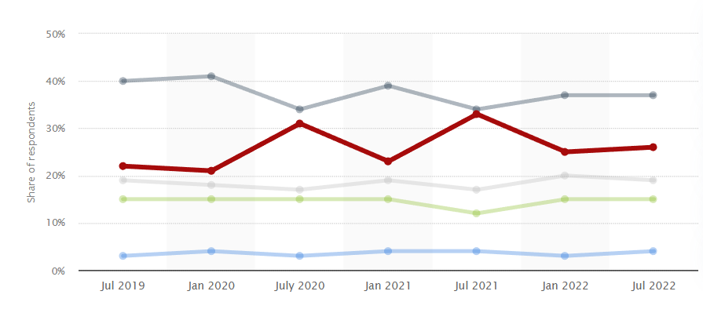
Source: (Statista, 2023)
Figure 1Travelers choosing green hotels to reduce environmental impact in the UK 2019-2022

Explanation
According to Statista, based on the online survey, it was noticed that customers prefer eco-friendly hotels rather than choosing other hotels. Additionally, between 2019 and 2022, the rate of environment-concerned customers increased by 37% (Statista, 2023). Customers have in recent days more likely to spend money on those hotel sectors which prefer sustainability while maintaining their business operations. Modern visitors are completely aware of their ecological footprint and therefore they choose the specific hospitality industry that intends to take sustainable initiatives to minimise the negative impact on the environment. Plenty of guests can be attracted towards the business organisation if they realise that the concept of indulging comfort while understanding their accommodation has minimal negative impact on the environment. Besides that, consumers also focus on the sustainable practices of the hospitality industry. This includes available organic foods, recycling and composting programs, water management and others (Saprov, 2023). Henceforth, maintaining sustainability is an essential asset for the hotel as well as the hospitality industry to attract plenty of tourists. The economic growth of the business organisations can be uplifted through taking sustainable initiatives while maintaining business operations.
Theme 2: Impact of sustainability on the business operations of hotels.
The hotel industry is popular for its consumption of substantial energy forces, water usage as well as waste generation. Nevertheless, sustainable business practices can help the hospitality sector to lower its carbon footprint along with water conservation. Especially, sustainable practices do not harm employees and suppliers and they also can feel comfortable working proficiently for the business growth. Apart from that, sustainable practices can protect natural resources which is beneficial for safeguarding the environment like water, electricity and many more (Darling, 2024). Consumers prefer eco-friendly hotels for maintaining cost-effectiveness. For instance, if any hotel sector minimises its energy usage by implementing energy-efficient lighting systems can entirely save the bills. This scenario showcases that, a business can increase its profitability through applying sustainable business operations.
Graph and chart analysis
Graph
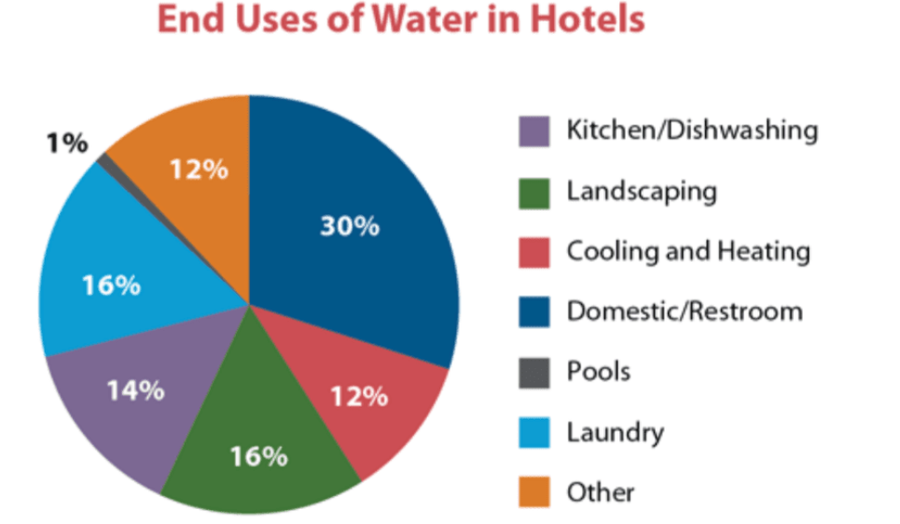
Source: (Darling, 2024)
Figure 2Water Management

Explanation
Many hotel industries have started to implement sustainable practices and from the above graph, it can be stated that the availability of water is required for various purposes in the hotel industry including cooling, healing, laundry, pools and others (Revnomix, 2024). A large amount of water would be wasted if the hospitality industry cannot manage to keep up the level of water at the right amount. Therefore, planting drought-resistant plants would be effective in minimising the overall usage of water. Besides that, various activities may be required to maintain the water amount for safeguarding nature. This includes conducting water audits to calculate the daily usage of water in hotel industries, installing low-flow fixtures, adopting smart techniques monitoring water consumption and many others. Additionally, the application of systems that can collect rainwater for further recycling for non-potable applications like toilet flushing would be effective. Most importantly, setting clear as well as concise water management goals is beneficial for implementing such sustainable practices to increase customer engagement towards the business operation. Henceforth, it can be stated that through water conservation, hotel companies can save their additional spending on important resources while increasing the revenue of the profit on a simultaneous basis. Customers who intend to stay at hotels where clean and safe water is provided can easily attract eco-friendly business organisations (Razgaitis, 2023). Water management as well as control is one of the most crucial purposes of the hotel industry for minimising the negative influence from the environment while safeguarding their business objectives.
Theme 3: Technological Barriers to the implementation of sustainable business policies in the hotel business.
Various studies found that technology plays the foremost role in enhancing business performance in the context of the environmental field. Resource management is the prime aspect through which companies can allocate and manage their resources in the right place. The lack of technical expertise among employees can disrupt the overall process of sustainable practices. Besides that, technology has various purposes and activities to promote sustainable business operations (Mariani, 2022). This includes renewable sources, eco-friendly transportation, and waste reduction methods for maintaining a harmonious ecological balance while lowering the carbon footprint. Modern technology based on the environmental aspect enables organisations to capture directly the occurring energy for conversion into useful heat through solar panels, water turbines and many more. Hence, technological barriers can hamper the entire business framework.
Graph and chart analysis
Graph
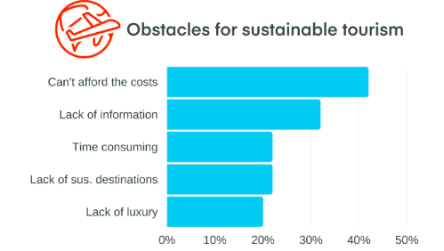
Source: (Revnomix, 2024)
Figure 3 Obstacles to Sustainability in the Hospitality Industry

Explanation
One of the major disadvantages is the lack of technical expertise. From the above graph, it can be assumed that sometimes the travel sectors have less money to afford the technical equipment. This scenario can disrupt the overall performance of the business organisation. Besides that, a lack of technical information among employees and staff also can be an effective barrier towards sustainable initiatives of companies (Revnomix, 2024). For promoting sustainable operation, technical presence must be adopted by the companies so that the employees, as well as staff, can perform their technical tasks without any hindrance. Employee training and development programs must be initiated by the hospitality industry to avoid any such difficulties in promoting sustainability for increasing brand awareness. Additionally. Many technical instruments might take a lot much time to control and measure energy conservation. Hence, choosing the right technical solution to save time as well as money can be effective for hotel industries to initiate sustainable programs. Therefore, hotel sectors that want to avoid some technical barriers should adopt the idea of technology like the application of AI to detect and monitor data for measuring daily performances.

Theme 4: Challenges a hotel faces due to a lack of skilled workforce to implement the sustainable business model
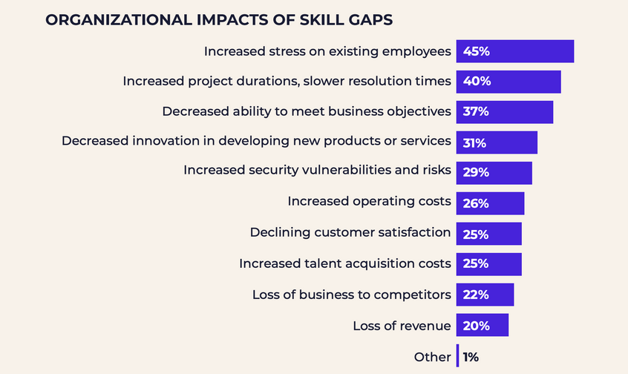
Source: (Olson, 2024)
The above-presented graph is a study on the topic which is related to the impact of skill gaps on an organisation. A study of the graph shows that skill gaps can affect the various aspects of an organisation including the life of employees to organisational goals. The graph shows that due to the skill gap, the work pressure on the existing staff increases significantly. This can reduce the ability of a company to effectively manage a sustainable business model within the company. Besides this skill gap can also affect the operations of a company as it can increase project duration and slower resolution time. Further study of the presented graph shows that the skill gap can also affect the ability of a business to effectively address the needs of its customers as it decreases innovation in developing new products or services. Other impacts of the skill gap, which can be identified on the operations of a company from the above presented graph are increased risks, increased operating costs, declined customer satisfaction and loss of competitive edge. This shows that in the absence of a skilled workforce each and every aspect of a business is affected. This reduces the ability of a company to manage the business operations sustainably. Thus, from the above study of the graph, a close connection can be established between the lack of skilled workforce and the implementation of a sustainable business model in a hotel. From the study of the graph, it can be said that the lack of skilled workforce affects the businesses operating in the hospitality industry to effectively manage their operations this affects the sustainable growth of the hotels.

Theme 5: Clear goal setting a strategy to overcome the challenges for sustainable business policies.
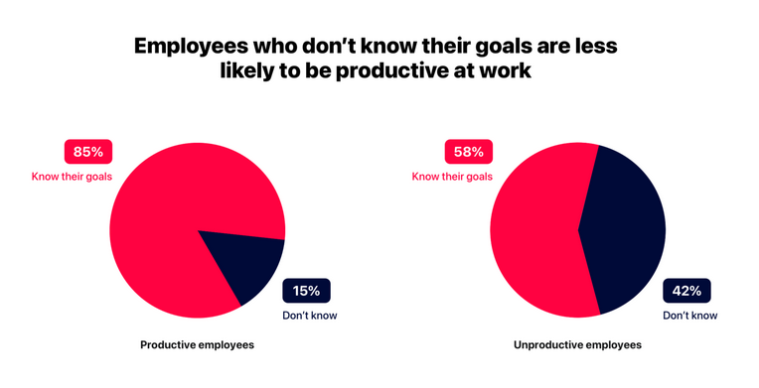
Source: (Kahansky, 2022)
In the above graph, a study on the employees has been presented. A study of the graph shows that 85% of the employees who are productive know their goals while among the productive employees, only 15% are unaware of the company’s goals. In contrast the presented graph for unproductive employees shows that 42% of unproductive employees are those who do not know the goals of the company. In light of this comparison presented in the graph, a clear connection between the productivity of the employees and their productiveness can be established. Consequently, it can be said that setting clear goals can reduce the number of unproductive employees. Productive employees are essential for business growth because they play a crucial role in increasing the operational efficiency of a company. A productive workforce is also essential for an organisation to offer quality services or products to customers. Besides this, they also help a company enhance its employee engagement and retention. All these factors directly impact the operations of a company. So for the hospitality sector businesses, it can be said that setting a clear goal is essential to efficiently introduce a sustainable business policy in the company. Productive employees will help a hotel optimise resource utilisation. Thus, by maximising efficiency and minimising waste productive workforce can help a hotel sustain efficient business operations. Besides this, productive employees stay motivated and allow a hotel to provide the best services to its customers. This helps a company to gain a reputation and compete in the market efficiently. Thus, an efficient workforce allows a hotel to gain a competitive edge and improve its financial performance. From the above discussion, it can be said that the direct relation that has been established between clear goals and employee productivity can be an effective strategy which can be used by a hotel to overcome the challenges of sustainable business policies.

Theme 6: Role of employee training and awareness in mitigating challenges related to the implementation of sustainable business policies in hotel businesses.
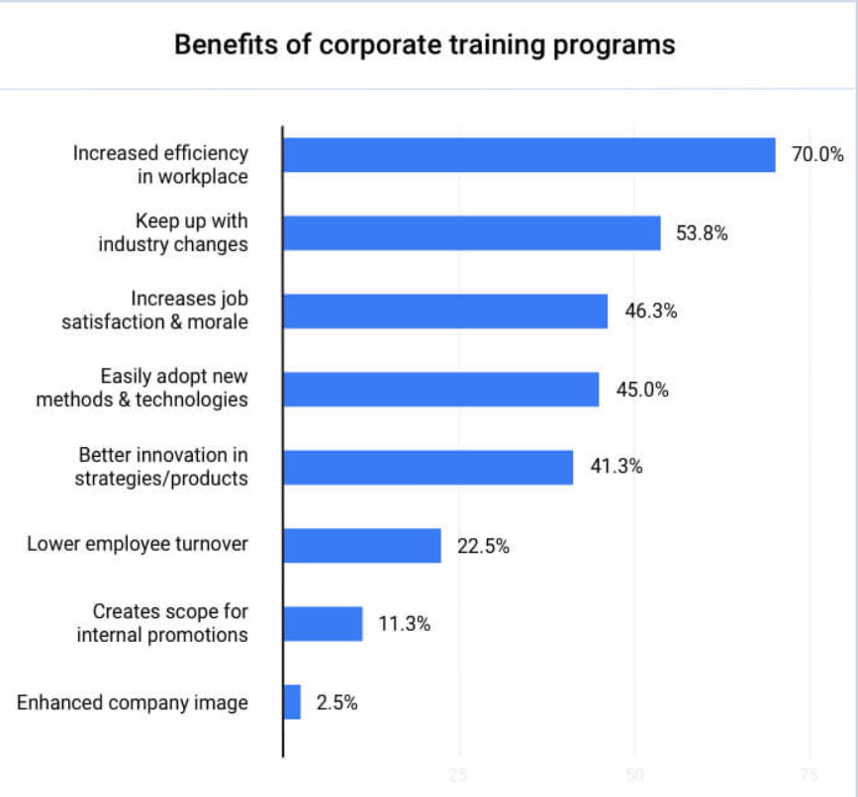
Source: (Raymond, 2023)
The above graph presents the result of a study which was conducted to investigate the benefits of corporate training programs. A study of the presented graph shows that training and development program increases the efficiency of the employees by 70%. This suggests that the training and development programme of a hotel has the potential to increase the productivity of the employees which can be directly related to the sustainable business growth of a company. Besides this, a training and development programme also allows a company to keep up with the industry change by increasing its flexibility by 53.8% which can be easily related to the sustainable business growth of a hotel. Further study of the presented graph shows that training and development programme also plays an important role in increasing job satisfaction and boosting the morale of the employees. This can help a hotel to retain top talents in the company and help it to perform well. Further, the graph shows that training and development programmes allow a company to bring the element of innovation in its product and service development. This can be related to customer satisfaction and the reputation of a hotel. Thus, based on the provided graph it can be said that the training and development programme of a hotel can help it to improve its operations which can lead to sustainable growth of the hotel and the adoption of a sustainable business model. Through training and development programmes a hotel can effectively manage the efficiency of its employees and the organisation. This can help a hotel to improve various operational areas of the business including employee engagement and retention.

Conclusion
This report focuses on the Maldron Hotels company which is trying to establish a sustainable business model in the UK. The brand has gained popularity among the tourists of the UK due to its premium services. The brand has focused on discipline, punctuality and humility which has helped the brand to maintain the quality of its services. It has decided to adopt a sustainable business model to reduce its carbon footprint. It has taken initiatives to promote ecotourism in the UK. The brand has also adopted sustainable business infrastructure. The brand is facing problems related to the implementation and monitoring of the sustainable business model. This report explains the issues the company is facing in implementing the sustainable business model. It has also covered the potential strategies which support the company to implement a sustainable business model for the company. A skilled workforce is a major challenge for the brand which is reducing the work efficiency of the company. The profit of the company has also declined in recent years which has impacted the business of the company. The company has a major advantage due to its location. The brand needs to work on its workforce and business management to fulfil its sustainability targets.

Recommendations
There are a few strategic and calculated recommendations for Maldron Hotel Newcastle, that will help the company to remain competitive in the market and maintain its prime position. The lack of monitoring systems and scarcity of skilled workforce can be navigated by implementing the following recommendations. The proper implementation of these recommendations might help the Maldron Hotel and also provide strengths to maintain sustainability, improve the capabilities of monitoring and will also help maintain competitiveness in the hospitality sector (Ecobnb, 2023).
Employee training and development: The organisation should establish a comprehensive training program that will be focused on sustainability practices. They can strategically partner with local educational institutes or organisations who are specialising in sustainable hospitality for training purposes. This training will help the company to upskill its existing employees and will further help in the implementation of the sustainability model.
Recruitment and talent management: The HR department of the hotel should collaborate with workforce development agencies or sustainable tourism organisations. This will help the hotel attract skilled employees who are aware and passionate about following sustainability practices. Further, HR should implement sustainable practices to engage more employees and increase their skills for enhanced productivity and they should provide them with flexible work arrangements. Also, fair wages and wellness programs have the potential to attract and retain capable employees in the organisation (Garitty, 2024).
Technology Integration for Monitoring: The Hotel Maldrone in New Castle should invest in new advanced monitoring systems, for example, IoT sensors and energy management software. They should also invest in a waste tracking system to monitor resource consumption; this will help the company to identify the areas of improvement. The company can partner with technological firms to develop and innovate customised monitoring solutions for the particular needs of the hotel (maldronhotels, 2024).
Green acquisition practices: The service-providing organisation should strengthen its work policy and also should implement strategies to navigate the risk and threat factors. This could be navigated with the help of ethical sourcing of the products and services, further, the hotel can implement ethical policies. These policies will encourage the workers to use eco-friendly cleaning supplies, organic toiletries and appliances which are energy-efficient and environmentally suitable. Further, the company can create a green team and encourage their teams to responsibly participate in eco-friendly best practices.
Green movement: Further, the hotel along with monitoring and upskilling its workforce, stem and employees, can take inspiration from other hotels to maintain a sustainable business model. For example, Molina Sustainability Center, in Colorado which has specialisation in solar panels and Arosea Life Balance Hotel in Italy is widely famous for the use of local materials. Further, companies like Macav Lodge and Hotel Glamping Ribno are continuously operating on a minimal footprint in Costa Rica and Slovenia respectively have set good examples of sustainable practices (Aksöz et al., 2020).
Moreover, the organisation can continuously improve their employee's skills and remain competitive in the service sector by fostering a culture of innovation and development through feedback, and idea generation. Developing KPIs might be helpfully aligned with sustainability goals to progress over time and increase productivity (Milo, 2022).

Reflection on the Placement Experience
I have gathered my placement experience while being a part of Maldron Hotel Newcastle. During this respective time, I have gathered some notable collaborative experiences, along with some practical experiences. I have gathered several knowledge and skills during this placement experience. The overall experience is stated in the following.
Overview of the placement experience
During the placement, I have gathered different skills such as research procedures and time management. I also learnt to use various technologies during my placement journey. My knowledge of sustainability and its implementation in businesses also improved. I have learnt the importance of teamwork and completed the assigned tasks significantly. Maldron Hotel is one of the renowned hotels in the UK. Therefore, as a student of the hospitality industry, placement in this hotel will allow me to gain knowledge and experience. I also learnt about the staff structure which helps the hotel to keep functioning at the maximum capacity rate. During the placement, I gathered that the hotel is popular for providing better and innovative services to the customers. The availability of clean and comfortable rooms, budget-friendly experiences, and other positive aspects are able to grab the attention of the customers. I was always interested in working in the hotel business and acquiring knowledge about different processes. Sustainability has become an important aspect of the hotel businesses. Therefore, this opportunity has helped me to gather knowledge regarding sustainable practices as well.
Acquired skills in the placement
I have acquired several skills while working in the aforesaid hotel. I have built an effective communication skill, which is one of the significant employability skills as well. During my course and internship, I learnt the way to establish verbal and written communication in an effective manner. Initially, I was facing an issue in conducting productive communication. However, my team members and seniors helped me to resolve this issue. My time management skills were also poor before participating in the placement program. My seniors helped me to set a routine and divide tasks according to their priorities. As a result, I was able to accomplish my tasks within a given timeline. My acquired communication and time management skills will also be beneficial for me in my future career. It will also help me to achieve personal growth and success. During the internship, my confidence level also improved. I was able to perform tasks with more knowledge and confidence gradually. I also feel that my goals were appropriate to the culture of the organisation. During the placement journey, I have set some of the goals and objectives regarding my personal and professional growth. My developed teamwork skills will allow me to gain success in my professional field (Ashmore-Pascua and Elsmore, 2023).
Reflective summary
My placement journey helped me enhance my existing skills and grasp various new opportunities. The presence of the set of transferable skills is able to boost my work experience, job roles, and others, which are beneficial in terms of developing new skills. I will be able to use my communication skills to enhance my confidence and achieve success. I feel both excited and anxious thinking about the career path in the future. My experience at Maldron has helped to change my way of looking at the professional work field. I felt that my placement at the aforesaid hotel consisted of hard work and determination. It was sometimes exhausting as well. According to me, working in a hospitality environment, it is important to consider social activities as well. I understood that I could continue my career path in this field by improving some of my other skills. For instance, during the placement journey, I understood that I needed to improve my technological skills in order to gain success. Having proper knowledge regarding the way to use technologies properly is an important aspect of employability. There were times when I had to use technical devices in order to complete tasks. However, my lack of knowledge sometimes led me to some difficulties. Another important aspect I learned during my placement journey was the importance of CSR or sustainability in hotels. I gathered that people mostly select hotels with proper eco-friendly services and products. Therefore, learning about sustainable aspects and their proper implementation was one of my notable experiences. It is important to learn about the proper implementation of sustainability as well as the knowledge of sustainable aspects for the purpose of gaining success and improving the overall performance of the organisation. I gathered that sustainability and eco-friendly approaches have now become the most essential attributes in order to fulfill the experience of the customers and provide better services.

References
Aksöz, E.O., Aydın, B. and Esin, Y., (2021). Tourists approaches to eco-friendly hotels and determination of green hotel preferences: The case of Eskişehir. Turizam, 25(2), pp.83-95.
Aleksandrovna, B.I., (2020). The Brexit factor in the social and political development of the United Kingdom.
Ashmore-Pascua, C. and Elsmore, I., (2023). Assessing placement students perceptions of university support through the critical incident technique: Placement students perceptions of university support. The Student Journal of Service Sector Management Research, 1(2).
Bregroup, (2024). BREEAM certification from BRE. [Online] Available at: https://bregroup.com/products/breeam [Accessed 21 April 2024].
Businesspost, (2023). Hotel group Dalata’s revenue tops €600m but profits fall. [Online] Available at: https://www.businesspost.ie/news/hotel-group-dalatas-revenue-tops-e600m-but-profits-fall/ [Accessed 21 April 2024].
Bux, H., Zhang, Z. and Ahmad, N., (2020). Promoting sustainability through corporate social responsibility implementation in the manufacturing industry: An empirical analysis of barriers using the ISM‐MICMAC approach. Corporate Social Responsibility and Environmental Management, 27(4), pp.1729-1748.
Careers portal, (2023). Dalata Hotel Group is one of the ‘Best Places to Work in Hospitality’. [Online] Available at: https://careersportal.ie/news/dalata-hotel-group-is-one-of-the-best-places-to-work-in-hospitality [Accessed 21 April 2024].
Collis, J & Hussey, R (2014), Business Research, A Practical Guide for Undergraduate and Post Graduate Students, Palgrave, London
Cottrel, S. (2011) Critical Thinking Skills: Developing Effective Analysis and Argument, Palgrave Study Guides, Palgrave Macmillan: Basingstoke.
Darling, S., (2024). Water And Energy Are Intertwined: Here’s How We Can Start Treating Them That Way. [Online] Available at: https://www.forbes.com/sites/forbestechcouncil/2024/01/10/water-and-energy-are-intertwined-heres-how-we-can-start-treating-them-that-way/?sh=25d8dd394214 [Accessed 22 April 2024].
Davies, B. and Kolaczkowski, J., (2022). The United Kingdom: Political and labour market influences. In The Evolution of Supplementary Pensions. Edward Elgar Publishing.
Denscombe, M., (2010). Ground rules for social research : guidelines for good practice 2nd ed., Maidenhead: Open University Press.
Diamantopoulos, A. and Schlegelmilch, B. B. (2002), Taking the Fear Out of Data Analysis, Dryden, London
Duric, Z. and Potočnik Topler, J., (2021). The role of performance and environmental sustainability indicators in hotel competitiveness. Sustainability, 13(12).
Ecobnb, (2023). Green Hospitality: Sustainable Practices for Hotels and Resorts. [Online] Available at: https://ecobnb.com/blog/2023/05/green-hospitality-sustainable-practices-hotels-resorts/ [Accessed 29 April 2024].
Floričić, T., (2020). Sustainable solutions in the hospitality industry and competitiveness context of “green hotels”. Civil Engineering Journal, 6(6).
Garitty, O., (2024). The Customer Experience: Lessons From Luxury Hotels. [Online] Available at: https://www.forbes.com/sites/forbesagencycouncil/2023/04/21/the-customer-experience-lessons-from-luxury-hotels/?sh=517eccf817c3 [Accessed 29 April 2023].
González-Rodríguez, M.R., Díaz-Fernández, M.C. and Font, X., (2020). Factors influencing willingness of customers of environmentally friendly hotels to pay a price premium. International Journal of Contemporary Hospitality Management, 32(1).
Grbich C. (2006), Qualitative Data Analysis, Sage Publications Lt
Greetham, B. (2014) How to Write your Undergraduate Dissertation, Palgrave Macmillan, Basingstoke.
Inkson, C. and Minnaert, L., (2022). Tourism management: an introduction. Sage.
Kahansky, N., (2022). Why goals are important: The top 3 benefits of goal-setting. [Online] Available at: https://hypercontext.com/blog/work-goals/why-are-goals-important [Accessed 22 April 2024].
Maldronhotel, (2024). Living Green. [Online] Available at: https://www.maldronhotels.com/environment/ [Accessed 20 April 2024].
maldronhotels, (2024). Quality 4 star Hotels in Ireland & UK | Maldron Hotels. [Online] Available at: https://www.maldronhotels.com/environment/ [Accessed 29 April 2024].
Mariani, J., (2022). How Sustainability Has Become A Marketing Necessity In Luxury Hotels. [Online] Available at: https://www.forbes.com/sites/johnmariani/2022/07/19/how-sustainability-has-become-a-marketing-necessity-in-luxury-hotels/?sh=11d3626306de [Accessed 22 April 2024].
Milo, S., (2022). Implementing Sustainability Into The Hospitality Industry. [Online] Available at: https://www.forbes.com/sites/forbesbusinesscouncil/2022/09/29/implementing-sustainability-into-the-hospitality-industry/?sh=5ebc7c556c30 [Accessed 29 April 2024].
Mooney, S.K., (2020). Gender research in hospitality and tourism management: time to change the guard. International Journal of Contemporary Hospitality Management, 32(5), pp.1861-1879.
Olson, A., (2024). What is a Skills Gap? (And Why It Matters). [Online] Available at: https://www.skillsoft.com/blog/what-is-a-skills-gap [Accessed 22 April 2024].
Peterson, M., Minton, E.A., Liu, R.L. and Bartholomew, D.E., (2021). Sustainable marketing and consumer support for sustainable businsses. Sustainable Production and Consumption, 27, pp.157-168.
Raymond, M., (2023). 6 Corporate Training and Development Trends of 2021. [Online] Available at: https://www.goodfirms.co/resources/corporate-training-development-trends [Accessed 22 April 2024].
Razgaitis, R., (2023). Sustainability Drives Consumer Choice For Travelers. [Online]Available at: https://www.forbes.com/sites/forbesbusinesscouncil/2023/08/18/sustainability-drives-consumer-choice-for-travelers/?sh=548c49fa273f [Accessed 22 April 2024].
Revnomix, (2024). Ultimate Guide to Sustainability in the Hospitality Industry. [Online]Available at: https://revnomix.com/ultimate-guide-to-sustainability-in-the-hospitality-industry/ [Accessed 22 April 2024].
Samanlioglu, F., Burnaz, A.N., Diş, B., Tabaş, M.D. and Adıgüzel, M., (2020). An Integrated fuzzy best-worst-TOPSIS method for evaluation of hotel website and digital solutions provider firms. Advances in Fuzzy Systems, 2020, pp.1-10.
Saprov, I., (2023). The Evolving Landscape Of Sustainable Travel Tech: Challenges And Solutions. [Online] Available at: https://www.forbes.com/sites/forbesbusinesscouncil/2023/11/22/the-evolving-landscape-of-sustainable-travel-tech-challenges-and-solutions/?sh=4d5e47744971 [Accessed 22 April 2024].
Saunders, M., Lewis, P. and Thornhill, A. (2012) Research Methods for Business Students, FT/Prentice Hall: Harlow
Statista, (2023). Share of travelers choosing eco-friendly hotels to reduce their environmental impact in the United Kingdom from July 2019 to July 2022. [Online] Available at: https://www.statista.com/statistics/1340780/travelers-choosing-ecofriendly-hotels-uk/[Accessed 22 April 2024].
statista, (2024). Inflation rate for the Consumer Price Index (CPI) in the United Kingdom from January 1989 to March 2024. [Online] Available at: https://www.statista.com/statistics/306648/inflation-rate-consumer-price-index-cpi-united-kingdom-uk/#:~:text=The%20UK%20inflation%20rate%20was,11.1%20percent%20in%20October%202022. [Accessed 22 April 2024].
Streimikiene, D., Svagzdiene, B., Jasinskas, E. and Simanavicius, A., (2021). Sustainable tourism development and competitiveness: The systematic literature review. Sustainable development, 29(1), pp.259-271.
Valeri, M. and Baggio, R., (2021). Social network analysis: Organizational implications in tourism management. International Journal of Organizational Analysis, 29(2), pp.342-353.
Veal, A J (2006), Research Methods for Leisure and Tourism, 3 rd Ed, Financial Times/ Prentice Hall.

