Task 1
- With reference to typical activities and behaviours, appraise what it means to be a ‘people professional’. (AC 1.1) (320)

“People professionals have the power to help shape good work and good working lives within organisations.” (CIPD, 2023) Some of the behaviours include creating a supportive and equitable working environment that is inclusive of all stakeholders to ensure the culture and ways of working are aligned with the values of the organisation.

Some of the activities include,but are not limited to valuing people, “valuing people may have a disproportionately strong effect on the culture of a business or organization,” (McNeff, M. E., & Irving, J. A. (2017) These activities include, employee appraisals, promoting work life balance for example introducing, “flexible working arrangements...designed to enable women (and in principle at least, men) to combine career and family.” (Lewis, S., & Humbert, A. L, 2010:2) The benefits include “improved employee job satisfaction and wellbeing... (and) higher levels of job satisfaction.” (CIPD, 2023)

Learning and development plays a vital role within the role of people professionals. There are many benefits to the employees and the organisation. These include “developing managerial and leadership capability ... supporting the organisation to understand how the current levels of Black, Asian and Minority Ethnic (BAME) representation at senior levels impact business delivery.” Richard Hale, Carolyn Norgate & James Traeger (2018).

People professionals are vital within an organisation, not only financially but also interpersonally. “People professionals are “responsible for not just formulating code of conduct and policies, but also getting them embedded in spirit within the DNA of every employee.” Anand, R. (2019).

- Discuss how ethical values underpin the work of a people professional, including two examples of how ethical values might be applied in a people practice context. (AC 1.2)
Ethical values act as the basis of the role carried out by people professionals, “it applies in all aspects of organisational conduct, including corporate governance, employment practices, sales techniques, stakeholder relations, accounting practices, and issues of product and corporate responsibility.” (CIPD,2022) The values can be applied by exercising deontology, which Rawling’s (2023) refers to as “acting, on each and every occasion, so as to maximise the amount of good in the world – to bring about the best state of affairs that we can.”

An example could be a ensuring the organisation’s ‘Code of Conduct’ is applied appropriately, it’s beneficial for the people practice profession, as it looks at the “not "nice to haves" in the support of business but "must haves" that define the specific contribution made by HR practitioners to organisations.” (Duff, 2009) This acts as a compass and a safe way to ensure employees are being treated fairly as well as behaviours are aligned with the organisation’s values and culture. It’s important to note that people professionals must behave in ways that honour the code of conduct too. There are heavy consequences and weighting on a person’s conduct where “the CIPD recognises and designates individuals, not organisations” (CIPD, no date). This proves that there is a seriousness around behaviours of people professionals and ensures people professionals are compliant according to their roles.
Utilitarianism according to Mulgan (2019) focuses on the “central commitment... to the promotion of well-being, impartially considered. This commitment shapes utilitarianism in a number of ways.” It’s influence is present in many polices across organisations such as ‘Grievance’ and the ethical code of challenging inappropriate behaviours. According to the CIPD (2023) “these procedures are needed to ensure every individual is treated equally in similar circumstances and to deal with issues fairly and reasonably.”

It’s important to note as Mulgan (2020) states that “uncertainty is a general problem for utilitarians. Taking the distant future seriously obviously exacerbates this problem.” In this instance, other modalities must be considered, such as considering implementing change management policies in training where utilitarianism doesn’t comply with company policy or ways of working.

- Consider the importance of people professionals being able to influence others and ensure that the ‘people practice voice’ is heard in an organisation, through informed, clear and confident communication. (AC 1.3)
“There are different ethical frameworks that people, societies and cultures adopt ....and rather than a situation being simply right or wrong, it may be seen differently depending on the ethical framework that is used to make that judgement.” (Taylor & Woodhams., 2022: 153) These influences include supporting, change policies, workforce planning, training and learning development opportunities to name a few. If people professionals are not heard or enabled to be informed, the consequences mean that decisions are not made which could have several retention and financial implications.
People practice professionals, must adopt a “strategic analysis.. (that) involves discussion and ideally analysis of a wide range of data from both inside and outside the organisation, often resulting in statistical projections into the future.” (Woodhams & Tayor., 2022:44) This then informs people professionals of current trends such as diversity, equality and inclusion within the workplace. With this lens, the profession is aware of any harm, including “reducing unconscious bias (and therefore) speeding up of the process; increasing the diversity... (and therefore) improving... (employee) experience” (Woodhams & Taylor., 2022: 97).

In doing so, unconscious biases could affect the reputation of the organisation as well as employee satisfaction rates. An example of this could be looking at team ethnicities, to find one member of the BAME community in a whole organisation of white British people. One would question how psychologically safe that person would feel to speak up safely, they felt any difficult conversations to be had there is fair representation or understanding.

Companies can confidently implement Speaking Up Safely policies, however, if one person is working in a role that represents a marginalised group, one has to ask how comfortable that person would feel utilising the policy? Therefore, in this case, advisors can influence line managers and set the standards of how to behave and interact with staff, whereas HR staff can work strategically to set the strategy of the organisation. As Woodhams and Taylor (2022) explain “on the positive side, it allows the retention (of staff)...., which is conducive to effective teamworking and high levels of job satisfaction,” therefore making it imperative for the people professionals voices to be heard establish confidence amongst teams within the organisation.

- For each of the situations below (a & b), provide an example of an issue that would cause you to raise the matter to a manager (or other authority) - and describe how you would do this.
a) where you consider something to be unethical (whether or not it is illegal),
b) where you believe something contravenes legislation. (AC 1.4)

A) Research states “any organisational member action that violates widely accepted moral norms’. Examples include theft,lying... misreporting of earnings.” (CIPD,2019)
An issue that could be perceived as unethical was when teaching overseas, many parents would give cash gifts to teachers over the recommended amount of £20 as per induction when starting the role. The reason for not accepting gifts over £20 could be perceived as a bribe, and can cause favouritism between children and teacher, which goes again the teaching code of conduct. It also has reputational risks and can have a negative impact on pupils’ learning outcomes. In this instance, rather than raising it with the headteacher, it would be appropriate to raise it, direct to the teacher’s line manager. This is because it respects the hierarchy chain of command and allows for immediate action to be taken whilst maintaining trust in ones colleague and longer term working relationships.

B) Discrimination is an issue which goes against the moral ethics of an organisation. An example could be,not hiring a person for a promotion because they are pregnant, despite being qualified and capable of fulfilling the role. Knowing this goes against the 9 protected characteristics, and is illegal as it goes against the Equality Act 2010. It is up to employers to act within the Equality Act and create reasonable adjustments for pregnant women in this case. If made aware of this as a people professional, I would make a note of the date, time and facts of the conversation I observed. It would then be escalated internally to HR and the anti-discriminatory laws would have to be referred to.
If HR were not acting on this, it would mean seeking further advice from the Equality and Human Rights Commission.

Throughout this whole process, it’s important to note that it can be a very stressful one if dealing with it from people professional perspective, so it’s advised for the person reporting to take care of themselves and to be mindful of their wellbeing. Conduct like this can impact the pregnant person, staff morale as well as a person’s mental health. It can also be reputationally damaging as the organisation can be perceived as hugely discriminatory of people who are of child bearing age. Long term, this could impact the leadership and management opportunities of female employees, and could contribute towards the gender pay gap. As the CIPD (2019) states “It’s clear that the causes of unethical behaviour are complex. But, there are key ways in which behaviour can be shifted, with good management practices, leadership and accountability all playing a part.”

- Discuss two theories or models relating to the human and business benefits of people at work feeling included, valued, and fairly treated, concluding your discussion with a summary of your own view of these benefits. (AC 2.1)

Maslow’s Hierarchy of Needs is a prime example that relates to the human and business benefits of people feeling valued, respected and included at work. “The pyramid of needs.... offers a model to define the needs of human beings, from...basic functions (eating, sleeping, etc.) to the more fulfilling (self-improvement)” (Pichère, P., 2015:4). It focuses on ensuring the working conditions are of a standard required for individuals to fulfil their roles, the benefits of this are that people feel valued and want to come to work that’s respectful of their roles. Rogers (2017) argues that “respect is among the most important of all social cues that employees receive from their work environment, as it validates their worth and meets universal human needs.” Therefore employees feel a sense of belonging and are therefore attached to their roles, resulting in increased “performance and productivity”. (Ghosh,S., 2022)

Psychological safety looks at “creating a psychologically safe working environment, that concerns establishing clear boundaries about which behaviors are and are not valued.” (Leroy, H. et al., 2012) In doing so, teams feel empowered to report any errors that occur in their working roles, blame free of the consequences. This approach values teams, as it values the leaders of the organisation and places them in the prime position of impacting the team culture. “Leadership style is an important management tool because, if used properly, it can enhance positive relationships with employees, improve the organizational climate and increase service performance” as seen in Erkutlu, H., & Chafra, J. (2016) People therefore feel valued and a sense of belonging towards their role and the organisation.
To summarise, the Hierarchy of Needs model and Psychological Safety both look at employees being treated fairly at work and puts the employee at the heart of their role. In doing so, the organisation can expect to see increases of job satisfaction that is strongly linked to “employee recognition (which) increases performance.” (CIPD, 2022) One of the benefits as Roberson (2006) states are when “organisations have come to focus on the configuration of its structures and systems to value and leverage the potential of differences in the workforce, including the removal of obstacles to the full participation and contribution of all employees” This also creates a return on investment which contributes to the longevity of the employee working within the organisation. Having witnessed a working culture of safety in my own organisation, I’ve seen colleagues who feel psychologically safe to own their mistakes and being praised for doing so, has a profound effect on their self esteem and working performance. It allows them to be innovative without any limits on their self image and as a result, people have gone on to gain promotions as my organisation has valued their honesty and seen the value of demonstrating integrative behaviours, through a psychologically safe and compassionate leadership approach, which has been adopted by Dr Michael West at the King’s Fund.

- Discuss two ways in which a people professional can build inclusivity into a people practice initiative at the design stage, and two ways of checking inclusivity after a people practice initiative is implemented. (AC 2.2)

Using the initiative of ‘Flexible Working’ which describes “a type of working arrangement which gives a degree of flexibility on how long, where, when and at what times employees work.”(CIPD, 2023) will provide the appropriate context to answer this question.
Inclusivity in this instance will consider the 9 protected characteristics and “should go beyond legal compliance and take an intersectional approach to EDI, which will add value to an organisation, contribute to the wellbeing and equality of outcomes and impact on all employees.” (CIPD, 2022) At the design stage it’s important to have the opinions and thoughts of key staleholders. One method to ensure this takes place is to hold a consultation with the networks within an organisation that includes but not subject to, LGBTQI+, Disability networks, Race and Cultural Networks, Women’s Networks.
Another method to ensure all members of the organisation are captured within the implementation of the ‘Flexible Working’ policy, would be to produce a survey that captures the wider organisation, including those who work from home and onsite. By using a survey “enables organisations to measure levels of work satisfaction, to identify areas of under-performance, and to track progress over time.” (Woodhams & Taylor, 2022:16) with a focus on capturing everyone’s voice, as workforce planners, one would expect to “notably (increase) the promotion of improved diversity and inclusion, as well as employee wellbeing.” (Woodhams & Taylor, 2022:12)

Once the initiative of flexible working has been initiated, one of the two ways of checking the impact of inclusivity would be to evaluate the policy with a focus group. The purpose of this would be to qualify the policy’s sentiment. This gives the workforce planners the ‘Flexible Working Policy’ to improve or change the design of the policy with immediate effect. The benefits of having focus group discussions are that the employee voice is being valued and points can be actioned with immediate effect. This shows the trust and efficiency of the organisation and would impact on the wellbeing of employees overall.
The second way of checking the impact of inclusivity of the policy would be to survey the impact of the implementation of the Flexible working policy, periodically. This would produce key performance indicators, allowing for data to be recorded over time. The survey would include all employees and would capture employee voice, engagement and wellbeing. “It’s important to recognise that hybrid working has inclusion and wellbeing advantages for employees and can help attract and retain people who otherwise might struggle to hold down employment.” (CIPD, 2023) This would provide key data drivers for future workforce planning as it considers all employees within the organisation. “Flexible working can also reduce absence rates and allows employees to manage disability and long-term health conditions, as well as supporting their mental health and stress. (CIPD,2023) To ensure the survey is inclusive it would be important to make it accessible, to the needs of the employees, this could be providing online and paper copies, having large fonts, as well as the survey in braille should the need be required.

Task 2

- Reflect on your own approach to working inclusively and building positive working relationships with others. (AC 2.3)
At work, inclusivity and establishing positive working relationships with colleagues with a strong emphasis on diversity and inclusion is very important to me.
Because I am mixed race, I understand the intersectionality of my interaction and feel I can have a huge impact on all members of the workforce, valuing the experiences and backgrounds that individuals bring into the organisation. A “key to successfully establishing a supportive work environment is not only the organization’s efforts to foster diversity in the workplace, but valuing diversity is also vital and needs to percolate throughout the organization (Gilbert & Ivancevich, 2000; Hopkins, Hopkins & Mallette, 2001; Ng & Sears, 2018). I believe that when people feelvalued, they are likely to feel they belong and offer authentic contributions to the workforce.
My passion is wellbeing and employee engagement and my approach to work correlates to both my personal and professional beliefs. When our workforce feels supported and has a sense of belonging, I understand the impact of wellbeing as well as the company returns on investment, as colleagues are likely to contribute where they feel they belong and are valued. Conversely, I understand the opposite to be true. When colleagues are not recognised and valued, this impacts not only team morale but productivity within the organisation. “At the organizational level, diversity climate has been reported to act as a moderator in the relationship between organizational heterogeneity and its productivity and return on profit” (Gonzalez & DeNisi, 2009). Raising awareness on inclusion and working relationships creates a workplace where people want to be, and are truly present, accountable and can bring their best selves to work.

- Explore how the role of a people professional (specialist or generalist) is evolving and the implications this has for your CPD. (AC 3.1)

With Gibbs’ Reflective Cycle in mind, my current role places me as a wellbeing and culture specialist within my organisation. This new role was created post pandemic with the focus to support employees transition back into work, along with new ways of working which include working in silos for long periods of time at home.
With the organisation having to align itself with the new priorities of the ways of working that include coaching. As the Hayden (2023) states “coaching and mentoring can be effective approaches to developing employees.” It’s imperative that I explore further CPD options to ensure employees are gaining what they need to succeed at work from a wellbeing perspective and feel able to express themselves with a coach.
Since starting the role in September 2023, I have engaged in the CIPD course to learn a range of beneficial skills that will equip me with the current and future trends of the workforce as well as develop the skills of our colleagues. According to Hesketh and Cooper (2019), “getting this vital aspect of workplace strategy right can improve operational performance, and can lead to reduced sickness, increased discretionary effort, trust and employee loyalty.” As a result the organisation will gain from a return on investment as well as longevity within the workforce.
I believe there is an increasing need for wellbeing based work within the workforce as a result of the pandemic and future issues people face at work.

- With reference to your responses for Q1 & Q2, and feedback on your behaviours or performance obtained from (at least) one other person, assess your current strengths, weaknesses, and development needs. Your response should include an explanation of the feedback received and how it has informed your self- assessment. (AC 3.2)

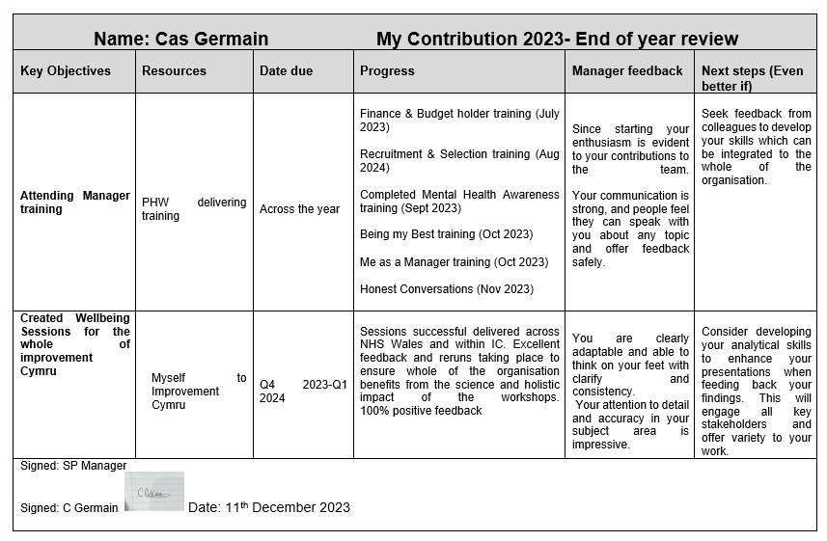
Strengths: My passion for staff wellbeing is evident, as I understand that “wellbeing must be viewed in a positive light; it is not something that brings an organization to its knees, quite the opposite.” (Hesketh & Kooper, 2019: 58)
Working in an agile way is part of my personality, and being a subject specialist ensures the team are getting quality expertise about their wellbeing and ways of working.
Weaknesses: I am confident in sharing information, however as I work alone it’s important to engage with and collaborate with key stakeholders to ensure I am valuing the opinions, ideas and expertise of others, because working inclusively “is important in delivering effective outcomes.” (CIPD, 2023)
Development needs:
Working with the analytics team will develop my analytical skills and ensure I am aligned with the organisation’s ways of working. Also to attend an analytical skills basics course, to understand how to interpret data and present it in an accessible way. As Mello & Goodman (2018) suggest, “data sharing helps fulfill the ethical obligation to make the most of ... participants' contributions.” This ensures that I am working with “fairness of the process used in making decisions”(Cotton, C., 2022).... and as a result it “help(s) create trust” (Cotton, C., 2022) across the organisation, and builds a credible reputation for myself as a people practice professional.

- In follow-up to your self-assessment, identify a range of formal or informal development activities you will undertake to support your ongoing professional development. Your response should include a brief description of your chosen activities and your reasons for selecting them. (AC 3.3)

Reading articles and listening to podcasts on working inclusively and artificial intelligence (AI), because “the way we work with others – and listening to diverse voices in the planning and delivery of our work – is important in delivering effective outcomes.” (CIPD, 2024)
As an ex-teacher I wish to refresh my knowledge in a reading context as the time is right and provides an opportunity for myself to refresh my practice and implement inclusive working, especially disabled colleagues as well as integrating AI, as I plan for future activities within my wellbeing role.
As a people practice professional and with the increase of AI technologies being introduced within the workforce, being people-focused and offering human-focused activities are ways we can increase our interpersonal skills which AI cannot replicate. “An essential element of a truly intelligent type of future of work, however, means that we do expand the workforce where both humans and machine will be part of, but with the aim to improve humanity and well-being while also being more efficient in the execution of our jobs.” (De Cremer, D. & Kasparov, G.,2021).
5. Reflect on the impact of three previous learning activities (i.e., not the activities planned at Q4 above) on your behaviour and performance. The selected activities may be any formal/planned or informal/unplanned activities undertaken in the last 12 months, which you consider to have impacted your behaviour and performance. (AC 3.4)
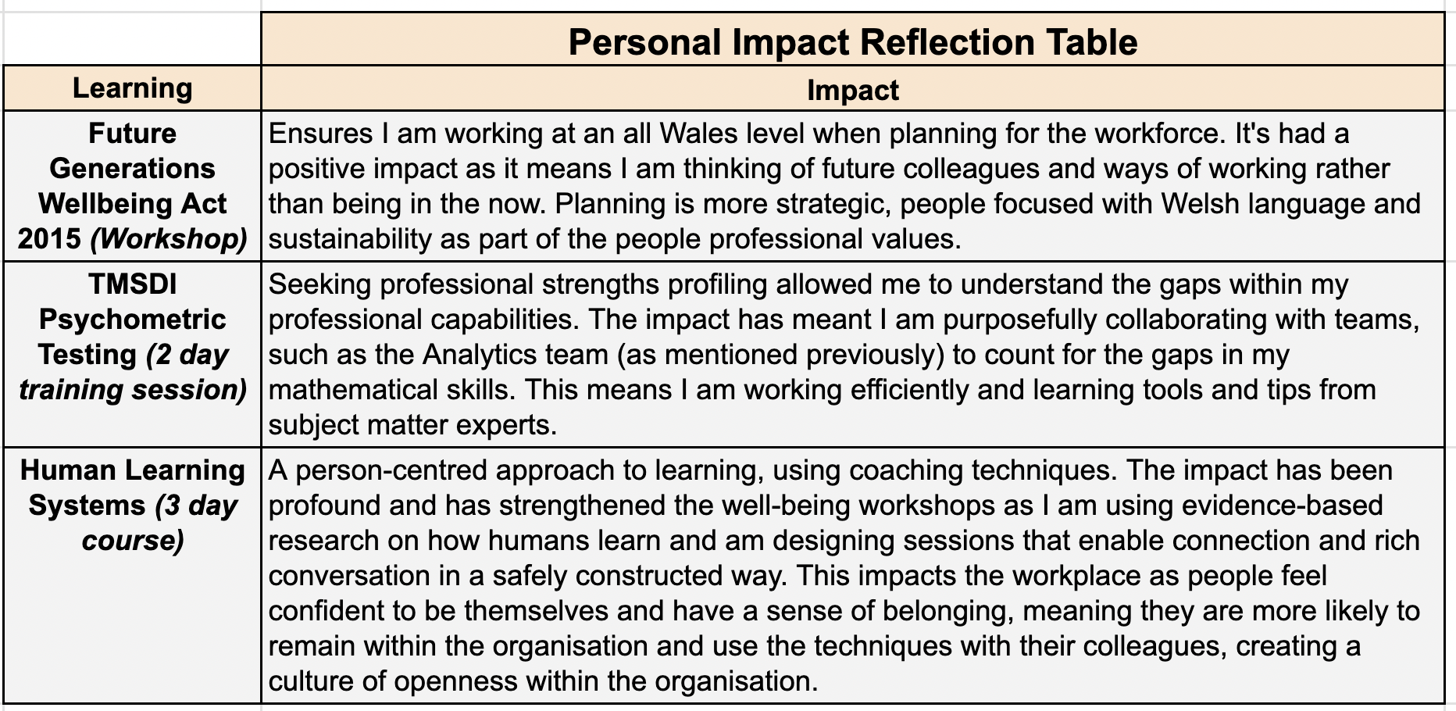

Working in healthcare it’s important my work is accessible to everyone, therefore I have attended courses to learn the plans for the future of Wales, including learning the Welsh language by taking a self directed online course. In doing so, I am not only igniting my passion for learning, but ensuring I am compliant with the NHS’ values & The Well-being of Future Generations Act 2015, which is about improving the social, economic, environmental, and cultural wellbeing of Wales... These are for a more equal, prosperous... and globally responsible Wales, with cohesive communities....and thriving Welsh language.” (Welsh Government, 2023)

“HLS’s unique contribution to addressing... challenges is that it seeks to take a holistic approach.... in the context of complexity.” (Lowe et al., 2021) By asking powerful questions and facilitating in a coaching style has changed the way I conduct sessions as I’ve learnt the importance of holding space for colleagues, which has had a huge impact on people feeling heard and valued.

The TMSDI strengths profiling has had a huge impact on my capabilities with the wellbeing role and has allowed me to speak with confidence in meetings and pitch new ideas as my personality is strongly aligned to this field. As a result I’ve curated purposeful wellbeing sessions, “to develop services in an ever-changing world, but additionally to ensure the future workforce is equipped to lead it effectively.” (Viggars et al., 2022)

References
Anand, R. (2019). Corporate Governance: Role of HR. NHRD Network Journal, 12(4), 301–310. https://doi.org/10.1177/2631454119873154

CIPD (2022). Ethical Practice and the Role of People Professionals. [online] CIPD. Available at: https://www.cipd.org/uk/knowledge/factsheets/ethics-role-hr-factsheet/ [Accessed March 2 2024].
CIPD (2023a). CIPD | Flexible Working Practices | Factsheets. [online] CIPD. Available at: https://www.cipd.org/uk/knowledge/factsheets/flexible-working-factsheet/.(Accessed March 1 2024)
CIPD (2023c). Discipline & Grievance at Work. [online] CIPD. Available at: https://www.cipd.org/uk/knowledge/factsheets/discipline-factsheet/. [Accessed March 2 2024].
CIPD (2022b). Employee Recognition and Non-Finanical Rewards [online] CIPD, pp.1–28. Available at: https://www.cipd.org/globalassets/media/knowledge/knowledge-hub/evidence-reviews/non-financial-recognition-scientific-summary_tcm18-105469.pdf [Accessed 8 Mar. 2024].
CIPD (2022b). CIPD | Equality, Diversity and Inclusion in the Workplace | Factsheets. [online] CIPD. Available at: https://www.cipd.org/uk/knowledge/factsheets/diversity-factsheet/ [Accessed 9 Mar. 2024].
CIPD (2023b). CIPD | Flexible Working Practices | Factsheets. [online] CIPD. Available at: https://www.cipd.org/uk/knowledge/factsheets/flexible-working-factsheet/#title2 [Accessed Mar. 9AD].
Cotton, C. (2022). CIPD | Pay Fairness & Pay Reporting | Factsheets. [online] CIPD. Available at: https://www.cipd.org/uk/knowledge/factsheets/pay-fairness-reporting-factsheet/ [Accessed 12 Mar. 2024].
CIPD (2023). CIPD | The People Profession. [online] CIPD. Available at: https://www.cipd.org/uk/the-people-profession/.(Accessed March 1 2024)
CIPD (2024). CIPD | The Profession Map / Core behaviours / Working inclusively. [online] CIPD. Available at: https://www.cipd.org/en/the-people-profession/the-profession-map/explore-the-profession-map/core-behaviours/working-inclusively/ [Accessed 12 Mar. 2024].
CIPD (2023d). CIPD | the Profession Map / Core Behaviours / Working Inclusively. [online] CIPD. Available at: https://www.cipd.org/uk/the-people-profession/the-profession-map/explore-the-profession-map/core-behaviours/working-inclusively/ [Accessed 11 Mar. 2024].
CIPD (2019). CIPD | Rotten apples, bad barrels and sticky situations: a review of unethical workplace behaviour. [online] CIPD. Available at: https://www.cipd.org/uk/knowledge/evidence-reviews/ethical-behaviour/ [Accessed 8 Mar. 2024].
De Cremer, D. and Kasparov, G. (2021). AI Should Augment Human Intelligence, Not Replace It. [online] Harvard Business Review. Available at: https://hbr.org/2021/03/ai-should-augment-human-intelligence-not-replace-it [Accessed 12 Mar. 2024].
Duff, A., 2009. Code of conduct elevates HR profession. Canadian HR Reporter, 22(13), pp. 23.
Erkutlu, H., & Chafra, J. (2016). Benevolent leadership and psychological well-being: The moderating effects of psychological safety and psychological contract breach. Leadership & Organization Development Journal, 37(3), 369–386. https://doi.org/10.1108/LODJ-07-2014-0129

Equality of Human Rights (2022). Pregnancy and maternity discrimination | EHRC. [online] www.equalityhumanrights.com. Available at: https://www.equalityhumanrights.com/equality/equality-act-2010/your-rights-under-equality-act-2010/pregnancy-and-maternity#:~:text=The%20Equality%20Act%20protects%20you. [Accessed March 8 2024].

Ghosh, S. (2022). Firm Performance and Productivity: Is Labour an Obstacle? Indian Journal of Labour Economics, 65(3), 709–728. https://doi.org/10.1007/s41027-022-00385-7

Government, W. (2023). Welsh language use in the workplace (Welsh Language Use Survey): July 2019 to March 2020 | GOV.WALES. [online] www.gov.wales. Available at: https://www.gov.wales/welsh-language-use-workplace-welsh-language-use-survey-july-2019-march-2020-html [Accessed 12 Mar. 2024].

Hayden, D. (2023). Coaching and Mentoring. [online] CIPD. Available at: https://www.cipd.org/uk/knowledge/factsheets/coaching-mentoring-factsheet/ [Accessed 11 Mar. 2024].
Hesketh, I., & Cooper, C. L. (2019). Wellbeing at work : how to design, implement and evaluate an effective strategy.

Hutson, P., & Hutson, J. (2023). Neurodiversity and Inclusivity in the Workplace: Biopsychosocial Interventions for Promoting Competitive Advantage. Journal of Organizational Psychology, 23(2), 1–16. https://doi.org/10.33423/jop.v23i2.6159

Leroy, H., Dierynck, B., Anseel, F., Simons, T., Halbesleben, J. R. B., McCaughey, D., Savage, G. T., & Sels, L. (2012). Behavioral Integrity for Safety, Priority of Safety, Psychological Safety, and Patient Safety: A Team-Level Study. Journal of Applied Psychology, 97(6), 1273–1281. https://doi.org/10.1037/a0030076

Lewis, S., & Humbert, A. L. (2010). Discourse or reality?: “Work‐life balance”, flexible working policies and the gendered organization. Equality, Diversity and Inclusion: An International Journal, 29(3), 239–254. https://doi.org/10.1108/02610151011028840
Lowe, T., French, M., Hawkins, M., Hesselgreaves, H., & Wilson, R. (2021). New development: Responding to complexity in public services-the human learning systems approach. Public Money & Management, 41(7), 573–576. https://doi.org/10.1080/09540962.2020.1832738

Mansoor, S., Tran, P. A., & Ali, M. (2021). Employee outcomes of supporting and valuing diversity: mediating role of diversity climate. Organization Management Journal, 18(1), 19–35. https://doi.org/10.1108/OMJ-09-2019-0801

Mello, M. M., Lieou, V., & Goodman, S. N. (2018). Clinical Trial Participants’ Views of the Risks and Benefits of Data Sharing. The New England Journal of Medicine, 378(23), 2202–2211. https://doi.org/10.1056/NEJMsa1713258

Mulgan, T. (2019). Utilitarianism (1st ed.). Cambridge University Press. https://doi.org/10.1017/9781108582643

Mulgan, T. (2020) Utilitarianism. Cambridge: Cambridge University Press (Elements in Ethics).

McNeff, M. E., & Irving, J. A. (2017). Job Satisfaction and the Priority of Valuing People: A Case Study of Servant Leadership Practice in a Network of Family-Owned Companies. SAGE Open, 7(1), 215824401668681-. https://doi.org/10.1177/2158244016686813

Pichère, P., & Cadiat, A.-C. (2015). Maslow’s hierarchy of needs (C. Probert, Trans.). Lemaitre Publishing.

Richard Hale, Carolyn Norgate & James Traeger (2018) From nurturing the H in HR to developing the D in OD – systemic benefits where action learning and organisational development combine, Action Learning: Research and Practice, 15:2, 154-167, DOI: 10.1080/14767333.2018.1464712
Rawling, P. (2023). Deontology (1st ed.). Cambridge University Press. https://doi.org/10/1017/9781108581196

Roberson, Q. and Perry, J.L. (2021). Inclusive Leadership in Thought and Action: A Thematic Analysis. Group & Organization Management, 47(4), pp.755–778.

Rogers, K. M., & Ashforth, B. E. (2017). Respect in Organizations: Feeling Valued as “We” and “Me.” Journal of Management, 43(5), 1578–1608. https://doi.org/10.1177/0149206314557159

Taylor, S., & Woodhams, C. (Eds.). (2022). Studying human resource management : a guide to the study, context and practice of HR (Third edition.). KoganPage.

The University of Edinburgh (2020). Gibbs’ reflective cycle. [online] University of Edinburgh. Available at: https://www.ed.ac.uk/reflection/reflectors-toolkit/reflecting-on-experience/gibbs-reflective-cycle [Accessed 9 Mar. 2024].

Viggars, A., Charlton, T., Olsson-Brown, A., Hughes, D., Hindocha, S., & Pickwell-Smith, B. (2022). Acute Oncology: Increasing Engagement and Visibility in Acute Care Settings – The Trainee Perspective. Clinical Oncology (Royal College of Radiologists (Great Britain)), 34(8), 545–548. https://doi.org/10.1016/j.clon.2022.04.008

