Software Development ACCB4017_LON

Assessment 1

Georgi Karachorov 2011240

Lecturer – Renuga Jayakumar

Table of Contents

Introduction

Explanation and Examples

Exercises

Conclusion

Introduction

In this task, I will show my best understanding about what is “Python” and how it works. I will give an explanation followed by examples, to support my theory and to show that I have the skills not only to explain, but also to practice software development. I will provide screenshots, to prove my practice skills. After my explanations about Python, I will do the four exercises given, with an explanation about what have been done in the particular code. Then I will write a conclusion about everything, that have been done in this task.

Explanations and Examples

What is a variable and why are they important in writing programs?

Variable is a piece of data, that stores a value set by the programmer, so the computer can process it. Every variable(data) has a datatype, this can be, “integers” which is datatype that contains a simple number, it can be, “float” which contains a number with floating point, it can be, “string” which contains letters.

Here is the example: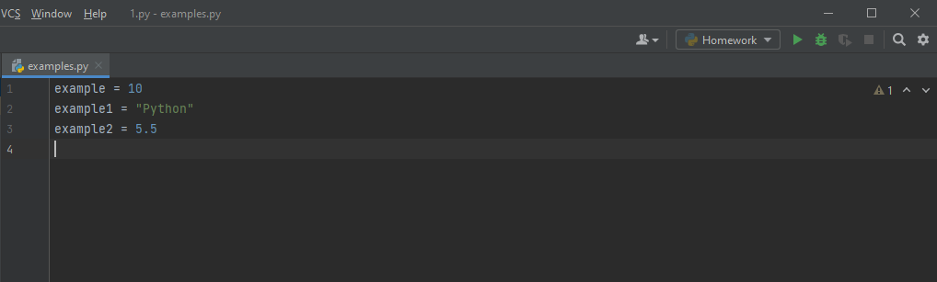

“Example” is datatype – integers.

“Example1” is datatype – string.

“Example2” is datatype – float.

The variable can be unknown value (x), that the programmer can set an option for the user, to type his own variable value. But the datatype needs to be set and the user need to be informed about what datatype he can write.

Here is example about it: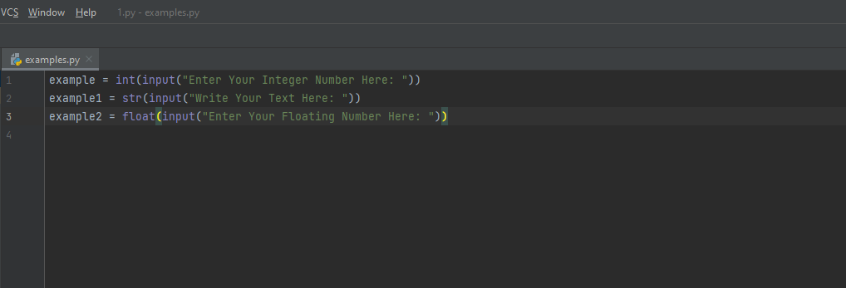
With this method, the user can type his own variable value, then the computer will store this value for future functions, that the program is designed for. The function “input” in Python, allows the user to enter his value. The function before the “input” function, defines the datatype of the value.
“int” – Stands for integer.
“str” – Stands for string.
“float” – Stands for Float.

Now let’s see how the input will looks like.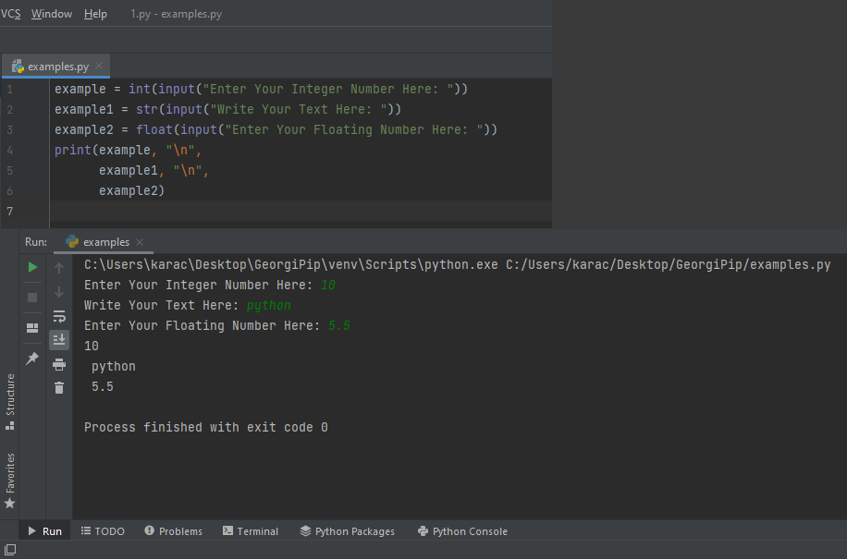
The “print” statement does the function to show us the output for the particular data value.
In this case, we can clearly see that the program prints all three values, that the user typed.
But let’s see what will happen, if the use type wrong datatype. For example, in the section where asks the user to type a number, lets type letters instead.

Here is what will happen: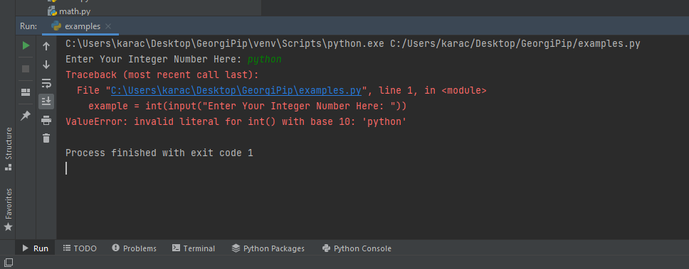
The program indicated an error because the wrong datatype was written. The input is set for numbers not for letters.

And of course, we can print variable that has been already set by the programmer.

Here is an example for it: 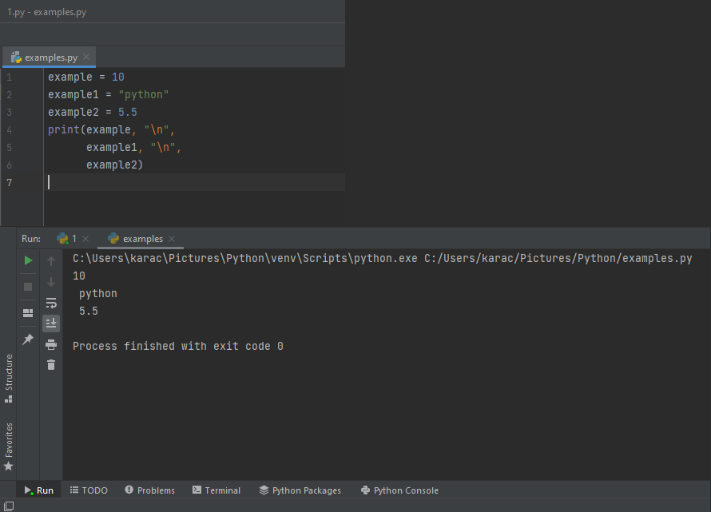

Now lets look at the statements “if” “elif” “else”.

Those statements are basically to create a logic code, or code that can does logical function, based on what the user types. They can also be used to create rules. Those statements are very important in the programming.
Here is one example: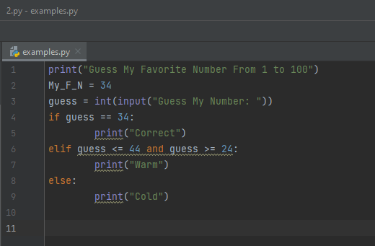
In this example, the use is asked to guess a number between 1 and 100. The “if” statement has been used to set the rule that contains the value of the varible “My_F_N” which is 34. The rule is simple, if the user type the number 34, the program will print “correct” and he will win. The second statement “elif” sets different rule. If the number that the user typed is smaller or iqual to 44 and bigger or iqual to 24, then the proggram will print “warm” to indicate that the user was close to the correct number. The 3th statement was set with the rule that prints “cold” for any other numbers that are different from the rules that have been set in the first and the second statements.

Here is examples of the actual output of this logic code: 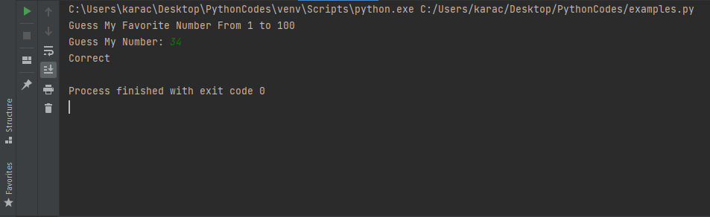
This is the correct number.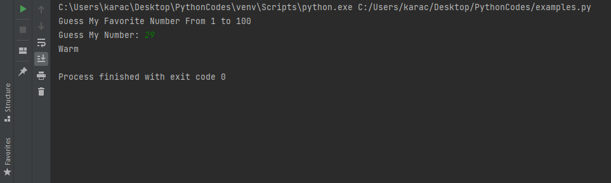
This is a random number, closer to the correct one. 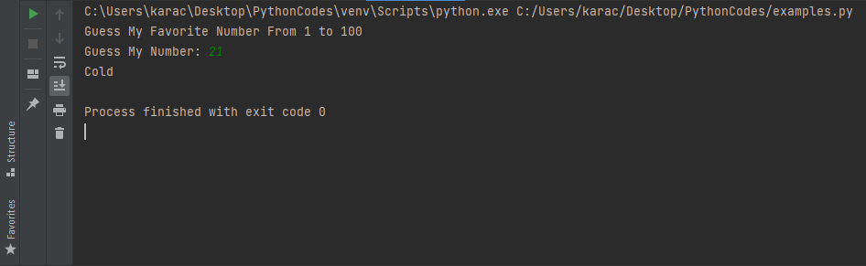
And last example is, a random number that is far away from the correct one.

What are the loops and why they are need it in the programming?

I am going to explain the two loops “for” and “while”.
Firs think first, what do the loops do. The loops can execute a code as many times as need, till certain condition is met. In other words, they do exactly what their name is. They create loops. A piece of code, that is designed to repeat the same loop till the requirement is met. One more useful function that the “for” loop can does is, creating a list of numbers or words, depends on how the programmer design it, then print this list. Those two loops can be combined in one code, even more the loops can be combinate with the statements: “if” “elif” “else”. I will show how does this work in the 4th exercise given in this assessment. After all that have been said, it is clear that the loops are very important part in the programming. It is time for the examples.

First let’s take a look how “for” loop can be used to list the numbers from 0 to 100: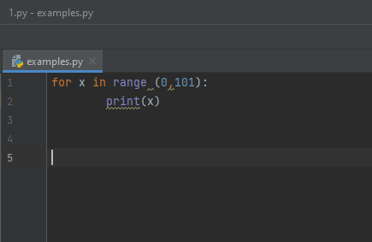
This is a simple example.

And there is the output:
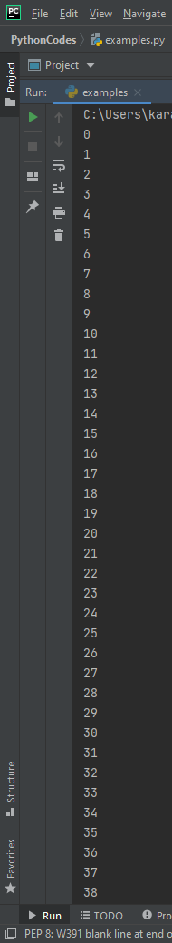

I can’t take so big screenshot to show all numbers but all numbers from 0 till 100 have been printed.
However we can set the code to stop listing till certent number by using “brake”.
Like this:
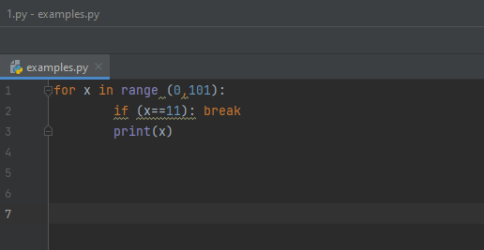
Now the code will execute only the numbers from 0 till 10. Python is designed to count -1 so in order to count till 10, the programmer need to set the counting option in the code to be till 11.
And the output: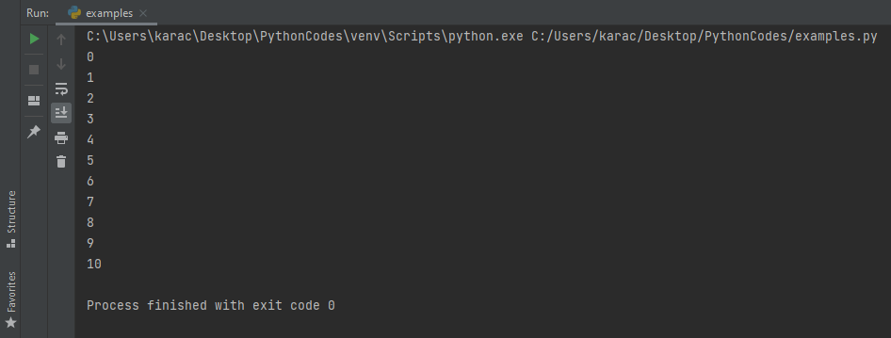
It can be seen that “for” loop has been combined with the statement “if”.

Now let’s see how “for” loop can list an order of words.
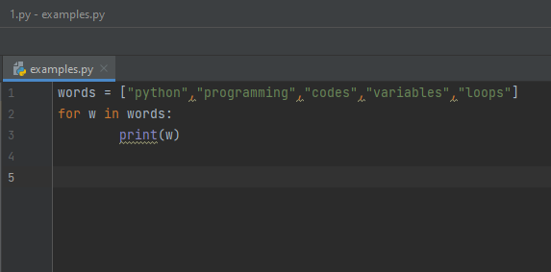
This is the code that will execute all those words. Let’s do it.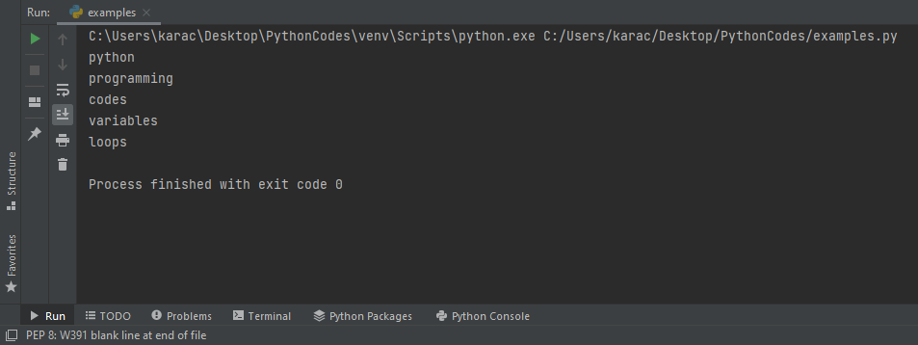
All words set by the programmer have been executed.
There are some different options that the programmer can do with “for” loop. I will make one example. Let’s say that I want to print each word 5 times.
This is how: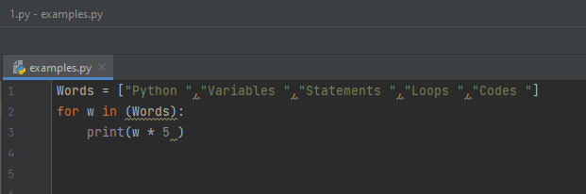
By simply add multiply symbol and then the number 5, I have made the code to execute each word 5 times.

Here is the result: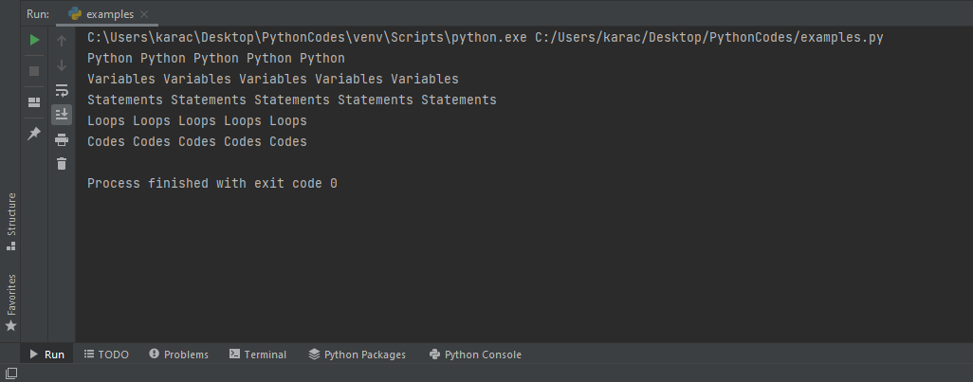

Now let’s take a look about “while loop.

Let’s create a code with “while” loop: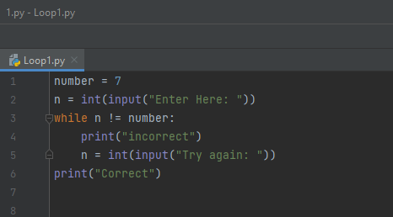
Here it is. Now here, we have repeatable loop, that will continue asking for value and it will end once the required value is met. In this case the required value is the number “7”. The loop starts in the line 3, where the rule is set. It is simple rule, if the input value is not equal to the number “7”, then the program will print “incorrect” and will ask the user to try again, till the required value is met. Once the correct number is typed, the program will print “correct”.
Let’s see how this looks like.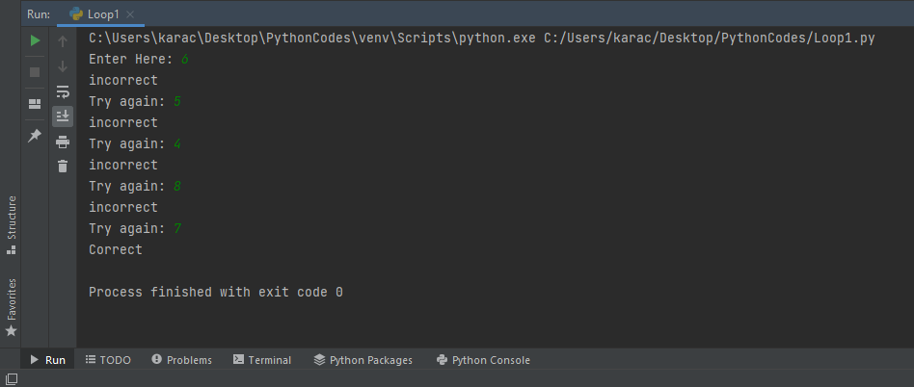Every time, that number who is not equal to “7” was type, the program continues asking the user to try again. Finally, when the correct value of number “7” was type, the program printed “correct”, and the loop has been closed.
Now let’s see how “while” loop can be combinate with the statements “if”, “elif”, “else”.
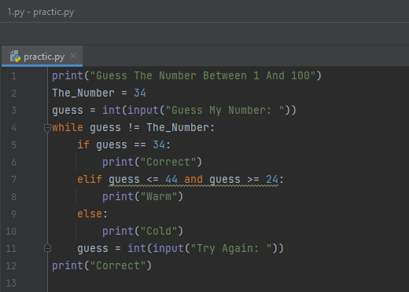
Here, the correct value that is required from the program is “34”. The same rule has been set, if the number that the use type is not equal to 34, the loop starts. But here “if” statement is used, to define the correct value and to print “correct”. However, if the user does not guess the number, the “elif” statement comes to give the user a hunt, by setting the rule to print “warm” if the user types a number that is smaller or equal to 44 and greater or equal to 24. If the number from the user is different than the rule from the “elif” statement, the program will print “cold”, due to the rule set from "else" statement.
Here is the output:
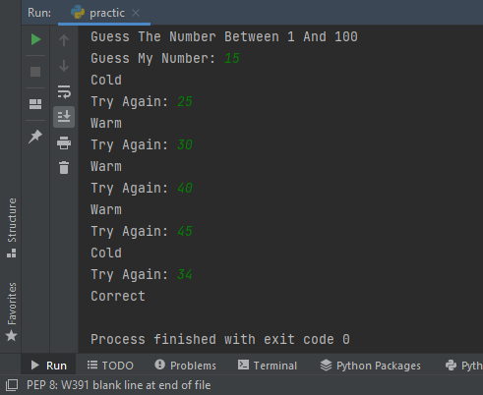
Now let’s combinate “for” loop, with the "if" statement. I will create a list of numbers, then will write a code, to skip all odd numbers and print only the even numbers from the list.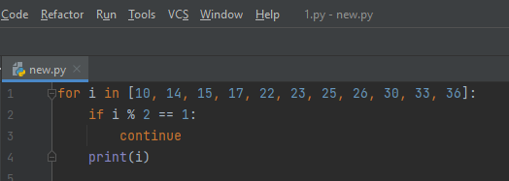So, this is my list of even and odd numbers. The symbol “%” in Python is used to find the remainder of the division for two numbers. So, the rule is simple, if there are numbers in the list who divided by 2 will produce remainder equal to 1, the program will skip those numbers.
Here is the result: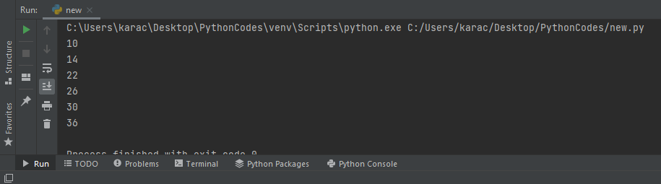
All odd numbers from the list have been skipped, and only the even numbers were printed.

The Exercises

The Exercise 1:
Show how variables can contain different types of values...…etc.
The code:
A = str(input("Please Enter The Car's Model: "))
B = float(input("Please Enter The Car's Mileage: ")) # Three different variables A B and C are given for the user to type
C = int(input("Please Enter The Number of Doors: "))
print("The Model is: ", A, "\n"
"The Mileage is: ", B, "\n" # The print function will display everything that the user types
"The Number of Doors is: ", C) # Each variable will be printed separately due to the \n command
(The code looks like a screenshot, but it is not and can be copied)
Output: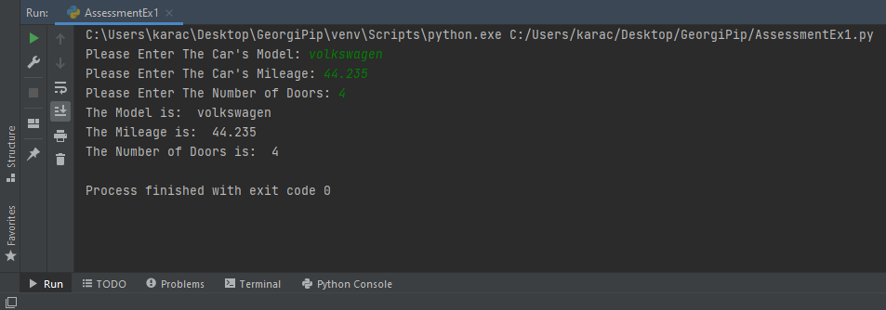
This is just to show different types of variables and to allow the user to type it. In this case there are 3 types: string(letters), float(number with floating point) and integer(just number).

Exersice 2:
A person wants to grow carrots in a vegetable bed……. etc.

The code:

A = int(input('Please Enter Your Vegetable Bed in Square Meters "cm" Horizontally: '))
B = int(input('Please Enter Your Vegetable Bed in Square Meters "cm" Vertically: ')) # Two variables A and B are given for the user to type
C = (A*B//64) # Simple math calculation for calculating the square meters given from the user
print("The Amount of Carrots That Your Can Growth is: ", C) # Print the result

Output:
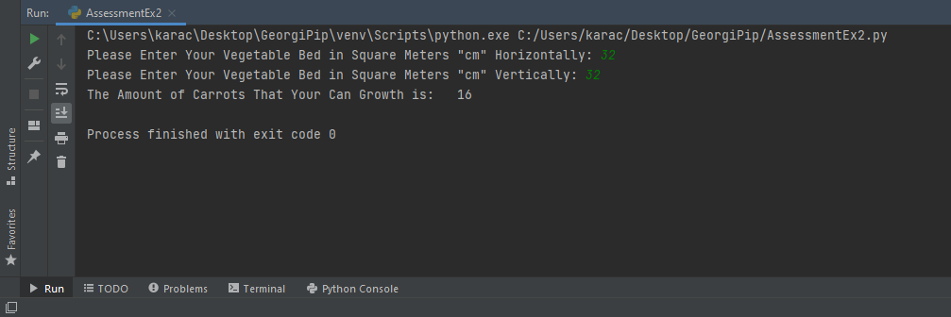
This is a simple code, that calculate how many carrots can grow in the particular area. The user writes the details of his area, then the code calculates it. The symbol “//” in Python is use exactly for this purpose, calculating area.
Here is one more example: 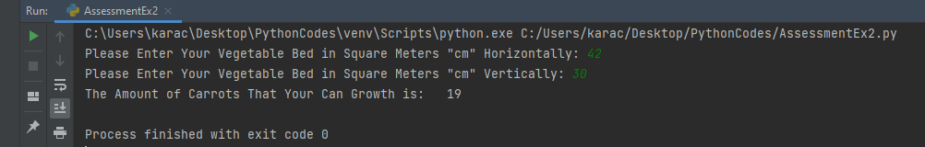

Exercise 3:
Write a program that allows the user to enter the names of five products into an array/list……and so on.
For this exercise I did two different codes. One is without loops, the other one is with “for” loop.
Here is the code without loops:
print("Please Enter You Five Chosen Products")
A = str(input("Enter Your 1st Product: "))
A1 = float(input("Enter The Price For The 1st Product: "))
B = str(input("Enter Your 2nd Product: "))
B1 = float(input("Enter The Price For The 2nd Product: "))
C = str(input("Enter Your 3rd Product: ")) # Here are all variables for the user to type
C1 = float(input("Enter The Price For The 3rd Product: "))
D = str(input("Enter Your 4th Product: "))
D1 = float(input("Enter The Price For The 4th Product: "))
E = str(input("Enter Your 5th Product: "))
E1 = float(input("Enter The Price For The 5th Product: "))
print("1:", A, "£", A1, "\n"
"2:", B, "£", B1, "\n"
"3:", C, "£", C1, "\n" # Prints the products and their price
"4:", D, "£", D1, "\n"
"5:", E, "£", E1)
total = (A1+B1+C1+E1)
total1 = total*0.15 # calculation function to define the price after the 15% of discount
total2 = total - total1
print("The Total Amount is: £", total, "\n" # Print the result
"Your Discount is 15%", "\n"
"The Amount After The Discount is: £", total2)
Three different types of variable for the user to write, the calculation and displaying the result.
The result:
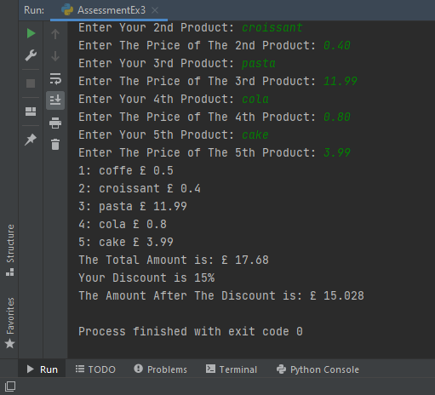

Now the code with “for” loop:
print("Check You Staff Discount")
f = str(input("Enter You Food: "))
d = str(input("Enter Yuo Drink: ")) # The four variables f d a and p for the user to type
a = str(input("Add Something Additional: "))
p = float(input("Enter The Total Price: "))
for x in f, d, a, p: # The for loop that will list all variables from the user
print(x)
total = (p)
total1 = total*0.15 # Math function for calculating the discount
total2 = total - total1
print("The Total Amount is: £", total, "\n" # Print the result
"Your Discount is 15%", "\n"
"The Amount After The Discount is: £", total2)

This code is smaller than the first one but does the same thing. The “for” loop is used to display everything that the user write, the simple calculation does its job and display it.
Here is the result:
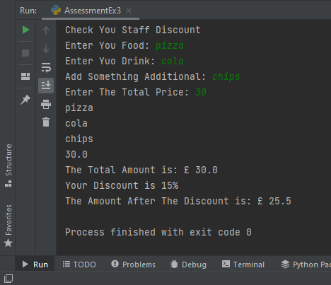

Exercise 4:
Treasure hunt.
I did not do the exact same game from the description, but I did something similar.
Here it is:
print("Guess The Winning Number From 0 to 25", "\n"
"You Have Only 3 Attempts!")
treasure = 13 # The variables 13 or the wining number
attempts = 1 # The user trying attempt
guess = int(input("Try You Luck: ")) # Input function for the user to try his luck
while guess != 13 and attempts <3: # While loop that set the rule for the game
if guess == 1 or 2 or 3 or 4 or 5 or 6 or 7 or 8 or 9 or 10 or 11 or 12 or 14 or 15 or 16 or 17 or 18 or 19 or 20 or 21 or 22 or 23 or 24 or 25:
print("Wrong") # The if statement that will print "wrong" if any of the listed number was typed
guess = int(input("Try You Luck: ")) # Input for the second chance of guessing
attempts = attempts + 1 # + One more chance for the user
if attempts >= 3: # The if statement that set the rule if there are more of 3 attempts then the user losses
print("You Have Lost")
if guess == treasure: # The if statement that print "Well done" if the user types the correct number
print("Well Done :)")

This is a game that asks the user to guess a winning number. The catch is that the user has only 3 attempts. “While” loop is used to repeat the guessing loop. If the user writes three wrong guesses, the game will display “You Have Lost”. If the user writes the correct number, the game will display “Well Done”.
Here are few output examples:
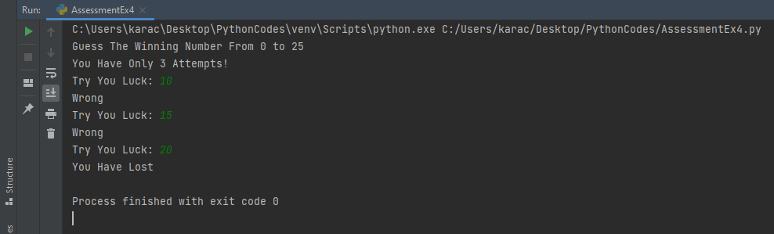
This is the result if the user writes three times wrong number.

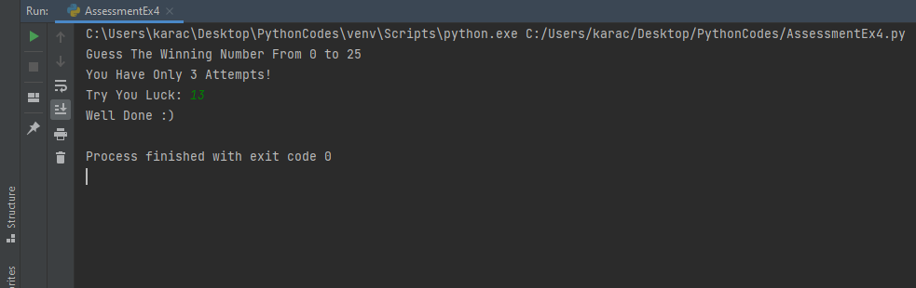
This is the result if the user writes the correct number.

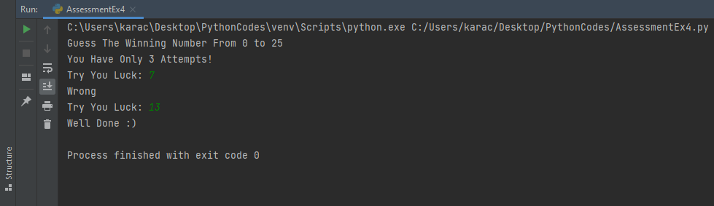
This is the result if the user writes one wrong and then the correct number.

Conclusion.

During this task, I explained what the variables in Python are, what are the statements “if”, “elif” and “else” and their functionality, the two loops “for” and “while” and how they work, I provided examples and explanation of each of them. Then I did the three exercises, follow by examples and explanation as well.
I have learned a lot during this module, going to the fact that I have never study programming language before. Everything was completely new for me and I enjoyed. Everything that I have displayed above, come from my personal skills, that I have gathered during this module. Python is an amazing language, and I will continue to explore it.

Georgi Karachorov

