

Student Name: Daniel Petcu
LCLM5006
DEVELOPING EMOTIONAL INTELLIGENCE SKILLS

COMPONENT TWO: INDIVIDUAL REPORT

Table of Contents
Introduction 2
1. Critical Evaluation of Emotional Intelligence in the Workplace 2
Theoretical Foundations of Emotional Intelligence 3
Self-Awareness and Workplace Behaviour 4
Self-Regulation in Professional Contexts 4
Motivation and Emotional Resilience 5
Empathy and Workplace Relationships 5
Social Skills and Organizational Interaction 6
Mindfulness as a Tool for Developing Emotional Intelligence 6
Critical Evaluation of Emotional Intelligence in the Workplace 7
2. Generational Differences and Recruitment: Implications for Effective Work Environments 7
Introduction 8
Understanding Generational Diversity in Organizations 8
Generation X: Autonomy and Experience 8
Generation Y (Millennials): Meaning and Progression 9
Generation Z: Technology and Flexibility 10
Implications for Recruitment Strategies 10
Creating an Inclusive Multi-Generational Work Environment 11
Critical Evaluation of Generational Approaches 11
Conclusion 12
Recommendations 13
List of References 13

Introduction
In contemporary organizational environments, the ability to understand and manage people effectively has become a critical determinant of success. This report has explored two key areas that significantly influence workplace performance: emotional intelligence and generational diversity. Emotional intelligence provides a framework through which employees can regulate their own emotions, understand others, and navigate complex interpersonal dynamics. At the same time, generational diversity introduces varying expectations, values, and communication styles, which must be carefully managed to maintain cohesion and productivity.
The earlier sections of this report demonstrated that emotional intelligence is not only a theoretical construct, but a practical skill set that can enhance decision-making, leadership, and collaboration. Similarly, the analysis of Generations X, Y, and Z highlighted that employee are shaped by different socio-economic and technological experiences, influencing how they engage with work and organizational structures. These insights emphasize that effective management requires both emotional awareness and an understanding of workforce diversity.
Therefore, this final section brings together the key findings of the report, providing a concise conclusion and practical recommendations for managers seeking to create inclusive, high-performing work environments.

1. Critical Evaluation of Emotional Intelligence in the Workplace
Emotional intelligence (EI) is widely recognized as a key determinant of employee effectiveness, influencing workplace relationships, decision-making, and overall organizational performance. As noted by Daniel Goleman, individuals who lack awareness of their own emotional states are less capable of accurately interpreting the emotions of others. This is particularly significant in professional settings, where interactions, judgment, and responses to pressure are strongly shaped by emotional awareness.
The submitted poster highlights those emotions such as anxiety, stress, and motivation have a direct impact on performance, especially in environments requiring sustained cognitive effort. Although these ideas are explored within an academic context, they are equally applicable to organizational settings, where employees face similar emotional demands. Consequently, this section provides a critical discussion of how emotional intelligence components are used in the workplace, drawing on established theoretical models while incorporating practical insights reflected in the poster.

Theoretical Foundations of Emotional Intelligence
Emotional intelligence has been explained through two main theoretical perspectives, each offering different implications for its application in professional environments. The Ability Model developed by Salovey, and Mayer (1990) conceptualises EI as a form of intelligence centered on the processing of emotional information. It proposes that individuals must be capable of accurately recognizing emotions, using emotions to support thinking, understanding emotional processes, and effectively regulating emotional responses. One of the key advantages of this model is its strong theoretical foundation, positioning EI as a measurable cognitive ability.
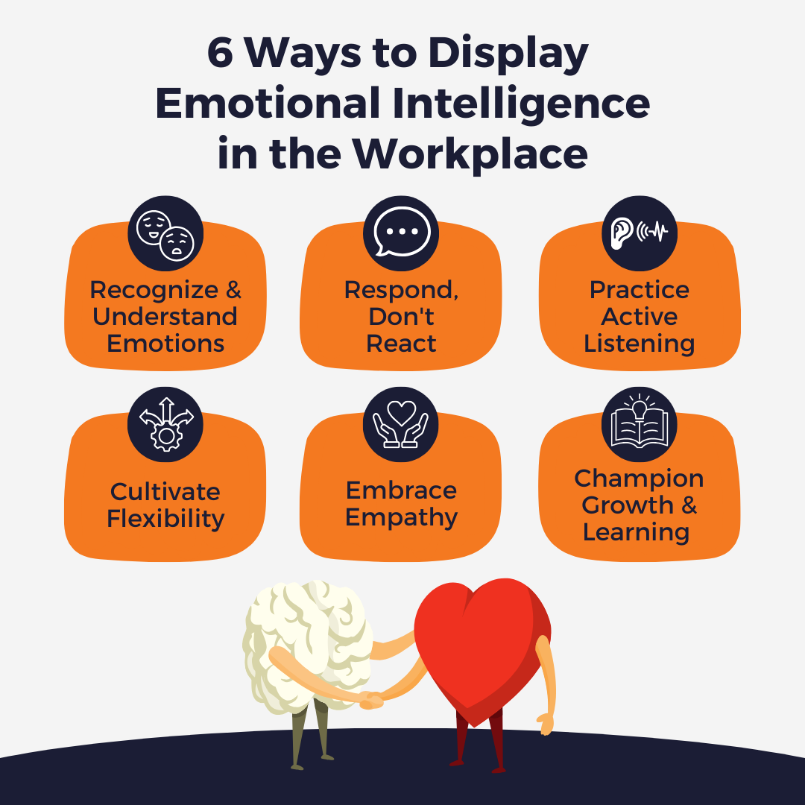
However, despite its conceptual strength, the model has been criticized for its limited relevance to real workplace behaviour. Organizational environments involve complex interpersonal dynamics, situational pressures, and personality influences that extend beyond purely cognitive processes. Therefore, while the Ability Model is valuable for explaining the structure of emotional intelligence, it may not fully reflect how emotional competencies operate in practice.
Alternatively, Goleman's Mixed Model (1995) adopts a broader approach by incorporating behavioural and social competencies such as self-awareness, self-regulation, motivation, empathy, and social skills. This framework has been widely adopted in organizational research due to its direct connection with leadership performance and employee effectiveness. Nevertheless, it has also faced criticism for its lack of conceptual precision, particularly due to its overlap with personality traits and general social competence (Landy, 2005).
From a critical standpoint, both models offer important contributions. The Ability Model provides clarity and measurement potential, whereas Goleman's model offers greater applicability in workplace contexts. A comprehensive evaluation of emotional intelligence therefore requires consideration of both perspectives.

Self-Awareness and Workplace Behaviour
Self-awareness is often regarded as the core element of emotional intelligence, as it involves recognizing one's emotions and understanding their influence on behaviour. In professional environments, employees who possess strong self-awareness are more capable of managing stress, evaluating their performance, and adjusting their behaviour in response to different situations.
The poster suggests that individuals who lack emotional awareness may experience decreased productivity and may avoid demanding tasks. This insight is highly relevant to workplace settings, where employees frequently encounter pressure through deadlines, targets, and performance expectations. Without self-awareness, individuals may react defensively or disengage, which can negatively affect both individual and team outcomes.
Importantly, self-awareness is not an inherent ability but develops through conscious reflection. McCann et al. (2020) argue that reflective practices enable individuals to identify emotional triggers and understand how these influence their behaviour. This aligns with the strategies outlined in the poster, which emphasize reflection as a method of enhancing emotional understanding. However, the development of self-awareness may be constrained by personal biases or organizational cultures that discourage open reflection and emotional expression.

Self-Regulation in Professional Contexts
Self-regulation refers to the ability to manage emotional reactions in a controlled and appropriate manner. Within the workplace, this includes maintaining composure under pressure, responding constructively to feedback, and avoiding impulsive behaviours that could disrupt professional relationships.
The poster identifies mindfulness as an important strategy for supporting self-regulation. By encouraging individuals to observe their emotions without reacting immediately, mindfulness creates an opportunity for more thoughtful and rational responses. Supporting this view, Davis and Hayes (2011) highlight that mindfulness improves both emotional control and cognitive functioning.
Despite these benefits, self-regulation can also present challenges. While managing emotions is generally advantageous, excessive control may result in emotional suppression. Grandey (2000) argues that prolonged suppression, particularly in roles involving emotional labour, can lead to stress and burnout. Therefore, effective self-regulation requires a balance, allowing individuals to manage emotions without completely suppressing them.

Motivation and Emotional Resilience
Within emotional intelligence frameworks, motivation is associated with an individual's ability to remain focused and committed despite difficulties. Employees who demonstrate high emotional intelligence are often resilient, persistent, and capable of maintaining long-term goals.
The poster highlights the importance of resilience in maintaining engagement during challenging situations. In organizational contexts, this is reflected in an employee's capacity to cope with pressure, adapt to change, and recover from setbacks. Perkin and Linnenbrink-Garcia (2012) suggest that emotional experiences, such as anxiety or frustration, can significantly influence motivation, depending on how they are managed.
However, the inclusion of motivation within emotional intelligence has been debated. Some researchers argue that motivation extends beyond emotional processes and should be considered a broader psychological construct (Zeidner et al., 2008). Nevertheless, in practical terms, motivation remains closely linked to emotional regulation and resilience, making it an important factor in workplace performance.

Empathy and Workplace Relationships
Empathy plays a vital role in emotional intelligence by enabling individuals to recognize and understand the emotions of others. In workplace environments, this supports effective communication, collaboration, and conflict resolution.
The poster emphasizes the importance of respectful communication and expressing concerns appropriately in group settings. This reflects how empathy contributes to building trust and fostering positive relationships within teams. Employees who demonstrate empathy are more likely to support colleagues and contribute to a cooperative working environment.
However, empathy must be applied carefully. While understanding others' emotions is beneficial, excessive emotional involvement may reduce objectivity, particularly in leadership roles. Effective use of empathy therefore requires maintaining professional boundaries while still demonstrating understanding.

Social Skills and Organizational Interaction
Social skills represent the practical expression of emotional intelligence in everyday interactions. These include communication, teamwork, and the ability to influence others. Employees with strong social skills are better able to navigate organizational dynamics and contribute to collective goals.
The poster's focus on collaboration and peer support highlights the importance of social interaction in managing emotional challenges. In workplace settings, this translates into improved teamwork and more effective knowledge sharing.
Critically, social skills depend on underlying emotional competencies such as self-awareness and empathy. Without these foundations, interactions may appear superficial or ineffective. Additionally, there is a potential ethical concern, as individuals with advanced social skills may use them to manipulate others for personal advantage (Kilduff et al., 2010).

Mindfulness as a Tool for Developing Emotional Intelligence
Mindfulness is increasingly viewed as a key approach to enhancing emotional intelligence. By encouraging present-moment awareness, mindfulness enables individuals to observe their thoughts and emotions without immediate judgment.
As demonstrated in the poster, mindfulness supports emotional regulation and improves concentration. In organizational contexts, this can lead to reduced stress, improved focus, and better decision-making. Employees who practice mindfulness are often more capable of managing workplace pressures effectively.
However, mindfulness is not a quick solution. Its benefits depend on consistent practice and organizational support. Without integration into workplace culture, mindfulness initiatives may lack effectiveness or be perceived as superficial.

Critical Evaluation of Emotional Intelligence in the Workplace
Emotional intelligence provides several advantages within organizations, including improved communication, stronger leadership, and enhanced stress management. These benefits are supported by both theoretical models and practical applications, as reflected in the poster.
Nevertheless, there are limitations that must be considered. The lack of a unified definition of emotional intelligence creates challenges in measurement and application. Furthermore, the overlap between EI and personality traits raises questions about its distinctiveness. There is also the risk that emotional intelligence may be used strategically for manipulation, particularly in roles involving influence.
Despite these challenges, emotional intelligence remains a valuable framework for understanding behaviour in the workplace. Its significance lies in its practical relevance and its potential for development rather than its theoretical precision.

2. Generational Differences and Recruitment: Implications for Effective Work Environments

Introduction
Contemporary organizations increasingly consist of employees from a range of generational backgrounds, each contributing differently to organizational outcomes. These groups—typically classified as Generation X, Generation Y (Millennials), and Generation Z—have developed within distinct social, economic, and technological contexts, which shape their expectations of work, communication preferences, and career priorities. For managers, recognizing these differences is essential when designing recruitment strategies and fostering effective work environments. Failure to account for generational variation may lead to a disconnect between organizational practices and employee expectations, ultimately affecting engagement and performance.
This section provides a critical analysis of the defining characteristics of Generations X, Y, and Z, and explores how managers can adjust recruitment approaches and workplace practices to accommodate generational diversity while maintaining organizational effectiveness.
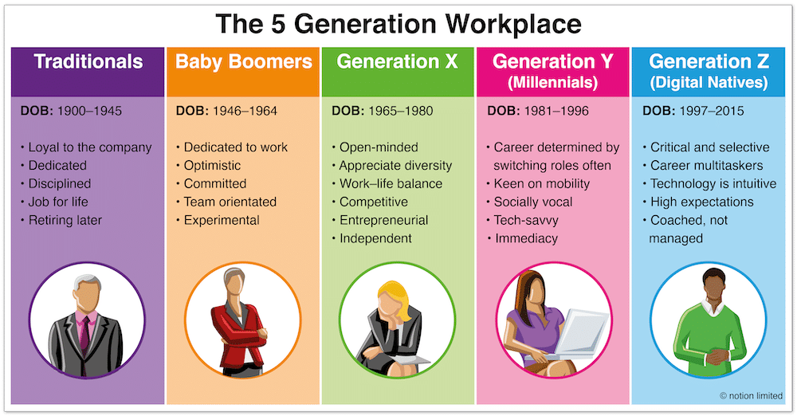

Understanding Generational Diversity in Organizations
Generational diversity refers to the coexistence of employees from different age groups within the same workplace, each influenced by the social conditions experienced during their formative years. As proposed by Karl Mannheim, shared historical experiences play a significant role in shaping generational values, behaviours, and expectations.
Within modern organizations, such diversity offers both advantages and challenges. On the positive side, it enables access to a broader range of skills, perspectives, and experiences, which can enhance innovation and problem-solving. However, it may also result in communication difficulties, differing work preferences, and conflicting expectations. Managers are therefore required to adopt strategies that both acknowledge generational differences and promote cohesion within teams.

Generation X: Autonomy and Experience
Individuals belonging to Generation X, generally born between the mid-1960s and early 1980s, are often associated with independence, adaptability, and a results-oriented mindset. Having experienced economic instability and organizational restructuring, this group tends to value job security, efficiency, and the ability to work autonomously (Superhumid, 2000).
In recruitment settings, Generation X candidates are typically drawn to roles that provide clarity in responsibilities, stability, and the opportunity to exercise independence. Their decision-making is often guided by practical considerations, such as how well the role aligns with their existing skills and long-term career trajectory.
From a management perspective, supporting this group requires balancing structured expectations with flexibility. While clear guidance is appreciated, excessive control may reduce motivation, as Generation X employees often prefer to manage their own work processes. Nevertheless, it is important to avoid assuming uniformity within this group, as individual differences and career stages may significantly influence behaviour.

Generation Y (Millennials): Meaning and Progression
Generation Y, commonly known as Millennials and typically born between the early 1980s and mid-1990s, is frequently described as a cohort that values ​​purpose, collaboration, and professional growth. Growing up during a period of rapid technological advancement and expanded educational opportunities has shaped their expectations of work environments.
Millennials often seek employment that offers a sense of meaning, opportunities for career development, and alignment with organizational values ​​(Twenge et al., 2010). During recruitment, they are more likely to be influenced by an organization's culture, mission, and potential for growth rather than focusing solely on financial incentives.
To attract and retain this group, managers must prioritize development opportunities, continuous learning, and clear progression pathways. Regular feedback is also particularly important, as Millennials tend to value ongoing communication regarding their performance.
Although Millennials are sometimes perceived as expecting rapid advancement or demonstrating reduced organizational loyalty, such interpretations may oversimplify their behaviour. Research indicates that these tendencies may reflect broader changes in the labour market rather than inherent generational traits (Costanza et al., 2012). Consequently, organizations should adapt to these expectations rather than dismiss them, recognizing the growing importance of purpose-driven work.

Generation Z: Technology and Flexibility
Generation Z, generally defined as individuals born from the mid-1990s onwards, represents the newest generation entering the workforce. Having grown up in a digital environment, they are often described as technologically proficient and highly adaptable.
This generation tends to prioritize flexibility, access to technology, and opportunities for continuous learning (Schroth, 2019). They are comfortable using digital tools for communication and expect organizations to integrate modern technologies into everyday work practices.
In terms of recruitment, Generation Z candidates are particularly influenced by organizations that demonstrate innovation, inclusivity, and social responsibility. They are also more likely to conduct extensive research on potential employers, often relying on online platforms to evaluate organizational culture and reputation.
Managers must therefore ensure that recruitment processes are accessible through digital channels and reflect contemporary expectations. Traditional methods may be less effective, as this generation prefers interactive and engaging recruitment experiences.
However, Generation Z may encounter challenges when transitioning into professional environments, particularly in developing interpersonal skills and adapting to formal workplace structures. As a result, managers should provide guidance and support to facilitate this adjustment.

Implications for Recruitment Strategies
An understanding of generational differences is essential for designing effective recruitment processes, as it directly influences how organizations attract and retain talent. A uniform recruitment strategy is unlikely to meet the needs of a diverse workforce.
For Generation X, recruitment should highlight stability, clearly defined roles, and opportunities for independence. In contrast, appealing to Millennials requires emphasizing organizational values, career progression, and a supportive work culture. For Generation Z, recruitment approaches should incorporate digital engagement, technological innovation, and opportunities for skill development.
However, it is important to critically consider the limitations of tailoring recruitment solely based on generational categories. While such approaches can improve engagement, they may also lead to stereotyping. Managers must therefore combine generational insights with an understanding of individual differences to ensure fairness and inclusiveness in recruitment practices.

Creating an Inclusive Multi-Generational Work Environment
Beyond recruitment, managers must consider how to support employees from different generations within the workplace. This involves creating an environment that encourages collaboration, communication, and mutual respect.
Flexible working arrangements are one effective strategy, as they accommodate varying preferences across generations. For example, older employees may prioritize work-life balance, while younger employees may value flexibility and autonomy. Additionally, mentoring initiatives can promote knowledge exchange, allowing experienced employees to guide newer entrants while also benefiting from fresh perspectives.
Leadership plays a crucial role in managing generational diversity. Managers must demonstrate adaptability and emotional intelligence, ensuring that they respond to individual needs rather than relying solely on generational assumptions.

Critical Evaluation of Generational Approaches
Although generational frameworks offer useful insights, they are not without limitations. A key criticism is that they may oversimplify human behaviour by assigning characteristics to entire groups. This can result in stereotyping and may overlook other influential factors such as personality, cultural background, and individual experiences.
Furthermore, empirical research on generational differences presents mixed findings. Costanza et al. (2012) suggest that differences between generations are often less pronounced than commonly assumed, indicating that organizational practices should focus more on individual needs than broad generational categories.
Despite these limitations, generational analysis remains a valuable tool when applied critically. It can assist managers in anticipating potential differences in expectations and adapting their approaches accordingly, provided it is used flexibly rather than rigidly.

Conclusion
The evaluation undertaken in this report confirms that emotional intelligence plays a fundamental role in shaping employee behaviour and organizational effectiveness. Employees who demonstrate strong self-awareness, emotional regulation, empathy, and social competence are better equipped to manage workplace challenges, build relationships, and contribute to team performance. However, the report also highlighted that emotional intelligence is not without limitations, particularly in relation to its conceptual ambiguity and potential overlap with personality traits.
In addition, the analysis of generational differences revealed that employees from Generations X, Y, and Z bring distinct expectations and working styles into the organization. While these differences can create challenges, such as communication barriers or conflicting priorities, they also present opportunities for innovation and knowledge sharing. Importantly, the findings suggest that generational characteristics should not be applied rigidly, as individual differences remain highly significant.
Overall, the report demonstrates that both emotional intelligence and generational awareness are essential for effective management. Organizations that fail to recognize these factors risk reduced employee engagement, lower productivity, and increased workplace conflict. Conversely, those that successfully integrate emotional intelligence development and inclusive practices are more likely to achieve sustainable performance and positive organizational culture.

Recommendations
Based on the findings of this report, several practical recommendations can be proposed to support managers in creating effective work environments.
Firstly, organizations should invest in the development of emotional intelligence through targeted training programs. Workshops focusing on self-awareness, emotional regulation, and communication skills can help employees better understand their own behaviour and improve interactions with others. Embedding reflective practices, such as feedback sessions or coaching, can further support ongoing development.
Secondly, recruitment strategies should be adapted to reflect generational diversity while avoiding stereotyping. Managers should ensure that job roles, organizational values, and development opportunities are clearly communicated in ways that appeal to a broad range of candidates. At the same time, recruitment decisions should prioritize individual competencies rather than relying solely on generational assumptions.
Thirdly, organizations should promote flexible working practices to accommodate diverse employee needs. Flexibility in working hours, communication methods, and career progression pathways can enhance engagement across all generations. This approach recognizes that employees value different aspects of work depending on their personal circumstances and career stage.
Finally, leadership development should emphasize adaptability and inclusive management. Managers must be equipped to recognize individual differences, manage diverse teams, and create environments where employees feel valued and supported. This includes fostering open communication, encouraging collaboration, and addressing potential conflicts constructively.

List of References
Bar-On, R. (2006) 'The Bar-On model of emotional-social intelligence (ESI)', Psicothema, 18, pp. 13–25.
Carmeli, A. (2003) 'The relationship between emotional intelligence and work attitudes, behavior and outcomes', Journal of Managerial Psychology, 18(8), pp. 788–813.
Costanza, DP, Badger, JM, Fraser, RL, Severt, JB and Gade, PA (2012) 'Generational differences in work-related attitudes: A meta-analysis', Journal of Business and Psychology, 27(4), pp. 375–394.
Davis, DM and Hayes, JA (2011) 'What are the benefits of mindfulness? A practical review of psychotherapy-related research', American Psychologist, 66(4), pp. 198–208.
Goleman, D. (1995) Emotional Intelligence: Why It Can Matter More Than IQ. New York: Bantam Books.
Goleman, D. (1998) Working with Emotional Intelligence. New York: Bantam Books.
Grandey, AA (2000) 'Emotion regulation in the workplace: A new way to conceptualize emotional labor', Journal of Occupational Health Psychology, 5(1), pp. 95–110.
Joseph, DL and Newman, DA (2010) 'Emotional intelligence: An integrative meta-analysis and cascading model', Journal of Applied Psychology, 95(1), pp. 54–78.
Kilduff, M., Chiaburu, DS and Menges, JI (2010) 'Strategic use of emotional intelligence in organizational settings', Research in Organizational Behavior, 30, pp. 129–152.
Kupperschmidt, BR (2000) 'Multigeneration employees: Strategies for effective management', The Health Care Manager, 19(1), pp. 65–76.
Landy, FJ (2005) 'Some historical and scientific issues related to research on emotional intelligence', Journal of Organizational Behavior, 26(4), pp. 411–424.
MacCann, C., Jiang, Y., Brown, LER, Double, KS, Bucich, M. and Minbashian, A. (2020) 'Emotional intelligence predicts academic performance: A meta-analysis', Psychological Bulletin, 146(2), pp. 150–186.
Mannheim, K. (1952) Essays on the Sociology of Knowledge. London: Routledge.
Mayer, JD, Salovey, P. and Caruso, DR (2004) 'Emotional intelligence: Theory, findings, and implications', Psychological Inquiry, 15(3), pp. 197–215.
Ng, ESW, Schweitzer, L. and Lyons, ST (2010) 'New generation, great expectations: A field study of the millennial generation', Journal of Business and Psychology, 25(2), pp. 281–292.
Pekrun, R. and Linnenbrink-Garcia, L. (2012) Academic Emotions and Student Engagement. New York: Springer.
Salovey, P. and Mayer, JD (1990) 'Emotional intelligence', Imagination, Cognition and Personality, 9(3), pp. 185–211.
Schroth, H. (2019) 'Are you ready for Gen Z in the workplace?', California Management Review, 61(3), pp. 5–18.
Twenge, JM, Campbell, SM, Hoffman, BJ and Lance, CE (2010) 'Generational differences in work values: Leisure and extrinsic values ​​increasing, social and intrinsic values ​​decreasing', Journal of Management, 36(5), pp. 1117–1142.
Zeidner, M., Matthews, G. and Roberts, RD (2008) What We Know About Emotional Intelligence: How It Affects Learning, Work, Relationships, and Our Mental Health. Cambridge, MA: MIT Press.

