Assignment feedback

Student Name: Evan Fray
Student University Email: 1700724@student.uwtsd.ac.uk
Module code: AHA4005  Module title: Introduction to fieldwork | Student ID number: 1700724 |  | Educational support needs:  No
Assignment title:
Reflective journal
Assignment due date: 27/03/2018
Assignment Number: 1
(i.e. 1,2,3)
Marker’s signature: |  | Date:
Provisional.
NB. All marks are provisional until confirmed by the final examination board.

Reflective Field Journal
Date: 1st February 2018
Session: 1
Type of session: Theory
Summary:
Today was the first lecture on Practical Archaeology, where we were introduced to the basic principles of fieldwork such as mapping, recording, and surveying. During the lecture we were also taught about how organisations such as the National Grid used these recording methods when creating a map. In one of the activities we had to complete a worksheet by using a map of Lampeter and identifying the areas which were prompted by the questions. During this activity I was working with two other students Matt Cowley and Nadia Seal. I found some parts of the worksheet difficult to complete, particularly in the parts where we were asked to go to a specific set of coordinates on the map which frustrated me whilst I was trying to complete the task. However, I was able to understand the process better after discussing it with my classmates and was able to complete the task with little difficulty. On reflection I did not feel my map reading skills were good enough and because of this I decided to go and practice this by looking at sources on map reading, such as https://dash4it.co.uk/reading-grid-references to help me improve my map reading skills.

Date: 8th February 2018
Session: 2
Type of session: Theory
Summary:
Today we went into further detail on reading maps, focussing on particular features on the map such as contour lines which are “a line drawn on a map that joins points of equal height above sea level” (https://getoutside.ordnancesurvey.co.uk/guides/understanding-map-contour-lines-for-beginners/) and ordnance datum values which is a “mean sea level calculated from observation taken at Newlyn, Cornwall and used as the official basis for height calculation on British maps” (https://www.collinsdictionary.com/dictionary/english/ordnance-datum). We reviewed how they are used when undergoing a desktop survey, as well as how they can be used to compare sites which are overseas. We were also made aware that different countries use a different value for their ordnance datum when they create their maps and the best method for converting the data. This surprised me because I believed that all countries used the same method data when they were creating maps. In addition to this, we were taught how to draw a cross-section on a map from a given area on a map or context at a site. We then applied these skills by completing the rest of the tasks set on the worksheet. I found the lecture on how to draw a cross section to be clear and understandable, so I had no difficulty in completing the task set. Some of my classmates however struggled with the task so I provided support to them and guided them through the task. I found this to be very useful for myself as well as my classmates, as it provided an opportunity for me to reinforce my learning through explaining the methodology to my classmates and supporting them to better understand the process behind the task.

Worksheet that was used during session 1 and 2
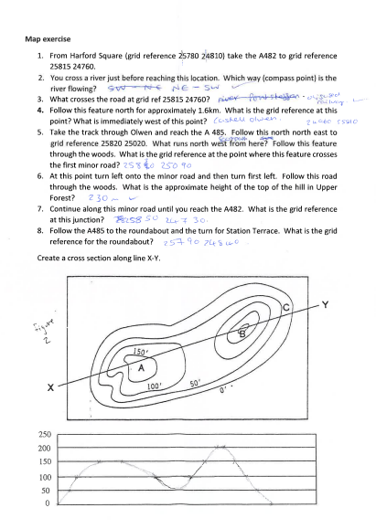
(image provided by Nadia Seal)

Date: 15th February 2018
Session: 3
Type of session: Practical
Weather: cloudy, chilly
Summary:
Today was the first practical session of the module, where we were tasked with creating a site plan for the building surrounding the lecture room. Prior to starting the practical task, we were given a lecture on how to draw a site plan and the main components behind it. Following this we were put into groups of two and were told to complete the task set. For this task I was paired with Nadia Seal. We began the task by establishing what features we wanted to record and agreed the way we wanted to set out our key on the map. We agreed to each draw half of the building and the surrounding features while the other person pointed out features in the landscape and on the building. I volunteered to draw the first half of the building and Nadia agreed to draw the second half. Before we began we established where North was and the scale we were using for the site plan. Approximately halfway through completing drawing the site plan we realised that we had done the scale too small and as a result of this our site plan was very small. In order to complete the task in the time set we decided to continue drawing the site plan and redraw it to a more suitable scale once we had completed the initial plan. This frustrated me due to the fact that because of this error we were unable to clearly mark out features on the building as accurately as I would have liked. However, I think that this was a positive experience because it has made me realise that I am too conservative with my estimates which means that I will not underestimate the scales which I will use in the future when creating a site plan. Despite having a small scale whilst recording the building Nadia and I were still able to produce an accurate site plan with a lot of details in our key, as well as being able to orientate our site plan with true North which I was very happy with.
Site plan of the Arts hall building in Lampeter
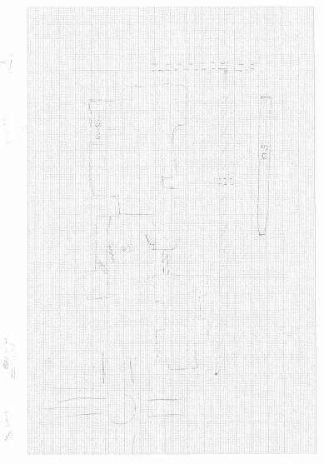
(image provided by Nadia Seal)
Date: 22nd February 2018
Session: 4
Type of session: Theory
Summary:
Today our lecturers prepared us for the second assignment of this module which is a graveyard survey. The key aim of this is to allow us to apply the skills we had learnt in lectures practically in “the field” and create an appropriate report of the findings. During the lecture we were told about the various techniques we could use to make our survey as effective as possible. These included using various sampling methods and sizes, depending on the type and overall size of the site, to gain an accurate representation of the site. In addition to this the lecturers also suggested areas that we could focus our assignments on, for example analysing the social structure of the site by comparing the materials used for the construction of the grave, the style of grave marker used to mark the grave and the orientation of the graves around the graveyard in comparison to a place of worship if one is present. One particular method which caught my interest was to do a typological analysis of the graves to establish a relative time period when a particular style was popular or to determine the relative time period of where the gravesite was in use. This prompted me to talk to one of my lecturers, Quinton Drew, on the best sources for researching graveyard typology. He suggested that I looked at ‘Recording and Analysing Graveyards’ by Harold Mytum which provided information on the different types of gravestones, as well providing different methodologies that I may use. As a result of this research I was able to identify the methodologies I intend on using for the graveyard survey.
Date: 8th of March 2018
Session: 5
Weather: wet, cloudy
Type of session: Practical
Summary:
Today we were tasked with creating a cross-sectional diagram of a field in the campus grounds and to do this we had to use a dumpy level to set up a level. A dumpy level is an is an “optical surveying levelling instrument consisting a telescope tube firmly secured in two collars fixed by adjusting screws to the stage by the vertical spindle” (https://civiltoday.com/surveying/12-dumpy-level). Before we started, our lecturers demonstrated how to set up and use this equipment as well as explaining the principles behind it. I found this extra information to be very helpful while I was completing the task as it enabled me to fully understand the theoretical and practical elements of the equipment. Following the demonstration we were put into groups of four or five, I was grouped with Matt Cowley, Nadia Seal, and Sam Smith. Before we started the task, we discussed role allocation and when we would be rotating roles during the exercise. I started out with the role of setting up and taking readings with the dumpy level. At first I found setting up the equipment to be very confusing and difficult, particularly when calibrating the tripod so that it was level. When I finally did finish levelling the instrument our lecturer informed us that the equipment that we were using was not working properly, but would be sufficient for the task set, which explained why I had had difficulties. We then took a reading of a benchmark which had been set by our lecturers in order to calculate the instruments height in comparison to the fixed point. From this we then took readings of our area along a transect which the rest of my group had set up while I was putting the dumpy level together. Due to the weather conditions being very cloudy there was limited natural light so recording the heights along the transect was difficult but to overcome this my group decided that Matt and I should take the readings together to ensure that they were accurate. Approximately halfway through recording the transect we switched roles to make sure everyone had an experience of doing the different roles. I was switched to holding the measuring pole so that the height of the transect could be recorded which I had no difficulty in doing and we managed to complete the task with no difficulties. After we had finished recording and put the equipment back we then returned to the lecture room where we exchanged the information we had gathered and then drew the diagram.
Cross-sectional diagram of a mound in Lampeter campus meadow
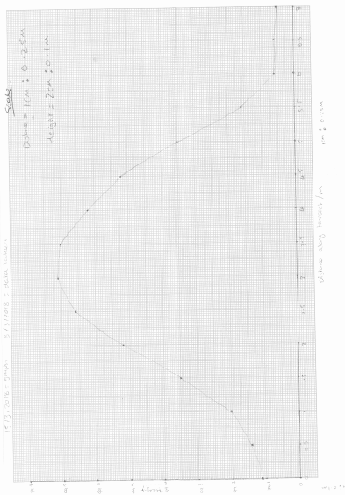(image provided by Nadia Seal

Date: 15th of March 2018
Session: 6
Weather: cloudy
Type of session: Practical
Summary:
Today we were tasked with creating a rough site plan of an open area and adding in drawing conventions these are “the symbols used to depict natural and man-made features in a simple but understandable format” (https://csirm.files.wordpress.com/2011/02/csi_handbook_gs153.pdf). We were asked to only use hachures, these are “one of a series of short parallel lines drawn on a map to indicate topographic relief” (http://www.dictionary.com/browse/hachure). Before we started the exercise our lecturers explained to us what drawing conventions were and how to use them when creating a site plan. This was in addition to instructing us on how to create a rough site plan which I found to be very interesting. After the lecturers had finished we were organized into groups of four, I was grouped with Matt Cowley, Nadia Seal and Sam Smith. Between us we decided which area we were going to survey and roles that we were going to play in it. I volunteered to record the distance between points due to me having a stride length that was the closest to a meter. During the survey there were some communication issues between my group and I due to them being on higher ground in order to better see the area that we were surveying. Consequently this resulted in neither of us being able to clearly hear what the other person was saying and as a result of this the task took longer than it should have which frustrated me a little. However this provided a key learning experience and enabled me to identify areas for improved communication skills for future tasks.

Site plan of Lloyd Thomas garden
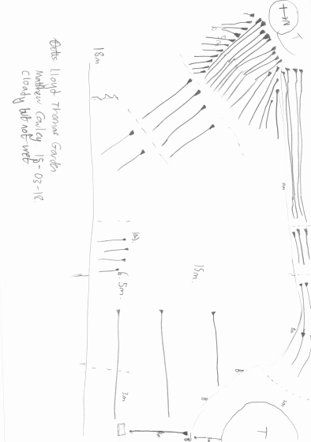
(image provided by Nadia Seal)

Date: 22nd of March 2018
Session: 7
Weather: sunny
Type of session: Practical
Summary:
Today we were taught how to use scales in our drawings and the appropriate scales to use when recording different things, for example, you would use a scale of 1:50 when recording a single building but not for a single grave. We were also taught the problems that can occur when trying to draw to scale such as the impact of weather conditions, size of drawing table and methods to overcome them. For example if there is limited time to do an accurate scale of the site then an object of known size that is near the site can be used for a rough estimate so that there is a rough idea of the dimensions of the site is known which can be revisited at a later time. I found this to be very surprising because I had thought that archaeologists would use more precise methods when conducting a survey even if there were time constraints. After our lecturers had finished explaining this to us we were asked to go into groups and produce a scale drawing. I was in a group with Matt Cowley, Nadia Seal, and Sam Smith. Sam volunteered to be the one recording and the remainder of the group agreed to rotate between measuring and drawing during the task. We found the task difficult at first due to trying to identify the best way to plot out the points so that the feature could be recorded in as much detail as possible. Once we identified an appropriate methodology we were able to complete the task with little difficulty.
Sketch of “dead person”
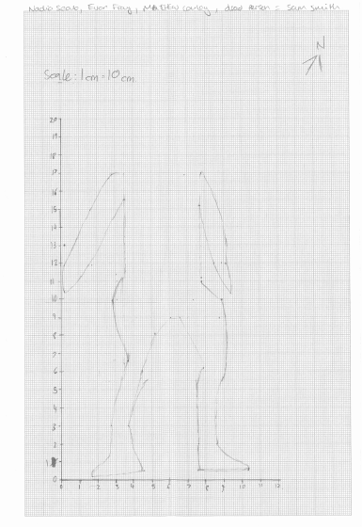
(image provided by Nadia Seal)

Word count: 2199

Bibliography
https://dash4it.co.uk/reading-grid-references (24/03/18 13:30)
https://getoutside.ordnancesurvey.co.uk/guides/understanding-map-contour-lines-for-beginners/ (24/03/18 14:00)
https://www.collinsdictionary.com/dictionary/english/ordnance-datum (24/03/18 14:30)
https://civiltoday.com/surveying/12-dumpy-level (24/03/18 15:00)
Recording and Analysing Graveyards by Harold Mytum (2000)
https://csirm.files.wordpress.com/2011/02/csi_handbook_gs153.pdf (25/03/18 19:18)
http://www.dictionary.com/browse/hachure (25/03/18 19:23)
Images provided by Nadia Seal student number 1700647 on 22nd of March 2018

SELF-REFLECTION SHEET.

PLEASE COMPLETE BEFORE SUBMISSION AND ATTACH TO YOUR WORK

Date: 27/03/18 Module: AHAH4005 Name: Evan Fray

Guidance: You might consider the following elements:

- Argument: does it have one/ is it backed by sufficient evidence/ how lucid is it?
- Structure: how clear is it / is my essay easy to follow/ does it help my argument?
- Analysis: is more/less analytical than narrative/ does it address the question?
- Reading: was this sufficiently broad/ have I referenced properly?
- How might I improve my performance in future?

Strengths
I think that I have been able to reflect on my work in a detailed and honest manner

Weaknesses:
I have not been able to add as much detail on some of the sessions as I would have liked, in the future I will make more detailed field notes

General Comments:
I found this to be very useful to do since it has allowed me to look back on my progress in a more constructive manner

Please give a mark for your work: 58

(for eg: 1st = 70+: 2/1 = 69-60: 2/2 = 59-50: 3rd = 45-49: pass = 40-44: fail = 39- )

