BMIH4003 HOSPITALITY AND GUEST SERVICES
THE IMPORTANCE OF EFFECTIVELY MONITORING GUEST SERVICE APPROACHES

Student name: Marian Simion
Student ID: 2242476

Executive Summary
This report discusses the fact that guest services performance monitoring is a very critical issue in the hospitality industry. The report evaluates hospitality services focusing on the guest services strategies, determination of the guest needs, empowerment and service measurements. It emphasises reputation management, culture services, brand consistency services, and customer loyalty solutions. It addresses the potential technical changes that can affect the guest services as well. The research highlights the harmony of these elements aimed at service quality and guest contentment.

Table of Contents
Introduction 4
Main Findings 4
Importance of Guest Services Strategies 4
Evaluation of Hospitality Services and Provision 5
Reputation Management in Guest Services 5
Service Culture in Hospitality 6
Ensuring Brand Consistency 7
Strategies for Enhancing Customer Loyalty in the Hospitality Industry 7
Future Technological Impacts on Guest Services 8
Conclusion 8
Recommendations 9
References 10

Introduction
In the hospitality industry, guest service surveillance is a critical success factor. This report discusses the elements, which are crucial in maintaining the continuity of the process of hospitality services with special attention to the role of guest service strategies. The report examines numerous areas of interest including guest needs, service processes, evaluations, reputation management, service culture, brand consistency, and customer loyalty. The report concludes with a forecast of the changes that technologies will bring to the sector, and provides recommendations for enhancing guest service monitoring in this dynamic environment.

Main Findings

Importance of Guest Services Strategies
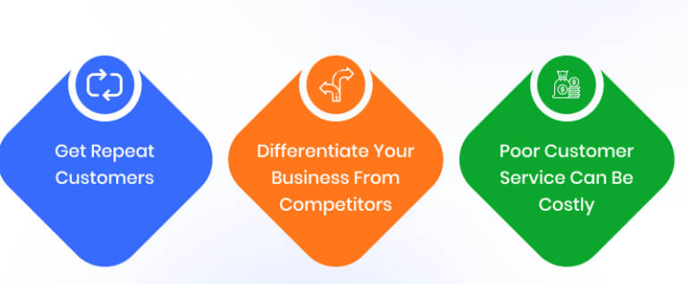
Figure 1: Importance of Guest Services
(Source: Crotts et al., 2022)
According to Minwoo et al. (2019), the hospitality industry has a lot of potential for guest services strategies to help identify quickly the changing and emerging needs of guests. Hotels can make their services unique and surpass the requirements of the different diversified client bases by using methods such as multi-dimensional market research, customer feedback channels, and trend analysis. This respect of guest needs contributes to a personalised and pleasant visit, which in turn fosters loyalty and positive referrals.
The empowerment aspect in deploying Guest Service Strategies by the frontline workers is critical as it allows them to make decisions that translate into outstanding customer satisfaction. For instance, Premier Inn empowers it’s staff with the opportunity to fix the problems on the spot that guarantees a satisfying resolution for the customers.
Monitoring the effectiveness of guest services is vital for continuous perfection. According Crotts et al. (2022), guest Service Measurements involve analysing key performance indicators (KPIs), feedback metrics, and service quality standards. Organisations gain excellence and identify opportunities for enhancement through these measurements. The use of a data-driven approach enables strategic decision-making which ensures that guest services are aligned with market trends.

Evaluation of Hospitality Services and Provision
The hospitality industry is seeing a change in consumer demands because of technical developments and increasing attention to the environmental issue. The Shard Hotel exemplifies this by integrating cutting-edge technology into its operations. Streamlining check-in processes, utilising strong reservation systems, and optimising backend operations contribute to a seamless and efficient service delivery model. The Shard Hotel skilfully advises this new trend by providing smart room controls and sustainable initiatives, establishing the added value of their services relative to the demands and expectations of contemporary, tech-savvy and green-minded guests (The-shard.com, 2024). This adaptability ensures that the hotel remains at the forefront of meeting the needs of its customer base.
Service excellence is contingent upon the judicious provision of resources. The hotel strategically allocates resources to ensure a premium guest experience. From well-trained staff to unique amenities, the hotel demonstrates how resource provision directly influences the quality of service. Investing in staff training, maintaining quality facilities, and employing cutting-edge technologies collectively contribute to a comprehensive resource strategy that enables establishments to deliver high quality hospitality services (Ford, 2020).

Reputation Management in Guest Services
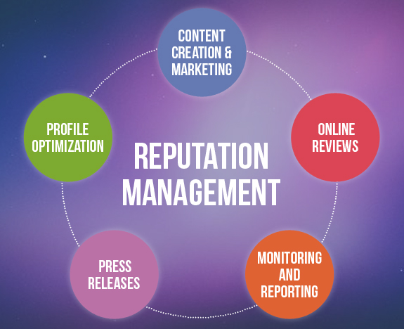
Figure 2: Reputation Management
(Source: Heppell, 2015)
- Significance of Reputation Management
In the competitive realm of guest services, reputation management plays a pivotal role in shaping the success and longevity of hospitality establishments. A positive reputation serves as a powerful marketing tool, influencing potential guests and establishing trust. In the UK hospitality sector, where consumer choices are abundant, maintaining a sterling reputation is indispensable for attracting and retaining clientele (Heppell, 2015). The significance of reputation management extends beyond the visible aspects of service, encompassing online reviews, social media sentiment, and word-of-mouth referrals.
- Strategies for Maintaining a Positive Reputation
The Connaught Hotel in London upholds its prestigious reputation through a commitment to unparalleled service. Ensuring that every guest interaction is memorable and seamless contributes to positive reviews and word-of-mouth endorsements. The Connaught distinguishes itself in a crowded market, enhancing its reputation in luxury hospitality by consistently introducing innovative guest experiences, such as exclusive events or bespoke services (The-connaught.co.uk, 2024). Actively managing online platforms is crucial. The Connaught maintains a strong presence on review sites, promptly responding to reviews, both positive and negative. This demonstrates transparency and a proactive approach to guest satisfaction.
- Handling Negative Feedback
The Connaught Hotel responds immediately to the problems of the customers, demonstrating a commitment to resolving issues and ensuring guest satisfaction. They communicate openly about any challenges. Connaught applies a constructive criticism approach to its improvement, and thus prevents recurrence of such issues, thus indicating a focus on service quality enhancement (Chen et al., 2022).

Service Culture in Hospitality
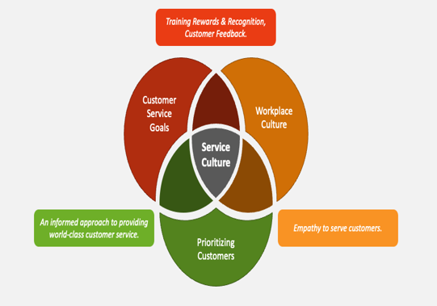
Figure 3: Service Culture
(Source: Tajeddini et al., 2020)
Importance of Service Culture
Service culture in hospitality is the fundamental pillar which ensures excellent guest experiences (Tajeddini et al., 2020). It refers to the cohesive set of values, attitudes, and behaviours within an organisation that lays the foundation for the way that employees engage or interact with their guests. A positive service culture is essential for a welcoming and customer-centric atmosphere. It defines a hotel’s identity and distinguishes it in a competitive market.
Building and Nurturing a Positive Service Culture
At Claridge’s, an iconic luxury hotel in London, the guest-centered mindset underlies the entire strategy. The employees are trained to make guest service the top priority providing beyond current requirements and creating an environment where exceptional service is a shared value. The hotel invests in comprehensive training programs to equip staff with the skills and knowledge needed for service excellence (Tuan et al., 2021). This includes particular skills such as interpersonal, cultural understanding and a sense of the importance associated with all the guest interactions. Claridge gives its employees freedom to communicate with guests. This self-sufficiency motivates the staff to feel accountable and creates a positive attitude towards service generally where each person plays their part in the overall guest satisfaction.
Impact on Guest Experience
- Consistency in Excellence: Guests experience consistent, top-tier service throughout their stay. It creates a sense of reliability and trust in the brand (Panchapakesan Padma and Ahn JiSeon, 2020).
- Memorable Interactions: A positive service culture leads to genuine and memorable interactions. This makes guests feel valued and appreciated.
- Enhanced Guest Satisfaction and Loyalty: The cumulative effect is heightened guest satisfaction and loyalty, contributing to its positive reputation.

Ensuring Brand Consistency
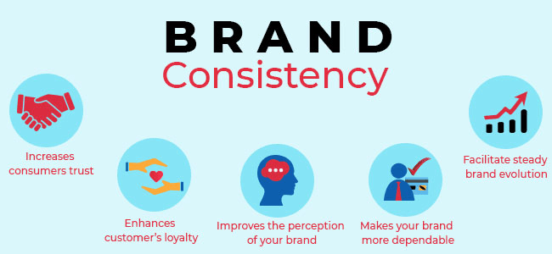
Figure 4: Importance of Brand Consistency
(Source: Soloman, 2018)
Brand consistency is the main element of successful guest services, ensuring a unified and recognisable experience across all touchpoints. In the hospitality industry, maintaining a consistent brand image is crucial for fostering guest trust, loyalty, and positive perceptions. Maintaining brand consistency poses challenges, especially in large hospitality chains. Challenges may include discrepancies in service standards, varying guest experiences across locations, and communication breakdowns (Soloman, 2018). Solutions involve rigorous training programs, clear brand guidelines, and effective communication channels to disseminate brand values. Implementing technology for real-time monitoring and feedback mechanisms helps address challenges swiftly, ensuring that the brand promise is consistently delivered across all guest interactions.

Strategies for Enhancing Customer Loyalty in the Hospitality Industry

Figure 5: Strategies for enhancing customer loyalty
(Source: Self-made)
In the fiercely competitive hospitality industry, fostering customer loyalty is a strategic imperative for sustained success. Loyal customers not only contribute to revenue but also act as brand advocates, influencing others to choose a particular establishment. Building and maintaining customer loyalty requires a combination of exceptional service, personalised experiences, and effective engagement strategies.
- Personalised Guest Experiences: Customising the services to the particular tastes of each client fosters a feeling of uniqueness, which further strengthens customer loyalty (Koo et al., 2020).
- Loyalty Programs and Rewards: Introduction of tiered loyalty programs with attractive rewards makes the guests return often and builds the relationship between the guests and the operation.
- Proactive Communication: Regular communication, personalised outreach, and gathering feedback indicate customer orientation and reinforce the emotional attachment to the brand.

Future Technological Impacts on Guest Services
Current Technological Trends in Hospitality
The hospitality industry is leading in the use of innovative technologies in improving guest experiences. Current trends are represented by contactless check-ins, mobile room keys, AI-based chatbots for immediate help, and smart room controls. Integration of technology is a dynamic aspect of future hotels that not only improves operations but also satisfies the requirements of tech savvy guests as well as make the environment ready for future innovations (Wood, 2015).
Adapting to Technological Advances

Figure 6: Adapting to Technological Advances
(Source: Self-made)
Adapting to technological advances at Hilton ensures a seamless guest experience, from booking to departure, aligning with the industry’s trends.
- Contactless Check-in and Check-out: Hilton has embraced contactless technology, allowing guests to check in and out seamlessly using their smartphones, reducing wait times and enhancing overall efficiency.
- Digital Key Access: The implementation of digital key technology at Hilton enables guests to unlock their rooms with their mobile devices, providing a secure and convenient alternative to traditional key cards (Stringam and Gerdes, 2021).
- In-Room Technology: Hilton’s investment in in-room technology includes smart controls for lighting, temperature, and entertainment, offering guests a personalised and technologically advanced experience during their stay.
- Artificial Intelligence (AI) Integration: Hilton utilises AI-driven chatbots for instant guest assistance. These bots provide real-time responses to queries, room service requests, and local recommendations, enhancing guest satisfaction through efficient and personalised interactions.

Conclusion
This report has explained the critical significance of effectively monitoring guest service approaches. Emphasising guest services strategies, understanding guest needs, empowerment, and precise service measurements, the findings reveal an interconnected web that contributes to service excellence and guest satisfaction. From the evaluation of hospitality services, reputation management, and service culture to ensuring brand consistency, strategies for customer loyalty, and anticipating technological impacts, each aspect plays a pivotal role. The industry examples showcase how a commitment to these elements fosters success, setting the stage for continued innovation and adaptation in the ever-evolving hospitality landscape.

Recommendations
- Embrace Sustainable Practices
According to Tsao (2018), hotels should adopt eco-friendly initiatives, from energy-efficient operations to reducing single-use plastics, aligning with the growing environmental consciousness of guests.
- Enhance Digital Presence
They should invest in online platforms, social media, and mobile apps for seamless booking, personalised guest interactions, and post-stay engagement.
- Staff Training and Retention
Hotels need to invest in continuous training programs to enhance staff skills and adaptability (Walker, 2021). They should implement employee recognition initiatives to improve staff morale and reduce turnover, ensuring consistent service quality.
- Invest in Technological Infrastructure
They can overcome technological challenges by investing in strong infrastructure and ensure seamless integration of technologies to enhance operational efficiency and guest experiences.

References
Chen, Y.F., Law, R. and Yan, K.K., 2022. Negative eWOM management: how do hotels turn challenges into opportunities?. Journal of Quality Assurance in Hospitality & Tourism, 23(3), pp.692-715.
Crotts, J.C., Magnini, V.P. and Calvert, E., 2022. Key performance indicators for destination management in developed economies: A four pillar approach. Annals of Tourism Research Empirical Insights, 3(2), p.100053.
Ford, R.C., 2020. Managing hospitality organizations: achieving excellence in the guest experience, SAGE Publications.
Heppell, M., 2015. Five Star Service: How to deliver exceptional customer service. Pearson UK.
Koo, B., Yu, J. and Han, H., 2020. The role of loyalty programs in boosting hotel guest loyalty: Impact of switching barriers. International Journal of Hospitality Management, 84, p.102328.
Minwoo, L. Seonjeong, L, Yoon, K., 2019. Multisensory experience for enhancing hotel guest experiences: Empirical evidence form big data analytics.
Panchapakesan Padma, P.P. and Ahn JiSeon, A.J., 2020. Guest satisfaction & dissatisfaction in luxury hotels: an application of big data.
Soloman. M., 2018. The heart of hospitality: a great hotel and restaurant leaders share their secrets, SelectBeeks.
Stringam, B.B. and Gerdes, J.H., 2021. Hotel and guest room technology. University of South Florida (USF) M3 Publishing, 17(9781732127593), p.6.
Tajeddini, K., Martin, E. and Altinay, L., 2020. The importance of human-related factors on service innovation and performance. International Journal of Hospitality Management, 85, p.102431.
The-connaught.co.uk, 2024. About us. Available at - [online]: https://www.the-connaught.co.uk/. [Accessed on 28.02.2024].
The-shard.com, 2024. About us. Available at - [online]: https://www.the-shard.com/shangri-la-the-shard-london/. [Accessed on 28.02.2024].
Tsao, W.C., 2018. Star power: the effect of star rating on service recovery in the hotel industry. International Journal of Contemporary Hospitality Management, 30(2), pp.1092-1111.
Tuan, L.T., Rowley, C., Masli, E., Le, V. and Nhi, L.T.P., 2021. Nurturing service-oriented organizational citizenship behavior among tourism employees through leader humility. Journal of Hospitality and Tourism Management, 46, pp.456-467.
Walker, J.R., 2021. Introduction to hospitality. Pearson.
Wood, R.C. ed., 2015. Hospitality management: a brief introduction. Sage.

