Why is it important that children need visual stimulation when reading and looking through Picture books?

Rhianon Snyder 1451532
BA Illustration
Tutor: Jonathan Williams
Submitted in partial fulfilment for the degree of BA (hons) University of Wales Trinity Saint David, Swansea, (11th December 2019)
5437 words

The primary purpose of this thesis is to show the how illustrations in picture books have an impact on how young children learn. When a child reads a book they interact with the image as well as the story being read aloud to them, how do they correlate images with sound? When children are growing and learning, books are an important part of their education not just for learning to read, but also helping them communicate and learning morals in life. Reading with their parents or their carers is a way to start understanding words, but the images can help a child comprehend what a word means, this also associates with language, when someone cannot speak a language or understand the words written down, images help break down what is being said on paper.

There will be a thorough study to look at how words and image are connected and how images can sometimes tell a story better than the writing on the page, sometimes images and the text don’t go hand in hand with each other. How do the illustrators communicate with children through image? How do you keep a child stimulated with a book especially when it’s a story that has been told hundreds of times since it was written.
When a child is growing up, they are usually going through a fun but sometimes stressful time, learning is hard and sometimes the pressure is put on too strongly. Children need to learn, and they do it through many ways, play, communication and reading are the primary sources for education. When children look through books their eyes are naturally drawn to the illustrations, and with their parents reading the book, the story captures the attention of the child, pulling them into a world of make belief bringing the story alive.
Before children learn to read words, they read pictures instead. “For many young children, their first reading experiences often involves the use of picture books” (Taylor & Francis, 2019) Suggesting that the illustrator holds a big responsibility in helping that child learn to read by creating images that draw in the attention of the reader as well as the parent, because they need to buy the book first.
Illustrators work in tangent with authors to create a fun filled, adventurous experience for children to explore their imaginations and learn. “Certainly the prevalence of illustration in books for children in the past and in the present reflects an adult decision that pictures will attract and hold children’s interest or help them to learn about a subject” (Nodelman, 1988) This backs up the statement of children learning to read through images rather than just learning straight from words because the author and illustrator have wished this . If they have pictures alongside their text, they will be able to look at the image and understand a bit better as to what the words mean. Bodmer wrote in 1992 that illustrations are used to "expand, explain, interpret, and or decorate a written text"(Bodmer 1992) This statement works in conjunction with what has been said so far, that images and word need to work together in order to explain the text a bit more than what the words can say.

Children’s picture books can sometimes show and teach children about difference. Children can learn about different cultures through picture books, and in doing so they learn that people are different and that it is okay to be different. Some picture books exist for those who have learning difficulties and what their day to day life is like, these books are very unique in their content but they help children, not just the ones that have been diagnosed but also the children around them, they are learning about autism and other disabilities and how to react.
There have been children’s picture books about refugees and the struggles that they have had and have been through, these types of books help children understand how to feel, they help identify that a child is not alone. This is an educational way to communicate with children through image and through word, teaching them about difference and equality.
Some books also teach children about losing a family member, these types of books are beneficial to everyone, when a family member is lost everyone is in mourning and that means this can then be a hard topic to talk about, but children do not understand death as adults do, so some help is needed. There are lots of books that express bereavement for children one book ‘I’ll always love you’ by Hans Wilhelm is about a little boy who has a dog ‘Elfie’ who one day doesn’t wake up. The story is about how this little boy is going to get through the tough time ahead. Once the boy gets a new pet, he remembers he must say ‘I love you’ it is a softly spoken sweet book, and these books that are so carefully written are important. The illustrations in this book give the story the sentimental feelings they need, when the reader sees the dog doing something silly, they can remember that’s what their dog used to do. The illustrations are so empowering with the text, they work alongside each other to create a peaceful book to help in a time of need.
Picture books about bereavement don’t just teach children, but they teach adults to, a parent is learning about how to handle the situation and move fourth especially in front of their child, they need to be able to sit down and tell them about the recent events and that can be made easier with a book.
Animals are popular characters in picture books, sometimes the bereavement books contain animals as children have been known to connect with them more. Animals that have been anthropomorphised,’ appear in children’s picture books, which is when they are given human characteristics, like sitting down drinking tea or speaking out loud. These traits given to the animals make the characters more appealing to children, children have stuffed teddys and toys they play and talk to, so when a character that is an animal is present in a book, they engage the child’s attention.
It has been known in some countries that symbolism is shown differently, a study took place in poor parts of South Africa where children were shown an illustration of a giraffe, however these children didn’t understand, they couldn’t comprehend that the illustration was a giraffe because they had never seen a simplified cute version of the long necked animal, these children were only used to the real animal. Cultures that have been brought up all their life with picture books have adopted this nature for being able to see objects and creatures for what they are even if they don’t show all the characteristics of the original. It is not just in picture books where illustrations are simplified it is everywhere, from advertisement to packaging. Children are brought up learning that there are simplified versions of what they see around them and this is to do with culture. In poorer countries or those with different teaching methods, art sometimes isn’t as popular. Children are brought up to be creative, they draw and when they draw they capture what they can as best as possible, now it is the correlation that people associate simple drawings with children’s drawings, because a child has captured what they see, they just haven’t learnt how to draw to a higher standard yet. Picture books are teaching children about art, the simpler image associates with their abilities to draw and create.

Before picture books, there were just books, and you were lucky to have the ability to be able to read. Picture books weren’t a common occurrence, but they soon started to arise and bringing popularity with them. Picture books make a worldwide appearance, thousands are selling daily across the nations, this is because there are so many picture books attracting the eye of parents, young readers, teachers and other passionate people. They are attracted to the stories and the art, and of course learning. People don’t really think about picture books being taken for granted, as it is something that most people have grown up with. Some countries aren’t privileged to have picture books or education, and sometimes these books are banned for superstitious reasons such as promoting witchcraft, The Harry Potter books.

The first book to be recognised as a children’s picture book is ‘Orbis Sensualium Pictus’ published in Latin and German in the year 1729 by Johann Amos Comenius, and then later translated into English. Comenius was a teacher and his subject of interest was educational theory. He created this book to help children learn through all the senses, making the book available to all. The content of the book are animals and the sounds these animals make are used to help teach the alphabet. In an example the child can copy a noise the animal makes to help identify the letter, “the cat cryeth” (Comenius, 1729) makes an ‘oh’ sound helping the child learn the letter ‘O’. This method of teaching is not unheard of in fact it is very common especially in the 21st century. Children learn the alphabet through song but also through books that contain letters alongside illustrations, ‘A’ is for apple, which would then have an illustration of an apple next to it.
In children’s books that are older they are usually in black and white, any illustration that is present in the book would be a print this is because “The printing press is a device that allows for the mass production of uniform printed matter” (History.com, 2019) so in order to create a mass quantity of books the illustrations would have been printed traditionally. As opposed to today, illustrators tend to do most things digitally, an illustrator can work anywhere in the world but live in the middle of a forest, and this is purely because of technology in the 21st century they are given the ability of the internet, meaning any resource is available at the tip of their fingers. In Alice’s adventure in wonderland the illustrations in the book are stunning prints. The viewer can see all the individual lines that build up the picture, creating shadows through cross hatching, but the illustrations would be printed in black and white, due to the expensive nature of coloured ink. It wasn’t impossible to print in colour it just wasn’t strategically a good idea. However, in books today the reader will, most of the time, find the illustrations in full colour, and this is because printing isn’t as expensive, there is new technology that allow images to printed in full colour.
Colours in books help children learn “it’s common for children to have trouble discerning between fact and fiction. Colourful books can help them begin making distinctions between what’s real and what isn’t” (Happy Designer, 2019) children’s books demonstrate a power to help children learn. Colour doesn’t just help differentiate between fact and fiction, colour can have a hidden meaning. When looking at colour meanings you can identify that some colours have hidden meanings, “Colours are the most commonly used tool by children to express their emotions and thoughts.” (Happy Designer, 2019) When a child draws, they use colour to express themselves. Colours are important for many reasons, one being that colours make the picture book stand out. Chris Haughton creates picture books with wild colours, bright backgrounds and colourful birds, but he uses the colours to his advantage. Haughton understands how to use colour, he created a book that consisted of a blue background and blue characters, but added bright vibrant birds, this stands out to children and parents, pulling them into the book fully.
If a page in a book is built up of shades of blue it can portray that the emotion the reader should be feeling is calm, or sometimes sadness. Yellow is a colour that is mostly correlated with happiness, but it can also be associated with anxiety. When reading and looking through picture books the reader engages with every aspect of the book, the mood is set in many ways, through colour, image and written text, all these aspects help a child learn new ways of communication.
With the use of colour in books children learn about colours, they can ask their parents what the colour is, so when they are younger in the toddler years the colours in books are usually primary colours, simple blues, reds and yellows. They start off with basic colours and then as the child grows the books become harder and the child starts to see more colours, they are introduced to more detail and longer books. Children’s books start off as small usually quite thick paged books, because they are all about the senses of touching, tasting and throwing. When a book is made for a baby the colours are easy to identify and there are usually items in the book to help stimulate all the senses, pieces of crinkly fabric will be added to a page alongside with reflective surfaces and soft touching pieces of fabric. These are books that are designed to help a child learn. When playing with this book a child is starting to understand how their senses work. As the child grows the books change becoming harder and more challenging to suit the age. This helps a parent understand what level their child is at, whether they are progressing the way they should be, as books are designed for certain age groups. Eventually as the child grows, there becomes a point where illustrations are no longer needed in a book, which allows the mind to use its imagination to travel into the story.
Art forms have changed throughout the years so much, that books look completely different to what they were, some books are even digital. ‘Electronic books’ have become a popular frontier in the reading industry as many households found themselves stacked to the ceiling with books, now with technology such as the ‘Amazon Kindle’ an avid reader can contain thousands of books in a small electronic device. This is a great idea, it is practical for minimalists, however it takes away the sensation of sitting in a quiet place, smelling the paper and turning the page of the exciting story the reader has become a part of. With books being on devices, it draws attention to children. Children won’t learn the same way from a physical book than to one online and this is because not all their natural senses are being used, taste, touch, smell, see and hear. The illustrations would not have the same affect if they were in a physical book and if the book was digital it creates a barrier of reading to a child at bedtime or anytime. Children’s picture books are often very large that’s because “big books make it possible for children to fully engage, and interact, with the story.” (Booksforkeeps.co.uk, 2019) It’s a larger surface area, a parent can hold one half of the book and the child could hold the other half, sharing an experience together.

Throughout centuries images have been used as a way of communication. When a person doesn’t understand something they often turn to images for help, a good example of this is when a person is trying to follow instructions, but find that the words don’t quite make sense so the only solution is to look at the image and ninety percent of the time the picture works hand in hand with the words to help you understand what is happening and what is to be done. There is however an argument that states picture books don’t necessarily help in all aspects. J.J Parson wrote “The illustrator, provides us with images that may be imaginative, but are not formed by the reader’s imagination.” (Pasons, 2019) Parson believes that picture books are good for learning to read and developing speech but they aren’t helping a child who isn’t an avid reader to become one and this is due to the fact that they aren’t using their own imaginations to transport them into a book, they are sort of cheating and being lazy by looking at the pictures instead, Parson doesn’t think these children will go onto using their own imaginations instead. This is a valid argument however, children’s books aren’t usually that descriptive, so in order to paint an image so vividly in their minds, from just words on the paper, it would have to be quite descriptive. When looking at children’s picture books often the text will be basic, so in little red riding hood, she is described as wearing “the little girl wore a red riding cloak”(Elliot, 2017) that’s all the description the reader obtains from her appearance, so it is quite difficult to proceed with imagination if all the reader knows is she wears a red cloak. A descriptive version would help like ‘A little girl with long wavy brow hair, skips merrily in the forest wearing her favourite blue dress, with the puffed sleeves. Wrapped around her is a bright red riding cloak’ this paints an image in the mind of the reader, they start to obtain a bit about her personality and age and maybe even the decade this book could be themed in. But some books are different to others, Alice’s Adventures in Wonderland contain rather vivid descriptions of the characters, and still have illustrations in the book, however Lewis Carroll wrote that the original Alice illustrations are basically what he wanted her to look like. Children’s picture books may not allow the reader to imagine the characters, but the author has chosen the illustrator because they liked the illustrator and they believe that’s how they wanted their character to look.
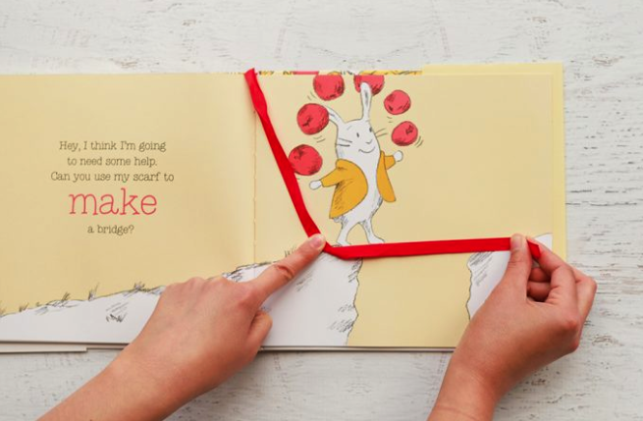
In a book called Hungry Bunny by Claudia Rueda, the story is about a bunny who comes across many challenges and has to face them in order to move forward, to do this the bunny has to use his scarf, which is a simple red ribbon attached to the book.
Fig.1: The Hungry Bunny
One challenge is that the bunny must cross a large gap between two rocks, the only way for the bunny to surpass this task is for the young reader to make a bridge with the rabbit’s little red scarf attached to the book.
The book is a very creative way of teaching children, it has a smart yet simple design to engage and capture the attention of the readers. Once the child has surpassed the challenge brought forward, they can then turn the page to find, that with their help the bunny has found his way across the bridge that they created, leaving the child feeling rewarded and giving them the motive to now move forward. This bit of interaction in a book helps a child learn, they are understanding that there are solutions to simple problems, and they can learn how to combat them. The pictures in this book are very important because without the drawings there would just be a story, and challenges, but no visual representation, making the book incomprehensible and boring. The text works alongside the illustrations to produce an enjoyable pleasurable book for children to read with their parents.

Children are hard to keep stimulated when you don’t know what makes them excited, so authors and illustrators have a hard job in keeping their attention to the book rather than the outside world. Children often find their attention drifting if the book doesn’t keep them entertained. A book needs to have eye catching illustrations but also a wonderful story line that keeps them guessing to prevent boredom. That is why Rueda’s book works so well, as it presents a new challenge to accomplish every time a page is turned, the book is creating a world that entices the young reader to enter and explore with the protagonist bunny.
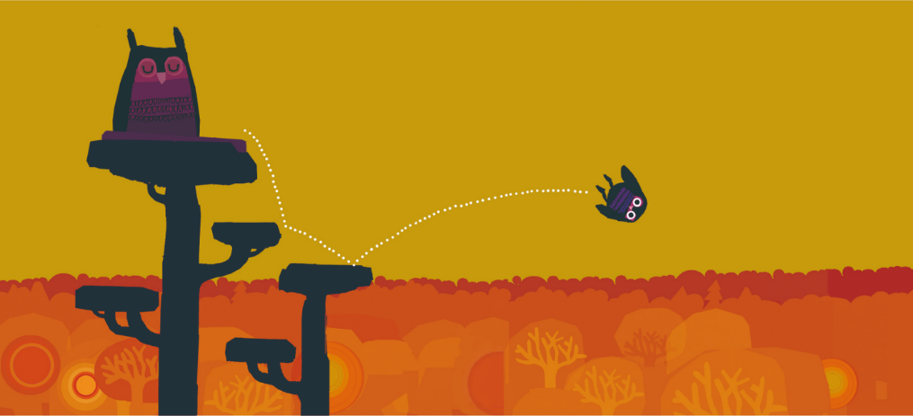
In a book called ‘A bit lost’ created by Chris Haughton, he has managed to tell his story with very little words. In this page the reader can see a sleeping mommy owl and a baby owl bouncing from a tree
Fig. 2: A bit lost
branch, that he was once perched on.
This page doesn’t need words to tell the reader what is happening, they can see for themselves. The illustrations show that this baby bird is bouncing, and Chris Haughton has managed to create this illusion by simply using white dots in a repetitive “jumping” motion. The white line made of dots stands out on the page because of the contrast from the background colour. From looking at the page they can see that the bird hit two places before plummeting into the air, which a thumping sound can be imagined in the reader’s mind.
This page is so well thought out that words aren’t needed, thus proving that pictures are so important that they can sometimes tell the story better than words. Chris Haughton stated that when he was creating the book, he found himself trying hard to think of words to go on the page but then came to the realisation that he in fact did not need as many words or any in some cases to bring his story to life.

One item to pay attention to in children’s picture books are the illustrations and their detail. Children’s picture books often change with age. When a child is younger the words are basic if there any and frequently the illustrations tend to be simplified to suit the young reader. As a child gets older their level of reading develops meaning the sentences in books become longer, involving harder words rather than easy sounds that are present in baby books. The illustrations also grow up with the age group becoming more intricate and detailed, rather than using the block shapes, primary colours and simple designs, the pictures expand into something more beautiful and exciting allowing the reader to still be transported into a world other than their own.

When looking at a classic story, one that is common around the world, how does the story change for different age groups?
The story that is the key focus for this study is the three little pigs. The best known version of this story made its first real appearance in 1898 by Joseph Jacobs and it was published in a book called English fairy tales, But he credited James Orchard Halliwell as his source who created the first print version of the story in 1849.(1)
This story is a loved one, but how has a story that’s over one hundred years old stayed interesting for readers? There are hundreds of variations of the three little pig’s tales, with the story staying on track most of the time but has known to have a few twists and turns. The story of the three little pigs is briefly about pigs who build houses and a wolf whose ambition is to eat the pigs. Children have grown up reading about these notorious pigs and each child has seen the pigs and the wolf in different art styles, have heard about their tale in different ways.
The story varies on the age of the child, in a simple rendition of the three little pigs written by Ronne Randall “The little pig’s reedy, weedy straw house just fell to pieces” (Randall, 1989) these are strong verbal adjectives that are very vocal and very easy for a child to learn, descriptive words are used to help children with their vocabulary.
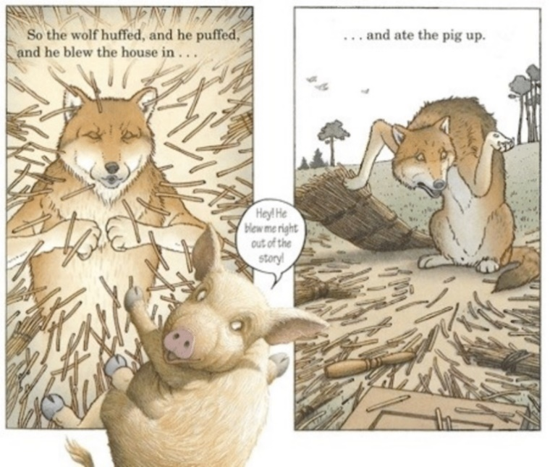
Illustrations can sometimes tell a slightly different story or sometimes even contradict a storyline in a book. In the classic tale of the three little pigs, the story is known for the first two of the pigs to get eaten by a wolf whereas the third survives,
Fig. 3: The Three Pigs
sometimes this tale changes to the pigs running away to take shelter in the other houses and the wolf ends up deceased.
This however wasn’t the case for The Three Pigs created by David Wiesner. In his variation of the three little pigs, the story written on the paper tells the reader that the first two pigs are consumed by the wolf, as opposed to the illustrations which portray a rather confused wolf, who clearly hasn’t had his lunch, and a mischievous pig who has managed to escape the story he was in, because the wolf had blown him out, crossing the frame of the illustrations and onto the white space.
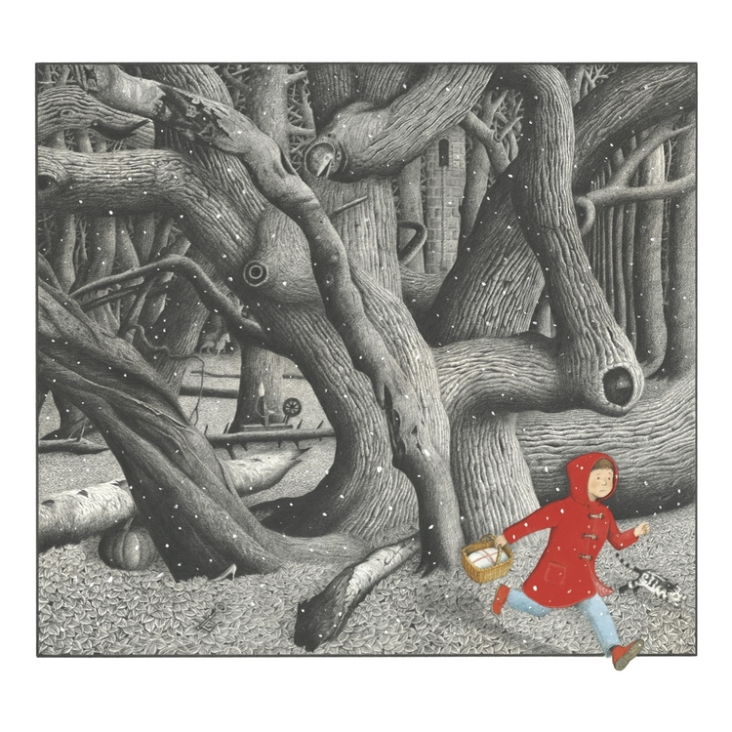
In doing so the pig’s art style changes from a simple, not to detailed illustrated character, to a very hairy pig that now is semi realistic. Every part of this book has been thoroughly thought about, the story isn’t supposed to match up with the illustrations, it’s a great way to engage the reader into a captivating book, the story may be one that isn’t unheard of but the illustrations make it into something more. It takes the pressure off it being the same as the other books before it.
This book is another extraordinary way of demonstrating how amazing picture books can be, a child can get lost in the adventure with the pigs whilst the parents read the story, embarking upon a few giggles when the child realises that the words written aren’t matching up to the story the pictures are telling. An author Cyndi Giorgis wrote in 2012 “A picture book is a unique art form, and every aspect of it is meaningful”(Giorgis 2012) This is a good statement to support what was said before, illustrations usually need to work hand in hand with the story to create something beautiful but Wiesner demonstrates that’s not always the case, he’s not the only person to have done this, in 1968 a book called Rosie’s walk was published by Pat Hutchins. In this beautifully presented book, it shows a chicken named Rosie going for a walk, the text states that the hen, “takes a peaceful stroll around the farm and gets back in time for dinner.”(Hutchins 1968) However, the illustrations tell a different story, the hen Rosie is being stalked by a rather sly fox, who is plotting to eat the poor chicken.
Illustrators don’t just help children learn to read, they help in other ways too, like perception. Authors and illustrators are passionate, creative people, and it is their passion that assist children and those that are different to move forward in the world and help them. Children often go through struggles in life and sometimes these struggles can be unfortunate events, such as bullying, the loss of a family member or pet, and it is illustrators and authors that can sit down together and help others from behind the scenes.
When an author writes a children’s book, they need to find and artist to work hand in hand with them, stating that already word and image are correlating together without being on paper, you cannot have one without the other. Because of this dynamic duo, the two or one, as some illustrators are the author, can come up with ways to communicate with children through either image or word.
Illustrators are known to make a book fun, hiding ‘Easter eggs’, hidden gems throughout the book, sometimes the book will be about a fairy tale like Snow White and in that book the reader will find references to other fairy tales, example a slipper can be seen in a book called ‘Into The Forest’ by Anthony Browne, it is a tale about a boy heading into the woods in search of his father who disappeared in the night during a terrible storm. In this book the reader can see references to other stories, on a page where the boy wears a red coat, to portray little red riding hood, there are hidden illustrations of pumpkins, slippers and other small items that are heavily known for other popular fairy tale stories. This book teaches a child about perception, the reader is not just reading the book, but they are thoroughly looking at the illustrations, trying not to miss out a single detail. The book is a fun one, to keep the attention of the reader they added all the ‘easter eggs’ and this then allows the reader to re-engage with the book it becomes a book that they’ll want to re-read again and again, spotting new items each time. The illustrations in this book are quite intricate and the thought and planning that has gone into the book don’t go unmissed. The book contains some striking imagery that really works in its favour, the bright red coat of the boy is unmissable against the grey dim background, but weirdly enough the readers eyes are drawn to the mysterious background with hidden gems.
Fig. 4: Into The forest
The books mentioned in this essay all have a recurring theme, they are interactive. They might not have physical flaps to lift and close or pop ups, but they do all have interactive features. In the ‘Hungry Bunny’ Rueda added a little red ribbon and challenges for a child to complete teaching them basic strategic skills. Haughton teaches children about feelings of being lost and scared, subtly adding that it is okay to ask for help, he is teaching children how to express their feelings. The three pigs, Wiesner brings the reader into the book, by using the white space and the change of art style the reader feels as though they have been transported into another world. He is teaching children about adventure and imagination. Browne created a book that expresses the feeling of fear and how this one little boy was going to get over it. Children’s picture books are remarkable things, so much thought, time and effort have gone into them, the children that are capable of having such items around the house are lucky and in a sense privileged as some children do not get the chance to learn anything in their lives, so to be brought up with education from the start is an amazing opportunity and picture books are an adventurous way to do it.
In conclusion this thesis has shown a brief history of picture books demonstrating how they were once made and how they are now made, looking briefly at how printing methods have changed in order to meet the high demand of picture books. There has been a thorough examination of why pictures are important in picture books and what aspects of the picture books help children, when they are growing up and learning. How picture books can help those families that have gone through a rough time, such as the loss of a family member. Struggling with disabilities.
A brief point about the use of colour was mentioned to help put forward the argument that picture books help children to learn, colour meaning and why colour is important, however some children still do enjoy a good old fashioned black and white book. There was discussion about other picture books including the first recognised picture book, and how they have developed with times. The overall conclusion is that children need visual stimulation when reading from picture books because the illustrations provide a helping hand in how children learn, they learn sounds, shape, colour, how to speak and communicate and many more things, without picture books growing up wouldn’t be so exciting. Artists and authors have created a learning platform that is considered fun, with the books being able to transport a child and parent to another world, accessing many adventures from the comfort of their home. Issues regarding books taking away the imagination aspect of the reading experience have been addressed and stated the argument for both sides, undergoing research to back up any statement provided. This thesis has answered the issue as best as it can looking at all the topics related to the question ‘Why is it important that children need visual stimulation when reading and looking through Picture books?’ To narrow it down children need visual stimulation to help maintain their focus in the book and to help them learn, not just verbally but mentally too. Children have learnt through books for many years and will continue to do so.

Bibliography

Bodmer,G.R. (1992). Approaching the illustrated text. In G.E. Sadler (Ed.), Teaching children's literature: Issues, pedagogy, resources NY: The Modern Language Association of America.

Booksforkeeps.co.uk. (2019). Children's Books - Articles - Big Books Are Brilliant! | BfK No. 100. [online] Available at: http://booksforkeeps.co.uk/issue/100/childrens-books/articles/other-articles/big-books-are-brilliant [Accessed 11 Dec. 2019].

Browne, A. (2011). Into The Forest. London: Walker Books Ltd.

Browne, A. (n.d.). Fig.4: Into The Forest. [image] Available at: http://www.anthonybrownebooks.com/new-page-2 [Accessed 10 Dec. 2019].

Comenius, J. (1729). Joh. Amos Comenii Orbis sensualium pictus. London: Printed for Aaron Ward, p.4.

Fang, Z. (1996). Illustrations, Text, and the Child Reader: What are pictures in children’s storybooks for? Reading Horizons.

Giorgis, C. (2012). The art of picture books. Book links

Happy Designer. (2019). The Importance of Colour in Children’s Books. [online] Available at: https://www.happydesigner.co.uk/the-importance-of-colour-in-childrens-books/ [Accessed 10 Dec. 2019].

Haughton, C. (2019). Little Owl Lost / A Bit Lost reviews. [online] Chris Haughton. Available at: https://blog.chrishaughton.com/little-owl-lost-reviews/ [Accessed 11 Dec. 2019].

Haughton, C. (n.d.). Fig.2: A Bit Lost. [image] Available at: https://www.chrishaughton.com/abitlost [Accessed 10 Dec. 2019].

History.com. (2019). Printing Press - HISTORY. [online] Available at: https://www.history.com/topics/inventions/printing-press [Accessed 10 Dec. 2019].

Hutchins, P. (1968). Rosie's walk. New York: Macmillan.
Nodelman, P. (1988) Words about pictures. Georgia: University of Georgia Press p.7

Pasons, j. (2019). J.J. Parsons's Blog: Reading With Eyes Shut - Learning to Read with Eyes Shut: What’s Wrong with Picture Books and Comics? - February 23, 2014 07:40. [online] Goodreads.com. Available at: https://www.goodreads.com/author_blog_posts/5796375-learning-to-read-with-eyes-shut-what-s-wrong-with-picture-books-and-com [Accessed 10 Dec. 2019].

Rueda, C. (2019). Fig. 1: The hungry Bunny. [image] Available at: https://www.chroniclebooks.com/blog/2018/10/02/7-interactive-childrens-books-shake-storytime/ [Accessed 10 Dec. 2019].

Surlalunefairytales.com. (2019). SurLaLune Fairy Tales: History of Three Little Pigs. [online] Available at: http://www.surlalunefairytales.com/threepigs/history.html [Accessed 10 Dec. 2019].

Taylor & Francis. (2019). Preparing Early Childhood to Use Art in Teachers the Classroom. [online] Available at: https://www.tandfonline.com/doi/abs/10.1080/00043125.2003.11653505 [Accessed 11 Dec. 2019].

The British Library. (2019). The origins of children’s literature. [online] Available at: https://www.bl.uk/romantics-and-victorians/articles/the-origins-of-childrens-literature [Accessed 11 Dec. 2019].

Wiesner, D. (2001). The Three Pigs. United States: Houghton Mifflin Harcourt.

Wiesner, D. (n.d.). Fig.3 : The Three Pigs. [image] Available at: https://mshahnsreadinglist.wordpress.com/2012/10/21/121/ [Accessed 10 Dec. 2019].

