

Programme: MSc Public Health and Social Care in Practice

Module code and Title: LCHS7003 Community care and Management of longer-term Conditions

Student Name: Simran Khaitan

Student ID: 2531472
Component 1: Information Booklet of Long-term Condition Management (Type 2 diabetes)

Lecturer Name: Muhammad Khan

Words: 3010

Submission Date: 17 July 2026

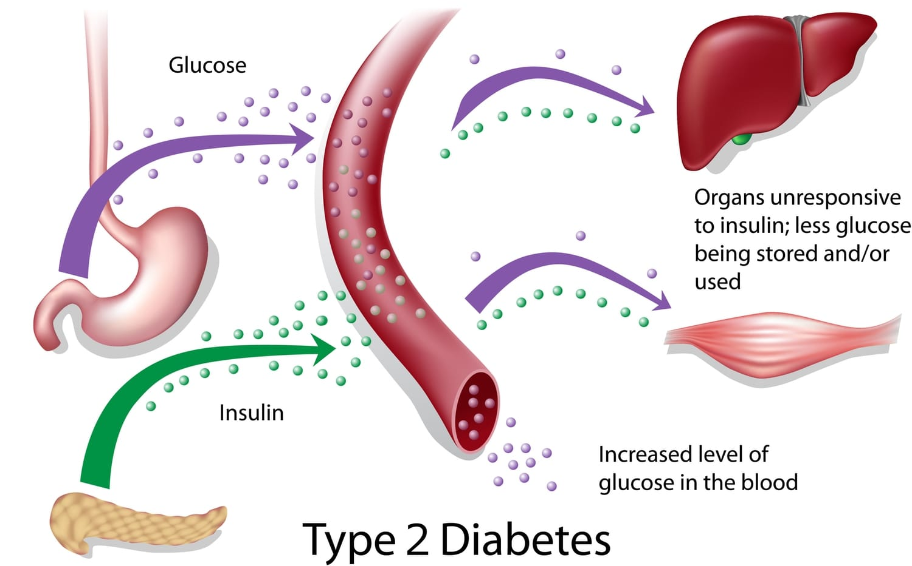

Table of Contents
1. Introduction, Aim and Definition 1
2. Burden, Epidemiology and Prevalence (Global and UK) 2
3. Causes, Risk factors and Disease Progression 3
4. Living with Type 2 Diabetes: Impact on Individuals and Families 4
4.1 Physical Impact 4
4.2 Psychological Impact 4
4.3 Social and economic impact 5
4.4 Impact on families and informal carers 5
5. Evidence-based Management and Treatment within the NHS 6
5.1 NHS care pathway and diagnosis 6
5.2 Lifestyle management and structured education 7
5.3 Pharmacological treatment (NICE guidance) 7
5.4 Ongoing monitoring and multidisciplinary care 8
6. Models and Theoretical perspectives for long-term condition management 8
6.1 UK Model – House of Care Framework 8
6.2 International Model – Chronic Care Model (CCM) 9
7. UK Policy and Health & Social Care Priorities 10
7.1 National strategies 10
7.2 Local implementation through Integrated Care Systems (ICSs) 10
8. Person-Centred Care and Future Recommendations 11
9. Conclusion 11
References 12

1. Introduction, Aim and Definition
Type 2 diabetes mellitus (T2DM) is one of the most prevalent long-term health conditions globally and is a major public health problem because of its growing prevalence, complications and potential economic impact on health services (Khunti et al. 2023). The disease occurs when the pancreas cannot make enough insulin to keep the blood glucose normal, although the body does not respond to it. Without treatment, this can lead to long-term hyperglycaemia, which can harm the blood vessels, nerves and major organs, with cardiovascular disease, chronic kidney disease, diabetic retinopathy and lower-limb amputation being some of the potential complications (Davies et al. 2022). Type 2 diabetes is heavily correlated with lifestyle modifications (such as physical inactivity, unhealthy food habits and obesity) as well as other factors such as age, ethnicity and genetic predisposition, unlike Type 1 diabetes. The National Institute for Health and Care Excellence (NICE) Type 2 Diabetes Guideline (NG28) recommends that the management of Type 2 diabetes should be individualised and person-centred to combine lifestyle changes with structured education and frequent monitoring (Nice.org.uk, 2015).
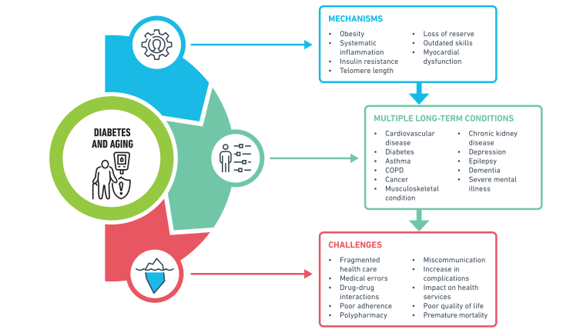
Figure 1: Diabetes and its long-term multiple conditions
(Source: Khunti et al. 2023)
This information booklet is designed for health and social care professionals, patients and family carers to give them evidence-based information about Type 2 diabetes and how it is managed in the United Kingdom. It provides an understanding of the definition, burden and prevalence of the condition, its risk factors and the physical, psychological and social effects of the condition on the individual and family. In addition, the booklet explores evidence-based approaches to managing long-term conditions through the National Health Service (NHS). These theoretical frameworks underpin long-term condition management and provide an overview of current policies in the UK that impact diabetes treatment and care. Lastly, recommendations for promoting person-centred care, self-management and better long-term outcomes are given.

2. Burden, Epidemiology and Prevalence (Global and UK)
Type 2 diabetes mellitus (T2DM) is one of the leading diseases worldwide, which is characterised as a long-term condition, and it is actually a reason for premature death, disability, and high medical expenses. The IDF Diabetes Atlas - 11th Edition (2025) is one of the main data providers on diabetes statistics worldwide, and one of the most recent studies by the IDF reports that in 2024, there might have been almost 589 million people aged between 20 and 79 years living with diabetes (International Diabetes Federation, 2025). That is 11.1% or one out of nine of the adult population had diabetes. Type 2 diabetes is generally considered to be the commonest type of diabetes and is responsible for more than 90% of diabetes cases (Chandrasekaran and Weiskirchen, 2024).
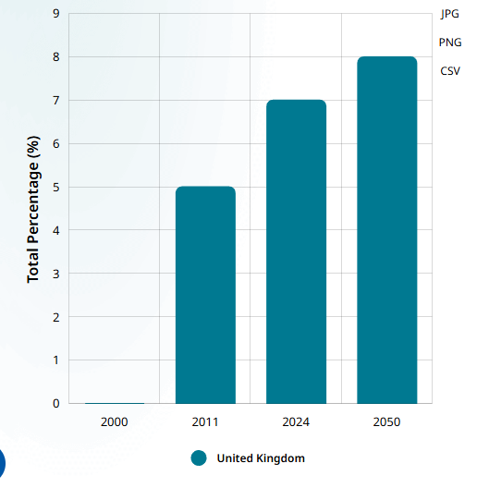
Figure 2: Age-standardised prevalence of diabetes
(Source: Diabetes Atlas, 2025)
Type 2 diabetes remains a huge burden on the National Health Service (NHS) in the United Kingdom. According to the IDF Diabetes Atlas 2025, around 4.5 million adults in the UK had diabetes in 2024, and the majority had type 2 Diabetes (Diabetes Atlas, 2025). In 2024, there was estimated to be a 7. 8% prevalence of Type 2 diabetes for those having diabetes diagnosed and recorded as a chronic condition in primary care (Chen et al. 2025). On the other hand, for those who had diabetes recorded as Type 2, there was a 7. 0% prevalence (from the national data source published by OHD in the report published in 2025) (Magliano et al. 2025). Persistent health inequalities are seen in the people who live in socioeconomically deprived areas and in individuals from South Asian, Black African and Black Caribbean ethnic groups, with both having higher prevalence and earlier onset of the disease. The increasing prevalence of type 2 diabetes has significant economic implications for the NHS, as long-term management and treatment of complications such as diabetic retinopathy, neuropathy, chronic kidney disease and others.

3. Causes, Risk factors and Disease Progression
The development of type 2 diabetes mellitus is a complex process with the participation of genetic, metabolic and environmental factors. It is a problem that arises when the body's tissues, especially the liver, skeletal muscles and fat cells, become insensitive to insulin, and the pancreatic β-cells slowly stop producing enough insulin to keep blood sugar levels normal (Chandrasekaran and Weiskirchen, 2024). The synergistic effect of insulin resistance and progressive β-cell dysfunction leads to ongoing hyperglycemia and may cause serious microvascular and macrovascular complications if not treated (Yang et al. 2024).
The NHS has stated that the most important modifiable risk factors for Type 2 diabetes are excess abdominal fat (hyperinsulinaemia) and overweight and obesity (NHS, 2026). Other important risk factors include physical inactivity, an unhealthy lifestyle with too many processed foods and sugar in the diet, age (>40 years or >25 years in South Asian people), family history of diabetes, previous treatment for gestational diabetes, high blood pressure and certain ethnic groups (South Asian, black people, Chinese people). High blood pressure, excessive alcohol intake, and smoking also raise the risk of cancer from metabolic dysfunction and cardiovascular risk (Dhondge et al., 2024).
The disease tends to be progressive and can take many years to be diagnosed because it may be asymptomatic. At first, the pancreas tries to make up for the insulin resistance by producing more insulin. Eventually, the pancreatic beta cells lose effectiveness at making insulin. In this way, sugar remains high in the blood. The consequence of prolonged high blood sugar levels is that neuropathy and blood vessel damage (retinopathy or diabetic kidney disease) occur (Ansari et al. 2022). These conditions can cause heart problems and foot complications due to diabetes. Hence, early diagnosis, structured education, changing lifestyle, regular HbA1c testing, and individualised treatment to slow down the disease process and reduce the risk of complications and long-term morbidity are important aspects (Przybyłek-Stępień et al. 2025).

4. Living with Type 2 Diabetes: Impact on Individuals and Families

4.1 Physical Impact
Poorly managed over time, type 2 diabetes can have a major impact on a person's physical well-being. High blood sugar over time can harm small or large blood vessels, which can lead to serious complications such as cardiovascular disease, stroke, diabetic kidney disease, diabetic retinopathy and peripheral neuropathy (Liu et al. 2022). This can lead to a loss of sensation in the feet, which can lead to foot ulcers, infections and lower-limb amputations. NICE Guideline NG28 recommends that optimal glycaemic control is essential through lifestyle change, regular HbA1c monitoring and appropriate pharmacological treatment to minimise the risk of diabetes related complications (Nice.org.uk, 2015a). NHS also suggests testing kidney function, screening the retina, and performing diabetic foot assessments annually to help detect and treat complications early, which will have a positive impact on long-term health and quality of life ().

4.2 Psychological Impact
Managing Type 2 diabetes can be significantly stressful. People may worry, feel frustrated or stressed about having to take medications for their whole life, their diet, frequent blood glucose testing and possible future complications. Studies have shown that diabetes and emotional distress are risk factors for depression in people with diabetes compared to the general population (Basiri et al. 2023). The fear of hypoglycaemia worries about insulin treatment, and uncertainty about the course of the disease could decrease confidence in self-management and thus impact adherence to treatment advice. The NHS acknowledges that emotional health is a crucial part of diabetes care and encourages the routine review of emotional health as part of diabetes reviews (Diabetes UK, 2019). Similarly, NICE recommends a person-centred approach that includes discussions with the patient about their feelings, encourages shared decision-making and offers access to psychological support services as appropriate (Nice.org.uk, 2015a).

4.3 Social and economic impact
There are also important social and economic implications for individuals, communities and the health-care system of type 2 diabetes. Living with diabetes involves frequent medical visits, lab tests, drug use, dietary adjustments, and ongoing lifestyle changes that can impact employment, education and social life. Diabetes can cause fatigue, which may lower work productivity and impact sickness absence, and in severe cases, early retirement (Luís et al. 2026). Social participation may also be affected as people may feel constrained by dietary needs, fear of blood glucose management in public or be affected by limitations due to complications. The national cost of diabetes is significant, and the NHS is paying a high price for the cost of medication, regular monitoring, hospital admissions and treatment of preventable complications (Diabetes UK, 2024). Diabetes UK estimates that an average of 10% of NHS spending goes on diabetes, most of which is on treating avoidable complications, which is not diabetes management itself (Diabetes UK, 2024).

4.4 Impact on families and informal carers
Type 2 diabetes is not just a disease for the individual but can also affect the people who are in their family and provide practical and emotional support, such as informal carers. Often, family members help prepare meals, take medications, attend appointments and support healthy lifestyle behaviours. In the event of complications, carers can also fill in with extra duties such as mobility, wound care, and the activities of daily living. The demands of these roles can lead to emotional stress, anxiety and caregiver burden, especially for people who are in hospital multiple times or have progressive complications (Newson et al. 2024). There can also be financial pressures whether there are family members working less to care for the person. However, family support can play a positive role in diabetes management by helping to increase adherence to diabetes treatment, encouraging a better lifestyle and boosting emotional well-being (Busebaia et al. 2023).

5. Evidence-based Management and Treatment within the NHS

5.1 NHS care pathway and diagnosis
Within the NHS, the care pathway for Type 2 diabetes started with the risk assessment in primary care, especially for the individuals with obesity, family history, hypertension, or belonging to the high-risk ethnic groups. Diagnosis is initially confirmed using the glycated haemoglobin (HbA1c) levels, where a value of 48 mmol/mol (6.5%) or above shows diabetes (Kua et al. 2023). In case, HbA1c testing is improper because of the situations impacting red blood cells, fasting plasma glucose or other appropriate blood glucose tests are suggested. Following diagnosis, patients consider detailed baseline assessments such as blood pressure, body mass index (BMI), lipid profile, kidney function, and retinal screening. In this context, individualized care plans are developed effectively with the patients focusing on glycaemic control, cardiovascular risk reduction, and protection of long-term complications. However, referral to diabetes specialist is also considered for complicated cases needs advanced management. This structured NHS pathway promotes early diagnosis, timely intervention, and coordinated long-term care based on the national evidence-based standards.
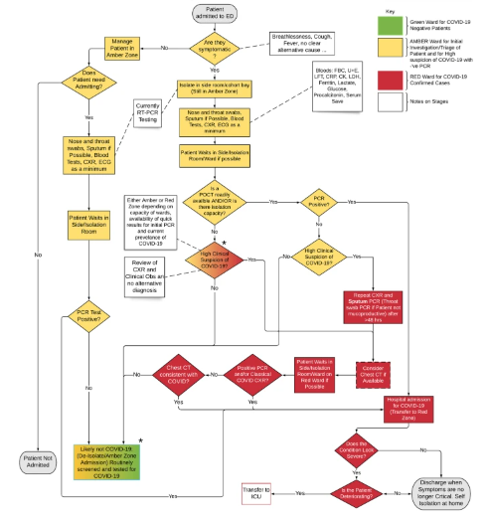
Figure 3: Care pathway and prioritization of rapid testing
(Source: Hicks et al. 2021)

5.2 Lifestyle management and structured education
Lifestyle modification is the foundation of Type 2 diabetes management within the NHS. In addition, patients are encouraged to achieve sustainable weight loss through balanced nutrition, daily physical activity, smoking cessation, and reduced alcohol consumption. The NHS suggests at least 150 minutes of medium-intensity exercise per week along with the healthy dietary patterns which limits saturated fats, refined sugars, and excess calories (NHS, 2022). NICE also recommends that all newly diagnosed adults must be offered structured education programmes including the DESMOND in order to enhance self-management skills, medication adherence, and understanding of disease progression (Scannell et al. 2025). These interventions massively enhance glycaemic control and minimize the risk of diabetes-related complications.

5.3 Pharmacological treatment (NICE guidance)
The National Institute for Health and Care Excellence (NICE) Guideline NG28 suggests that, where targets for glycaemia are not met, pharmacological therapy should be used alongside lifestyle changes (NICE, 2022). For the majority of adults, Metformin is the first-choice drug on account of its effectiveness, the safer it is to use and the benefit it gives in the heart. Depending on clinical characteristics, other medications may be used, including DPP-4 inhibitors, sulfonylureas, pioglitazone or SGLT2 inhibitors, if metformin is not tolerated or contraindicated. SGLT2 inhibitors are recommended in people with existing cardiovascular disease, chronic kidney disease or heart failure because they have been shown to have beneficial effects on heart and kidney health (Di Costanzo et al. 2023). GLP-1 receptor agonists are a medication option for selected individuals with obesity for whom glycemic control is suboptimal despite multiple therapies. Insulin therapy is initiated when other oral or injectable hypoglycaemic agents have not successfully lowered HbA1c to levels or have been used in the presence of hyperglycaemia that is felt to be severe (Galdón Sanz-Pastor et al. 2024).

5.4 Ongoing monitoring and multidisciplinary care
Long-term management of Type 2 diabetes needs daily monitoring, and it also coordinated to the multidisciplinary care. The NHS suggests routine assessment of HbA1c, blood pressure, lipid profile, renal function, body weight, and foot health for detecting complications at an early stage (NICE, 2023). In addition, annual retinal screening is also delivered to minimize the risk of diabetes-related vision loss. Diabetes care includes the collaboration among the general practitioners, diabetes specialist nurses, dietitians, podiatrists, pharmacists, and ophthalmology services with referral to endocrinologists when clinically indicated. In addition, constant patient education, medication review and personalized care planning enhances treatment adherence, optimizes glycaemic control and also improves long-term health outcomes (Religioni et al. 2025).

6. Models and Theoretical perspectives for long-term condition management

6.1 UK Model – House of Care Framework
The House of Care Framework is a person-based model that is hugely taken towards the NHS to support individuals living with long-term situations including Type 2 diabetes (Coningsby et al. 2022). The framework mostly emphasizes effective care planning in which healthcare professionals and patients work together to develop personalized treatment goals based on the clinical evidence and individual choices. The model consists of 4 interconnected components such as engaged and informed patients, healthcare professionals committed to partnership working and organizational systems that support coordinated care, and community sources that promote self-management. For people with Type 2 diabetes, this framework encourages the shared decision-making related to medication, diet, physical activity, blood glucose monitoring, and risk factor management (Health and Social Care Alliance Scotland, 2018). In addition, structured education programmes, daily reviews as well as access to the multidisciplinary services enhances confidence of the patients and treatment adherence. Through adopting clinical care with the community and social support, the House of Care Framework improves self-management, minimizes diabetes-related concerns and also enhances the overall life quality (Health and Social Care Alliance Scotland, 2018). This approach links with the NHS’s England’s commitment to personalised, integrated care for long-term situations.
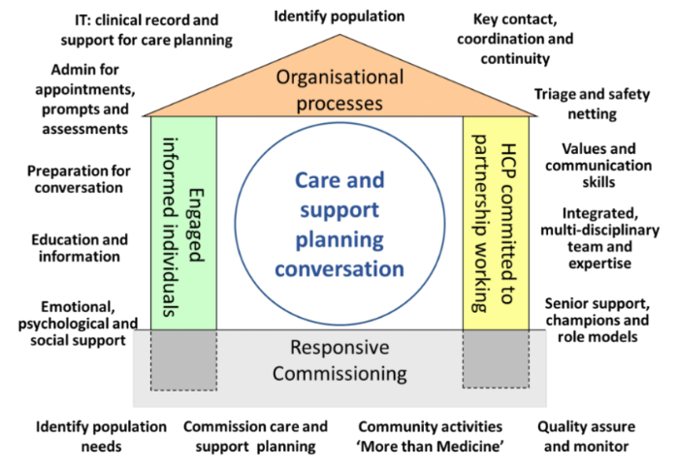
Figure 4: House of Care Framework
(Source: Yearofcare.co.uk, 2024)

6.2 International Model – Chronic Care Model (CCM)
The Chronic Care Model (CCM) is developed by Wagner and colleagues, which is an internationally determined framework in terms of enhancing the outcomes in chronic diseases such as Type 2 diabetes (Goh et al. 2022). The model determines 6 important components such as healthcare organisation, community resources, self-management support, delivery system design, decision support, and clinical information systems. These elements mostly promote proactive, planned and evidence-oriented care instead of reactive treatment of complications. In diabetes management, the CCM always encourages patient education, daily monitoring of HbA1c and cardiovascular risk factors, multidisciplinary collaboration, along with the use of electronic health records to support the clinical decision-making (Levy et al. 2026). It also improves connections between health and community services to promote healthy lifestyle practices and ongoing self-management. The implementation of the CCM has been shown to positively impact glycaemic control and medication adherence, patients' satisfaction, and reduce hospital admissions (Goh et al. 2022). The model has been adopted internationally to influence diabetes care programmes and will support strategies for integrated care for chronic diseases in the NHS.
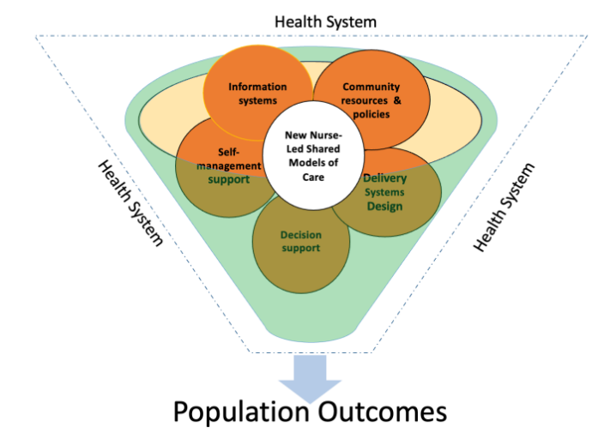
Figure 5: Chronic Care Model (CCM)
(Source: Nursology, 2021)

7. UK Policy and Health & Social Care Priorities

7.1 National strategies
The Type 2 diabetes management in England is guided through various national policies. The NHS Long Term Plan always prioritizes protection, early diagnosis, personalised care, and the larger use of various digital technologies in order to enhance long-term condition management. NICE Guideline NG28 delivers evidence-based suggestions on diagnosis, lifestyle interventions, medication, monitoring, and complication prevention to assure continuous, high-quality care (Vasey et al. 2024). Along with that, the Core20PLUS5 approach aims to minimize health inequalities through enhancing diabetes protection and treatment among the most deprived communities and other vulnerable populations.

7.2 Local implementation through Integrated Care Systems (ICSs)
Integrated Care Systems (ICSs) are responsible to implement national diabetes policies at the local level through coordinating services towards the primary care, hospitals, community healthcare, local authorities, and voluntary organisations. For people with Type 2 diabetes, ICSs enhance access to structured education, screening, foot care, weight management programmes, and multidisciplinary specialist services (Zarora et al. 2022). They also use population health data in order to determine individuals at high risk and target protective interventions, especially in disadvantaged communities. Through the integrated service planning and collaborative care, ICCs improves continuity of care, enhance clinical outcomes, minimize avoidable hospital admissions, and support the NHS goal to deliver high-quality, locally tailored diabetes services.

8. Person-Centred Care and Future Recommendations
Person-centred care is important to the long-term management of Type 2 diabetes within the NHS. Patients must be effectively involved in shared decision-making, with personalized care plans which consider their health goals, cultural background, preferences, and lifestyle. Daily education, self-monitoring and psychological support might enhance treatment adherence and entire life quality (Aji et al. 2026). In this context, future enhancements must focus on increasing access to digital health technologies, continuous glucose monitoring for eligible patients, and remote consultations to improve self-management. However, it is recommended to improve preventive programmes, minimizing health inequalities by the Core20PLUS5 initiative and enhancing multidisciplinary collaboration will also improve diabetes outcomes across the NHS in the near future.

9. Conclusion
Type 2 diabetes is one of the key chronic diseases that needs to be identified promptly, evidence-based management and regular person-centred care. Health outcomes and quality of life are enhanced through NHS strategies, NICE guidance, multidisciplinary working and self-management support. Incorporating new methods of diabetes care, improving health inequalities and improving prevention remains important for sustainable diabetes management in the UK.

References
Aji, P.T., Rizkasari, E. and Baidhowy, A.S., 2026. Digital self-management and psychological well-being in hypertensive patients: The mediating role of adherence across the life course. Life Course Psychology, 1(1), pp.7-15. https://journal.scidacplus.com/index.php/lcp/article/download/830/374
Ansari, P., Tabasumma, N., Snigdha, N.N., Siam, N.H., Panduru, R.V., Azam, S., Hannan, J.M.A. and Abdel-Wahab, Y.H., 2022. Diabetic retinopathy: an overview on mechanisms, pathophysiology and pharmacotherapy. Diabetology, 3(1), pp.159-175.https://doi.org/10.3390/diabetology3010011
Basiri, R., Seidu, B. and Rudich, M., 2023. Exploring the interrelationships between diabetes, nutrition, anxiety, and depression: implications for treatment and prevention strategies. Nutrients, 15(19), p.4226.https://doi.org/10.3390/nu15194226
Busebaia, T.J.A., Thompson, J., Fairbrother, H. and Ali, P., 2023. The role of family in supporting adherence to diabetes self‐care management practices: An umbrella review. Journal of Advanced Nursing, 79(10), pp.3652-3677.DOI: 10.1111/jan.15689
Chandrasekaran, P. and Weiskirchen, R., 2024. Cellular and molecular mechanisms of insulin resistance. Current Tissue Microenvironment Reports, 5(3), pp.79-90.https://doi.org/10.1007/s43152-024-00056-3
Chandrasekaran, P. and Weiskirchen, R., 2024. The role of obesity in type 2 diabetes mellitus—An overview. International journal of molecular sciences, 25(3), p.1882.https://doi.org/10.3390/ijms25031882
Chen, X., Zhang, L. and Chen, W., 2025. Global, regional, and national burdens of type 1 and type 2 diabetes mellitus in adolescents from 1990 to 2021, with forecasts to 2030: a systematic analysis of the global burden of disease study 2021. BMC medicine, 23(1), p.48.https://doi.org/10.1186/s12916-025-03890-w
Coningsby, I., Ainsworth, B. and Dack, C., 2022. A qualitative study exploring the barriers to attending structured education programmes among adults with type 2 diabetes. BMC health services research, 22(1), p.584. https://doi.org/10.1186/s12913-022-07980-w
Davies, M.J., Aroda, V.R., Collins, B.S., Gabbay, R.A., Green, J., Maruthur, N.M., Rosas, S.E., Del Prato, S., Mathieu, C., Mingrone, G. and Rossing, P., 2022. Management of hyperglycaemia in type 2 diabetes, 2022. A consensus report by the American Diabetes Association (ADA) and the European Association for the Study of Diabetes (EASD). Diabetologia, 65(12), pp.1925-1966.https://doi.org/10.1007/s00125-022-05787-2
Dhondge, R.H., Agrawal, S., Patil, R., Kadu, A. and Kothari, M., 2024. A comprehensive review of metabolic syndrome and its role in cardiovascular disease and type 2 diabetes mellitus: Mechanisms, risk factors, and management. Cureus, 16(8).Doi:10.7759/cureus.67428
Di Costanzo, A., Esposito, G., Indolfi, C. and Spaccarotella, C.A.M., 2023. SGLT2 inhibitors: a new therapeutical strategy to improve clinical outcomes in patients with chronic kidney diseases. International Journal of Molecular Sciences, 24(10), p.8732.https://doi.org/10.3390/ijms24108732
Diabetes Atlas., 2025. United Kingdom. [online] Available at: https://diabetesatlas.org/data-by-location/country/united-kingdom/?utm_source=chatgpt.com [Accessed 16 July 2026].
Diabetes UK., 2019. Diabetes and Emotional Health - a Practical Guide for Healthcare Professionals Supporting Adults with Type 1 and Type 2 Diabetes. [online] Diabetes UK. Available at: https://www.diabetes.org.uk/for-professionals/improving-care/good-practice/psychological-care/emotional-health-professionals-guide [Accessed 16 July 2026].
Diabetes UK., 2024. Cost of Devastating Complications Highlights Urgent Need to Transform Diabetes Care in the UK. [online] Diabetes UK. Available at: https://www.diabetes.org.uk/about-us/news-and-views/cost-complications-highlights-urgent-need-transform-diabetes [Accessed 16 July 2026].
Galdón Sanz-Pastor, A., Justel Enríquez, A., Sánchez Bao, A. and Ampudia-Blasco, F.J., 2024. Current barriers to initiating insulin therapy in individuals with type 2 diabetes. Frontiers in endocrinology, 15, p.1366368.https://doi.org/10.3389/fendo.2024.1366368
Goh, L.H., Siah, C.J.R., Tam, W.W.S., Tai, E.S. and Young, D.Y.L., 2022. Effectiveness of the chronic care model for adults with type 2 diabetes in primary care: a systematic review and meta-analysis. Systematic Reviews, 11(1), p.273. https://doi.org/10.1186/s13643-022-02117-w
Goh, L.H., Siah, C.J.R., Tam, W.W.S., Tai, E.S. and Young, D.Y.L., 2022. Effectiveness of the chronic care model for adults with type 2 diabetes in primary care: a systematic review and meta-analysis. Systematic Reviews, 11(1), p.273.https://doi.org/10.1186/s13643-022-02117-w
Health and Social Care Alliance Scotland (2018). The House of Care Model. [online] Health and Social Care Alliance Scotland. Available at: https://www.alliance-scotland.org.uk/past-work-and-projects/scotlands-house-of-care/the-house-of-care-model/ [Accessed 17 July 2026].
Hicks, T., Winter, A., Green, K., Kierkegaard, P., Price, D.A., Body, R., Allen, A.J., Graziadio, S., Price, D.A., Body, R. and Allen, A.J. (2021). Care pathway and prioritization of rapid testing for COVID-19 in UK hospitals: a qualitative evaluation. BMC Health Services Research, 21(1). doi:10.1186/s12913-021-06460-x.
International Diabetes Federation., 2025. Over 250 million people worldwide unaware they have diabetes, according to new IDF research - International Diabetes Federation. [online] Available at: https://idf.org/news-and-resources/news/idf-diabetes-atlas-11th-edition/?utm [Accessed 16 July 2026].
Khunti, K., Chudasama, Y.V., Gregg, E.W., Kamkuemah, M., Misra, S., Suls, J., Venkateshmurthy, N.S. and Valabhji, J., 2023. Diabetes and multiple long-term conditions: a review of our current global health challenge. Diabetes Care, 46(12), pp.2092-2101.https://doi.org/10.2337/dci23-0035
Kua, P., Akani, C.I., Innimgba, N., Okocha, A.N., John, D.H., Sapira-Ordu, L., Altraide, B.O., Ocheche, U.S., Mba, A.G., Iwo-Amah, R.S. and Jaja, M.A., 2023. Glycosylated Haemoglobin (HbA1c) as a diagnostic criterion for hyperglycaemia first detected in pregnancy. Nigerian Medical Journal, 64(2), pp.281-292. https://www.ajol.info/index.php/nmj/article/download/248141/234690
Levy, N.A., El‐Boghdadly, K., Lobo, D.N., Stubbs, D.J., Avari, P., Buggy, D., Frank, C., Howson, K., Moffett, J., Morris, E. and Mustafa, O.G., 2026. Peri‐operative management of diabetes mellitus: a multidisciplinary consensus statement from the Association of Anaesthetists and the Joint British Diabetes Societies for Inpatient Care group. Anaesthesia.https://associationofanaesthetists-publications.onlinelibrary.wiley.com/doi/pdf/10.1111/anae.70181
Liu, R., Li, L., Shao, C., Cai, H. and Wang, Z., 2022. The impact of diabetes on vascular disease: progress from the perspective of epidemics and treatments. Journal of diabetes research, 2022(1), p.1531289.https://doi.org/10.1155/2022/1531289
Luís, J.I.D., de Andrade, R.M. and Silva-Junior, J.S., 2026. Impacts of diabetes mellitus in the workplace: an integrative review of occupational and economic factors. Revista Brasileira de Medicina do Trabalho, 23(4), p.e20251509.https://doi.org/10.47626/1679-4435-2025-1509
Magliano, D.J., Boyko, E.J. and Atlas, D., 2025. 3. The global picture of diabetes. [online] Nih.gov. Available at: https://www.ncbi.nlm.nih.gov/books/NBK618744/ [Accessed 16 July 2026].
Newson, L., Brown, J.E. and Dugdale, S., 2025. Being the supporter: an interpretative phenomenological analysis of the role of caregivers in the self-management of type 2 diabetes. Psychology & health, 40(3), pp.377-393.https://doi.org/10.1080/08870446.2023.2231004
NHS., 2022. The Eatwell Guide. [online] NHS. Available at: https://www.nhs.uk/live-well/eat-well/food-guidelines-and-food-labels/the-eatwell-guide/
NHS., 2026. Overweight and obesity in adults. [online] nhs.uk. Available at: https://www.nhs.uk/conditions/overweight-and-obesity/ [Accessed 16 July 2026].
NICE., 2022. Type 2 Diabetes in adults: Management. [online] Nice.org.uk. Available at: https://www.nice.org.uk/guidance/ng28
NICE., 2023. Quality statement 6: 9 key care processes | Type 2 diabetes in adults | Quality standards | NICE. [online] www.nice.org.uk. Available at: https://www.nice.org.uk/guidance/QS209/chapter/quality-statement-6-9-key-care-processes
Nice.org.uk., 2015. Overview | Type 2 diabetes in adults: management | Guidance | NICE. [online] Available at: https://www.nice.org.uk/guidance/ng28?UID=9037047162025127125649&utm [Accessed 16 July 2026].
Nice.org.uk., 2015a. Blood glucose management | Type 2 diabetes in adults: management | Guidance | NICE. [online] Available at: https://www.nice.org.uk/guidance/ng28/chapter/Blood-glucose-management [Accessed 16 July 2026].
Nursology., 2021. The Expanded Chronic Care Model. [online] Available at: https://nursology.net/nurse-theories/the-expanded-chronic-care-model/
Przybyłek-Stępień, Z.A., Szustak, J., Bartosiński, R., Wijata, M., Wijata, A., Dutkiewicz, J., Mączyńska, W., Kąpa, M., Szepietowski, B., Kaźmierczak, J. and Rycerz, E., 2025. The Education and Lifestyle as Elements of Type 2 Diabetes Therapy. Quality in Sport, 39, pp.58454-58454.https://doi.org/10.12775/QS.2025.39.58454
Religioni, U., Barrios-Rodríguez, R., Requena, P., Borowska, M. and Ostrowski, J., 2025. Enhancing therapy adherence: impact on clinical outcomes, healthcare costs, and patient quality of life. Medicina, 61(1), p.153.https://doi.org/10.3390/medicina61010153
Scannell, C., O’Neill, T. and Griffin, A., 2025. The Effectiveness of a Primary Care Diabetes Education and Self‐Management Program in Ireland: A 6‐Month Follow‐Up Study. Endocrinology Diabetes & Metabolism, [online] 8(2). doi:10.1002/edm2.70036
Vasey, M., Besag, F., Bronowska, Z. and Cini, E., 2024. The NICE guideline for the recognition and treatment of eating disorders. Cutting Edge Psychiatry in Practice, (6), pp.117-127. https://kclpure.kcl.ac.uk/portal/files/333961555/CEPiP6-Article-15_1.pdf
Yang, D.R., Wang, M.Y., Zhang, C.L. and Wang, Y., 2024. Endothelial dysfunction in vascular complications of diabetes: a comprehensive review of mechanisms and implications. Frontiers in endocrinology, 15, p.1359255.https://doi.org/10.3389/fendo.2024.1359255
Yearofcare.co.uk., 2024. The Year of Care House – Year Of Care. [online] Available at: https://www.yearofcare.co.uk/implementation/the-year-of-care-house/
Zarora, R., Immanuel, J., Chivese, T., MacMillan, F. and Simmons, D., 2022. Effectiveness of integrated diabetes care interventions involving diabetes specialists working in primary and community care settings: a systematic review and meta-analysis. International Journal of Integrated Care, 22(2), p.11. https://doi.org/10.5334/ijic.6025

