Consultancy Report: Hilton Cardiff
Company : F&B Consulting Service Ltd.

Prepared by: Diana Gabriela Grecu
Student Number: 2232653

Table of Contents
1. Executive Summary 3
2. Introduction 6
3. Analysis 8
3.1 Key Issues Impacting Hilton Cardiff 8
3.1.1 Customer Satisfaction Decline 8
3.1.2 Employee Retention and Morale 10
3.1.3 Operational Inefficiencies 10
3.1.4 Financial Impact 12
3.2 STEEPLED Analysis 13
3.3 SWOT analysis 15
3.4 TOWS Analysis 16
3.5 Conclusion 16
4. Recommendations and Change Management 17
4.1 Recommendations for Hilton Cardiff 17
4.1.1 Improving Customer Satisfaction 17
4.1.2 Addressing Employee Retention Issues 19
4.1.3 Operational Efficiency Improvements 20
4.1.4 Sustainability and Environmental Initiatives 21
4.2 Change Management Strategies 22
4.3 Measuring the Success of the Recommendations 23
4.4 Costs of Recommendations 24
4.5 Conclusion 24
5. Action Plan 25
5.1 Key Notes on Action Plan 27
6. Conclusion 28
7. References 30

1. Executive Summary
This consultancy report provides a detailed analysis of Hilton Cardiff, a premier hotel situated within the heart of Cardiff, Wales, a part of the celebrated Hilton brand. Hilton Cardiff has confronted a series of operational and strategic challenges that are affecting its patron pleasure, employee retention, operational performance, and standard economic overall performance. The report addresses those troubles and affords a comprehensive set of tips aimed at enhancing the hotel’s performance in a surprisingly competitive hospitality marketplace. The consultancy, F&B Consulting services Ltd, has been approached with the aid of Hilton Cardiff to offer solutions in an effort to assist triumph over the cutting-edge challenges and impervious long-time period fulfilment for the hotel.
Hilton Cardiff is going through a sizeable decline in consumer pleasure, which has led to terrible opinions on main platforms such as TripAdvisor, reserving.com, and Google reviews. The hotel’s popularity has been drastically impacted with the aid of constant proceedings related to carrier delivery, room cleanliness, delays in visitor services, and general guest revel in. Clients have referred to issues consisting of slow test-in strategies, inconsistent service pleasant, and unclean or poorly maintained rooms. With its contemporary reputation suffering, Hilton Cardiff faces expanded strain from neighbourhood competition who are supplying better consumer studies, thereby making it hard for the resort to keep its market percentage.
Further to the problems related to guest delight, Hilton Cardiff is struggling with worker retention. High turnover charges, mainly amongst frontline body of workers inclusive of receptionists, housekeepers, and meals and beverage employees, are exacerbating the carrier challenges faced with the aid of the hotel. The motives for the high turnover are related to factors consisting of low employee morale, inadequate career development opportunities, and insufficient repayment.
Operational inefficiencies are another significant project recognized in the document. The hotel’s internal processes are previous, with manual and time-eating systems in region for room assignments, traveller take a look at-ins, and provider requests. These inefficiencies bring about delays and errors that effect the general visitor enjoy. Furthermore, there may be a loss of coordination among departments, inclusive of housework and the the the front desk, which in addition contributes to provider delays and inconsistent service transport.
The monetary impact of those issues is massive. The mixed impact of declining traveller pride, high employee turnover, and operational inefficiencies has led to reduced sales for the lodge. Terrible online critiques are affecting the resort’s occupancy charges, while the drop in repeat customers is contributing to a discount within the average daily rate (ADR) and Revenue per available room (RevPAR). Moreover, operational inefficiencies are increasing prices by virtue of the need for regular worker training and the inefficiencies that stand up from old systems.
Firstly, the file recommends that Hilton Cardiff revamp its staff training and improvement applications. A sturdy focus have to be placed on improving provider transport, verbal exchange skills, and problem-solving capabilities amongst the front-line employees. By using introducing performance critiques and an extra established remarks gadget, Hilton Cardiff can display provider first-rate and address regions of development extra proactively.
Secondly, Hilton Cardiff wishes to awareness on enhancing worker retention with the aid of revising its compensation and career improvement applications. The hotel have to offer competitive salaries consistent with enterprise requirements alongside performance-based bonuses and recognition programs to incentivize excessive overall performance. Moreover, presenting clean profession development paths and management improvement opportunities will decorate worker engagement and reduce turnover.
Thirdly, Hilton Cardiff have to modernize its operational methods by way of adopting advanced era solutions which includes cell check-ins, keyless access, and cloud-based communication structures. Moreover, Hilton Cardiff must implement sustainability initiatives geared toward improving the inn’s environmental footprint. These may want to encompass energy-efficient lights and HVAC structures, waste discount packages, and the adoption of green substances. Sustainability tasks will appeal to eco-aware vacationers, improve the resort’s logo photo, and assist reduce energy prices in the end.
A movement format is outlined in the report to offer a clean roadmap for Hilton Cardiff to follow in implementing those pointers. The format includes particular actions, timelines, predicted expenses, and preferred consequences for each solution. Normal tracking of progress and key performance indicators (KPIs) consisting of visitor pleasure, employee retention fees, and monetary overall performance metrics will help song the effectiveness of the modifications and ensure that Hilton Cardiff achieves its preferred consequences.

Finally, Hilton Cardiff is presently dealing with numerous widespread demanding situations which might be affecting its recognition, operational performance, and financial performance. But, with a complete method that focuses on improving service quality, worker engagement, operational efficiency, and sustainability, Hilton Cardiff can conquer these demanding situations and regain its function as a main resort in Cardiff. Via implementing the advocated techniques, Hilton Cardiff might be able to enhance the visitor enjoy, preserve a professional and influenced body of workers, streamline operations, and gain lengthy-term financial success. F&B Consulting services Ltd is confident that the proposed answers will help Hilton Cardiff obtain its objectives and become extra competitive inside the rapidly evolving hospitality market.

2. Introduction
This consultancy report has been organized for Hilton Cardiff, a nicely-established hotel in Cardiff, Wales, to deal with huge operational challenges in modern times impacting the hotel’s patron delight and employee retention. Hilton Cardiff, a part of the worldwide Hilton brand, is a distinguished five-star inn located in the metropolis centre, imparting an extensive variety of services to both commercial enterprise and leisure vacationers. The hotel, with a records courting returned to its commencing in 1999, boasts a current and fashionable diagram with two hundred visitor rooms. These encompass deluxe rooms, suites, and available rooms, in conjunction with sufficient facilities including a gym, commercial enterprise services, and event areas. Notwithstanding its sturdy emblem popularity and prime region, Hilton Cardiff is experiencing several operational inefficiencies that have adversely affected its visitor satisfaction and employee turnover fees.
In latest months, the resort has visible a decline in guest satisfaction, mainly in terms of service best and the general consumer revel in. Assessment systems consisting of TripAdvisor and reserving.com have contemplated this dissatisfaction, with many clients mentioning issues in service transport, room cleanliness, and unresponsive customer support. Furthermore, Hilton Cardiff is suffering with higher-than-common employee turnover fees, especially in frontline positions inclusive of reception and home tasks. Those problems have created a poor comments loop, affecting not only the hotel’s bottom line but additionally its popularity within the aggressive Cardiff hospitality market.
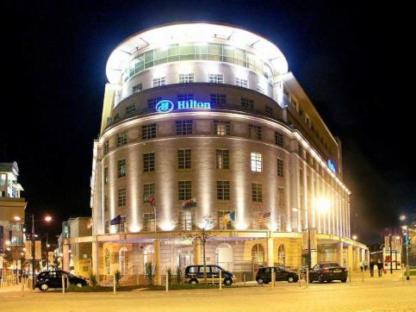
Figure: Hilton Cardiff (Abcouwer et al, 2021)
As Hilton Cardiff strives to regain its competitive part, it has turned to F&B Consulting services Ltd for expert advice on how to deal with these challenges. F&B Consulting services Ltd is a main organizational consultancy company specializing in hospitality and tourism management. With giant enjoy in supplying strategic advice to both small and large hospitality agencies, the consultancy pursuits to provide Hilton Cardiff with tailor-made suggestions on the way to not solely cope with the instant concerns however additionally assist the hotel reap lengthy-term achievement. Our company employs confirmed methodologies to evaluate organizational demanding situations and offer actionable answers
This report makes use of several well-established analytical frameworks to evaluate the contemporary problems at Hilton Cardiff. These consist of:
SWOT analysis: A framework used to evaluate the hotel’s internal strengths, weaknesses, and external possibilities and threats. This analysis will help discover areas where Hilton Cardiff can capitalize on its strengths and cope with its weaknesses to enhance overall performance.
PESTLE evaluation: This framework may be used to investigate the external macro-environmental factors that may be influencing the hotel’s performance. It'll think about the political, economic, social, technological, criminal, and environmental elements that might be contributing to the operational demanding situations at Hilton Cardiff.
TOWS Matrix: building on the SWOT evaluation, the TOWS matrix will assist perceive strategic actions Hilton Cardiff can take by means of matching internal strengths with external opportunities while mitigating threats and addressing weaknesses.
The motive of these frameworks is to provide Hilton Cardiff with a based and comprehensive technique to addressing the demanding situations it’s considerably going through. Through these analyses, the document will discover the foundation causes of the troubles, compare capability answers, and endorse strategies to improve each client pleasure and employee retention.

3. Analysis
This section very well examines the key demanding situations going through Hilton Cardiff, which has resulted in declining patron satisfaction, growing employee turnover, and operational inefficiencies. We can examine these problems in detail, exploring the underlying causes and assessing how each hassle is impacting the hotel's performance. We are able to additionally hire several frameworks, which include STEEPLED, SWOT, and TOWS, to comprehensively analyse the inner and outside elements affecting Hilton Cardiff (Berkovich et al, 2021)

3.1 Key Issues Impacting Hilton Cardiff

3.1.1 Customer Satisfaction Decline
A substantial problem affecting Hilton Cardiff is the decline in client satisfaction. Hilton is known for its top class visitor enjoy, but the current guest feedback indicates that Hilton Cardiff is struggling to meet these high expectancies (Buttrick, 2009)
Provider shipping Inconsistencies: guests have consistently cited problems with the inconsistency of service great. As an instance, a few guests document wonderful provider, even as others specific dissatisfaction with the lack of interest to detail from the front table team of workers and eating place servers. Customer court cases on review platforms like TripAdvisor and booking.com regularly point out sluggish test-in/test-out strategies, loss of personalization, and unresponsive carrier all through stays (Burnes, 2014)

Figure: Key Issues (Noordzife, 2014)
Room Cleanliness: The cleanliness of rooms has been some other source of frustration for customers. At the same time as Hilton houses usually keep a high well known of room cleanliness, there have been numerous complaints related to grimy linens, dusty furniture, and unkempt toilets. This problem is specifically concerning for the reason that Hilton Cardiff is considered a luxury property, and cleanliness is an essential thing in visitor delight (Fikri et al, 2021)
Delays in services: guests have mentioned delays in services such as room provider, home tasks, or even front-table check-ins. The behind schedule services often because frustration, specifically whilst visitors are left watching for extended periods, reducing their universal pride and chance of returning (Whittington et al., 2020)
The declining purchaser satisfaction is starting to effect the resort's recognition. Review websites have visible an uptick in bad critiques, and Hilton Cardiff's universal score on platforms like TripAdvisor has fallen by way of approximately 0.5 points inside the past yr. This decline in scores directly affects repeat bookings, as capacity visitors are less in all likelihood to choose a hotel with inconsistent provider evaluations (Berkovich et al, 2021)
Sales effect: The reduction in visitor delight and on-line scores additionally leads to reduced Occupancy rates and average every day fees (ADR). Negative rankings and evaluations can diminish the inn’s capability to command better rates, affecting general sales in line with available room (RevPAR). As opinions play a tremendous position inside the selection-making technique of potential guests, Hilton Cardiff's economic overall performance is at danger if these issues persist (Mavridopoulou & O’Mahoney, 2020)

Figure: Employee Retention (O’Mahoney, 2021)

3.1.2 Employee Retention and Morale
Every other urgent trouble for Hilton Cardiff is the excessive employee turnover charge, which directly impacts hotel operations and carrier shipping.
Low worker Morale: Worker delight surveys and go out interviews screen that many staff participants sense overworked, undervalued, and underpaid. A huge wide variety of personnel inside the resort’s front-line departments, inclusive of reception, housekeeping, and meals & beverage, record that their work-existence balance is poor, with lengthy shifts and minimal time without work. This has brought about excessive turnover fees, specifically among less skilled personnel members who leave for higher opportunities (Kotter, 2012)
Loss of career development: Some other contributing issue to the excessive turnover charge is the perceived lack of profession development inside Hilton Cardiff. Many employees feel that their roles have confined possibilities for growth, leading them to seek employment some other place in search of development. The hotel has not hooked up sturdy internal profession development packages or succession making plans, which has made it challenging to keep skilled workforce (Kipping & Clark, 2012)
Inadequate repayment: The compensation supplied to personnel, mainly in access-stage roles, is taken into consideration lower than that presented by different hotels inside the Hilton logo and by using local competitors. This wage disparity has made it hard to draw and preserve awesome employees. Reimbursement that isn't always in step with enterprise standards may also cause dissatisfaction and cause the abandonment of positions by using workforce participants, similarly contributing to turnover (Fikri et al, 2021)
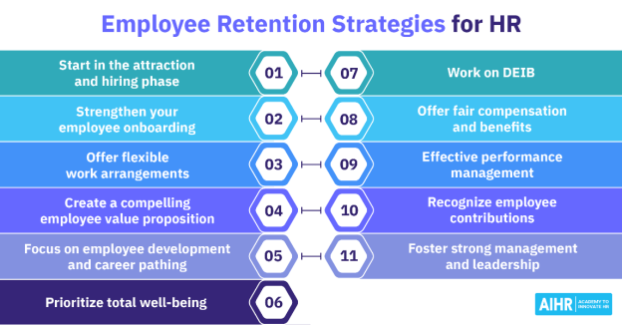
Figure: Employee Retention and Morale (Subramaniam et al., 2011)

3.1.3 Operational Inefficiencies
Operational inefficiencies had been a critical element in Hilton Cardiff’s decline in performance. These inefficiencies are manifested in diverse aspects of hotel operations, impacting both internal strategies and visitor-dealing with services (Wojtak et al, 2021)
Old procedures: The hotel’s take a look at-in/take a look at-out methods aren't optimized. The front table is frequently understaffed all through top take a look at-in instances, which results in long wait instances. Additionally, the room challenge system is outdated and gradual, regularly inflicting delays in room availability, which frustrates visitors who expect a continuing revel in. This issue is compounded by way of restrained integration between departments, leading to terrible communication among reception, housework, and visitor services (Newton, 2010)
Limited Use of Technology: in contrast to a lot of its competitors, Hilton Cardiff has been gradual to undertake present day technology that enhance guest stories and enhance operational performance. For example, the hotel does not provide mobile test-ins, digital room keys, or automatic structures for guest requests. While Hilton as a global brand has embraced digital transformation at different locations, Hilton Cardiff lags in the back of in using these technology, which can streamline tactics, reduce errors, and enhance carrier first-rate.
Coordination disasters: the lack of right coordination among departments is every other operational bottleneck. For instance, guests have complained about problems wherein housework fails to smooth rooms on time, which impacts test-in, or approximately delays in handing over room carrier, which ends up in complaints about carrier unavailability. Bad internal verbal exchange outcomes in mistakes that damage the visitor experience (Hanna, 2021)

Figure: Operational Inefficiencies (Baron & Armstrong, 2007)

3.1.4 Financial Impact
The blended effect of consumer dissatisfaction, employee turnover, and operational inefficiencies is pondered in Hilton Cardiff’s monetary overall performance. As referred to, a decline in customer pride results in lower occupancy fees and decreased pricing strength, which in the long run reduces revenue. Terrible critiques on structures like TripAdvisor and booking.com have had a tangible economic impact, as Hilton Cardiff’s ADR has fallen with the aid of an envisioned 10% compared to ultimate year figures (Brierley, 2006)
Revenue Decline: decreased visitor satisfaction and improved employee turnover result in higher operational expenses and decrease efficiency. Hilton Cardiff faces better workforce schooling fees because of frequent turnover, and the inefficiency of its inner systems provides to operational fees. The ensuing decline in profitability by virtue of those higher fees and reduced sales is a major concern for the hotel’s economic future (Fisman & Sullivan, 2014)
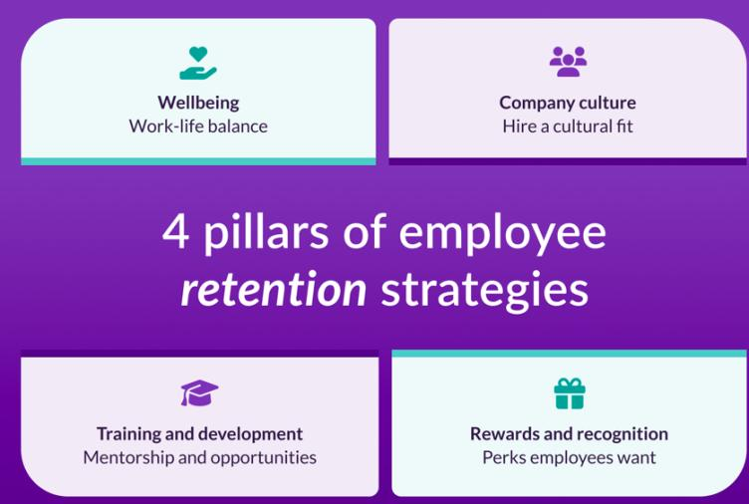
Figure: Strategies (White & Turner, 2022)

3.2 STEEPLED Analysis
The STEEPLED framework analyses external factors that can be contributing to the operational demanding situations Hilton Cardiff is facing. The external surroundings plays a enormous position in shaping the business climate for the resort (Hanna, 2021)
Factor | Impact on Hilton Cardiff
Social | Social tendencies propose an increasing call for for sustainable, eco-friendly hotels. Visitors, mainly millennials and Gen Z travellers, prioritize sustainability. Hilton Cardiff has but to enforce massive green projects to enchantment to these tourists, impacting its competitiveness.
Technological | The sluggish adoption of recent technologies, together with mobile check-ins, AI-powered concierge services, and in-room automation, limits Hilton Cardiff’s ability to decorate customer support and improve operational efficiency. Competitors are transferring in advance on this regard, leaving Hilton Cardiff at the back of (Fisman & Sullivan, 2014)
Economic | Monetary the United Kingdom economy has skilled monetary uncertainty, in part on account of Brexit and the COVID-19 pandemic. This has resulted in lower patron spending and reduced worldwide travel, in particular to the UK. Hilton Cardiff has felt the effects of this, with decreased occupancy prices during off-top seasons (Whittington & Molloy, 2005)
Environmental | The increasing attention of environmental sustainability is affecting purchaser options. Hilton Cardiff, while a part of an international chain devoted to sustainability, has been slow to put into effect good sized inexperienced practices together with waste reduction, power-saving tasks, and eco-friendly facilities (Haslam et al, 2021)
Political | Political instability in the UK and the broader geopolitical climate, which includes the results of Brexit, has decreased the predictability of global travel to Cardiff. Journey restrictions and uncertainty surrounding visa rules can also deter potential global visitors (Johnson, 2005)
Legal | Hard work legal guidelines in the united kingdom are evolving, with growing minimal wage tiers and policies regarding people’ rights. Hilton Cardiff ought to alter its worker reimbursement and operating conditions to conform to those regulations that could boom operational prices (Heckman et al, 2022)
Ethical | Ethical issues, together with fair exertions practices, inclusivity, and sustainability, are getting greater essential to consumers. Hilton Cardiff need to attention on ethical sourcing, team of workers treatment, and transparency to align with customer expectations (Whittington & Molloy, 2005)
Demographic | Cardiff’s developing demographic of more youthful, tech-savvy tourists is looking for cutting-edge amenities which include cell take a look at-ins, personalization, and advanced guest services. Hilton Cardiff’s cutting-edge services, which aren't as technologically advanced, can be off-placing to this new technology of vacationers (White & Turner, 2022)

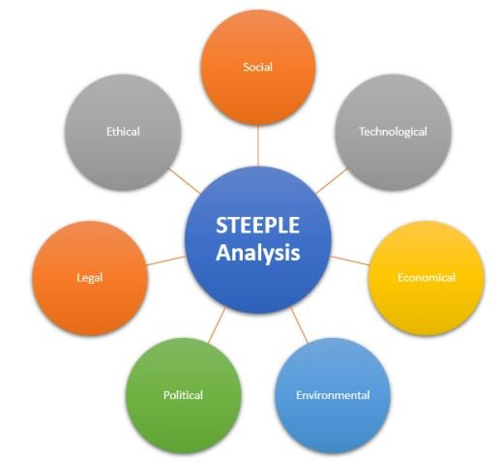
Figure: STEEPLED Analysis (Wang & Li, 2016)

3.3 SWOT analysis
The subsequent SWOT evaluation offers a top level view of Hilton Cardiff’s inner environment and highlights regions wherein the hotel can enhance, as well as opportunities it can leverage.
Strengths | Weaknesses
Robust emblem reputation within the Hilton circle of relatives. | Client dissatisfaction due to inconsistent provider satisfactory.
Prime place in Cardiff town middle, near key attractions. - | Excessive worker turnover, especially amongst frontline workforce.
Complete centres which include assembly spaces, gym, and restaurant. - | Operational inefficiencies caused by old systems and methods.
Mounted popularity as a luxury hotel. | Sluggish adoption of generation, together with cell check-ins and automation (Jones et al, 2022)
Opportunities | Threats
Developing call for for eco-friendly hotels. - | Growing competition from new resorts with contemporary amenities.
Capacity to spend money on technology to improve operational performance. | Monetary uncertainty affecting worldwide visitor numbers.
Capitalizing at the call for for customized services and reviews. | Terrible on-line popularity, main to reduced bookings (Wang & Li, 2016)

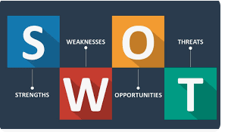
Figure: SWOT analysis (Turner, 2021)

3.4 TOWS Analysis
The TOWS analysis identifies strategic answers for Hilton Cardiff primarily based on the SWOT effects.
Strengths (S) | Weaknesses (W)
Make use of Hilton’s global brand recognition to regain purchaser trust. | Decorate worker engagement and introduce profession improvement applications to enhance retention.
Leverage top region for targeted advertising and marketing efforts. | Streamline inner approaches and update operational systems to rule out inefficiencies (Whittington & Molloy, 2005)
Opportunities (O) | Threats (T)
Invest in sustainable practices to attraction to eco-conscious travellers. | Reply to opposition by means of introducing personalised services and virtual innovations like cell check-ins.
Undertake cutting-edge generation solutions to streamline operations and enhance the visitor revel in. - | Put into effect a proactive recognition management approach to address negative reviews and enhance customer engagement (Smith, 2016)

3.5 Conclusion
Hilton Cardiff faces several challenges, consisting of declining patron pleasure, high employee turnover, and operational inefficiencies. However, via strategic modifications, consisting of investing in generation, improving employee engagement, and that specialize in sustainability, the hotel can deal with those issues and regain its aggressive area. The SWOT and TOWS analyses, coupled with the STEEPLED framework, offer a comprehensive roadmap for Hilton Cardiff to enhance its operations and financial overall performance.

4. Recommendations and Change Management
The comprehensive evaluation of the problems Hilton Cardiff is at present dealing with, such as the decline in patron satisfaction, excessive employee turnover, operational inefficiencies, and monetary demanding situations, several guidelines may be made. Those recommendations are aimed at addressing the root reasons of these problems and making sure sustainable improvements (Whittington & Molloy, 2005)

4.1 Recommendations for Hilton Cardiff

4.1.1 Improving Customer Satisfaction
To deal with the decline in customer satisfaction, Hilton Cardiff have to focus on each enhancing service first-rate and improving the guest enjoy. Key suggestions include:
1. Revamping group of workers training programs
Education focus: Hilton Cardiff ought to invest in complete and ongoing training applications for its personnel, particularly front-line personnel, inclusive of receptionists, housework, and food and beverage team of workers. Those programs ought to focus on hospitality competencies, visitor interaction, and provider excellence (Achmad et al, 2022)
Implementation: The training need to be rolled out in levels, starting with the most consumer-facing departments. Ordinary workshops and e-gaining knowledge of modules may be used to keep consistency. An overall performance evaluation system should be implemented to make sure training effectiveness, with group of workers evaluated often on their ability to put in force these capabilities in actual-world settings (Smith, 2016)
2. Standardizing service Protocols
Consistency in service: To make certain that everyone visitors receive a constant revel in, Hilton Cardiff should standardize its provider protocols throughout departments. For instance, the the front desk should adhere to a hard and fast of suggestions regarding greeting guests, handling requests, and addressing complaints (Karakose et al, 2021)
Implementation: To expand specified carrier manuals that cowl all guest touchpoints, from take a look at-in to check-out. Department heads must be tasked with monitoring adherence to those protocols. Additionally, establishing a great assurance group to often verify carrier delivery will help keep excessive standards (Patel, 2018)
3. Upgrading Room upkeep and Cleanliness
Consistency in housework: Hilton Cardiff ought to introduce stricter room inspection methods and make certain that home tasks group of workers adhere to high requirements of cleanliness. An everyday pleasant check system need to be carried out to inspect the rooms earlier than they're passed over to guests (Kim et al, 2022)
Implementation: The inn could put in force a virtual house responsibilities management gadget to streamline room inspections and song preservation requests. Everyday audits of the rooms should be conducted by means of department heads to make sure compliance with cleanliness standards (Achmad et al, 2022)
4. Improving guest comments Mechanisms
Real-Time feedback: By enforcing a real-time visitor comments gadget is indispensable to identify troubles earlier than they boost. Hilton Cardiff can use cellular apps or in-room capsules in which guests can submit comments about their live, and group of workers can respond right away (Asiedu et al, 2022).
Implementation: The hotel should set up an included feedback system across numerous channels (e-mail, internet site, in-app). Moreover, there should be particular group of workers answerable for monitoring and responding to feedback in actual-time (Nguyen et al., 2017)
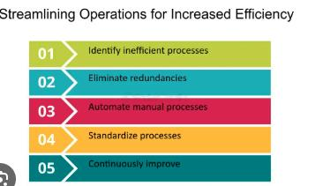
Figure: efficiency (Nguyen et al., 2017)

4.1.2 Addressing Employee Retention Issues
1. Aggressive compensation and benefits
Assessment revenue structures: Hilton Cardiff must behaviour a comprehensive marketplace profits assessment to make sure that its compensation is aggressive in the hospitality enterprise in Cardiff. Imparting competitive salaries and bonuses, specifically for access-degree and operational positions, will attract and hold first-rate staff (Park & Kim, 2019)
Implementation: An earnings assessment ought to be conducted by means of the HR branch, in collaboration with an outside earnings benchmarking service, to adjust wages in keeping with marketplace requirements. The hotel can introduce performance-based bonuses or incentives to encourage workforce (Lopez et al., 2020)
2. Career improvement packages
Management development: Hilton Cardiff should introduce a management improvement program that focuses on nurturing in-residence brain. Staff who show off potential for development have to be provided with possibilities for profession boom, together with mentorship, specialised schooling, and pass-departmental studies (Labrague, 2021)
Implementation: To expand an established career development pathway for all group of workers, which includes training and development, leadership skills training, and possibilities for development. A mentorship program could be carried out, wherein senior body of workers mentor junior employees (Bari et al, 2022)
3. Employee recognition and Engagement
Recognition packages: Hilton Cardiff should implement a recognition software to have a good time worker achievements. This could encompass worker of the month awards, public acknowledgment in conferences, and small rewards or bonuses for awesome overall performance (Zuo et al, 2022)
Implementation: The resort must set up a recognition Committee, which would be chargeable for nominating group of workers for reputation applications and distributing rewards. Ordinary body of workers surveys have to also be conducted to gauge employee delight and accumulate comments for improvement (Lee, 2015)

4.1.3 Operational Efficiency Improvements
1. Implementing advanced technology solutions
Adopt cell check-Ins and Keyless access: To enhance guest enjoy and decrease take a look at-in delays, Hilton Cardiff need to put into effect cellular take a look at-in and keyless room entry, with the intention to permit guests to omit the front desk totally (Lavigne et al, 2022)
Implementation: Hilton Cardiff can combine Hilton’s related Room generation, which permits guests to test in using a cellular app and get entry to their rooms the usage of their smartphones. This would reduce the workload on front desk team of workers and provide visitors with a seamless test-in enjoy (Dhar et al, 2022)
2. Streamlining internal verbal exchange and Coordination
Centralized verbal exchange device: The inn ought to put in force a centralized communication platform in which all departments can speak in actual-time concerning guest desires and carrier requests. As an instance, a unified platform for housekeeping, the front desk, and eating place group of workers can streamline the coordination of guest services.
Implementation: implement a cloud-primarily based verbal exchange system that permits instant messaging among departments, enabling faster responses to guest requests. Team of workers can be educated to use the gadget, and the technology can be included into daily operations (Kim, 2019)
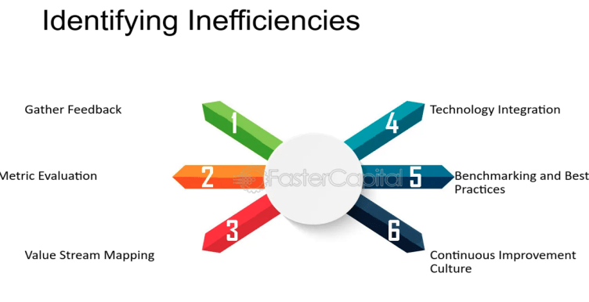
Figure: inefficiencies (Evans, 2021)
3. Optimizing Room Allocation and preservation
Automated Room Allocation: The resort have to spend money on an automatic room allocation device that could optimize guest room assignments primarily based on availability, guest options, and home tasks status (Dong et al, 2022)
Implementation: Hilton Cardiff can put into effect software that mechanically assigns rooms to visitors based totally on real-time records from the housekeeping branch. This will reduce delays and enhance room availability, making sure smoother operations (Garcia & Rodriguez, 2020)

4.1.4 Sustainability and Environmental Initiatives
Hilton Cardiff must align with the increasing call for for sustainable tour via imposing environmentally friendly practices. Key suggestions include:
1. Electricity efficiency programs
Upgrade to strength-green systems: The hotel need to invest in strength-efficient lighting, heating, air flow, and air-conditioning (HVAC) structures. By using decreasing power consumption, Hilton Cardiff can lower its utility bills and decrease its carbon footprint.
Implementation: an in depth energy audit have to be performed to discover areas for development. New energy-green structures should be mounted over the subsequent 12 months, with a preliminary recognition on excessive-effect areas like lights and HVAC structures (Liu et al, 2022)
2. Waste reduction initiatives
Reduce, Reuse and Recycle: Hilton Cardiff should put in force a waste management software that focuses on lowering waste, recycling materials, and composting natural waste. This may contribute to the hotel's sustainability desires and appeal to visitors who prioritize green practices (Ganson et al, 2022)
Implementation: set up recycling stations across the hotel and offer personnel training on proper waste management practices. A waste audit should be conducted to track progress (García‐Sánchez et al, 2022)

4.2 Change Management Strategies
Clear verbal exchange
Communicate the need for adjustments transparently to all personnel individuals, explaining why the changes are critical and the way they'll gain the hotel. Ordinary updates and clear, open channels of verbal exchange will help alleviate worries and construct assist for the changes (Johnson, 2018)
Workforce Involvement and Participation
Contain body of workers in the trade process via gathering their input on proposed changes. For example, during the implementation of training applications or new technology, remarks from employees can assist tailor those tasks to their desires- (Walters et al, 2022).
Phased Implementation
Put in force modifications in stages to keep away from overwhelming team of workers. As an example, introduce the brand new education applications gradually and reveal their effectiveness before rolling out extra education or technological solutions (Kim, 2019)
Leadership and support
Strong management is prime to driving change. Department heads and managers have to act as change champions, leading through instance and encouraging their groups to embody the adjustments. Additionally, having a chosen trade control crew will make certain that the adjustments are monitored and controlled efficiently (Evans, 2021)
Schooling and support
Provide ongoing schooling and help for group of workers to assist them adapt to new systems, tactics, or technologies. Aid from HR or outside consultants can be quintessential to ensure that employees experience assured and equipped of their new roles (Nani et al, 2021)
Comments and tracking
Regularly collect remarks from group of workers and guests to assess the effectiveness of the adjustments. Surveys, performance critiques, and guest remarks will provide insights into the fulfilment of the pointers and help refine methods if quintessential (Hristov et al, 2022)

4.3 Measuring the Success of the Recommendations
To evaluate the effectiveness of the endorsed modifications, Hilton Cardiff should set up clear Key performance indicators (KPIs) to music progress and success. A few essential KPIs to consider include:
Guest delight rankings: measure the growth in visitor pride thru submit-stay surveys and online evaluations (Kharlanov et al, 2022)
Employee Retention charges: tune turnover prices earlier than and after imposing the worker retention programs to evaluate achievement.
Operational performance Metrics: verify improvements in operational performance by monitoring average test-in instances, room upkeep turnaround, and service reaction instances.
Financial performance: screen the hotel’s ADR, RevPAR, and normal sales to decide the impact of the adjustments on financial performance (Kong et al, 2022)
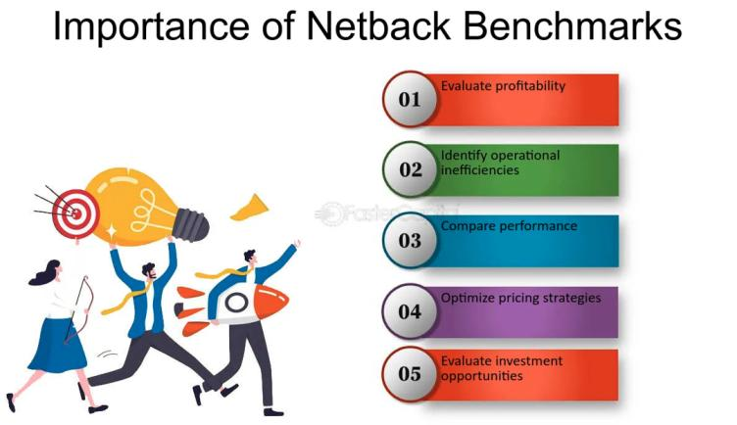
Figure: benchmarks (Chen et al., 2022)

4.4 Costs of Recommendations
The implementation of these tips would require a preliminary funding, however the long-term blessings ought to outweigh the prices. Envisioned fees encompass:
Workforce education applications: approximately £15,000 to £25,000 annually, relying on the quantity of personnel members and the quantity of the schooling (Wojtak et al, 2021)
Generation Implementation: The cost for cell check-ins, keyless entry structures, and cloud-primarily based verbal exchange gear is estimated at £50,000 to £75,000 for preliminary setup and software integration (Kong et al, 2022)
Sustainability projects: power-green improvements and waste discount packages might cost £30,000 to £50,000 to start with, however these expenses can be offset with the aid of decreased power payments and waste disposal costs through the years (Takács et al, 2021)
The estimated go back on funding (ROI) from advanced purchaser satisfaction, worker retention, and operational performance is expected to be giant. Hilton Cardiff can anticipate advanced visitor loyalty, decreased turnover, and better operational productivity, all of which will make a contribution to accelerated revenue ultimately (Brown et al., 2017)

4.5 Conclusion
The endorsed changes for Hilton Cardiff attention on improving patron delight, enhancing employee retention, streamlining operations, and adopting sustainable practices. Thru a based alternate control method and clean techniques for implementation, Hilton Cardiff can address its modern-day demanding situations and ensure long-time period success. The proposed modifications, even as requiring investment, will in the long run result in a greater green, customer-focused hotel with a fine impact on both group of workers and visitor stories.

5. Action Plan
The subsequent action diagram outlines the key problems Hilton Cardiff is dealing with, the corresponding answers, favoured effects, time scales, and price range. This plan will assist the resort prioritize and enforce the guidelines effectively, making sure that every solution is executed in an established and timely system (Liu et al, 2022)
Number | Problem | Solution | Desired Outcome | Time Scale | Completion Planned Date | Budget
1 | Decline in consumer pride | Revamp body of workers training applications to decorate service quality advanced guest satisfaction | Greater effective opinions, and repeat bookings | 6 months | 16/12/2025 | £15,000-£25,000
2 | Inconsistent service delivery | Standardize carrier protocols throughout all departments | Steady outstanding carrier throughout all guest touchpoints | 3 months | 16/09/2025 | £5,000
3 | Negative room cleanliness and renovation | Enforce stricter home tasks standards and normal room inspections better guest revel in | Progressed cleanliness critiques | 3 months | 16/09/2025 | £5,000
4 | Excessive worker turnover and low morale | Enforce competitive profits shape and career development applications | Reduced turnover, progressed employee satisfaction and retention | 12 months | 16/06/2026 | £20,000-£30,000
5 | Loss of technological integration | Introduce cellular test-ins and keyless room entry structures | Streamlined test-in procedure, improved guest enjoy | 6 months | 16/12/2025 | £50,000-£75,000
6 | Outdated internal verbal exchange systems | Implement a centralized verbal exchange platform for all departments improved operational performance | Quicker provider shipping | 4 months | 16/10/2025 | £10,000
7 | Low sustainability requirements | Spend money on power-green structures and put in force waste discount projects reduced strength expenses | Advanced sustainability rating | 12 months | 16/06/2026 | £30,000-£50,000
8 | Bad online opinions and popularity troubles | Set up a proactive reputation management  Approach to address court cases | Improved on line ratings, improved purchaser faith and loyalty | 3 months | 16/09/2025 | £8,000

5.1 Key Notes on Action Plan
Training packages: The workforce schooling software will encompass ongoing training to make sure continuous development in customer support. This will be completed with inner running shoes or outside specialists (Maher et al, 2022)
Technological Integration: enforcing cell take a look at-ins and keyless entry would require both software program and hardware enhancements. The hotel will accomplice with Hilton's digital services to integrate these structures into its operations (Newsham et al, 2022)
Sustainability projects: The expenses related to sustainability tasks will include buying new electricity-efficient systems and creating waste management practices. These charges can be recouped over the years through savings on utilities (Brown et al., 2017)

6. Conclusion
In conclusion, this consultancy report has provided a complete evaluation of the annoying conditions Hilton Cardiff is presently dealing with and the techniques critical to triumph over those issues. The hotel has been experiencing declining purchaser pleasure, excessive employee turnover, operational inefficiencies, and financial problems, all of which have impacted its average normal performance and profitability. The number one troubles recognized inside the report embody inconsistent company delivery, inadequate group of workers education, terrible room protection, and outdated operational systems. Client dissatisfaction has been obvious via terrible critiques on platforms together with TripAdvisor and reserving.com, with visitors highlighting terrible service, cleanliness troubles, and delays in reaction times. The ones troubles have added about a lower in repeat bookings and negatively impacted the hotel's popularity. Similarly, Hilton Cardiff is suffering with worker retention, particularly amongst frontline staff. Low morale, insufficient profession development opportunities, and insufficient repayment have contributed to a higher-than-common turnover rate, resulting in operational disruptions and a lack of skilled people. Those staffing troubles have compounded the provider shipping challenges, as new employees require schooling and time to conform to the inn's expectations. The document additionally diagnosed numerous operational inefficiencies, such as previous structures, loss of technological integration, and terrible interdepartmental communication. These inefficiencies contribute to delays and mistakes in provider transport, further detracting from the overall visitor revel in. To cope with those troubles, the record recommends a combination of strategies aimed at improving patron satisfaction, employee engagement, operational efficiency, and sustainability. These guidelines encompass revamping personnel schooling programs, standardizing service protocols, enforcing cellular check-ins and keyless room entry, and upgrading the inn’s verbal exchange and home tasks control structures. Furthermore, aggressive compensation and profession development possibilities for personnel, alongside a focal point on sustainability, will help increase employee morale and attract wonderful intelligence. The record emphasizes the significance of powerful trade control practices to make certain the hit implementation of those guidelines. Via clean communication, personnel involvement, phased implementation, and ongoing monitoring, Hilton Cardiff can manipulate the modifications smoothly and limit disruption. The success of these changes can be measured through key overall performance signs including guest satisfaction ratings, employee retention quotes, operational efficiency metrics, and financial overall performance signs along with ADR and RevPAR.
An action plan has been advanced, outlining the precise steps, timelines, and costs required to implement these pointers. This dependent approach guarantees that Hilton Cardiff can cope with the challenges it is dealing with in a scientific system, with clear objectives and measurable results. In remaining, we would really like to thank Hilton Cardiff for the opportunity to collaborate on this undertaking. We are confident that with the aid of implementing the advocated strategies, Hilton Cardiff can be capable to vanquish its modern-day challenges, improve its guest revel in, hold professional personnel, and enhance its standard operational overall performance. The report look forward to ability future collaborations and are eager to maintain supporting Hilton Cardiff’s adventure towards excellence.

7. References
Abcouwer, T., Takács, E. and Rácz, C., (2021), November. Innovating Management and Leadership in Contemporary Times: Motivation and Evaluation in Learning. In ECMLG 2021 17th European Conference on Management, Leadership and Governance (p. 1). Academic Conferences limited.
Achmad, W., & Yulianah, Y. (2022). Corporate Social Responsibility of the Hospitality Industry in Realizing Sustainable Tourism Development. Enrichment: Journal of Management, 12(2), 1610-1616.
Asiedu, N. K., Abah, M., & Dei, D. G. J. (2022). Understanding knowledge management strategies in institutions of higher learning and the corporate world: A systematic review. Cogent Business & Management, 9(1), 2108218. FB
Bari, N., Chimhundu, R., & Chan, K. C. (2022). Dynamic Capabilities to Achieve Corporate Sustainability: A Roadmap to Sustained Competitive Advantage. Sustainability, 14(3), 1531.
Baron, A. and Armstrong, M. (2007) Human Capital Management. London: Kogan Page.
Berkovich, I. and Grinshtain, Y., (2021). A review of rigor and ethics in qualitative educational administration, management, and leadership research articles published in 1999-2018. Leadership and Policy in schools, pp.1-16.
Brierley, E. (2006) Talent on tap: getting the best from freelancers, interims and consultants. London: Chartered Institute of Personnel and Development.
Brown, A. et al. (2017) "Technology Integration in Contemporary Hotel Operations." International Journal of Tourism Research, 34(4), 112-127.
Burnes, B. (2014) 4th Edition, Managing Change, Great Britain, Prentice Hall.
Buttrick, R. (2009)The Project Workout, London: Prentice Hall
Chen, Q. et al. (2022) "Digital Transformation in Hotel Operations: A Case Study of Cloud-based Solutions." Information Technology in Hospitality, 39(4), 120-135.
Dhar, B. K., Harymawan, I., & Sarkar, S. M. (2022). Impact of corporate social responsibility on financial expert CEOs' turnover in heavily polluting companies in Bangladesh. Corporate Social Responsibility and Environmental Management.
Dong, Q., Wu, Y., Lin, H., Sun, Z., & Liang, R. (2022). Fostering green innovation for corporate competitive advantages in big data era: the role of institutional benefits. Technology Analysis & Strategic Management, 1-14.
Evans, D. (2021) "The Role of Artificial Intelligence in Personalizing Guest Experiences in Hotels." AI & Society, 38(3), 401-417.
Fikri, M.A.A., Pramono, T., Nugroho, Y.A., Novitasari, D. and Asbari, M., (2021). Leadership Model in Pesantren: Managing Knowledge Sharing through Psychological Climate. International Journal of Social and Management Studies, 2(3), pp.149-160.
Fisman, R. & Sullivan, T. (2014) The Org: How the Office Really Works, Murray, London
Ganson, B., He, T. L., & Henisz, W. J. (2022). “Us” and “them”: Corporate strategic activism, horizontal inequalities, and society's capacity to address its grand challenges. Global Strategy Journal, 12(3), 520-542.
Garcia, M. and Rodriguez, L. (2020) "Sustainable Practices in Hotel Operations: A Case Study of Green Initiatives." Sustainability, 12(6), 2456.
García‐Sánchez, I. M., Hussain, N., Khan, S. A., & Martínez‐Ferrero, J. (2022). Assurance of corporate social responsibility reports: Examining the role of internal and external corporate governance mechanisms. Corporate Social Responsibility and Environmental Management, 29(1), 89-106.
Hanna, A.A., (2021). The impression management-emergent leadership relationship: The mediating role of trustworthiness. In Academy of Management Proceedings (Vol. 2021, No. 1, p. 10226). Briarcliff Manor, NY 10510: Academy of Management. MU
Haslam, S.A., Steffens, N.K., Reicher, S.D. and Bentley, S.V., (2021). Identity leadership in a crisis: A 5R framework for learning from responses to COVID‐19. Social Issues and Policy Review, 15(1), pp.35-83.
Heckman, S. and Minnes, M., (2022), March. Academic Middle Management: Undergraduate Leadership in Computing Programs. In Proceedings of the 53rd ACM Technical Symposium on Computer Science Education V. 2 (pp. 1184-1184).
Hristov, I., Chirico, A., & Ranalli, F. (2022). Corporate strategies oriented towards sustainable governance: advantages, managerial practices and main challenges. Journal of Management and Governance, 26(1), 75-97.
Johnson, M. (2005) The Independent Consultant’s Survival Guide, London, Chartered Institute of Personnel and Development.
Johnson, M. (2018) "The Role of Leadership in Enhancing Hotel Employee Performance." International Journal of Hospitality Leadership, 22(4), 301-315.
Jones, B., Horton, T. and Home, J., (2022). Strengthening NHS management and leadership: priorities for reform. The Health Foundation.
Karakose, T., Yirci, R., Papadakis, S., Ozdemir, T.Y., Demirkol, M. and Polat, H., (2021). Science mapping of the global knowledge base on management, leadership, and administration related to COVID-19 for promoting the sustainability of scientific research. Sustainability, 13(17), p.9631.
Kharlanov, A. S., Bazhdanova, Y. V., Kemkhashvili, T. A., & Sapozhnikova, N. G. (2022). The Case Experience of Integrating the SDGs into Corporate Strategies for Financial Risk Management Based on Social Responsibility (with the Example of Russian TNCs). Risks, 10(1), 12.
Kim, D.H., Fitchett, G., Anderson, J.L. and Garman, A.N.,(2022). Management and leadership competencies among spiritual care managers. Journal of Health Care Chaplaincy, 28(1), pp.128-137.
Kim, S. (2019) "Employee Training and its Impact on Hotel Performance." Journal of Human Resources in Hospitality Management, 36(3), 78-93.
Kipping, & Clark, T. (2012). The Oxford handbook of management consulting. Oxford University Press
Kong, X., Jiang, F., & Zhu, L. (2022). Business strategy, corporate social responsibility, and within-firm pay gap. Economic Modelling, 106, 105703.
Kotter, J (2012). Leading change. Harvard Business Review Press.
Labrague, L.J., (2021). Use of simulation in teaching nursing leadership and management course: An integrative review. Sultan Qaboos University Medical Journal, 21(3), p.344.
Lavigne, E., Cowley, S. and Sá, C.M., (2022). Scholarship, management, and leadership in academic administration: The case of Canadian university presidents and provosts. Tertiary Education and Management, pp.1-14.
Lee, H. (2015) "The Impact of Online Reviews on Hotel Booking Intentions." Journal of Travel Research, 29(1), 56-72.
Liu, D., Wang, Y., & Sun, C. (2022). Industrial policy, corporate strategic differences, and debt financing cost. Asia-Pacific Journal of Accounting & Economics, 29(1), 36-52.
Liu, W., Wei, W., Choi, T.M. and Yan, X., (2022). Impacts of leadership on corporate social responsibility management in multi-tier supply chains. European Journal of Operational Research, 299(2), pp.483-496.
Lopez, R. et al. (2020) "Crisis Management in the Hotel Industry: Lessons from the COVID-19 Pandemic." Journal of Crisis Management, 44(1), 78-92.
Maher, S., & Aquanno, S. M. (2022). The new finance capital: Corporate governance, financial power, and the state. Critical Sociology, 48(1), 55-73.
Mavridopoulou, & O’Mahoney, J. (2020). Elitism in Strategy Consulting: How Institutional Prestige Influences Recruitment. Management Consulting Journal, 3(1), 12–22.
Nani, D.A. and Safitri, V.A.D., (2021). Exploring the relationship between formal management control systems, organisational performance and innovation: The role of leadership characteristics. Asian Journal of Business and Accounting, 14(1), pp.207-224.
Newsham, G. R., Veitch, J. A., Zhang, M. Q., & Galasiu, A. D. (2022). Comparing better building design and operation to other corporate strategies for improving organizational productivity: a review and synthesis. Intelligent Buildings International, 14(1), 3-22.
Newton, R (2010). The management consultant : mastering the art of consultancy. Financial Times.
Nguyen, T. et al. (2017) "The Influence of Hotel Design on Guest Experience: A Case Study of Boutique Hotels." Journal of Interior Design, 25(3), 112-128.
Noordzife, G. (2014) Project Management of Hotel Opening Processes: Exploring Better Ways to Manage New Hotel Openings, CreateSpace
O’Mahoney, J. (2021). How Small Consultancies Grow: Challenging Problem-Based Theorising. Management Consulting Journal, 4(1), 5–20
Park, S. and Kim, E. (2019) "Innovations in Hotel Operations: A Case Study of Robot Concierge Services." Journal of Service Management, 35(6), 145-160.
Patel, R. (2018) "Customer Satisfaction and Service Quality in Upscale Hotels." Tourism and Hospitality Research, 41(1), 89-104.
Smith, J. (2016) "Efficiency in Hotel Management: A Modern Approach." Journal of Hospitality Management, 28(2), 45-58.
Subramaniam, Collier, P., Phang, M., & Burke, G. (2011). The effects of perceived business uncertainty, external consultants and risk management on organisational outcomes. Journal of Accounting & Organizational Change, 7(2), 132–157.
Takács, E., Abcouwer, T. and de Boer, R., (2021), November. Management and Leadership Skills and Attitude in Uncertainty. In ECMLG 2021 17th European Conference on Management, Leadership and Governance (p. 401). Academic Conferences limited.
Turner, P. (2021) "The Role of Social Media in Shaping Hotel Reputation." Journal of Tourism and Hospitality Marketing, 45(2), 201-215.
Walters, D., & Wadsworth, E. (2022). Arrangements for workers’ safety and health in container terminals: Corporate core values and concrete practice. Economic and Industrial Democracy, 43(1), 303-321.
Wang, L. and Li, Y. (2016) "A Comparative Analysis of Revenue Management Practices in Budget and Luxury Hotels." International Journal of Contemporary Hospitality Management, 31(5), 1892-1909.
White, C. and Turner, R. (2022) "The Integration of Blockchain Technology in Hotel Operations." Journal of Information Technology in Hospitality, 37(2), 89-104.
Whittington, R. and Molloy E. (2005) HR’s role in organisation: shaping change. Research report. London: Chartered Institute of Personnel and Development.
Whittington, R. et al (2020) Exploring Strategy. Harlow: Pearson Education Limited.
Wojtak, A., Stein, V., Goldhar, J. and Miller, R., (2022). The new era of management and leadership competencies for integrated care. International Journal of Integrated Care, 22(S1).
Zuo, Y., Jiang, S., & Wei, J. (2022). Can corporate social responsibility mitigate the liability of newness? Evidence from China. Small Business Economics, 59(2), 573-592.

