
Student Name: | Marva Walters Cadogan
Student Number: | 1711042
Module No: | BMSK4001
Module Title: | Academic and Employability Skills
Assessment: | 2
Skills for the Workplace
Module Assignment Submission
Date of Submission: 28/08/2018

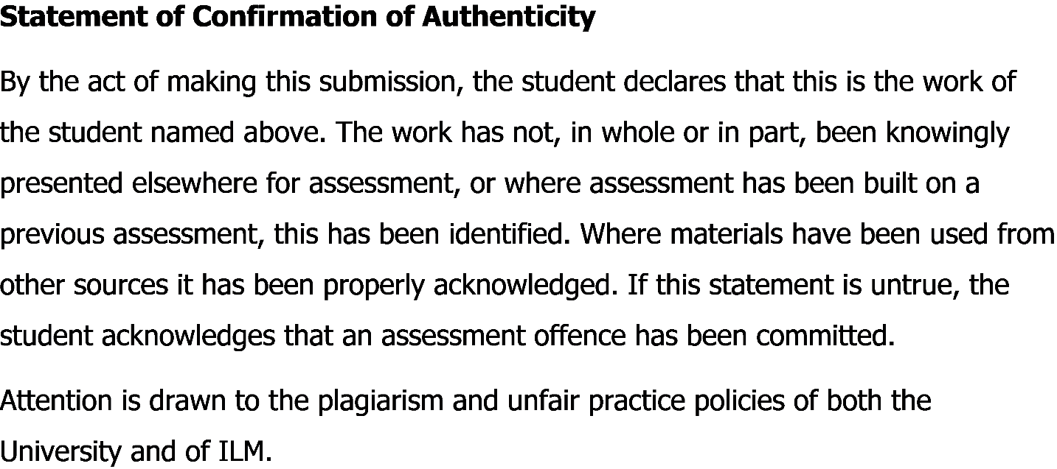

Table of Contents
Introduction 3
Main body 3
Description 5
Feelings 5
Evaluation 6
Analysis 6
Conclusion 7
Action Plan 7
Conclusion 8
References 9

Introduction
A reflective writing is one where the writer tries to analyze and examine an event, memory or observation. The writer tries to reflect on the impact and meaning of the occasion (YourDictionary, 2018). In a reflective writing the writer tries to show the reader how he or she has tackled a certain situation or accomplished a certain task given to him/her. He also tries to show the problems they faced, the way they solved such issues, how they could better their performance in this context and how they wish to change their approach in case of an occurrence such as this type happens again. In a word this type of writing helps the reader and the writer both to realize how one performs a certain task and how he or she learns from the mistakes to use it in their future tasks.

Main body
A reflective writing is the written way to reflect on the way a job is done and deciding on how to improve the way the job was done on the firsthand. The reflective report I have prepared is on the employability and academic skills. To be precise, the skills I need to have to excel in the academic life as well as in employment life. I have also highlighted skills gap of mine and possibility for improvement. The process of writing a reflective report is as follows:
- Description
- Feelings
- Evaluation
- Analysis
- Conclusion
- Action plan
These steps were described according to Gibbs reflective style (Research & Learning Online, 2018). This cycle was described by American sociologist and psychologist Graham Gibbs (ToolsHero, 2018). This cycle gives a better understanding of how the reflective report should be written to get the best insight from the respective event or experience and use it in later experiences and improvement.
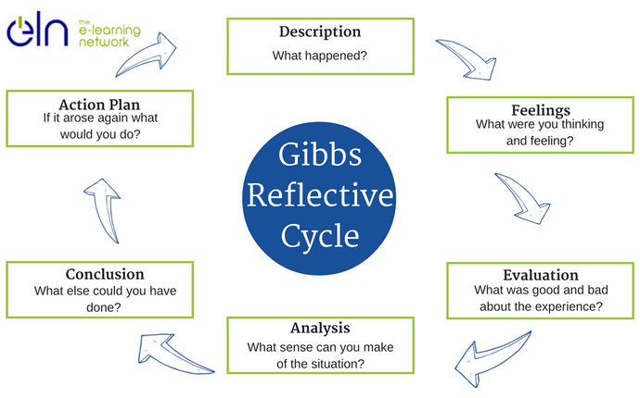
(ELN Resources, 2018)
Figure: Gibbs Reflective Cycle

Description
The task given to me was the evaluation and enlistment of skills that were needed in the employment and academic sectors of various organizations. Normally, I didn’t really think that there was actually any kind relation between the academic skills and the skills used in employed state, but however after following the module and its requirements, I have started to see that there are some skills that one cannot really get unless he/she gets some academic education. The task given to me was writing a report. I tried to show in the report that the amount of effectiveness in a person’s performance depends on the total amount of academic skills along with the job skills altogether. So, there is no scope to say that only job skills are necessary rather academic skills also play a crucial role in making one capable of excelling in one’s career. There are communication skills, interpersonal skills, time management skills- all relate to the capability of one in a work place (Skillsforlearning.leedsbeckett.ac.uk, 2018). Academic skills all add up to such type of skills. For example- to get a good academic result I must have better time management skill, good communication with the course instructors to understand each and every topic, ability to write a CV, performance development for job interviews, good interpersonal relation with people to talk about topics of academic subjects. This all skills are needed in the workplaces more than ever. Moreover, in academic arena, one gets to learn the concept of various subjects that are later used in job life. A student with good statistical knowledge can later be a good researcher as he/she is already aware of the techniques used in doing research. In the total paper, I have tried to show that the excellence of a person results from both academic skills as well as employment skills. I have to use my personal communication skills in the business I am in currently.

Feelings
While working for the report on academic and employment skills, I was very much doubtful on whether there was actually any need to depend on academic skills to succeed in later job life. So, I was really surprised when I saw there was in fact statistical data to support that people with better academic skills tended to be on top of their performance in their job life as well (Mindtools.com, 2018). Moreover, working for this report has given me a better chance to know about the skills that employers actually look for in a candidate looking for a job. I now know that my typing speed, decision making aptitude, technical knowledge are all crucial to my success in the workplace. I can see that my technical knowledge, interpersonal skills, personal skills and moral sense have developed a lot during this period.

Evaluation
The experience of the report making was actually a heterogeneous one. I needed a lot of data to find out what was the actual amount of preference for academic skills to job skills. But such types of information were too much available in the internet, blogs, newspapers which were secondary source of data for us. But secondary data sources are not that much reliable (University, 2018). There were a lot of times when I faced a problem of finding a data about a certain organization and had to contact the spoke-person of that organization to receive data. Then again, some people were very much helpful in giving data but some were suspicious about our intention of using the data. Although I showed my student ID card to all of them, the problem didn’t vanish totally. I guess some people are by born suspicious to every person they meet for the first time. But the best part of the task was actually getting to know a lot of people that were in job sector who shared many interesting experiences in their career with us. This type of experiences actually helped us understand what types of working condition were prevalent in most working places. We were surprised to see that many companies were actually encouraging worker involvement in even the smallest type of decision while in some organization, even the wages were not discussed with the workers. I also learnt how to work as a team, how to manage deadlines through time management.

Analysis
The entire work for creating the reflective report was tiresome for sure but it was very fruitful as I really had the chance to see in the inside picture of the professional world. By doing my work according to the module, I realized that there was a positive correlation between the excellence in job with academic skills and employment skills. I used various types of statistical tools to show the numerical evidence which showed that there was in fact a positive correlation between these three. I am now opposed to say that academic skills are absolutely unnecessary in getting career excellence. By working in this report I have learnt how to work in a team, how to coordinate among team members to get the desired output. I had to type a lot that helped me improve my technical skills such as- data processing, typing, designing and many other team oriented skills. It also improved my communication skills as I spoke to various persons for gathering information. Throughout working in this report I have found that I have understood team work better than before. I have understood how to think about particular situation and reach an optimum solution. I have also understood that no matter how hard one tries to stay prepared, there are just some moments when some unwanted hassles occur and you just can’t forecast them before. So, there is really no one perfect solution to any issue we want to discuss (Nicole Brown, 2018). Various people will have various type of solution to one situation and we must show respect to each and everyone’s opinion. Also, I have understood the importance of ethics in workplace.

Conclusion
After making this report, I have learnt plenty of things. From this module, I have learnt that organizations see workers from the perspective of value. This means they see each employee as a unit of value adding. The more value one employee adds to the organization, the more he/she becomes important to the organization and its objective. Moreover, I have seen how various type of academic concepts are actually implemented in the real job scenario. I have learnt many software based skills such as MS Word, MS Power Point and MS Excel throughout this task. As I have worked to create this report, I have done a lot of typing, data processing and all these skills are also very much needed in all organizations as most of the organizations today make decision based on the data processed. These skills coupled with the personal, interpersonal, communication skills will transform a personnel into a very highly productive employee who can add more value to the company than other employees (Crowe-associates.co.uk, 2018). From the experience, I can say that I could have got my data more from the primary source if I had a better interpersonal communication skills already in the beginning.

Action Plan
The action plan I intend to do is simple. To learn from my experience regarding the skills in employability and academic life and use this experience to better perform in the future when I am really at an workplace. I will try to be more open minded in conversation with different people. As I already know what type of skills and abilities are needed by companies, I intend to acquire those skills to make myself more compatible in the ever competitive world (Crowe-associates.co.uk, 2018). The change should be seen by my changed outlook on workplace eligibility. I want to be a person that has both the academic knowledge alongside the technical, interpersonal and other relevant skills to add value in any place I go to.

Conclusion
Working on this report has given me a clear idea about what type of ability I need to acquire in order to have a good place in the current workplaces. So, it is really necessary to be attentive to the lessons that are given in academic life because they create a basic foundation of understanding that is needed in everyone’s career. People that have had an ideal career life have had a good academic background knowledge. Although there are some people that have excelled in their career without academic knowledge, statistics has shown that prior academic knowledge gives an increase in self-confidence as the employees feel confident in their job more than those without prior knowledge (OpenLearn, 2018). Students should really try to acquire the skills necessary both in academic life as well as career to excel as per their ability. This will make sure that they have the best understanding and support to help them get through the hassles they might have to face in their workplace in the future.

References
YourDictionary. (2018). What Is Reflective Writing?. [online] Available at: http://grammar.yourdictionary.com/for-students-and-parents/what-is-reflective-writing.html [Accessed 20 Aug. 2018].
Research & Learning Online. (2018). The structure of reflective writing. [online] Available at: https://www.monash.edu/rlo/assignment-samples/education/education-reflective-writing/reflective-writing-structure [Accessed 20 Aug. 2018].
Skillsforlearning.leedsbeckett.ac.uk. (2018). Example 2 - Gibb's reflective cycle | Models for structuring reflection | Skills for Learning Preview. [online] Available at: https://skillsforlearning.leedsbeckett.ac.uk/preview/content/models/03.shtml [Accessed 20 Aug. 2018].
Mindtools.com. (2018). Gibbs' Reflective CycleHelping People Learn From Experience. [online] Available at: https://www.mindtools.com/pages/article/reflective-cycle.htm [Accessed 20 Aug. 2018].
University, O. (2018). Reflective writing: About Gibbs reflective cycle - Oxford Brookes University. [online] Brookes.ac.uk. Available at: https://www.brookes.ac.uk/students/upgrade/study-skills/reflective-writing-gibbs/ [Accessed 20 Aug. 2018].
Nicole Brown. (2018). Reflective model according to Gibbs - Nicole Brown. [online] Available at: http://www.nicole-brown.co.uk/reflective-model-according-to-gibbs/ [Accessed 20 Aug. 2018].
Crowe-associates.co.uk. (2018). GIBBS REFLECTIVE _CYCLE | Crowe Associates. [online] Available at: https://www.crowe-associates.co.uk/coaching-and-mentoring-skills/gibbs-reflective-cycle/ [Accessed 20 Aug. 2018].
Crowe-associates.co.uk. (2018). GIBBS REFLECTIVE _CYCLE | Crowe Associates. [online] Available at: https://www.crowe-associates.co.uk/coaching-and-mentoring-skills/gibbs-reflective-cycle/ [Accessed 20 Aug. 2018].
OpenLearn. (2018). Learning to teach: becoming a reflective practitioner. [online] Available at: http://www.open.edu/openlearn/education/learning-teach-becoming-reflective-practitioner/content-section-6.2 [Accessed 20 Aug. 2018].
ToolsHero. (2018). Gibbs Reflective Cycle: learning through personal reflection | ToolsHero. [online] Available at: https://www.toolshero.com/management/gibbs-reflective-cycle-graham-gibbs/ [Accessed 20 Aug. 2018].
ELN Resources. (2018). Graham Gibbs Reflective Cycle Model 1988. [online] Available at: http://resources.eln.io/gibbs-reflective-cycle-model-1988/ [Accessed 21 Aug. 2018].

