A study of adequacy of support services and its impact on retention of Probationary Police Officers in South Wales

by

Fraser Durston

A Policing Practice Project (BMPP6003D)
supervised by

Jane Davies
and
Arpu Kumar

A dissertation submitted in partial fulfilment
of the requirements for the degree of

Professional Policing Practice (BSc Hons)

and in agreement with the

University of Wales Trinity St David

2026


Acknowledgements

I would like to thank everyone who has supported me throughout the completion of my Police Constable Degree Apprenticeship over the past three years.
Firstly, I would like to thank my dissertation supervisor, Arpu Kumar, who has provided me with guidance, expertise, and constructive feedback throughout the completion of this dissertation. Arpu, your support has been invaluable in helping me complete this dissertation.
I would also like to thank all the participants who took time out of their busy lives to contribute to the research. Without their willingness to share their honest experiences and insights, this dissertation would not have been possible.
My thanks are extended to my family, friends, and colleagues, especially Team 5 Ely, who have all supported me throughout these last three years. I am grateful to each and every one of you.
Finally, I would like to thank my wife, Charlotte. Charlotte, you have supported me from day one and have been there with me every step of the way. This would not have been possible if it were not for you. You have motivated me, encouraged me, and have been there throughout so thank you.

Declarations


This work has not previously been accepted in substance for any degree and is not being concurrently submitted in candidature for any degree.
Signed: Date: 27/06/2026

This dissertation is being submitted in partial fulfilment of the requirements for the degree of BSc.
Signed: Date: 27/06/2026

This dissertation is the result of my own independent work/investigation, except where otherwise stated. Other sources are acknowledged by footnotes giving explicit references. A bibliography is appended.
Signed: Date: 27/06/2026

I hereby give consent for my dissertation, if accepted, to be available for photocopying and for interlibrary loan, and for the title and summary to be made available to outside organisations.
Signed: Date: 27/06/2026

I hereby give consent for my dissertation, if accepted, to be available on the university’s IT system to those who have consent to use the system.
Signed: Date: 27/06/2026

Abstract

This study explores the perceptions of police officers in relation to the support and wellbeing options and networks available to them within the United Kingdom. Policing is recognised as a highly demanding profession, with officers regularly being exposed to stressful environments, traumatic incidents, and organisational pressures that could negatively impact upon their health and well-being. Using a quantitative research design with a limited proportion of open-ended questions within the questionnaire, data has been collected in the form of an online survey which was distributed to officers. The findings of this survey highlight varying levels of awareness, accessibility, and uptake of wellbeing support services available to officers. Results suggest that deep rooted organisational cultures which are embedded within policing, workload demands, and stigmas surrounding help-seeking behaviours continue to influence police officers’ engagement with support mechanisms. This study concludes that while there are wellbeing initiatives which are widely viewed positively, further efforts are required to improve awareness, accessibility, and trust in these support services. Recommendations are provided to assist police and academic organisations to enhance the wellbeing of police officers within their probation period and to foster a positive working environment for those officers who are within their probationary period.

Key words: Welsh Police, Probationary, Officers, Mental Health, Support, University, Retention

Table of Contents

Contents. Page no.
Research Proposal Form 6 - 9
Application for Ethical Proposal 10 - 43
1. Introduction 44 - 49
The Probationary Period 44
Mentoring 46
Supervisory Support 47
Specialised Support Programmes 48
2. Aims and Hypothesis 50
3. Methodology 51 - 57
Research Design 51
Data Collection 53
Participant Selection Criteria 53
Data Analysis 55
Trustworthiness 56
4. Analysis of Results 58 - 62
5. Discussion 63 - 65
6. Limitations 66
7. Future Recommendations 67
8. Conclusions 68 - 69
9. Reference List 70 - 76
10. Appendices 77 - 86

UNDERGRADUATE DISSERTATION
RESEARCH PROPOSAL FORM

Please complete the following research proposal and submit it to Turnitin.

Which project option are you taking? Please tick:

8,000 word project

NAME: Fraser Durston | STUDENT ID No.: 2319897
DRAFT RESEARCH TITLE QUESTION: Support for probationary Police Officers in the UK:
Is there a link between retention of Probationary Police Officers and these Officers obtaining the right support?

Do probationary Police Officers receive the right support?

INTRODUCTION:

This topic has been chosen as recently there have been issues surrounding police officer retention and I believe that this may be linked to the support received during a police officer’s probationary period, especially surrounding where police officers are working full time and carrying an operational workload, with also completing a university degree at the same time (Police Federation, 2019).

There are several areas of support available to officers which may come in the form as support at home, colleagues, work initiatives, and from universities due to officers having to complete academic work during their probationary period.

This research is likely to highlight reasons as to why police officers have remained within their jobs, or reasons why they have considered leaving.

27% of officers who resigned between 2017 and 2024 did so before reaching the pension age (Cumbria Police Federation, 2024). This has raised concerns as to the reasons for officers resigning. Several officers are stating there is low morale and the factors around this may be varied.

Voluntary resignations increased to 3433 voluntary resignations from April 2021 to March 2022; this is a 72% rise from the previous year and a staggering 196% rise from the year ending March 2012 (Tyson and Charman, 2023). This supports the concerns regarding why police officers resign and is there enough support for officers working on the frontline.

This leaves the question, does a positive start to a career in policing, with adequate support set officers up to succeed?

SUMMARY OF RESEARCH OBJECTIVES:

I wish to obtain information surrounding support available to officers, barriers to obtaining this support, reasons for taking / not taking the support, and any other factors leading to officers wishing to resign.

I am going to create a questionnaire which will be sent to colleagues within my own force, and further afield to obtain an accurate representation of officers’ views across England and Wales.

LITERATURE REVIEW:

Police Federation articles - Why police officers are leaving and why retention is crucial

University of Portsmouth - Police officer resignations have risen by 72% in the last year – we asked former officers why | University of Portsmouth

UK Government - Police workforce, England and Wales: 31 March 2024 - GOV.UK

Met Police FoI request - Rates of Police leavers | Metropolitan Police

Jemma TYSON and Sarah CHARMAN Journal - Leaving the table: Organisational (in)justice and the relationship with police officer retention - Jemma Tyson, Sarah Charman, 2025

Policing Journal Article - Narrative Review of the Literature on the Recruitment of Younger Police Officers in Age and in Service: What Are the Implications for the Police in England and Wales? | Policing: A Journal of Policy and Practice | Oxford Academic

Policing Journal Article - New Generation of Police Officers: Experiences of Student Officers Undertaking the Police Constable Degree Apprenticeship in One UK Police Force | Policing: A Journal of Policy and Practice | Oxford Academic

There is a clear gap within the areas of if officers are receiving the correct support and if there is any correlation in the support available and officers resigning from the force.

This research will display any areas in which police forces are lacking and where further support is required.

SUMMARY OF RESEARCH –SURVEY METHOD:

I am going to create and send a survey to colleagues and other forces to obtain accurate and honest data from the participants.

This will be the best way to obtain the data due to time and financial constraints of attending and interviewing the participants in person.

SUMMARY OF SAMPLING FRAMEWORK:

My target sample will be probationary police officers working within response department. A generalised questionnaire will be sent to all participants to gain the perspectives of several persons who work in this specific area.

This will be the best sample group for my research as those officers who are in their probationary periods will be experiencing first hand the support, or lack of support, and will be able to provide specific, up to date insights into this area.

ETHICAL ISSUES:

I do not see any ethical issues arising from this research.

TIME SCALE:

I anticipate the research will take 3-4 months to complete, with the proposal being accepted, survey being created and allowing time for answers to be submitted and reviewed.

REFERENCE LIST:

Charman, S. (2022). Police officer resignations have risen by 72% in the last year – we asked former officers why. [online] University of Portsmouth. Available at: https://www.port.ac.uk/news-events-and-blogs/blogs/building-an-inclusive-and-growth-led-economy-and-society/police-officer-resignations-have-risen-by-72-in-the-last-year-we-asked-former-officers-why [Accessed 10 Nov. 2025].

Cumbria Police Federation (2024). Cumbria Police Federation speaks out on #RecruitmentAndRetention. [online] Polfed.org. Available at: https://www.polfed.org/cumbria/news/2024/cumbria-police-federation-speaks-out-on-recruitmentandretention/ [Accessed 10 Nov. 2025].

Home Office (2024). Police workforce, England and Wales: 31 March 2024. [online] GOV.UK. Available at: https://www.gov.uk/government/statistics/police-workforce-england-and-wales-31-march-2024/police-workforce-england-and-wales-31-march-2024 [Accessed 10 Nov. 2025].

Metropolitan Police (2024). Rates of Police Leavers. [online] Metropolitan Police. Available at: https://www.met.police.uk/foi-ai/metropolitan-police/disclosure-2023/december-2023/rates-of-police-leavers/ [Accessed 10 Nov. 2025].

Police Federation (2019). Officers Bearing Brunt of Disorganised College of Policing Scheme. [online] www.polfed.org. Available at: https://www.polfed.org/news/latest-news/2019/officers-bearing-brunt-of-disorganised-degree-scheme/ [Accessed 10 Nov. 2025].

Police Federation (2024). Why police officers are leaving and why retention is crucial. [online] Polfed.org. Available at: https://www.polfed.org/news/latest-news/2024/why-police-officers-are-leaving-and-why-retention-is-crucial/ [Accessed 10 Nov. 2025].
Tyson, J. and Charman, S. (2023). Leaving the table: Organisational (in)justice and the relationship with police officer retention. Criminology & Criminal Justice, [online] 25(4). doi:https://doi.org/10.1177/17488958231191648.

Watkinson-Miley, C., Cox, C. and Deshpande, M. (2022). A New Generation of Police Officers: Experiences of Student Officers Undertaking the Police Constable Degree Apprenticeship in One UK Police Force. [online] Oup.com. Available at: https://academic.oup.com/policing/article-abstract/16/1/122/6421685 [Accessed 10 Nov. 2025].

Williams, E. and Sondhi, A. (2022). A Narrative Review of the Literature on the Recruitment of Younger Police Officers in Age and in Service: What Are the Implications for the Police in England and Wales? Policing: A Journal Of Policy And Practice, 16(4). doi:https://doi.org/10.1093/police/paac001.

APPLICATION FOR ETHICAL APPROVAL

SECTION A: About You (Lead Researcher)
1 | Full Name: |  | Fraser Durston
2 | Tick all boxes that apply: |  | Member of staff: |  | ☐ | Honorary research fellow: |  | ☐
2 | Undergraduate Student | ☒ | Taught Postgraduate Student |  | ☐ | Postgraduate Research Student |  | ☐
3 | Institute/Academic Discipline/Centre: |  | FACULTY OF BUSINESS AND MANAGEMENT  PUBLIC SERVICE PROGRAMME
4 | Campus: |  | Swansea
5 | E-mail address: |  | 2319897@student.uwtsd.ac.uk
6 | Contact Telephone Number:
7 | Project Title |  | A study of adequacy of support services and its impact on retention of Probationary Police Officers in South Wales
8 | Proposed Start Date |  | 20/10/2025 | Proposed End Date |  |  | 29/07/2026
For students:
9 | Student Number: |  | 2319897
10 | Programme of Study: |  | Police Constable Degree Apprenticeship
11 | Director of Studies/Supervisor: |  | Jane Davies and Arpu Kumar

SECTION B: Grant or Contract Funding
1 | Has your research been awarded, applied for, or intend to apply for external funding? | YES | Click to continue to appendix 1 | NO | Continue to the next section
2 | Have you completed appendix 1? | YES | ☐ | NO | X

SECTION C: Internal and External Ethical Guidance Materials
Ethical Guidance Documents
Please list the core ethical guidance documents that have been referred to during the completion of this form (including any discipline-specific codes of research ethics, location-specific codes of research ethics, and also any specific ethical guidance relating to the proposed methodology). Please tick to confirm that your research proposal adheres to these codes and guidelines. You may add rows to this table if needed.
1 | UWTSD Research Ethics & Integrity Policy | ☐
2 | UWTSD Research Data Management Policy | ☐
3 | UWTSD Open Access Publications Policy | ☐
4 | UWTSD Export Control Policy  Required if Appendix 8 completed | ☐
5 | UWTSD Trusted Research and Innovation Policy  Required if research is taking place outside the UK | ☐
6 | [List any other relevant documents here] | ☐

SECTION D: External Collaborative Research Activity
1 | Does your research involve collaborating partners at another institution or organisation? | YES | Click to continue to appendix 2 | NO | Continue to the next section
2 | Have you completed appendix 2? | YES | ☐ | NO | X

SECTION E: Details of Research Activity
Aims, Vision and Approach of the Research (maximum 200 words per section)
Please outline what are you hoping to achieve with your proposed work and how will you deliver it?
1 | Research aims and objectives
Briefly state your research:
- Aims (what the research is trying to achieve or advance)
- Objectives (action or tasks required to do this)

My aim of this research is to ascertain whether Police Officers receive enough support during their probationary period and if this support has any relation to thoughts of retiring from the Police Service, transferring to different departments, or transferring abroad.

My objectives will be to have Police Officers during their probationary period during their service answer questions relating to the research and to collate these answers and find any correlations between their answers and research already conducted.

(this box should expand as you type)
2 | Vision
Explain how your research:
- Is of importance within or beyond your area of research
- Has the potential to advance current understanding, generates new knowledge, thinking or discovery within or beyond the field or area
- Is timely given current trends, context and needs
- Has the potential to generate impact in society, the economy or the environment

This research is important as it will highlight areas of support that probationary Officers feel are good and also what areas require attention in order to retain and develop police officers in England and Wales.

This research has the potential to advance the current understanding of probationary police officers views on the support available to them, what is needed to improve and what is needed to prevent further loss of officers.

This research is current with the needs of the field due to there being significant attention surrounding police officers in the UK and how the levels of support may impact their decisions on staying within policing.

This research has the potential to positively impact police forces across the UK and also the communities that the officers work within as if this research highlights areas for improvement these may be able to be addressed and improved to prevent a further loss of officers working within forces.

3 | Approach
Explain your approach and how you have designed:
- Clearly describe both the methodological framework for data collection (if applicable) and any specific analysis methods proposed, making it clear what specific techniques may be used
- Explain the reasons for their choice
- Explain how these are feasible, effective and proportionate to achieve your objectives
- Identify any risks to delivery and how they will be managed
- Explain how your approach will maximise translation of outputs into outcomes and impacts

I am planning to create a questionnaire that will be disseminated to police forces within England and Wales in order to obtain a variety of responses from different areas across England and Wales.

The questionnaire will be designed to be an easy, not time-consuming survey in order to not add to the daily stresses of police work. This will be something that officers can provide their answers to anonymously in order to achieve truthful accurate responses.

This is the most feasible way to obtain the data I am gathering as the survey will not be time consuming, will not cost anything to create and send and will allow for honest answers to be provided from a variety of areas.

The risks of this are that people do not engage and therefor no data will be collected and also if answers are not returned as honest and truthful as this will sway the data in a negative manner.

This approach will allow for the most return of data to the surveys.

(this box should expand as you type)
4 | Location of research activity  Identify all locations where research activity will take place.
South Wales Police officers who are in their probationary period that are willing to engage and and answer the questionnaire.

5 | Will any of your research be undertaken outside of the UK? | YES | Click to continue to appendix 3 | NO | Continue to the next section
6 | Have you completed any of appendix 3? | YES | ☐ | NO | X

SECTION F: Research Methods
Will the research activity include: |  | YES | NO
1 | Use of a questionnaire or similar research instrument? | ☒ | ☐
2 | Use of interviews? | ☐ | ☒
3 | Use of focus groups? | ☐ | ☒
4 | Use of participant diaries? | ☐ | ☒
5 | Use of video or audio recording? | ☐ | ☒
6 | Use of computer-generated log files? | ☐ | ☒
7 | Participant observation with their knowledge? | ☐ | ☒
8 | Participant observation without their knowledge? | ☐ | ☒
9 | Access to personal or confidential information without the participants’ specific consent? | ☐ | ☒
10 | Administration of any questions, test stimuli, presentation that may be experienced as physically, mentally or emotionally harmful / offensive? | ☐ | ☒
11 | Performance of any acts which may cause embarrassment or affect self-esteem? | ☐ | ☒
12 | Investigation of participants involved in illegal activities? | ☐ | ☒
13 | Use of procedures that involve deception? | ☐ | ☒
14 | Administration of any substance, agent or placebo? | ☐ | ☒
15 | Working with live vertebrate animals? | ☐ | ☒
16 | Procedures that may have a negative impact on the environment? | ☐ | ☒
17 | Other primary data collection methods. Please indicate the type of data collection method(s) below. | ☐ | ☒
Details of any other primary data collection method:  (this box should expand as you type) |  | ☐ | ☒

SECTION G: Research Participants

Research participants include people who will be taking part in your research as providers of research data (e.g. being interviewed, answering questionnaires, or doing user testing of hardware or software). This includes animal participants.
1 | Does your research involve human or non-human participants? | YES | Continue this section | NO | Click to continue to section N

Participant numbers and source
How will you ensure an appropriately convened sample group in order to meet the aims of the research? Give details for subgroups separately, if appropriate. How will any potential pitfalls, for example dual roles or potential for coercion, be addressed?
1 | How many participants will be recruited and how was the number decided upon? | I will submit the survey to as many probationary police officers as possible with the view to receive 30 completed surveys to analyse.  (this box should expand as you type)
2 | Who will the participants be? | Probationary Police officers within South Wales Police.  (this box should expand as you type)
3 | How will you identify the participants? | They will be Probationary Police officers within South Wales Police who are willing to answer the questionnaire.  (this box should expand as you type)
4 | Will you be excluding any groups of people, and if so what is the rationale for that? | Yes, only probationary police officers will be asked to answer the questionnaire due to the focus of the research.  (this box should expand as you type)
5 | Will the research involve any element of deception? If yes, please describe why this is necessary and whether participants will be informed at the end of the study | No.  (this box should expand as you type)
6 | Describe whether participants will be able to withdraw from the study, and up to what point (eg if data is to be anonymised). If withdrawal is not possible, after a certain point, explain why not. | Participants will be able to withdraw until the point of submission of their answers due to the anonymous nature of the replies it will not be achievable to withdraw past the point of submission.  (this box should expand as you type)
7 | How long will the participant have to decide whether to take part in the research? | Until their answers have been completed.  (this box should expand as you type)
8 | What arrangements have been made for participants who might have difficulties understanding verbal explanations or written information, or who have particular communication needs that should be taken into account to facilitate their involvement in the research? | The questionnaire will be sent to serving police officers, reasonable adjustments can be made to the questionnaire which will allow for persons with additional needs to be able to provide their answers.  A series of tick boxes, and text boxes will allow for participants to provide their answers in a manner that will be achievable to them.  (this box should expand as you type)

SECTION H: Research with Vulnerable People
1 | Are your participants classed as vulnerable people? | YES | Click to continue to appendix 4 | NO | Continue to the next section
2 | Have you completed appendix 4? | YES | ☐ | NO | X

SECTION I: Research Involving Animals
1 | Are your participants non-human animals? | YES | Click to continue to appendix 5 | NO | Continue to the next section
2 | Have you completed appendix 5? | YES | ☐ | NO | X

SECTION J: Research with the Prison Service or the Probation Service
1 | Are your participants staff or offenders within the Prison Service or the Probation service? | YES | Click to continue to appendix 6 | NO | Continue to the next section
2 | Have you completed appendix 6? | YES | ☐ | NO | X

SECTION K: Health and Social Care Research
1 | Are your participants selected due to their health or social care needs? | YES | Click to continue to appendix 7 | NO | Continue to the next section
2 | Have you completed appendix 7? | YES | ☐ | NO | X

SECTION L: Types of Personal Data
Personal Data  Does the research activity involve personal data (as defined by the General Data Protection Regulation 2016 and the Data Protection Act 2018)? |  | YES | NO
1 | Personal data means any information relating to an identified or identifiable natural person (‘data subject’). An identifiable natural person is one who can be identified, directly or indirectly, in particular by reference to an identifier such as a name, an identification number, location data, an online identifier or to one or more factors specific to the physical, physiological, genetic, mental, economic, cultural or social identity of that natural person. Any video or audio recordings of participants and transcription of such are considered to be personal data. | ☐ | X
1 | If you ticked YES, provide a description of the data and explain why this data needs to be collected: | ☐ | X
(this box should expand as you type)

Special Category Data  Does the research involve the processing of special category data (as defined by the General Data Protection Regulation 2016 and the Data Protection Act 2018)? |  |  | YES |  | NO
2 | Racial or ethnic origin |  | ☐ |  | ☒
3 | Political opinions |  | ☐ |  | ☒
4 | Religious or philosophical beliefs |  | ☐ |  | ☒
5 | Genetic, biometric or health data |  | ☒ |  | ☐
6 | Sex life or sexual orientation |  | ☐ |  | ☒
7 | Trade union membership |  | ☒ |  | ☐
If you ticked YES to any of questions L2-L7, provide a description of the data and explain why this special category data needs to be collected to support the research and that it is in the public interest to do so:
8 | The gender of the participant will be asked to be able to categorise replies and to view any trends within the answers as different groups may provide similar responses that will raise further questions into the support required.  There will be an option for not wishing to state their gender.  There will be an option to state if they are a member of the police federation and if the federation offers any support as this is another avenue of support that is available.  There will be an option prefer not to say to allow those who do not wish to state their federation membership preferences to answer.  (this box should expand as you type)
9 | Please describe how the research has been designed to gather the minimum amount of personal data necessary for the specified research purpose:
The only data from the participants that will be requested will be gender, area of police work (i.e. response, traffic etc) and federation membership as this is the only data necessary to accurately group and review the data provided from the questionnaire.

(this box should expand as you type)
10 | Demonstrate that the processing is not likely to cause substantial damage or distress to individuals and that their interests will be safeguarded:
The questionnaire will be designed in such a way that it will not cause distress to individuals.

(this box should expand as you type)
11 | Demonstrate that the data will not be used to take any action or make decisions in relation to the individuals concerned:
Data will not be used to take any action or influence decisions in relation to the individuals involved.

(this box should expand as you type)
12 | Data should be anonymised wherever possible, either at point of capture or once collated. If the data cannot be anonymised, and if pseudonymisation is not possible, demonstrate why the that is possible. If special category data cannot be anonymised, explicit consent to share that data must normally be obtained.
Data will be anonymised at the source of answers being provided and no personal data will be obtained.

(this box should expand as you type)
13 | If special category data cannot be anonymised, will you obtain explicit consent to share that data? | YES |  | NO |  | N/A
13 |  | ☐ |  | ☐ |  | ☒

SECTION M: Participant Information and Consent

Information for participants  It is normally expected that those participating in research should do so having given their informed consent. If this is not appropriate or practical, explicit justification must be provided, in line with prevailing disciplinary conventions. Please note however, that informed consent to participate in the research is separate from consent to process (e.g. collect, analyse, store, reuse or share) personal data, as the University’s lawful basis for processing personal data in research activities is part of its ‘public task’. |  | YES |  | NO |  | N/A
1 | Will you obtain written consent for participation? | ☒ |  | ☐ |  | ☐
2 | Will you describe the main research procedures to participants in advance, so that they are informed about what to expect? | ☒ |  | ☐ |  | ☐
3 | Will you tell participants that their participation is voluntary? | ☒ |  | ☐ |  | ☐
4 | Will you explain to participants that refusal to participate in the research will not affect their treatment or education (if relevant)? | ☐ |  | ☐ |  | ☒
5 | If the research is observational, will you ask participants for their consent to being observed? | ☐ |  | ☐ |  | ☒
6 | Will you tell participants that they may withdraw from the research at any time and for any reason? | ☐ |  | ☒ |  | ☐
7 | Will participants be made aware of how you will treat any information that may reasonably by considered as confidential? | ☒ |  | ☐ |  | ☐
8 | If your research requires your participants to sign up for a service provided by an external company or organisation will you inform them that their data may be stored and processed outside UWTSD? | ☐ |  | ☐ |  | ☒
9 | Will you give participants the UWTSD Privacy Notice for Research? | ☒ |  | ☐ |  | ☐
If you have answered NO to any of questions M1-M8, please provide justification detailing why this is necessary for the research.
10 | Participants will be advised that once answers have been submitted, they will not be able to retract them due to the anonymous nature of the questionnaire.  (this box should expand as you type)
Informed consent: Describe the arrangements to inform potential participants, before providing consent, of what is involved in participating. Describe the arrangements for participants to provide full consent before the research begins. If gaining consent in this way is inappropriate, explain how consent will be obtained and recorded.
11 | Consent will be provided by participants by them submitting their answers.  Prior to this, a written explanation of the research I am conducting will be provided to them.  (this box should expand as you type)
Confidentiality: Confidential information refers to information that can be related to an identifiable individual, whether living or deceased, which is not in the public domain and which is given with the expectation that it will be kept confidential. Under Common Law when an individual entrusts a researcher or research team with confidential information, the team must handle this in line with ‘reasonable expectations’. In other words, confidential information should only normally be shared when there would be ‘no surprises’ for the individuals concerned. Where participants would not expect the researcher to be sharing their confidential information with others, researchers can manage their expectations by informing them of their intentions (e.g. in the participant information sheet or during discussions about participation) and asking them if they are happy with these plans. They should understand what is being proposed and what this might mean for them, before they decide whether the researcher can share their confidential information with others.
Please detail how you will treat confidential information:
12 | No confidential information will be stored or requested.  (this box should expand as you type)
Copies of any written consent form, written information and all other explanatory material should accompany this application. If you have included these then please list the documents included here.
13 | Sample information sheets and consent forms are available from the University ethical review intranet page at https://intranet.uwtsd.ac.uk/research/research-integrity-and-ethics  UNABLE TO OPEN CONSENT FORM LINK DOES NOT WORK ON LAPTOP. ASKED FOR ASSISTANCE WITH OTHER POWERPOINTS ALSO NOT LOADING AND WAS TOLD THE FORM IS STRAIGHT FORWARD AND TO ANSWER AS MUCH AS I CAN.  I have answered as much as I can without support from the university. SWP ATO and ATS aware.  Consent will be provided by participants when they read the disclaimer and submit responses.
14 | Consent form attached? |  | YES  ☐ |  | NO  ☒ |  | N/A  ☐

SECTION N: Research with Potential Military Application
1 | Does your research have any potential military application? | YES | Click to continue to appendix 8 | NO | Continue to the next section
2 | Have you completed appendix 8? | YES | ☐ | NO | X

SECTION O: Use of Artificial Intelligence Tools
Use of generative AI and other AI-based tools  There are a number of ethical issues relating to the use of generative AI and other AI-based tools, including data security, output bias, and output errors. In general you should assume that any generative AI or other AI-based tool that you pay to use is more secure and accurate than one which is free to use.  Will the research use AI tools to do any of the following: |  | YES | NO | N/A
1 | Capture data? | ☐ | ☒ | ☐
2 | Generate and/or edit text? | ☐ | ☒ | ☐
3 | Generate graphics? | ☐ | ☒ | ☐
4 | Generate video? | ☐ | ☒ | ☐
5 | Generate sound/music? | ☐ | ☒ | ☐
6 | Generate code? | ☐ | ☒ | ☐
7 | Generate synthetic data? | ☐ | ☒ | ☐
8 | Analyse data? | ☐ | ☒ | ☐
9 | Analyse personal or sensitive data? | ☐ | ☒ | ☐
10 | Classify data? | ☐ | ☒ | ☐
11 | Do you intend to use the free version of any AI tools? | ☐ | ☒ | ☐
If you have answered YES to any of questions O1-O11, please provide justification detailing why this is necessary for the research.
12 | N/A  (this box should expand as you type)

Section P: Research Data Management Plan

1 | Data Summary
- Briefly introduce the types of data the research will create or access.
The research will provide quantitative data in the form of age brackets, years of experience. Qualitive Data in the form of personal opinions and experiences in relation to questions posed to them and Categorical data should any trends be found between the quantitative data and qualitative data.

2 | Responsibilities
- Who will be responsible for data management?
- Outline responsibilities for data management within research teams at all partner institutions

I will be responsible for the data management, the data will be sorted legally and in line with all laws and regulations surrounding this.

3 | Assessment of existing data
- Provide an explanation of the existing data sources that will be used by the research project (if applicable).
- Provide an analysis of the gaps identified between the currently available and required data for the research.

Open-source findings will be used to locate existing data and findings to allow for a comparison between my findings and those of persons who have also researched this area.

There is a clear gap in research with the relation of adequate support being provided to probationary police officers and long-term retention. Police Federation of England and Wales and a freedom of information request to the Met Police have displayed that retention of officers is at an all time low. But the reason for this is not clear.

This research aims to identify areas where police officers within their probationary period are not obtaining support when they most need it and if this has any reflection on whether these officers have plans to change careers or not due to the support, or lack of.

4 | Management and curation of data
- Outline your plans for preparing, organising and documenting data.

The data will be gathered following a survey that will be sent out to several probationary police officers before it is then evaluated and interpreted by the length of service and gender and area of policing. This will be organised using excel.
5 | Quality assurance of data
- Describe the procedures for quality assurance that will be carried out on the data collected at the time of data collection, data entry, digitisation and data checking.

The data will be reviewed and analysed using Microsoft Excel following the submission of the answers from the survey.

The data will be categorised and reviewed prior to analysis and review.

6 | Short-term data storage
- How will the data be stored in the short term during the research.
- Describe the data access, security and backup procedures you will adopt to ensure the data and metadata are securely stored during the lifetime of the project.

The data will be stored securely on a laptop which is password protected. The data will be securely stored on the cloud and therefor is backed up appropriately.

7 | Long-term data storage and preservation
- Which data are of long-term value and should be retained, shared, and/or preserved?
- How the data will be stored in the long term?
- Are the plans for preparing and documenting data for sharing and archiving with an external data repository (e.g. the UK Data Service) or the UWTSD data repository?
- How long will it be stored for and why?

The data will be retained for the duration of the research, using a secure one drive account before being deleted once it has been evaluated.

There are no plans to store the data for long periods.

8 | Documentation and metadata
- What documentation and metadata will accompany the data?
- How will the data be documented during research to provide high quality contextual information and/or structured metadata for secondary users?

Documentation will accompany the data which will include an analysis of the data and the findings and will provide information allowing for other persons to be able to understand the results of the data.

The metadata that will accompany the data will include the gender (if supplied), area of police work, federation membership, and length of service to be able to provide some categorising factors of the data.

9 | Data sharing
- If you plan to share your research data explain how it will be shared and the value it will have to others
- If you are planning to share the data, please advise when you will be releasing it.
- Are any restrictions on data sharing required?
- Identify any potential obstacles to sharing your data, explain which and the possible measures you can apply to overcome these
- If the data will have value to different audiences, how these groups will be informed?
- Will the data need to be updated? Include future plans for updating if this is the case.
- Will the data be open or will you charge for it? Justify if charging to access the data.

I will not be sharing the data generated with any third parties.

The data will be analysed and included within the research document. This will be clearly outlined at the start of the survey where the data will be obtained from the participants.
10 | Copyright and intellectual property ownership
- Who will own the copyright and Intellectual Property Rights (IPR) of any new data that you will generate?

I do not know the answer to this, guidance document would not load. JANE DAVIES advised me to answer as much as I can as it is straight forward.

I believe that either the university, or myself will own the copyright for the research that is generated.

11 | Resources
- What resources will you require to deliver your plan?
- Costs of storage – why are these appropriate?
- How will these be met? (costs related to long term storage will be normally permitted by funders providing these are fully justified and relate to the project)

Google docs / survey monkey will be used to deliver the plan with emails used to communicate with other police forces.

There will be no cost of storage of the data, it will be stored using a secure one drive account for the duration of the research, before then being deleted.

SECTION Q: Risk Assessment

Outline any anticipated risks that may adversely affect any of the participants, the researchers and/or the University, and the steps that will be taken to address them.

If you have completed a full risk assessment (for example as required by a laboratory, or external research collaborator) you may append that to this form.
1 | Full risk assessment completed and appended? |  | YES | NO
1 |  |  | ☒ | ☐
Risks to participants, researchers, and the University
2 | Social risks: disclosures that could affect participants standing in the community, in their family and their job. |  | YES | NO
2 |  |  | ☐ | ☒
Risk:  (this box should expand as you type) |  | How will you address any risks?
3 | Legal risks: activities that could result in the participant, researchers and / or University committing an offence; activities that might lead to a participant disclosing criminal activity to a researcher which would necessitate reporting to enforcement authorities; activities that could result in a civil claim for compensation |  | YES | NO
3 |  |  | ☐ | ☒
Risk:  (this box should expand as you type) |  | How will you address any risks?
4 | Economic harm: financial harm to participant, researcher and / or University through disclosure or other event. |  | YES | NO
4 |  |  | ☐ | ☒
Risk:  (this box should expand as you type) |  | How will you address any risks?
5 | Reputational risk: damage to public perception of University or the University / researchers’ reputation in the eyes of funders, the research community and / or the general public. |  | YES | NO
5 |  |  | ☒ | ☐
Risk:  Officers disclose in their responses a lack of support from the academic suppliers.  (this box should expand as you type) |  | How will you address any risks?  Liaise with the universites to inform them of any potential negative findings regarding them.
6 | Safeguarding risks: Risk to young people, vulnerable adults and / or researcher from improper behaviour, abuse or exploitation. Risk to researcher of being in a comprising situation, in which there might be accusations of improper behaviour. |  | YES | NO
6 |  |  | ☐ | ☒
Risk:  (this box should expand as you type) |  | How will you address any risks?
7 | Sensitive, embarrassing or upsetting topics. If research activity may include sensitive, embarrassing or upsetting topics or issues likely to disclose information requiring further action (e.g. criminal activity), give details of the procedures to deal with these issues, including any support/advice (e.g. helpline numbers) to be offered to participants. Note that where applicable, consent procedures should make it clear that if something potentially or actually illegal is discovered in the course of a project, it may need to be disclosed to the proper authorities. |  | YES | NO
7 |  |  | ☐ | ☒
(this box should expand as you type)
 | Health and safety risks
8 | Location hazards: for example: fire; visiting or working in participant’s homes; working in remote locations and in high crime areas; overseas travel; hot, cold or extreme weather conditions; working on or by water. Also hazardous work locations, such as construction sites, confined spaces, roofs or laboratories. For overseas travel, researchers will need to check country / city specific information, travel health requirements and consider emergency arrangements as part of their research planning. In all cases the University’s International Travel Policy must be followed. |  | YES | NO
8 |  |  | ☐ | ☒
Risk:  (this box should expand as you type) |  | How will you address any risks?
9 | Activity hazards: for example: potentially mentally harmful activities; distressing and stressful work and content; driving; tripping, or slipping; falling from height; physically demanding work; lifting, carrying, pushing and pulling loads; night time and weekend working. |  | YES | NO
9 |  |  | ☐ | ☒
Risk:  (this box should expand as you type) |  | How will you address any risks?
10 | Machinery and equipment: for example: ergonomic hazards, including computer workstations and equipment; contact with electricity; contact with moving, rotating, ejecting or cutting parts in machinery and instruments; accidental release of energy from machines and instruments. |  | YES | NO
10 |  |  | ☐ | ☒
Risk:  (this box should expand as you type) |  | How will you address any risks?
11 | Chemicals and other hazardous substances: the use, production, storage, waste, transportation and accidental release of chemicals and hazardous substances; flammable, dangerous and explosive substances; asphyxiating gases; allergens; biological agents, blood and blood products. |  | YES | NO
11 |  |  | ☐ | ☒
Risk:  (this box should expand as you type) |  | How will you address any risks?
12 | Physical agents: for example: excessive noise exposure, hand-arm vibration and whole body vibration; ionising radiation; lasers; artificial optical radiation and electromagnetic fields |  | YES | NO
12 |  |  | ☐ | ☒
Risk:  (this box should expand as you type) |  | How will you address any risks?
13 | Environmental risks: for example: accidental spillage of pollutants, damage to local ecosystems |  | YES | NO
13 |  |  | ☐ | ☒
Risk:  (this box should expand as you type) |  | How will you address any risks?

SECTION R: Disclosure and Barring Service

Disclosure and Barring Service
1 | If the research activity involves children or vulnerable adults, a Disclosure and Barring Service (DBS) certificate must be obtained before any contact with such participants. | YES | NO | N/A
 | Does your research require you to hold a current DBS Certificate? | ☐ | ☒ | ☐
2 | If YES, please give the certificate number. If the certificate number is not available please write “Pending”; in this case any ethical approval will be subject to providing the appropriate certificate number.

SECTION S: Declaration
The information which I have provided is correct and complete to the best of my knowledge. I have attempted to identify any risks and issues related to the research activity and acknowledge my obligations and the rights of the participants.

In submitting this application I hereby confirm that I undertake to ensure that the above named research activity will meet the University’s Research Ethics and Integrity Policy which is published on the website: https://www.uwtsd.ac.uk/research/research-ethics/

1 | Name of applicant | Fraser Durston
2 | Electronic or written signature of applicant: | F.DURSTON 10/11/2025
3 | Date | 10/11/2025
4 | Name of Director of Studies
5 | Electronic or written signature of Director of Studies:
6 | Date

Checklist: Please complete the checklist below to ensure that you have completed the form according to the guidelines and attached any required documentation:
1 | ☒ | I have read the guidance notes supplied before completing the form.
2 | ☒ | I have completed all relevant sections of the form in full.
3 | ☒ | I have attached a copy of the Participant Information Sheet (PIS) or Consent Form
4 | ☐ | I have attached a completed copy of the Trusted Research and Innovation Checklist (where applicable)
5 | ☒ | I have attached a full risk assessment (where appropriate)
6 | ☒ | I understand that it is my responsibility to ensure that the above named research activity will meet the University’s Research Ethics and Integrity Code of Practice
7 | ☒ | I understand that it is my responsibility to ensure that the above named research activity will meet the University’s Research Data Management Policy
8 | ☒ | I understand that it is my responsibility to ensure that the above named research activity will meet the University’s Research Export Control Policy
9 | ☒ | I understand that it is my responsibility to ensure that the above named research activity will meet the University’s Open Access Research Policy
10 | I have completed the following appendices: |  | 1 | ☒ | 2 | ☒ | 3 | ☒ | 4 | ☒
10 |  |  | 5 | ☒ | 6 | ☒ | 7 | ☒ | 8 | ☒

All communications relating to this application during its processing must be in writing and emailed to pgresearch@uwtsd.ac.uk , with the title ‘Ethical Approval’ followed by your name.

APPENDIX 1 – Grant or Contract Funding

A1.1 | Has your research been awarded external funding? | YES | ☐ | NO | ☒
A1.2 | Have you applied for funding / awaiting decision? | YES | ☐ | NO | ☒
A1.3 | Are you intending to apply for funding? | YES | ☐ | NO | ☒
A1.4 | Funding Body | N/A
A1.5 | Lead institution (grant holder)
A1.6 | If awarded, grant reference
A1.7 | If awarded, grant value
A1.8 | If awarded, start date and duration

Return to the main form

APPENDIX 2: External Collaborative Research Activity

INSTITUTION 1
A2.1 | Name | N/A
A2.2 | Researcher name and position
A2.3 | Role in project (e.g. co-investigator)
A2.4 | Contact e-mail address
A2.5 | External Ethical Approval  Please detail the ethical approval required and arrangements for this partner. See Section 14 of the UWTSD Research Ethics and Integrity Policy. If approved, please supply confirmation. | Obtained? | YES | NO | PENDING
A2.5 |  | Obtained? | ☐ | ☐ | ☐

INSTITUTION 2
A2.6 | Name | N/A
A2.7 | Researcher name and position
A2.8 | Role in project (e.g. co-investigator)
A2.9 | Contact e-mail address
A2.10 | External Ethical Approval  Please detail the ethical approval required and arrangements for this partner. See Section 14 of the UWTSD Research Ethics and Integrity Policy. If approved, please supply confirmation. | Obtained? | YES | NO | PENDING
A2.10 |  | Obtained? | ☐ | ☐ | ☐

INSTITUTION 3
A2.11 | Name | N/A
A2.12 | Researcher name and position
A2.13 | Role in project (e.g. co-investigator)
A2.14 | Contact e-mail address
A2.15 | External Ethical Approval  Please detail the ethical approval required and arrangements for this partner. See Section 14 of the UWTSD Research Ethics and Integrity Policy. If approved, please supply confirmation. | Obtained? | YES | NO | PENDING
A2.15 |  | Obtained? | ☐ | ☐ | ☐

Add additional collaborators as needed

Return to the main form

APPENDIX 3: Research Undertaken Outside of the UK

A3.1 | Research activity outside of the UK  If research activity will take place overseas, you are responsible for ensuring that local ethical considerations are complied with and that the relevant permissions are sought. Specify any local guidelines (e.g. from local professional associations/learned societies/universities) that exist and whether these involve any ethical stipulations beyond those usual in the UK (provide details of any licenses or permissions required). Also specify whether there are any specific ethical issues raised by the local context in which the research activity is taking place, for example, particular cultural and/or legal sensitivities or vulnerabilities of participants. Describe the measures you have taken to comply with these and provide evidence of approvals etc. If you live in the country where you will do the research then please state this. If you have a local research supervisor or research advisor then please give their contact details here.
N/A
(this box should expand as you type)
A3.2 | Responsible Research and Innovation  If research is taking place overseas please refer to the UWTSD Trusted Research and Innovation Policy and complete the Trusted Research and Innovation Checklist and submit it with this form.
A3.3 | Confirm that you have read the Trusted Research and Innovation Policy | ☐

If you are a postgraduate research student working with a research supervisor or research advisor at your local university then you do not need to fill in any more sections of this appendix.  If you are working in a research collaboration with an overseas partner please complete the remaining sections of this appendix. | Return to the main form

Organisational Details
A3.4 | Name of Organisation
N/A
A3.5 | Country where organisation is based:
N/A
A3.6 | Registration number and name of registration body (examples of relevant registration bodies are government, tax, corporation, charity, educational authority):
N/A

(this box should expand as you type)
A3.7 | What is the legal status of the organisation? (for example: public university, private university, charity, private company, non-profit making company, government research organisation, independent research organisation) Please include the date of foundation. Note: We may be required to ask for evidence of this at a later stage.
N/A
(this box should expand as you type)
A3.8 | Is your organisation affiliated to any other organisation? (i.e. is the organisation legally part of a larger organisation or a group of larger organisations).
N/A
(this box should expand as you type)
A3.9 | Name(s) of investigators in the organisation who will be responsible for the collaborative research and innovation
N/A

(this box should expand as you type)

About New Partners
A3.10 | Why does a partner want to work with you?
N/A

(this box should expand as you type)
A3.11 | What are they expecting in return for their financial support or involvement?
N/A
(this box should expand as you type)
A3.12 | Is the organisation associated with a country which may be viewed as hostile to the UK or one which has different democratic and ethical values from our own? If you have ticked YES, please briefly describe below how you will maintain the UK’s democratic and ethical values within the research. | YES | NO
A3.12 |  | ☐ | ☒
N/A
(this box should expand as you type)
A3.13 | Has due diligence into the partner identified any involvement in research on behalf of the military or police with links to a hostile state? If you have ticked YES, please summarise below how you will prevent information from this research from being released to these organisations. | YES | NO
A3.13 |  | ☐ | ☒
N/A

(this box should expand as you type)
A3.14 | Set within the context of any information gained from due diligence, could your research be misused or have unintended applications which would be negative? If you have ticked YES, please summarise below how this might occur. | YES | NO
A3.14 |  | ☐ | ☒
N/A

(this box should expand as you type)
A3.15 | Are there any legal, regulatory or university policy constraints on undertaking your research with this partner? If you have ticked YES, please summarise these below. | YES | NO
A3.15 |  | ☐ | ☒
N.A
(this box should expand as you type)
A3.16 | Having considered the answers to questions A3.10-A3.15, are there potential reputational or ethical risks to you or the university? If you have ticked YES, please summarise these risks below. | YES | NO
A3.16 |  | ☐ | ☒
N/A
(this box should expand as you type)

About Research Relationships |  | YES | NO
A3.17 | Are the terms of any proposed Memorandum of Understanding (MoU) in keeping with the expectations of your department and university? | ☐ | ☒
A3.18 | Are you providing existing intellectual property (IP), research data, confidential or personally identifiable data to the project? If so, how is this going to be protected? | ☐ | ☒
N/A

(this box should expand as you type)
A3.19 | Who will own any IP that is generated?
N/A
(this box should expand as you type)
A3.20 | What plans do you have in place for protecting the resulting IP?
N/A

(this box should expand as you type)
A3.21 | What contractual requirements are you able to put in place to protect the interests of your academic institutions?
N/A

(this box should expand as you type)
A3.22 | What access will the research partner have to your IT network? If they do have access, what broader visibility might this provide?
N/A

(this box should expand as you type)
A3.23 | Is there any physical separation or protection required between research in similar fields?
N/A

(this box should expand as you type)

About Existing Partners
A3.24 | Would proceeding with the research raise potential conflicts of interest with existing research partners? If you have ticked YES, please explain these conflicts below. | YES | NO
A3.24 |  | ☐ | ☒
N/A
(this box should expand as you type)
A3.25 | Have you spoken with your existing partners about any potential conflict of interest? If you have ticked YES, please briefly summarise their response(s) below. | YES | NO
A3.25 |  | ☐ | ☒
N/A

(this box should expand as you type)
A3.26 | Does any non-disclosure agreement for this project include an expectation that you will need to provide visibility to existing partners? If you have ticked YES, please explain below how this will be managed. | YES | NO
A3.26 |  | ☐ | ☒
N/A

(this box should expand as you type)
A3.27 | Will this research breach any existing contractual agreements that you, your department or university already have? If you have ticked YES, please explain below how this will be managed. | YES | NO
A3.27 |  | ☐ | ☒
N/A
(this box should expand as you type)

Return to the main form

APPENDIX 4: Research with Vulnerable People

Will the research involve data processing involving the following data subjects: |  |  |  |  | YES |  | NO
A4.1 | Children under 16 |  |  |  | ☐ |  | ☒
A4.2 | Adults with learning disabilities |  |  |  | ☐ |  | ☒
A4.3 | Adults with other forms of mental incapacity or mental illness |  |  |  | ☐ |  | ☒
A4.4 | Adults in emergency situations |  |  |  | ☐ |  | ☒
A4.5 | Prisoners or young offenders |  |  |  | ☐ |  | ☒
A4.6 | Those who could be considered to have a particularly dependent relationship with the investigator, e.g. members of staff, students |  |  |  | ☐ |  | ☒
A4.7 | People who have not given their explicit consent to participate in the project |  |  |  | ☐ |  | ☒
A4.8 | People engaged in illegal activities |  |  |  | ☐ |  | ☒
A4.9 | Any other people who can be considered vulnerable in the context of this project |  |  |  | ☐ |  | ☒
Please justify the inclusion of the above people (if applicable), explaining why the research cannot be conducted on non-vulnerable people.
A4.10 | N/A  (this box should expand as you type)
Please give details of extra steps taken to assure the protection of vulnerable people participating in the research. You should describe any arrangements to be made for obtaining consent from a legal representative.
A4.11 | N/A  (this box should expand as you type)
It is the researcher’s responsibility to check whether a DBS check (or equivalent) is required and to obtain one if it is needed. Please confirm:
A4.12 | DBS Check required? | YES |  | NO
A4.12 | DBS Check required? | ☐ |  | ☒
A4.13 | DBS certificate obtained? | YES | NO |  |  | N/A
A4.13 | DBS certificate obtained? | ☐ | ☐ |  |  | ☒

Return to the main form

APPENDIX 5: Research Involving Animals
The use of animals in research is tightly governed and monitored by law and by the Home Office, specifically under the Animals (Scientific Procedures) Act 1986 and its accompanying codes of practice and processes. The Act regulates procedures that are carried out on protected animals for scientific or educational purposes that may cause pain, suffering, distress or lasting harm. Under the Act, a protected animal is ‘any living vertebrate, other than man, and any living cephalopod’. The University does not hold a Home Office issued Establishment Licence and therefore researchers must ensure that any proposed work involving animals is either exempt from the Act or falls outside of its scope. Exempted research, for example involving routine veterinary practice or clinical veterinary research, may still require external ethical approval from the Royal Society of Veterinary Surgeons. When undertaking collaborative research involving animals, the UWTSD Research Ethics Committee must be assured that the partner institution(s) conform to the appropriate regulatory framework or legislation, and have approval from their local Research Ethics Committee. Any such work must follow the guidance of the National Centre for the Replacement, Reduction and Refinement of Animals in Research, known as the 3Rs. In all cases, advise must be sought from INSPIRE for any proposed research involving animals, either at UWTSD, or by research collaborators in partnership with UWTSD. This should be at the very early stages of research design, so that an appropriate due diligence exercise can be undertaken.
Will the research involve any work with any of the following animals (including observation in their natural habitat) |  | YES | NO
A5.1 | Any living vertebrates, other than humans? | ☐ | ☒
A5.2 | Any living cephalopods? | ☐ | ☒
A5.3 | Has INSPIRE undertaken an initial due diligence exercise? | ☐ | ☒
A5.4 | Due diligence assessment appended to this application? | ☐ | ☒
Please provide a summary of the due diligence exercise, noting arrangements for compliance with the necessary regulatory frameworks and legislation. Please append the full due diligence assessment from INSPIRE.
A5.5 | N/A  (this box should expand as you type)

Return to the main form

APPENDIX 6: Research with Staff or Offenders in Prison Establishments and Probation Services

Research with staff and/or offenders in prison establishments, the Probation Service or within His Majesty’s Prison and Probation Services requires additional approvals.
Will the research involve any of the following? |  | YES | NO
A6.1 | Staff in prison establishments | ☐ | ☒
A6.2 | Offenders in prison establishments | ☐ | ☒
A6.3 | The Probation Service | ☐ | ☒
A6.4 | His Majesty’s Prison and Probation Services | ☐ | ☒
All researchers wanting to conduct research with staff and/or offenders in prison establishments, the Probation Service regions or within HM Prison and Probation Service (HMPPS) Headquarters are required to formally apply for research approval to the HMPPS National Research Committee (NRC). Before doing so, INSPIRE must undertake an initial due diligence exercise. If you have not contacted INSPIRE, please do so immediately. If YES to any of the above, please confirm:
A6.5 | Has INSPIRE undertaken an initial due diligence exercise? | ☐ | ☒
A6.6 | Have you applied to the HMPPS National Research Committee (NRC)? | ☐ | ☒
A6.7 | Has HMPPS National Research Committee approval been granted? If yes, please append to this application. | ☐ | ☒
A6.8 | Due diligence assessment appended to this application? | ☐ | ☒
Please provide a summary of the due diligence exercise, noting arrangements for compliance with the necessary regulatory frameworks and legislation. Please append the full due diligence assessment from INSPIRE.
A6.9 | N/A  (this box should expand as you type)

Return to the main form

APPENDIX 7: Health and Social Care Research
All health and social care research must have a sponsor as defined by the Health Research Authority UK Policy Framework for Health & Social Care. The University will under no circumstances act as the sponsor of health and social care research (i.e. that which requires approval by a NHS Research Ethics Committee). In all cases, therefore, an appropriate collaborating partner must lead the research. Any health and social care research therefore requires an initial due diligence exercise, which will be undertaken by INSPIRE. The purpose of the due diligence exercise is to ensure that the University has the capability to undertake the research, either independently or in collaboration with research partners. This will include advice on suitable collaborative arrangements and the appropriate involvement of UWTSD researchers in the proposed research study. This is likely to apply to the following areas:
Will the data processing involve: |  |  |  | YES |  |  | NO
A7.1 | Participants who have been recruited on the basis of medical and health conditions, life stage or other physical or mental attribute. |  |  | ☐ |  |  | ☒
A7.2 | Participants who will engage in physical exercise, activity or exertion of any kind, or who use exercise equipment, assistive devices or other apparatus for the purposes of the research study. This includes interventions that are minimally invasive. |  |  | ☐ |  |  | ☒
A7.3 | Patients and users of the NHS (including NHS patients treated in the private sector). |  |  | ☐ |  |  | ☒
A7.4 | Individuals identified as potential participants because of their status as relatives or carers of patients and users of the NHS. |  |  | ☐ |  |  | ☒
A7.5 | Patients who are cared for in private and voluntary sector nursing homes. |  |  | ☐ |  |  | ☒
A7.6 | Confidential patient information. |  |  | ☐ |  |  | ☒
A7.7 | Clinical trial of a medicinal product or medical device. |  |  | ☐ |  |  | ☒
A7.8 | Access to organs or other bodily material of past and present NHS patients, or any material consisting of or containing human cells. |  |  | ☐ |  |  | ☒
A7.9 | Use of human tissue (including non-NHS sources) where the collection is not covered by a Human Tissue Authority licence. |  |  | ☐ |  |  | ☒
A7.10 | Foetal material and IVF involving NHS patients. |  |  | ☐ |  |  | ☒
A7.11 | The recently deceased under NHS care. |  |  | ☐ |  |  | ☒
A7.12 | NHS staff or premises. |  |  | ☐ |  |  | ☒
A7.13 | Practising midwives conducting a clinical trial. |  |  | ☐ |  |  | ☒
A7.14 | Investigational medicinal product. |  |  | ☐ |  |  | ☒
A7.15 | Medical devices that are not CE-marked or CE-marked medical devices that have been modified or are being used for a new purpose. |  |  | ☐ |  |  | ☒
A7.16 | Exposure to ionising radiation. |  |  | ☐ |  |  | ☒
A7.17 | Other health and social care related research. |  |  | ☐ |  |  | ☒
Please specify  N/A  (this box should expand as you type) |  |  |  |  |  |  | ☒
Researchers proposing to work on projects involving health and social care research must check whether their study meets the HRA definition of research and whether it should undergo ethics review by a NHS Research Ethics Committee. If you have answered YES to any of questions A7.1-A7.17 then this is likely to be the case and sponsorship by a third party will be required. This can be checked via the Health Research Authority’s Decision Tool : https://www.hra-decisiontools.org.uk/research/
A7.18 | Does the research meet the HRA definition of research? | YES | NO |  |  | N/A
A7.18 | Does the research meet the HRA definition of research? | ☐ | ☐ |  |  | ☒
A7.19 | Is the Research being sponsored by a collaborating partner? | YES | NO |  |  | N/A
A7.19 | Is the Research being sponsored by a collaborating partner? | ☐ | ☐ |  |  | ☒
A7.20 | Has NHS ethics approval been granted? | YES | NO |  |  | N/A
A7.20 | Has NHS ethics approval been granted? | ☐ | ☐ |  |  | ☒
A7.21 | Has INSPIRE undertaken an initial due diligence exercise? | YES |  |  | NO
A7.21 | Has INSPIRE undertaken an initial due diligence exercise? | ☐ |  |  | ☒
Please provide a summary of the due diligence exercise, noting arrangements for compliance with the necessary regulatory frameworks and legislation. Please append the full due diligence assessment from INSPIRE. If you have not contacted INSPIRE, please do immediately.
A7.22 | N/A  (this box should expand as you type)

A7.23 | Have you been granted NHS ethical approval? | YES | Click to continue to Section R | NO | Return to the main form

APPENDIX 8: Export Control for Research with Potential Military End Uses
Export controls apply to the physical, electronic or oral transmission outside the UK of applied research, sensitive technology, software and equipment that could potentially be misused, either directly or indirectly, for military purposes. These legal controls are a serious obligation and UWTSD researchers must actively manage the risks of these being misused to fuel conflict, threaten national security, support terrorism and crime, violate human rights or proliferate Weapons of Mass Destruction. UWTSD’s Export Control Policy provides a clear six step process to determine if your research is covered by export controls. Please complete the following screening to judge if you need to compete a full export control assessment. If you are in any doubt, then please contact INSPIRE. Any research in UWTSD involving the following high-risk areas must be screened.
Will the research involve:
Defence |  | YES | NO
A8.1 | Military equipment and munitions | ☐ | ☒
A8.2 | Defence equipment, including satellites | ☐ | ☒
A8.3 | Technical data, including some border and port information | ☐ | ☒
A8.4 | Dual use research | ☐ | ☒
Materials and Technologies |  | YES | NO
A8.5 | Nuclear materials, facilities and equipment | ☐ | ☒
A8.6 | Chemicals, microorganisms and toxins | ☐ | ☒
A8.7 | Electronics design, development and production | ☐ | ☒
A8.8 | Computers | ☐ | ☒
A8.9 | Telecommunications | ☐ | ☒
A8.10 | Sensors and lasers | ☐ | ☒
A8.11 | Navigation and avionics | ☐ | ☒
A8.12 | Marine technology | ☐ | ☒
A8.13 | Composite materials | ☐ | ☒
A8.14 | Aerospace and propulsion | ☐ | ☒
Sensitive Information |  | YES | NO
A8.15 | Cryptology | ☐ | ☒
A8.16 | Counterterrorism | ☐ | ☒
A8.17 | Counternarcotics | ☐ | ☒
A8.18 | Cyber-related | ☐ | ☒
A8.19 | Non-proliferation | ☐ | ☒
A8.20 | Transnational criminal organisations | ☐ | ☒

Genetic Resources |  | YES | NO
A8.21 | Genetic material of actual or potential value | ☐ | ☒
A8.22 | Organisms, or parts thereof | ☐ | ☒
A8.23 | Populations (or organisms) | ☐ | ☒
A8.24 | Other biotic components of ecosystems | ☐ | ☒
A8.25 | Domesticated or cultivated species in which the evolutionary process has been influenced by humans | ☐ | ☒

Will you be exporting military or dual-use technology, now or possibly in the future? This information may take many forms, including: |  | YES | NO
A8.26 | Physical transfer of goods, technologies, material or equipment | ☐ | ☒
A8.27 | Blueprints | ☐ | ☒
A8.28 | Plans | ☐ | ☒
A8.29 | Diagrams | ☐ | ☒
A8.30 | Models | ☐ | ☒
A8.31 | Formulae | ☐ | ☒
A8.32 | Tables | ☐ | ☒
A8.33 | Engineering designs and specifications | ☐ | ☒
A8.34 | Manuals and instructions | ☐ | ☒
A8.35 | Software | ☐ | ☒
A8.36 | Know-how | ☐ | ☒

Will your project transfer technology using any of the following physical methods? |  | YES | NO
A8.37 | USB flash drives | ☐ | ☒
A8.38 | Portable hard drives | ☐ | ☒
A8.39 | Laptops | ☒ | ☐
A8.40 | Tablets | ☐ | ☒
A8.41 | Intangible forms by using electronic media, such as email, phone storage and cloud file sharing | ☐ | ☒
A8.42 | Physical exports | ☐ | ☒

Will your project involve any of the following? |  | YES | NO
A8.43 | Oral transfer by phone or videoconferencing or presentations | ☐ | ☒
A8.44 | Travelling overseas for any purpose, while unintendingly carrying any of the above. | ☐ | ☒
A8.45 | Will you be hosting foreign visitors? | ☐ | ☒

If you answer YES to any of questions A8,1-A8.45 then you should complete a full export control assessment and append that to this application. Before doing this please contact INSPIRE who will advise further. |  | YES | NO
A8.46 | Full export control assessment required? | ☐ | ☒
A8.47 | Full export control assessment completed? | ☐ | ☒
A8.48 | Full export control assessment appended? | ☐ | ☒

Return to the main form

1. Introduction

The Probationary Period
The probationary period for police officers plays an important role in developing and shaping an officer’s career. When new police officers transition from training school to frontline policing, they often encounter stressful and complex situations for the first time. These stressful environments alongside academic work, and the expectations of new police officers highlight that a support network is required for new officers across the UK.
The probationary period is thought to be some of the most challenging years for a police officer. There can be several implications during the probationary period including wellbeing, retention, performance, academia, and professional socialisation. Between 2017 and 2024, 59% of officers who resigned before reaching retirement reported that psychological trauma they have encountered during their role played a part in their decision to leave policing. From the 74% of police officers who resigned during this period, it was stated that low morale was part of the reason they left policing (Police Federation, 2024). Support services both within police forces and external sources of support play a critical role in developing and influencing new police officers, potentially shaping how their career will unfold.
The research into support services available to police officers has expanded over recent years. Research has been conducted alongside large recruitment drives by UK police forces who have used initiatives such as the Police Uplift Programme (PUP) (Gov.uk, 2024). The PUP is stated to have recruited 46,504 new officers between November 2019 and March 2023. A survey conducted by the UK Government invited 10,206 of these new officers to participate, with only 3,462 officers providing responses (Gov.uk, 2022). The findings highlighted that 81% of new officers intended to stay until retirement, with only 1% wanting to leave as soon as possible. There is research that contradicts these findings, which show that new officers feel under supported especially when continual professional development is looked in to. The online learning that officers are required to complete is reported to be ineffective and not supportive to new officers (Kassem and Erken, 2024). Understanding the effectiveness and the types of support services available to new officers during their probation is vital for research into the retention and wellbeing of new officers.
The probationary period within policing consists of three stages. The first stage is the training school where theories, policies, and legislation are taught. The second stage is tutorship, where new police officers are mentored by an experienced officer in the real world. The third stage is when the new officer gains independent patrol status (IPS) by being deemed as competent by their tutor and they can now respond independently to calls while continuing their learning through the academic programmes during their probation. The tutorship stage is one of the most important parts of a new officer’s career. This ten-week period (Thames Valley Police, 2024) is where officers can apply their learning from training into real world environments. This is where the first of many support services are offered to new officers. The tutor officer provides support and guidance to the new police officer (College of Policing, 2019b), sometimes during incidents that the new police officer has never encountered before. Although there is support available to new police officers in the UK, research suggests that there may be issues with this support as a significant number of police officers resign prior to receiving their confirmation in rank at the end of their probation period (Gov.uk, 2023).
During the probationary period, new officers are subject to high workloads, educational pressures from both universities and their police forces, with both emotional and psychological strains, all while having to work as a professional police officer (Porter and Gavin, 2024). Police officers both new and experienced have reported that they experience work related stress because of workloads, traumatic events, and continued exposure to such events. These feelings within the probation period display the need for adequate support for new police officers.
There is research to suggest that during the initial developmental stages of a police officers’ career, support systems are not evenly distributed, and they are based on individual factors. This research states on how social networks, mentoring, and organisational support influence a new officer’s progression through the recruitment process and early professional socialisation within their new career. Several differences were found in relation to the access of support and how this support relates to retention of officers and how confident new officers feel within their new roles (Stubbs and Tong, 2024). This suggests that support is not evenly distributed across police forces and that some officers are missed in terms of receiving support.
This research from Stubbs and Tong, (2024) aligns with further research relating to the broader organisational issues surrounding police forces today. This highlights that access to social support has a direct impact upon job satisfaction and retention within high stress workplaces such as policing.
There is a clear gap in research surrounding the support available to probationary police officers and how this relates to retention of officers. However, there is research into the support available to the wider workforce within the world of policing including wellbeing and organisational support to promote healthier living, reducing stress, and improving productivity. Phythian et al. (2021) states that there are several policies and interventions in place to offer support to police officers at a national level, but there is limited research into this support at a local level. It is suggested that poor organisational support increases stress and reduces the wellbeing of the workforce, emphasising the importance of supportive organisations for health and performance of its staff.

Mentoring
Mentoring plays a crucial role during a probationary police officers’ development. The mentor combines theoretical practices and allows the new police officer to use newly learnt skills in the ‘real world’ thus bridging the gap between training school and working on shift. The mentor provides guidance, emotional support, and learning opportunities all while being a role model themselves. Research from Wikström et al. (2023), which is from outside of policing, displays that mentoring provides numerous benefits for new employees and their substantive counterparts. These benefits include psychological learning, social support, and role modelling. All of which are key roles in policing, supporting the requirement for mentors within policing. This research also highlighted that a mentorship programme provides the new employee with a feeling of self-confidence, safety, and improved knowledge of their skills which is crucial to policing. Another study from 2025 into workplace contexts displays the importance of mentoring and how it can positively impact the mental health of the employees (Gau and Paoline, 2025), placing mentorship as a promising element to the support toolkit of probationary officers.
There are mentoring initiatives within policing, and these are becoming further integrated into daily practices within police forces. For example, the ‘Positive Steps’ mentoring network in the Metropolitan Police provides mentors to new employees to assist with their probation period, including support with developmental challenges, networking, confidence, and guidance (College of Policing, 2023).
There is evidence that indicates through a structured mentoring programme and regular contact with mentors prolongs an employee’s longevity within an organisation. Although the effectiveness and quality of mentoring can vary, the importance of mentoring is clear. The College of Policing (2016) highlights the importance of mentoring along with other interventions to provide a sustained positive impact for new officers. Although there have been positive impacts of mentoring found, research surrounding mentoring during police probation remains limited, displaying that there is a need for further research to be conducted to ascertain if mentoring provides support for new police officers and how this impacts longevity within policing.

Supervisory Support
Direct supervisors play an important role to probationary police officers. Supervisors are the initial line of support within the workplace as they are the direct link between new officers and the wider organisation. Sergeants are responsible for debriefing following incidents, wellbeing of officers, and acting upon distress signals from their officers allowing for signposting to the appropriate resources to provide further support to their officers (College of Policing, 2019a). There is guidance from the College of Policing which highlights the importance of support from supervisors to their staff; however, these guidelines relate to the wider staff network as opposed to probationary police officers (College of Policing, 2022).
There is research that shows the relationship between help-seeking intentions and both individual and organisational cultures within policing. A project conducted by the University of Leicester, which is due to be completed in September 2026, aims to show how stigmas, support, and leadership influence a police officer’s readiness to seek psychological help. Even though this research is yet to be published, this study displays that there are still cultural stigmas preventing officers from obtaining support. This suggests that probationary support programmes and services must be normalised within organisations to aid new police officers in seeking support and help, reducing the stigma surrounding struggling within the police.

Specialised Support Programmes
There has been a significant rise in the amount of specialised support programmes available to police officers including programmes such as the National Police Wellbeing Service (NPWS) (Oscar Kilo, 2022) and Code 0 which provides peer to peer support for police officers who are suffering with their mental health (Code 0, 2025). These services provide toolkits, guidance, and other resources which are all geared towards improving the awareness of mental health within policing. Although most wellbeing support initiatives are not specific to probationary police officers, they do provide probationary police officers with the support that they need to ensure their mental wellbeing is prioritised and offers referrals should they be required.
Within police forces, there is specific training available to officers such as becoming a mental health first aider, which further contribute to the psychological support available to police officers in their probation. The Metropolitan Police have made it a necessity that new police officers are aware of the mental health services available by providing inputs from their mental health support network within the initial 17-week training period. This displays that support is a priority and is available to all new officers within their organisation (Metropolitan Police, 2025).
There is limited academic research within the field of training programmes which support mental health for probationary police officers, this highlights that further academic research is required to display the impact of this support on probationary police officers. Current academic research displays there is a broad focus on police wellbeing, organisational support, or mentoring within the policing environment (Phythian et al., 2022). Despite many relevant findings from the broad research, there is limited targeted research into the services available for probationary police officers. Studies such as the social support research by Stubbs and Tong (2024) contribute indirectly to displaying the importance of support within the early stages of a new police officer’s career, however, academic research into the support available within the probationary period remains limited.
There is a clear need for this research to be conducted including the impact of mentoring, supervisors’ interventions, wellbeing programmes, and training available to probationary police officers with the relation of these areas to the long-term retention of police officers. This research needs to also take a view of how the long-standing stigma surrounding mental health and receiving support impacts probationary police officers and their attitude towards obtaining such support.
There is a clear gap in the research which shows that there is an immediate need for research surrounding a police officer’s probation period focusing on what types of support services are the most effective and how their implementation reflects upon the retention of police officers within their probationary period. Strengthening this research will be important for improving the retention of officers, the wellbeing of officers, and allow longevity for officers.

2. Aims and Hypothesis

Taking into consideration the above research that has previously been completed, this study aims to investigate if there is adequate support for probationary police officers and how this support impacts the retention of police officers in the United Kingdom. The primary research question is solely an exploratory topic and as a result no formal hypothesis can be made from this research.
However, an exploratory hypothesis states that there will be a relationship between the support received by police officers in their probation and the retention of police officers within the United Kingdom. As found by the Police Federation (2024) most police resignations between 2017 and 2024 reported that trauma and low morale played a part in their decision to leave the police.
This study aims to explore these findings further and ascertain if adequate support within the probationary period of a police officers’ career can aid the longevity within a policing career. Therefore, it is hypothesised that there is going to be a positive correlation between support received during the probationary period and thoughts about leaving the police force.

3. Methodology

Research Design
This study utilised a structured survey to obtain the data. This study used a quantitative approach to examine whether police officers receive enough professional, organisational, and academic support during their probationary period to complete their respective roles in policing.
Quantitative research was the most appropriate method to obtain this data for this study as it allowed for the systematic collection and analysis of data to identify patterns and trends across the participants. The survey also allowed for optional qualitative responses to be provided which explore the behaviours and experiences of the participants (Creswell and Creswell, 2025). A survey was suitable for obtaining this data as it aims to gather information from a relatively large number of participants, using a structured and controlled manner (Bryman, 2012). Within the realm of policing research, surveys are frequently used to explore the views of officers, workplace wellbeing, and organisational support.
This study used a cross-sectional research design. This means that the data will be collected at a single point in time as opposed to collecting the data over an extended period. Cross-sectional studies are regularly used in social science research studies to explore attitudes, behaviours, and experiences from a specific demographic of person at a specific moment in time (Setia, 2016). This design is the most appropriate for this study as it aims to obtain the perceptions of police officers regarding support available to them and the uptake of such support. Cross-sectional surveys are more efficient and practical than other research methods available within professional organisations where long-term access to participants may be limited due to varied reasons (Maier et al., 2023).
The data has been collected through a self-administered online survey. Online surveys provide many advantages, including accessibility, cost effectiveness, and the ability to reach a wide audience in a short space of time (Evans and Mathur, 2018). Online surveys allow for the anonymity of participants which encourages honest feedback from participants. Especially when participants are asked about organisational support within their workplace. In policing contexts, anonymity is particularly important as officers may feel reluctant to provide critical views and opinions if they feel that their response can be identifiable.
This survey has been made up of closed questions including multiple choice questions and Likert scale statements. Likert scales are widely used when research is based around attitudes of participants as it allows for the participants to indicate the degree in which they agree or disagree with statements (Joshi et al., 2015). For example, the participants were asked to rate statements relating to supervisory support, academic support, access to wellbeing opportunities, and organisational support. These responses have been quantified and analysed to identify overall trends in officer perceptions of support available to them whilst in their probationary period. The use of structured questions allowed for consistency in the data that is collected and enhances the reliability of the results.
Although the study has primarily been quantitative, the survey also included a limited number of optional open-ended questions. These questions will allow participants to expand upon their closed-ended answers and express their personal views and experiences should they wish to. The inclusion of open-ended questions provided further insights that will complement the data obtained through the quantitative data. This helped to identify areas in which organisational support mechanisms are working, or may require improvement (Braun and Clarke, 2019).
The target audience for this study was current serving police officers, particularly those who are within their probationary period. Probationary officers often experience a significant professional transition from the civilian world into policing organisations. This transition relies heavily on mentorship, supervision, organisational, and academic support throughout this period. Due to practical limitations in accessing police participants, a non-probability sampling strategy, such as convenience sampling has been used. While this approach may have limited generalisability of the findings, it remains commonly used in organisational research where access to participants is limited (Bryman, 2012).
Once the data has been collected, it was analysed using descriptive statistical techniques, such as frequencies, percentages, and mean scores to summarise the responses provided. These techniques allowed researchers to identify patterns in the perceptions of the participants relating to the adequacy of the support available to them. Overall, this survey-based research design allows for a structured and efficient method for exploring police officer perceptions relating to the support mechanisms available to them within the organisation.

Data Collection
Data for this study was collected through a self-administered online survey. This is a commonly used method in quantitative research to gather information from a specific demographic of person in a structured and efficient manner. Survey-based collection enabled the researcher to obtain standardised responses from numerous participants, allowing for simpler comparison and analysis of trends within the data (Bryman, 2012). In the context of this research, the survey was designed to gather police officers’ perceptions and views of whether they receive adequate support within their roles during the probationary period.
The survey was distributed electronically using an online platform such as Google Forms. Online data collection methods provide several advantages such as accessibility, efficiency, and cost effectiveness. Participants were able to complete the survey at their own pace, in their own time around organisational demands making this a convenient method for data collection. This convenience will improve participation rates and reduce time constraints often associated with paper-based surveys (Evans and Mathur, 2018). Furthermore, online surveys allow for responses to be automatically saved and uploaded, reducing the likelihood of errors and loss of data.
The final survey was distributed to the participants following a Pilot Study. This Pilot Study involved three participants to test the questions and for them to be deemed fit for purpose in relation to the research area, prior to the survey being circulated to the target audience (van Teijlingen and Hundley, 2026). This ensured clarity and relevance of the survey and allow for any issues including ambiguous wording or technical issues to be addressed, further ensuring the reliability and validity of the data collected via the survey (Creswell and Creswell, 2025).

Participant Selection Criteria
This research utilised a convenience sampling method to recruit participants for the survey which explored whether police officers perceive that they are receiving adequate support. Convenience sampling is a non-probability technique in which participants are selected based on their accessibility and willingness to take part in the research (Bryman, 2012). This method is commonly used when exploring organisational research where accessing a wide number of participants can be challenging due to a variety of reasons. Within policing, access to officers is often restricted, making probability sampling difficult to implement effectively.
Convenience sampling was particularly appropriate for this research as it seeks to gather responses from current serving police officers, a population that may be difficult for external researchers to access. By distributing the survey through professional networks, internal communication channels, and voluntary participation the researcher has been able to obtain a sample of officers who are readily available and willing to provide their experiences and perspectives. This approach allowed for the data to be collected efficiently and within the practical limitations of time and access (Etikan, Musa and Alkassim, 2016). This survey was distributed to 75 police officers, with these officers being able to share the survey to other officers who also wish to participate in the research. Following the conclusion of the survey, 20 officers provided their responses.
Convenience sampling does come with its limitations. Due to the participants not being selected at random, the sample may be biased towards a single viewpoint and may not fully represent the wider policing communities’ views. This may introduce a sampling bias, meaning that the findings cannot be generalised to the views of all police officers (Creswell and Creswell, 2025). Despite this limitation, convenience sampling remains widely utilised in exploratory and organisational research, especially while the research aims to obtain the understanding of attitudes and experiences within a group of police officers.
Therefore, whist the use of convenience sampling may provide limitations in terms of generalisability, it provided a practical method for obtaining numerous responses. This will provide valuable insights and real-world experiences from serving police officers perceptions of support within their probationary period.

Data Analysis
Following the collection of the data through the online survey, the data was analysed using quantitative data analysis techniques to identify any patterns, trends, and relationships within police officers’ perceptions surrounding the support available to them during their probationary period. Quantitative analysis enables researchers to systematically examine numerical data and draw conclusions bases on the measurable evidence (Creswell and Creswell, 2025). As the survey primarily consisted of structured and closed-ended questions, the answers were easily digested and analysed using statistical techniques.
Initially the data was sorted and prepared for analysis. Responses from the online survey were collated using the Google Forms software. During this stage the researcher will check for any in complete responses, duplicate responses, or any anomalies within the data received. Cleaning the data is important is an important step to ensure the reliability and accuracy of the findings (Bryman, 2012). Each response was then coded numerically, particularly for Likert scale questions where levels of agreement are assigned numerical value.
The analysis mainly involved descriptive statistical techniques. These descriptive statistics are commonly used in survey research to summarise and present data in a meaningful way (Field, 2024). Measures such as frequencies, percentages, and mean scores were calculated to display how participants responded to organisational support, academic support, supervision, mentoring, and wellbeing resources.
The results were also presented through charts and graphs to help visually communicate the findings of the research. Visual representation allows readers to identify key trends and differences quickly.
Where appropriate the analysis also involved a comparative analysis between groups of officers who provided a response. For instance, responses from officers who are still within their probationary period may be compared with other officers who are confirmed in rank and have several years of policing experience. This allowed for the perceptions of a variety of officers to be considered and how cultures have changed over the years. While the study will primarily be descriptive, such comparisons can provide further insights into how support is received differently across varying stage of a policing career.
A small number of open-ended questions were asked within the survey. These responses were analysed using a basic thematic approach to identify recurring ideas or concerns expressed by the participants. This qualitative approach can help to provide context to the numerical findings and highlight areas where officers feel that support could be improved (Braun and Clarke, 2019).
Overall, the combination of descriptive statistical analysis and limited thematic analysis allowed the researcher to develop a clear understanding of police officers’ perceptions of organisational support, whilst ensuring that the findings are presented in a structured manner.

Trustworthiness
Trustworthiness was an important consideration when conducting this research. It ensured that the findings are reliable, credible, and accurately represent the data collected. Within quantitative survey-based research, trustworthiness is often discussed in relation to reliability, validity, and the transparency of the research process (Bryman, 2012). Ensuring these elements strengthens the credibility of the study, and the integrity of the conclusions made from the analysis of the data.
Reliability refers to the consistency of a research method and whether the results would be similar if the study was repeated within similar conditions (Creswell and Creswell, 2025). In this research, reliability will be supported with the use of a structured survey, in which all participants will be asked the same series of questions which will be in the same format. Using this standardised approach, which will include Likert scale questions, this will allow responses to be measured consistently.
Validity related to whether the research accurately measures what it intended to measure (Field, 2024). In the context of this study, the survey was designed to measure police officers’ perceptions surrounding the support available to officers within their probationary period. The questions focused on areas such as supervision, mentoring, wellbeing services, academic support, and organisational support. Ensuring that all questions are clearly worded and directly aligned with the research aims to help strengthen the validity of the study.
Another important aspect of trustworthiness relates to transparency within the research. Providing a clear explanation of the research design, sampling method, data collection procedures, and data analysis allows the readers to understand how the results of the study were produced (Bryman, 2012). Transparency allows other researchers to conduct their own studies if required, further supporting the reliability of the research.
The use of anonymous surveys enhanced the trust of the participants by encouraging them to provide honest responses to the questions. Within organisational research particularly while researching police officers’ views and opinions, police officers may feel reluctant to provide an honest answer relating to workplace support. Ensuring the anonymity can reduce social desirability bias and improve the authenticity of the responses provided (Evans and Mathur, 2018).
Through the careful design of the survey, testing the survey, maintaining transparency within the research, ensuring anonymity of the participants, this study aims to produce findings that are credible, reliable, and reflective of police officers’ experiences and feelings surrounding support during the probationary period.

4. Analysis of Results

The findings from this survey consisted of 20 current serving police officers responses, which provided a valuable insight into police officers perceptions of support, wellbeing, and retention during the probationary period within the early stages of police officer’s career. The data reflects the ongoing impact of the Police Education Qualifications Framework (PEQF), especially the Police Constable Degree Apprenticeship (PCDA) and the Degree Holder Entry Programme (DHEP) pathways into policing within England and Wales, on welfare and the first-hand experiences of officers. Although the sample size is relatively small, these responses highlight several important areas surrounding organisational support, university engagement, mental health support, peer relations, and intentions of officers as to their futures within the world of policing.
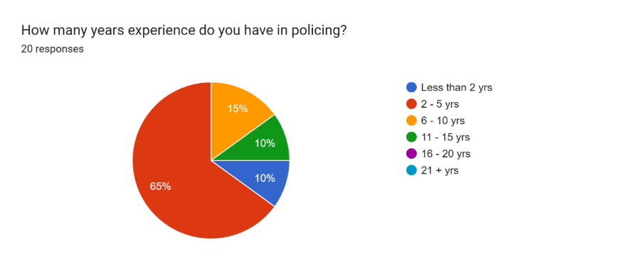
Demographically, most participants were early-career constables. Most participants were aged between 18 and 34 with 30% of responses coming from 18- to 24-year-olds and 45% of responses coming from those ages between 25 and 34 (Appendix A). Additionally, 95% of all responses held the rank of constable (Appendix D) and 65% of the participants fell within the 2-to-5-year length of service category (Figure 1, Appendix E). This suggests that the findings of this survey are representative of officers who are still within their probationary period and are transitioning from student constables to substantive officers. There is a relatively balanced distribution within the gender of participants of 45% of responses coming from female officers and 55% of responses coming from male officers (Appendix B). This provides a broader representation of differing experiences across policing cohorts of officers.
(Figure 1, Appendix E)
Most responses (85%) came from officers currently working within Response (Appendix C), this is significant because response policing is widely associated with high operational demand, exposure to regular traumatic experiences, shift work fatigue, and organisational stressors. The occupational environments in which response officers regularly work in directly influences their perceptions of organisational support and wellbeing during the probationary period.
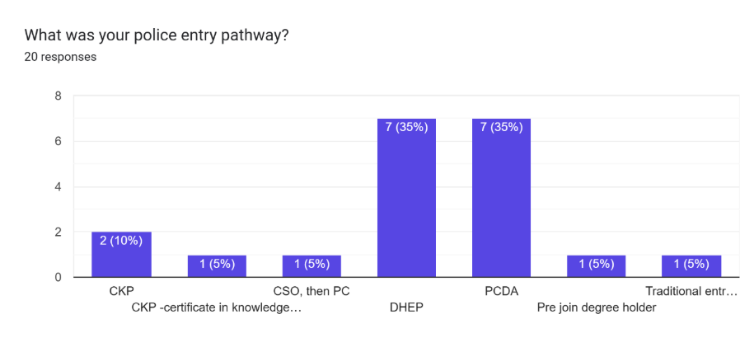
The data collected in relation to each participants respective entry route into policing further reflects the contemporary poling education landscape which was introduced by the PEQF. The largest number of participants started their careers via the PCDA (35%) and DHEP (35%) pathways. Smaller proportions of participants of the research entered through the Certificate in Knowledge of Policing (CKP), PCSO to PC progression, or pre-join degrees. These findings align with the national recruitment trends following the implementation of the degree entry policing pathways (Figure 2, Appendix F).
(Figure 2, Appendix F)
Out of the 20 responses to the question During your probationary period, did you feel supported by the respective academic institution? 9 persons answered no, with 5 answering not applicable (Appendix K). It was then asked If you answered No, what support was lacking, to which 10 participants provided a similar response of a general lack of support from the academic institutions (Appendix L).
Notably, perceptions of organisational support during the probationary period were the views surrounding current support levels. Most were positive with 65% of responses being between 7/10 and 10/10. This was similar with the answers relating to support during the probation period as many responses were 7/10 or 8/10. These findings suggest that many officers view their respective police forces support networks as positive, especially during the early years of a police officers’ career. However, the presence of lower rating scores of 3/10, 4/10, and 5/10 indicate that the positive experiences of the majority were not shared with all participants (Figure 3, Appendix I). This variation of response may reflect inconsistencies of supervisor support, tutor – student relationships, overwhelming workloads, or limited access to welfare services.
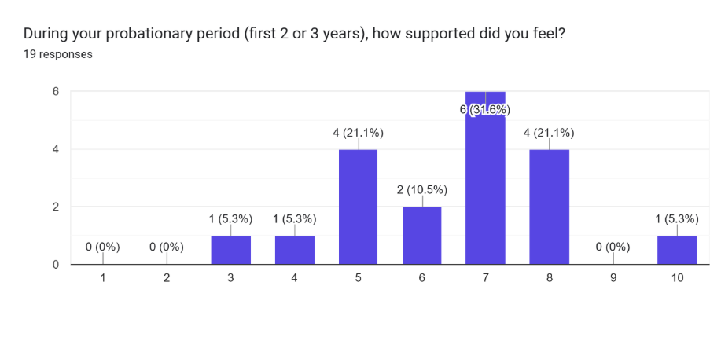

(Figure 3, Appendix I)
When asked about peer support, 100% of officers responded that they feel that they receive enough support from their colleagues (Appendix O). Furthermore, when asked where any additional support was obtained from, 70.7% of responses stated family, colleagues, or sports teams (Appendix Q). This demonstrates the critical role of informal support networks within the modern policing culture. Peer support appears particularly important during the probationary period where officers are adapting from civilian life to becoming an operational police officer while simultaneously managing academic responsibilities.
There has been a significant concern raised from this survey in relation to the support to police officers from their respective universities. While 30% of participants stated that they felt supported by their university, 45% reported that they did not. The remaining 25% of officers answered not applicable, this is likely due to their length of service and the PEQF not being in place upon their entry into the police (Figure 4, Appendix K).
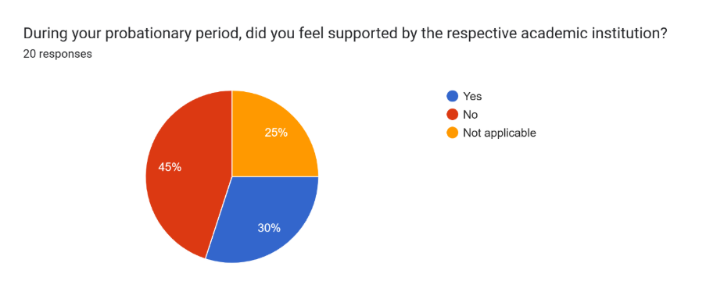

(Figure 4, Appendix K)
20% of officers raised that there was a lack of mental health support during their probationary period. When asked what support was missing, responses included, “Again I felt supported by my sergeant at the time however that’s as far as it went. Thankfully he was very helpful and understanding.”, “I went to a sudden death that was awful and did not receive any support other than a colleague saying are you okay after that.”, “Was a big stigma at the time so didn’t speak about it.”, “Firstly I didn’t need it. Secondly I wasn’t aware of any support” (Appendix N). These comments further highlight that although policing cultures have moved on significantly in recent years, there is still a stigma surrounding mental health or there is a lack of mental health support that is tailored to a police officers’ requirements with such services.
One important finding was in relation to the intention of officers regarding the retention of them within the police. 40% of responses highlighted that they have had thoughts about leaving policing. Although the majority (60%) of participants had not yet considered leaving policing as a career, the large proportion of those who expressed their thoughts of leaving remains substantial and raises concerns about policing as a lifelong career as many participants are early within their careers (Figure 5, Appendix R). This finding reflects the growing concerns nationally surrounding the retention of police officers and the attraction of policing as a career for life.
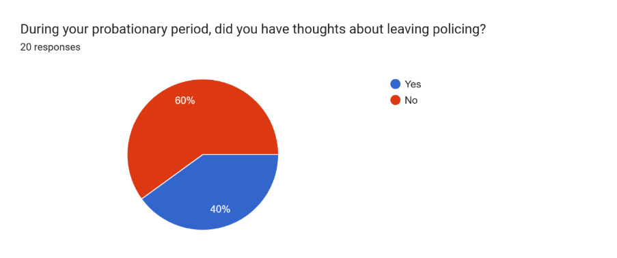
(Figure 5, Appendix R)
There are some limitations to this research, which must be acknowledged, the sample size of 20 responses limits the generalisability across the wider policing network. Secondly, the survey focuses primarily on the responses of response officers, this may sway the feelings and not allow a clear representation of feelings across the wider policing community within specialist departments.
The survey raises questions regarding the sustainability of the PEQF for current and future student police officers. While degree-entry programmes aim to professionalise policing nationally and improve evidence led investigations, the findings suggest that some officers continually experience frustrations with academic and organisational expectations not being aligned. This reflects the broader criticism surrounding the PEQF model, where officers often perceive academic requirements as less important than their policing competent and workloads (Andrews, 2023). Police forces and universities may need to strengthen their working relationships by ensuring that the educational content remains relevant to modern day policing, including mandatory post incident debriefs, and collaborative tutor-student training opportunities to make the probationary officer feel more supported.

5. Discussion

One of the key themes emerging from this study is the importance of peer support. Harkin et al. (2025) found that officers who work on the frontline value supportive leadership and peer networks the most, yet they often perceived organisational support services as inaccessible or disconnected from the reality of operational policing. These current findings support this interpretation suggesting that officers may rely heavily on colleagues and other personal or informal relationships rather than the support services available through police forces. Existing literature also states that peer support is a significant factor in protecting officers from work related stress (Traynor, Rydon-Grange and Scott, 2024). The findings from this study support such previous research suggesting that policing culture promotes solidarity and teamwork aiding resilience among officers. Loftus (2010) argues that the occupational culture within policing develops as a coping strategy against stress and pressures. Due to this peer support is often seen as more accessible and trustworthy than the alternative support through organisations support and wellbeing networks. The survey results reinforce this, as the participants appeared to have more confidence in peer support from colleagues than from organisational and academic support.
Despite the positive perceptions of peer support, the results displayed concerns surrounding organisational support during the probationary period. While most participants rated the current and probationary support relatively positively, lower scoring responses highlight there are inconsistencies among the experiences of the officers within the sample. Lower scoring responses indicate that not every probationary police officer feels supported during the early years of their service. This inconsistency may reflect the differences in supervisors, tutor constable relationships, or differences between police forces.
Significantly, concerns relating support from academic institutions has been raised from this study. Numerous participants stated that they did not feel adequately supported by their respective academic institutions, this finding reflects the ongoing criticism surrounding the roll out of the PEQF programmes. While these entry routes were introduced to professionalise policing, concerns remain regarding their practical delivery and impact upon student officers, this finding is supported by research conducted by Watkinson-Miley, Cox and Deshpande (2021).
The data relating to mental health support for police officers presents a more positive picture than that of the perceived support from universities. This may reflect the efforts across UK policing to positively improve officer wellbeing through occupational health services, counselling, and trauma management strategies. Throughout recent years, police forces within the UK have recognised the importance of psychological wellbeing and how policing can impact upon the psychological wellbeing of officers. By introducing wellbeing programmes aimed at reducing the stigma surrounding mental health and obtaining support more officers are obtaining such support which is reflected within the findings. Research into police wellbeing highlights that supportive supervision and peer relationships are some of the most influential aspects in terms of positive mental health outcomes within police organisations (Traynor, Rydon-Grange and Scott, 2024).
However, the findings should be interpreted carefully as some responses indicated insufficient mental health support. This indicates that communication surrounding officer welfare and wellbeing remains inconsistent across the UK. Existing research highlights that officers may be reluctant to engage with formal support services due to fears surrounding stunted career progression, stigma, and overall perception of weakness (Traynor, Rydon-Grange and Scott, 2024). Therefore, the availability of support does not always guarantee accessibility, uptake, or confidence in using such services.
The relationship between wellbeing and retention has become increasingly important when researching the profession of policing. Student officers who are partaking in the PEQF pathways are often subjected to high pressures due to the operational duties, academic studies, and maintaining a personal life away from policing. Andrews (2024) found that student police officers often viewed the university requirements negatively, especially where the academic work was disconnected from frontline policing in the modern day. Similarly, the research that was conducted by Honess and Clarke (2023) identified that there was an ongoing disconnect between policing cultures and higher education providers, with officers struggling to integrate the academic expectations into operational policing environments. Not balancing these areas can negatively impact upon an officer’s wellbeing and increase the risk of professional burnout of police officers before their careers have left probation (Porter and Gavin, 2024). Where officers experience a lack of support or a poor work-life balance, their intentions to leave the profession may rise.
The findings suggest that improving support structures may not only enhance the wellbeing of police officers but could also lead to improved retention figures. The relationship between support and retention is significant. Officers who perceive stronger support networks are more likely to demonstrate resilience and commitment to their work (Cox et al., 2025). However, insufficient support from supervisors, poor communication, and excessive academic pressure may increase the urge to resign from policing. The findings therefore suggest that effective welfare provision is important along with further wellbeing provisions will be key in improving the retention of officers within the UK.

6. Limitations

Following the completion of this research, the following limitations have been discovered. The demographic of this research provides for important context to be able to fully interpret the findings. Most participants were Police Constables with between two and five years of service, meaning that many of the participants are still adapting to frontline policing (Williams and Sondhi, 2022). Meaning that the true representation of response policing has not been captured fully. Many participants work within the response department. This is an environment which is associated with high workloads, traumatic incidents, shift work, and fatigue (Porter and Gavin, 2024). Research displays that response police officers experience higher levels of occupational stress than some specialist departments due to the constant exposure to emergency incidents and the unpredictable demand (Harkin et al., 2025). The experiences identified within the study may therefore not reflect the wider pressures that currently face frontline policing.
Despite these limitations, these findings do provide valuable insights into the first-hand experiences of police officers within the probationary period. The data suggests that peer support networks are highly valued and often fill the gaps where formal support networks fall short. While many of the responses reported positive perceptions of organisational and mental health support, there are concerns raised regarding the support provided from universities, awareness of available support services, and retention intentions of probationary police officers. The findings reinforce existing literature suggesting that probationary police officers face significant pressures which are associated with working as a full-time police officer, completing academic studies, and their personal wellbeing (Andrews, 2023).

7. Future Recommendations

Future research is required to further explore the adequacy of support for probationary police officers. This further research should incorporate qualitative interviews or thematic analysis to explore these issues raised in greater depth (Creswell and Creswell, 2025). Especially qualitative exploration could examine how police officers interpret support from their organisations and what are the barriers to officers accessing the support and wellbeing services that are so important in policing. This research would provide further understandings into modern day policing and how police forces and the higher education providers can better support probationary police officers throughout the difficult transition into the policing profession.
Further research should also incorporate a larger sample size from across the United Kingdom, potentially using purposive sampling techniques (Etikan, Musa and Alkassim, 2016). This will allow for the views of probationary police officers to be better understood, and for the research to be better directed to the views of probationary police officers. This will allow for police forces and universities to better understand where further support is required to aid probationary police officers in their transition from a civilian to a police officer.
Finally, future research should further explore the relationship of police support systems and the retention of police officers. Although this study did incorporate this topic, further research is required to solidify the findings and understand the reasons why police officers are resigning (Cox et al., 2025), especially during their probationary period.

8. Conclusion

The findings from this study provide important insights into the experiences of modern-day probationary police officers in relation to organisational support, wellbeing of officers, and retention. The data displays that there are wider nationwide concerns regarding the PEQF and the challenges associated with policing and simultaneously completing university level courses. While many participants reported that they felt positively supported whilst at work and while completing their university courses, several findings indicate concerning issues surrounding mental health, lacking engagement from universities, and the retention of police officers. Research consistently demonstrates that those officers working on the frontline experience high levels of psychological strain due to their workload pressures and emotional labour (Harkin et al., 2025).
Research conducted by (Harkin et al., 2025) displays how police wellbeing is being heavily influenced by organisational cultures and leadership. Officers who perceive their supervisors as approachable and supportive are significantly more likely to experience positive wellbeing outcomes. However, those officers who are subject to high workloads, low staffing, and poor communication may feel more stress and less supported leading to feeling dissatisfied at work. The current findings suggest that although formal support is available, the quality and consistency of this support can vary significantly.
Current literature identifies that there are opportunities and challenges relating to these programmes. While the PEQF was intended to professionalise the police forces within the UK and embed evidence-based policing across the UK, many student officers report tension between operational demands and academic expectations (Andrews, 2023). Several other studies have highlighted the tensions between operational policing and the academic work that is required within the PEQF. Watkinson-Miley, Cox and Deshpande (2021) found that many student officers have trouble in balancing academic assignments with policing workloads.
The current findings appear to support these arguments. The high percentage of responses indicating a dissatisfaction with the university support networks highlights that the universities are not currently meeting the needs of the student police officers fully. Potential issues may include limited academic flexibility, insufficient understanding of operational policing in the modern day, or ineffective communication between the universities themselves and the police forces. The findings therefore suggest that there is a need for stronger collaboration between policing organisations and the universities to improve the support and experience for student police officers.
Peer support is clearly working as a support mechanism within policing, but reliance on informal support alone may not be sustainable in the long run for officers or their organisations. Policing organisations must ensure that there is formal wellbeing support readily available, visible to all officers, and easily accessible while being embedded within the modern culture of policing (Craig and Duran, 2026). Universities who are involved with the PEQF programme should ensure that the academic expectations of the student officers are realistic and sensitive to operational policing while collaborating with police forces to provide a well-rounded support system for probationary police officers.

9. Reference List

Andrews, T. (2023). Perceptions of student officers of the police constable degree apprenticeship. The Police Journal, [online] 97(4). doi:https://doi.org/10.1177/0032258x231208904.

Andrews, T. (2024). Public Expectations of Police Education in England and Wales. Policing: a Journal of Policy and Practice, 18(1). doi:https://doi.org/10.1093/police/paad101.

Braun, V. and Clarke, V. (2019). Reflecting on Reflexive Thematic Analysis. Qualitative Research in Sport, Exercise and Health, [online] 11(4), pp.589–597. doi:https://doi.org/10.1080/2159676X.2019.1628806.

Bryman, A. (2012). Social research methods. 4th ed. [online] Oxford: Oxford University Press. Available at: https://arunodayauniversity.ac.in/wp-content/uploads/2025/01/Social-Research-Methods-4th-Edition-Bryman.pdf [Accessed 9 Mar. 2026].

Code 0 (2025). Landing – Code 0 – Hapstar. [online] Hapstar.app. Available at: https://hapstar.app/code-0/ [Accessed 5 Feb. 2026].

College of Policing (2016). Mentoring. [online] College of Policing. Available at: https://www.college.police.uk/research/crime-reduction-toolkit/mentoring [Accessed 27 Jan. 2026].

College of Policing (2019a). Sergeant | College of Policing. [online] College of Policing. Available at: https://www.college.police.uk/career-learning/support-for-career-development/policing-professional-profiles/core-rank-profiles/sergeant [Accessed 27 Jan. 2026].

College of Policing (2019b). Tutor | College of Policing. [online] College of Policing. Available at: https://www.college.police.uk/career-learning/support-for-career-development/policing-professional-profiles/business-support-profiles/tutor [Accessed 22 Jan. 2026].

College of Policing (2022). Supporting wellbeing. [online] College of Policing. Available at: https://www.college.police.uk/guidance/effective-supervision/supporting-wellbeing [Accessed 27 Jan. 2026].

College of Policing (2023). Positive Steps mentoring network. [online] College of Policing. Available at: https://www.college.police.uk/support-forces/practices/positive-steps-mentoring-network [Accessed 26 Jan. 2026].

Cox, C., Blockley, T., Hagan, R. and James, A. (2025). Is the police service still a long-term career choice? Perspectives of new recruits. Policing An International Journal, 48(2). doi:https://doi.org/10.1108/pijpsm-09-2024-0147.

Craig, E. and Duran, F. (2026). A review exploring wellbeing interventions for police personnel in the UK: what support is available? Police Practice and Research, pp.1–30. doi:https://doi.org/10.1080/15614263.2026.2627207.

Creswell, J. and Creswell, D. (2025). Research Design Qualitative, Quantitative, And Mixed Methods Approaches By John W. Creswell J. David Creswell (z Lib.org) : John W. Creswell; J. David Creswell : Free Download, Borrow, and Streaming : Internet Archive. [online] Internet Archive. Available at: https://archive.org/details/research-design-qualitative-quantitative-and-mixed-methods-approaches-by-john-w./page/46/mode/2up [Accessed 9 Mar. 2026].

Etikan, I., Musa, S.A. and Alkassim, R.S. (2016). Comparison of convenience sampling and purposive sampling. American Journal of Theoretical and Applied Statistics, [online] 5(1), pp.1–4. doi:https://doi.org/10.11648/j.ajtas.20160501.11.

Evans, J.R. and Mathur, A. (2018). The Value of Online Surveys: a Look Back and a Look Ahead. Internet Research, [online] 28(4), pp.854–887. doi:https://doi.org/10.1108/intr-03-2018-0089.

Field, A. (2024). Discovering Statistics Using IBM SPSS Statistics. [online] Google Books. Available at: https://books.google.co.uk/books?id=83L2EAAAQBAJ&printsec=frontcover&source=gbs_ge_summary_r&cad=0#v=onepage&q&f=false [Accessed 19 Nov. 2025].

Gau, J.M. and Paoline, E.A. (2025). Mentorship, Culture, and Job Satisfaction among Police Officers. Criminal Justice and Behavior, 52(10). doi:https://doi.org/10.1177/00938548251343827.

Gov.uk (2022). Police Uplift Programme New Recruits Onboarding Survey 2021 – Report. [online] GOV.UK. Available at: https://www.gov.uk/government/publications/police-uplift-programme-new-recruits-onboarding-survey-2021/police-uplift-programme-new-recruits-onboarding-survey-2021-report [Accessed 22 Jan. 2026].

Gov.uk (2023). Police Uplift Programme New Recruits Onboarding Survey 2023 - Report. [online] GOV.UK. Available at: https://www.gov.uk/government/publications/police-uplift-programme-new-recruits-onboarding-survey-2023/police-uplift-programme-new-recruits-onboarding-survey-2023-report [Accessed 26 Jan. 2026].

Gov.uk (2024). Police Uplift Programme: entry routes of officer recruits. [online] GOV.UK. Available at: https://www.gov.uk/government/statistics/police-uplift-programme-entry-routes-of-officer-recruits/police-uplift-programme-entry-routes-of-officer-recruits [Accessed 22 Jan. 2026].

Harkin, B., Rawlinson, L., Davies, L.E. and Yates, A.J. (2025). Beyond the badge: organizational barriers to police anxiety and mental health support. Policing: A Journal of Policy and Practice, 19. doi:https://doi.org/10.1093/police/paaf039.

Honess, R. and Clarke, S. (2023). ʻItʼs Not ‘Uni’ Work, itʼs Essential Learning to be a Police Officerʼ: Examining the Higher Education Elements of Police Education Qualifications Framework Programmes. Policing: A Journal of Policy and Practice, 17. doi:https://doi.org/10.1093/police/paad023.

Joshi, A., Kale, S., Chandel, S. and Pal, D.K. (2015). Likert Scale: Explored and Explained. British Journal of Applied Science & Technology, [online] 7(4), pp.396–403. doi:https://doi.org/10.9734/BJAST/2015/14975.

Kassem, R. and Erken, E. (2024). In their own words: Police officers’ insights on identifying and overcoming contemporary policing challenges. International review of administrative sciences, [online] 0(0). doi:https://doi.org/10.1177/00208523241256029.

Loftus, B. (2010). Police occupational culture: classic themes, altered times. Policing and Society, [online] 20(1), pp.1–20. doi:https://doi.org/10.1080/10439460903281547.
Metropolitan Police (2025). Mental health training for officers during a crisis. [online] met.police.uk. Available at: https://www.met.police.uk/foi-ai/metropolitan-police/disclosure-2025/october-2025/mental-health-training-officers-during-crisis/ [Accessed 5 Feb. 2026].

Maier, C., Thatcher, J.B., Grover, V. and Dwivedi, Y.K. (2023). Cross-sectional research: a Critical perspective, Use cases, and Recommendations for IS Research. International Journal of Information Management, 70(70), p.102625.

Metropolitan Police (2025). Mental health training for officers during a crisis. [online] met.police.uk. Available at: https://www.met.police.uk/foi-ai/metropolitan-police/disclosure-2025/october-2025/mental-health-training-officers-during-crisis/ [Accessed 5 Feb. 2026].

Oscar Kilo (2022). Oscar Kilo. [online] Oscar Kilo. Available at: https://www.oscarkilo.org.uk/ [Accessed 5 Feb. 2026].

Phythian, R., Birdsall, N., Kirby, S., Cooper, E., Posner, Z. and Boulton, L. (2021). Organisational and individual perspectives of police wellbeing in England and Wales. The Police Journal: Theory, Practice and Principles, [online] 96(1), p.0032258X2110522. doi:https://doi.org/10.1177/0032258x211052250.

Phythian, R., Birdsall, N., Kirby, S., Cooper, E., Posner, Z. and Boulton, L. (2022). Developments in UK police wellbeing: A review of blue light wellbeing frameworks. The Police Journal: Theory, Practice and Principles, [online] 95(1). doi:https://doi.org/10.1177/0032258x211073003.

Police Federation (2024). Why police officers are leaving and why retention is crucial. [online] Polfed.org. Available at: https://www.polfed.org/news/latest-news/2024/why-police-officers-are-leaving-and-why-retention-is-crucial/ [Accessed 10 Nov. 2025].

Porter, C.N. and Gavin, P. (2024). ‘Constant pressures from all angles’: Understanding the mental health of UK police officers. The Police Journal Theory Practice and Principles, [online] 98(2). doi:https://doi.org/10.1177/0032258x241280217.

Setia, M.S. (2016). Methodology Series Module 3: Cross-sectional Studies. Indian Journal of Dermatology, [online] 61(3), pp.261–264. doi:https://doi.org/10.4103/0019-5154.182410.

Stubbs, G. and Tong, S. (2024). The ‘haves and have-nots’ of social support during police recruitment: why the playing field is anything but level. Policing & society, 34(6), pp.1–17. doi:https://doi.org/10.1080/10439463.2024.2317313.

Thames Valley Police (2024). POLICE OFFICER RECRUITMENT FREQUENTLY ASKED QUESTIONS. [online] Available at: https://tvpcareers.co.uk/wp-content/uploads/2024/09/Frequently-Asked-Questions-Sept-2024.pdf [Accessed 22 Jan. 2026].

Traynor, I., Rydon-Grange, M. and Scott, H. (2024). Intrapersonal and Organisational Predictors of Psychological Help-Seeking in a UK Police Force. Intrapersonal and Organisational Predictors of Psychological Help-Seeking in a UK Police Force. [online] doi:https://doi.org/10.1007/s11896-024-.

van Teijlingen , E.R. and Hundley, V. (2026). Social Research Update 35: The importance of pilot studies. [online] Surrey.ac.uk. Available at: https://sru.soc.surrey.ac.uk/SRU35.html?utm [Accessed 15 Jun. 2026].

Watkinson-Miley, C., Cox, C. and Deshpande, M. (2021). A New Generation of Police Officers: Experiences of Student Officers Undertaking the Police Constable Degree Apprenticeship in One UK Police Force. Policing: a Journal of Policy and Practice, [online] 16(1), pp.122–134. doi:https://doi.org/10.1093/police/paab062.

Wikström, E., Arman, R., Dellve, L. and Gillberg, N. (2023). Mentoring programmes – building capacity for learning and retaining workers in the workplace. Journal of Workplace Learning, 35(8), pp.732–751. doi:https://doi.org/10.1108/jwl-01-2023-0003.

Phythian, R., Birdsall, N., Kirby, S., Cooper, E., Posner, Z. and Boulton, L. (2022). Developments in UK police wellbeing: A review of blue light wellbeing frameworks. The Police Journal: Theory, Practice and Principles, [online] 95(1). doi:https://doi.org/10.1177/0032258x211073003.

Williams, E. and Sondhi, A. (2022). A Narrative Review of the Literature on the Recruitment of Younger Police Officers in Age and in Service: What Are the Implications for the Police in England and Wales? Policing: A Journal Of Policy And Practice, 16(4). doi:https://doi.org/10.1093/police/paac001.

10. Appendices

Survey questions and responses

Appendix A:
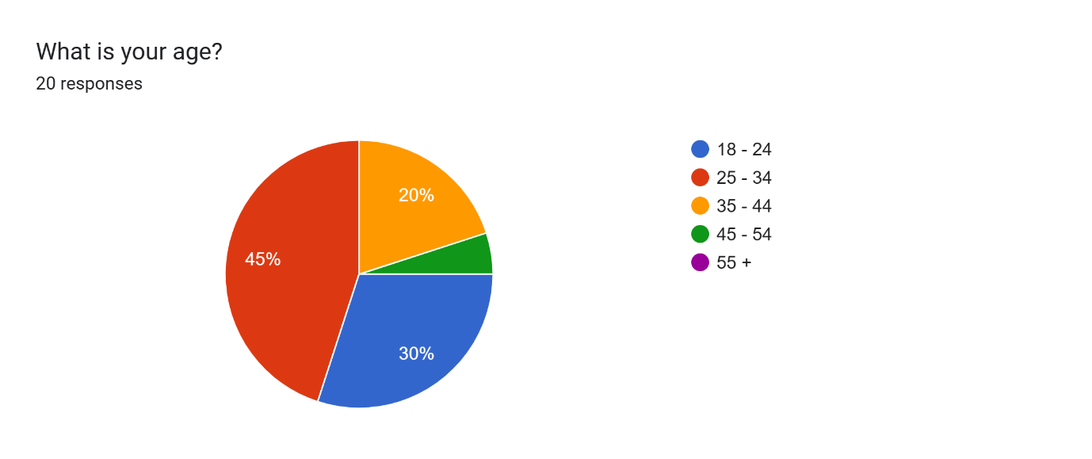

Appendix B:
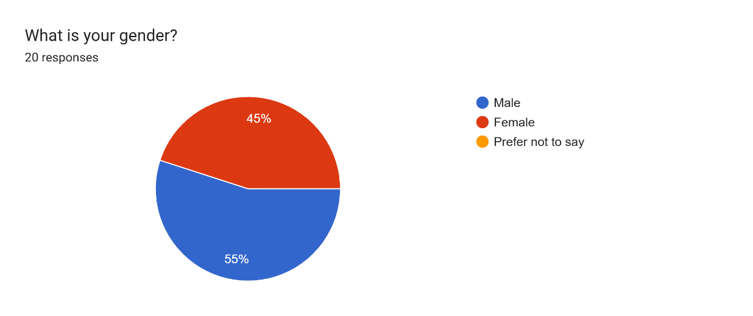

Appendix C:
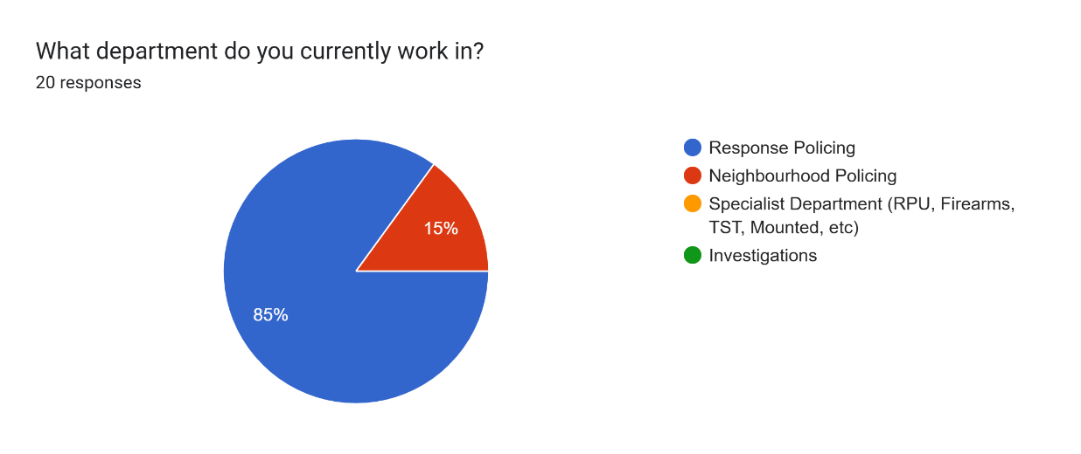

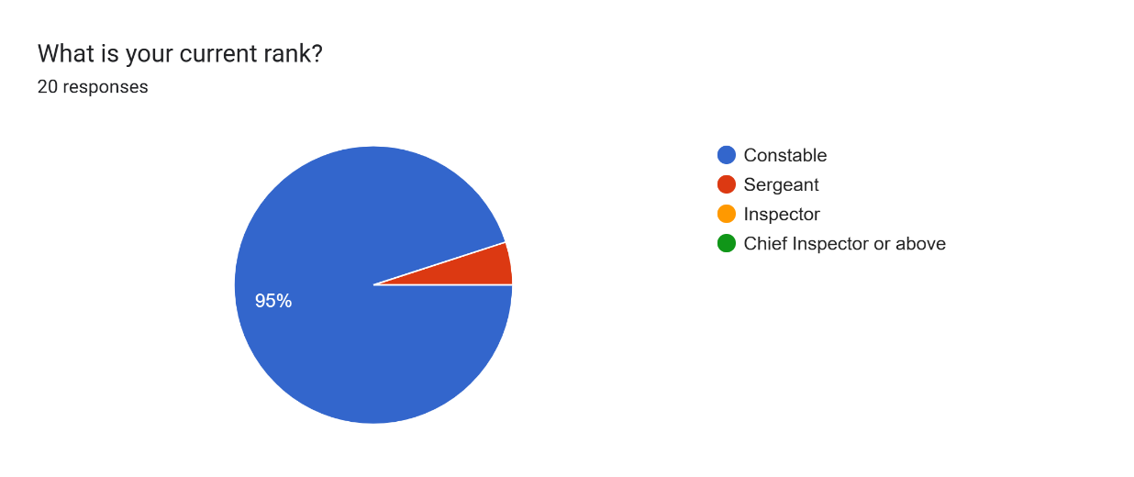
Appendix D:

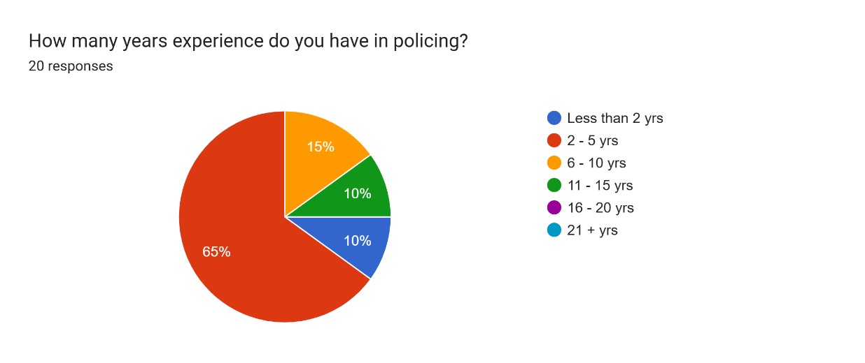
Appendix E:

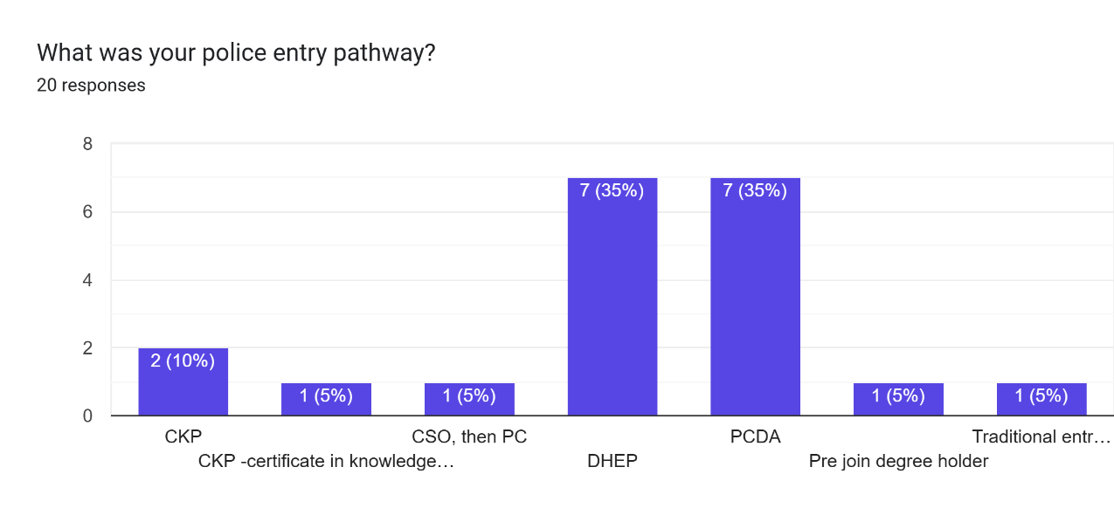
Appendix F:

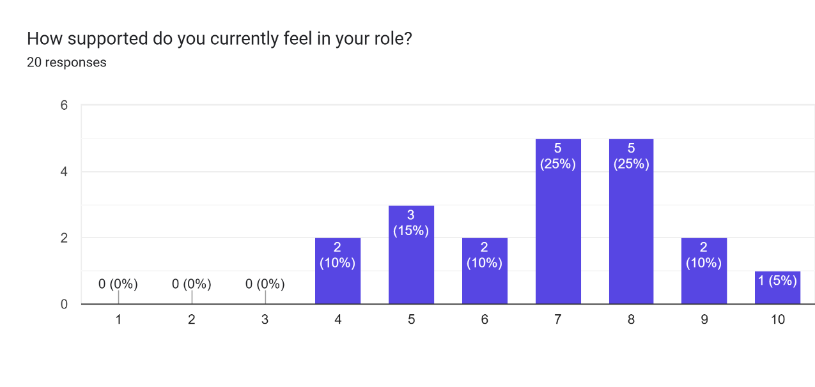
Appendix G:
Appendix H:

- Great support from my peers
- Be nice to see the line manager a bit more and see them out and about with the other boots on the ground
- Often times feel that response is the bottom of the pile for policing from other departments, however, a supportive team, sergeant and other SMT bring this ranking up higher.
- Training school was great for support now onto shift and my team are really supportive
- I feel well supported but there areas which are lacking such as academia
- Lack of support from force and uni
- Currently being supported for personal issues and I could not thank the force for what they are doing for me
- I feel as though I’m supported by my sergeant however currently any rank further up I do not. Often feel as though response officers are the last thought, welfare of officers is not currently a priority, often feel as though Trik is offered but that’s as far as it goes in regards to any welfare. Don’t feel as though response are appreciated as they should be because majority of the officers are new and therefore not considered as much however response is one of the toughest roles and that should not be the case.
- Great support from colleagues, SGT is questionable in terms of support and approachability.
- Great support from the team, uni does not support great and sometimes it seems SMT are on a different planet to response
- My team are great and good support from the insp
- It feels as though there is limited support for officers currently in policing. Forces appear more concer ed with how they appear to the public and the media, rather than how they appear to their serving officers or the service they provide current officers. I would have scored lower than 5, but my current supervisors are very understanding and supportive
- I feel supported but there’s feels no relief on shift and it’s relentless
- There are times when I feel like the wider SMT does not support you but I’ve always had good support from my Seargent
- I feel like I am supported well by my peers and supervisors, but there needs to be further support available, rather than the current tick box exercises completed.
- Great team
- With in the team and the larger station up to inspector we are supported and our work and effort - is appreciated. Beyond that we are just numbers. We have an SMT that looks out for themselves and keep implementing ideas and policies without much thought how it actually impacts the frontline officers. Our SMT are managers and not leaders that goes to the top. If they were leaders they would appreciate and look out , and support the frontline officers. No matter how good a job we do, we are rarely supported or praised and they are quick to beat us with a stick if something goes wrong.
- I have a good sarge and inspector for support
- I have a good sergeant and bronze inspector who look out for us, however my sergeant is not always in work and has been off for large chunks of my service so far.

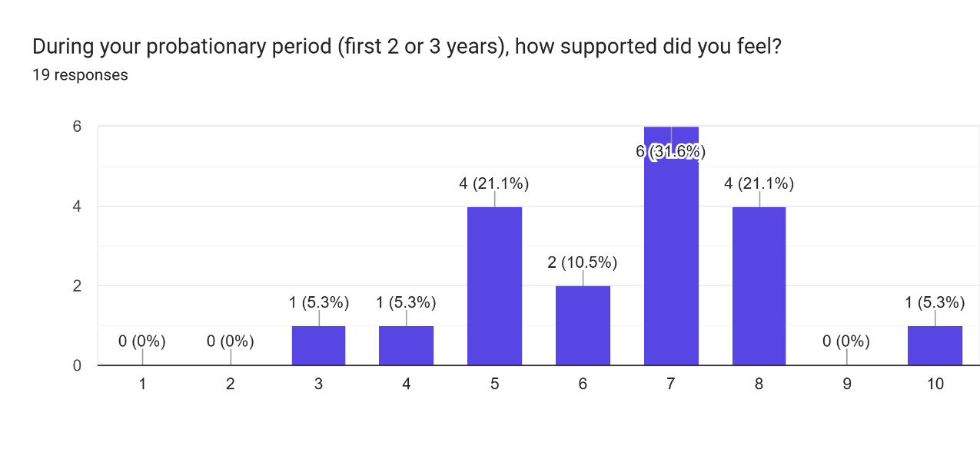
Appendix I:
Appendix J:

- Fairly good support all round
- Could have had more support from the university and the job. PLT was a nightmare
- I felt adequately supported. My tutor and the rest of the team were really supportive, but I had an extremely high workload and did not feel supportive enough as to how to make decisions and carry out these enquiries on my own and could have definitely used further support with this
- As above
- As above, lack of support through uni
- As above
- Great support from the university programme, tutors, sergeants and peers
- Again, I felt supported by my sergeant at the time however in regards to the tutors on the uni course, the uni, and anyone higher rank than my sergeant I did not feel supported. At the time my university was UWTSD. I believe it has now changed, thankfully.
- As above still in probation.
- As above, team are great but uni and SMT support lacks
- I had a great team
- As above. Probation felt like survival rather than a period when supported
- My supervisor supports me
- The university was extremely helpful
- I had a supportive tutor and sergeant and moved to a supportive shift when I became independent. Later into it I became the senior on shift and now I am the one to give out the support, with less support than initially joining.
- Some old sweats stuck in their ways but in general good support
- My tutor and team were superb and if it was just based on this, this would be a 10. But beyond that there was little to no support from the training wing once I had finished training, left very much to our own devices.
- When you are new, sometimes it be harder to ask for support or know where to find it. So I think this naturally makes you feel less supported. You are less confident and don’t always know what is the right and wrong way to feel
- Many changes in supervisor
- As above. Also in terms of the academic side the PLT days were good to ensure that we had at least some time to complete uni assignments within work time.

Appendix K:

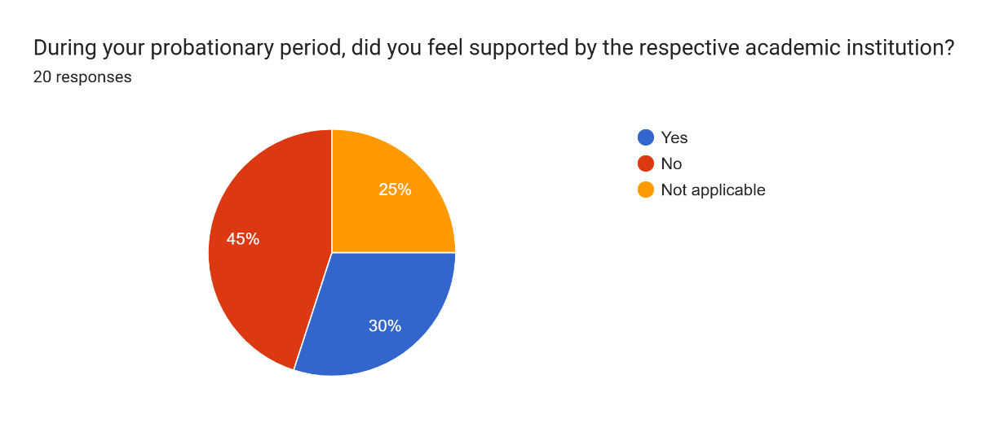
Appendix L:

- I didn’t get any support academically really. When they provided feedback about draft assignments, I did not feel this was useful in the slightest
- It feels impossible to get help and the help given is not amazing
- I don’t feel that the uni care about us officers
- At the time I was in probation, they have you the work and left you to it, would now and again have a teams lecture however was not useful in anyway and very impersonal. I still do not agree with having to do the DHEP when you already have a degree. I think you should have to do an OCP and that is it.
- Difficult to get hold of, generalised support, and overall feeling of unwillingness to help.
- General support that was not a scheduled appointment as shift workers it is hard to attend set times and there does not seem to be any flexibility
- I thankfully joined before the pointless academic process student officers have to go through now.
- Very poor communication
- Lack of communication between the policing side and academic side
- UWTSD were very difficult to speak with and to get replies from.

Appendix M:
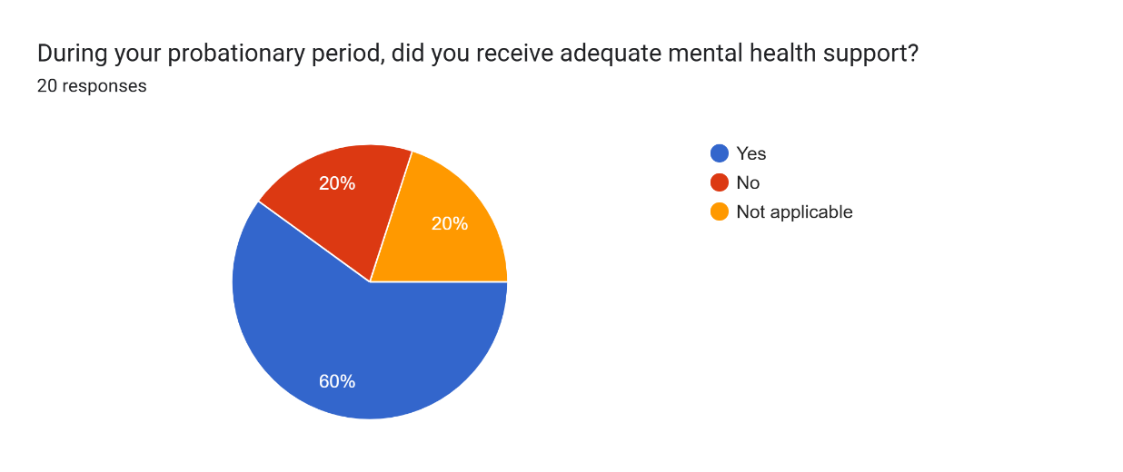

Appendix N:

- Again I felt supported by my sergeant at the time however that’s as far as it went. Thankfully he was very helpful and understanding.
- I went to a sudden death that was awful and did not receive any support other than a colleague saying are you okay after that
- Was a big stigma at the time so didn’t speak about it
- Firstly I didn’t need it. Secondly I wasn’t aware of any support.

Appendix O:

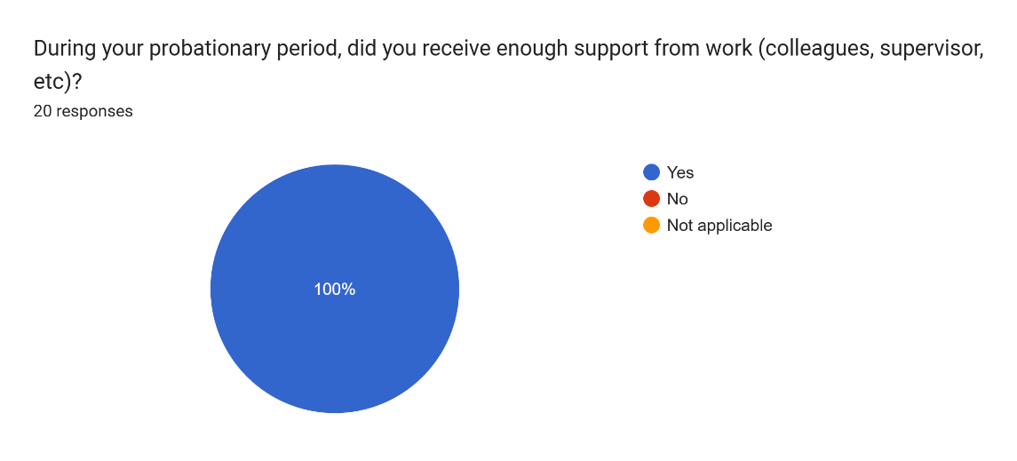

Appendix P:

- As stated above I was lucky with the sergeant I had at the time as I know this is not always the case.
- My tutor and team were superb and the best support. Thankfully cops on team look out for each other. Otherwise there was next to no support that I was aware of.

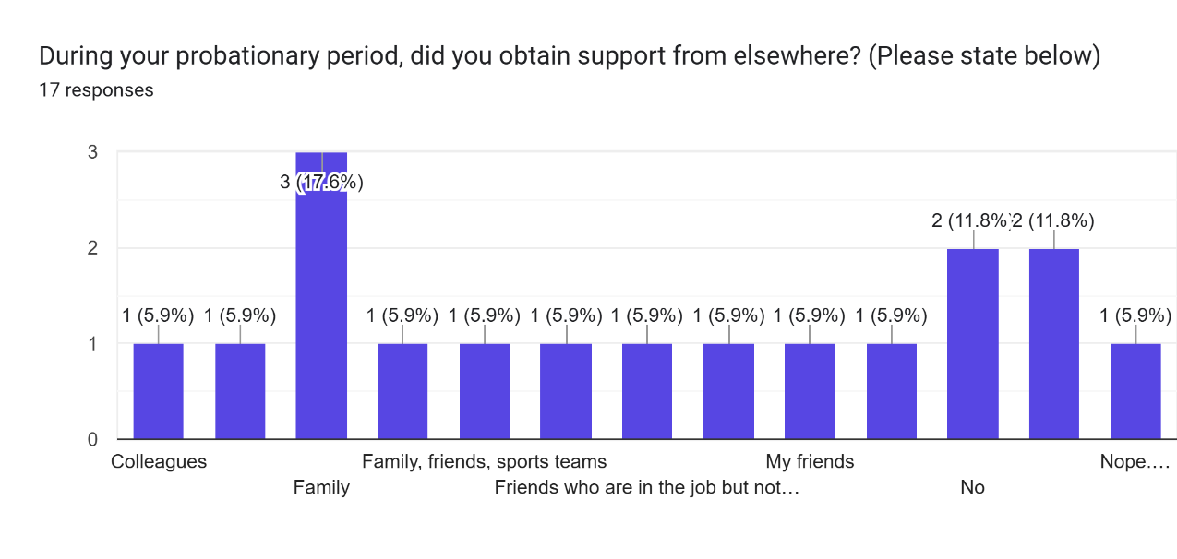
Appendix Q:

Appendix R:
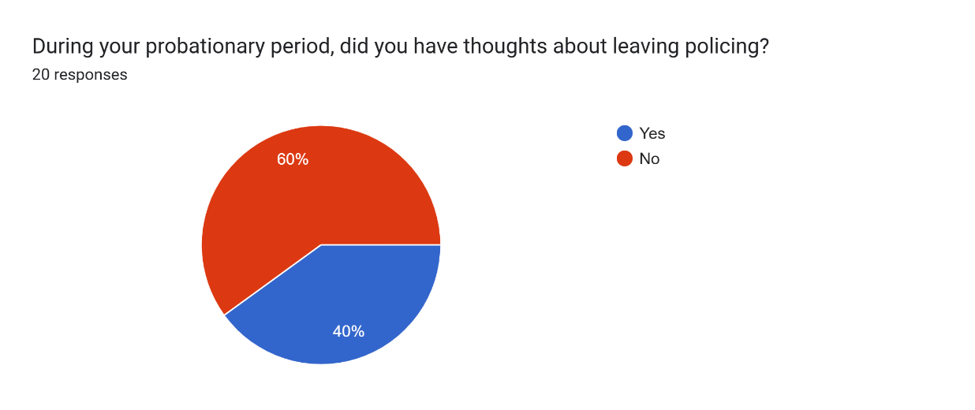

Appendix S:

- Pay
- N/a
- Uni work
- I have wanted to move teams due to supervisor and lack of support and differing support for different colleagues but not leave policing.
- Lack of support, stress of uni work
- It’s hard when there’s only 2/3 of you in and it’s the same people going to calls, getting prisoners, dealing with g4s going on watched and then on top of it all having to try and do your workload in between
- At times it felt like there was no staff and it was constantly just the same few staff members in dealing with an entire teams workload
- High demand and low staffing becoming an everyday issue, with no clear support in place or plan to change it.
- Pay, shift work
- N/A

Appendix T:
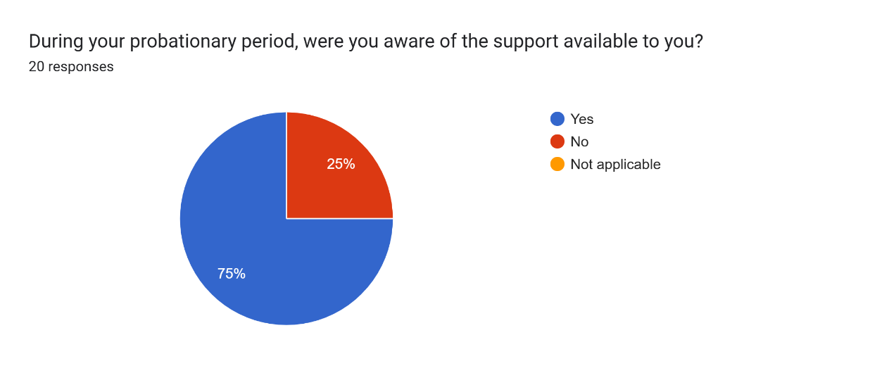

Appendix U:

- Easier access to academic support around shifts
- Better uni support either in work or from the uni
- Was aware but didn’t think it would have been helpful anyway, at the time it was via teams.
- Better uni support, wider access to peer support
- Ongoing support with academia
- I feel there should be readily available support for officers, for whatever they need. It shouldn't take a significantly traumatic incidents for officers to 'qualify' for support
- More support around when people go off on long term sick and the team is left to deal with the rest of the teams workload
- There needs to be something in place to allow officers to raise issues with current practices and a work closer with SLT on resolving these issues to ensure these issues are being dealt with, which would allow officers to feel more supported.
- More support from SMT to response
- Welfare, both physical and mental. Support for post training was lacking. In general we get no support. It’s all smoke and mirrors

