
Component 1: Design and Implementation of a Relational Database System
Introduction to Web and Database Concepts - ACCA4023

Sadhana Jha

Assessment: Component 1
Student name: Serhii Lypka
Student ID:2024 0943 61
Date:08/03/2026

UNIVERSITY OF WALES TRINITY SAINT DAVID

Contents
Scenario Analysis 2
List of attributes and their descriptions 3
Screenshot of the all the tables showing the dataSample data 6
Query Development 8
Testing and Validation 10
Design Decisions and Future Work 11

Scenario Analysis
MediLink Pharmacy needed a database system to better keep track of sales, prescriptions, drugs, inventories, customers, and sales transactions. Before the database was created, these tasks were done by hand, which made it more likely that mistakes would be made, entries would be duplicated, and data would be handled poorly. The database's goal was to use Microsoft Access to make a structured and dependable system. The new system was made to keep all of the following in one place: customer information, prescriber information, pharmaceutical data, prescription details, stock information, and sales transactions. This helps pharmacy workers get to information more quickly and make daily operations more accurate overall. The database also helps management by letting the pharmacy keep an eye on low stock levels, find controlled substances, go over prescription records, and look at sales data for medicines. This helps the pharmacy make better decisions, follow the rules, and keep its data in a more ordered way. Database systems help organisations manage large amounts of information efficiently and reduce errors in data handling[1].
Entity Relationship Diagram (ERD)
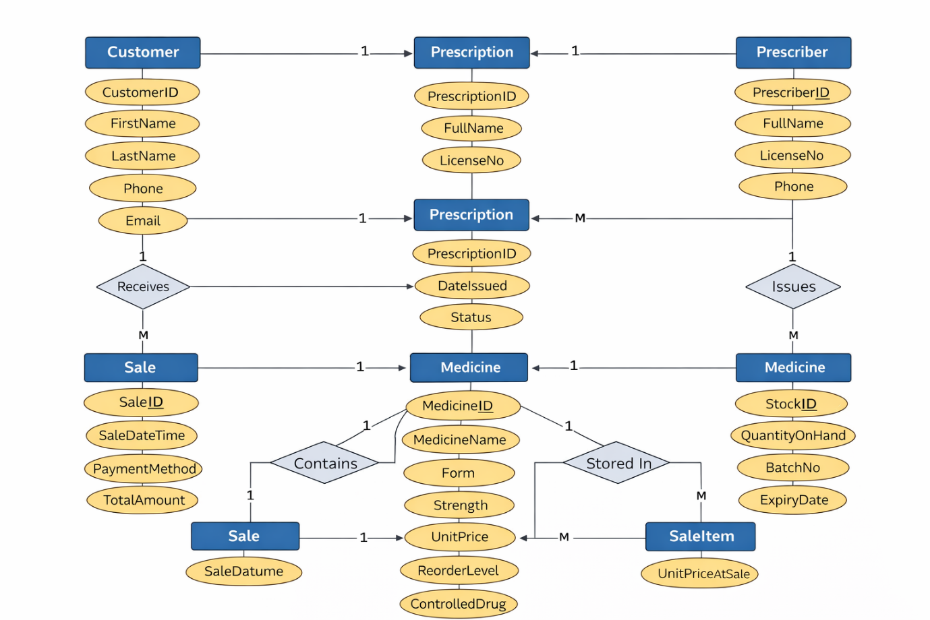
Figure 1 ER- Diagram

List of attributes and their descriptions
The database contains several entities that store information about customers, prescribers, medicines, prescriptions, sales, and stock. Each entity contains a primary key that uniquely identifies each record, while other attributes store relevant operational information.
Entity
  Attribute
  Description
Customer | CustomerID
  Unique identifier for each customer (Primary Key)
 | FirstName
  Customer
  Customer first name
 | PrescriberID
  Prescriber
  Unique identifier for each prescriber (Primary Key)
  Medicine
  MedicineID
  Unique identifier for medicine
  Prescription
  PrescriptionID
  Unique identifier for each prescription (Primary Key)
Sale
  SaleID
  Unique identifier for each sale (Primary Key)

List of relationships and their meaning.
Provide the list of all relationships. For each relationship escribe the cardinality and participation constraints
Relationship | Cardinality
  Meaning
 | 1:M
  Customer – Prescription
  One customer can have many prescriptions
 | 1:M
  Prescriber – Prescription
  One prescriber can issue many prescriptions
 | 1:M
  Prescription – Prescription Item
  A prescription can contain multiple medicines
 | 1:M
  Medicine – Prescription Item
  One medicine can appear in many prescription items
 | 1:M
  Customer – Sale
  One customer can make multiple sales
 | 1:M
  Sale – SaleItem
  One sale can contain multiple medicines
 | 1:M
  Medicine – SaleItem
  One medicine can appear in many sale items
 | 1:M | One medicine can have multiple stock record
  Medicine – Stock

ER diagram:
The ER diagram below illustrates the structure of the MediLink Pharmacy database.
It shows the main entities such as Customer, Prescriber, Medicine, Prescription, Sale, and Stock.
The diagram also represents the relationships between these entities and their cardinality, helping to visualise how the database stores and connects pharmacy information.
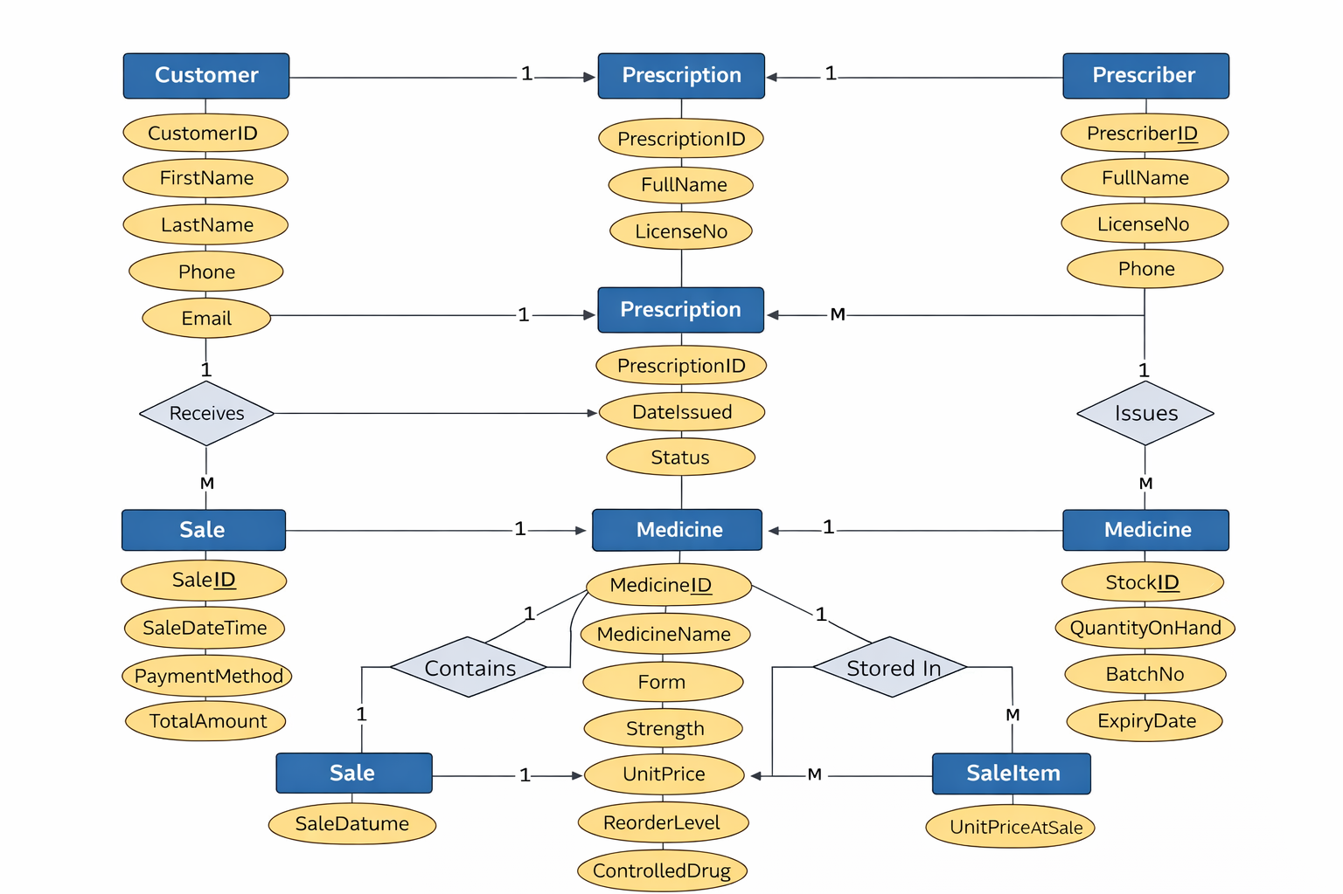
Figure 1 — ER Diagram
Normalization
Database normalization is used to organise data efficiently and reduce redundancy by dividing data into related tables [2]
In the MediLink Pharmacy database, normalization was applied to structure the data into logical tables such as Customers, Medicines, Prescriptions, Sales, and Stock. This separation helps ensure that data is stored efficiently and reduces the possibility of duplicate information. The design of the database is based on the rules of First Normal Form (1NF), Second Normal Form (2NF), and Third Normal Form (3NF). There are atomic values, a primary key, and characteristics that only depend on the primary key in each table. This makes sure that the data is consistent and makes the database structure better overall.
Sample Data Population
Screenshot of the all the tables showing the dataSample data was inserted into each table in the MediLink Pharmacy database to test the functionality of the system. The data includes records for customers, medicines, prescriptions, sales, and stock information.
These records simulate real pharmacy operations and allow the database to be tested through queries and relationships between tables.
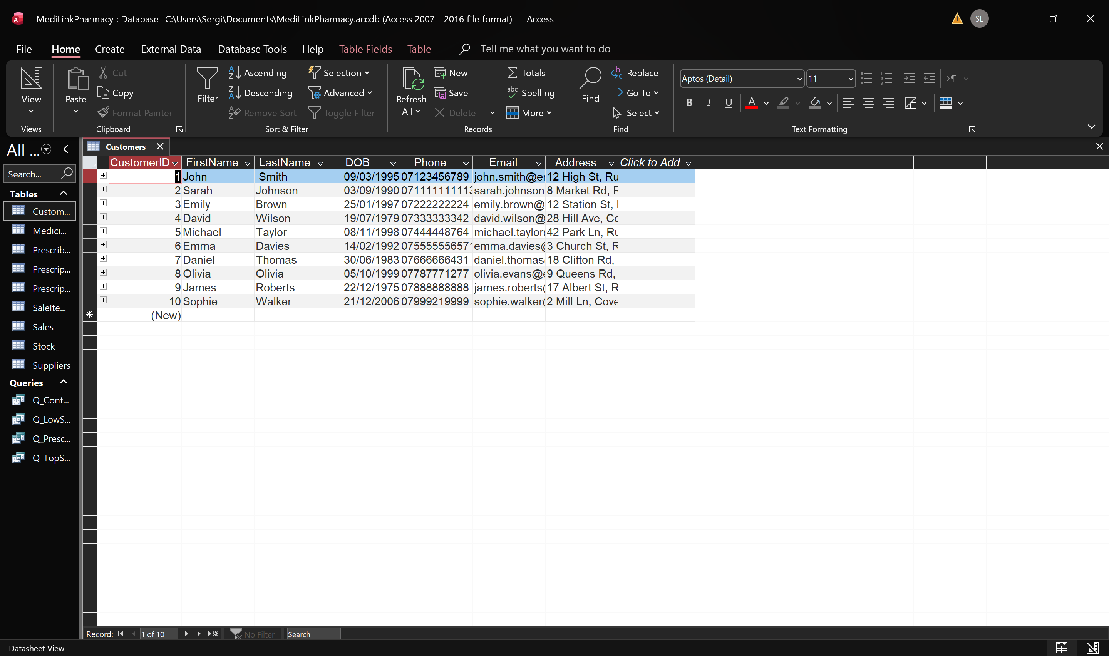Figure 2: Customers table with sample data
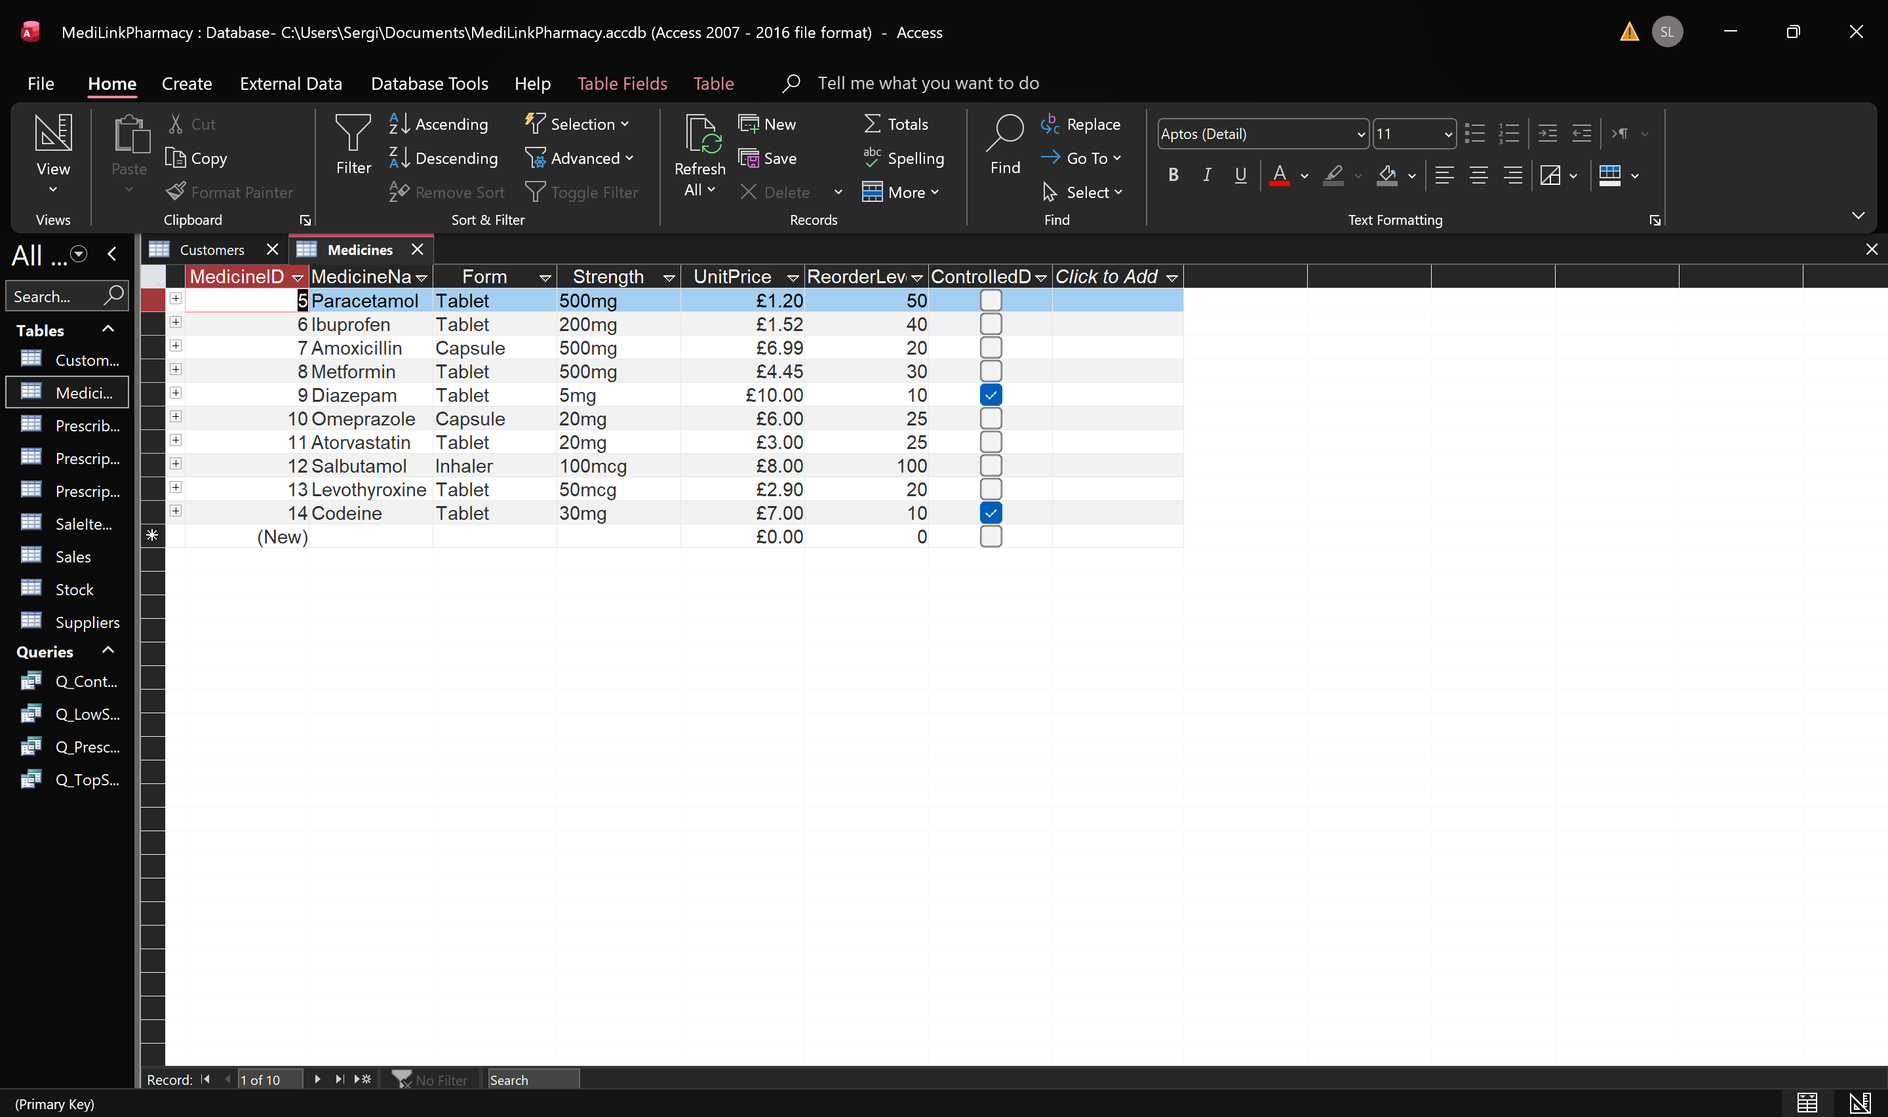
Figure 3: Medicines table with sample data
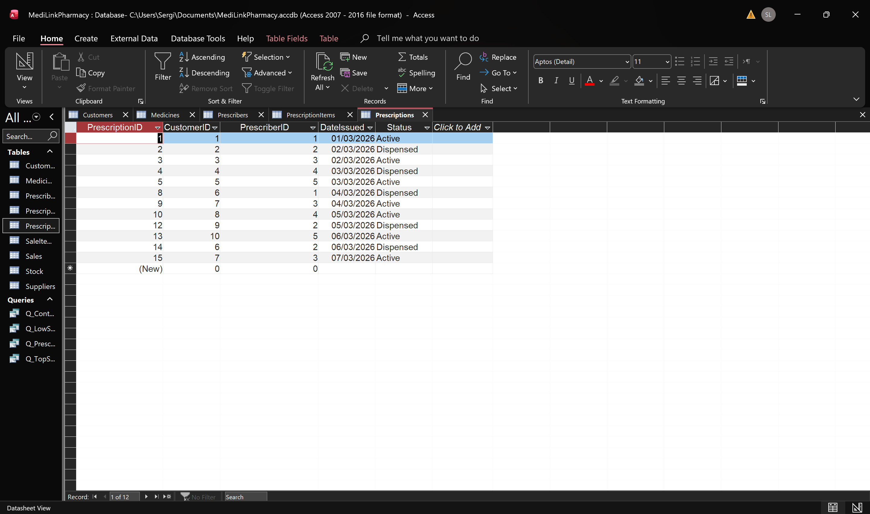
Figure 4: Prescriptions table with sample data
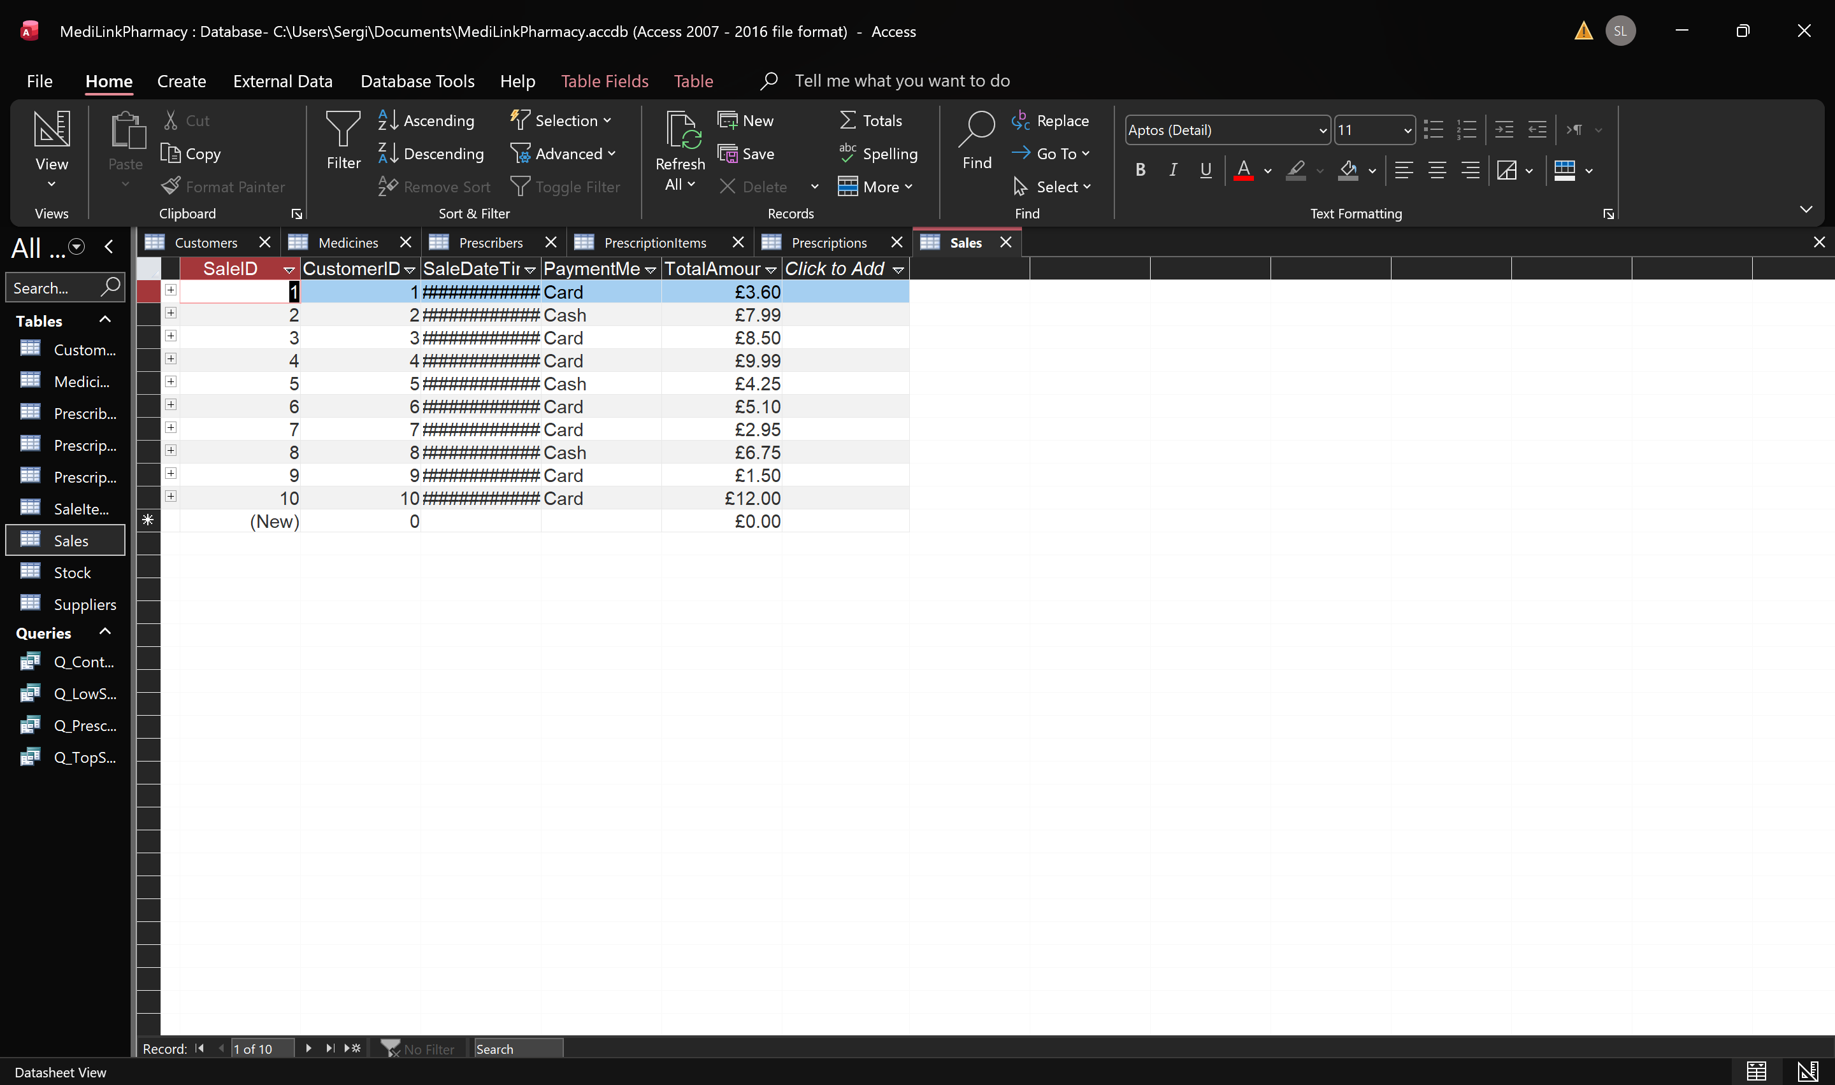
Figure 5: Sales table with sample data
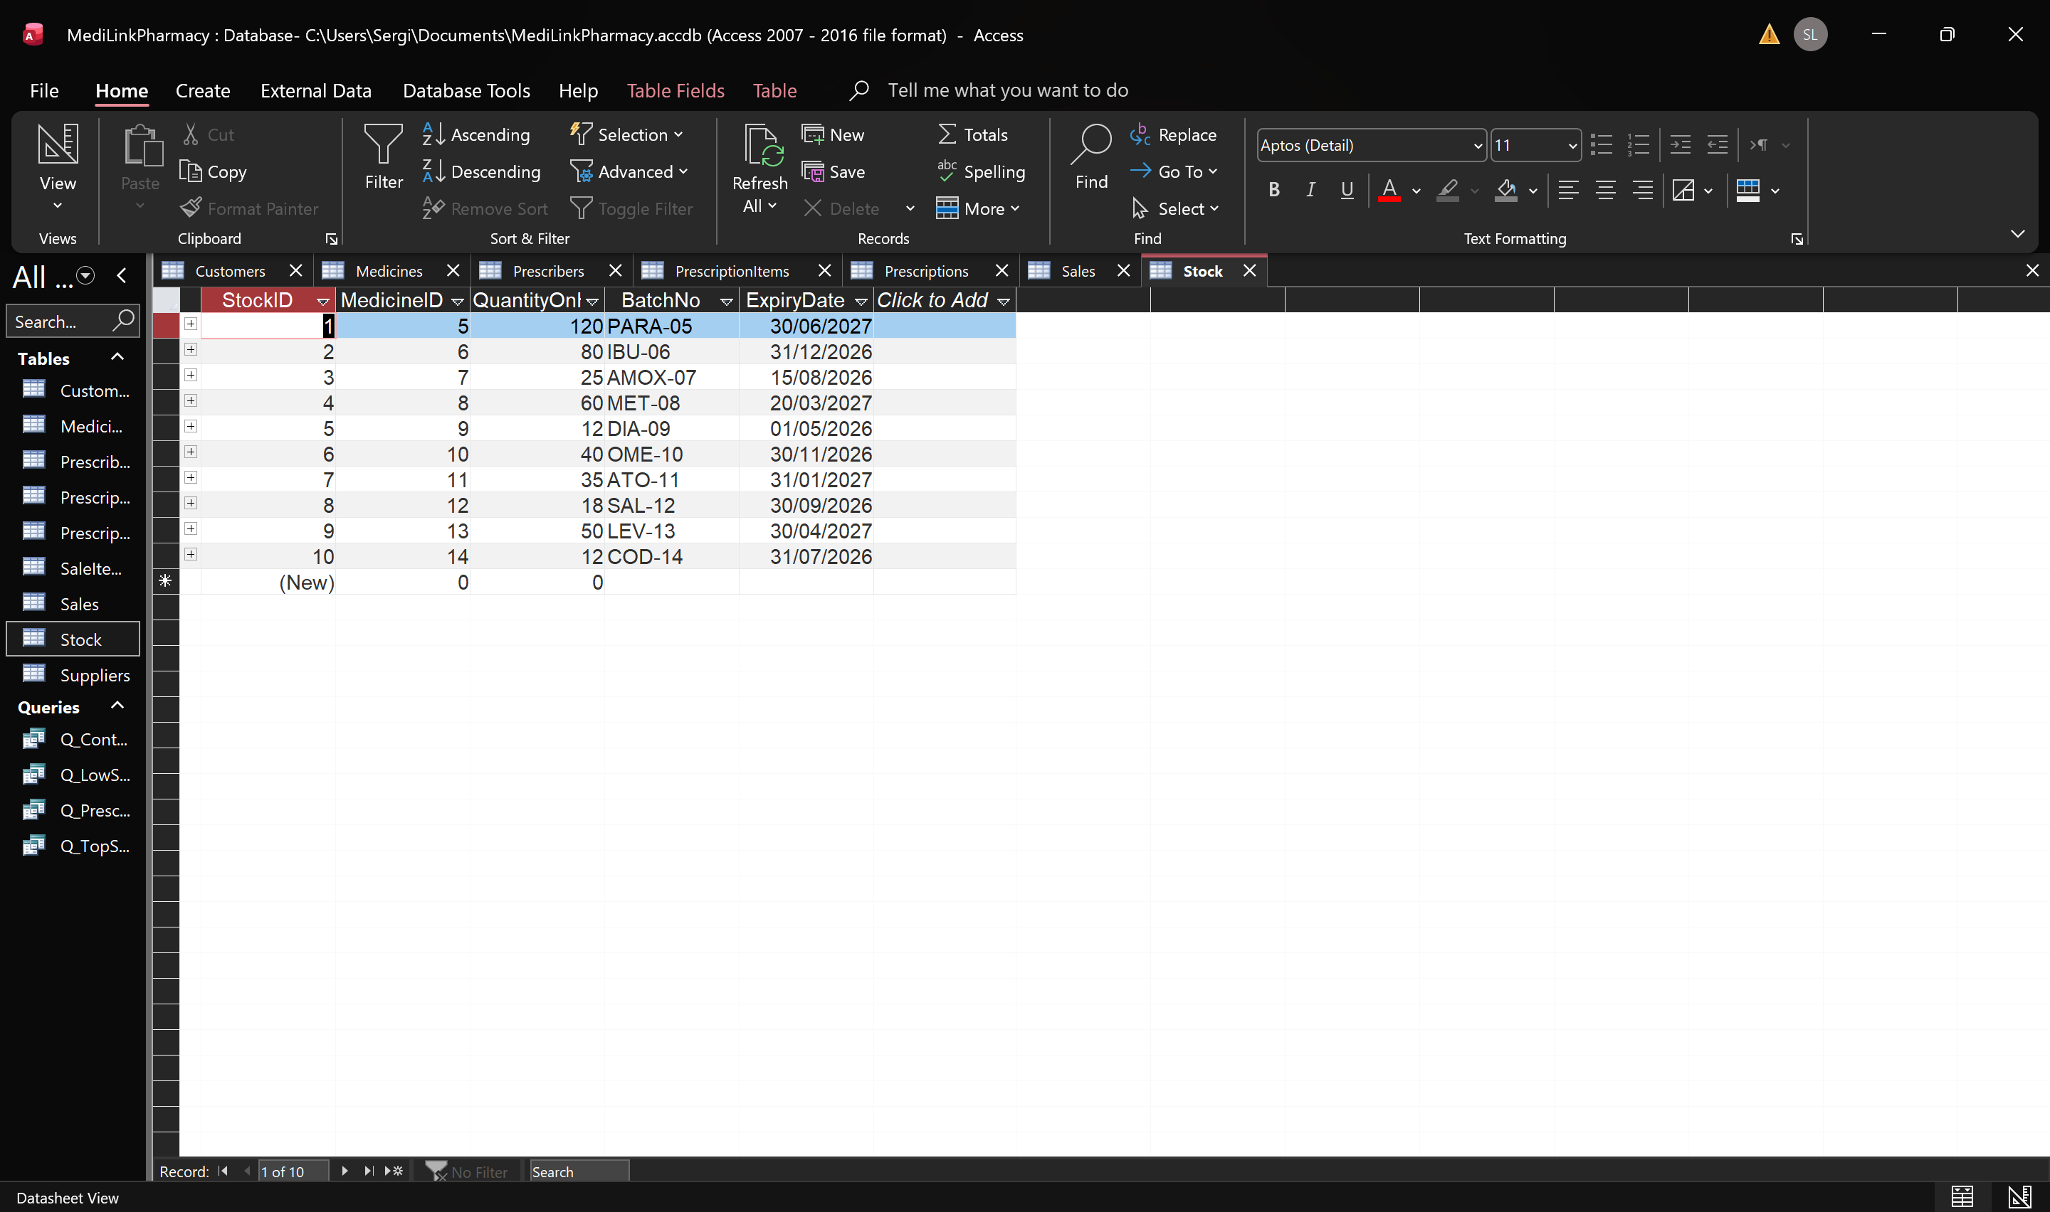
Figure 6; Stock table with sample data

Query Development
Queries were created in Microsoft Access to retrieve and analyse data stored in the MediLink Pharmacy database. These queries help support pharmacy operations such as identifying controlled medicines, monitoring stock levels, reviewing prescription details, and analysing medicine sales.
The following queries were developed as part of the database system.
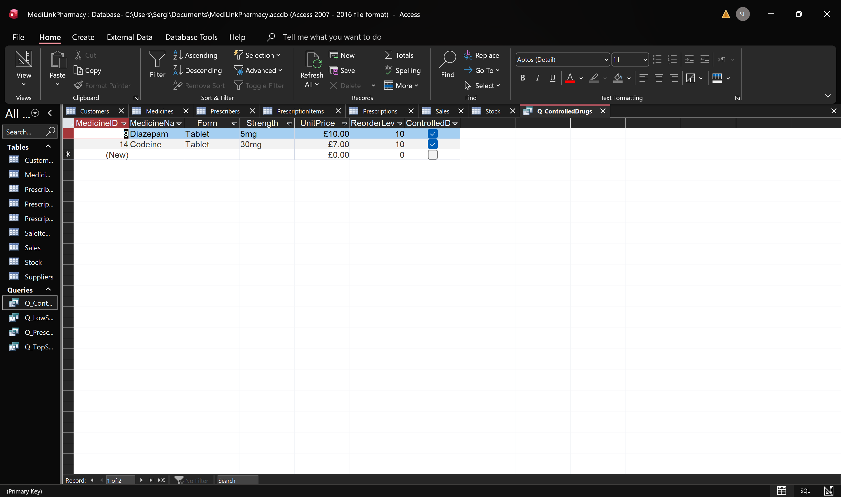Figure 7: Controlled Drugs query result
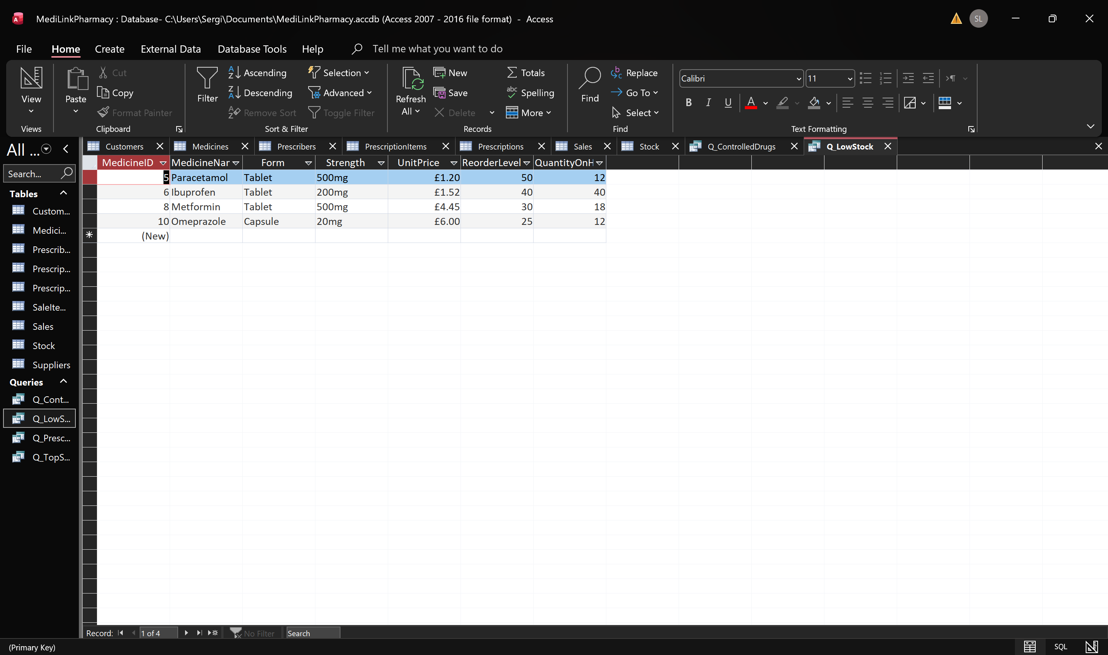Figure 8: Low Stock query showing medicines that need restocking
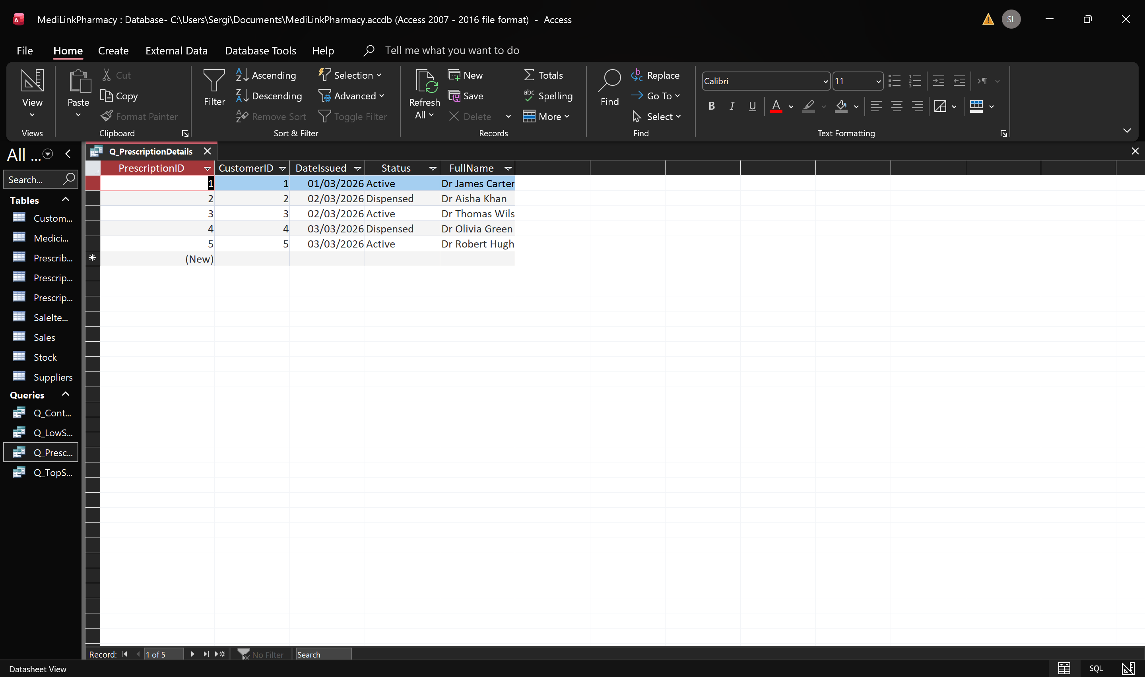Figure 9: Prescription Details query
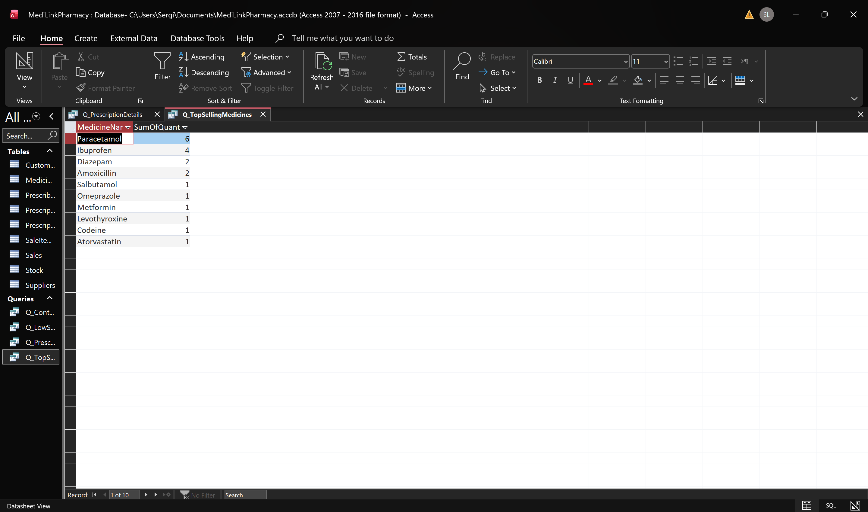Figure 10: Top Selling Medicines query

Testing and Validation
Testing and Checking We tested the MediLink Pharmacy database to make sure that all of its tables, relationships, and queries worked well. We put sample data into the database to make it look like a real pharmacy. Queries were run to make sure that the database returned the right information. We also reviewed the links between tables to make sure that data is linked correctly throughout the system. Testing a database is crucial to make sure that queries give the right results and that tables are linked appropriately.[3]

Design Decisions and Future Work
The designers had to make a lot of crucial choices to make sure the MediLink Pharmacy database is quick, dependable, and easy to keep up with. The main goal of the database design was to make a system that allows pharmacy staff keep track of client, prescription, pharmaceutical, and sales information in a way that is organised and consistent. One of the most important design choices was to split the data into several linked tables. Not all of the data in the database is in one table. Instead, it has separate tables for things like customers, prescribers, drugs, prescriptions, sales, and stock. This plan helps keep the database's information consistent and easy to change, and it cuts down on duplicate data. Using main and foreign keys was another crucial design choice. There is a primary key for each table that makes each record unique. For instance, MedicineID tells you what medicine is in the database, and CustomerID tells you who each client is. Foreign keys link tables and keep their connections going. This structure makes sure that the right information is linked together and that the data is correct. The database design also did a good job of handling many-to-many relationships. For example, a prescription can have more than one medicine, and a medicine can be in more than one prescription. A connecting table called PrescriptionItems was made to fix this problem. The SaleItems table employed a similar method for sales. You can keep track of all the information regarding the drugs that are sold or given out with these linked tables. Using normalisation methods, the data was set up in a way that made it easy to use and hard to copy. The database structure employs the first three normal forms (1NF, 2NF, and 3NF) to make sure that each table has the right attributes and that all of its columns depend on the main key. This makes the whole database system more stable and secure. The design also thought about how easy it would be to use. Because of how the database was set up, pharmacy workers can easily find critical information including client information, prescription records, and stock levels. People also asked queries to get useful information from the database, like information about drugs that are not allowed, low stock levels, and prescription records. When building the MediLink Pharmacy database, the goal was to create a system that would help a pharmacy run smoothly every day while also making sure that the data was correct, consistent, and efficient.
The current MediLink Pharmacy database contains everything it needs to handle pharmacy data, but there are a number of things that might be done in the future to make the system even better. Setting up automatic stock monitoring is one method to improve things. The device might automatically know when the amount of a given medicine falls below a certain level. When this happens, the database might send pharmacy personnel warnings or notifications to let them know that they need to order more drugs. This function would help make sure that important pharmaceuticals are constantly on hand. Adding features for managing suppliers would be another useful improvement. The database only has information about medications, prescriptions, and customers at the moment. It could potentially hold information about suppliers and orders in the future. This would make it easier for the pharmacy to maintain track of where they buy pharmaceuticals, when they are delivered, and their relationships with suppliers. A graphical user interface (GUI) could make the database better, at least in theory. A user-friendly interface would make it easy for pharmacy staff to use the database without having to go straight to the tables. You can design forms to keep track of purchases, register prescriptions, and enter customer information. There is a chance that security features will be better in future versions of the system. Access control strategies could be used to limit who can see or change private information. This would make sure that only authorised staff members can do so. This is especially important for pharmacy systems, where prescription information and medications that are illegal must be handled with care. Another thing that could happen in the future is that the database could be linked to other healthcare systems. For example, the system could be connected to electronic prescription services or hospital systems. This connection would let patients get their medicines online, which would cut down on paperwork and make things operate more smoothly. In conclusion, the current MediLink Pharmacy database is good for pharmacies, but these changes could make the system much more usable, practical, and effective in the future.
List of reference sources in IEEE format

[1] C. Coronel and S. Morris, Database Systems: Design, Implementation, and Management. Boston: Cengage Learning, 2023.

[2] T. Connolly and C. Begg, Database Systems: A Practical Approach to Design, Implementation, and Management. Harlow: Pearson, 2024.

[3] P. Rob and C. Coronel, Database Systems: Design, Implementation, and Management. Boston: Cengage Learning, 2025.‌

‌

