[2017-18
Marts(hons) Creative computer games design
Games Design and Asset creation – m5x02043
alex king
Research Undertaken
After coming back from the first years break the team met back up to talk about the future of the project and the state of the game as it stands. After receiving the feedback on the first years’ work and the overall standard the team looked over the work and decided on changing the demographic/style/ of the game as it lacked a unified style and the game idea wasn’t what the team wanted. The demographic was lowered to a younger age and the game was changed from a multiplayer arena game to a rogue-like shooter and instead of there being 15 characters they would only be one focusing on buckshot to give the player an attachment to that character instead of 15 boring characters with no personality or identity. This change was taken into consideration as last term one of the problems that was brought up was the characters lacked personality and originality the environment also received the same complaints so that also received a redesign.
Alex was tasked with creating the environment of the ship and the assets and also texturing everything e.g level environment /assets/character. The previously made ship designs and sketches where taken and redesigned with the new ideas and concepts the team discussed before redesigning so the simpler style and age rating/demographic was taken into consideration when research on games was undertaken. Research was based around games like borderlands and Splatoon for fun shooters and style but the research on games like doom and unreal tournament was still used from last term. Many topics where looked into such as star Trek /Disney and comic books to get a good range of ideas and a style that almost blends the three into one. The biggest change in the overall style/look of the game was the implementation of cell shading and new shading styles in the games assets and level design this was taken to the team and approved, and the other members also used that when creating their objects and characters to have a coherent overall style that the team lacked from last term (2).
This drastically cut down on the design process as cell shading is basically taken a simple object and drawing over it with dark lines to give the illusion of detail games. many games today use this style and even games as old as Konami’s The Simpsons Arcade Game (1991), Sega’s Castle Of Illusion Starring Mickey Mouse (1990), and Shiny Entertainment’s Earthworm Jim (1994), all used cell shading in there art style and this was the style that was taken forwards when designing the ship (1).
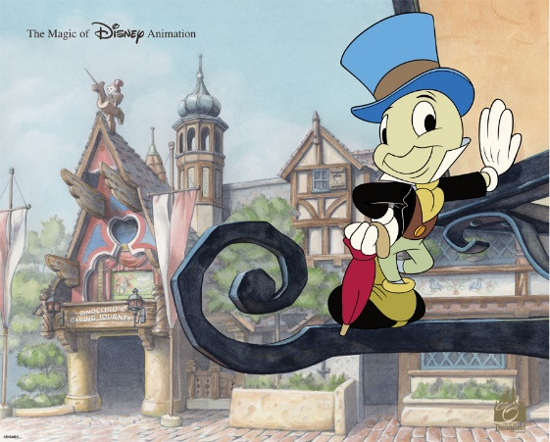
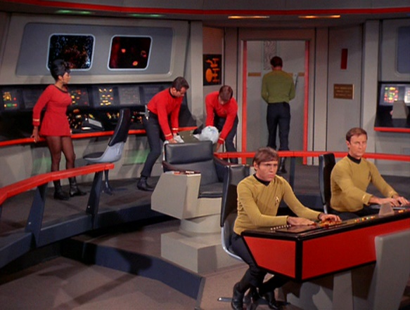

Star treck - Gene Roddenberry all rights reserved (3)
Disney land concept – walt Disney – all rights reserved (4)
Because of the use of cell shading in the environment and assets design Alex could take a sketch of an asset that was drawn up in the team meeting and create it in maya and texture it all in an hour or less and take it back to the team to present the complete asset. This ultimately worked out well for Alex as this simpler style and design process really made it faster and easier for him to see what assets and the environment would look like create them and present them to the rest of the team to look over and if they didn’t like it the asset could be changed very easily and quickly. From using this design process, it was much easier and faster than last term and the team worked far better as well this process of design can be applied in future projects if the need calls for.

Production planning
To make sure that the team wouldn’t fall into the same problems as last year the concept of a Gantt chart was brought up and one was produced for the team and showed each person’s job and the dates they needed to be done by and then each member went off and produced a solo version that only showed them what they needed to do. This really helped the team in the long run as each job was easily laid out to see what needed to be done and each week it could be updated with changes for each member to follow and by when unlike last year where people just did what they thought needed doing and some jobs where forgotten or missed. From seeing this form of organisation work well first hand gantt charts will be used in future projects as they helped the team a huge amount and provided each member a clear goal to follow.
Alongside the Gantt chart team meetings where also held each week ones or sometimes two times a week to talk about the progress of the work that each member had produced or did not produce and why. Each week any research done or new idea regarding the work would be brought up in the meeting for each member to talk about this structure really helped the team and put more focus on the end goal. Any problems in the workflow could also be brought up and others on the team could offer them help for example one-week Amber had been struggling with the characters fingers so she brought it up in the meeting and the team all offered her help to complete it. Last year the team never thought to hold meetings and each member struggled and did not talk about it therefore in future projects meetings will be mandatory.
The team used the website trello to store all their work and share ideas and concepts with each member getting a page to show their work and ideas that they had found or came up with. This website was very useful to the team as it was clear and helped each member get there point across and for example the person doing characters could show their research to the environment designer and they could collaborate and therefore have a much more unified style.

Individual contribution on the project

At the start of the project the team decided on who was best for each roll based on last terms performance and therefore Alex was put into the environment/asset design roll. At the start of the project all the sketches of the assets and the ship design was redesigned with the updated style that the team had asked for this was completed early in the first two weeks, so the rest of the team could see what the ship looked like as early as possible. Alongside this asset where slowly completed in order of importance for example the floor/walls where high priority so they were completed and textured first. As well as creating assets alex was tasked with texturing everything as well so the styles stayed consistent and unified this include the character, but time had run out before that could be completed. work on making the menu and HUD was also asked for with Owain implementing the finished outcome but time also ran out for that.
problems encountered
As the textures and assets needed to be completed to a different standard than last term each member had to practically reteach themselves the programs needed with Owain needing to understand game mechanics, Amber needing to learn z-brush again and alex and Felix needing to relearn maya as it had been upgraded to 2018 and the settings and the way you UV unwrap things had changed this lead to a small setback that really made more problems down the line. As Felix and Alex had to relearn Maya some problems plagued the game later with a big problem being Felix’s work on his gun as he just could not unwrap it leading to the team having no gun for coding and mechanics taking much longer as a response. This was saved by help from outside the team with tutors and other groups offering help to Uv unwrap it after a lot of trouble felix did get this done on time.
Alongside working with Felix on the assets and environment, models needed to be placed into the engine, when changes where needed, bottlenecks where caused as changes were backed into unfinished models causing stress. but this ended up working out in the long run as he could get rid of problems very quickly wand root out problems.
As the weeks went on the team encountered many problems that where not considered for example Alex oversaw the environment /asset design and therefore all of the work needed to be done by working alone and there where many problems and some of the assets where delayed many times and that hindered the rest of the teams work production pipeline. The gantt chart and team meetings really ended up saving the team towards the December deadline as with that the team could help each other back on track and offer any help that was needed to put the workflow back on track.
only one problem was encountered that was substantial and that was all the completed textures had some of the naming conventions mixed up and therefore where needed to be changed so unreal would not run into any problems. This was all changed before any real damage was done.

working dynamics of the production team

As the team needed to get stuff started very quickly this term we were given rolls to fill individual but there was room to collaborate for example in the team one role was to create the environment and assets, so they worked alongside Felix as he needed to structure the level layout. Amber also worked closely with the environmental side of the designing as the team needed the character to fit the ships environment talk about this work was brought up in every team meeting and in the team blog.

Possible future work
After the Christmas holidays the team will return and work on the level and character and make sure that at least the first level is complete and fully playable with a complete character. Therefore, during the holidays, the team will carry on working on making the less needed assets such as computers and wall signs and opening up some of the complete assets or ship environments to see if any changes or mistake are there that the team did not catch.
More research on pre-existing games and sci fi references can also be considered to see if there is anything else that can be include in the work for the second half of the term this will be communicated with the team to see if they are ok with the changes or not.
Ruff Sketches of the next levels and alternate levels such as boss levels or bonus stages will be sketched up to show the team, so they have a pre-existing image of what can be done when the team comes back from there holidays.
conclusion
The overall project went well this term and the team worked far better than last term. There was far more order this term than last term and the team could compensate for each member weaknesses as compared to last year when each member was new and learning the ropes. This year each member had a far better understanding of their strengths and weaknesses and where best they could be put to maximise their work output and who to ask if they encountered a problem. The introduction of the gantt chart and the team meetings also really help the team this year and offered a structure to follow that last term the team lacked. Each member also felt far more confident in their abilities and went off and just did the work instead of waiting around. Last year’s work was slow, and the product was rushed this term there’s far more understanding of how the pipeline works and deadlines work and therefore the work is of a far better quality and just overall a better structured outcome was produced. The project did not go perfect as well though as this term there was far more work to be produced and the team ran into problems that where faced last term again. Buckshot again has not been completed and this was down to the team not planning that far ahead and not adjusting the workflow to account for the problems faced. The problems that the team ran into will need to be looked at to make sure that they are not repeated in the next term this can be done by looking over the gantt charts and see where the problems laid.

In conclusion the project went far better than last term the team provided a far better outcome considering the state of the work from last term. But the project did not go perfect and there was still plenty of problems the team faced that will need to be addressed for the second half of the project when the holidays are over.

Bibliography/references

Websites
Jonathan Kinkley. (12/16/14 12:00am). The “flat” 3-D look: A brief history of cel shading in video games. Available: https://games.avclub.com/the-flat-3-d-look-a-brief-history-of-cel-shading-in-1798274914. Last accessed 18th oct. (1)
N.A. (2011). Shading - Creative Comic Art. Available: https://www.creativecomicart.com/about-us.html. Last accessed 16/10/2017. (2)
Images

star Trek - Paramount Television - Gene Roddenberry all rights reserved (3)
Disney land concept – walt Disney – all rights reserved (4)

