Introduction to Health and Social Care

LCHS4003

Portfolio

Student: Cristina Nicoleta Stoiculescu
Id number: 2519903
Module: Introduction to Health and Social Care
Module code: (LCHS4003_BIRM)

Lecturer: Vivian Osuchuk

Table of Contents
Task 1 Poster 4
Task 2 5
Introduction 5
Origins and Historical Development 5
Current Functioning of Community Mental Health Services 5
Significance in Enhancing Quality of Life 6
Conclusion 7
References 8

Task 1
Poster

Ambulance Services
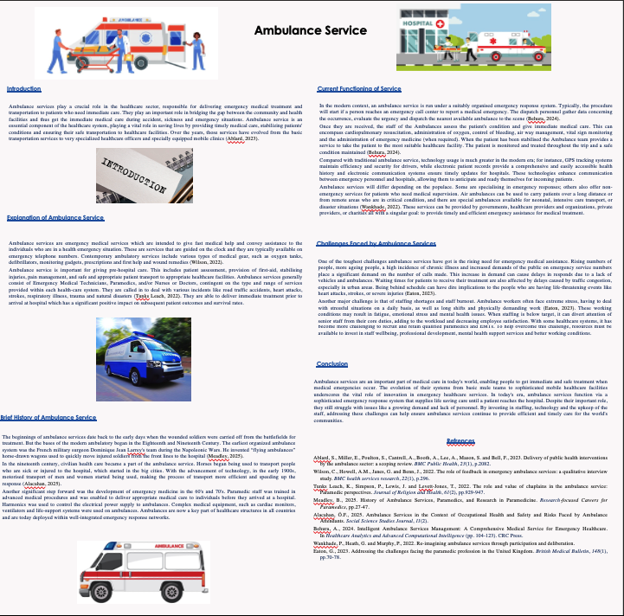

Task 2

Community Mental Health Services

Introduction

Community mental health services are a vital component of social care and provide individuals with mental health problems with facilities, services and help to continue to live in the community through which they were seen. These services are designed to support mental health, decrease social isolation and enhance life for individuals with mental health issues. The primary differences are that people are supported in their community and within their own familiar surroundings (community mental health services), compared with institutional care, which places people in locked facilities (Thornicroft, 2016).

Origins and Historical Development

The beginnings of community mental health services can be related to the changes of attitudes toward mental illness in the twentieth century. In the past, people living with mental illnesses would typically be put in a large psychiatric hospital or asylum and treatment would be mainly about containment in that hospital, and not necessarily engagement in care and recovery. In the 19th and early 20th centuries, these institutions were blamed for conditions that were appalling and were often crowded (Rosen, 2020).

After the Second World War the widespread progress of psychiatric medicines, psychology therapies, and social care practices facilitated a decrease in institutionalisations. Growing awareness by governments and health practitioners that many people could be cared for more effectively in the community. In the 1950s and 1960s, deinstitutionalisation took place in many countries and long-stay psychiatric hospitals were closed and services were increasingly provided to the community (Averill, 2023).

Awareness of human rights and social inclusion were also factors in the development of community mental health services. Policymakers wanted to enable individuals with mental health needs to live in their communities, enjoy their social relationships, and receive the help they need without having to physically leave their communities.

Current Functioning of Community Mental Health Services

The modern community mental health service (CMHS) is commonly staffed by a multidisciplinary team that offers a variety of services to those with mental health issues. Members of these teams can sometimes be psychiatrists, psychologists, social workers, community psychiatric nurses, occupational therapists and support workers. They're able to provide service users full services in one go, catered to their individual needs (Hawke, 2024).

Typical services are mental health evaluations, counselling, psychological therapy, medication management, crisis intervention, social support and rehabilitation programs. Individuals can seek help in the areas of employment, education, housing and daily living skills. Healthcare services, social care agencies, families and voluntary organisations all work in tandem with community mental health teams to provide effective coordination of support (Hawke, 2024).

There is a range of strengths and limitations demonstrated within existing community mental health services identified through a critical evaluation of these services. An important advantage is that people can be treated without being isolated from their family, friends and community.

However, challenges remain. Enhanced mental health awareness together with high numbers of people needing mental health support, are placing greater demand on many services. Shortages in funding, staff and waiting times can impact on the quality and accessibility of services. People might find it difficult to gain access to specialist care or be able to access timely interventions when mental health crises strike in some locations (Pasquarella, 2022).

Significance in Enhancing Quality of Life

A key role of community mental health services is to enhance service users' quality of life. These services offer immediate assistance in the community, and offer the individual the opportunity to learn how to cope with the symptoms and to become as independent as possible. Service users are sometimes given a strong voice to their service and treatment and their regained ability to help to affect their own recovery can raise their own confidence and self-esteem (Kapur, 2024).

The services also are an element for social inclusion that are able to support people in keeping their connections, functioning in education or on the labor market and/or community activities. This helps to decrease feeling of isolation and build the feeling of belonging (Kapur, 2024).

In addition, services can help families and carers/guardians by offering guidance, education and practical help from community mental health services. This not only improves for the service users themselves, but also enhances the wider support base that exists for them.

Conclusion
The current model of community mental health services offers a shift from previous approaches of institutional care to a community-based approach with a focus on supporting recovery, social inclusion and community-based support. They were influenced by changing attitudes towards mental illness, the growth of effective treatment and the growing recognition of human rights. Modern services appear to have many advantages, such as better access to support and increased independence for individuals; however, funding constraints and staff shortages remain issues that impact services. Although these challenges are present, community mental health services are crucial in supporting the mental health and wellbeing of people with mental health issues, their social inclusion and quality of life.

References
Averill, P., Vincent, C., Reen, G., Henderson, C. and Sevdalis, N., 2023. Conceptual and practical challenges associated with understanding patient safety within community‐based mental health services. Health Expectations, 26(1), pp.51-63.
Hawke, L.D., Sheikhan, N.Y., Bastidas-Bilbao, H. and Rodak, T., 2024. Experience-based co-design of mental health services and interventions: a scoping review. SSM-Mental Health, 5, p.100309.
Kapur, D.R., 2024. Understanding Significance of Education: Essential in Promoting Enhancement of Living Conditions. Indian Journal of Management and Language. https://doi. org/10.54105/ijml. a2066, 3021023.
Pasquarella, F.J., Lizano, E.L., Lee, S. and De La Peza, D., 2022. An examination of work engagement's antecedents and consequences in a sample of US community mental health providers. Health & social care in the community, 30(5), pp.e2318-e2329.
Rosen, A., Gill, N.S. and Salvador-Carulla, L., 2020. The future of community psychiatry and community mental health services. Current opinion in psychiatry, 33(4), pp.375-390.
Thornicroft, G., Deb, T. and Henderson, C., 2016. Community mental health care worldwide: current status and further developments. World Psychiatry, 15(3), pp.276-286.

