Richard Jones - 1809132
rojones@gmail.com & 1809132@student.uwtsd.ac.uk
Computer Networks and cyber security
ACCB6000 – Nitheesh Murugan Kaliyamurthy

Abstract
The Author was tasked with conducting two tasks within the following paper. Task one which was broke down in to two sections included, section one detailed research in to types of cyber-attacks methods. How they are implemented and their outcomes, along with a detailed research in to two recent cyber-attacks (Marriot Data Breach 2018 & Wannacry 2017). Section two of part one then detailed two methods of gaining information and access which is used in cyber-attacks. The two methods used were Nessus Vulnerability Assessment Tool and the Social Engineering Toolkit also known as SET. Task two contained a synthesized solution to a real life scenario, The scenario was to improve the security of the Che-Si Construction companies network infrastructure. The Author researched, implemented and documented a number of security improvements including but not limited to ACL, Firewalls, VPN Access and AAA Access methods.

Table of Contents
Abstract 1
Table of Contents 2
Introduction 1
1. Part 1 – Research 2
1.1 Task A – Research 2 recent Cyber Attacks. 4
1.1.1 Cyber Attack 1 – Marriot / Starwood Group Breach – September 2018 4
1.1.1.1 – What is the motive 4
1.1.1.2 – What method implemented 5
1.1.1.3 – What is the weak point of the victim 5
1.1.2 Cyber Attack 2 – WannaCry – May 2017 6
1.1.2.1 – What is the motive 6
1.1.2.2 – What method implemented 6
1.1.2.3 – What is the weak point of the victim 7
1.2 Task B – Analyse and Document 2 information & gaining access methods. 7
1.2.1 Method 1 – Nessus Vulnerability Assessment (Lab 6). 7
1.2.1.1 Nessus Example 8
1.2.2 Method 2 – Social Engineering Toolkit (Lab 4) Phishing 13
1.2.2.1 SET Example 13
2. Part 2 – Synthesize a Solution to a Real Life Scenario. Design and Implement Security Measures. 18
2.1 Current Setup Overview Example (Cisco Packet Tracer) 18
2.1.1 Server/ Infrastructure Area (Blue) (Fig 17). 18
2.1.2 Local Staff Office (Yellow) (Fig 17). 19
2.1.3 Remote Client and/or Remote Staff Office (Orange) (Fig 17). 19
2.1.4 Remote Worker (Red) (Fig 17). 19
2.2 Proposed Network Improvements 19
2.2.1 Access Control List. 19
2.2.2 Personal Endpoint Firewalls 21
2.2.3 AAA Radius Implementation. 23
2.2.4 VPN Access Implementation. 23
2.2.5 On Site Physical Security Measures. 24
2.3 Additional Security Counter Measures 25
2.4 Summarise the Network Benefits Suggested vs. Existing Setup. 26
3. References 27

Introduction
In the following document the author was tasked with carrying out two tasks. The tasks included Part 1 which will research a number of cyber-attacks methods and provide a brief background in to the history of cyber-attacks. Following on from the research in to the types of cyber-attacks and their history, the author will then look to research and document two examples of recent cyber-attacks.
The two cyber-attacks the author chose were the Marriot 2018 data breach and the Wannacry 2017 attack. In these two examples the author will look to break down the analysis of the attack in to three sections, the Motive, the Method and then the analysis of the weak point of the victim(s) that allowed the successful attack
The Author then concludes task one by researching and documenting two examples of tools or processes used to gain information and/or access to systems that are utilised by attackers and by security staff in detecting weak points in their systems to prevent attacks.
The first of the two methods selected was the Nessus Vulnerability Assessment Tool, which allows either attackers or security staff to scan for weaknesses in the targeted systems and then utilise the garnered information to either assist in an attack or aid in patching and preventing attacks weaknesses. The second of the two methods selected was the Social Engineering Toolkit also known as SET. This tool is a suite of attack vectors and methods that can be used by security professionals to demonstrate the methods utilised in many cyber security attacks for research purposes. It can be used by attackers who wish to learn and utilise methods of gaining access and information as part of a cyber-attack.
The author then moved on to the second task Part 2. Part two contained a real life scenario of a construction company called Che-Si. This construction company’s current setup was detailed, explaining the current security stance and current methods of working and how the company wanted to operate moving forward. From this information the author was tasked with documenting and analysing the current setup and providing improved security implementation to aid with security officer in improving the current setup and aiding in the prevention of possible cyber-attacks aimed at Che-Si in the future.

Part 1 – Research
In part one, the author has been tasked with researching two recent cyber-attacks. Whilst researching the attacks the author will outline the overall attack, whilst also breaking down the attack in to three key areas. These area’s will include the “Motive” behind the attack, how the attack was “Implemented” along with surmising the “Weak point” of the victim(s) of the attack to understand how it was carried out, and what could be done in the future to prevent or minimise the damage of such an attack.
The definition of the phrase “Cyber Attack” can be surmised as utilising or attacking from one or more digital devices such as but not limited to personal computers, laptops and phones etc. to another digital device or devices. This can be on single networks or across multiple networks. As part of these attacks there can also be non-technology elements to either aid or carry out the entire attack such as “Vishing”.
According to reports Cyber Crime cost the world economy $11.5 billion dollars in 2019[1]. It is estimated that by 2021 there will be a Ransomware attack on businesses across the world every 11 seconds, this has risen from around every 40 seconds in 2016[2]. With the ever increasing amount of business and consumer devices connected to the internet, estimated to be three times more than the human population of the earth. This would mean there will be estimated to be 21 trillion devices connected to the internet by 2023[3]. The increase in this estate means there are even more devices/systems and access mediums/devices that can be targeted and penetrated unless secured correctly will open the attack surface for cyber-crime even further in the coming years.
Broadly speaking there are multiple categories of Cyber Attacks. They include but are not limited to the following:
- Malware
Malware is a shortened abbreviation for “malicious software”. The term Malware refers to the many types of software that are utilised in these types of attacks, regardless of how they are structured, or how they are deployed to carry out their designed task. Their main aim is to essential penetrate computers and networks and either render the device inoperable or limit their functionality. They are also used to potentially gain a higher administrative level of access to the remote system. The verities of malware are often classed as Worms, Viruses, Trojans [4]and these terms are often labelled to classify how the malware replicates, spreads and penetrates the end user devices.

- Ransomware
Ransomware is another word for a form of malware, but Ransomware has a specific goal in mind. As eluded to in the name itself, Ransomware’s end goal is to hold the end users or owners of the penetrated device to ransom by encrypting the file system and demanding payment[5] often in form of crypto currency such as bitcoin (due to the ability to avoid tracing), to acquire a decryption key to recover the encrypted data. This has become a very common activity by criminal organisations for profiteering. It is estimated Ransomware cost the US more than $7.5 billion in 2019[6] for example.

- DOS (Denial of Service)
A Denial of service attack is a method in which traditionally a brute force attack is carried out on the target to prevent the target system from functioning correctly. A basic example of this is when an attacker targets a website with an overwhelming amount of traffic[7] in the aim of flooding it with so many requests that the system crashes and become inoperable. This has then expanded to what is more commonly known as DDOS or Distributed Denial of Service attack. DDOS is an attack that utilizes many devices to carry out an attack at the same time[8], this is usually achieved through malware penetrating and infection other devices.

- Man in the middle
A man in the middle attack can come in many forms, but it is essentially when an attacker manages to impose themselves or their systems in between two users and/or systems and sniff (collect) the data between them[9]. Once the data has been collected it can then be analysed or attempted to be decrypted to gain/collect sensitive data such as but not limited to usernames, passwords and end user device information. This data can then be utilised in further attacks to gain greater access for example.

- Crypto jacking
Cryptojacking is a more recent form of attack that targets end devices such as user desktops or servers, the aim of which is to hijack and utilise the victims computing resources to harvest crypto currency for the attackers[10]. With the recent rises of crypto currency value it has become a rising form of cyber-attack, but has declined in the last few years due to more profitable forms of attack. It has been reported that in 2019 the cryptomining attacks account for around 7% of all attacks[11].

- SQL Injection
SQL injection attacks have been around for a number of decades, believed to be going back to around 1998 when they first started to appear[12]. SQL Injections are a means of written SQL code in web forms or queries for example exploiting the vulnerabilities of the targets database if not programmed correctly to avoid such vulnerabilities. All types of information held on vulnerable databases can then be recovered through this process, such as but not limited to usernames, passwords or even private data held on customers for example such as addresses or contact numbers.

- Zero-day exploits
Zero-day exploits are vulnerabilities in software that have yet to be patched or remediated. These software vulnerabilities can be in any type of software including the underlying operating systems themselves[13]. It is key that regular and up to date patching processes are put in place on system to reduce the vulnerability of end devices to such exploits and attacks. It is also believed that government agencies at times discover these vulnerabilities and utilise them for their own hacking purposes[14]. There have been a number of examples were this has been the case rather than the vulnerability being released to then be patched.

1.1 Task A – Research 2 recent Cyber Attacks.
As already eluded to Cyber-crime is fast becoming bigger business for the criminal. Element in society as each year passes, and as more and more of the day to day consumer and business driven elements rely on networks and the wider internet connectivity. A number of recent examples include[15]:
- Twitter: Twitter accounts/handles being compromised and fraudulent tweets being sent out around crypto-currency[16].
- Zoom: With the rapid deployment and uptake is usage of video conference apps such as Zoom, in 2020 Zoom had a breach of 500,000 user accounts[17] that had emerged for sale on the dark web forums
- Greek Banking System: Following a breach on a Greek travel website. Four of the country’s main banks had to cancel and replace 15,000 customer credit and or debit cards to prevent further fraudulent activity[18].
- Magellan Health: a Social engineering phishing attack, in which the attackers had obtained employee credentials to access secured systems. This then led to a large amount of patient & staff data being compromised[19]. This included health insurance details, contact numbers and social security numbers of those affected.

The author will now provide two examples of recent cyber-attacks and provide a brief overview of the attack, along with the motive, method and the weak point that led to the attack being successful. The two examples are the Marriot /Starwood Group breach discovered in September 2018 and the Wannacry attack in May 2017.

Cyber Attack 1 – Marriot / Starwood Group Breach – September 2018

On September the 8th 2018, an internal security software tool utilised within the Marriott/Starwood group had flagged suspicious activity in regards to attempting to access the group’s databases for guest reservation details. It is believed through future investigations that the attackers had attempted (and believed to be successfully) capture and encrypt data that would then be removed from the Marriot/Starwood group legacy system. In the future investigation it is believed 500 Million guest records where breached[20]. Data including but not limited to Card Details, passport numbers and other sensitive data had been captured.

1.1.1.1 – What is the motive
The motive for the attack to this day contains some uncertainty. Originally it was believed that the attack was a part of a consumer data attack, with the aim of collating and future sale of such data on the dark web by cybercriminal elements, aiming to simply profit from the attack. But as time progressed and further investigations were carried out, it is believed that the attack was carried out by a state sponsored entity from China as being involved.
It was revealed later, when the U.S. Intelligence services were involved in the investigation[20], which first hinted that the involvement of state sponsored hackers could have been involved. Evidence such as the revealing that cloud hosting space frequently used by Chinese hackers had been used, along with the lack of the compromised data being released on the dark web for example, for profiting from the sale of was another factor that led to the fact that this was unlikely a typical consumer data cybercrime.
It is believed that the main motive for the attack was to gain highly sensitive personal information on American government employees and intelligence officers. As the Marriot hotel group is the top level provider of accommodation for the US government and military services. It is believed that passport data for example could be utilised in the aid of tracking government and military official’s movements around the globe by the Chinese government[21].

1.1.1.2 – What method implemented
The method in which the attackers are believed to have implemented the breach on the Marriot/Starwood database systems, is when a security tool which was ran by a company called Accenture, had flagged an unusual database query. Accenture where original running the IT and Security infrastructure services for Starwood before the merger with Marriot. They had continued to do so on the legacy systems moving forward.
Once the query was flagged, it was quickly identified that the account was an administrative account belong to someone within the organisation. Despite this it was then confirmed that it was not that person who actually carried out the query. The account had been identified to be compromised, and was therefore being used by an external entity to carry out the query and continue the breach. In the continuing investigation it was discovered that a Remote Access Trojan (RAT) along with a tool named MimiKatz was utilised[22]. The combination of these tools allowed for the attacker to sniff out username and passwords in the system memory of systems within the Marriot/Starwood infrastructure. How the original Remote Access Trojan was placed on the system was never identified, but it is believed to be common practise that through penetration methods such as phishing emails is when such software can be delivered.

1.1.1.3 – What is the weak point of the victim
While the breach of the data concerned was not identified until September 2018. It is believed that the original breach occurred in 2014[23], Starwood at the time before the merger with Marriot had identified to have a poor security culture and protocol in place and once acquired by the Marriot group, the systems in place by the Marriott were not ready to take on board a vast amount of new bookings. So the legacy Starwood booking system continued to be operated and utilised up to the identified attack in 2018. It is surmised that the original infection in 2014 continued undetected or unresolved allowing for the continuation of data to be harvested and breached by the attacking entity. A combination of poor due diligence at the time of Marriott’s acquisition of Starwood and its systems, along with poor security controls in place with the ongoing legacy system previous to its acquisition led to an undetected breach for many years. The Marriot Group also failed to disclose the breach a further 2 months from its discovery which in turn breached the SECs timeframes for reporting such activity. It is currently estimated that the breach had cost the company $350 million dollars[24], but estimates do vary. This includes fines from various countries regulatory bodies and items such as remediation work and insurance costs.

1.1.2 Cyber Attack 2 – WannaCry – May 2017

On May the 12th 2017 numerous security software companies such as but not limited to Symantec noticed a high increase in the underlying exploit attempts and being blocked by its systems. The vulnerability quickly continued to be exploited over a number of days and weeks and spread all across the world to many business and home devices throughout the world. Its aim was to encrypt data and hold its victims at ransom, requiring the victim to pay a fee of around $300 in crypto currency (Bitcoin) for a decryption code. It is believed over 200,000 devices were affected across more than 150 countries worldwide[25]. One of the more well-known victims included the NHS (National Health Service) in the United Kingdom.

1.1.2.1 – What is the motive
The motive behind the WannaCry attack is not 100% clear. The first and obvious motive from the WannaCry attack is one of financial gain as is often the case with all Ransomware attacks. In October 2017 following the attack it has been reported that £108,000 in bitcoin payments had been removed from the bitcoin digital wallets. These withdrawals were carried out in a number of smaller batches between July and August 2017[26].
Continuing from the original attack and subsequent investigations, it is believed by many countries including but not limited to the US, Canada, New Zealand and the UK, that the attack was carried out by North Korean Lazarus group who have been linked to state sponsored hacking by the North Korean government[27]. And in turn the subsequent investigations have led to the belief that the attacks were not only centred solely around monetary gain, but also a politically driven attack to cause mass disruption, and crippling of technology infrastructure across the world.
In turn costing those countries and business affected large amounts of financial loss in business disruption and remediation. The NHS in the United Kingdom have estimated the cost as much as £92 million as a result of downtime to access of information and systems[28], which resulted in cancelled appointments and also additional IT support and resources that were required to resolve and aid prevent future breaches.

1.1.2.2 – What method implemented
The WannaCry Ransomware consists of multiple components. First component to discuss is the dropper. The Dropper is a self-contained program that extracts the other components embedded within itself. The other components that are embedded are the application that encrypts and decrypts the data, the files that contain the encryption keys and a copy of Tor (service used for command and control via the Tor network).
The Malware itself utilises an exploit within the SMB (Server Message Block) protocol within windows systems. It uses this to help communicate with other nodes/devices on the network and aid in the spread of the malicious program. It is believed the vulnerability was discovered previously by the US National Security Agency[29]. And rather than report the exploit to the InfoSec community, the NSA developed code to exploit it for its own uses. The exploit/code was named “Eternal Blue” and as some point was stolen by a hacking group known as the “Shadow Brokers” who then released it to the wider hacking community.
Once on a device it first looks to a so called kill-switch URL. This URL is hard coded in the malware and if the URL could not be contacted (which at the time the URL was not registered and not contactable on the internet) it would then proceed to search and encrypt files on the victims device(s). The file types targeted are vast and range from Office .doc, .docx, .xlsx files for example, right through to media files types such as .mkv or .mp3.once this is then completed the ransom notice is then ran and prompted to the end user. This ransom would demand the $300 in bitcoin payments for the decryption key.

1.1.2.3 – What is the weak point of the victim
A month before the original spike and spread in Wannacry cases. Microsoft themselves had been aware and released a patch to prevent the vulnerability from being actioned. This was on the 8th of April 2017. But what was a weakness in the numerous victims and industry in general was the lack of timely patching regimes in place. Those that had the patching in place wouldn’t not have been affected by the Ransomware. Many businesses and individuals did not have a robust patching process, this left them vulnerable to the exploit, in turn this event in many countries across the world led to businesses especially becoming more aware of their shortcomings in their patching/security processes. What also helped in the minimising of the fallout of the Ransomware was a discovery and quick action by a British security researcher Marcus Hutchins. Mr Hutchins had discovered that the Wannacry Ransomware was trying to contact the so called kill switch URL and in turn paid for and registered the URL/Domain[30]. This in turn meant that malwares affects from this point onwards had been blunted if the continuing infected devices were able to gain internet access and contact the URL that had been now created.

Task B – Analyse and Document 2 information & gaining access methods.
The author will look to Analyse and Document the background information and processes, in relation to two methods in gaining information and gaining access. The two methods chosen to be analysed and discussed are the Nessus Vulnerability Assessment Tool and the Social Engineering Toolkit (SET). After analysing and documenting the processes involved in utilising the tools, the author will reflect on the potential targets security posture and what could be done to minimise or prevent such an attack in the future.

Method 1 – Nessus Vulnerability Assessment (Lab 6).
The Nessus Vulnerability Assessment Tool is a remote security scanning tool[31], it is called a remote scanner because the product does not need to be installed on the target devices to operate its scanning abilities. The function of the vulnerability scanner is to scan selected endpoint devices and retrieve a list of vulnerabilities that may be utilised by attackers. Nessus can be utilised by both sides of an attack, for example a potential hacker could utilise it on target devices to see what potential weaknesses can be exploited as part of an attack. Alternatively a system administrator can use it to check for vulnerabilities on their systems and look to put systems/processes in place to prevent attacks.
Nessus is not an overall security solution for administrators[32], or attacking package for hackers. Instead Nessus is a cog in the process of both actions. For example Nessus does not proactively look to prevent attacks in regards to a system administrator role looking to secure their systems, likewise from a hacker’s perspective Nessus would not carry out an attack from beginning to end. In both instances it is up to the system administrator to utilise the information provided from Nessus to look at patching potential weaknesses with other software/solutions once identified, And Hackers would then look to utilise other tools to target the specific weakness identified via Nessus.

Nessus Example
Nessus look to scan ports and their services on end devices. For example each end user device (Computer) or system device (Server) Utilises many ports to allow various services/software to operate and function without interfering with other services/software that also runs on the device. An example of this could be but not limited to a Server that might be being used for multiple services, the services could be a Web Server as well as an FTP Server. To prevent these services from interfering with each other they run on different ports.
Nessus Scans the ports and services and tests each port available to see if there is a service running to start with, then checks the port(s) / service(s) to see if there is a vulnerability within the port/service.
Nessus can be installed on both Linux and Windows operating systems. And once installed you are presented with a console via the web browser (Fig 1).
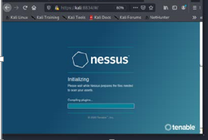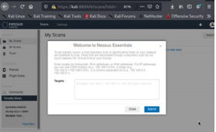
Figure 1. Nessus Login Screen. Figure 2. Nessus Post Login Screen.
Once you have logged in to the console, you are then presented with a menu (Fig 2). In this menu are a number of options in relation to Carrying out Scans. These are split in to many scan templates (Fig3). Each of these templates simply simplify the options/settings that are configurable by the user whilst explaining them before the scan is then ran.
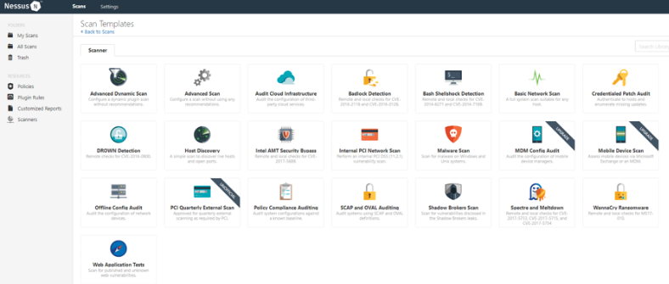
Figure 3. Nessus Console Templates example.
A Basic network scan has been selected as shown (Fig 4). A GUI driven wizard is then presented for the user to follow, information such as a descriptive name for the scan for reference along with any other descriptions that may want to be added is presented (Fig 5). The target is identified by entering the IP address for example or you are able to upload a pre-configured larger list of targets.
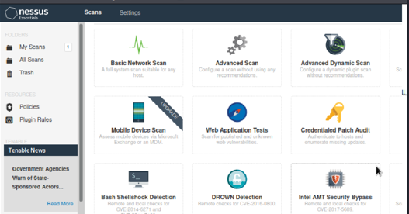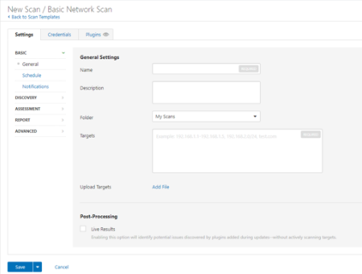
Figure 4. Nessus Console GUI interface options.
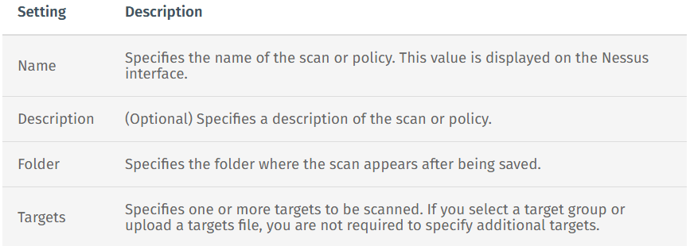
Figure 5. Nessus Console Descriptions.
Once the information has been populated the Scan can then be set to run. The Nessus tool will then as already described look on all available ports/services to check for running services/software and detect vulnerabilities that may be present (Fig 6). Depending on the targeted device and what services it is configured to run this can take a varying amount of time.
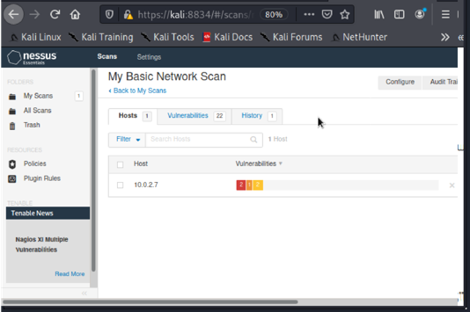
Figure 6. Nessus Console Scan Template.
Once completed the Nessus tool will display a console report (Fig 7) detailing various aspects. These include any detected vulnerabilities or issues within services. For example including but not limited to SSL, HTTP, SSH and TLS Issues, again depending on the endpoint device that is targeted and what its role is.
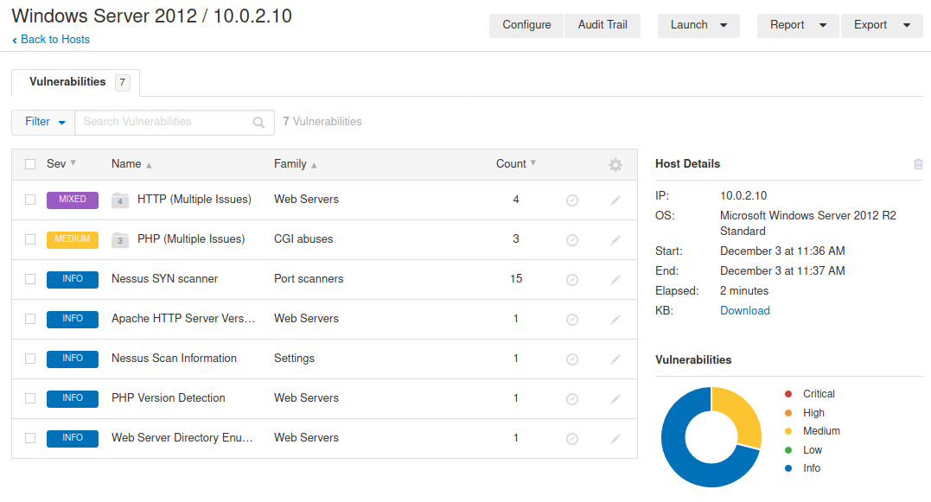
Figure 7. Nessus Console Endpoint Scan Results example.
If we look at some of the Vulnerabilities highlighted in the results we can see that the Nessus Tool has highlight multiple vulnerabilities around HTTP and PHP services on the endpoint (Fig 7). You are able to click on the specific category and dig deeper to look specifically at what vulnerabilities are being listed.
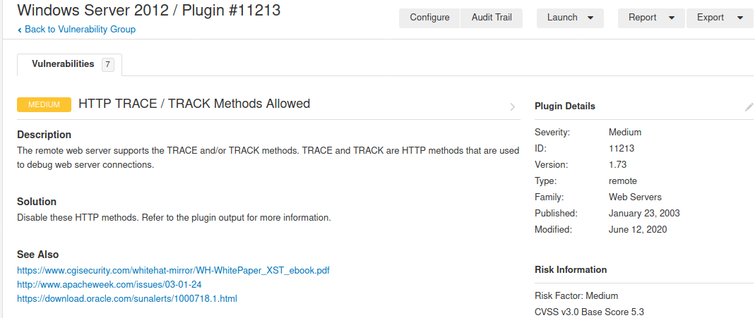
Figure 8. Nessus Console HTTP Trace/Track Vulnerability Example.
An example of one of the HTTP issues highlighted is the Trace/Track method being allowed (Fig 8). In this example the server has been configured to allow the TRACE and TRACK methods most likely for debugging ability on the web server connections. But this function being enable potentially on a permanent basis allows hackers to abuse the functionality. An example of this is that an attacker could craft a page on the site which would return the visitors authentication cookies to the attacker. This would mean an attacker could gain login details from an unsuspecting user of a web site for example.

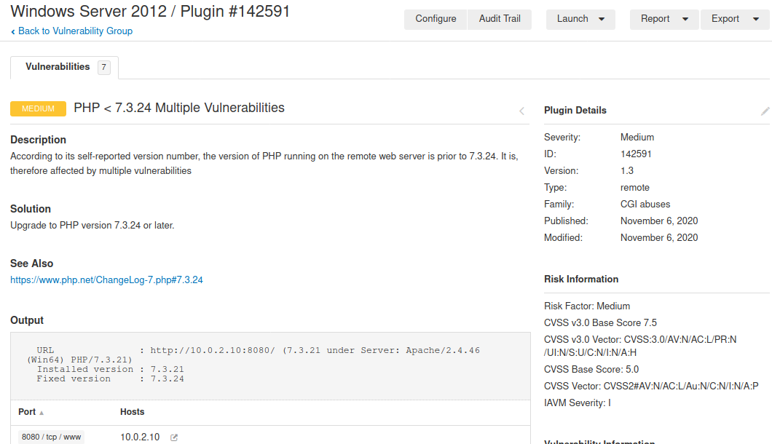
Figure 9. Nessus Console PHP Vulnerability Output Example.
The example (Fig 9) is one of the PHP Vulnerabilities listed by the Nessus tool. In this instance the Nessus tool has identified that the version number of the PHP product in use is a specific version (7.3.24) [33]and is therefore not up to date. This means that there will be multiple vulnerabilities which the software owner may have patched in a newer version that are still open and vulnerable to attacks on this particular device. Nessus provides links where applicable to the change log in this example (Fig 10). From the change log the system administrator could look to see what is vulnerable and patch if deemed necessary or the hacker can then research the known vulnerabilities within the software version and again look to see if they can use these in aid of a future attack on the service.
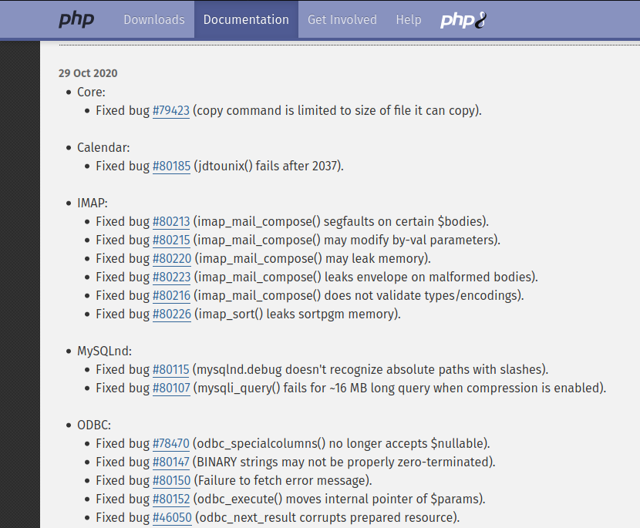
Figure 10. PHP Software Change log for patch
      - Security Posture and Preventative Actions
In the example we have investigated above, we can see that there are multiple vulnerabilities with the system. From a hacker’s perspective, they would potential look to see if the HTTP TRACE vulnerability[34] would allow them to conduct a future attack that would gain users authentication details to the website running on the server. They could also look to see if any of the vulnerabilities within older version of PHP being ran on the server would aid in any future attacks. This is how when using Nessus to remote scan a device an attacker can start to build up a list of potential opening and vulnerabilities that can then be leveraged in future attacks.
From a system administrator perspective, Nessus has identified a number of areas that the system administrator could then look to investigate further and remedy if required in their instance. For example the HTTP TRACE functionality may only be something that is required to be activated for short period of time when debugging software, and could be disabled when in a live environment to prevent leakage of data such as end user authentication data. The administrator could also look to update the version of PHP that is running on the site to mitigate and fix the bugs that are identified by the software developer. This is part of a wider best practise patching solution that should be in place and monitored to prevent zero day attacks for example.

Method 2 – Social Engineering Toolkit (Lab 4) Phishing
The Social Engineering Toolkit also widely known as SET was created by Dave Kennedy from TrustedSec. It is an open source Cyber Security Tool designed for security research and penetration testing. Within the application SET there are many features than can be utilised. Again like many tools these tools can be used by system administrators to expose and then learn what areas of security need improving, but at the same time can be used by hackers to obtain sensitive information in the aid of carrying out an attack. The types of tools within SET include but not limited to the following categories:
- Phishing Attacks
- Web Attack
- Infectious Media Generator
- Create a Payload and Listener
- Mass Mailer Attack
In this example the author will be carrying out an example of a Web Attack utilising the Credential Harvester method. This will involve a cloned website being created and the end user being supplied a link to connect to this site which will imitate another website with the username and password field having the information collected and returned to the attacker or SET console. The Link itself can be passed on to the end user in a number of ways. For example it can either be registered against a URL which look very similar to the original authentic URL in the hopes that the victim is unaware of the difference. Other ways such as embedding the URL in an image which the end user clicks on which makes it’s less obvious for the user to spot the illegitimate URL for example.

SET Example
When launching the SET console you are presented with a GUI interface within the console (Fig 11). This interface provides the end user with an explanation of the software and its origins, along with the main menu. This main menu as discussed earlier breaks down the attack types in to categories. In this instance we have chosen number two, which is Website Attack Vectors.
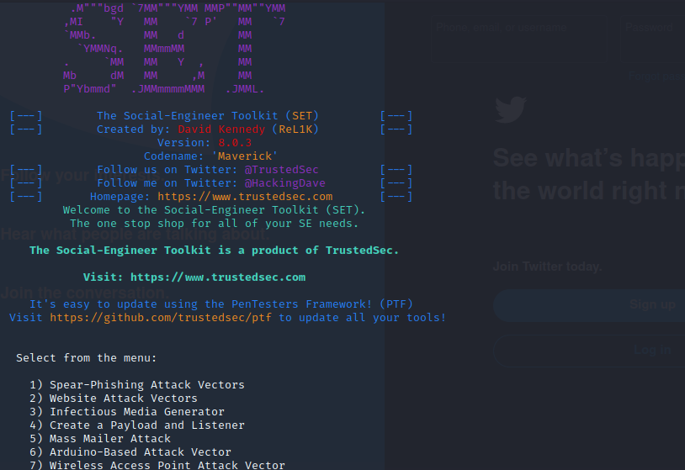
Figure 11. SET Console Interface Main Menu.
Upon selecting the Website Attack Vectors option, the sub menu appears detailing the various types of web attacks that can be performed (Fig 12). In this instance we will be running the Credential Harvester. As already described this method will utilise cloning a website and then having the information from the username and password field captured and posted in the SET console.
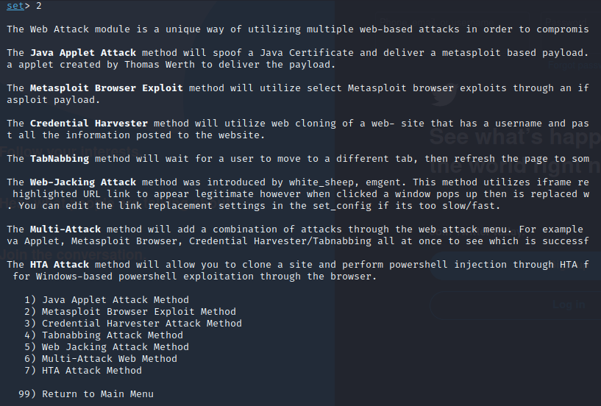
Figure 12. SET interface Web Attack Vectors Sub Menu.
Upon selecting the Credential Harvesting option, the user is presented with the options to either use an existing website template built in to the system, along with either a site cloner or a custom import of a site the user may have already created for the attack (Fig 13).
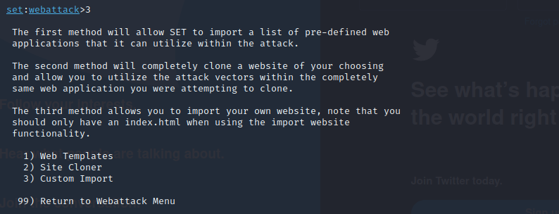
Figure 13. SET Credentials Harvesting Sub Menu.
In the example we are going to clone the well-known search engine and social media site google.com and target the account login page. So from this menu (Fig 14) we select the host that will run the site (Local host in our case) and then the website URL we wish to clone. The SET package will then run the service under the host machine and also capture any login attempts on the console.
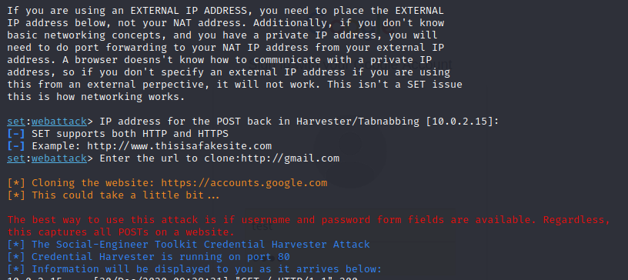
Figure 14. SET Web Site Cloning Option Example.
As discussed previously at this point the host is now running a clone version of the website we have selected in the example (Fig 14). This host can now either user a register URL that looks similar to the original and redirect users to the host. Or the link can be embedded in fake URL such as shortening URL services (Bitly.com as an example), the other method would be to embed the URL in to an image. The embedding to an image could be the gmail logo and promting the victim to click on the logo in an email for example.

Whichever method is chosen, once the victim clicks on the link they will be redirected to the cloned site and enter in their credentials as demonstrated (Fig 15).
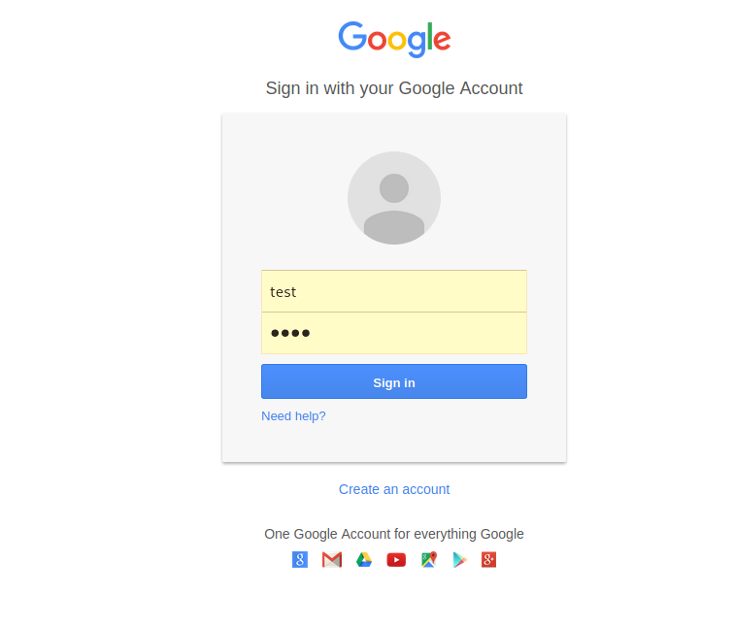
Figure 15. – Example of User login for Google Services.
Once the credentials are entered and submitted the credentials captured would then be displayed and captured on the host SET console as shown in (Figure 16).
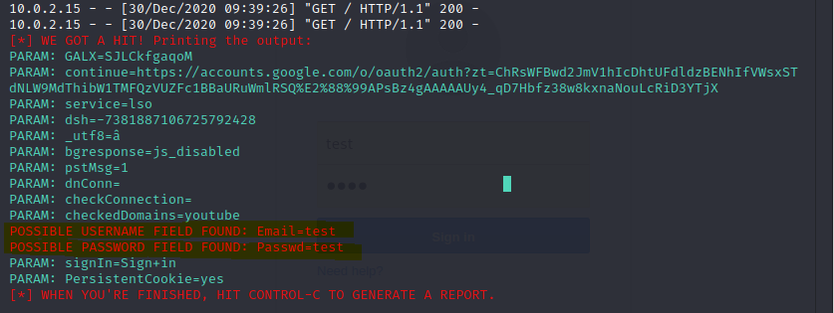
Figure 16. SET console example of Credentials being captured.
At this point the attacker now has the credentials of the victim that has been targeted and can now look to utilise these credentials to either take over account by changing passwords and/or recovery process information for example. Or simply use the credentials to potential garner further information from their email for example to continue to expedite the attack deeper.

      - Security Posture and Preventative Actions
In the example shown utilising the Web Attack/Credential harvesting features of the SET package, we can demonstrate that users credentials can be targeted and obtained very easily if the targeted victim is not vigilant as to what website for example they are being directed to. There are many ways to aid in the prevention of Phishing attacks like this, some examples are listed but not limited to the below.
- Email Filtering: End users can utilise email filtering from their providers or in corporate environment utilise their own filtering. By filtering we mean software that is able to identify compromised or known accounts to be carrying out such phishing activity.
- Website Filtering: Many ISP providers recently have begun to offer website filtering tools that can identify fraudulent web links that are not genuine. There are also a number of software packages that the consumer can utilise to carry out such activities. Example include Net Nanny or DNSFilter. These packages often utilise AI powered real-time threat detection to aid in detecting fraudulent sites amongst many other features.
- Anti-Virus: Traditional Anti-Virus packages from companies such as Sophos, Norton, Bit Defender and Trend for example have moved on in recent times. They not only provide the traditional Library AV scanning tools, but to tackle modern day vulnerabilities like phishing include Email/Website filtering tools as part of their overall protection package.
- User/Consumer Training: Most Phishing scams rely on the end user not being aware of what they are initial clicking on for example. So user training plays a big part in preventing Phishing scams. Example of areas user should look to be trained in are:

  - Check URLs of sites you are visiting and entering sensitive information in to.
  - Do not rush and trust alarming messages requesting you to enter information.
  - Do not open attachments that you are not expecting.
  - Avoid clicking on embedded link within images for example.
  - Always keep software up to date.

Part 2 – Synthesize a Solution to a Real Life Scenario. Design and Implement Security Measures.
The following company Che-Si construction is looking to improve their security posture for their current network and operations setup. Che-Si construction has a 24x7 operation that includes connectivity to a number of office located around the globe. The business currently requires access but not limited to technology such as:
- Video Conferencing Facilities
- Cloud Storage Facilities
- Client Access from any Network
- Vendor Access from any Network
- Personal Device access to internal Network
The Current Security setups allows access for these facilities and access types from any network unrestricted. As such the current security chief is concerned that this level of unfiltered access leaves the company wide open to potential attacks, not only of the company networks but potentially to the personal and corporate data.
With these concerns in mind the Che-Si Construction Company has contracted the author to propose a network design along with other recommended security measures with the aim of securing the Che-Si Network.

Current Setup Overview Example (Cisco Packet Tracer)
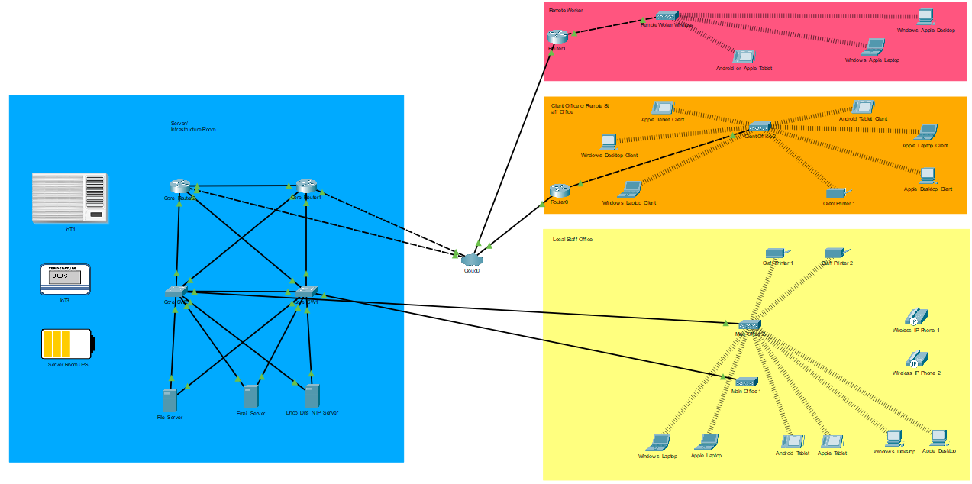
Figure 17. Example overview of the current network setup (Packet Tracer).

Server/ Infrastructure Area (Blue) (Fig 17).
In the current setup the Server/Infrastructure area consists of locally hosted services that may include but not limited to File Servers, Email Servers and DHCP/DNS/NTP Servers. These are connected to the external network (Cloud/Internet)

2.1.2 Local Staff Office (Yellow) (Fig 17).
The local staff offices on the same physical location as the server/infrastructure is demonstrated above. In this example wireless and/or hard wired Ethernet connections are routed back directly to the core network infrastructure. End user device connect to the wireless and/or Ethernet connections to gain access to the hosted services in the server room, and routed out via the cloud connection for cloud and external internet based services.

2.1.3 Remote Client and/or Remote Staff Office (Orange) (Fig 17).
The Client Offices and/or Remote Staff sites access are connected internal in their localities either via Ethernet and/or wireless, and then via routers connect out to the cloud to the Cloud connection back to the server/infrastructure room of Che-Si to gain access to hosted resources. All cloud based services are accessed via the cloud link.

2.1.4 Remote Worker (Red) (Fig 17).
The Remote worker access is similar to the remote client/staff access in that for example a home user would be connected to their own home network either via wireless or Ethernet. Then via the home or public internet connection routed over the cloud to gain access to the Che-Si hosted services within the Che-Si hosted infrastructure. Also any cloud services would be access via the home/public internet/cloud connection.

Proposed Network Improvements
The network diagram in (Fig 18) demonstrates a number of initial improvements in network security for Che-Si in relation to securing the locally hosted infrastructure and connectivity of client offices, remote staff offices and remote worker connections.
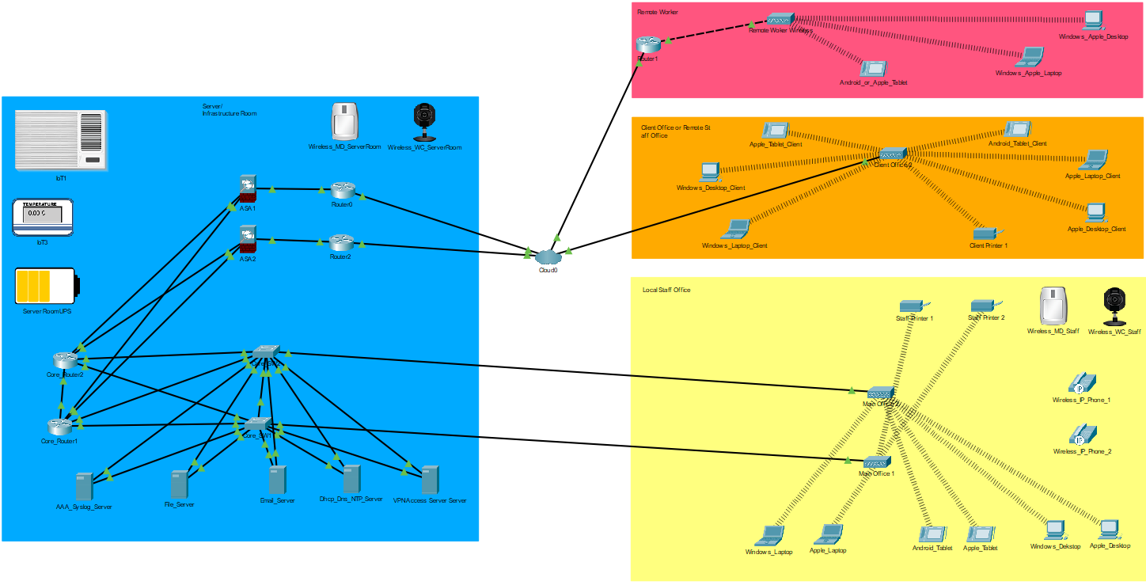
Figure 18. Example Overview of Proposed network improvements (Packet Tracer)

Access Control List.
In the above diagram we have introduced Cisco ASA Devices. The devices are situated on the internal access side of the cloud connection. This is done so that any traffic passing from the internal network to the external network and vice versa via the cloud connection can be controlled. On the ASA devices (Fig 19) below shows how an Access Control List or ACL can be configured to only allow certain traffic to route through the ASA devices between the internal and external connections.
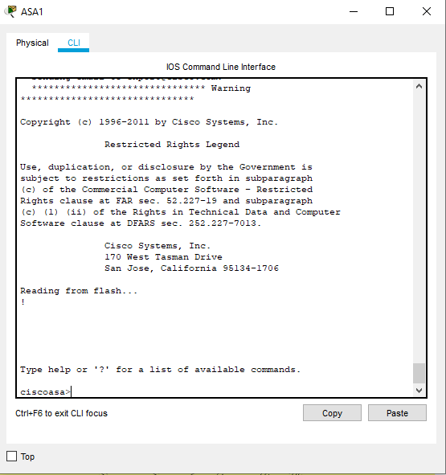
Figure 19. ASA Console Interface example.
The example (Fig 20) of the Client Line Interface for the Cisco ASA device. From here we would setup the basic config of the device to make sure it is configured for the network. Once this is complete we can look to implement an Access Control List to permit or deny access to and from specified network hosts and destinations. A short example of such a config is show below.
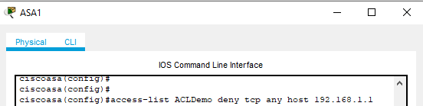
Figure 20. ASA CLI - Access Control List Entry example.
We would be able to view and confirm the ACL amendment as shown in (Fig 21). In this example you can see that any traffic attempting to come from a source of “Any” to a Destination of “192.168.1.1” will be denied access. This example could be preventing external devices being able to connect through to SSH on to a switch for example.

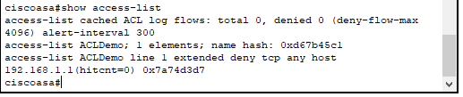
Figure 21. ASA CLI - Access Control List output example.

Personal Endpoint Firewalls
Che-Si would implement multiple ACL rules on the ACL to define what traffic it would allow in to the internal network and what traffic it would allow to exit through the ASA.
From a client perspective Che-Si would look to implement personal firewall rules. This can be configured and managed in multiple ways. The most basic is to utilise Windows Firewall for example, but there are many products on the market such as Sophos or Norton that would have a managed end user firewall within the software package.
Below (Fig 22) is a short example of the configuration on a windows firewall within the packet tracer simulation.
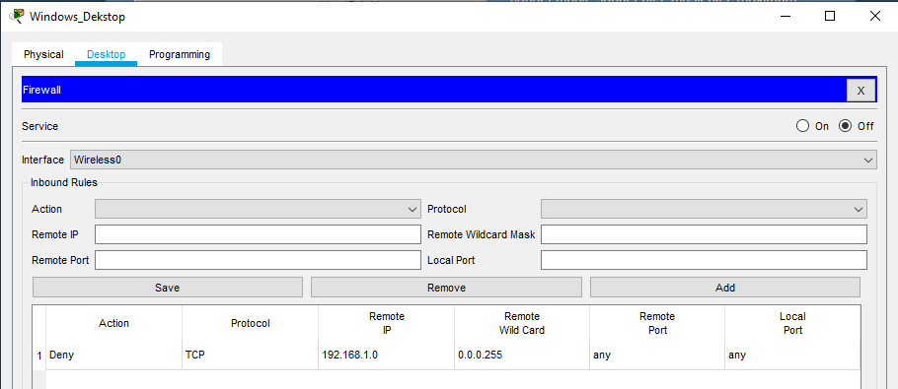
Figure 22. Windows Firewall GUI within Packet Tracer.
An example of what the user interface would look like outside of a packet tracer emulation is shown in (Fig 23).
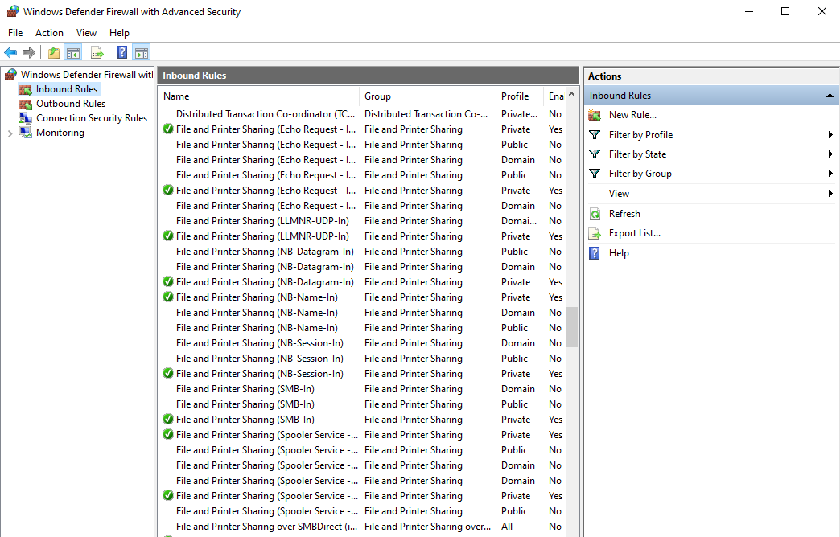
Figure 23. Windows Firewall Application Interface example.
Rules would be configured on the inbound and outbound areas to specific what traffic is allowed and blocked for the endpoint device.
For a larger estate a single point of managed can be utilised for configuring the rules to apple to all devices within the company. For example Group Policy Abject could be utilised to configure and set rules for all devices as shown in (Fig 24).
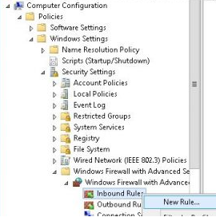
Figure 24. Windows Group Policy Object for Windows Firewall Settings example.

AAA Radius Implementation.
Implementing an AAA solution within Che-Si which could be used for multiple purposes. In this instance we would look to utilise the AAA (Authentication, Authorization and Accounting) services, Radius can be used for securing access to network equipment, allowing predefined accounts and security methods in terms of privilege of access for example, to access and configure network devices (Fig 25).
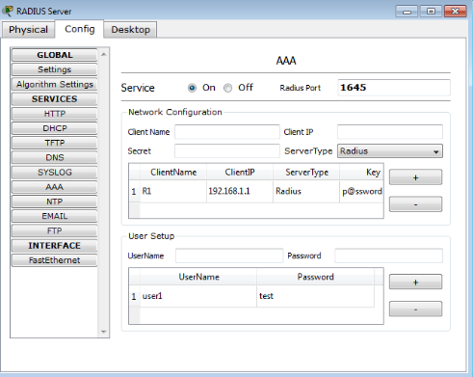
Figure 25. AAA Server Radius config GUI example.
With this security feature implemented within the Che-Si Network it would limit the ability for attackers to be able to penetrate network devices by obtaining unencrypted password used on the network for access to network devices such as switches and routers.

VPN Access Implementation.
A VPN solution could be utilised to tunnel and encrypt traffic from either client/remote staff offices along with remote workers. Within Cisco Packet Tracer you can configure a server as shown in (Fig 26) to act as a VPN server
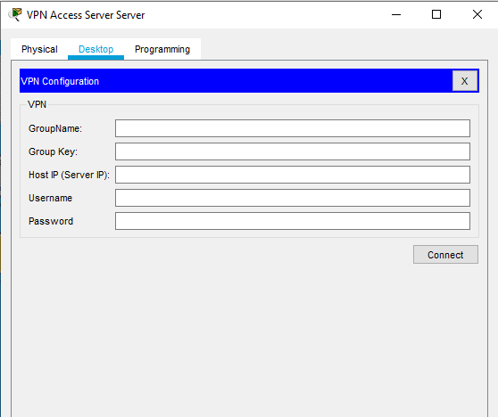
Figure 26. VPN GUI example from Packet Tracer.
But there are many other solutions and products within the marketplace that can carry out the same functions. Products such as but not limited to Open VPN, Remote Access VPN and Cisco AnyConnect all provide the ability to create a VPN solution with their own advantages and disadvantages.
A VPN solution for Che-Si would allow for remote office/workers to only access the corporate infrastructure once connected by the VPN solution. This would mean devices provided with the correct configuration setup would be able to connect to the network, but that all traffic travelling across public connection such as the cloud/internet, would then be tunnelled and encrypted helping prevent attacks such a “sniffing/Man in the middle”.
In Cisco Packet Tracer you can demonstrate the usage of a Sniffing attack utilising the sniffing tool. The Sniffing tool emulates the man in the middle attack capturing and logging all of the traffic that passes between the areas targeted on the network. As shown in (Fig 27) a basic example of a ping between devices on a network without a VPN or other types of traffic encryption would lead to packet data being captured. This data could then be analysed and potential provide useful information such as username/passwords to network devices.
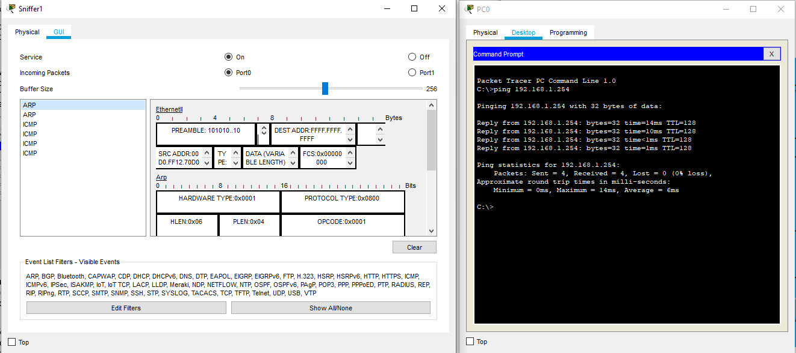
Figure 27. Packet Tracer Sniffing device output example.

On Site Physical Security Measures.
What is sometimes overlooked in the setup of a network and its security, is the presence and implementation of on-site physical security measures. In the proposed example (Fig 28), the on-site infrastructure/server room and staff offices have security features such as Key Code door locks, Alarms, Movement detectors, Server room and office Camera monitoring solutions. Which would alert security staff for an intrusion and/or attacks to the physical infrastructure.
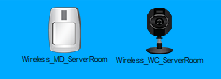
Figure 28. Example of Onsite Physical Security Monitoring devices in Packet Tracer.
As well as this array of on-site security, the Infrastructure/server room would be fitted with environment monitoring systems. These would monitor for environment attacks, or accidents to aid in the safety and security of the server room equipment. These types of environment monitoring systems would include UPS for Power interruption or failure, Automated Air Conditioning monitoring systems and temperature monitoring to prevent for failure/downtime of device either through natural disasters or through attacks (Fig 29).
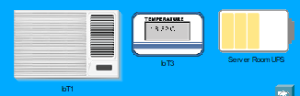
Figure 29. Example of Onsite Physical Environment & Monitoring devices in Packet Tracer.

Additional Security Counter Measures
- Routing Protocols
The use of specific transport layer routing protocols could be used to aid in attacks such as spoofing or modification of routing protocol messages. An example would be to utilise TCP for BGP.

- Security on the Routers/Network Devices
To aid in the baseline security of network devices from attacks at Che-Si. It would require and implementation of Securing network devices such as Routers/Switches with the correct Encrypted passwords for access and privileged access as (Fig 30).

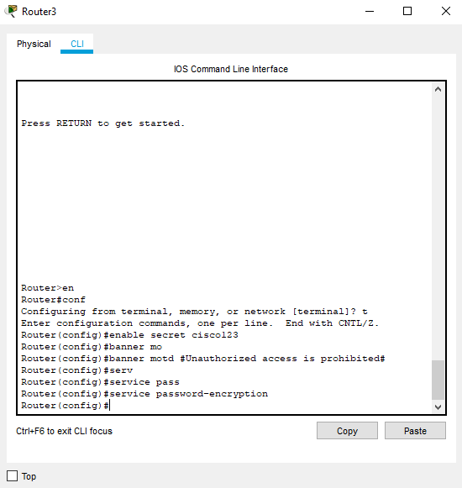
Figure 30. Example of Cisco GUI implementing encrypted passwords commands.

Along with the correct banner MOTD’s that make any potential intruders aware of the consequences and pending legal action that would be undertaken with unauthorised access

Summarise the Network Benefits Suggested vs. Existing Setup.
With the implementation of the listed security methods above within the Che-Si network. The security has now been enhanced. Unauthorised attempts at accessing the internal network infrastructure of Che-Si is now protected via ACL’s, AAA Access Methods and enhanced security encryption on the network devices. This would mean that any intruders would be unable to obtain and access security logins and information for network sensitive devices within Che-Si as easily as they would have previously without these implemented methods.
The implementation of a VPN access system would also mean that traffic travelling outside of the core Che-Si Network would now be encrypted and tunnelled to the remote workers and clients. Any intruders would now find it far more difficult to obtain sensitive data and credentials via methods including but not limited to Sniffing Man in the Middle attacks. Before this implementation attackers would have been able to obtain data using such methods.
The introduction of Physical on-site security measures such as the implemented Camera, Motion detection devices along with the Environmental Monitoring and backup devices allows for the Che-Si Security staff to be warned of any potential on-site security attacks either in advance and be notified, or recorded for investigation and prosecution post intrusion. Previously there were no security measures in place, which would have meant attackers could have obtained or penetrated Che-si’s infrastructure and the security staff would not have been aware.

References

[1] “Get ahead of cyber security breaches - KPMG Global,” May 2019, Accessed: Dec. 09, 2020. [Online]. Available: https://home.kpmg/xx/en/home/insights/2019/05/get-ahead-of-cyber-security-breaches.html.
[2] “Cybercrime To Cost The World $10.5 Trillion Annually By 2025.” https://cybersecurityventures.com/hackerpocalypse-cybercrime-report-2016/ (accessed Dec. 13, 2020).
[3] “Gartner Says 8.4 Billion Connected ‘Things’ Will Be in Use in 2017, Up 31 Percent From 2016.” https://www.gartner.com/en/newsroom/press-releases/2017-02-07-gartner-says-8-billion-connected-things-will-be-in-use-in-2017-up-31-percent-from-2016 (accessed Dec. 10, 2020).
[4] “What is Malware? Defined, Explained, and Explored | Forcepoint.” https://www.forcepoint.com/cyber-edu/malware (accessed Dec. 10, 2020).
[5] “What Is Ransomware? | McAfee.” https://www.mcafee.com/enterprise/en-gb/security-awareness/ransomware.html (accessed Dec. 13, 2020).
[6] “Ransomware Costs in 2019 - CPO Magazine.” https://www.cpomagazine.com/cyber-security/ransomware-costs-in-2019/ (accessed Dec. 10, 2020).
[7] “What Is a Distributed Denial-of-Service (DDoS) Attack? | Cloudflare.” https://www.cloudflare.com/learning/ddos/what-is-a-ddos-attack/ (accessed Dec. 15, 2020).
[8] “What Is a DDoS Attack? Distributed Denial-of-Service Attack Explained | Norton.” https://us.norton.com/internetsecurity-emerging-threats-what-is-a-ddos-attack-30sectech-by-norton.html (accessed Dec. 15, 2020).
[9] “What is a man-in-the-middle attack?” https://us.norton.com/internetsecurity-wifi-what-is-a-man-in-the-middle-attack.html (accessed Dec. 15, 2020).
[10] “What is cryptojacking? How to prevent, detect, and recover from it | CSO Online.” https://www.csoonline.com/article/3253572/what-is-cryptojacking-how-to-prevent-detect-and-recover-from-it.html.
[11] “Cryptojacking – What is it, and how does it work? | Malwarebytes.” https://www.malwarebytes.com/cryptojacking/ (accessed Dec. 16, 2020).
[12] “What is SQL injection? How these attacks work and how to prevent them | CSO Online.” https://www.csoonline.com/article/3257429/what-is-sql-injection-how-these-attacks-work-and-how-to-prevent-them.html (accessed Dec. 16, 2020).
[13] “Understanding vulnerabilities - NCSC.GOV.UK.” https://www.ncsc.gov.uk/information/understanding-vulnerabilities (accessed Dec. 16, 2020).
[14] “The U.S. Government and Zero-Day Vulnerabilities: From Pre-Heartbleed to Shadow Brokers | JIA SIPA.” https://jia.sipa.columbia.edu/online-articles/healey_vulnerability_equities_process (accessed Dec. 16, 2020).
[15] “Top Cyber Attacks of 2020 and How to Build Cyber Resiliency.”
[16] “Twitter hack: 130 accounts targeted in attack - BBC News.” https://www.bbc.co.uk/news/technology-53445090 (accessed Dec. 16, 2020).
[17] “Zoom Gets Stuffed: Here’s How Hackers Got Hold Of 500,000 Passwords.” https://www.forbes.com/sites/daveywinder/2020/04/28/zoom-gets-stuffed-heres-how-hackers-got-hold-of-500000-passwords/ (accessed Dec. 19, 2020).
[18] “Greece’s major banks cancel 15,000 cards after travel website breach - FinTech Futures.” https://www.fintechfutures.com/2020/01/greeces-major-banks-cancel-15000-cards-after-travel-website-breach/ (accessed Dec. 19, 2020).
[19] “Extent of Magellan Health Ransomware Becomes Clear: More Than 364,000 Individuals Affected.” https://www.hipaajournal.com/extent-of-magellan-health-ransomware-becomes-clear-more-than-364000-individuals-affected/ (accessed Dec. 19, 2020).
[20] “Marriott data breach FAQ: How did it happen and what was the impact? | CSO Online.” https://www.csoonline.com/article/3441220/marriott-data-breach-faq-how-did-it-happen-and-what-was-the-impact.html (accessed Dec. 20, 2020).
[21] “Marriott reveals 5 million unencrypted passport numbers were leaked in 2018 data breach.” https://www.nbcnews.com/tech/tech-news/marriott-reveals-5-million-unencrypted-passport-numbers-were-leaked-2018-n954791 (accessed Dec. 20, 2020).
[22] “Unraveling the Marriott Breach & Examining Credential Theft Attacks - Cyber Security Magazine.” https://cybersecuritymagazine.com/unraveling-the-marriott-breach-examining-credential-theft-attacks/ (accessed Dec. 20, 2020).
[23] “Autopsying the Marriott Data Breach: This is why insurance matters - Hashed Out by The SSL StoreTM.” https://www.thesslstore.com/blog/autopsying-the-marriott-data-breach-this-is-why-insurance-matters/ (accessed Dec. 20, 2020).
[24] “The Marriott Data Breach - Lessons Learned For Boards.” https://www.oliverwyman.com/our-expertise/insights/2018/dec/the-marriott-data-breach.html (accessed Dec. 20, 2020).
[25] “What is WannaCry ransomware, how does it infect, and who was responsible? | CSO Online.” https://www.csoonline.com/article/3227906/what-is-wannacry-ransomware-how-does-it-infect-and-who-was-responsible.html (accessed Dec. 22, 2020).
[26] “WannaCry: hackers withdraw £108,000 of bitcoin ransom | Malware | The Guardian.” https://www.theguardian.com/technology/2017/aug/03/wannacry-hackers-withdraw-108000-pounds-bitcoin-ransom (accessed Dec. 22, 2020).
[27] “Treasury Sanctions North Korean State-Sponsored Malicious Cyber Groups | U.S. Department of the Treasury.” https://home.treasury.gov/news/press-releases/sm774 (accessed Dec. 22, 2020).
[28] “WannaCry Cost NHS £92 Million - Infosecurity Magazine.” https://www.infosecurity-magazine.com/news/wannacry-cost-nhs-92-million/ (accessed Dec. 22, 2020).
[29] “An NSA Cyber Weapon Might Be Behind A Massive Global Ransomware Outbreak.” https://www.forbes.com/sites/thomasbrewster/2017/05/12/nsa-exploit-used-by-wannacry-ransomware-in-global-explosion/?sh=35b86537e599 (accessed Dec. 22, 2020).
[30] “The man who stopped WannaCry.” https://www.newstatesman.com/spotlight/cyber/2020/05/man-who-stopped-wannacry (accessed Dec. 22, 2020).
[31] “A Brief Introduction to the Nessus Vulnerability Scanner - Infosec Resources.” https://resources.infosecinstitute.com/topic/a-brief-introduction-to-the-nessus-vulnerability-scanner/ (accessed Jan. 10, 2021).
[32] “Nessus.” https://www.cs.cmu.edu/~dwendlan/personal/nessus.html (accessed Jan. 10, 2021).
[33] “PHP: PHP 7 ChangeLog.” https://www.php.net/ChangeLog-7.php#7.3.24 (accessed Jan. 10, 2021).
[34] J. Grossman,  /, and /, “CROSS-SITE TRACING (XST) THE NEW TECHNIQUES AND EMERGING THREATS TO BYPASS CURRENT WEB SECURITY MEASURES USING TRACE AND XSS.”

