

Student name: Rahima Ibrahim
Student ID:2336641
Module name: Psychopathological Classification and Provisions
Module Code: ( BMHP6029_LON)

Rahima Ibrahim
Introduction  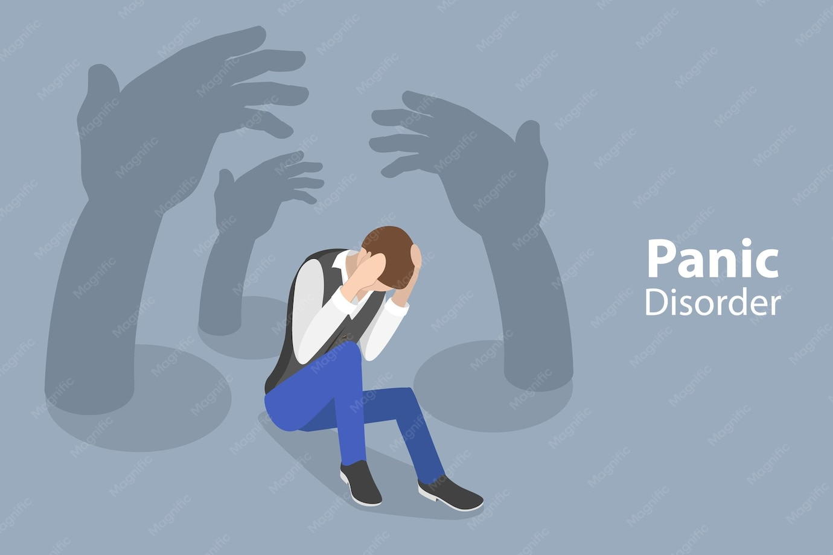  Panic disorder is an anxiety disorder in which a person experiences repeated, unexpected panic attacks and then becomes worried about having another one.  Classification  This condition belongs to the anxiety disorders group in ICD-11 it is not classed as a neurodevelopmental disorder nerveless the main features are fear, bodily alarm, and avoidance rather than difficulties linked to early development.  How common is the disorder?  How many people are diagnosed with this disorder?  According NHS data suggest that around 1.0% of adults in England meet the criteria for panic disorder. UK research also shows that panic disorder is a recognised condition in the general population and can cause real functional difficulty.  Historical Perspectives and Treatments  In the past, panic symptoms were often misunderstood as weakness, nerves, or only a physical complaint. Over time, clinicians came to recognise panic disorder as a specific mental health condition with a clear pattern of symptoms. Treatment has also improved, moving from reassurance alone to evidence-based psychological therapy and medication where needed.  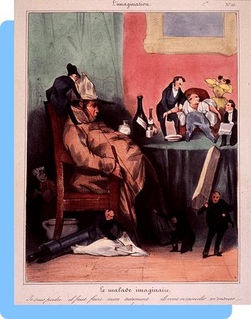  (19th-century drawing showing how people with sudden fear were often seen as imagining illness) |  | Anxiety or Fear- Related Disorder  Panic Disorder (ICD-11:6B01)  Definition  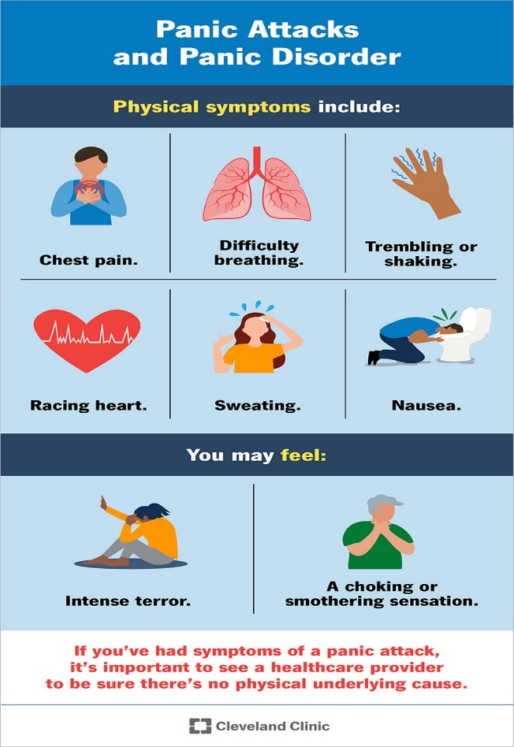  Panic disorder is defined by repeated panic attacks, intense fear, and ongoing worry about future attacks. Panic attacks can cause chest pain, a racing heart, dizziness, sweating, shortness of breath, trembling, and a strong feeling of dread.  Current Services and Treatments  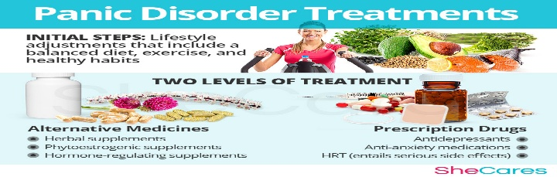  In England, adults can access NHS Talking Therapies and, many people can refer themselves directly. NICE recommends CBT as a main treatment, and SSIs may be used if medication is needed. These services can be provided face to face, online, or by phone, which makes them easier to access. |  | Causes  The exact cause is not fully known, however panic disorder may be linked to stress, life events, family history, and a heightened body response to fear. Some physical conditions can produce similar symptoms, so other explanations need to be considered as well.  Symptoms  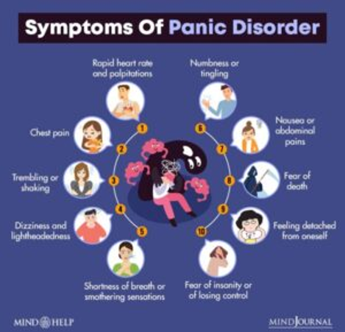  A person may experience a fast heartbeat, chest pain, shortness of breath, trembling, dizziness, sweating, nausea, fear of insanity of losing control, fear of death, and a sense that something terrible is happening. Some people also begin to avoid crowds, travel, or places where escape feels difficult.  Diagnosis  How is the disorder diagnosed?  Diagnosis is usually made by a GP after asking about the pattern of attacks, how often they happen, and how much they affect daily life. Doctors may also check for medical causes so the symptoms are not mistaken for another condition  Recommendation  Early support should be encouraged because panic disorder can become more limiting if it is left untreated. Public awareness, prompt GP assessment, and access to talking therapies can all improve recovery. Clear reassurance is also important once other causes have been ruled out.  Conclusions  Panic disorder is a common and disruptive anxiety disorder; however, it is treatable. A combination of early diagnosis, and according NHS support can reduce symptoms and improve day-to-day functioning.

Reference
Domschke, K. et al. (2025) ‘Taxonomy of anxiety disorders—a comparison of ICD-10 and ICD-11’, PMC. Available at: https://pmc.ncbi.nlm.nih.gov/articles/PMC12638383/
Moffitt, T.E. et al. (2024) ‘panic disorder and subthreshold panic in the UK general population’, PubMed. Available at: https://pubmed.ncbi.nlm.nih.gov/38501234/

NHS (2026) panic disorder. Available at: https://www.nhs.uk/mental-health/conditions/panic-disorder/
NHS (2025) Find NHS talking therapies for anxiety and depression. Available at: https://www.nhs.uk/nhs-services/mental-health-services/find-nhs-talking-therapies-for-anxiety-and-depression

NHS (2025) Talking therapies. Available at: https://www.nhs.uk/tests-and-treatments/talking-therapies

NHS Digital (2025) Adult Psychiatric Morbidity Survey: Common mental health conditions. Available at: https://digital.nhs.uk/data-and-information/publications/statistical/adult-psychiatric-morbidity-survey/survey-of-mental-health

NHS England (2026) Getting support with difficult feelings. Available at: https://www.england.nhs.uk/wp-content/uploads/2026/07/nhs-talking-therapies-easy-read-leaflet.pdf

NHS England (2026) NHS Talking Therapies for anxiety and depression. Available at: https://www.england.nhs.uk/mental-health/adults/nhs-talking-therapies/

NICE (2024) Generalised anxiety disorder and panic disorder in adults: management. Available at: https://www.nice.org.uk/guidance/cg113

NICE (2020) panic disorder. Available at: https://www.nice.org.uk/guidance/cg113/ifp/chapter/panic-disorder

