Assignment 2
Daniel Da Silva Fernandes (2510885)
[company name]
Module Name: Computer Architecture and Operating Systems
Module Code: ACCA4022
Student Name: Daniel Fernandes
Student ID: 2510885
Group:1 ㅤㅤㅤㅤㅤㅤㅤㅤㅤㅤㅤㅤㅤㅤㅤㅤㅤㅤㅤㅤㅤㅤㅤㅤㅤㅤㅤㅤㅤㅤㅤㅤㅤㅤㅤㅤㅤㅤㅤㅤㅤㅤㅤㅤㅤㅤㅤㅤㅤㅤㅤㅤㅤㅤㅤㅤㅤㅤㅤㅤㅤㅤㅤㅤㅤㅤㅤㅤㅤㅤㅤㅤㅤㅤㅤㅤㅤㅤㅤㅤㅤㅤㅤㅤㅤㅤㅤㅤㅤㅤㅤㅤㅤㅤㅤㅤㅤㅤㅤㅤㅤㅤㅤㅤㅤㅤㅤㅤㅤㅤㅤㅤㅤㅤㅤㅤㅤㅤㅤㅤㅤㅤㅤㅤㅤㅤㅤㅤㅤㅤㅤㅤㅤㅤㅤㅤㅤㅤㅤㅤㅤㅤㅤㅤㅤㅤㅤㅤㅤㅤㅤㅤㅤㅤㅤㅤㅤㅤㅤㅤㅤㅤㅤㅤㅤㅤㅤㅤㅤㅤㅤㅤㅤㅤㅤㅤㅤㅤㅤㅤㅤㅤㅤㅤㅤㅤㅤㅤㅤㅤㅤㅤㅤㅤㅤㅤㅤㅤㅤㅤ
Table of Contents
Introduction 2
Key functions of general Operating Systems 2
Use of Windows OS CLI commands 2
Use of Linux OS CLI commands 6
Use of Windows OS scripts 7
Use of Linux OS scripts 9
Conclusion 11
References 11

Introduction
So, this work I will be showing and talking about Windows and Linux operating systems, with commands and scripts and for that I will be using command prompt for windows and Ubuntu for Linux commands

Key functions of general Operating Systems
Key functions of the general operating systems are what manages the computer hardware and help to provide for applications.
- Memory management- It handles the creation it schedules after that it executes the process and then it terminates the process [1].
- Device management- It controls the hardware devices within the system using drivers and coordinates called input/output operations [2].
- File system management- It manages and puts the files in order meaning organising the files to make sure they are all tidied up and in their right place [3].

Use of Windows OS CLI commands
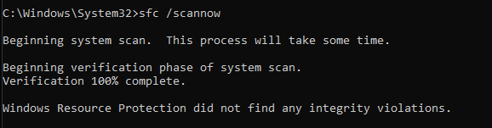
In this screenshot as you can see I used the command sfc /scannow and that command serves to help or tell you that your computer has corrupted files and what does it do? It goes ahead and scans the files and if there is indeed a corrupted file the command it self repairs the file or if there are system files missing the command just replaces them with a cached copy.
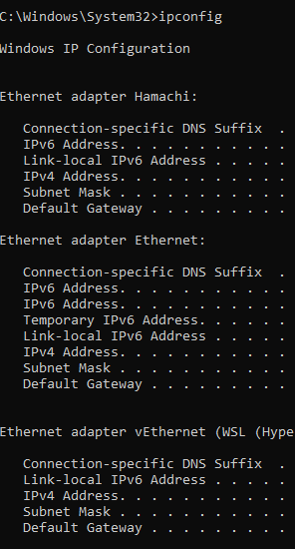
So this command I used just now is a command where you type in ipconfig and it tells you your ip configuration meaning it displays all the network details there are on your pc so it’s easy for you to check if your pc or internet have IPV4 only or if it also supports IPV6.
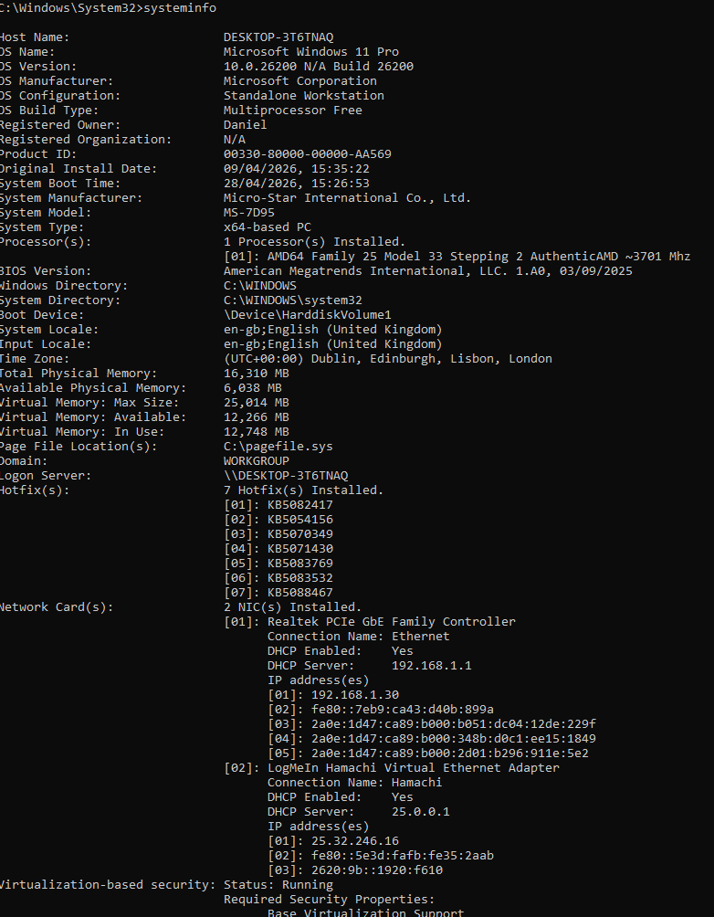
So in this command I typed in systeminfo to give me every single info/detail about my pc, so it shows you what components there are on your pc, what your RAM is all the network cards and that is why you would use this command.

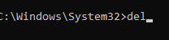
In this command I cannot really execute it because I am not sure whether it will harm my device or not, in a way that it could delete any of my files but long story short it’s a command where you type del and it deletes a certain file or even multiple files all at once.

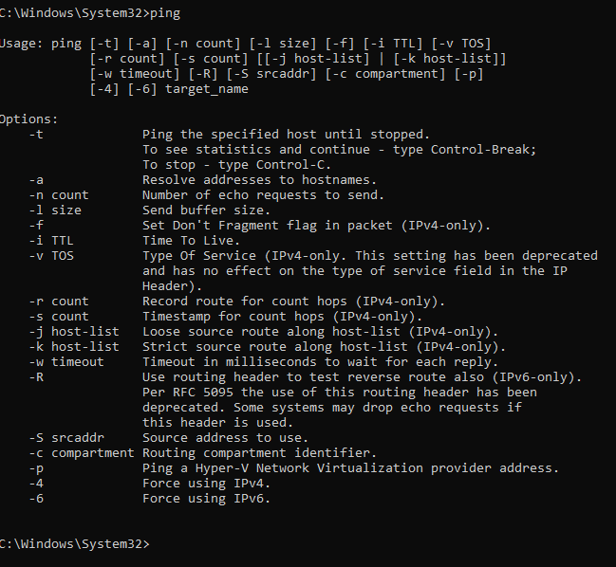

This exact command is called ping and by just looking at the screenshot you can see it tells you what you need to know and the reason why you typed in ping, so it mean it tests the network connectivity to a certain address

Use of Linux OS CLI commands
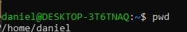
This command pwd just helps you realise what working directory your currently working at, it’s a very basic command but for beginners that don’t really know how to check what working directory they are currently at, this is a pretty solid command.
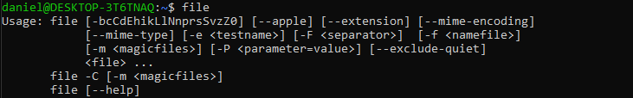
This command here called file helps you show and find the file types you’re looking for or trying to find out, not as solid as the one I mentioned previously but a command is still a command in it’s a command for some reason.
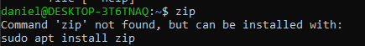
In this command that is called zip, it technically lets you turn any file meaning it let’s you compress any kind of file into a zip archive.
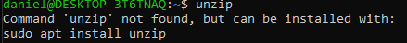
The command unzip is the opposite definition of the previous one so instead of letting you compress any file into a ZIP archive it lets you unzip any kind of archive to wherever you wish to on pc.
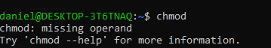
Chmod is a command that lets you change any file permission to whatever permission you want, so if want no permissions at all in one file then you can do so by changing the file permission.
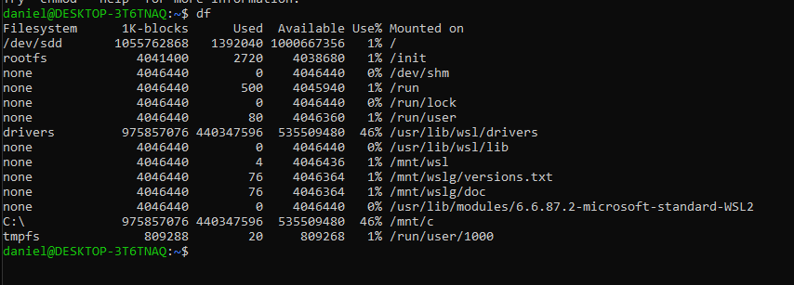
Ok this command here shows at you are actually looking for right now, on the ones before they were saying they could not really show because at the moment I am not able to select any file to demonstrate what the commands are really capable of but I kindly explained every single one of them based of on my knowledge.

Use of Windows OS scripts
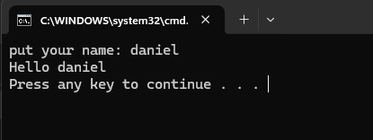
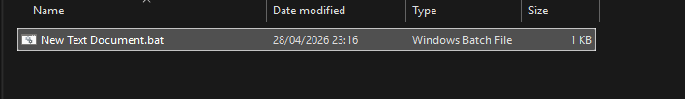
The initial line, @echo off, manages the visibility of commands. Typically, when a batch file is executed, each command is displayed on the screen prior to execution. The echo off feature turns off that behavior, resulting in a cleaner output. The @ sign at the beginning guarantees that this particular line is hidden as well.The second line, set /p name=enter your name:, is utilized to gather information from the user. The set command creates or changes variables. The /p option instructs the system to ask the user for input. In this situation, it shows the prompt “enter your name:” and pauses for the user to input a response. Anything the user inputs is saved in a variable named name.The third line, output Hello %name%, presents a response to the user.
The echo command displays text on the screen. The %name% segment fetches the value held in the variable name. Thus, if the user entered “Alex,” the result would be “Hello Alex.”The last line, pause, briefly prevents the script from shutting down right after it runs. It shows a notification saying “Press any key to continue…” and awaits user input. This is helpful as it enables the user to view the output prior to the command window closing. In summary, this script illustrates fundamental principles of batch scripting: managing command visibility, receiving user input, saving data in variables, presenting output, and halting execution.

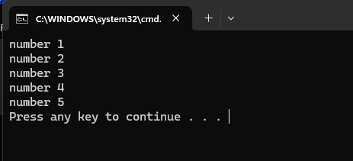
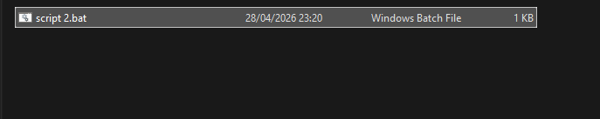
This is yet another straightforward Windows Batch Script that illustrates how loops function in the Windows command prompt .The line, @echo off, serves the same function as in many batch files: it stops commands from appearing on the screen when they run. Typically, every line of the script is shown in the console prior to execution, leading to a messy output. Disabling echo and employing the @ symbol to conceal this particular command allows the script to generate a neater output that displays solely what you explicitly print.The second line is where the primary operations take placefor %%i in (1 2 3 4 5) do echo value %%i. This utilizes a for loop, a control structure that executes a command for a specified range of values. In this case, %%i acts as a loop variable. The sequence (1 2 3 4 5) specifies the values that the loop will cycle through. In every iteration, %%i assumes a value from the list.The do keyword divides the loop definition from the command that needs to be executed. In this instance, the instruction is echo number %%i. Therefore, the script outputs a line for each value and it’s very simple to make as there is no need to get stressed about.

Use of Linux OS scripts

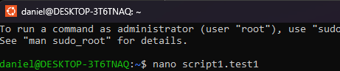
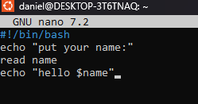
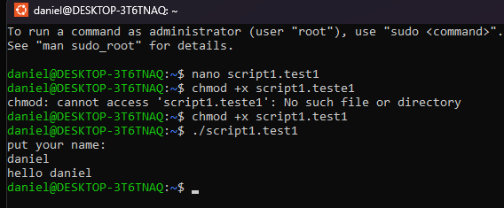
Initially, I launch a file with GNU nano by typing nano script1.test1, allowing me to create my script. Once I save it, I must set it as executable. I attempt to use chmod with chmod +x script1.teste1, but I misspell the filename. As a result, the terminal says “No such file or directory,” indicating it cannot locate the file I’m attempting to change. I fix the error by entering chmod +x script1.test1, and this time it functions. The script is now authorized to run. Then, I execute it with ./script1.test1. The ./ simply indicates to the system to execute a file located in my present directory. When the script executes, it asks me to “enter your name:”. I enter “daniel”, and it outputs “hello daniel”. That indicates the script is functioning correctly—it’s receiving input and producing output. In summary, I created a script, made an error in the filename once, corrected it, assigned execute permissions, and then ran it successfully

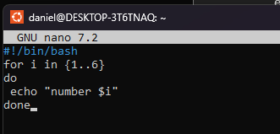
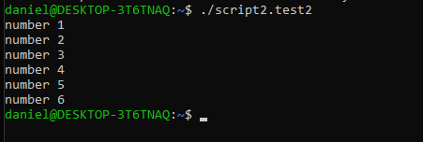
Initially, I launch a new file in GNU nano by entering the command nano script2.test2. That’s the place where I compose my script. From the results I receive later, the script likely has a loop that outputs numbers from 1 to 6. Once the file is saved, I execute chmod +x script2.test2. The chmod command alters file permissions, while +x allows the script to be executed. If I skip this step, I won't be able to execute it directly. I run the script by using ./script2.test2. The ./ simply instructs the shell to execute a file from the present directory rather than searching for a system command. Upon execution, the script outputs:
number 1
number 2
number 3
number 4
number 5
number 6
This indicates to me that within the script, I’ve set a loop for the numbers. In a standard shell script, it would appear as follows i in 1 2 3 4 5 6; do echo value $i; done. The loop iterates through each number in the list (1 to 6), assigns it to a variable (such as i), and then outputs “number” alongside that value for every iteration. In total, I developed a script, set it to be executable, and executed it. The script illustrates the functionality of loops in shell scripting by executing a command several times with varying values

Conclusion
I pretty much started the work doing some commands on windows OS but before that I had to state a few key factors about general operating systems, after that I had to use some commands on windows OS(command prompt) and also on Linux(Ubuntu) after writing down the commands I had to explain exactly what they meant and what they do.
After finishing the commands I moved on to the windows and Linux scripts as for that I also used codes to create the scripts then took a screenshot of each step, to make sure whoever is reading can understand what I was trying to explain.
With this work I gained a lot more knowledge about Linux and windows, I already had an above average knowledge about windows but when it came to Linux I knew exactly nothing, so this work really made me realise there are a lot of things that I am still not familiar with, and by saying that I think I did a pretty good job I would say, it’s not the best but I will keep on improving day by day. Hopefully I can make it to where I want and for last I think I deserve a passing grade due to my efforts throughout this assignment.

References
[1] Operating System Concepts, 10th ed. Hoboken, NJ, USA: Wiley, 2018.
[2] Modern Operating Systems, 4th ed. Boston, MA, USA: Pearson, 2015.
[3] Operating Systems Internals and Design Principles, 9th ed. Boston, MA, USA: Pearson, 2018.

