ACCA5026

Databases and Application Development

Database Design & Implementation

Name:
Radu Cristian Boros

ID:
2319948

Module Tutor: Divya Chidambaram

Table of Contents
Database-Driven Web Application – Book Collection Management System (Part B) 3
1. Introduction 3
2. Website and Database Overview 3
3. Database Design and Normalisation 4
3.1 Normalisation 5
4. PHP Database Connection and Dynamic Content 6
5. Search Facilities 6
6. Administrator Login and CRUD Functions 8
6.1 Administrator Login 8
6.2 CRUD Operations 9
7. Basic Security Measures 11
8. SQL Injection Overview 12
9. Review of SQL Injection Defences 13
9.1 Potentially Vulnerable Areas 13
9.2 Implemented Defences 13
9.3 Attempted Injection Test 13
9.4 Remaining Limitations 14
10. Testing and Evidence 14
11. Conclusion 15
12. References 15

Database-Driven Web Application – Book Collection Management System (Part B)

1. Introduction

This project developed a database-driven Book Collection Management System using PHP and MySQL. The public website presents a searchable catalogue, while an authenticated administrator can create, view, update and delete book records. It demonstrates database connectivity, relational design, dynamic content, search, CRUD, login, validation and protection against SQL Injection.
A book catalogue was selected because books can be linked clearly to authors and categories through foreign keys. This avoids repeating the same information in every record and allows joined queries to produce useful pages. The database contains twenty sample books and runs locally through XAMPP.

2. Website and Database Overview

The website is information-based and contains no shopping basket or payment system. The homepage displays books retrieved from MySQL and allows filtering by search term or category. After login, an administrator can add a book and access Edit and Delete controls.
- Public catalogue showing books, authors and categories from MySQL.
- Search and category filtering with a clear no-results response.
- Administrator login using sessions and a hashed password.
- Create, Read, Update and Delete functions for books.
- Validation, prepared statements, output encoding and CSRF protection.

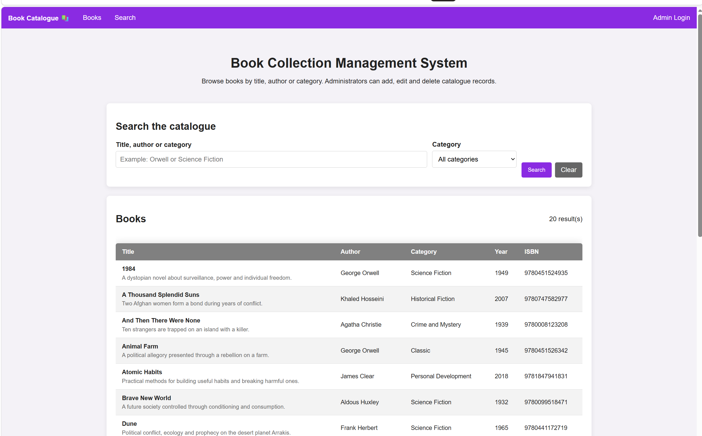Figure 1: Book Collection Management System homepage

3. Database Design and Normalisation

The book_catalogue database contains four tables: categories, authors, books and admins. Categories and authors store reusable descriptive information, books stores the main catalogue records, and admins stores login data. The sample database contains twenty books, twelve authors and six categories, providing enough data for search and CRUD testing.
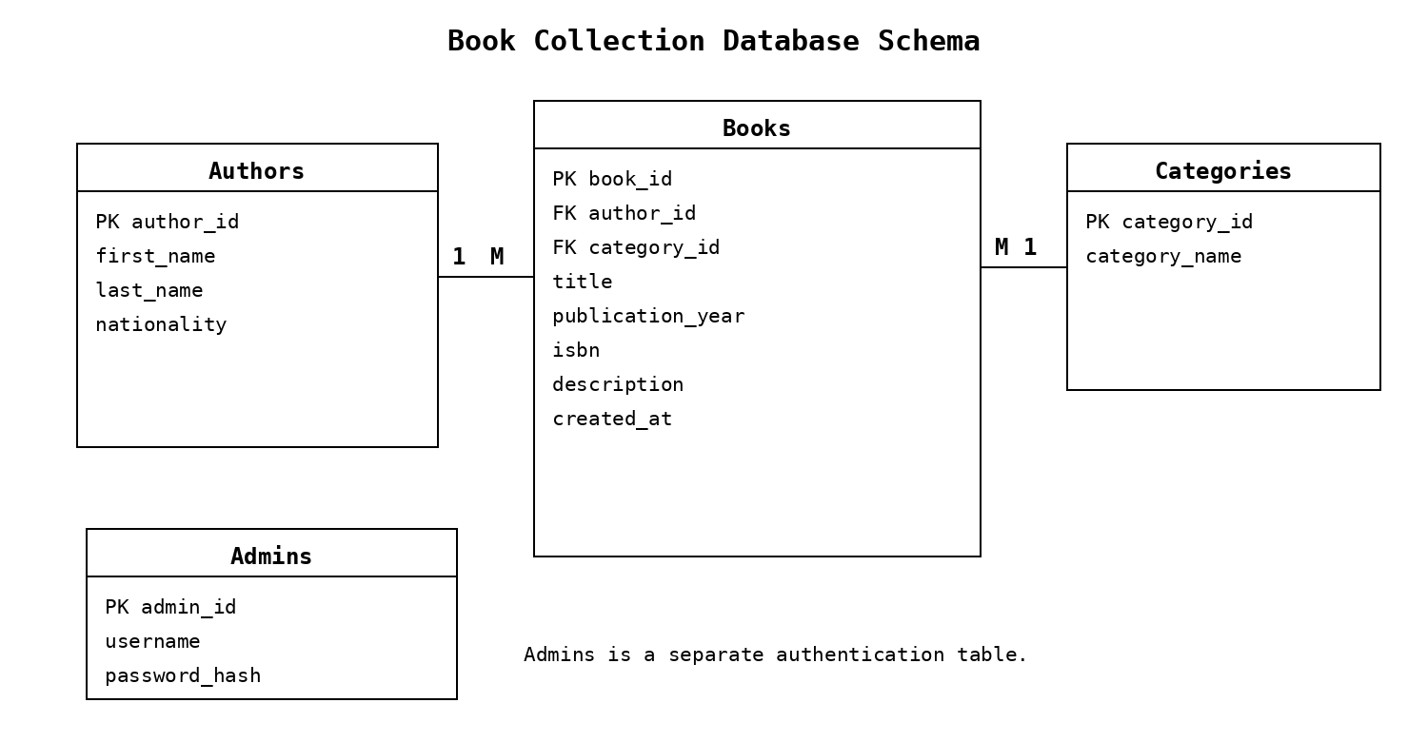
Figure 2: Database tables and relationships
UserName : admin
Password : Admin123!.
Table | Purpose | Important fields
categories | Stores category names. | category_id (PK), category_name
authors | Stores author details. | author_id (PK), first_name, last_name, nationality
books | Stores the main catalogue records. | book_id (PK), author_id (FK), category_id (FK), title, year, ISBN, description
admins | Stores administrator login information. | admin_id (PK), username, password_hash

3.1 Normalisation

The content tables are normalised to Third Normal Form. Each field stores one value and each table has a primary key. Author and category details are stored once in separate tables, while books contains author_id and category_id as foreign keys. This reduces duplication, supports referential integrity and allows an author or category to be updated without changing every related book.

4. PHP Database Connection and Dynamic Content

config.php creates a PDO connection to MySQL using UTF-8, exception error handling and associative fetching. PDO::ATTR_EMULATE_PREPARES is set to false so native prepared statements are requested. Website pages include this file, execute queries and display the returned rows.

$pdo = new PDO($dsn, $user, $pass, [
PDO::ATTR_ERRMODE => PDO::ERRMODE_EXCEPTION,
PDO::ATTR_DEFAULT_FETCH_MODE => PDO::FETCH_ASSOC,
PDO::ATTR_EMULATE_PREPARES => false
]);

The catalogue query joins books, authors and categories so each page can display title, author, category, year, ISBN and description without repeating author or category text inside books. Queries that load complete dropdown lists contain no external input.

5. Search Facilities

The homepage accepts a text search and optional category. Users can search by book title, author name or category. An empty search shows the full catalogue, while no matches produce the message 'No books matched your search' rather than a blank page.
Named parameters are used for the search values, and the category ID is validated as an integer. The query therefore remains flexible while keeping user data separate from SQL instructions.
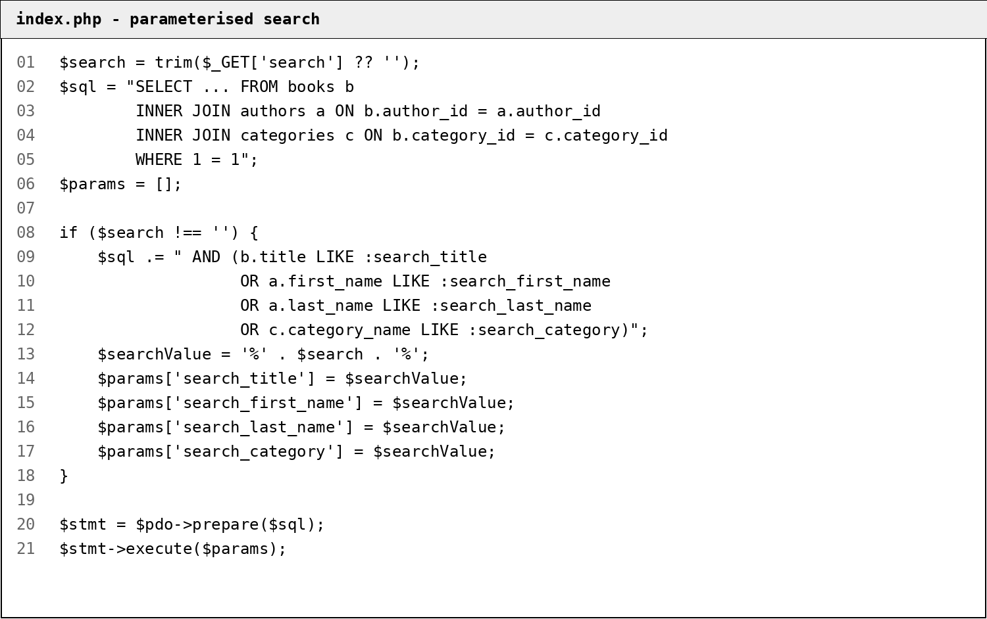
Figure 3: Parameterised search implemented in index.php

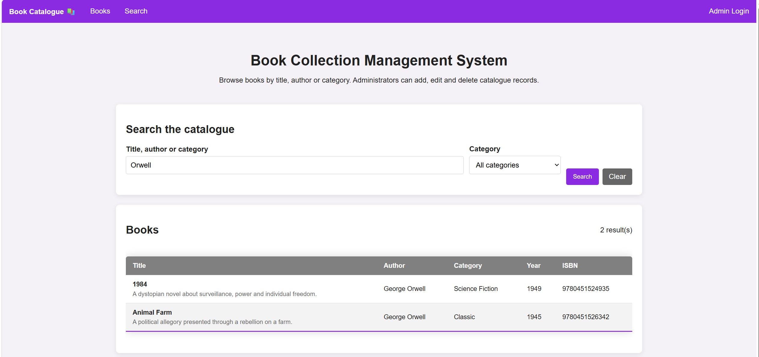 Figure 4: Example of filtered search results

6. Administrator Login and CRUD Functions

6.1 Administrator Login

Administrator functions are protected by login. login.php retrieves the submitted username with a prepared statement and checks the stored password hash using password_verify(). After successful authentication, the session ID is regenerated and the administrator ID is stored in the session. Protected pages call requireAdmin(), which redirects unauthenticated visitors.
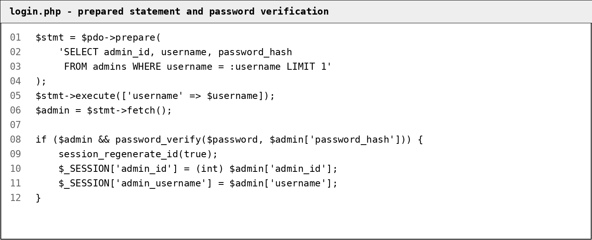
Figure 5: Secure administrator authentication code
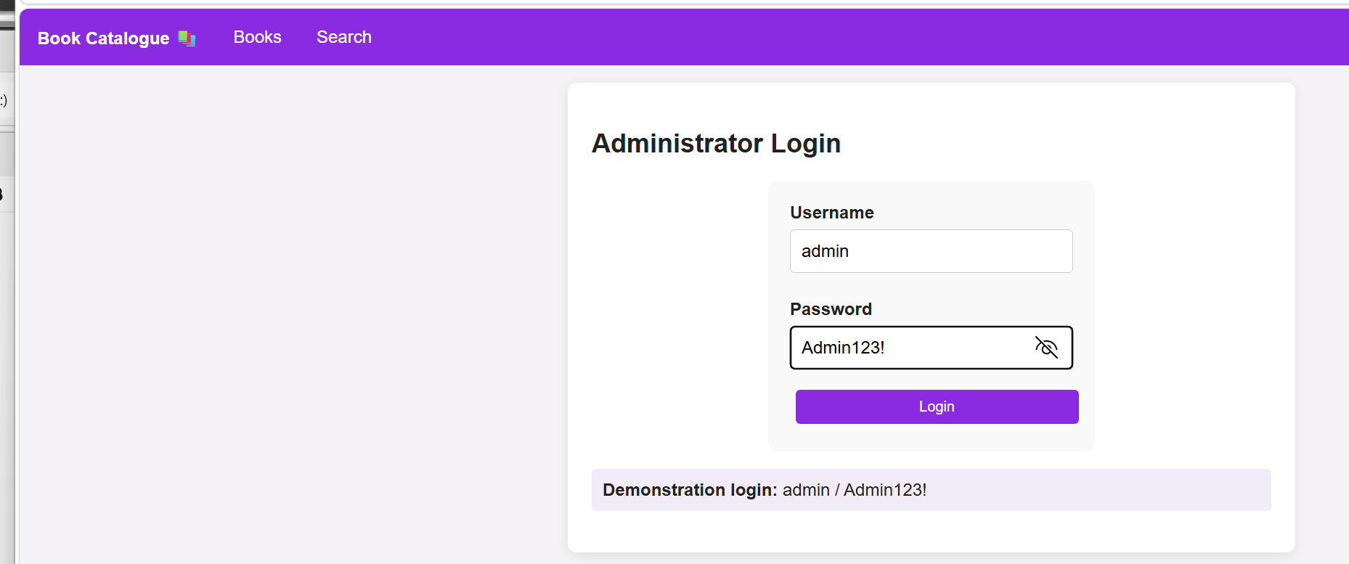
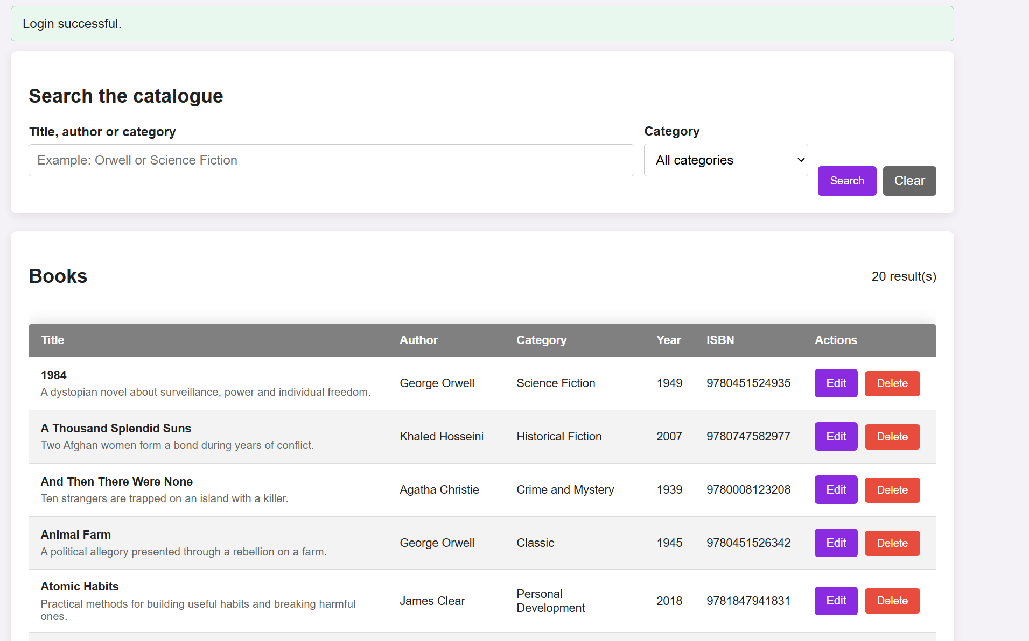 Figure 6: Administrator authentication test

6.2 CRUD Operations

Read is available on the homepage. createNewBook.php inserts a book after the administrator selects an author and category and supplies the title, year, ISBN and description. editBook.php loads and updates a record using a validated integer ID. deleteBook.php accepts only an authenticated POST request with a valid CSRF token.
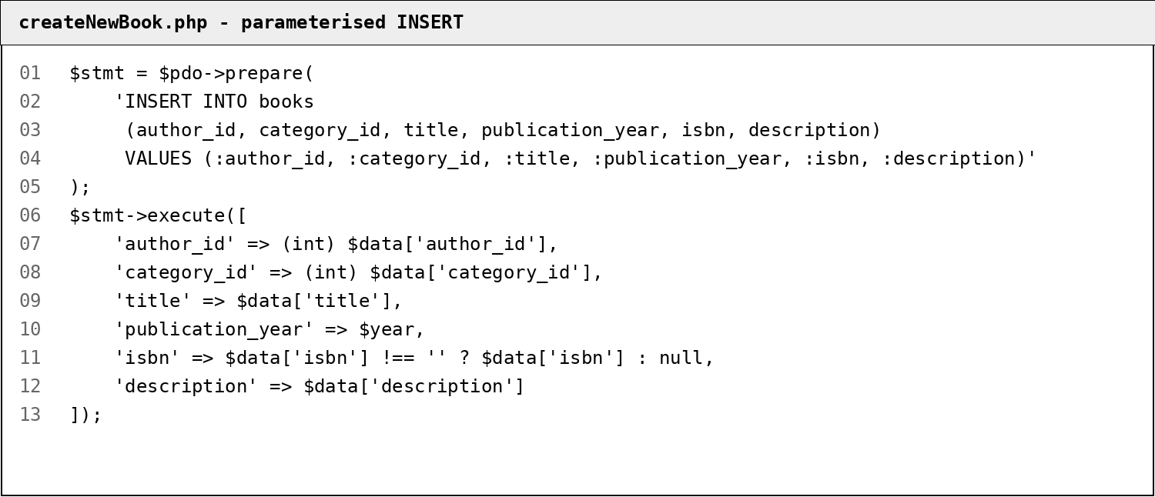
Figure 7: Parameterised INSERT used by the Create operation

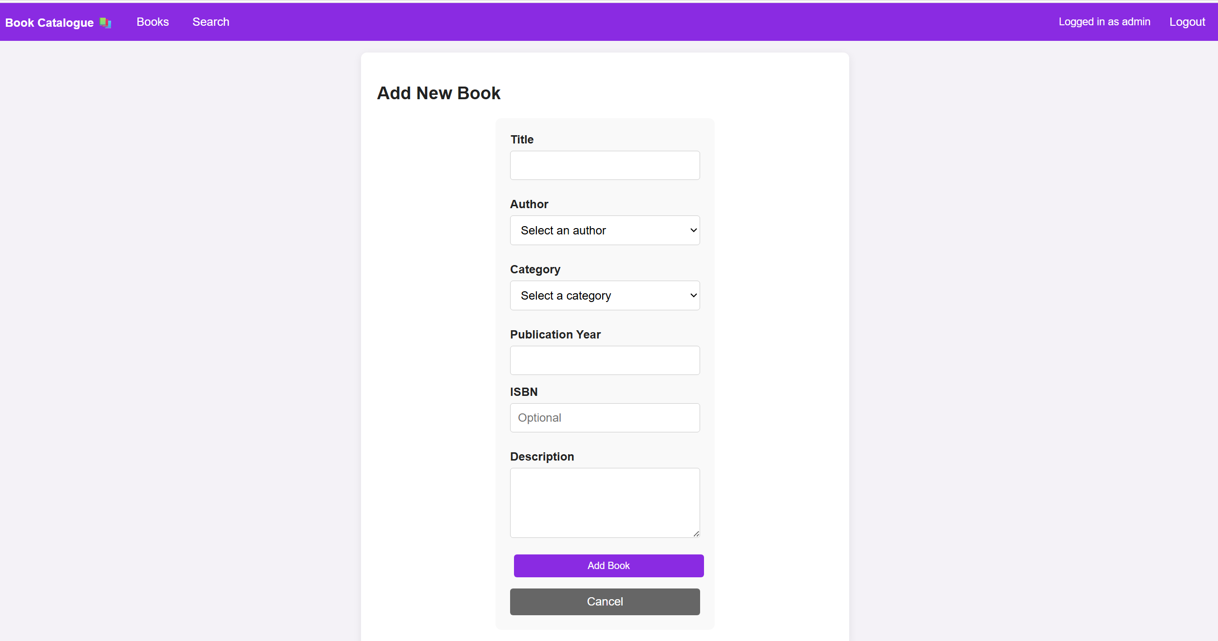Figure 8: CRUD operation testing

7. Basic Security Measures

Input is validated before database changes. IDs must be valid integers, required fields cannot be empty, publication years must be within an acceptable range and ISBN values use a restricted pattern. Unique, check and foreign-key constraints add database-level protection.
Displayed request and database values pass through the e() helper, which uses htmlspecialchars() with ENT_QUOTES and UTF-8. Converting special characters to HTML entities reduces stored and reflected cross-site scripting risk [5].
State-changing forms use random CSRF tokens checked with hash_equals(), and deletion uses POST rather than a link. Passwords are stored as hashes and checked using password_verify() [4]. These controls complement prepared statements and validation.
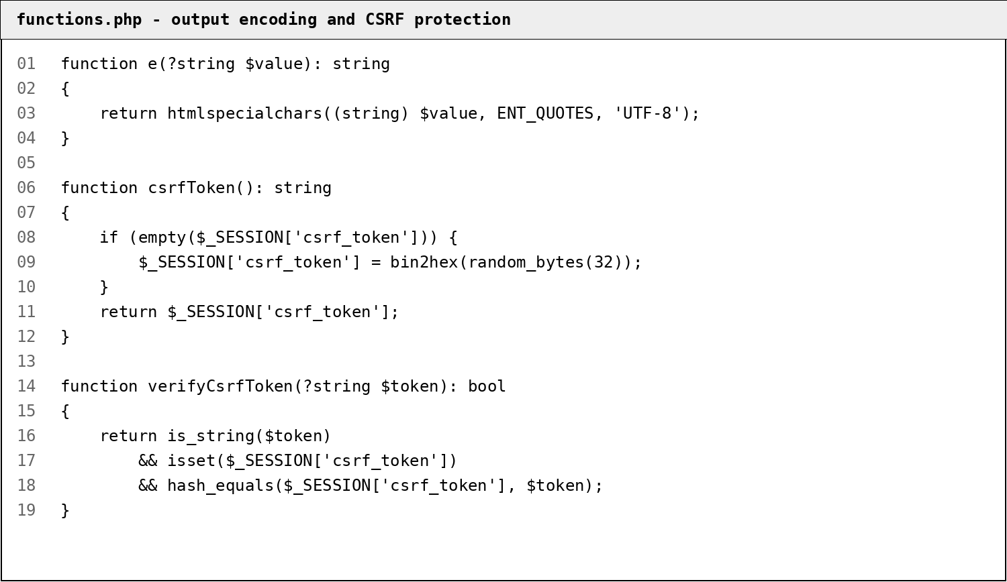
Figure 9: Output encoding and CSRF protection helpers
The local XAMPP configuration uses the root account with an empty password. This is acceptable only for a localhost demonstration. Deployment would require a dedicated least-privilege MySQL user, a strong password and protected configuration secrets.

8. SQL Injection Overview

SQL Injection occurs when user-controlled input becomes part of an SQL command instead of remaining ordinary data. MITRE classifies it as CWE-89 [3]. In PHP, the weakness commonly appears when GET or POST values are concatenated directly into a query.
For example, an unsafe login query might be built as follows:
$sql = "SELECT * FROM admins WHERE username = '$username'
AND password = '$password'";
Because username and password are inserted directly, an attacker could submit ' OR '1'='1. The added condition may make the WHERE clause true and bypass authentication. Depending on permissions, injection can expose, modify or delete records, so the risk is serious wherever personal or confidential information is stored.
Injection is not limited to login. Search fields, URL IDs, filters and administrator forms can affect SELECT, INSERT, UPDATE or DELETE statements. Error-based attacks use database messages, union-based attacks add attacker-selected results, and blind attacks infer information from changes in behaviour or response time.
OWASP explains that SQL Injection often results from dynamic queries built with string concatenation. Its primary defence is prepared statements with parameterised queries [1]. The SQL structure is defined first and each value is supplied separately, so SQL-looking input is treated as parameter data rather than a new command.
PHP provides this through PDO::prepare() and execute(). The PHP manual recommends parameter markers instead of inserting input directly and notes that prepared execution removes the need to quote values manually [2]. This protection fails if untrusted text is still concatenated into the statement. Dynamic table names, column names or sort directions cannot normally be bound, so they must come from a strict allow-list.
Validation is useful but does not replace parameterisation. It can reject invalid IDs, years or options, but simply removing quotes or SQL keywords is unreliable because attacks can use different syntax and encodings. OWASP therefore recommends prepared statements for values and allow-list validation for query elements that cannot be parameterised [1].
Defence in depth also includes least-privilege database accounts, generic public error messages, password hashing, protected sessions and HTML output encoding. These measures limit consequences and address related threats, although none should replace parameterised SQL.
The website is tested by entering ' OR '1'='1 in the search field. The expected outcome is zero results, unless a stored value literally contains that sequence. It must not return every book or alter the query. This confirms that the text is handled as search data. Login, create, edit and delete queries should also be reviewed because every database call containing external input requires the same protection.

9. Review of SQL Injection Defences

9.1 Potentially Vulnerable Areas
The main external inputs are the search term, category filter, username, book form values and book IDs used for edit or delete. Each would be vulnerable if concatenated directly into SQL.

9.2 Implemented Defences

All such operations use PDO prepared statements and named parameters. Search binds the text and category ID; login binds the username; create and update bind every book field; and delete binds the validated book ID. Native prepares are requested in the PDO settings. This follows OWASP and PHP guidance on separating code from data [1], [2].
Numeric IDs are checked with FILTER_VALIDATE_INT, and no request can supply a table or column name. Author and category choices come from database-populated dropdowns. Static queries used only to retrieve complete lists contain no user-controlled values.

9.3 Attempted Injection Test

After running the site in XAMPP, enter the following text into the public search field:
' OR '1'='1
The expected response is 'No books matched your search' with zero results. The application searches for the literal sequence rather than interpreting OR as SQL, showing that parameterisation preserved the original query structure.

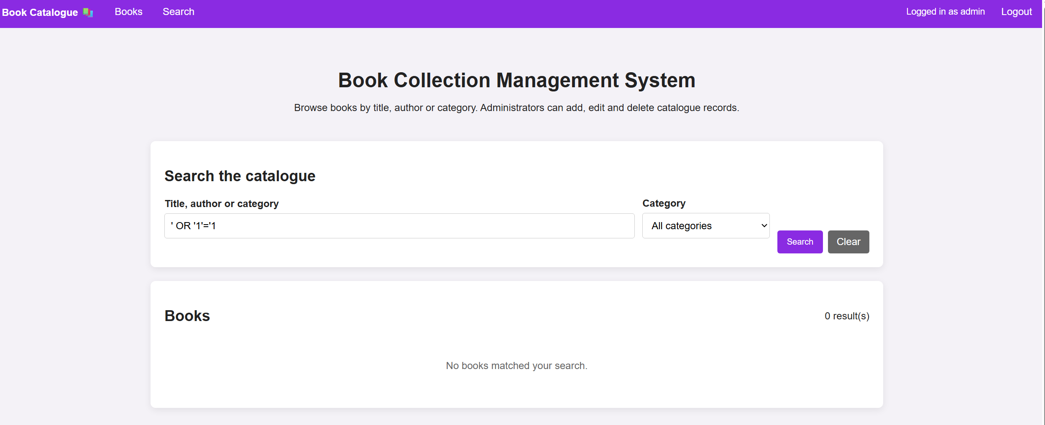Figure 10: Attempted SQL Injection treated as ordinary search data

9.4 Remaining Limitations

The site is appropriate for local coursework, but deployment would require a non-root database user, secrets outside the public folder, HTTPS, login rate limiting and security logging. These are wider deployment limitations rather than identified SQL Injection weaknesses in the current parameterised queries.

10. Testing and Evidence

The following tests are completed in XAMPP and recorded with screenshots:
- Import database.sql and confirm all four tables are created.
- Confirm that twenty books are displayed dynamically.
- Search for Orwell and verify the filtered results.
- Filter by Fantasy and verify the category filter.
- Log in and confirm that Add, Edit and Delete controls appear.
- Add, edit and delete a book record.
- Submit invalid year or ISBN data and confirm validation.
- Submit the SQL Injection test and confirm a safe zero-results response.
A phpMyAdmin screenshot of the four imported tables may also be included.

11. Conclusion

The Book Collection Management System meets Part B requirements. It stores normalised sample data in related MySQL tables, retrieves dynamic content through PHP, provides search and filtering, and demonstrates administrator-controlled CRUD. Separating books, authors and categories reduces duplication.
Security controls include hashed passwords, authenticated sessions, validation, HTML output encoding, CSRF tokens and PDO prepared statements for every query containing user input. The SQL Injection review explains why concatenation is dangerous and shows that parameterisation treats attack text as data. Future improvements could add author and category management, pagination, cover uploads, audit logging and production database permissions.

12. References

[1] OWASP Foundation, “SQL Injection Prevention Cheat Sheet,” OWASP Cheat Sheet Series. [Online]. Available: https://cheatsheetseries.owasp.org/cheatsheets/SQL_Injection_Prevention_Cheat_Sheet.html. [Accessed: 6-Aug-2026].
[2] PHP Documentation Group, “PDO::prepare,” PHP Manual. [Online]. Available: https://www.php.net/manual/en/pdo.prepare.php. [Accessed: 6-Aug-2026].
[3] MITRE, “CWE-89: Improper Neutralization of Special Elements used in an SQL Command (‘SQL Injection’),” Common Weakness Enumeration. [Online]. Available: https://cwe.mitre.org/data/definitions/89.html. [Accessed: 6-Aug-2026].
[4] PHP Documentation Group, “password_verify,” PHP Manual. [Online]. Available: https://www.php.net/manual/en/function.password-verify.php. [Accessed: 6-Aug-2026].
[5] PHP Documentation Group, “htmlspecialchars,” PHP Manual. [Online]. Available: https://www.php.net/manual/en/function.htmlspecialchars.php. [Accessed: 6-Aug-2026].
[6] OWASP Foundation, “Injection Prevention Cheat Sheet,” OWASP Cheat Sheet Series. [Online]. Available: https://cheatsheetseries.owasp.org/cheatsheets/Injection_Prevention_Cheat_Sheet.html. [Accessed: 6-Aug-2026].

