Assignment 1

Jordan Soroko, 1805357, Computational Thinking
Table of Contents
- BPM Diagram
- Use Case Diagram
- Robot Examination

A set of tasks were given to each student related to building a programmable robot and visualising the tasks using diagrams.
These diagrams illustrate the process of making the robot and letting it draw, with the objective of solving the problems associated with the instructions and visually representing how it is done.
The following document contains screenshots of all completed work:
- BPMN
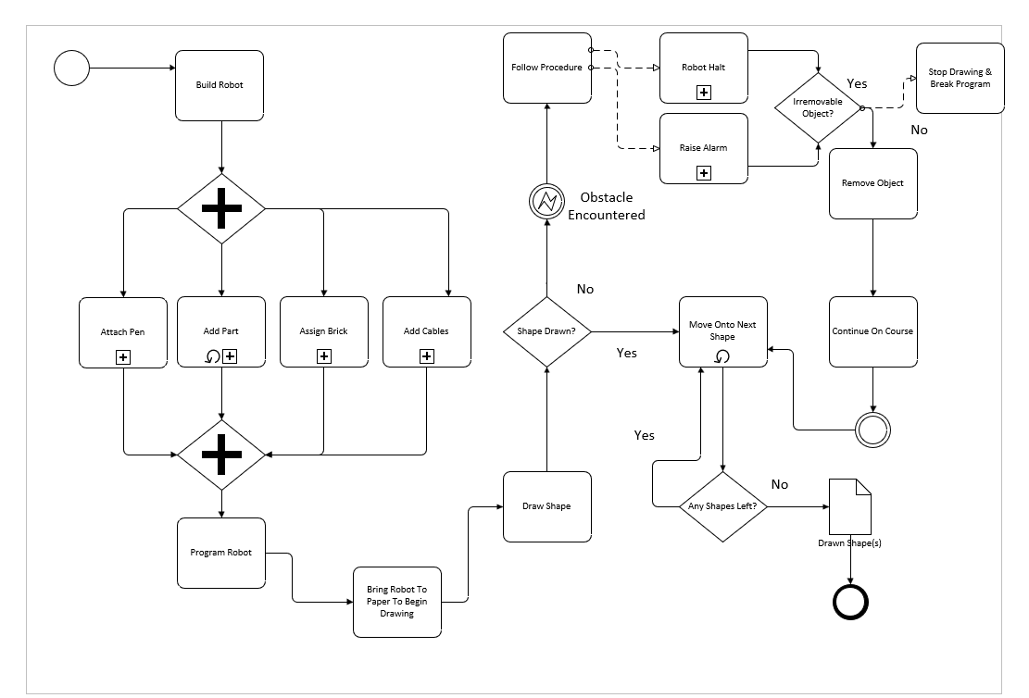

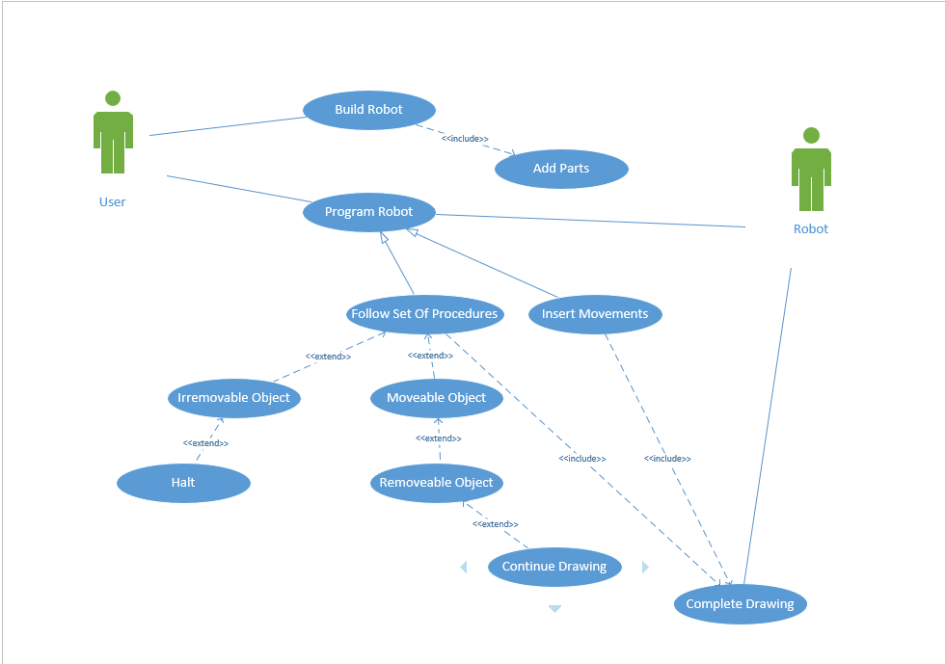
- Use Case

- Robot

Code

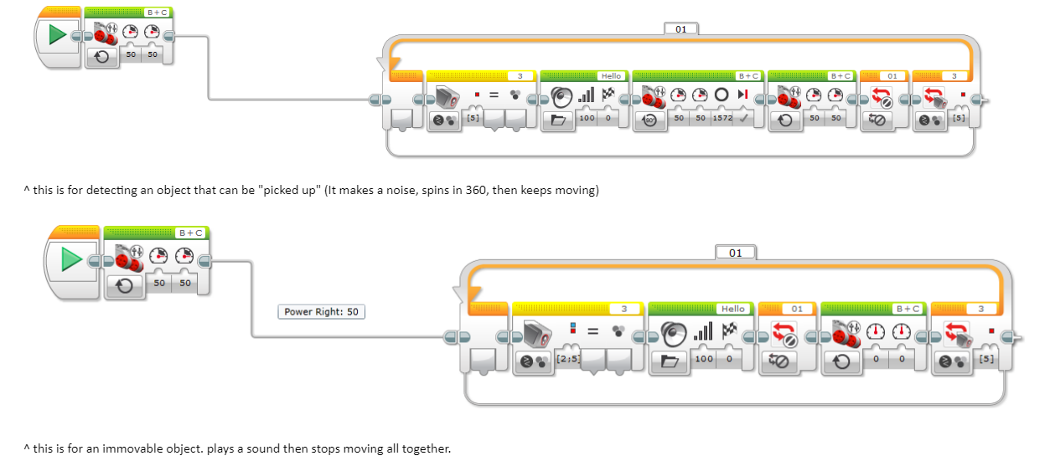
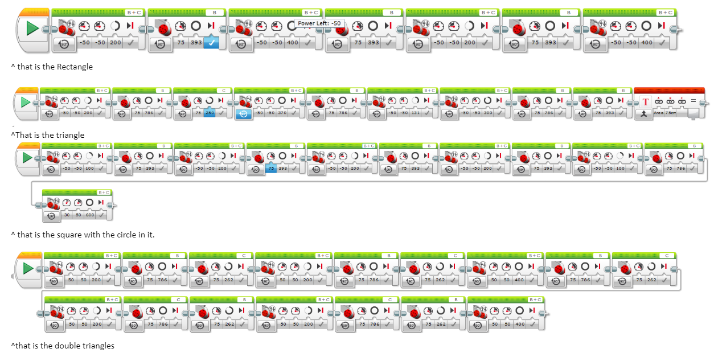

Built Robot


