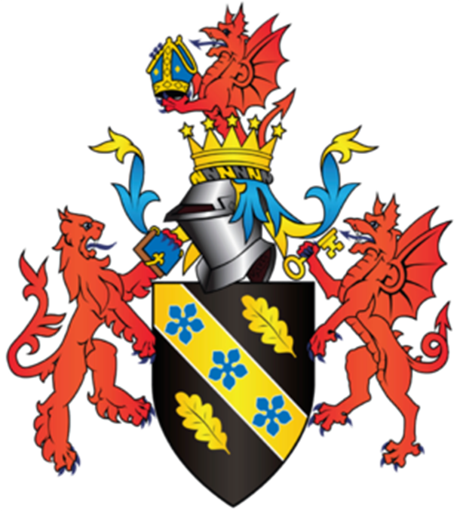
Module Name: Management Ethics
Student Name: Ruby Khatun
Student Number: 1702871

Executive Summary
This is a report based on a popular business called Coca cola. The writer will explain what CSR is and how it fits in within the chosen company. The report will also include triple bottom line each tier will also be explained in this report.

Table of Contents
- Introduction…………………………………………………………………….…………… 4
  - Report Remit…………………………………………………………………………………4-5
2.0 Corporate Social Responsibility in Business (CSR)…………………………5-6
3.0 Sustainability in a business……………………………………………………………5-6
3.1 Triple bottom line…………………………………………………………………………6
4.0 Sustainability in Coca cola…………………………………………………………….7
4.1 Environmental sustainability ………………………………………………………..7
4.2 Social Sustainability………………………………………………………………………7-8
4.3 Economic Sustainability ……………………………………………………………….8-9
5.0 Conclusion……………………………………………………………………………………9
6.0 Bibliography…………………………………………………………………………………10

- Introduction

  - Report Remit
This report will critically explain the part that sustainability plays within an organisation setting. Also examining the idea of sustainability within the company Apple. This investigation will be applied within many issues that Apple has faced. This report will explain how apple should overcome the problems that keep occurring.

2.0 Corporate Social Responsibility in Business (CSR)
Corporate social responsibility (CSR) is a professional method that donates to sustainable development by providing economic, social and environmental assistances for all investors.
CSR is a notion with numerous descriptions and practices. It is understood and applied to companies which may change it significantly for each company and country’s is a very extensive perception that reports numerous subjects such as human privileges, corporate governance, health and safety, environmental effects, working circumstances and influence to economic growth. The determination of CSR is to drive alteration towards sustainability (Lexicon.ft.com, n.d.).
The shareholder theory was initially suggested by Milton Friedman and it suggests that the only duty of a business is to rise earnings. It is built on the evidence that management are hired as the negotiator of the shareholders to run the corporation for their advantage, and so they are officially and ethically obligated to assist their attentions (Admin, 2013).
The shareholder theory is understood as the significant way of doing business with organisation understanding that there are difficulties to concentrating exclusively on the interests of shareholders (Admin, 2013).
Stakeholder Theory is an indication about how an organisation really works. Freeman said that for any company to be positive it has to produce worth for customers, suppliers, employees, communities and financiers, shareholders, banks and individuals with the money.
Stakeholders can be internal or external. Internal stakeholders are people who’s concern in a firm comes through a straightforward connection, such as work. External stakeholders are those individuals who do not work with a firm but are involved in by the activities and outcomes of the business.
Coca-Cola is an American based company which was founded in 1886 by pharmacist John Stith Pemberton in Atlanta, Georgia. The Coca-Cola formula and brand were bought in 1894 by Asa Griggs Candler, who incorporated The Coca-Cola Company (The Coca-Cola Company, n.d.). Coco-cola has faced many ethical and sustainability problems this includes, the sustainability sourcing, health issues and employee problems coca cola faced. The main sustainability aims for the company were summarised in 2007 Coca-Cola introduced its sustainability framework Live Positively implanted in the scheme at all stages, from manufacture and packaging to delivery. The businesses CSR strategy Live Positively creates seven main zones where the organisation establishes itself significant objectives to enhance the company’s sustainability practices.
3.0 Sustainability in Business
Corporate sustainability is frequently described as managing the triple bottom line this is a method by which businesses handle their financial, social and environmental risks, responsibilities and prospects. These three effects are occasionally described to as profits, people and planet (Lexicon.ft.com, n.d.).
Corporate sustainability is a company rule that is commonly known as a vital tactical interest for governments and businesses. Many companies have chosen to incorporate sustainability principles into their company models (Mar,2013).
According to Coca-Cola’s website it states that corporate responsibility and sustainability is an essential role of Coca-Cola HBC’s culture. It directs their choices and long-term assets to make sure they provide long-lasting importance (Coca-colahellenic.com, n.d.).
Their company approach is developed on the basic rule of establishing and sharing value with all of their stakeholders: consumers, customers, communities, employees and shareholders. This describes how they run their business and how they carry out events and improve relationships (Coca-colahellenic.com, n.d.).
Coca cola works with stakeholders to recognise the raw material problems to their business. Coca cola’s sustainability responsibilities come from connecting material problems to tactical priorities (Coca-colahellenic.com, n.d.).
Coca cola have three strategic goals for their sustainability approach, these three approaches are promoting health & wellness, minimising our environmental impact and also providing back to communities (Coca-colahellenic.com, n.d.).
3.1 Triple Bottom Line
The triple bottom line is an idea which expands a company’s concentrate on the economic bottom line to include social and environmental issues. A triple bottom line determines a business's level of social accountability, its economic value and its environmental effect (Kenton.2018).
The word was created in 1994 by John Elkington and later on applied in his 1997 book "Cannibals with Forks: The Triple Bottom Line of 21st Century Business (Kenton.2018).
Usually, a firm's bottom line on its income report is its net income, its profits. Elkington's triple bottom line is aimed to improve the aim of sustainability in corporate methods, in which the attention of businesses is stretched outside earnings to involve social and environmental problems to calculate the total cost of doing business (Kenton.2018).

4.0 Sustainability in Coca Cola
4.1 Environmental Sustainability
Events in the southern Indian state of Kerala, where a Coca Cola factory was forced to close two years ago after it was unproven to have polluted local water. Coca-Cola is the major drink company in the world, and used 283 billion litres of water in 2004 (Mathiason, 2019).
Since 2010 Coca cola has support marine life the water, they use in their method processes through complete wastewater treatment. Statistics show that 90% of wastewater in the developing planet is being released into the natural environment without care, Coca cola are devoted to constant improvements within their functions and are eager to motivate others to assist make substantial enhancements in this area (The Coca-Cola Company, n.d.).
86 manufacture facilities across The Coca-Cola Company have shown that they recycle water before or after treatment, or they also use collected rainwater, the 49 services have joined some figures for the amount of stored rainwater or water recycled after treatment (The Coca-Cola Company, n.d.).
The water used in their system processes is reused through a treatment and purification procedure. Preserved wastewater is sometimes used within plants for productivity reasons in boilers, evaporators, chillers and outside for environment irrigation and self-control. This diminishes the use of outer water sources (The Coca-Cola Company, n.d.).
Coca cola work alongside with local agencies to achieve targets. where public or other external treatment services do not exist, they are establishing their own wastewater, treatment services (The Coca-Cola Company, n.d.).
4.2 Social Sustainability
Social Sustainability is a technique that promotes the welfare within an company's own employees while also assisting the ability of prospective generations to maintain a healthy community (Benojo, n.d.).
Coca-Cola provides over 200 countries and territories from around the world, and Corporate Social Responsibility (CSR) is at the core of our business in each one of them.
CSR plays a big part for coca cola because dedication helps creating sustainable communities. The organisation gives back 1% of the company’s operating profit yearly to a variety of programs and causes.
In 2014 Coca cola has gave back $126 million to operating profit, which was spent in effective and healthy living projects, water stewardship programs, education, women’s empowerment, humanitarian and disaster relief programs (En.coca-colaarabia.com, n.d.).
Coca cola launched in the Middle East, a various amount of campaigns as part their business residency project. These projects can vary from helping students who want to become an entrepreneur through Coca cola’s project called ‘Ripples of Happiness’. They also provide a program called ‘Price of Water’ campaign that was released in 2014, this is a project that provides refugees with clean drinking water (En.coca-colaarabia.com, n.d.).
Coca cola supports numerous community projects for example economic development projects in the United States, they also provide awareness programs on HIV/AIDS prevention in Africa and Latin America.
4.3 Economic Sustainability
Economic sustainability describes methods that help long-term economic development without destructively affecting social, environmental, and cultural characteristics of the community (Sustainability, n.d.).
The Coca-Cola scheme is a global company that works on a local level in every single community around the planet.
CCI operates bottling and supply operations with 25 factories in 10 countries, making a clear economic effect both directly and indirectly. Their manufactured goods are supplied, sourced, delivered and traded locally. A bottle of Coca-Cola produces value for various areas during its trip from the manufacture line to the customer.
The company encourages employment innovation across their value chain. they add to the economic growth of local areas by hiring local individuals, paying taxes to governments, buying supplies, services and investment equipment from providers, and establishing social development projects.
Coca Cola encourage local stores to improve their companies by offering properties and instruction. They help providers to boost their global effectiveness through significant donations. They frequently perform financial effect surveys to evaluate and reveal their indirect economic effect in working countries.
5.0 Conclusion
To conclude this report the writer has spoke about how CSR is linked within a big cooperation. The writer has explained the triple bottom line and how all of the tiers linked within the chosen company.

6.0 Bibliography
Admin, C. (2013). Shareholder & Stakeholder Theories Of Corporate Governance. [online] Corplaw.ie. Available at: http://www.corplaw.ie/blog/bid/317212/Shareholder-Stakeholder-Theories-Of-Corporate-Governance [Accessed 23 Jan. 2019].
Benojo. (n.d.). Social Sustainability - What is Social Sustainability? — Benojo. [online] Available at: https://benojo.com/social-sustainability/ [Accessed 25 Jan. 2019].
Coca-colahellenic.com. (n.d.). Sustainability Approach. [online] Available at: https://coca-colahellenic.com/en/sustainability/sustainability-approach-and-performance/sustainability-approach/ [Accessed 24 Jan. 2019].
Kenton, W. (2018). Triple Bottom Line (TBL). [online] Investopedia. Available at: https://www.investopedia.com/terms/t/triple-bottom-line.asp [Accessed 24 Jan. 2019].
Lexicon.ft.com. (n.d.). Business Sustainability Definition from Financial Times Lexicon. [online] Available at: http://lexicon.ft.com/Term?term=business-sustainability [Accessed 24 Jan. 2019].
Lexicon.ft.com. (n.d.). Corporate Social Responsibility (Csr) Definition from Financial Times Lexicon. [online] Available at: http://lexicon.ft.com/Term?term=corporate-social-responsibility--(CSR) [Accessed 23 Jan. 2019].
Mar, A. (2013). What is Business Sustainability?. [online] Simplicable. Available at: https://business.simplicable.com/business/new/what-is-business-sustainability [Accessed 24 Jan. 2019].
Mathiason, N. (2019). Coke 'drinks India dry'. [online] the Guardian. Available at: https://www.theguardian.com/money/2006/mar/19/business.india1 [Accessed 25 Jan. 2019].
Sustainability. (n.d.). Economic Sustainability. [online] Available at: https://sustainability.umw.edu/areas-of-sustainability/economic-sustainability/ [Accessed 25 Jan. 2019].
The Coca-Cola Company. (n.d.). Brands. [online] Available at: https://www.coca-colacompany.com/packages/brands [Accessed 23 Jan. 2019].
The Coca-Cola Company. (n.d.). Coca-Cola - Sustainability - Protecting the Environment - Water Stewardship - Watershed Protection. [online] Available at: https://www.coca-colacompany.com/stories/recycle [Accessed 24 Jan. 2019].

