Maria Shipman
Student number: 2116519
Jewel Print Business Report

Contents
Introduction 2
Reasons to Innovate 2
Time of implementation 3
Market size and Scope for Jewel Print 3
Variable and Fixed costs: 4
Calculations: 5
Barriers and mitigations to market 6
Barriers and mitigations to market 6
Funding and R&D Tax claims 7
Grants 7
Crowd Funding 7
Welsh Government funding 7
Research and Development tax relief 7
Conclusion 7
References 7

Introduction
So, what is Jewel Print?
Jewel Print is a service bureau focused on Business to Business (B2B) Jewellery Manufacturing. It is an alternative manufacturing process to precious metal casting; Casting has been used for precious metal production for thousands of years and for the most part, has not changed at all. Casting creates 1000s of tons of carbon emissions each year (Haworth, 2017). With the Welsh government’s pledge for businesses to be carbon neutral by 2030 a solution to green manufacturing needs to be found.
The Diamond Centre Wales (DCW) researchers had a thought: if we are in this manufacturing predicament, other jewellery manufacturers must be too. Jewel Print was then created as a sister business to fulfil the manufacturing needs of Diamond Centre Wales.
The Diamond Centre Wales is a specialised jewellery manufacturing retail shop that has the goal of creating anything the customer desires. This adds a layer of complexity to finding an innovation that could serve the purpose of being carbon-neutral but flexible enough to create intricate and challenging pieces.
Currently, DCW outsources its casting to a third party; this will be the first time the business will have manufacturing control from start to finish on how its pieces are fabricated. In August 2022 DCW started a working friendship with Alpha Laser – a Selective laser melting printer company that has a focus on creating a system that will be beneficial to the jewellery industry.

Reasons to Innovate
Innovation allows DCW to expand their production capabilities, due to the 24-hour printing capabilities and flexibility to upscale and descale volumes. DCW can focus on growth knowing that Jewel Print can comfortably expand to complete prospective orders.
Secondly, 3D printing gives a more diverse design scope to casting; hollow, light weighted, articulated, foreign parts incorporated into builds and very high-resolution designs can be created with printing, whereas casting has limitations in those areas.
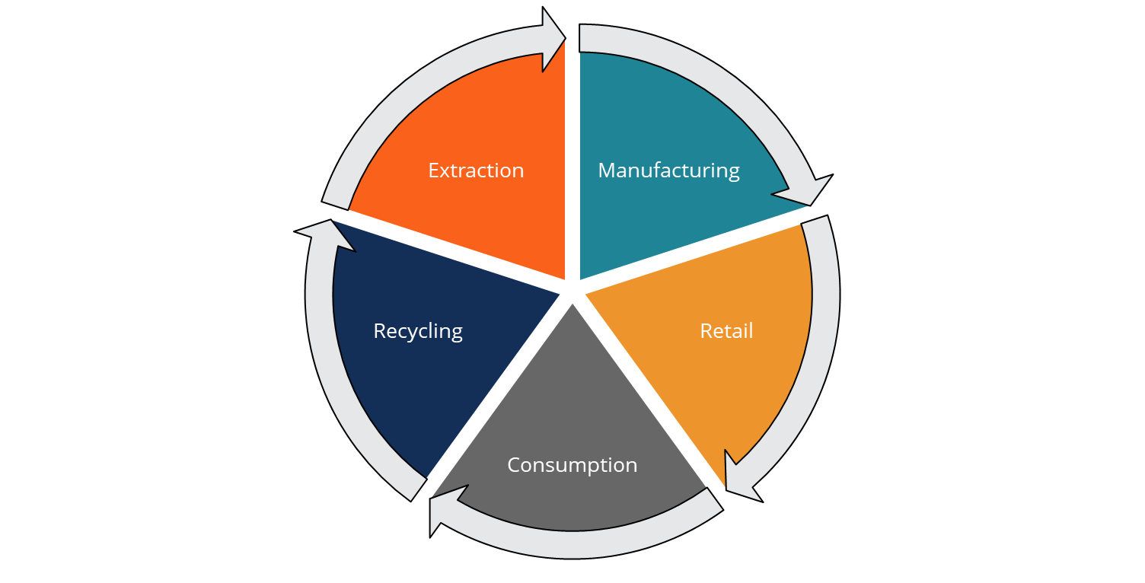
Thirdly, Jewel Print can choose who and where they purchase their metal from. Customers want a more transparent way of purchasing precious metals; Consumers want to know which mines their metal is sourced from, and the purity of the metal and the option to request recycled precious metals is on the rise. Bringing DCW’s manufacturing in-house will create more control over what impact the business has on a global consumption scale.
Figure 1 (CFI, 2021)
Naturally, the Jewel Print Business values are compatible with a circular economy - creating a start-to-finish production cell that follows the life of the pieces of jewellery beyond the workshop (see figure 1). Circular economies dictate that social, economic, and environmental impacts from a business are interdependent, with each aspect requiring individual attention to ensure maximum sustainability is achieved (Korhonena, 2018, pp. 37-46). DCW buys scrap metal and pieces of unwanted jewellery so they can be repurposed into new parts. In turn, Jewel Print could, in the future, reclaim and atomise recycled and scrap jewellery to offer the customer a sustainable and ethical piece of jewellery.

Time of implementation
When can we bring in the Innovation?
Currently, DCW has a Knowledge Transfer Partnership (KTP) with Birmingham’s School of Jewellery, with the objective to create the depth and breadth of research that lays the foundation stones for the start-up business. The financial and business plan forecast after the completion of the project in 2023, should see Jewel Print comfortably manufacturing all the Diamond Centre Wales production volumes.
In 2024 we want to expand our client portfolio to other jewellery design houses and offer them a service in which we provide them with green and complex production alternatives. We will aim to expand again year on year by 5%.
To complement our vast and extensive design rules, we would create a collection of jewellery that highlights the capabilities of 3D printing. This also creates another revenue stream for Business to Consumers (B2C) and further expands potential customisation to become an umbrella business that catches more customers. In 2025 the business aims to create a website portal bureau which will help them launch nationally and improve the customer buying experience.
Research and development will be a major cornerstone of jewel print; working with Sheffield University, Jewel Print aims to create a selective laser melting system of its own.

Market size and Scope for Jewel Print
The UK jewellery and luxury manufacturing and retail market are comprised of 4,310 retail jewellery shops in the UK as stated by the National Statistics (National Statistics, 2022)
- 1.41 billion GBP revenue from jewellery manufacturing in the UK
- Annual expenditure on jewellery and watches in the UK is £10,719M GBP
- Revenue in the UK per capita has risen steadily since 2017 (except for the Covid years, 2020, 2021) with the prediction it will keep rising through the next expected recession to 2027.
- With the cost of materials being so high and constantly fluctuating there is a large investment and initial outlay to start Jewel Print. An added difficulty is that there is a minimum order quantity is 2KG per metal.

Variable and Fixed costs:

We created figures for variable cost and fixed costs that would mimic what our day-to-day running of the project would need as well as a large capital expenditure of £375,000 for machinery and lab equipment, calculating that it would take 1.76 years to pay back the investment.
(12,026+39,432+375,000)/120,000 = 3.5 years until payback,

We calculated these figures, we needed to calculate how many units were required per week to not only breakeven, but ensure profitability to pay back investors, and what DCW unit cost per part looked like. A limitation we faced is that we could only reference/benchmark against what the Diamond centre and what their current production value costs for cast parts with an outsourced business.
 | Revenue | Cost
quantity | 25 | 25
weeks | 52 | 52
Price | £ 800.00 | £ 450.00
 | £1,040,000.00 | £585,000.00

An extra layer of complications arises when we take into consideration that metal prices fluctuate rapidly every day due to external factors such as wars, recessions and natural disasters which can all have an adverse effect on pricing.
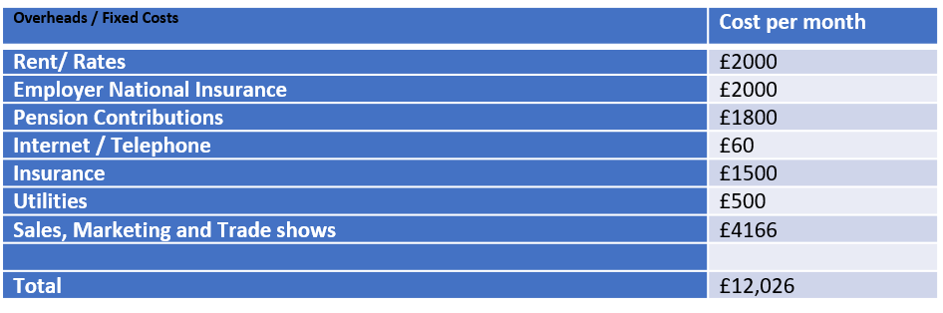
We considered the complications and were prudent with our cost estimations.

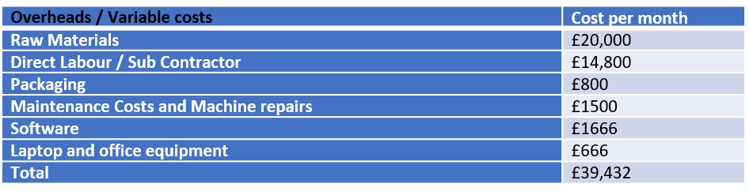

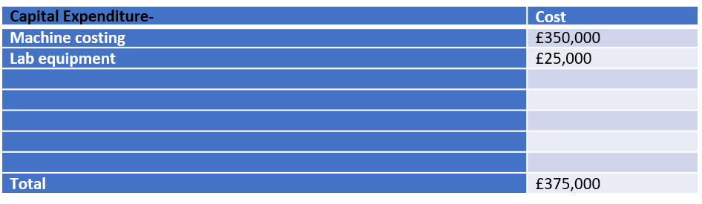

 | Price per G | Price per 2 KG | atomisation charge per KG
Silver | £16.20 | £4,009.84 | 1270.35 £/kg
18 Carat Yellow | £52.10 | £79,270.26 | 1270.31 £/kg
18 Carat Red Gold | £52.10 | £57,148.58 | 1270.31 £/kg
18 Carat White | £52.10 | £98,454.82 | 1270.31 £/kg
Platinum | £25.61 | £81,996.90 | 1270.31 £/kg
Total: |  | £320,771.94

Calculations:
Throughout this next section, I will explain the calculations of the projected business:
- The evidence shows the sales figures are expectedly high due to the cost of materials within this industry, this figure will be past over to the consumer to be charged appropriately. A 5% growth across each year is projected.
- Due to the rising sales from year 1 to 3, you can see this impacts the variable cost and makes it greater. The increase in material buying and labour can have a direct impact on the Variable costs.
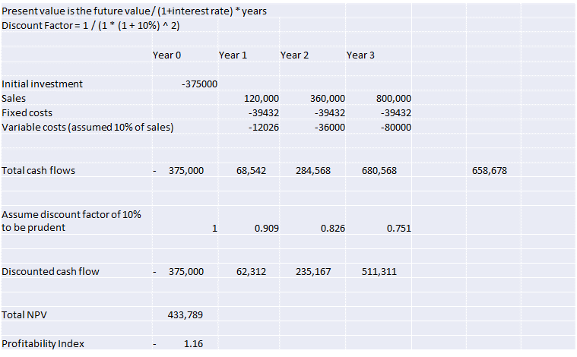
Figure 2 Calculations for costings
- A positive Net Present Value of £451,458 with the weighted average cost of capital (WACC) at 10%
- This created an Average rate of return of 73.5%
- Internal Rate of return: 49.8%
- And a profitability index of 1.2%
profitability Index | 1.203889 | £ 375,000

- These calculations as the most precise method for taking into into account the time value of money and the current risk to investors.

Barriers and mitigations to market
There are barriers to getting Jewel Print to market. The first row shows the difficulties we are predicting to encounter, and the second row is how we will mitigate these dangers.

Barriers and mitigations to market

Metal Prices are unregulated and hard to predict | Research not ready for commercialisation and production | Cost of bringing project may be too high, Return on investment too low | Global or a national recession may affect buying power from public | Lack of education in business could stifle the profits | Atomisation production for materials is limited and can create higher production and material cost.
Hedge funding to mitigate fluctuating prices, expansions into more stable priced metals | R&D Grant funding support through universities could speed up development | Funding, grants, and crowd funding | Create designs that suit different price point, move into industrial markets. | Trade shows and a strong marketing strategy can appeal | Future R&D projects

The research is not quite finished yet; we have at least 7 months of metal parameter development before we can comfortably launch to market. However, we have strong links to four universities that can support our endeavours and would like to be part of the research project. This may help speed the parameter development. With the capital needed being very large, investors may want a larger return.

Funding and R&D Tax claims

Grants
Using a Finance locator could isolate grants and financing opportunities that is specific the area of Jewel Print’s headquarters in Rhonda Cyon Taff. There are 238 grant and award opportunities that could help grow and establish Jewel Print.

Crowd Funding
Using Crowd and seed funding opportunities to bring capital into the business, secondly it launches the business to a vast network of people who are interested in that field. However, it could also complicate the funding situation; If criteria’s and goals aren’t met, this could have damaging image on the company.

Welsh Government funding
The positives of Jewel Print being located In Wales is the different finance option the Welsh assembly can offer; Business help and development can be externally funded to help develop staff and connect supporting networks

Research and Development tax relief
As Jewel Print is still in a Research and development phase, as an SME the business qualifies for tax relief and rebates. Machine and lab costs could create a sizable return to the business and put capital back at Jewel Prints disposal.

Conclusion
In conclusion, the cost of setting up Jewel Print are high and finding investors that are comfortable with investing in the unpredictable market of precious metals could be challenging. If investment is found, I would give the opinion this is a business that would give a quick return on investment as well as scope to grow as proven by the Payback 3.5 years.

With a business plan of constant innovation, building an implementing further revenue stream this can be an attractive manufacturing company to Jewellers looking for a sustainable alternative to casting. With Unit costs competitive to casting firms, Jewel print has the challenge of bringing its overheads in line with casting companies, if this can be achieved then I believe Jewel print Business model is a viable start-up.

References
CFI, 2021. Circular Economy. [Online]
Available at: https://corporatefinanceinstitute.com/resources/knowledge/economics/circular-economy/
[Accessed 21 09 2022].
Haworth, 2017. The history of metal casting part 1. [Online]
Available at: https://www.haworthcastings.co.uk/news/the-history-of-metal-casting-part-1
[Accessed 2 10 2022].
Korhonena, S. A. H. J., 2018. Circular Economy: The Concept and its Limitations. Ecological Economics, Volume 143, pp. 37-46.
National Statistics, 2022. Retail sales in watches and jewellery stores for Great Britain, January 2016 to December 2021. [Online]
Available at: https://www.ons.gov.uk/businessindustryandtrade/retailindustry/adhocs/14203retailsalesinwatchesandjewellerystoresforgreatbritainjanuary2016todecember2021
[Accessed 1 10 2022].

