Appendices
Appendix 1 -


CONSENT FORM

PROJECT TITLE: Research study ECAD6010

Name of Researcher:

Please initial box

1.I confirm that I have read and understand the information sheet dated 27/11/23 for the above study.

2. I understand that my child’s participation is voluntary and that I am free to withdraw my child from the study at any time, without giving any reason.

3. I understand that my child can choose to withdraw at any time, without giving a reason.

4. I understand that the information given by my child will be used in a university assignment.

5. I understand that my child’s name will not appear at any time.

6. I agree for my child to take part in the above study.

_____________________ _____________________________ __________
Child’s name Parent signature Date

When completed, please return to the class teacher by the 24/11/23

Thank you.

Appendix 2 -

INFORMATION sheet

PROJECT TITLE: Research study ECAD6010

Dear Parent / Guardian,

My name is Lily-May Newton, and I am studying for a BAEd qualification at Yr Athrofa, University of Wales Trinity Saint David. I am currently undertaking a research project withing your Childs class.

I would like to invite your child to participate in my research project. The title of the project is what strategies teachers use to promote positive behaviour in the class and I aim to gain a deeper understanding of different strategies used to promote positive behaviours. Through your child’s participation, I hope to ascertain how pupils experience different behaviour strategies used.

I hope to observe the learners as part of their everyday learning to see what strategies teacher uses to promote positive behaviour within their classroom. I would also like to interview some children so that I can explore how children feel regarding these strategies.

All names will be kept strictly confidential and will only be known by myself and my research partner. Your child’s participation in this study is completely voluntary so you or your child can withdraw from the study at any stage. Your child will also be asked to give their assent before the beginning of the study, I will ensure throughout this study that I ask your child’s assent during and after so I can ensure that your child is happy for me to use their answers and continue with my research.

After careful and precise analysis of the data obtained from the lesson observation and group interview, I would be happy to provide you with a copy of the findings at your request. The results of this study will be stored on a flash drive and all raw data will be destroyed once the assessment has been marked.

I thank you in advance for your time. If any questions do arise, feel free to contact me at your convenience.

Yours sincerely,

Lily-May Newton

Appendix 3 –
I would like to ask you some questions so I can understand what the behaviour in your class is like and what the teacher does to fix this, Is that okay?

All names will be kept strictly confidential and will only be known by myself and my research partner. Your participation in this study is completely voluntary so you can withdraw from the study at any stage.

Are you okay to start, what would you like your number to be?
Child Interview Questions:

Do you know what your school rules are?

What does the teacher do on a daily basis to get the attention of the class?

Can you tell me if you think this works?

How does this make you feel?

Think back to a time when there has been a behaviour problem in your class what did the teacher do to fix this?

What does the teacher do to help you want to behave in your class?

Following this does this make you want to behave more?

What rewards do you get in class?

How do you feel when your class is too loud and busy?

Who helps you overcome these emotions?

Is there somewhere you can go if you would like to go and calm down? If yes,
- How often do you use this?
- Do you have to ask to leave?
- How does the space make you feel?
- What is in this space that helps you?

Do you find the work in class too easy?
- Would you like the teacher to challenge you more?
- If yes, do you think you would enjoy class better if you were challenged more?

Do you enjoy the lessons in school?

What can your teacher do to help you more?

Thank you so much for you answers, I love… are you still okay for me to include these as part of my research with the name child…

Appendix 4 –
Teacher interview questions:

What strategies do you put in place in your class?

Do you feel like these strategies work?

Is there anything you don’t do that you think would be helpful?

Do you discuss with the children how they feel about these strategies?
-If yes, how do you go about asking them?

Do you see a difference in the children since implementing these strategies?

Do the children get to choose the reward they get or are they all the same?
What are the rewards?

What behaviour strategy do you think works best?

Appendix 5 –
Codes / Key
Strategies
Perspectives
Improvements
Behaviour issues
Triggers

Child interviews
Child 1 -
Question one – the teacher claps to get our attention when all the children are chatting in the classroom
Question two – no all the children still talk one the teacher asks us all to listen
Question three – they come and talk to us privately and ask us what’s wrong and what they can do to help
Question four – they give us dojos and sometimes we can go and behave
Question five – they give us rewards if we come to school and they also give us dojos If were good in class
Question six – making me feel angry as I can’t concentrate and do my work in class
Question seven – we go to a different classroom to calm down with a new teacher there is a calm concerned bit I don’t like it because people can see me go in there
Question eight - I enjoy the lessons we get inn class but sometimes it’s too loud ad I can’t concentrate
Question nine – ask us what we want to learn about so I will enjoy the lessons a little more
Question ten – ready respectful safe
Question eleven – the behaviour charter doesn’t work they still don’t behave

Child 2 -
Question 1 – the teacher shouts be quiet to us when we are all talking
Question 2 – it doesn’t work it makes them louder
Question 3 – they send us out the classroom if we don’t behave
Question 4 – they let us play a little more if we behave
Question 5 – they give jems if we behave and they phone home if we don’t behave
Question 6 – when the classroom is loud and noisy it makes my head feel windy and like everything is floating around in my head
Question 7 – we get sent out to a different class
Question 8 - I don’t enjoy the lessons I like doing science though as its fun
Question 9 - I would like them to ask the children to be quieter when I'm trying to learn
Question 10 - I don’t know my school rules
Question 11 –when I get a yellow card I don’t really care

Child 3 -
Question 1 – they count down from thee to get our attention when all were talking all the time
Question 2 – yes, we all go quiet because we have to be ready to learn
Question 3 – they tell the other children what they’re doing well
Question 4 – we get dojos which my mum can see, and she tells me I did good in school but sometime my dad gets angry when I'm naughty
Question 5 – Dojos
Question 6 – it makes me scared when the class to too loud
Question 7 - I can go to a quiet corner in the classroom if I need a place to go to calm down
Question 8 - I like the lessons sometimes but I really don’t like maths because the class get noisy in class
Question 9 – different rewards when were good, my mum doesn’t really look at my dojo so if I'm good she doesn't see it
Question 10 – I’m not sure what our school rules are
Question 11 - I think the behaviour charter works for me because I don’t want to get a red card, but some people get them all the time.

Child 4 -
Question 1 – they say class, class, class and we repeat
Question 2 – yes it gets our attention and makes most of us be quiet, but some people still keep on talking.
Question 3 – they wait until we are working, and they come and ask us what happened and what they can do to help
Question 4 – we have dojos when were good and they can take them away when were not
Question 5 – we get milkshake with the head if we get a certain amount of dojos, and we get phone call home if were good and sometime if were not good which I don’t like
Question 6 – I get a bit nervous when the class is noisy, and I like to have my ear defenders to help reduce the noise but sometimes I like to leave the room as that’s easier.
Question 7 – I can leave my class if I want to, or I can get my ear defenders and miss has a quiet corner I can go to which has books and fidget toys my favourite is the duck.
Question 8 – I don’t like pe at all the class is too loud and I can’t leave anywhere if it gets too noise because were outside
Question 9 – I would like the class to be quieter when I’m trying to learn and give us a small toy when we’re being extra good
Question 10 – ready respectful and safe
Question 11 – it doesn’t work sometimes I can’t help what I do because I just want to leave the room

Appendix 6 –
Teacher interviews
Participant 1
Question 1 - I like to use dojos and rip and pip in my class as the children like to hear the noise when they receive one and they have a competition of who can get the highest. There is also life skills and lunch club
Question 2 – they can work sometimes but it depends on the relationship you have with the children.
Question 3 – I feel like I give them lots of opportunities to improve their behaviour
Question 4 – no I’ve never really taken what they think about what I do into consideration
Question 5 – I can in some pupils, but I don’t think dojos work for some pupils in my class
Question 6 – not the children don’t get to choose their rewards
Question 7 – I still think dojos work the best in schools

Participant 2
Question 1 – to help the behaviour in my class I like to chunk my lessons and use dojos so they are shorter, and the children can then have regular brain breaks we have life skills club for them too
Question 2 – yes, they get a lot of their energy out when they have a brain break
Question 3 – I don’t have a visual timetable, but I think that would be good for the ALN learners to see their routine for the day
Question 4 – no there isn’t much time
Question 5 – yes, they are more engaged with the lesson, so they behave better
Question 6 – no they don’t get to choose their reward
Question 7 – I think that chunking works best as they are getting regular breaks throughout the day to burn off excess energy

Participant 3
Question 1 – differentiation, dojos and supporting them in life skills sessions and offering them to go to lunch club
Question 2 – yes if the work is too easy/hard they won’t engage with it and are more likely to misbehave
Question 3 – I don’t have any differentiated dictionary, but I think that would really help the ALN learners in my class
Question 4 – yes as part of our class ethos we chose the strategies I use in my class
Question 5 – yes, they are more engaged with their learning when the work is the right level for them
Question 6 – yes, we chose it when creating our class ethos
Question 7 – I definitely think differentiation works the best for ALN learner

Participant 4
Question 1 – I ignore the bad behaviour, but I praise the good behaviour as positive role models they can also go to life skills where they learn what they wouldn’t in the class
Question 2 – yes when their friend gets a dojo, they want one too
Question 3 – I don’t have a visual timetable in my class, but I think it would be helpful for the learners and me!
Question 4 – no
Question 5 – yes, they know what I expect from them
Question 6 – no
Question 7- Positive role models

Participant 5
Question 1 – I use gems and a peg system, but the school also has life skills which helps with their behaviour where they move their peg along the washing line depending on how many gems, they have to get golden time. The whole school also uses a system called RIP AND PIP
Question 2 – yes, they like getting gems and help around the class to try and get them
Question 3 – yeah, I feel like I could celebrate the strengths of all my learners to show that we all are different, but we all have good qualities
Question 4 – no not really
Question 5 – yes, they prefer having actual gems rather than dojos
Question 6 – no
Question 7 – I think that any form of positive praise and rewards work best to improve the behaviour of children

What strategies do teachers use to promote the positive behaviour of ALN pupils and what are pupil’s opinions on these strategies?
Focus: Strategies and pupils’ opinion |  |  | Goal: Finding out the strategies and the pupils experiences of those.
Date: 30/11/23 |  |  | Time Scale: 1 hour
Child 1:  Behaviour issue: Gets aggressive, starting kicking  Potential Triggers: Not being picked, losing  Strategies teacher used: Planned ignore, giving them a choice, giving them space  How did this impact the child? the child seemed to calm down in their own time he was able to regulate his feelings on his own and re-join the lesson. |  |  | Child 2:  Behaviour issue: doesn’t engage with the lesson, walks off  Potential Triggers: if their friends are in the game, they don’t want to play against them  Strategies teacher used: speak privately to the child, given time  How did this impact the child? the child didn’t move for the whole lesson, wouldn’t engage.
Strategy used | Rating  1 – 5 (See scale below) | Reasoning |  | Any extra Notes:
Planned ignore | 5 | When the teacher ignored the child’s behaviour they came back and engaged with the lesson in their own time
choice | 4 | When the teacher provides the child with a choice, they think about what they want to happen and make their decision based on the consequences of those choices
Speak privately | 2 | The child said yeah well, I don’t want to listen to you let me freeze so they were engaging with what the teacher was saying and doing what he wanted to do
space | 1 | When they give the child space the child continues with that behaviour and doesn’t think they’re doing anything wrong because the teacher has let them just run away. If you want to go over there then go
Appendix 7 –

1 – Teacher used the behaviour strategy however, the child still continued to portray that behaviour, so the strategy hasn’t been beneficial.
2 – Teacher uses the behaviour strategy, where the child acknowledges the strategy however does not engage with the teacher at all, so the strategy hasn’t worked.
3 – The behaviour strategy used hasn’t really had an effect, it was used and acknowledged but the behaviour continues.
4 – The behaviour strategy used has had an effect the child has calmed down slightly and is starting to engage with the teacher.
5 – The behaviour strategy used completely stopped this behaviour and worked for this child, now the teacher has the full engagement of this child.

Appendix 8 –
APPLICATION FOR ETHICAL APPROVAL

RESEARCH STUDENTS
This form is to be completed by the student within SIX months for full-time students and TWELVE months for part time students, after the commencement of the research degree or following progression to Part Two of your course.

Once complete, submit this form via the MyTSD Doctoral College Portal at (https://mytsd.uwtsd.ac.uk).

This document is also available in Welsh.

RESEARCH STAFF ONLY
All communications relating to this application during its processing must be in writing and emailed to pgresearch@uwtsd.ac.uk , with the title ‘Ethical Approval’ followed by your name.

STUDENTS ON UNDERGRADUATE OR TAUGHT MASTERS PROGRAMMES should submit this form (and receive the outcome) via systems explained to you by the supervisor/module leader.

In order for research to result in benefit and minimise risk of harm, it must be conducted ethically. A researcher may not be covered by the University’s insurance if ethical approval has not been obtained prior to commencement.

The University follows the OECD Frascati manual definition of research activity: “creative work undertaken on a systematic basis in order to increase the stock of knowledge, including knowledge of man, culture and society, and the use of this stock of knowledge to devise new applications”. As such this covers activities undertaken by members of staff, postgraduate research students, and both taught postgraduate and undergraduate students working on dissertations/projects.

The individual undertaking the research activity is known as the “principal researcher”.

Ethical approval is not required for routine audits, performance reviews, quality assurance studies, testing within normal educational requirements, and literary or artistic criticism.

Please read the notes for guidance before completing ALL sections of the form.

This form must be completed and approved prior to undertaking any research activity. Please see Checklist for details of process for different categories of application.

SECTION A: About You (Principal Researcher)
1 | Full Name: |  | Lily-May Newton
2 | Tick all boxes that apply: |  | Member of staff: | ☐ | Honorary research fellow: | ☐
 | Undergraduate Student | ☒ | Taught Postgraduate Student | ☐ | Postgraduate Research Student | ☐

3 | Institute/Academic Discipline/Centre:
4 | Campus:
5 | E-mail address:
6 | Contact Telephone Number:
 | For students:
7 | Student Number: | 2106147
8 | Programme of Study: | BA primary education with QTS
9 | Director of Studies/Supervisor: | Julia Holloway

SECTION B: Approval for Research Activity
1 | Has the research activity received approval in principle?  (please check the Guidance Notes as to the appropriate approval process for different levels of research by different categories of individual) |  | YES | ☒ | NO | ☐
 |  |  |  |  | Date
2 | If Yes, please indicate source of approval (and date where known): Approval in principle must be obtained from the relevant source prior to seeking ethical approval | Research Degrees Committee |  | ☐
2 |  | Institute Research Committee |  | ☐
2 |  | Julia Holloway (Module Lead) |  | ☒ | 16/11/23

SECTION C: Internal and External Ethical Guidance Materials
 | Please list the core ethical guidance documents that have been referred to during the completion of this form (including any discipline-specific codes of research ethics, location-specific codes of research ethics, and also any specific ethical guidance relating to the proposed methodology). Please tick to confirm that your research proposal adheres to these codes and guidelines. You may add rows to this table if needed.
1 | UWTSD Research Ethics & Integrity Code of Practice | ☒
2 | UWTSD Research Data Management Policy | ☒
3 | UWTSD Code of ethics plus discipline specific codes of ethical research | ☒

SECTION D: External Collaborative Research Activity
If there are external collaborators then you should gain consent from the contact persons to share their personal data with the university. If there are no external collaborators then leave this section blank and continue to section E.
1 | Institution
2 | Contact person name
3 | Contact person e-mail address
4 | Is your research externally funded? |  | YES | ☐ | NO |  | ☒
5 | Are you in receipt of a KESS scholarship? |  | YES | ☐ | NO |  | ☒
6 | Are you specifically employed to undertake this research in either a paid or voluntary capacity? | Voluntary | YES | ☐ | NO | ☒
7 |  | Employed | YES | ☐ | NO | ☒
8 | Is the research being undertaken within an existing UWTSD Athrofa Professional Learning Partnership (APLP)? | If YES then the permission question below does not need to be answered. | YES | ☐ | NO |  | ☒
9 | Has permission to undertake the research has been provided by the partner organisation? | (If YES attach copy)  If NO the application cannot continue | YES | ☐ | NO |  | ☒

Where research activity is carried out in collaboration with an external organisation
10 | Does this organisation have its own ethics approval system? | YES | ☐ | NO | ☒
 | If Yes, please attach a copy of any final approval (or interim approval) from the organisation (this may be a copy of an email if appropriate).

SECTION E: Details of Research Activity
1 | Indicative title: | An exploratory case study arising from practice (noticing) and investigated further through identified research tools. The assignment concludes with the identification of an intervention which can be piloted throughout Professional Teaching Experience and evidenced through reflection in the Professional Learning Standards.
2 | Proposed start date: | 27/11/23 | Proposed end date: | 1/12/23
Introduction to the Research (maximum 300 words per section)
Ensure that you write for a Non-Specialist Audience when outlining your response to the points below:
- Purpose of Research Activity
- Proposed Research Question
- Aims of Research Activity
- Objectives of Research Activity
Demonstrate, briefly, how Existing Research has informed the proposed activity and explain
- What the research activity will add to the body of knowledge
- How it addresses an area of importance.
3 | Purpose of Research Activity  To explore how teachers promote positive behaviour in the classroom and children’s experiences of these strategies in order for me to become better practitioner for my learners in the future.  (this box should expand as you type)
4 | Research Question  What strategies do teachers use to promote the positive behaviour of ALN pupils and what are pupils opinions on these strategies?  (this box should expand as you type)
5 | Aims of Research Activity  To explore a range of research tools which will help me to gain a deeper understanding of how different teachers promote positive behaviour in their classrooms and how pupils perceive these strategies.  (this box should expand as you type)
6 | Objectives of Research Activity  - To use a case study approach to gather information.  - To interview leaners and teachers regarding positive behaviours in their classroom and how they experience these.  - To use a questionnaire to get feedback of how teachers promote positive behaviour.  - To observe different teacher’s strategies of promoting positive behaviour in the classroom to understand how children perceive these strategies.  (this box should expand as you type)
Proposed methods (maximum 600 words)
Provide a brief summary of all the methods that may be used in the research activity, making it clear what specific techniques may be used. If methods other than those listed in this section are deemed appropriate later, additional ethical approval for those methods will be needed. You do not need to justify the methods here, but should instead describe how you intend to collect the data necessary for you to complete your project.
7 | In order to gather this information, I will be using a case study approach which allows you to generate an in-depth multi-faceted understanding of complex issues in real-life context. To do this I will use, questionnaires which I intend to send out to multiple teachers within the school. These will be sent out electronically and will be kept confidential and, on a password, protected laptop. I will also be conducting interviews with both learners and teachers, I aim to audio record these interviews, providing I have consent, and these will be kept on a separate flash drive and once transcribed will be destroyed. Finally, I will also be observing the strategies the teacher uses within their classroom making observation notes regarding pupil behaviour improvement or body language. Again all observations will be confidential (Child A etc).  (this box should expand as you type)
Location of research activity
Identify all locations where research activity will take place.
8 | This research will be taking place in a large sized rural school consisting of over 500 learners within south Wales. The school aims to provide a safe and inclusive environment that promotes pupils well-being.  (this box should expand as you type)
Research activity outside of the UK
If research activity will take place overseas, you are responsible for ensuring that local ethical considerations are complied with and that the relevant permissions are sought. Specify any local guidelines (e.g. from local professional associations/learned societies/universities) that exist and whether these involve any ethical stipulations beyond those usual in the UK (provide details of any licenses or permissions required). Also specify whether there are any specific ethical issues raised by the local context in which the research activity is taking place, for example, particular cultural and/or legal sensitivities or vulnerabilities of participants. If you live in the country where you will do the research then please state this.
9 | (this box should expand as you type)

10 | Use of documentation not in the public domain: Are any documents NOT publicly available? | NO | ☒
10 |  | YES | ☐
11 | If Yes, please provide details here of how you will gain access to specific documentation that is not in the public domain and that this is in accordance with the current data protection law of the country in question and that of England and Wales.  (this box should expand as you type)
 | Does your research relate to one or more of the seven aims of the Well-being of Future Generations (Wales) Act 2015? | YES | NO
12 | A prosperous Wales | ☒ | ☐
13 | A resilient Wales | ☒ | ☐
14 | A healthier Wales | ☒ | ☐
15 | A more equal Wales | ☒ | ☐
16 | A Wales of cohesive communities | ☒ | ☐
17 | A Wales of vibrant culture and thriving Welsh language | ☐ | ☒
18 | A globally responsible Wales | ☐ | ☒
19 | If YES to any of the above, please give details:
As my research is looking into the behaviour of ALN pupils and how teachers promote positive behaviours in the classroom, this links to the well being of all the pupils which in turn helps to magnify a more equal and inclusive Wales.

(this box should expand as you type)

SECTION F: Scope of Research Activity
 | Will the research activity include: | YES | NO
1 | Use of a questionnaire or similar research instrument? | ☒ | ☐
2 | Use of interviews? | ☒ | ☐
3 | Use of focus groups? | ☐ | ☒
4 | Use of participant diaries? | ☐ | ☒
5 | Use of video or audio recording? | ☒ | ☒
6 | Use of computer-generated log files? | ☐ | ☒
7 | Participant observation with their knowledge? | ☒ | ☐
8 | Participant observation without their knowledge? | ☐ | ☒
9 | Access to personal or confidential information without the participants’ specific consent? | ☐ | ☒
10 | Administration of any questions, test stimuli, presentation that may be experienced as physically, mentally or emotionally harmful / offensive? | ☐ | ☒
11 | Performance of any acts which may cause embarrassment or affect self-esteem? | ☐ | ☒
12 | Investigation of participants involved in illegal activities? | ☐ | ☒
13 | Use of procedures that involve deception? | ☐ | ☒
14 | Administration of any substance, agent or placebo? | ☐ | ☒
15 | Working with live vertebrate animals? | ☐ | ☒
16 | Procedures that may have a negative impact on the environment? | ☐ | ☒
17 | Other primary data collection methods. Please indicate the type of data collection method(s) below. | ☐ | ☒
 | Details of any other primary data collection method:  (this box should expand as you type) | ☐ | ☒
If NO to every question, then the research activity is (ethically) low risk and may be exempt from some of the following sections (please refer to Guidance Notes).

If YES to any question, then no research activity should be undertaken until full ethical approval has been obtained.

SECTION G: Intended Participants
If there are no participants then do not complete this section, but go directly to section H.

 | Who are the intended participants: | YES | NO
1 | Students or staff at the University? | ☐ | ☒
2 | Adults (over the age of 18 and competent to give consent)? | ☒ | ☐
3 | Vulnerable adults? | ☐ | ☒
4 | Children and Young People under the age of 18? (Consent from Parent, Carer or Guardian will be required) | ☒ | ☐
5 | Prisoners? | ☐ | ☒
6 | Young offenders? | ☐ | ☒
7 | Those who could be considered to have a particularly dependent relationship with the investigator or a gatekeeper? | ☐ | ☒
8 | People engaged in illegal activities? | ☐ | ☒
9 | Others. Please indicate the participants below, and specifically any group who may be unable to give consent. | ☐ | ☒
 | Details of any other participant groups: | ☐ | ☒

Participant numbers and source
Provide an estimate of the expected number of participants. How will you identify participants and how will they be recruited?
10 | How many participants are expected? | Approximately 4 pupils interviews  Approximately 4 teacher interviews  Approximately 2 class observations with up to 60 pupils
11 | Who will the participants be? | Learners, teachers and me
12 | How will you identify the participants? | The teacher interviews will be those ALN classes if they would like to participate.  I will ask the teacher which pupils would be suitable to interview, providing they have consent.

 | Information for participants: | YES | NO | N/A
13 | Will you describe the main research procedures to participants in advance, so that they are informed about what to expect? | ☒ | ☐ | ☐
14 | Will you tell participants that their participation is voluntary? | ☒ | ☐ | ☐
15 | Will you obtain written consent for participation? | ☒ | ☐ | ☐
16 | Will you explain to participants that refusal to participate in the research will not affect their treatment or education (if relevant)? | ☒ | ☐ | ☐
17 | If the research is observational, will you ask participants for their consent to being observed? | ☒ | ☐ | ☐
18 | Will you tell participants that they may withdraw from the research at any time and for any reason? | ☒ | ☐ | ☐
19 | With questionnaires, will you give participants the option of omitting questions they do not want to answer? | ☒ | ☐ | ☐
20 | Will you tell participants that their data will be treated with full confidentiality and that, if published, it will not be identifiable as theirs? | ☒ | ☐ | ☐
21 | Will you debrief participants at the end of their participation, in a way appropriate to the type of research undertaken? | ☒ | ☐ | ☐
22 | If NO to any of above questions, please give an explanation
 | (this box should expand as you type)

 | Information for participants: | YES | NO | N/A
24 | Will participants be paid? | ☐ | ☒ | ☐
25 | Is specialist electrical or other equipment to be used with participants? | ☐ | ☒ | ☐
26 | Are there any financial or other interests to the investigator or University arising from this study? | ☐ | ☒ | ☐
27 | Will the research activity involve deliberately misleading participants in any way, or the partial or full concealment of the specific study aims? | ☐ | ☒ | ☐
28 | If YES to any question, please provide full details
 | (this box should expand as you type)

SECTION H: Anticipated Risks

Outline any anticipated risks that may adversely affect any of the participants, the researchers and/or the University, and the steps that will be taken to address them.

If you have completed a full risk assessment (for example as required by a laboratory, or external research collaborator) you may append that to this form.
1 | Full risk assessment completed and appended? |  | Yes | ☐
1 |  |  | No | ☒
2 | Risks to participants  For example: sector-specific health & safety, emotional distress, financial disclosure, physical harm, transfer of personal data, sensitive organisational information
 | Risk to participants:  - Could cause emotional distress  - There could be sensitive information | How you will mitigate the risk to participants:  - I will ensure that all pupils feel like they are within a safe space and that they do not have to participate of they don’t want to, and they can withdraw from this experience at any time they like. I will also conduct these interviews in a space the pupils feel comfortable talking to me in.  - All information given will be kept anonymised and I will be making notes on what I see so I wont be directly having access to keep these documents, but I will be able to see and make notes.
3 | If research activity may include sensitive, embarrassing or upsetting topics (e.g. sexual activity, drug use) or issues likely to disclose information requiring further action (e.g. criminal activity), give details of the procedures to deal with these issues, including any support/advice (e.g. helpline numbers) to be offered to participants. Note that where applicable, consent procedures should make it clear that if something potentially or actually illegal is discovered in the course of a project, it may need to be disclosed to the proper authorities
 | If any sensitive topics are disclosed during my research, I will ensure that I listen to the individual and inform that I will have to promptly pass this information on to the correct safeguarding personnel.
4 | Risks to the investigator  For example: personal health & safety, physical harm, emotional distress, risk of accusation of harm/impropriety, conflict of interest
 | Risk to the investigator:  - Accusations | How you will mitigate the risk to the investigator:  - I will ensure that the door is kept open at all times during my research and that a staff member knows where I am for my own personal safety and all interviews will be recorded.
5 | University/institutional risks  For example: adverse publicity, financial loss, data protection
 | Risk to the University:  - Researcher affecting the image of the University.  - Affecting the relations between school and university. | How you will mitigate the risk to the University:  - I will make sure that I behave in a professional matter at all times conducting myself professionally.
6 | Environmental risks  For example: accidental spillage of pollutants, damage to local ecosystems
 | Risk to the environment:  General health and safety | How you will mitigate the risk to environment:  - I will ensure that I am following all relevant and up to date health and safety regulations to avoid any harm to the children or myself.

 | Disclosure and Barring Service
 | If the research activity involves children or vulnerable adults, a Disclosure and Barring Service (DBS) certificate must be obtained before any contact with such participants. | YES | NO | N/A
7 | Does your research require you to hold a current DBS Certificate? | ☒ | ☐ | ☐
8 | If YES, please give the certificate number. If the certificate number is not available, please write “Pending”; in this case any ethical approval will be subject to providing the appropriate certificate number.

SECTION I: Feedback, Consent and Confidentiality

1 | Feedback  What de-briefing and feedback will be provided to participants, how will this be done and when?
 | Thank them for taking part and answering the questionnaires, asking again that I still have assent, is there anything they want to ask me, how are you feeling? Ensuring that I’m checking they’re okay throughout.
2 | Informed consent  Describe the arrangements to inform potential participants, before providing consent, of what is involved in participating. Describe the arrangements for participants to provide full consent before data collection begins. If gaining consent in this way is inappropriate, explain how consent will be obtained and recorded in accordance with prevailing data protection legislation.
 | An information sheet and consent form will be sent to all learner’s parents/cares beforehand to ensure that I have consent to carry out this research.
3 | Confidentiality / Anonymity  Set out how anonymity of participants and confidentiality will be ensured in any outputs. If anonymity is not being offered, explain why this is the case.
 | I will keep confidentially by ensuring that all data is stored on a flash drive which will be destroyed once completing my assignment. I will ensure anonymity by referring to the child as Child 123 and will be redacting the school’s information. All paper copies of the transcript will be kept in a locked file and will be destroyed afterwards.

SECTION J: Data Protection and Storage

 | Does the research activity involve personal data (as defined by the General Data Protection Regulation 2016 “GDPR” and the Data Protection Act 2018 “DPA”)? | YES | NO
1 | “Personal data” means any information relating to an identified or identifiable natural person (‘data subject’). An identifiable natural person is one who can be identified, directly or indirectly, in particular by reference to an identifier such as a name, an identification number, location data, an online identifier or to one or more factors specific to the physical, physiological, genetic, mental, economic, cultural or social identity of that natural person. Any video or audio recordings of participants is considered to be personal data. | ☐ | X
 | If YES, provide a description of the data and explain why this data needs to be collected:
2 | (this box should expand as you type)
 | Does it involve special category data (as defined by the GDPR)? | YES | NO
3 | “Special category data” means sensitive personal data consisting of information as to the data subjects’ –  (a) racial or ethnic origin,  (b) political opinions,  (c) religious beliefs or other beliefs of a similar nature,  (d) membership of a trade union (within the meaning of the Trade Union and Labour Relations (Consolidation) Act 1992),  (e) physical or mental health or condition,  (f) sexual life,  (g) genetics,  (h) biometric data (as used for ID purposes), | ☐ | X
 | If YES, provide a description of the special category data and explain why this data needs to be collected:
4 | (this box should expand as you type)

 | Will data from the research activity (collected data, drafts of the thesis, or materials for publication) be stored in any of the following ways? | YES | NO
5 | Manual files (i.e. in paper form)? | ☒ | ☐
6 | University computers? | ☐ | ☒
7 | Private company computers? | ☐ | ☒
8 | Home or other personal computers? | ☒ | ☐
9 | Laptop computers/ CDs/ Portable disk-drives/ memory sticks? | ☒ | ☐
10 | “Cloud” storage or websites? | ☒ | ☐
11 | Other – specify: | ☐ | ☒
12 | For all stored data, explain the measures in place to ensure the security of the data collected, data confidentiality, including details of backup procedures, password protection, encryption, anonymisation and pseudonymisation:
For paper data I will keep these in a locked file, and they will be destroyed directly after completing my assignment.
For memory sticks I will keep this on my person at all times and once completed I will destroy it.
My laptop will be locked at all times.

 | Data Protection
 | Will the research activity involve any of the following activities: | YES | NO
13 | Electronic transfer of data in any form? | ☐ | ☒
14 | Sharing of data with others at the University outside of the immediate research team? | ☐ | ☒
15 | Sharing of data with other organisations? | ☐ | ☒
16 | Export of data outside the UK or importing of data from outside the UK? | ☐ | ☒
17 | Use of personal addresses, postcodes, faxes, emails or telephone numbers? | ☐ | ☒
18 | Publication of data that might allow identification of individuals? | ☐ | ☒
19 | Use of data management system? | ☐ | ☒
20 | Data archiving? | ☐ | ☒
21 | If YES to any question, please provide full details, explaining how this will be conducted in accordance with the GDPR and Data Protection Act (2018) (and any international equivalents, where appropriate):
 | (this box should expand as you type)
22 | List all who will have access to the data generated by the research activity:
Myself and my mentor

(this box should expand as you type)
23 | List who will have control of, and act as custodian(s) for, data generated by the research activity:
Myself

(this box should expand as you type)
24 | Give details of data storage arrangements, including security measures in place to protect the data, where data will be stored, how long for, and in what form. Will data be archived – if so how and if not why not.
For paper data I will keep these in a locked file, and they will be destroyed directly after completing my assignment.
For memory sticks I will keep this on my person at all times and once completed I will destroy it.
My laptop will be locked at all times.
Data will not be archived but will be transcribed.
All data will be kept until transcribed; I will be destroying this data on the 9/1/24.

(this box should expand as you type)
25 | Please indicate if your data will be stored in the UWTSD Research Data Repository (see https://researchdata.uwtsd.ac.uk/ ). If so, please explain. (Most relevant to academic staff)
No

(this box should expand as you type)
26 | Confirm that you have read the UWTSD guidance on data management (see https://www.uwtsd.ac.uk/library/research-data-management/) | YES | ☒
27 | Confirm that you are aware that you need to keep all data until after your research has completed or the end of your funding | YES | ☒

SECTION K: Declaration
The information which I have provided is correct and complete to the best of my knowledge. I have attempted to identify any risks and issues related to the research activity and acknowledge my obligations and the rights of the participants.

In submitting this application I hereby confirm that I undertake to ensure that the above named research activity will meet the University’s Research Ethics and Integrity Code of Practice which is published on the website: https://www.uwtsd.ac.uk/research/research-ethics/
1 | Signature of applicant: | Lily-May Newton | Date: 16/11/23

For STUDENT Submissions:
2 | Director of Studies/Supervisor: | Julia Holloway | Date: 16/11/23
3 | Signature: | Lily-May Newton | Date: 16/11/23

For STAFF Submissions:
4 | Academic Director/ Assistant Dean: |  | Date:
5 | Signature: |  | Date:

Checklist: Please complete the checklist below to ensure that you have completed the form according to the guidelines and attached any required documentation:
☒ | I have read the guidance notes supplied before completing the form.
☒ | I have completed ALL RELEVANT sections of the form in full.
☒ | I confirm that the research activity has received approval in principle
☒ | I have attached a copy of final/interim approval from external organisation (where appropriate)
☐ | I have attached a full risk assessment (where appropriate) ONLY TICK IF YOU HAVE ATTACHED A FULL RISK ASSESSMENT
☒ | I understand that it is my responsibility to ensure that the above named research activity will meet the University’s Research Ethics and Integrity Code of Practice.
☒ | I understand that before commencing data collection all documents aimed at respondents (including information sheets, consent forms, questionnaires, interview schedules etc.) must be confirmed by the DoS/Supervisor, module tutor or Academic Director.

RESEARCH STUDENTS ONLY
Once complete, submit this form via the MyTSD Doctoral College Portal at (https://mytsd.uwtsd.ac.uk).

RESEARCH STAFF ONLY
All communications relating to this application during its processing must be in writing and emailed to pgresearch@uwtsd.ac.uk , with the title ‘Ethical Approval’ followed by your name.

STUDENTS ON UNDERGRADUATE OR TAUGHT MASTERS PROGRAMMES should submit this form (and receive the outcome) via systems explained to you by the supervisor/module leader.

Appendix 9 –

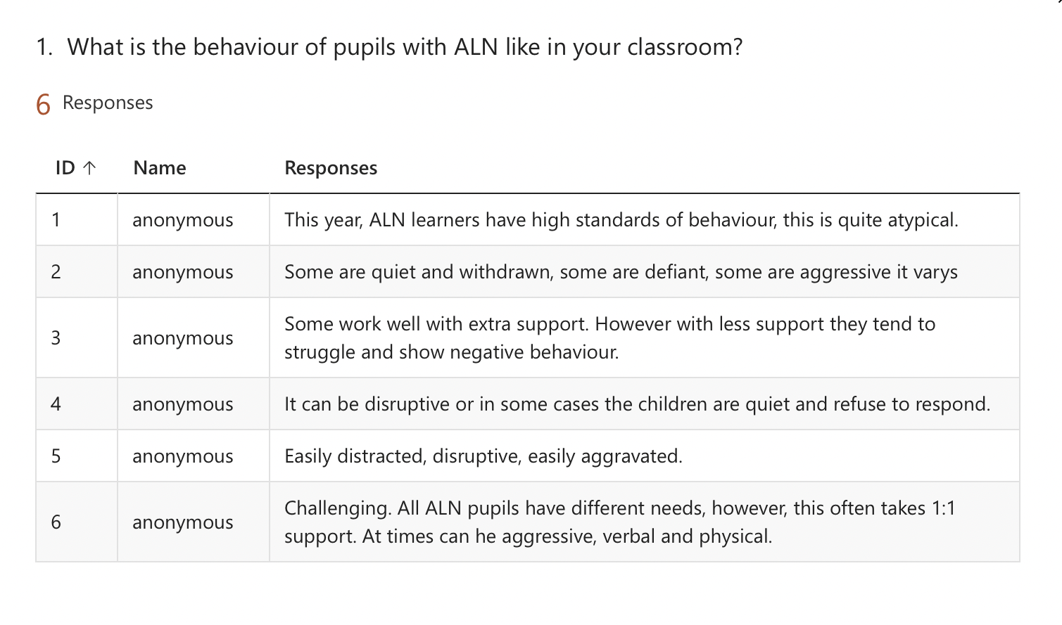
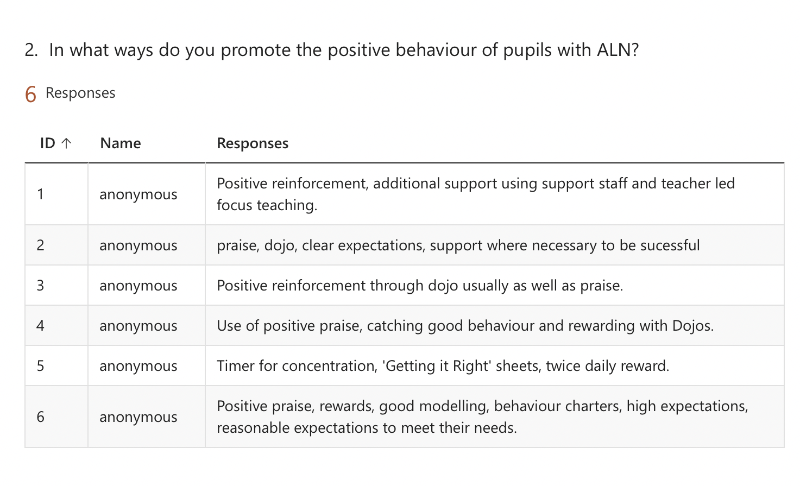
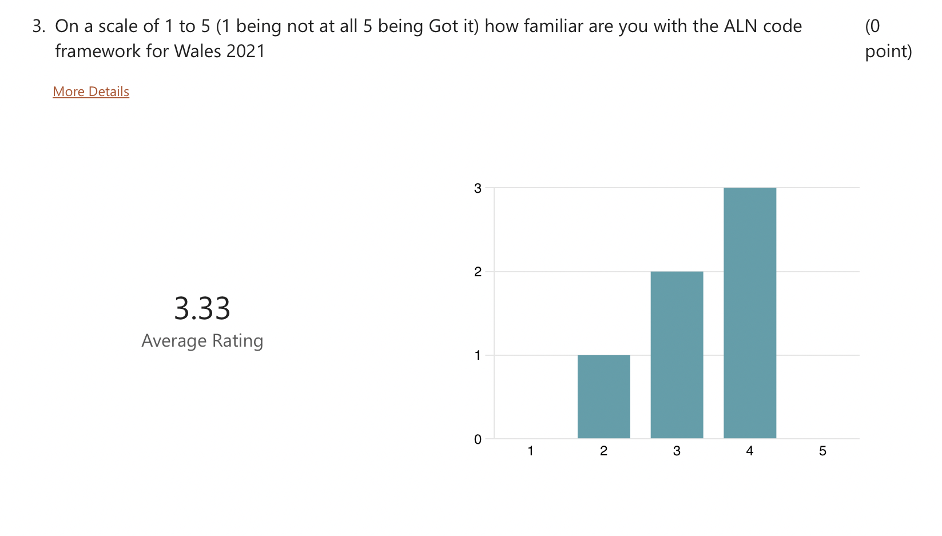

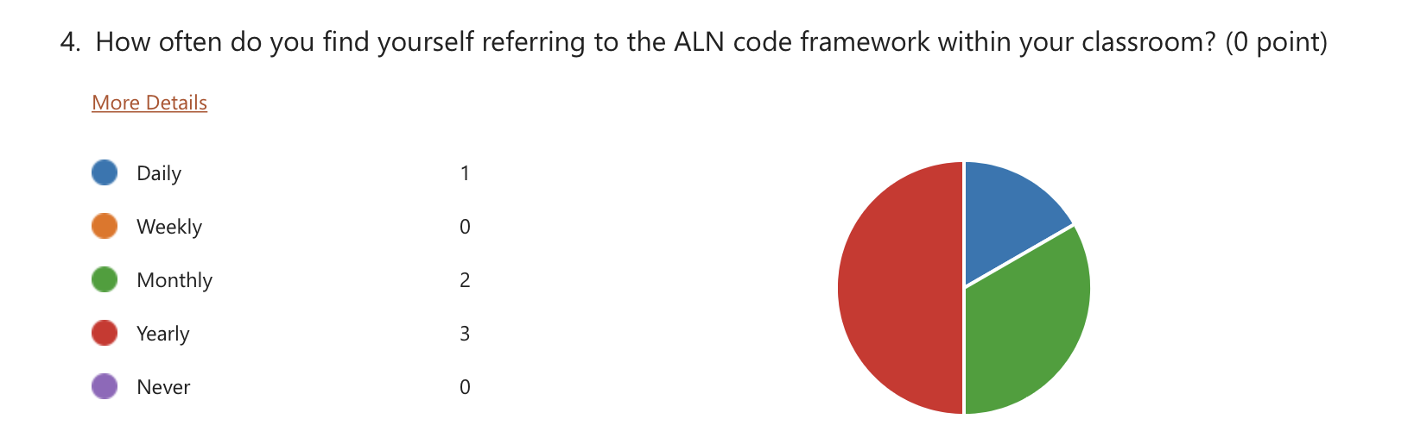

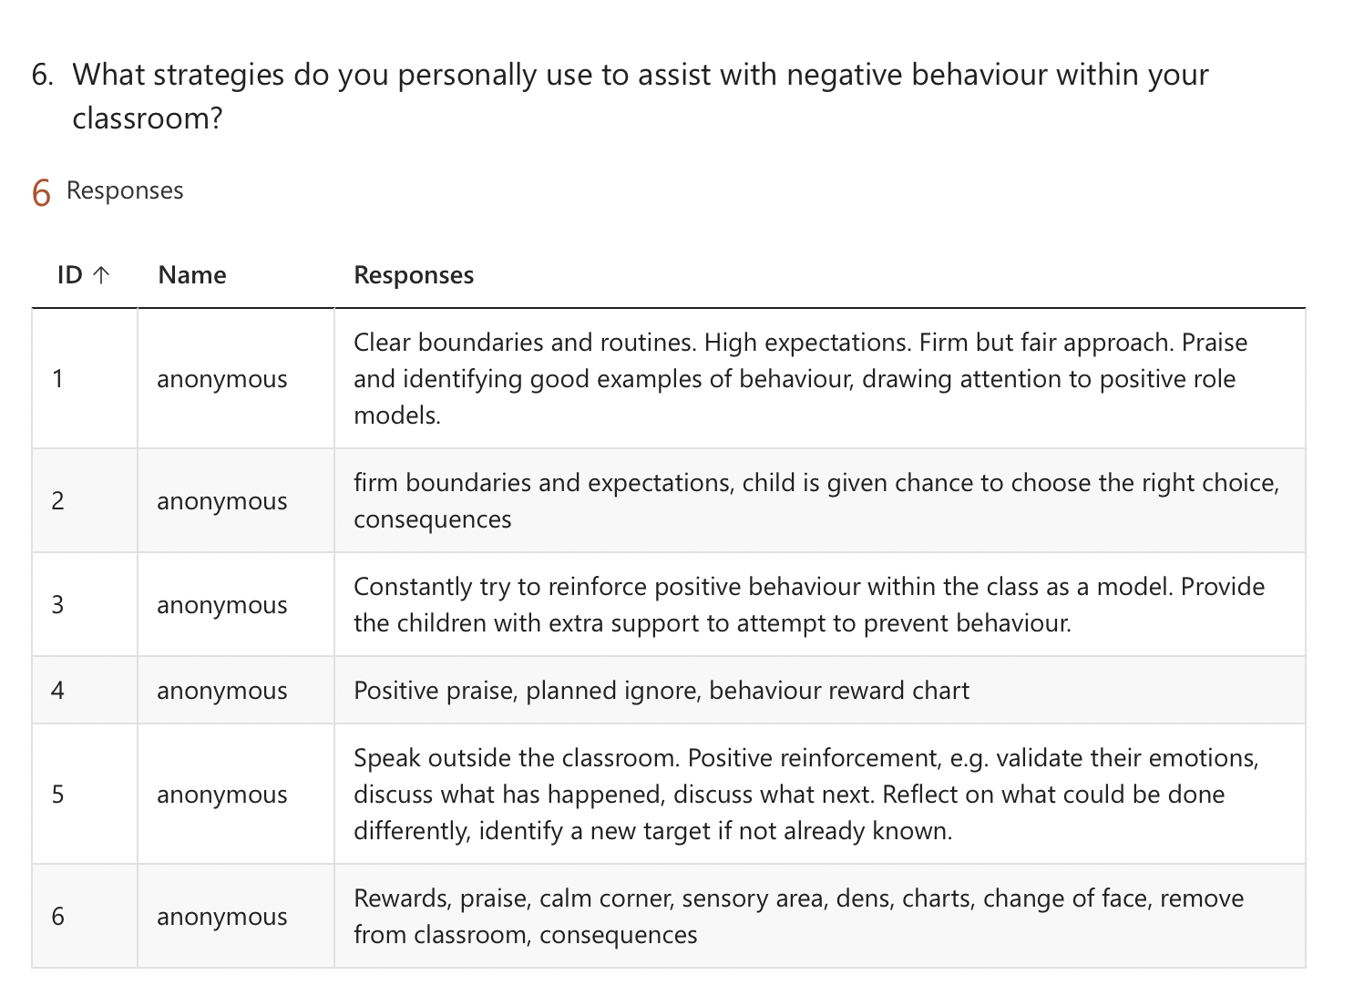

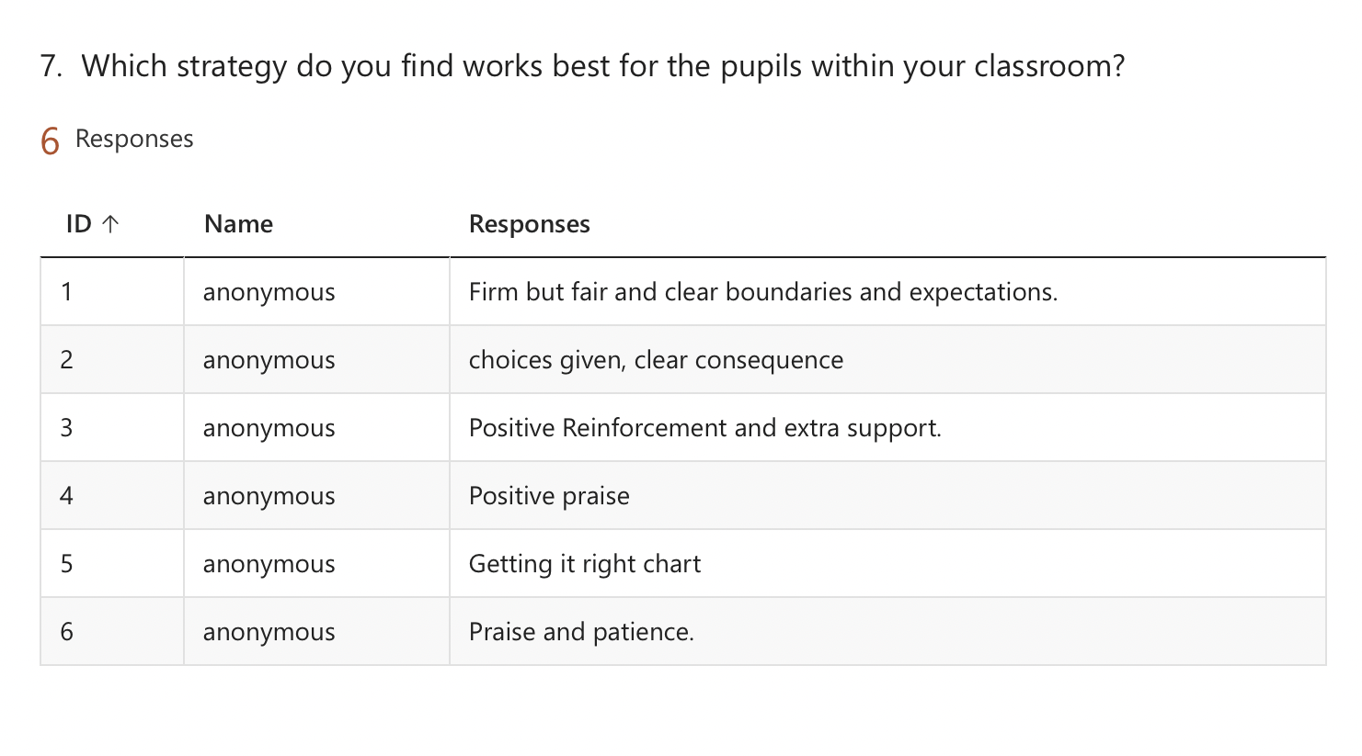

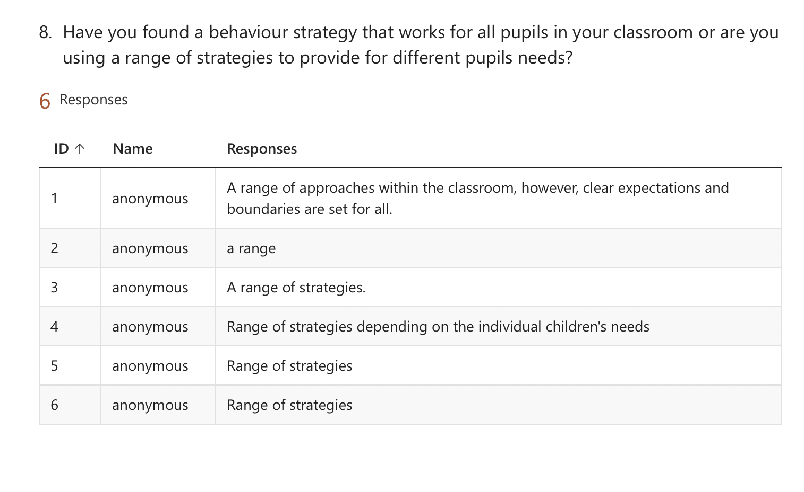
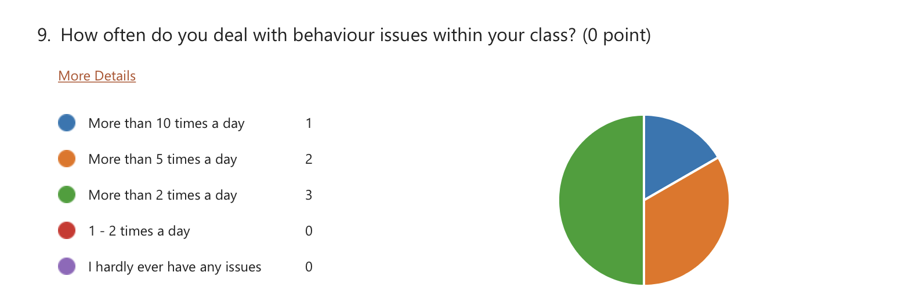

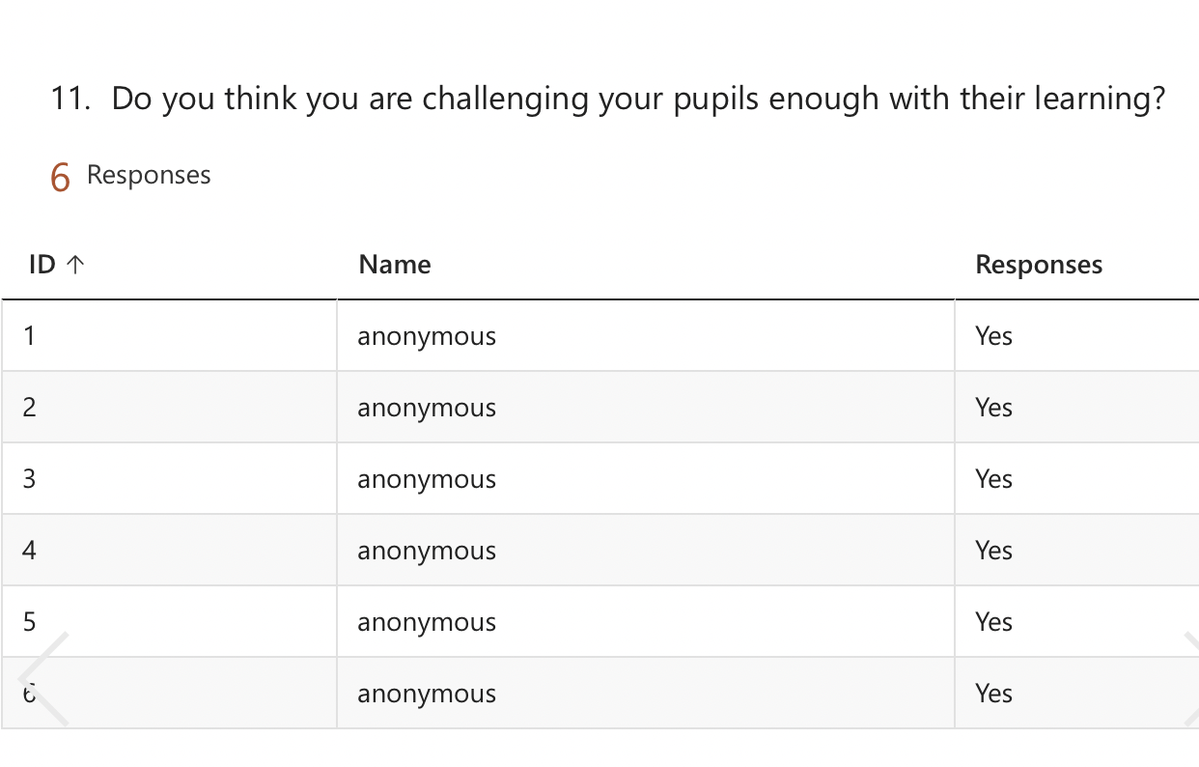

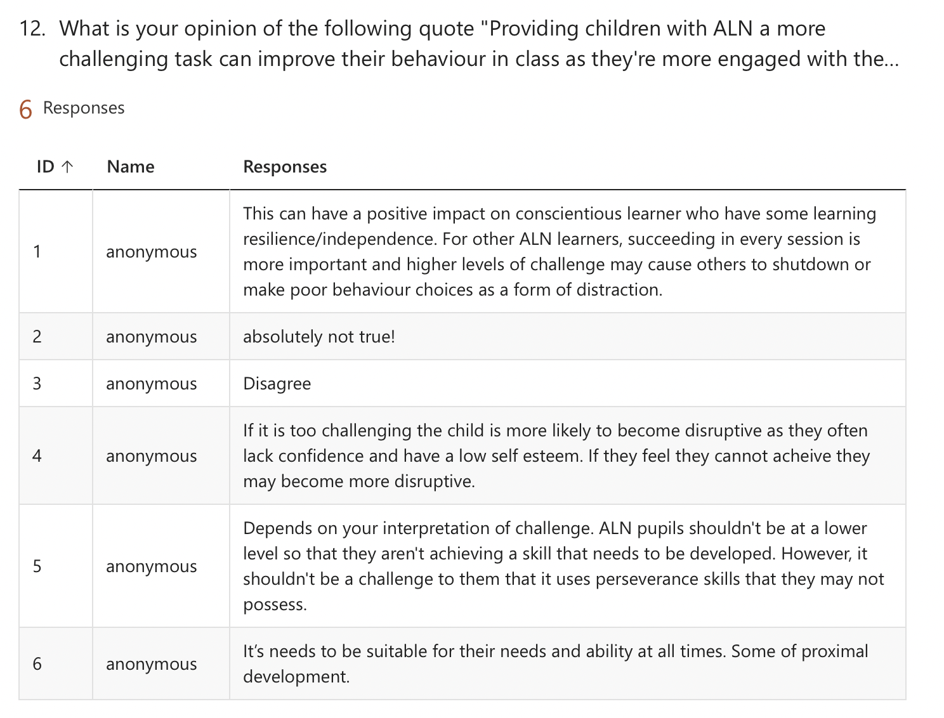

Appendix 10 –


