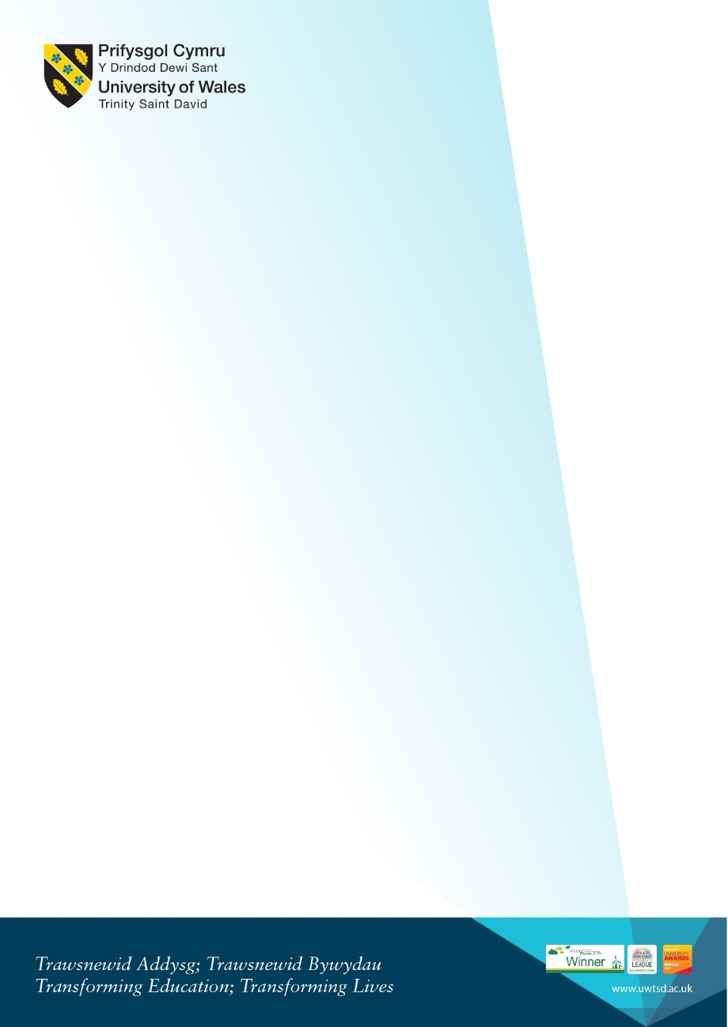
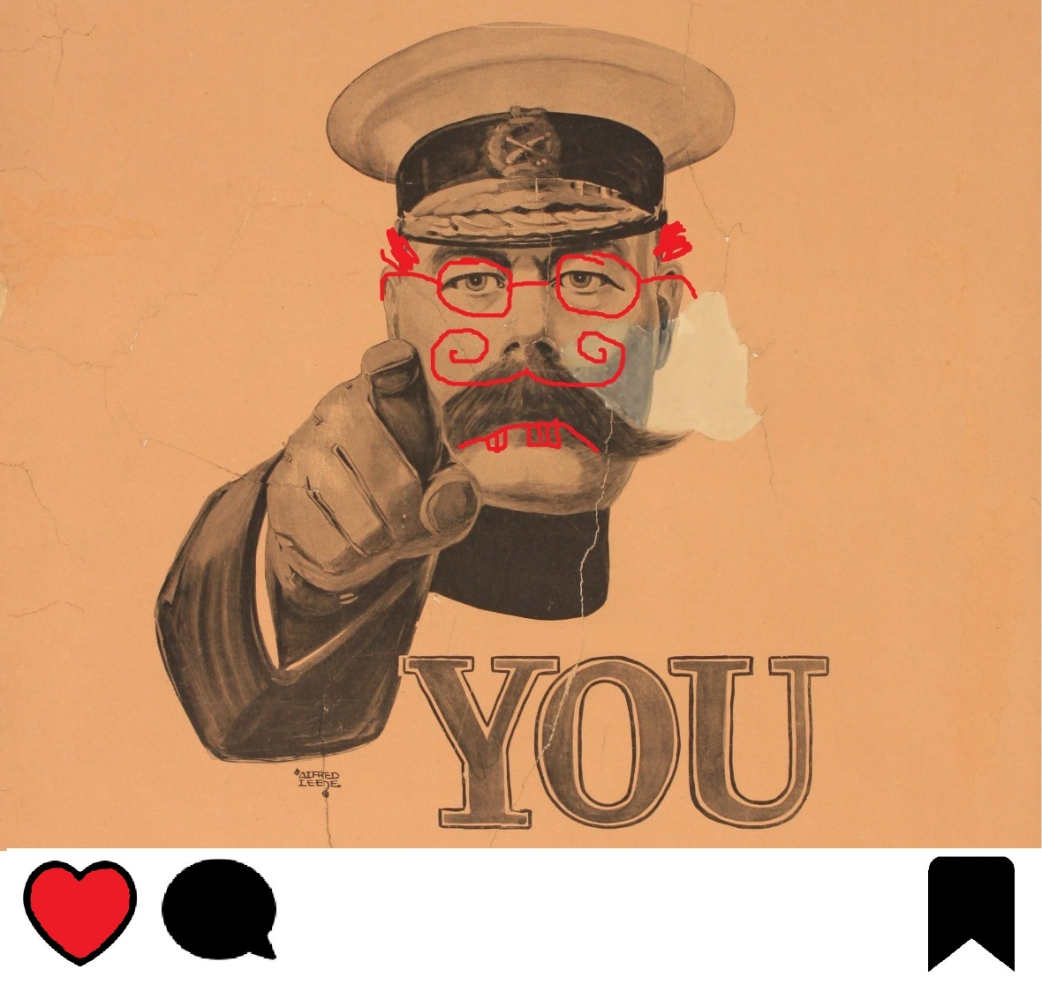
Find us on Facebook @uwtsdwar, or contact Jordan Edwards for further information: 1502326@student.uwtsd.ac.uk
WAR IS FUN
10am-1pm, 1st May, Founders Library.
Light lunch will be provided.
A Conference Exploring Conflict

