

Data Handling and Business Intelligence Assessment 2

Module: Data Handling and Business Intelligence
Module code: LCBB5014
Lecturer: Dr Said Usman
Student name: Marina Alexandra Chiuariu
Student ID: 2411412

Table of Contents
1. Introduction 3
2. Data Cleaning and Preparation 3
3. Descriptive Statistics and Summary 4
4. Trend Analysis and Visualisation (Excel) 7
5. Statistical Analysis using SPSS 9
6. Insights and Recommendations 11
7.Reference List…………………………………………………………………………………………………………..…….12

- Introduction

Business Intelligence (BI) refers to the use of data and analytical tools to support informed decision-making, while data analysis focuses on examining and interpreting data to identify trends and relationships (Witten et al., 2026). This report aims to utilise business intelligence (BI) and data analysis techniques to explore the Letterbox Movie Classification Dataset and draw conclusions on what makes a movie popular and how the average rating is influenced by viewers behaviour. Information about the films included in the dataset is provided, like title, director, genre, average rate by users, length of the movie, original language, number of watches, likes, fans and total rates. Analysing this data enables organisations in the media and entertainment sector to make informed decisions based on audience preferences and interaction trends (Maheshwari, 2015).
The main analytical software of this study are Microsoft Excel and SPSS. For data cleaning, preparation and descriptive statistics, as well as for visualisation, Excel is used for data cleaning, preparation, descriptive statistics, and visualisation, while SPSS is used for statistical testing and analysis. The objectives of this report are to clean and prepare the dataset by handling missing values and standardising key variables, to generate descriptive statistics, and to explore trends in ratings and popularity. In addition, SPSS is used for correlation analysis, t-tests, and regression analysis, in order to examine relationships between viewer engagement variables and movie ratings and to identify key factors contributing to movie popularity.

- Data Cleaning and Preparation
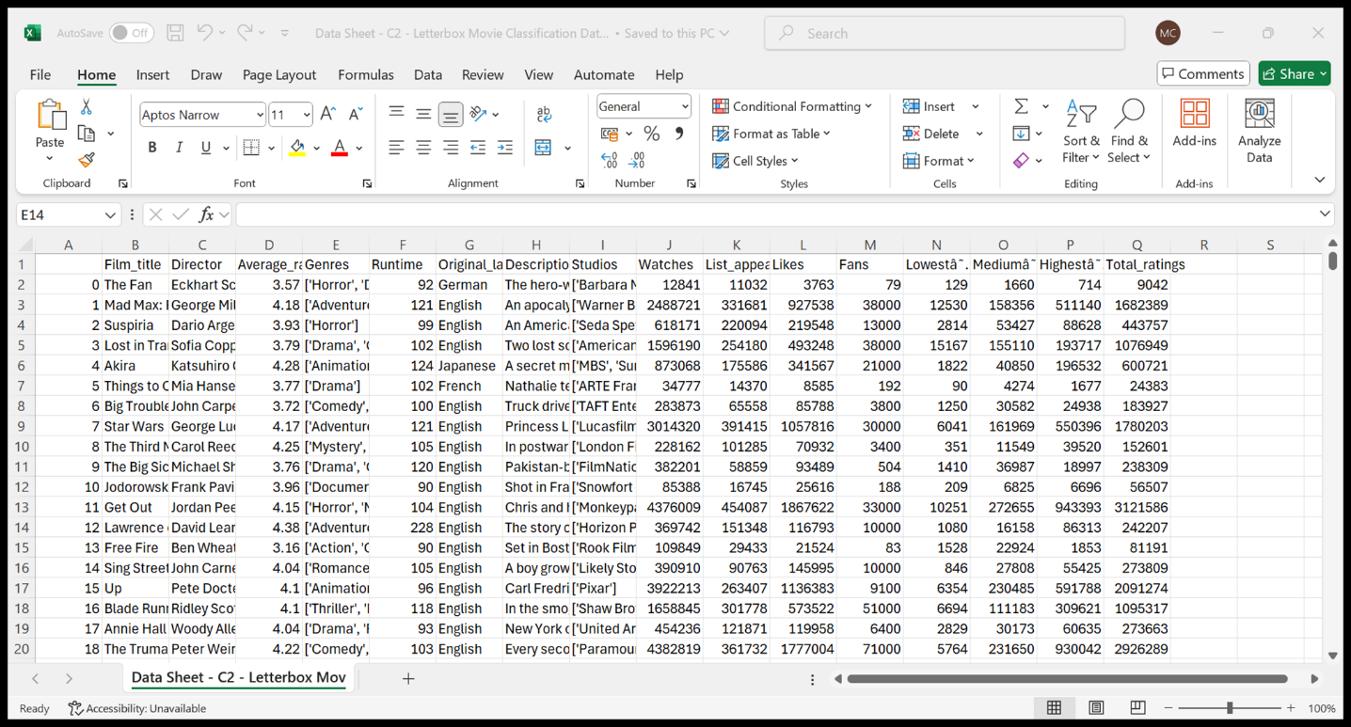

The dataset was cleaned in Excel before doing any analysis. First, I checked the data to see if there were missing or unclear values. Some movies did not have numbers for Runtime, Likes, or Fans. These missing values were filled in using the median, calculated in Excel with the formula =MEDIAN(A2:A1000). The median was used because it is not strongly affected by extreme values and gives a more realistic result (Maheshwari, 2015). Movies without genre information were removed because genres were important for comparing films. In addition, Excel functions such as VLOOKUP were used to organise and match film-related information across tables based on film titles. This helped ensure that variables such as genres and original language were correctly aligned within the dataset. The VLOOKUP function was applied using the formula=VLOOKUP(A2, TableRange, ColumnIndex, FALSE), which returns exact matches and improves data consistency (Connolly & Begg, 2015).
Some inconsistencies were also noticed in the categorical fields. Genre entries were stored as lists, such as [‘Horror’, ‘Drama’] or [‘Animation’, ‘Action’, ‘Science Fiction’]. These were standardized so that every genre was consistent and could be grouped correctly. The Original Language field was checked as well, and small differences or duplicates were corrected.

All runtimes were verified to make sure they were in minutes and stored as numbers, not text. Extra or empty columns from importing the data were removed, and each variable was given its own column. These steps ensured the data was accurate, reliable, and ready for analysis, trends, and further business intelligence work.

- Descriptive Statistics and Summary
After the data cleaning stage, descriptive statistics were generated using Microsoft Excel and verified in SPSS to summarise the key numerical variables in the dataset: Average_rating, Runtime, Watches, Fans, and Likes. Descriptive statistics are a fundamental component of business intelligence, as they provide an initial understanding of data distributions and support evidence-based decision-making (Vercellis, 2009).
Mean (Average)
The mean is the average value of a variable. It is found by adding all values together and dividing by the number of observations. In Excel, the mean was calculated using =AVERAGE(range). For example, the mean of Average_rating was calculated using =AVERAGE(A2:A10000) and resulted in a value of 3.27. The mean helps to show the general level of ratings across all films (Microsoft, 2023a).
Median
The median is the middle value when all values are sorted from smallest to largest. It is useful because it is not affected by very high or very low values. In Excel, the median was calculated using =MEDIAN(range). For Average_rating, the median was 3.27, showing that ratings are fairly balanced (Microsoft, 2023b).

Standard Deviation
The standard deviation shows how spread out the values are around the mean. A larger value means there is more variation in the data. In Excel, it was calculated using =STDEV.S(range). For Runtime, the standard deviation was 38.07 minutes, which shows that film lengths vary considerably (IBM, 2022).

Minimum and Maximum
The minimum and maximum values show the smallest and largest values in the dataset. They help to identify unusual or extreme cases. In Excel, these values were calculated using =MIN(range) and =MAX(range). For Runtime, the shortest film was 2 minutes and the longest was 907 minutes, which explains the presence of outliers (Microsoft, 2023c; Microsoft, 2023d).

Missing Values
Missing values are cases where information is not recorded. These were identified in Excel using =COUNTBLANK(range). For the engagement variables (Watches, Fans, and Likes), there were 209 missing values. Identifying missing data is important to avoid incorrect or misleading results (Microsoft, 2023e).
For categorical variables, frequency tables were used to analyse original language and genders. English-language films dominate the dataset, followed by Italian, Japanese, French, and Korean films. Genre analysis shows that films often belong to multiple genres, with Drama, Comedy, and Action appearing most frequently. Frequency analysis of categorical variables is commonly used in BI systems to identify market trends and audience preferences ( Azevedo & Santos, 2021).
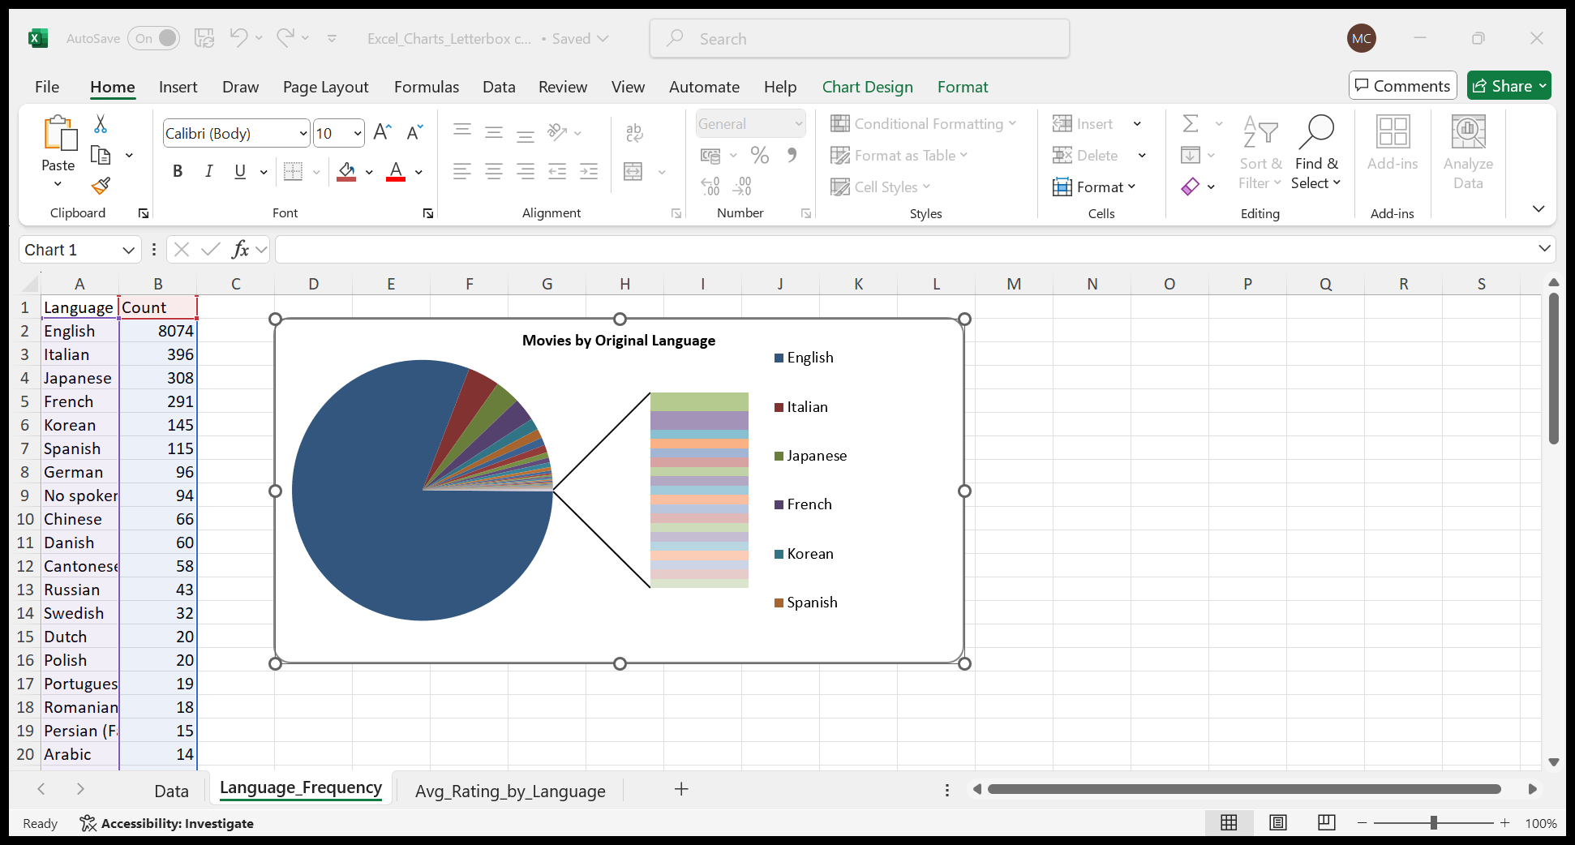

To support interpretation, visualisations were created in Excel. A pie chart showing the number of movies by original language highlights language dominance, while a bar chart showing average rating by original language allows comparison of audience ratings across language groups. Visual analytics enhance understanding and support effective business intelligence reporting (Vercellis, 2009).
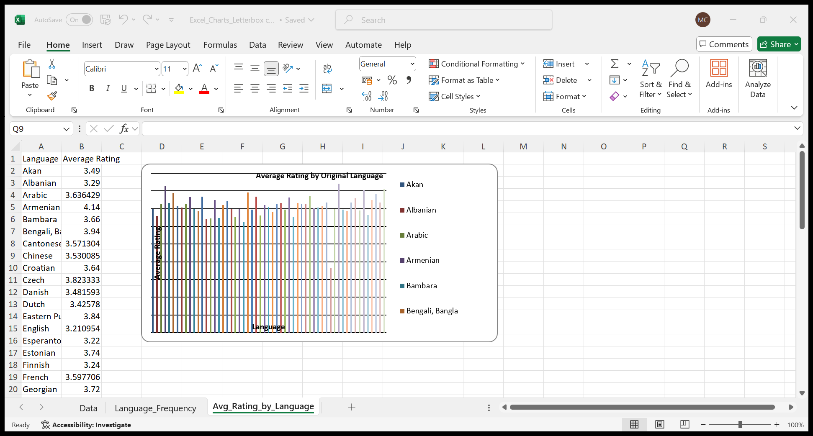

- Trend Analysis and Visualisation (Excel)
This part dives into the dataset trends with excel charts. The aim is to see how movie ratings and popularity change depending on original language, and to check how engagement variables such as watches and likes are related. Charts were used for spotting trends in the data and helping with the exploratory analysis in business intelligence. (Keele University, 2022).

Number of movies by original language

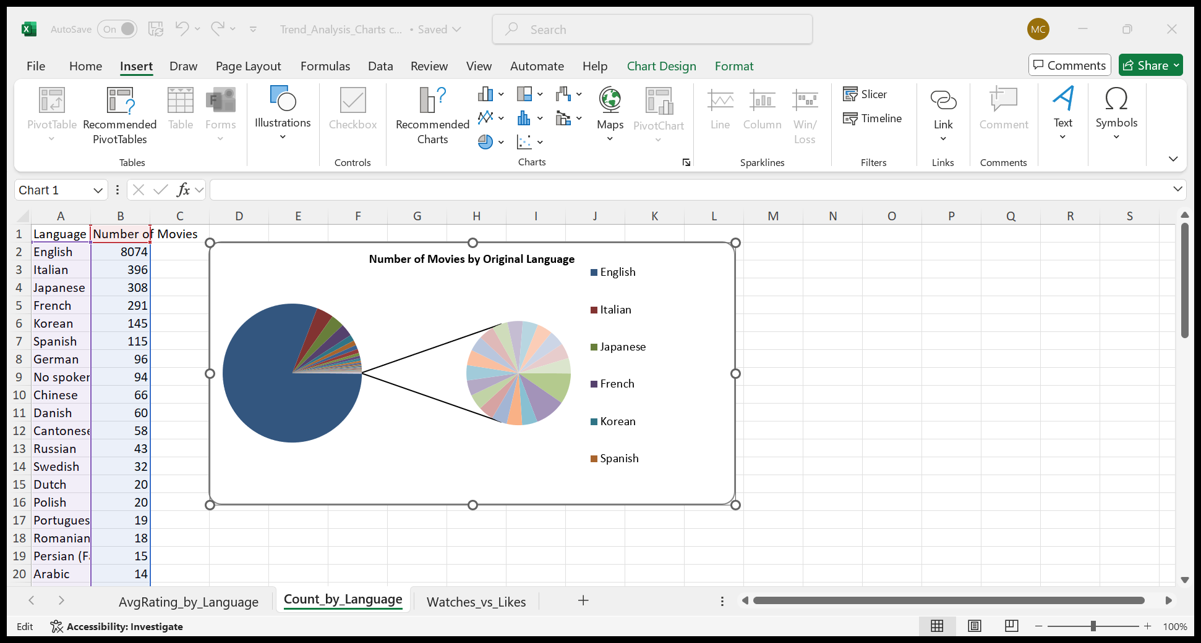
This chart shows the number of movies by original language. English-language films clearly make up the largest part of the dataset and other languages, such as Italian, Japanese, French, and Korean, appear much less often. This is important because it means the dataset is not evenly distributed across languages. The results are therefore influenced mainly by English-language films. This pattern reflects how English-language content is more common on many platforms. However, the smaller language groups may still represent specific audiences with different interests.

Average rating by original language

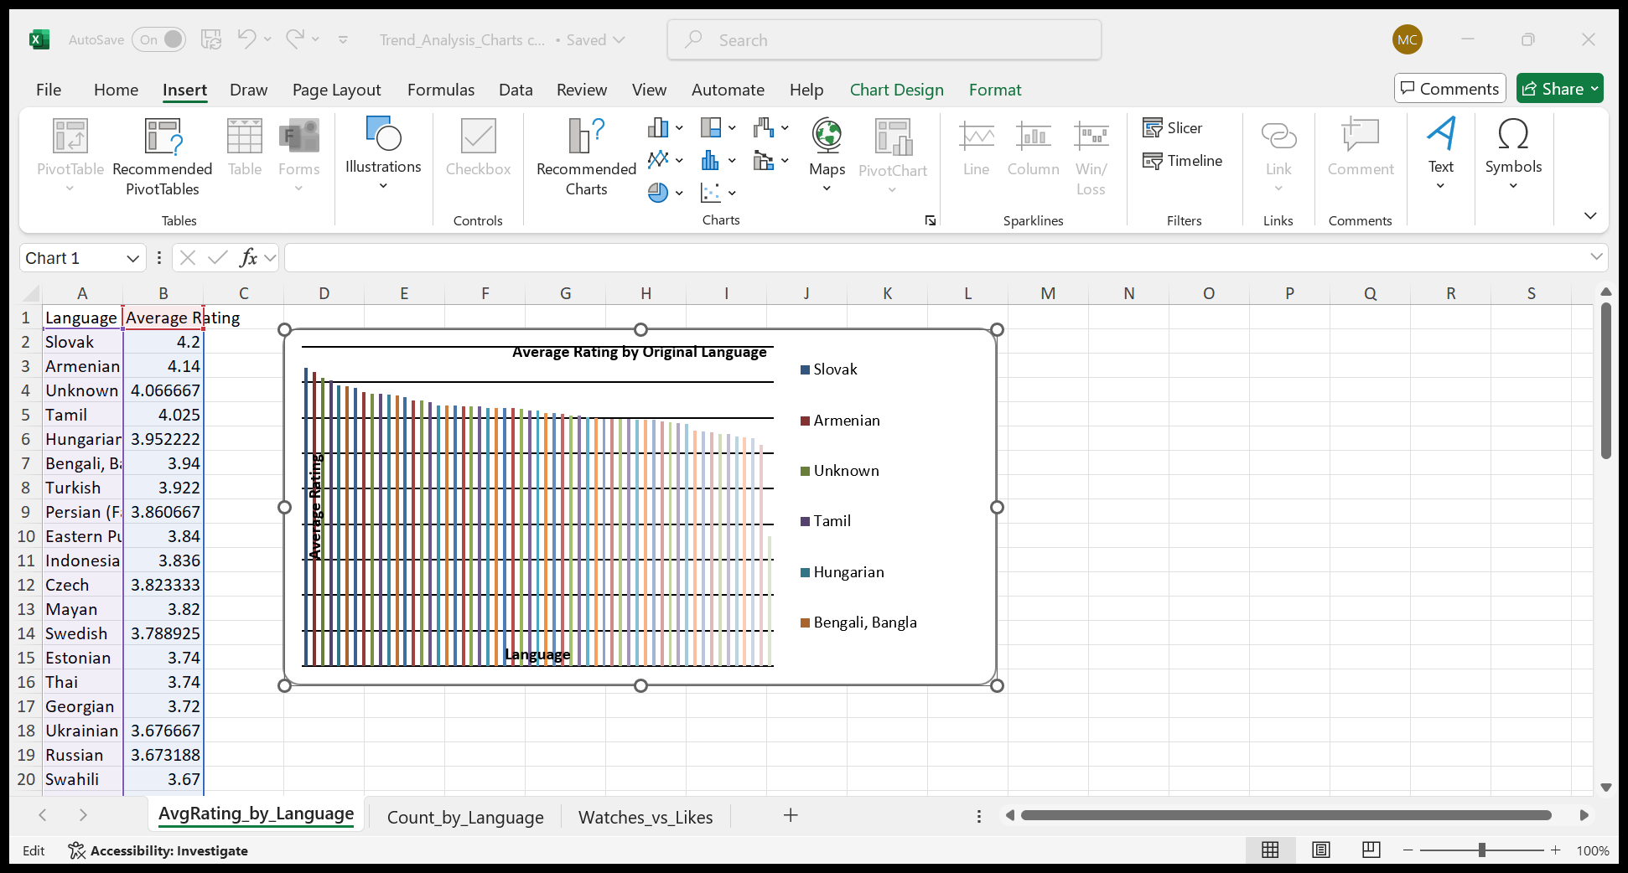
This chart compares the average rating by original language, and it shows that ratings vary between languages, moreover, some language groups have higher average ratings than others. This suggests that language may play a role in how films are evaluated by users. These differences could be linked to cultural factors or to the types of films included in each language group. This chart is useful because it helps compare English and non-English films and prepares the ground for later statistical testing.

Watches vs likes
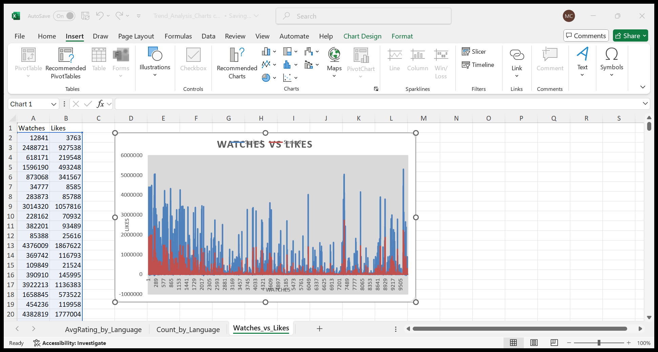

This chart illustrates the relationship between watch counts and likes, also showing that films with higher watch counts tend to have more likes. This indicates a clear positive relationship between the two variables. In simple terms, when more people watch a film, more people are likely to like it. This result shows that visibility is strongly linked to engagement.
Overall, the charts highlight differences in ratings across original languages and show that watches and likes increased together. These patterns help explain how users interact with films and provide a clear starting point for the statistical analysis in the next section.

- Statistical Analysis using SPSS

This section uses SPSS to analyse the relationships identified earlier using Excel. Three main tests were carried out: an independent-samples t-test, correlation analysis, and regression analysis. These methods were used to check whether the patterns observed in the charts are statistically meaningful (IBM, 2023).

Independent-samples t-test

An independent-samples t- test was used to examine whether there is a difference in Average rating vbetween English-language and non-English-language films. The dataset was split into two groups based on original language. This test is commonly applied when comparing the mean values of two separate groups (Laerd Statistics, 2022).

The results show that non- English movies tend to score a bit higher on average than their non-English-speaking counterparts The p-value was under 0.05, indicating a significant difference This implies that language used in films is connected to their ratings in this dataset. However, the difference between the two groups is small, so language alone cannot fully explain variations in ratings.

Correlation analysis

Correlation analysis was carried out to examine relationships between Runtime, Watches, Likes, and Fans. The strongest relationship was found between Watches and Likes. This confirms that films with more views tend to receive more likes, which is consistent with the engagement trend observed in Excel. Correlation analysis is commonly used to assess the strength of relationships between numerical variables (IBM, 2023).

The relationship between Runtime and Watches was weak and positive, showing that longer films are only slightly more likely to be watched. Similar weak relationships were found between Runtime and Likes, and between Runtime and Fans. These results suggest that film length has a limited influence on popularity and audience engagement.

Regression analysis

A linear regression analysis was used to identify factors that help predict Average rating. The model included Likes, Fans, Runtime, and Original language (English vs non-English) as independent variables. Regression analysis is useful for examining how several variables together influence a single outcome (Laerd Statistics, 2023).

The results indicate that Likes and Fans are positive predictors of Average rating, meaning that higher audience engagement is associated with higher ratings. Runtime had only a minor effect, suggesting that film length is not a major factor. The language variable was also significant, supporting the findings from the t-test. Overall, the model explains only part of the variation in ratings, which suggests that other factors not included in the dataset may also affect how films are rated.

- Insights and Recommendations

This analysis helped identify some clear patterns in the dataset. One of the main findings is that original language is linked to movie ratings. Non-English films tend to have slightly higher average ratings than English-language films. This could be because viewers who choose non-English films already have a strong interest in them or are more selective when rating. However, the difference is not very large, so language alone does not explain why some films are rated higher.

Another important result is the relationship between watches and likes. Movies that are watched by more users usually receive more likes. This suggests that visibility is very important. When a film is seen by more people, it has more chances to receive positive feedback. In contrast, runtime does not seem to matter much. Longer films are not clearly more popular or better rated than shorter ones. This shows that film length is not a key factor in audience engagement.

Based on these results, some simple recommendations can be made. Streaming platforms could promote non-English films more, for example by improving subtitles or including them more often in recommendations. Since engagement increases with visibility, making films easier to find could help improve likes and user interaction. For filmmakers, focusing too much on runtime does not seem necessary, as length has little impact on ratings or popularity.

There are also limitations in this analysis. The dataset does not include information such as release year, budget, or marketing activity, which could influence results. In addition, genre analysis was limited because many films belong to more than one genre. Future studies could include more variables or look at how viewer behaviour changes over time.

- Reference List
Azevedo, A. and Santos, M.F. (2021) Business intelligence and analytics: concepts, methodologies, tools, and applications. Hershey, PA: IGI Global.
Connolly, T. and Begg, C. (2015) Database systems: a practical approach to design, implementation, and management. 6th edn. Harlow: Pearson Education.
BM (2022) Descriptive statistics in SPSS. Available at: https://www.ibm.com/docs/en/spss-statistics/29.0.0?topic=statistics-descriptive-statistics (Accessed: 12 December 2025).
IBM (2023) Correlation and regression analysis in SPSS. Available at: https://www.ibm.com/docs/en/spss-statistics/29.0.0?topic=regression-linear-regression (Accessed: 17 December 2025).
Keele University (2022) Business intelligence and data visualisation. Available at: https://www.keele.ac.uk/study/modules/business-intelligence-and-data-visualisation/ (Accessed: 15 December 2025).
Laerd Statistics (2022) Independent t-test for two samples statistical guide. Available at: https://statistics.laerd.com/statistical-guides/independent-t-test-statistical-guide.php (Accessed: 18 December 2025).
Laerd Statistics (2023) Linear regression using SPSS Statistics tutorial. Available at: https://statistics.laerd.com/spss-tutorials/linear-regression-using-spss-statistics.php (Accessed: 18 December 2025).
Maheshwari, D. (2015) Data analytics made accessible. New Delhi: McGraw-Hill Education.
Microsoft (2023a) AVERAGE function. Available at: https://support.microsoft.com/en-us/office/average-function-047bac88-d466-426c-a32b-8f33eb960cf6 (Accessed: 07 December 2025).
Microsoft (2023b) MEDIAN function. Available at: https://support.microsoft.com/en-us/office/median-function-d0916313-4753-414c-8537-ce85bdd967d2 (Accessed: 08 December 2025).
Microsoft (2023c) MIN function. Available at: https://support.microsoft.com/en-us/office/min-function-61635d12-920f-4ce2-a70f-96f202dcc152 (Accessed: 08 December 2025).
Microsoft (2023d) MAX function. Available at: https://support.microsoft.com/en-us/office/max-function-e0012414-9ac8-4b34-9a47-73e662c08098 (Accessed: 13 December 2024).
Microsoft (2023e) COUNTBLANK function. Available at: https://support.microsoft.com/en-us/office/countblank-function-6a92d772-675c-4bee-b346-24af6bd3ac22 (Accessed: 10 December 2025).
Vercellis, C. (2009) Business intelligence: data mining and optimization for decision making. Chichester: Wiley.
Witten, I.H., Frank, E., Hall, M.A. and Pal, C.J. (2025) Data mining: practical machine learning tools and techniques. 5th edn. Cambridge, MA: Morgan Kaufmann.

