

Student name: Eunice Franco
Student ID:2244259

Module name: Independent Projecet

Module code:
Supervisor’s name:

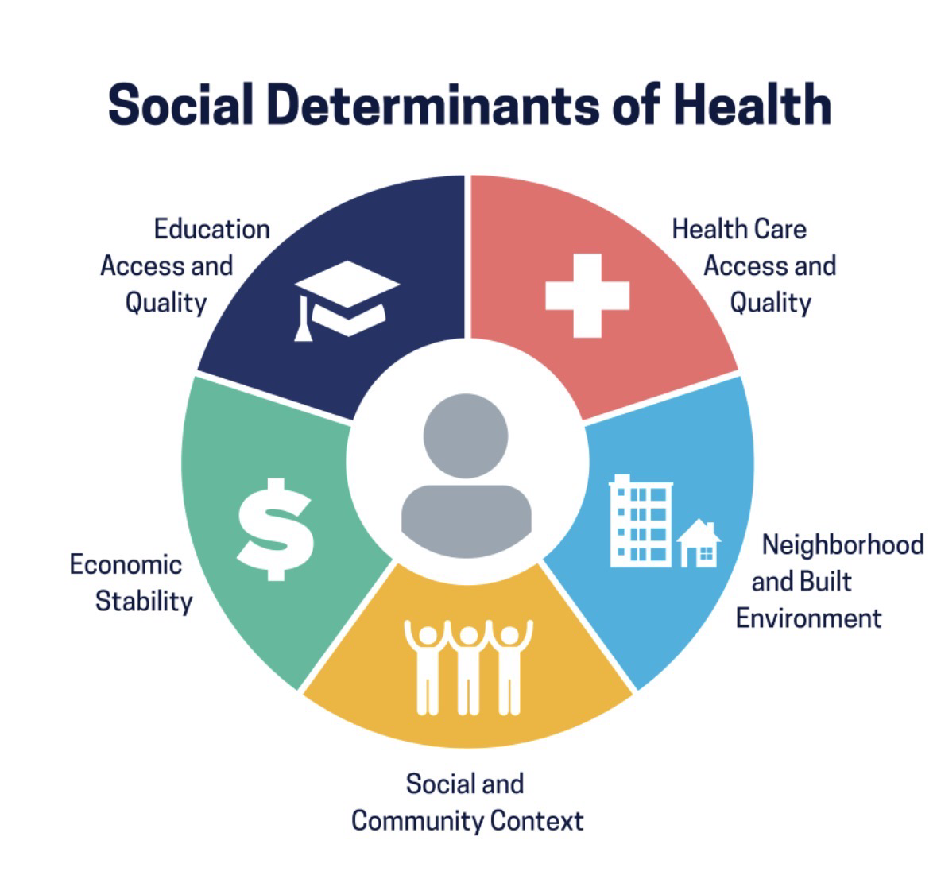 |  | Health Inequalities and Their Impact on Public Health Outcomes in the United Kingdom  Aim  To examine the causes of health inequalities in the United Kingdom and evaluate their impact on public health outcomes, focusing on poverty, education, housing and healthcare access  Research Design  - Qualitative Secondary Research  - Literature Review  - Thematic Analysis |  | 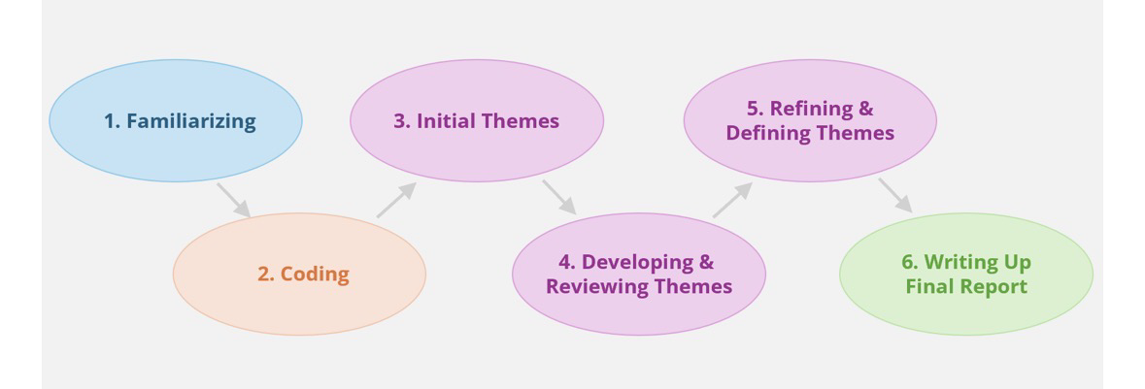
Methodology  - Qualitative research  - Secondary research  - Literature review  - Evidence-based approach  - No primary data collected  - Existing academic literature analysed  Key Findings  - Poverty is a major determinant of health.  - Education influences long-term health outcomes.  - Housing conditions affect physical and mental health.  - Health inequalities increase pressure on the NHS.  - Multi-sector collaboration is needed to reduce inequalities. |  |  |  | Thematic Analysis  Five themes were identified:  • Poverty  • Education  • Housing  • Mental Health  • NHS and Healthcare Access  Ethical Considerations  - Secondary research only  - No participants involved  - No interviews or questionnaires  - Harvard Referencing used  - Academic integrity maintained  - Reliable academic sources only

Data Collection
Databases
- Google Scholar
- PubMed
- NHS England
- WHO
- GOV.UK
- The King’s Fund
Keywords
- Health inequalities
- Social determinants
- NHS
- Public health
- Poverty
- Health equit

References
- Marmot, M. (2010). Fair Society, Healthy Lives.
- World Health Organization (2023).
- NHS England (2023).
- The King’s Fund (2023).
- Department of Health and Social Care (2021).
- British Medical Association (2023).

