
How to solve a problem of staff absenteeism of Mid Cheshire Hospitals NHS Foundation Trust (MCHT)
BMSW 4004


Student Name: Julia petrencikova
Student Code:2110746
module: PROBLEM SOLVING AND DECISION MAKING
LECTURER: CHIJIOKE UBA

Contents
Introduction: 2
Problem Solving 2
Problem 2
Decision Making 2
Problem Definition 2
Scope and Impact 3
Effects of staff absenteeism 3
Analysis of the organisation and problem 4
PESTEL analysis 4
Fishbone Diagram Analysis 5
Propose alternative solutions 6
Evaluation 7
Action Plan 7
Monitoring and evaluation 8
Success Criteria 9
Conclusion 9
References 10

BMSW4004 Problem Solving and Decision Making

Introduction:
A research-informed report has been written to discuss the nature and impact of the complex problem on employees and their organizations.

Problem Solving
According to the cognitive learning theories, the term problem solving is the representation of complex mental activities which consists of cognitive skills and actions. High order thinking is involved in the problem-solving process such as “Abstraction, Knowledge, connotation, conception, handling, analysis, fusion, simplification and all must be managed and synchronised” (Kirkley, 2003)
Problem: A complex problem of staff absenteeism has been faced by the trust hospital named The Mid Cheshire Hospital NHS Foundation Trust. The Staff Absenteeism caused financial loss to the hospital and the service of the hospital also has been compromised due to use of agency staff in the hospital.

Decision Making
The study of the identification and opting alternatives based on the preferences and the standards of the one who is making decision is term as decision making. (Fulop, 2005)

Problem Definition
Staff Absenteeism is referred to as the loss of working time duration when the staff do not come to the work and get absent when they are supposed to be present at their jobs. Absenteeism involves the absences, casual leaves, sick leaves and leaves of absence for the training and development programs participation. Different authors states that the absenteeism originates from several causal factors such as social, cultural, disease or work factors, other than that geographical, individual, organization or environmental factors. Other causes can be social, occupational disease which lead to increase in the rate of absenteeism.
The causes of absenteeism are not always associated with the staff or professionals, in fact other factors such as institution problems, unfavourable work conditions, lack of motivation, employee’s risky integration and psychological impact of a poor management can also be reason behind the absenteeism of the staff which should be taken into account. (Silva, 2017, pp. 546-553)

Scope and Impact
There are many ways in which the staff absenteeism effects the organization and the management such as it decreases the service quality and increase the cost as in the case of MID Cheshire hospital where 1 million pounds of cost incurred by the trust yearly due to the absenteeism of staff. In health profession, the problem of staff absenteeism has been seen since a long time aa a study on the financial consequences of absenteeism showed that the trusts incurred loss of billions of dollars due to staff absenteeism. For 1997, 2004 and 2011, the average loss per employee were 6.2, 7.5 and 9.3 respectively, per day. (Kandemir, 2017)

Effects of staff absenteeism
Trust
Absences due to sickness have an impact on the employee but also on the quality of services that the Trust provides through covering work, costs to business (more than £1 million each year per percentage point) and reduction of frontline staff delivering frontline care
Staff
There is an impact of absenteeism on the staff motivation and morale as well. The staff lack interest in their work which results in unsatisfied duties and responsibilities performance.
Patients
Staff absenteeism affects waiting time for the treatment, delays treatment for the patient who really needs it. The patient’s life can take on risk due to the lack of staff who take care of the patients.
Management
It becomes burden on the management of the hospital to cater the need of staff at the hospital. For such purpose, the management have to consider the agency staff which has a negative impact on the treatment of the patients in a way that the new agency staff does not know the history of the patients which results in poor treatment.

Analysis of the organisation and problem

PESTEL analysis
PESTLE is the framework used to identify the factors affecting the organisation from the outside. it would be difficult to know where to start without PESTLE, because organisations are affected by many external factors. This technique focusses on the external factors rather than solutions to identify the bigger picture of the problem. (WSU, 2022)
PESTLE stands for external factors, (P- Political, E- Economical, S- Social-Cultural, T- Technological, L- Legal, E- Environmental)
- Political: Brexit highly affects the staff absenteeism due to staff shortage and further when the staff available is absent it leads to the nature of the problem, COVID rules (quarantine and staff to be vaccinated) (Fahy, 2019)
- Economical: National minimum wage, Unemployment rates are low, the budget approved for NHS is not sufficient enough to cover the salary expenses of the staff.
- Social-cultural: Aging population (more patients, less workforce), High expectations from patients is a factor behind the problem faced by the trust.
- Technological: Technology and tools are being improved; people are more educated in healthcare. Proper training regarding the technology usage in the health care should be conducted for the staff. For patients, managed care plans by the usage of technology reduces the expenses of the hospital. (Chernew, 1998)
- Legal: lf people are not happy with the service received, they can put a complaint, seek the court for retribution, which may lead staff to become absent as they are afraid of the consequences if they do a mistake
- Environmental: Weather may lead to staff absenteeism in some circumstances

Fishbone Diagram Analysis
The visualizing tool for the categorization of the possible causes of a problem is fishbone diagram. To identify the root causes of the problem, fishbone diagram is used for the purpose. (Lewis, 2020)
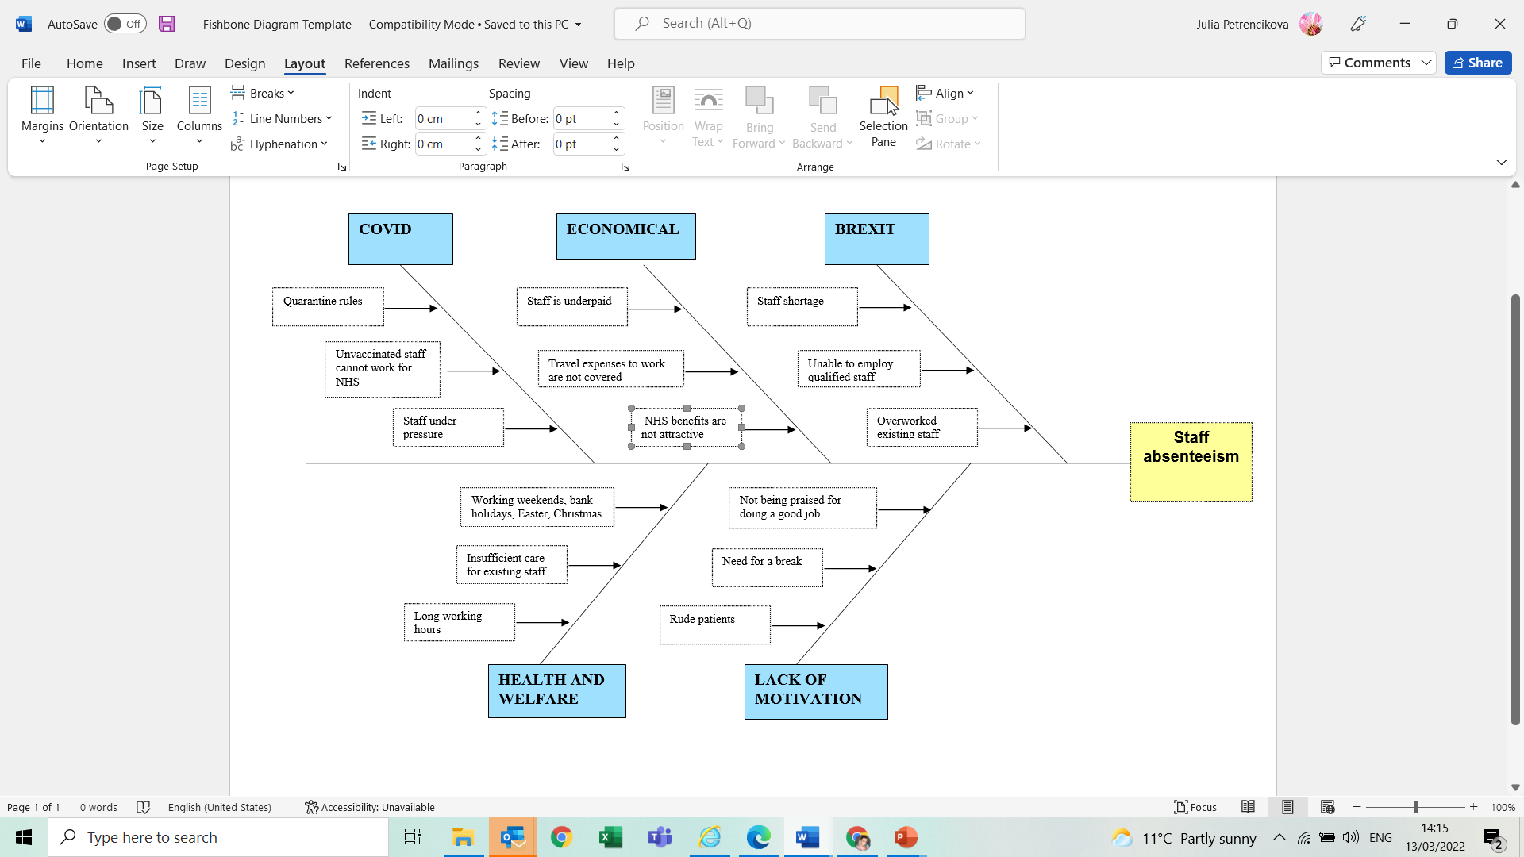
Covid
Due to covid pandemic, following the quarantine rules, the ratio of long-term staff absenteeism increased in the hospitals which is the core reason behind the problem. After the vaccination rolled out, unvaccinated staff was not allowed to work at hospitals which results in absenteeism as the staff was under pressure and cannot pursue their jobs which getting vaccinations.
Economical
The staff of the hospital is underpaid and the hospital is not giving transportation allowance to the staff which result in lack of interest and disloyalty of staff with their jobs.
Brexit
Brexit highly affects the staff absenteeism due to staff shortage and further when the staff available is absent it leads to the nature of the problem
Health and Welfare
Due to the shortage of staff, the staff absenteeism occurs on bank holidays, easter, Christmas holidays and further the NHS does not give extra wages on the bank and national holidays which is another behind the absenteeism of staff. The health care of the staff should be taken into consideration.
Lack of Motivation
Considering the problems above it has been seen that, the staff is not praised by the trust for doing a good job which results in the lack of motivation among staff. The rude patients at the hospital are another reason which reduces the motivation of the staff to work at the hospital regularly.

Propose alternative solutions
On the basis of cause-and-effect analysis, some of the alternate solutions are stated below:
- Relaxation in the covid rules will be given to the staff
- NHS staff should be given the vaccine in the first priority so the staff will be allowed to come to the hospital without any restriction
- The salary package of the NHS staff should be revised as they are the one who are helping in saving the lives.
- The travelling allowance should be given to the staff or vehicle shifts for the staff can be started for the pick and drop service.
- Mental Health programs for the staff of NHS should be conducted which help them in the dealing of their day-to-day life matters.
- Development plans for the staff should be created which help them in staying motivated and have the knowledge of selecting the best option for the efficient job performance.
- Extra hours wages should be given to the staff which increases in the presence of the staff.
- Rotating schedule should be created for the staff to decrease the rate of absenteeism

Evaluation
The following grid analysis is conducted to get possible best solution to deal with the problem of staff absenteeism.
Grid Analysis
 | Alternative Solution |  |  |  |  | Weighting  of  Factors
 | Revised Salary Packages | Travelling allowance or pick and drop service | Relaxation in covid restrictions | Rotating shifts | Health and welfare | Weighting  of  Factors
Increased work Efficiency | 2 | 3 | 0 | 2 | 3 | 4
Cost | 2 | 2 | 1 | 3 | 2 | 5
Service | 2 | 3 | 1 | 3 | 3 | 5
Ratio of absenteeism | 3 | 2 | 0 | 1 | 3 | 4
Motivation of staff | 2 | 2 | 1 | 1 | 3 | 3
Overall  Weighted  Score | 46 | 51 | 13 | 45 | 58

From the above analysis, the health and welfare need of the staff would be the best solution to decrease the rate of staff absenteeism.

Action Plan
Action Plan | Description | Timeline | Staff Responsible
Identify the health and wellness needs and these be to documented | Line managers and hospital absent to outline specific needs  Write these up in the log book | 04/04/2022 to 04/05/2022 | HR
Identify Programme recipients | Use attendance register to identify staff that are persistently absent; those that have reported health/well issues | 09/04/2022-ongoing | HR
Identify health and wellness coach | determine the best coach (by reading reviews or feedback) | 09/04/2022-09/05/2022 | HR and management

Monitoring and evaluation
 | Description | Time frame | Staff responsible
Feedback | Take staff feedback and give organization’s feedback to employees | Monthly | HR manager
Analysis | Appropriate analysis techniques use to monitor the plan implementation | Monthly | HR manager  IT manager
Regulation | The evaluation of the regulation plan and the changes in the analysis | Yearly | HR manager  Committee head

Success indicator(s) | Data source / Information collection method | Time frame | Staff responsible
Regular Staff Feedback | - Feedback forms  - Online forms | Weekly  Monthly | HR manager  IT manager
Patient’s feedback | - Feedback forms includes the grading of staff and comments | Daily | IT manager
Revenue | - Financial Statements | biannually | Accounting department

Success Criteria
The management of NHS and the trust have to work effectively in order to get long term success on the proposed plan. Proper monitoring should be conducted to ensure that proper actions are taken for the health care and welfare of the staff. Regular feedback evaluation of staff is necessary to know about the results of the implemented plan.

Conclusion
In the report above it has been indicated that appropriate actions are needed to deal with the complex problem of staff absenteeism in NHS. For the solution of the problem, the decision-making process has been done through the grid analysis According to the Grid analysis the health care and welfare of the staff can be appropriate solution to deal with the complex problem of long-term staff absenteeism. After taking health and welfare of staff into consideration, the motivation level of staff will be increased and the staff will be loyal to their jobs which result in decreased rate of staff absenteeism in the hospital.

References
Chernew, H. S. (1998). Managed Care, Medical Technology, and Health Care Cost Growth: A Review of the Evidence . SAGE.
Fahy, N. H. (2019). How will Brexit affect health services in the UK? An updated evaluation. The Lancet, 949-958.
Fulop. (2005). Introduction to Decision Making. In BDEI-3 workshop, Washington, 1-5.
Kandemir. (2017). The Level and Cost Burden of Absenteeism among Health Care Professionals. İşletme Bilimi Dergisi (JOBS), 1-23.
Kirkley, F. a. (2003). Principles for Teaching Problem Solving. Technical paper , 4.
Lewis. (2020). Retrieved from Whatis: https://whatis.techtarget.com/definition/fishbone-diagram#:~:text=A%20fishbone%20diagram%20is%20a,type%20of%20mind%20map%20template.
Silva. (2017). Proposal for Management of Absenteeism among Hospital Nurses: A Systematic Review. Acta Paulista de Enfermagem, 546-553.
WSU. (2022). WSU Libraries . Retrieved from https://libguides.libraries.wsu.edu/c.php?g=294263&p=4358409

