Module Name: Analysing and Solving Problems
Module Code: ACCA 4019
Student Name: Danuzia Aparecida Soares
Student ID: 2435233
Group: 3
Lecturer’s Name: Dr. Redhwan Al-amri

Problem
Analysis and Solution
Development

Table of Contents
Table of Contents 1
Introduction 2
2. Deconstruct the Problem 61 3
2.1 MoSCoW Technique Requirement 260 3
2.2 Variables Identification 173 4
3. Proposed Solution 55 5
3.1 Flowchart 6
4.1 Flowchart Explanation 355 7
4. Reflection and Justification 8
4.1 Abstract thinking 72 8
4.2 Sub-dividing 87 9
4.3 Justification of solution 89 9
4.4 Limitation 92 9
4.5 Assumption 57 10
Conclusion 10
References 10

Introduction

In many educational institutions, managing classroom allocation efficiently can be a complex task. In this scenario, a local college is experiencing problems such as overcrowded classrooms, underused spaces, timetable conflicts, and time wasted by students and staff moving between rooms. These issues can reduce efficiency and negatively impact the overall learning experience.
This assignment aims to analyse the classroom allocation problem and develop a structured solution using computational thinking and problem-solving techniques. The problem is deconstructed into smaller components, and key requirements and constraints are identified using the MoSCoW technique. In addition, relevant variables are defined to support the design of the solution.
A logical solution is then proposed and represented through a flowchart, showing how classroom allocation can be optimised step by step. The solution focuses on improving room utilisation, minimising movement time, and avoiding scheduling conflicts. Finally, the assignment reflects on the techniques used and justifies the approach, supported by relevant academic sources.

2. Deconstruct the Problem

Problem decomposition is an important technique in computational thinking, where a complex problem is divided into smaller and simpler parts. This makes the problem easier to understand and allows each part to be analysed step by step.
By breaking the problem down, it becomes clearer how different elements are connected, making it easier to find an effective and organised solution [1].

MoSCoW Technique Requirement

The MoSCoW technique is used to prioritise system requirements by dividing them into four categories: Must Have, Should Have, Could Have, and Won’t Have. This helps ensure that the most important features are implemented first, especially when solving real-world problems such as classroom allocation [2].

MUST HAVE: These are the most important requirements, and the system cannot work without them:
- Classrooms must be allocated based on class size and room capacity.
- The timetable must avoid scheduling conflicts.
- The system must store accurate information about rooms and classes.
- Room Type Compatibility so the system must match the class requirements with the specific room type (e.g., a Chemistry lab session must be assigned to a Laboratory, not a standard lecture room).If these are not included, the problem will not be solved properly.
SHOULD HAVE: These requirements are important, but not essential:
- Reduce the time students and staff spend moving between rooms.
- Allocate rooms that are closer to each other when possible.
- Provide basic reports about room usage.
They improve the system, but the system can still work without them.
COULD HAVE: These are extra features that would make the system better, but are not necessary:
- Automatic suggestions for the best room allocation.
- A visual timetable interface.
- Integration with other systems like attendance.
These features are useful, but not critical for solving the main issue.
WON’T HAVE: These are features that will not be included at this stage:
- Complex AI-based optimisation systems.
- Changes to the physical infrastructure of the college.
These are not included because they would require more time, cost, and resources.

Variables Identification

To build a working solution, it is also important to identify the main variables involved in the system. Variables represent the key data inputs that influence how the system makes decisions and optimises classroom allocation [3].
Variables: | Type: | Description:
Class_ID | Integer | Unique identifier for each class.
Class_Size | Integer | Number of students in the class.
Room_ID | Integer | Unique identifier for each room.
Room_Capacity | Integer | Maximum number of students allowed in a room.
Room_Type | String | Type of room (lecture hall, lab, etc.)
Room_Location | String | The physical location or block (e.g., Block A, 2nd Floor) to calculate travel distance.
Room_Availability | Boolean | Indicates whether the room is free or occupied at a specific time.
Time_Slot | String / Time | Scheduled time of the class.
Lesson_Duration | Integer / Time | Duration of each class session
Teacher_ID | Integer | Unique identifier for the teacher to prevent scheduling multiple classes for the same person.
Course_ID | String / Integer | Unique identifier for the specific course/degree (e.g., Computer Science Year 1).
Group_ID | String | Identifier for specific cohorts or student groups that move together between classes.

3. Proposed Solution

To address the classroom allocation problem, a structured solution has been designed to improve efficiency, reduce scheduling conflicts, and make better use of available space. The approach is based on a logical process that evaluates different conditions before assigning a classroom, ensuring that decisions are not made randomly but follow a consistent and organised method.
The solution operates by processing each class individually and applying a sequence of checks to identify the most suitable room. Instead of assigning the first available option, the system considers multiple factors at the same time, which allows it to make more balanced and practical decisions. This is important in a real college environment, where different constraints need to be managed simultaneously.
A key aspect of this solution is its ability to filter and compare different room options. It ensures that the selected room meets the required conditions, such as having enough capacity and being available at the correct time. By doing this, the system avoids common issues like overcrowded classrooms and timetable clashes. In addition, the solution also takes into account the location of rooms, which helps reduce unnecessary movement between classes and improves overall efficiency for both students and staff.
Another important feature is the use of an iterative process. If a suitable room is not found immediately, the system continues searching for alternative options until all conditions are satisfied. This makes the solution more flexible and capable of adapting to different situations, rather than failing when the first option is not suitable. It also ensures that all classes are eventually assigned a room, even when there are constraints.
The solution also includes a mechanism to update room availability after each allocation. This ensures that the system always works with accurate and up-to-date information, preventing the same room from being assigned to multiple classes at the same time. This step is essential for maintaining consistency and avoiding conflicts in the timetable.
Overall, this solution provides a practical and effective way to manage classroom allocation. By combining structured decision-making, continuous evaluation, and the use of relevant variables, it improves the use of space, reduces delays between classes, and supports a more organised and reliable scheduling system.
.

Flowchart
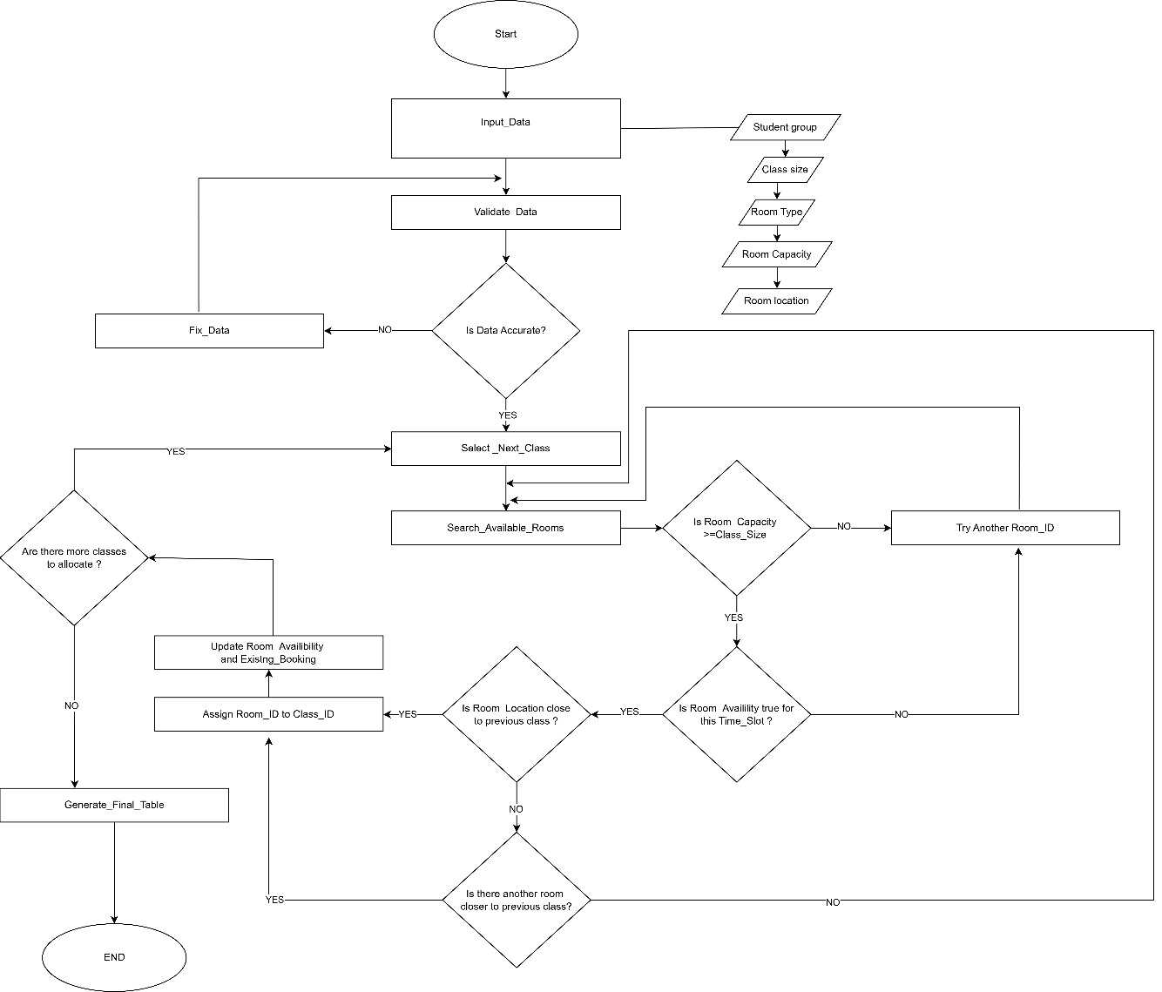

Flowchart Explanation

The flowchart represents a step-by-step process for solving the classroom allocation problem in a local college. The main objective of this system is to assign classrooms efficiently based on class size, room capacity, and timetable constraints, while also reducing movement time and avoiding scheduling conflicts.
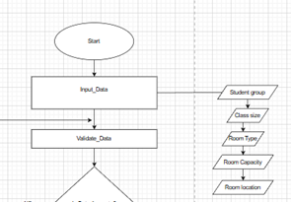
- As shown in Figure , the process begins with the input of data. At this stage, key variables such as student group, class size, room type, room capacity, and room location are collected. These inputs are essential because they define the conditions required for the classroom allocation process. For example, class size is used to determine whether a room is suitable, while room location helps reduce movement time between classes.

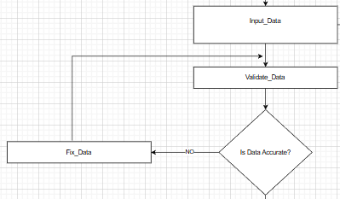
- The system then performs data validation to ensure that all input information is accurate. The decision point “Is Data Accurate?” checks whether the data is correct. If the answer is “No”, the process returns to the “Fix Data” stage, where errors are corrected before continuing. This step is important to prevent incorrect classroom allocation.

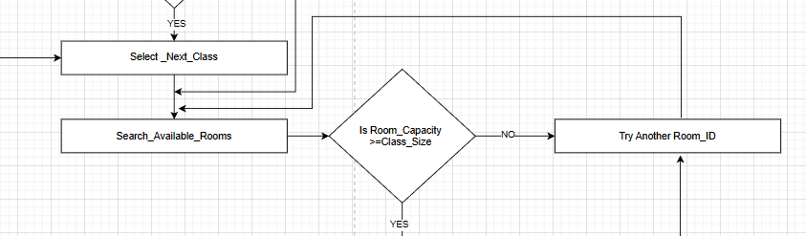
- If the data is accurate, then the next step is selecting the next class, the system searches for available rooms. The first step is to check if the room capacity is enough for the class size. If not, the system tries another room by going back to the stage search available rooms.

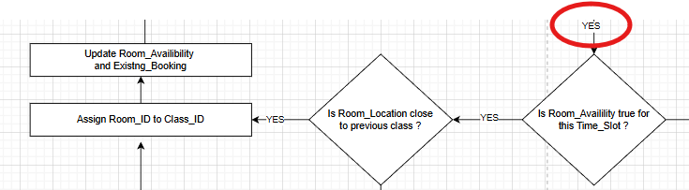
- If the capacity is suitable, the system checks if the room is available for that time slot. If the room is already booked, it selects another option to avoid conflicts.
When both capacity and availability are correct, the system then checks the room location. It tries to choose a room close to the previous class to reduce movement time.
This process repeats until a suitable room is found.

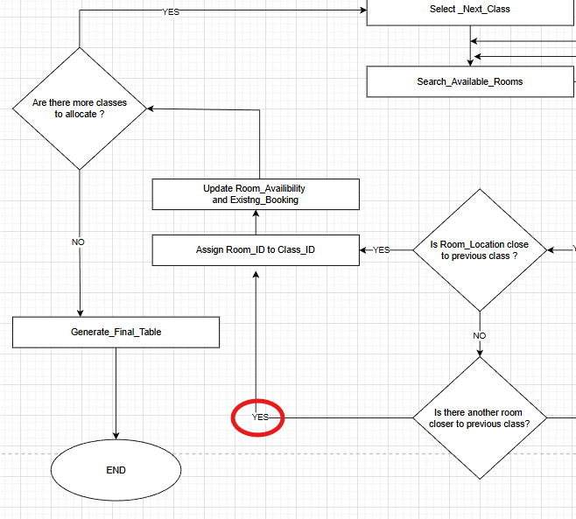
- Once a suitable room is found, the system assigns the Room_ID to the Class_ID. After
that, the room availability and existing bookings are updated to reflect the new allocation.
The system then checks if there are more classes to allocate. If yes, the process repeats for the next class. If no, the system generates the final timetable and the process ends.

4. Reflection and Justification

Abstract thinking

Abstract thinking is the ability to simplify a complex problem by focusing only on the most important elements and ignoring unnecessary details [4].
In this scenario, it was used by identifying key factors such as class size, room capacity, timetable slots, and availability, instead of focusing on specific rooms or individuals. This helped to understand the problem more clearly and made it easier to design a logical solution for allocating classrooms efficiently.

Sub-dividing
Sub-dividing was used in this scenario to break the classroom allocation problem into smaller and more manageable parts.
Instead of trying to solve everything at once, the problem was divided into stages such as input, processing, and output. For example, the system first collects data about classes and rooms, then checks capacity and availability, and finally assigns classrooms. This made the problem easier to understand and helped to create a clear step-by-step solution.
Decomposition is important because it improves organisation and makes complex problems more structured [5].

Justification of solution
The proposed solution is appropriate because it directly addresses the main problems identified in the scenario, such as overcrowded rooms, timetable conflicts, and inefficient use of space. It also considers assigning rooms that are close to each other in order to minimise the time spent moving between classes, while checking for existing bookings to avoid double bookings.
By using a structured approach with variables and a step-by-step flowchart, the system ensures that decisions are made logically and consistently. The inclusion of checks for capacity, availability, and location improves reliability.

Limitation
A limitation refers to a weakness or restriction in a solution that may affect how well it works in real [6].
In this scenario, one limitation is that the system depends on accurate data. If class sizes or room capacities are incorrect, the system may allocate rooms poorly, leading to overcrowding or unused spaces.
Another limitation is the use of a fixed timetable, which makes it difficult to handle last-minute changes. In addition, the lack of online classes reduces flexibility, since all teaching depends on physical rooms, increasing pressure on available space.

Assumption
In problem solving, assumptions are accepted as true without full proof, helping progress when information is limited [7].
These assumptions simplify the problem and make the solution more practical and manageable.
In this scenario, it is assumed that all data is accurate, each class uses one room, time slots are predefined, and rooms cannot be shared simultaneously.

Conclusion

In conclusion, this assignment analysed the classroom allocation problem and developed a structured solution using computational thinking techniques. By applying problem decomposition, the MoSCoW method, and variable identification, it was possible to clearly define the key requirements and constraints of the system. The proposed solution, supported by a flowchart, demonstrates a logical and practical approach to improving room allocation, reducing movement time, and avoiding scheduling conflicts.
Although some limitations exist, such as dependency on accurate data and fixed timetables, the solution provides an effective way to optimise classroom usage.
In general, this approach helps improve efficiency and supports a better learning experience within the college environment.

References

[1] N. Shin, J. Bowers, J. Krajcik, and D. Damelin, ‘Promoting computational thinking through project-based learning’, Discip. Interdiscip. Sci. Educ. Res., vol. 3, no. 1, p. 7, Aug. 2021, doi: 10.1186/s43031-021-00033-y.
[2] I. P. Ramayasa and I. G. A. Candrawibawa, ‘Usability Evaluation of Lecturer Information Systems Using Sirius Framework and Moscow Technique’, Sci. J. Inform., vol. 8, no. 1, pp. 16–23, May 2021, doi: 10.15294/sji.v8i1.27126.
[3] P. A. Gagniuc, ‘Variables’, in Coding Examples from Simple to Complex: Applications in MATLAB®, P. A. Gagniuc, Ed., Cham: Springer Nature Switzerland, 2024, pp. 7–16. doi: 10.1007/978-3-031-53805-6_2.
[4] J. M. Wing, “Computational thinking,” Communications of the ACM, vol. 49, no. 3, pp. 33–35,2006.
Available: https://doi.org/10.1145/1118178.1118215
[5] P. J. Rich, G. Egan, and J. Ellsworth, ‘A Framework for Decomposition in Computational Thinking’, in Proceedings of the 2019 ACM Conference on Innovation and Technology in Computer Science Education, Aberdeen Scotland Uk: ACM, Jul. 2019, pp. 416–421. doi: 10.1145/3304221.3319793.
[6] Fensel, D., “Assumptions and limitations of a problem-solving method: A case study,” in Proceedings of the 8th Banff Knowledge Acquisition for Knowledge-Based Systems Workshop (KAW’95), Banff, Canada, 1995.
[7] R. Benjamins and C. Pierret-Golbreich, ‘Assumptions of problem-solving methods’, in Advances in Knowledge Acquisition, N. Shadbolt, K. O’Hara, and G. Schreiber, Eds, Berlin, Heidelberg: Springer, 1996, pp. 1–16. doi: 10.1007/3-540-61273-4_1.

