Part 1
My professional practice combines digital and studio teaching. As a vocal coach, I teach one-to-one and group lessons and use social media, mainly YouTube. I must communicate complex singing concepts to audiences with varied backgrounds. Confusion about nasalance and twang is common in my teaching community, making this topic relevant to my growth as an educator. This study arises directly from a real pedagogical challenge I face.
Introduction (Context & Rationale)
Vocal acoustics are often misunderstood in voice pedagogy. Two crucial yet confusing concepts are nasalance and twang. Many singers and coaches use these terms interchangeably, but they are acoustically and physiologically distinct, even if they can sound similar. Misunderstanding these concepts can limit stylistic options, cause strain, reduce confidence (by leading one to believe a “nasal” sound is always bad), and confuse students on proper vocal function. As my work focuses on digital coaching content, I frequently see confusion around nasalance and twang. Clarifying their functions is key to my work.
Twang is vital for belt qualities and projection, but is often mistaken or confused with “nasality.” Nasalance is often seen as undesirable for its tone color and for vocal health concerns (Perna, 2008). Despite this, research shows both offer stylistic and functional benefits of twang and nasalance (Perna, 2008; Titze and Worley, 2009). Because online discourse equates nasalance with poor technique, singers may intentionally avoid it. Addressing this idea supports healthier, more flexible vocal training.
This study will examine the physiological and acoustic roles of nasalance and twang in singing and will present the findings in a 10-20-minute, evidence-based video for singers. Video suits this topic because my work is in this format, and it allows for explanations, demonstrations, and diagrams, which are essential for discussing vocal acoustics. Twang and nasalance may overlap in frequency and are perceived similarly, so clear explanations with demonstrations are pedagogically necessary for my audience.
This project bridges my academic and professional practice. As a vocal coach and content creator, I regularly translate complex concepts into language that broad audiences can understand. Balancing accuracy, entertainment, and clarity is a constant challenge. When speaking off the cuff, I tend to ramble or miscommunicate. By scripting my video, I can communicate more deeply and align with my professional strengths.
My artefact will give singers concise, evidence-based information. Because viewers are used to my style, I can guide them through advanced concepts with our shared language. This project teaches me to script educational videos, a skill I can apply to future content and distribute widely. Compared to my usual process, this project demands a more methodical, evidence-based approach, a deeper literature review, and more critical analysis, furthering my professional development.
Finally, this project aligns with the goals of the Independent Study Module by demonstrating the ability to research a complex area, design a relevant artefact, engage with appropriate methodologies, and critically reflect on the learning gained from planning its creation. Nasalance and twang represent a focused area of vocal pedagogy that directly relates to my daily teaching practice, my ongoing professional development, and my role as a creator responsible for disseminating accurate vocal information.

Aims and Objectives
Aims
The aim of this study is to produce an evidence-based and referenced educational resource that identifies the differences and benefits of nasalance and twang for singers. A brief history of the topic will also be touched upon to provide proper framing and clarity, as singers online are exposed to many “outdated” preconceived notions in this field, which need to be contextualized. In doing so, I hope to provide an accessible source of information suitable for general audiences. This aligns with my broader professional goals of improving the quality of online vocal education by grounding explanations in established research rather than in anecdotal, historical, or stylistically biased vocal-technique approaches that most are accustomed to online.
Objectives
To achieve this aim, the study pursues the following objectives:
Objective 1: Conduct a detailed literature review
This includes research from voice science, speech-language pathology, voice pedagogy, and acoustics, focusing on:
- A brief history of nasalance and twang
- The psysiology of nasalance (how it’s produced, how it impacts the voice, etc.)
- Benefits of naslance (nasal SOVT)
- Acoustic markers of nasalance (nasal formants, antiresonances)
- The physiology of twang (epilaryngeal narrowing)
- Acoustic markers of twang (formants)
- Benefits of twang (increased loudness, resonance tuning)
Objective 2: Create a video script that integrates:
· clear definitions
· diagrams
· physiology explanations
· acoustic explanations
· vocal demonstrations
· listening comparisons
· historical analysis
· real-world application (exercises, songs)
Objective 3: Reflect on my professional development
Using Kolb’s cycle, evaluate:
Objective 4: Produce a final artefact

A research-informed, script outline to be used in an educational video that can be used in or to supplement voice lessons and in my online learning spaces.
Methodology (Research Methods)
This project adopts a semi-systematic literature review methodology. The field of vocal pedagogy combines peer-reviewed scientific research (acoustics, SLP, voice science) with practitioner-based approaches (method books, gray literature, historical norms). A fully systematic review would be inappropriate given the diverse and uneven nature of available sources. However, a structured, rigorous search process ensures that findings remain credible and replicable.

Search Strategy
The database search includes Google Scholar, PubMed, JSTOR, the Journal of Voice, the Journal of Singing, and ResearchGate.
Possible search terms:
“nasalance,” “nasality,” “nasal resonance,” “velopharyngeal port,” “epilaryngeal narrowing,” “twang,” “aryepiglottic sphincter,” “resonance,” “formant tuning,” “vocal acoustics,” “nasal airflow,” “vocal brightness,” “belt acoustics,” “forward placement,” “opera,” “CCM”

Inclusion Criteria
· Peer-reviewed or academically credible
· Relevant to resonance or vocal tract shaping
· Published within ~20 years (unless foundational/historical)
· Applicable to pedagogical practice

Exclusion Criteria
· Purely anecdotal sources with no theoretical grounding (forum posts, blog posts from non-relevant figures, etc.)
· Literature that does not connect to singing

Evaluation Method
Sources are evaluated using:
· credibility (peer-review, author qualifications, historical significance)
· relevance to singing

2. Artifact design
The artefact, a 10–20-minute educational video, will require a script that I will loosely read from during the video. This script will:
· define nasalance and provide historical pedagogical context
· define twang and provide historical pedagogical context
· explain the physiology
· compare acoustic signatures
· demonstrate audio differences
· explain pedagogical applications
Select reputable visual diagrams, including: velopharyngeal port, nasal cavity, epilaryngeal narrowing, and acoustic signatures.

Learning Outcomes
By the end of this project, I will be able to:
· Demonstrate an advanced understanding of the physiology and acoustics of nasalance and twang.
· Critically analyse the distinctions and pedagogical implications of these two resonance phenomena.
· Apply theoretical knowledge to the creation of a research-informed digital teaching artefact.
· Evaluate my developmental process using an appropriate reflective framework (Kolb).
· Better understand the rigor and ethical considerations involved in presenting vocal science to a public audience.
· Better understand how to ethically communicate evidence-based topics in video format without overstating or exaggerating claims.
Part 2 - Introduction
The role of the nose in classical tenor singing spans physiology, acoustics, pedagogy, and aesthetics. Discourse often blurs these domains, leading to inconsistent and contradictory terminology stemming from the historical conflation of perceptual judgments, individual singing sensations, and inaccurate physiological beliefs (Perna, 2008). This paper examines significant historical developments following the invention of the laryngoscope to clarify why debates about the nose persist. Placing the topic in historical and scientific contexts clarifies distinctions among perception, sensation, and acoustic reality, providing a foundation for interpreting modern research.
Before exploring debates on "nasal singing," it is necessary to clarify key terms, specifically the distinctions among perceptual descriptions (subjective assessments of "nasal" tone), kinesthetic sensations (such as forward placement), and measurable acoustic phenomena (like nasalance or nasal resonance) (Havel et al., 2013; Jennings and Kuehn, 2008; Perna, 2008; Perna, 2020; Miller, 1993, pp. 120; Titze, 2001; Vennard, 1967). Clarifying these boundaries—perception, sensation, and acoustic measures—addresses much of the confusion past and present. With these distinctions in mind, the following sections will examine nasalance, nasal resonance, twang, and forward placement in detail.
Nasalance
Nasalance is the ratio of acoustic energy through the nasal to the oral cavity (Bressmann et al., 2000). It is regulated by the velopharyngeal opening (VPO) (Tanner et al., 2005; Vampola et al., 2024). Nasalance in singing research is often measured with a nasometer that uses a separation plate and dual microphones (Birch et al., 2002; Perna, 2008). Nasalance can also be measured by viewing velum position via X-ray (Birch et al., 2002). Nasofiberscopy also provides a direct view of VPO closure (Birch et al., 2002). Classical tenors adjust nasalance by pitch and vowel (Birch, 2002; Echternach et al., 2021; Perna, 2008; Vampola, 2021; Tanner et al., 2005). Evidence suggests nasalance may benefit vocal economy and enhance the singer’s formant, as reviewed later (Perna, 2008; Perna, 2014; Jennings and Kuehn, 2008; Vampola, 2024).
Nasal Resonance
Certain voice pedagogues have posited that the nose functions as an acoustic amplifier (Santoni, 2021). However, empirical evidence more strongly supports the view that the nasal cavity predominantly acts as a spectral-shaping dampener, absorbing rather than amplifying specific frequencies (Havel et al., 2021; Perna, 2020). The nasal structures preferentially attenuate lower frequencies, leaving higher frequencies comparatively unaffected (Perna, 2020). Accordingly, Perna questions the pedagogical utility of the term ‘nasal resonance.’
“The nasal passage does little to amplify sound, and equally does little to enrich a sound because it attenuates vocal tract resonances. I would propose eliminating the term “nasal resonance” altogether” (Perna, 2020).
Irrespective of the terminological preference for “nasal resonance” or “nasal dampening,” the application of nasal resonance remains stylistically significant across various singing genres and is relevant to specific articulatory requirements in languages such as French (Duff, 2023; Walton, 2020).
Twang
Historically, the term 'nasal' tone has referred to listener perceptions of brightness, constriction, or stridency (Birch, 2002; Perna, 2008; Titze, 2020). It is imperative to distinguish this subjective auditory quality from objectively measured nasalance. No empirical studies demonstrate that expert listeners can reliably identify singers who acoustically exhibit nasalance as possessing a 'nasal' tone (Birch, 2002; Perna, 2008; Perna, 2020). This distinction highlights the critical differences between subjective description ("nasal" tone), kinesthetic sensation (placement), and objective acoustic measurement (nasalance).
One explanation for the perception of a "nasal" sound is the vocal technique called "twang" (Perna, 2020). It is often linked to aryepiglottic narrowing (Titze, 2020). Recent research by Kerrie Obert connects it more to activation of the middle pharyngeal constrictor (Perna, 2020). The physiological origin of twang narrowing is still being studied, but the acoustic effects are clear (Titze, 2020). Twang increases high-frequency energy and can occur with very little or no velopharyngeal opening. Extreme twang sounds "nasal" to listeners, regardless of measurable nasalance (Perna, 2008; Titze, 2020). The sensory feel of twang often includes perceived forward or nasal placement, which can add to confusion (Titze, 2001).
Forward Placement
Forward placement, also referred to as nasal or mask placement, is a pedagogical approach in which singers focus on vibratory sensations near the nose to facilitate a brighter, clearer, or more efficient sound (Titze, 2001; Smith et al., 2005). These kinesthetic sensations are frequently associated with a twang and are attributable to bone and tissue vibrations that do not directly contribute to the voice's acoustic properties (Aura et al., 2022; Titze, 2001). Notably, these placement sensations may occur independently of measurable nasalance or velopharyngeal opening, underscoring the distinction between kinesthetic experience and acoustic output (Perna, 2008; Titze, 2001).
A Brief History of The Nose in Tenor Vocal Pedagogy
Francesco Tosi, a seventeenth-century singer and early pedagogical authority, warned explicitly against perceived nasal involvement in singing (Perna, 2008; Koeger, 2013).
-“Let the master attend with great care to the voice of the scholar, which... should always come forth neat and clear, without passing through the nose or being choked in the throat (which are the two most horrible defects in a singer, and past all remedy if once grown into a habit)” (Tosi, 1723).
Tosi’s language suggests he believes that singing "through the nose" is both undesirable and irreversible. However, he does not clarify whether this refers to nasalance, twang, or forward placement, nor does he delineate specific techniques for avoiding the described "horrible defect" (Koeger, 2013).
Enrico Caruso (1873-1921), an Italian operatic tenor and respected pedagogue, took a more nuanced view. Unlike Tosi, Caruso wrote during a time of growing scientific understanding of the voice. Manuel Garcia’s introduction of the laryngoscope in 1854 made this possible (Jahn and Blitzer, 1996). Caruso and his collaborators saw the nasal cavities as functionally significant. This is reflected in The Art of Singing: "High notes with plenty of head vibration can only be obtained when the head is clear and the nasal cavities unobstructed by mucous membrane." (Caruso and Tetrazzini, 1909, p. 28)
In Caruso’s Method of Voice Production, Marafioti describes the velopharyngeal mechanism as an active regulator of nasal involvement:“The uvula is attached to the soft palate and is prominent in the mechanism of the voice. By this function the nasal resonance can be improved or checked.” (Marafioti, 1957, p. 64)
Caruso further cautioned against excessive nasality, particularly as he perceived it in French singers: "Many teachers, especially the French, make a point of placing the voice in the nasal cavity on the pretext of strengthening it, and this nasal quality, partly on account of the sound of many of the French words, is only too prevalent." (Caruso and Tetrazzini, 1909).
These remarks show that Caruso distinguished between functional and excessive nasal qualities. His observations demonstrate an attempt to separate sympathetic resonance sensations (head vibration) from velopharyngeal opening (VPO), though his terms are imprecise by current standards. References to "nasal resonance," "head vibration," and "placing the voice in the nasal cavity" often combine sensation, timbre, and anatomical function. Radiographic images of Caruso’s singing suggest a limited velopharyngeal opening (Perna, 2008). This shows that historical debates often reflected sensation or style rather than measurable behavior. This pattern may explain why confusion persists, even as the field of voice science has advanced.
Around Caruso’s time, renowned laryngologist and vocal pedagogue Dr. Henry Holbrook Curtis (1856-1920) believed that “nasal resonance” reduced laryngeal tension and is reportedly among the first to teach its use (Perna, 2008; Sark, 2008). Dr. Curtis claims:
“..that added colouring of tone, which appeals to the heart as well as to the ear of the listener, must be brought about by the employment of those harmonics, which are added to the original tone by intervibrations within the accessory cavities of the nasal passages” (Perna, 2008).
Curtis’s approach faced significant criticism at the time (Stark, 2008). Blanche Marches, who followed Manuel Garcia’s methods, said Curtis practiced the "nasal method of singing." She wrote, "Nasal voice-production was not the joke it had seemed to be; it was spreading all over the world, and not a day passed without bringing me one of its wrecked victims" (Stark, 2008). While this paper does not cover it in detail, Curtis often spoke negatively about Garcia’s techniques. They disagreed on whether the soft palate should be raised to limit nasal resonance or lowered to promote it (Stark, 2008).
In 1954, acoustic researchers investigated the potential contribution of the nasal passages to the resonance characteristics of the singing voice (Vennard, 1967). The methodology involved occluding singers' nasal cavities with cotton gauze to eliminate nasal resonance. Subsequent acoustic analyses revealed no statistically significant differences in vowel spectra between occluded and non-occluded conditions. Furthermore, panels of expert listeners were unable to reliably distinguish between these conditions based on audio recordings. Wooldridge consequently concluded that the term "nasal resonance" lacks validity when applied to singing voice quality. These findings were replicated in a subsequent study with analogous results (Vennard, 1964; 1967). These data imply either that trained singers do not employ nasal resonance or that its acoustic effects are not easily perceptible to listeners.
Looking at contemporary pedagogical perspectives, Scott McCoy, author of the widely used pedagogy textbook Your Voice: An Inside View, recommends that the soft palate be raised by default in classical singing (McCoy, 2008). He refers to nasalance (what he calls nasality) as an “affliction” amongst young singers, which he says impairs diction, reduces projection, and diminishes vocal beauty (McCoy, 2008). Nicholas Perna, however, advances a contrasting interpretation (Perna, 2020). Perna argues that a controlled degree of velopharyngeal opening may assist some tenors in navigating the passaggio and that its usage may even be imperceptible to trained listeners (Perna, 2008). Rather than treating nasalance as undesirable, he suggests it may function as a resonance-tuning strategy that supports smoother register transitions and improved vocal efficiency (Perna, 2020).
This brief overview of the history of “nasal singing” and it’s implications in vocal pedagogy demonstrate that, throughout history and across different regions and between pedagogues, there seems to be little consensus, at least up until recently, on what “nasal singing” is exactly (a clearly perceptible tone color, nasal resonance, symapthetic vibrations, etc.) and what, if any, role it may play in vocal technique (Stark, 2008). However, modern research on nasalance suggests its usage in operatic tenors may be beneficial under specific circumstances (Perna, 2008).
Nasalance in Classical Tenors
The most substantial body of evidence on the use of nasalance in singing comes from studies of classical tenors, particularly in relation to the passaggio (Perna, 2008). Birch et al. (2002) and Birch & Chapman (2000) investigated nasalance patterns in trained tenors and found that singers often displayed increased nasalance when transitioning through the primo passaggio. Contrary to some traditional assumptions, this nasalance did not correlate with perceptible nasality. In fact, expert listeners have consistently been unable to determine whether a singer is using nasalance, indicating a disconnect between measured nasalance and perceptual judgments (Perna, 2020). Using epoxy models based on computed tomography scans of a baritone singer’s vocal tract and nasal cavities, Sundberg et al. (2007) examined velopharyngeal closure patterns in classical singing. Their results indicated that a small velopharyngeal opening may play a functional role in classical vocal production. Consistent with these findings, Tanner et al. (2005) and Perna (2008) observed that classically trained singers often demonstrate measurable nasalance during singing.
The dominant theory as to why nasalance seems to be present near the passaggio is that singers may create acoustic conditions in the vocal tract that facilitate more efficient and effortless vocalization (Echternach et al., 2021; Perna, 2008; Perna, 2020). Standing waves are produced in the vocal tract as a consequence of phonation and resonance (Titze and Worley, 2009). These waves can either assist in (inertive reactance) or interfere with (compliant reactance) the vibration of the vocal folds (Titze and Worley, 2009).
-“It has been shown that inertive supraglottal reactance is favorable to vocal fold vibration, while compliant supraglottal reactance hinders vocal fold vibration” (Titze, 2021).
The relationship between vocal tract resonances and source harmonics is considered inertive when a harmonic frequency (Hx) lies below a corresponding vocal tract resonance (Fx), and compliant when the harmonic coincides with or exceeds the resonance frequency (Titze, 2008). As a harmonic is tuned progressively closer to, yet remains below, a formant frequency, the supraglottal tract exhibits increasing inertive reactance (Titze, 2008). This configuration has been theorized to support more efficient phonation by facilitating greater vocal fold vibration amplitude, higher closed quotient, and enhanced harmonic energy at the source, thereby allowing for increased loudness with reduced effort (Titze, 2008).
Studying professional tenors, Perna (2008) found that nasalance frequently rose immediately after the passaggio, with values increasing by 5–10% in many singers. Perna (2014) later corroborated these findings. It is possible that nasalance is being used as a strategy to reduce instabilities (such as cracking) by increasing vocal tract inertance (Perna, 2014; Vampola, 2020). Computational modelling confirms that opening the velopharyngeal port increases vocal-tract reactance over singing-relevant frequencies (Vampola et al., 2024). This is done by using the dampening effects of nasal resonance to “detune” relevant lower-frequency formants, allowing harmonics to more easily pass over or sit below them (Perna, 2008; Perna, 2014). This is especially common near the passaggio.
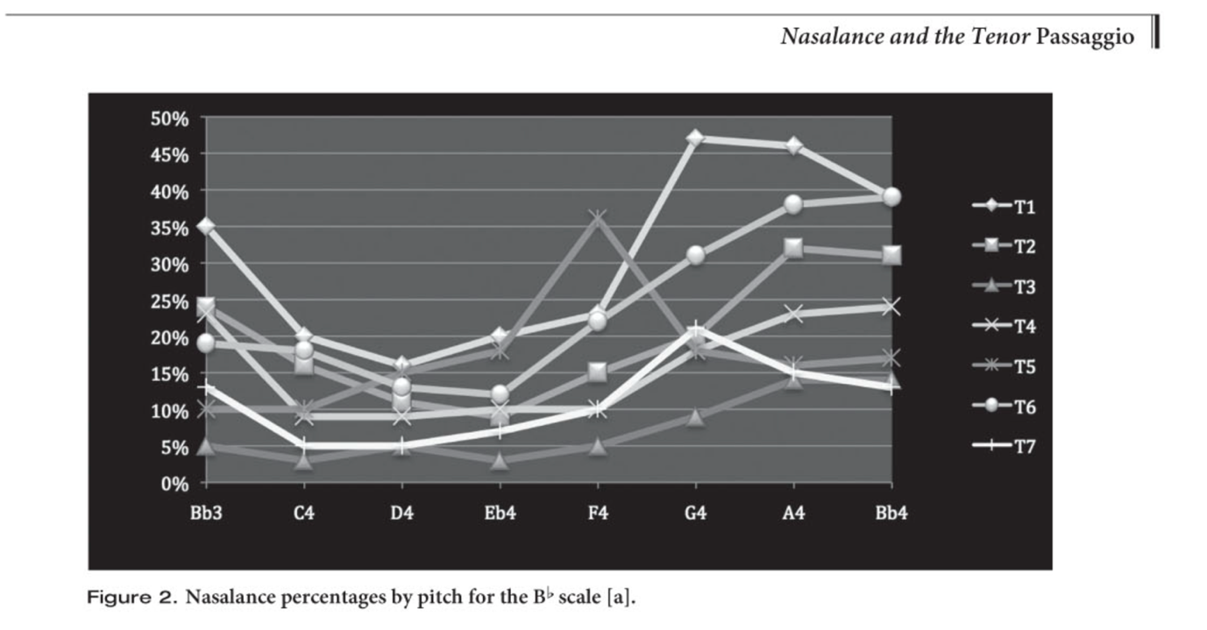
Nasalance scores of Tenors singing the vowel [a] (Perna, 2014)
Singer’s Formant and Nasalance
Titze suggests that nasal resonance may contribute to the perception of the singer’s formant, a distinct carrying resonance present in classical singers (Jennings and Kuehn, 2008; Titze, 2001). He believes this is due to similarities in the spectral patterns of vowels with high nasalance and vowels associated with the singer’s formant (Jennings and Kuehn, 2008). This is suggested to result from the dampening effects of “nasal resonance,” which primarily affects the lower frequency range (Perna, 2020; Vampola, 2020). This dampening of the lower frequency range relative to the higher frequencies can lead the listener to perceive a more prominent singer’s formant (Jennings and Kuehn, 2008).
Several studies, however, indicate that nasal coupling might not just function as a low-frequency dampener, but may even increase spectral energy in the singer’s formant cluster (Gil et al., 2020; Sundberg, 2007; Sundberg, 2020; Vampola et al., 2024). The cause is unknown (Gil et al., 2020), but it is hypothesized to be related to the aforementioned increased potential for vocal efficiency and greater resonance-tuning possibilities (Perna, 2008; Perna, 2014; Vampola, 2024). These factors may allow for an overall increase in vocal fold harmonic energy (Vampola, 2024). When combined with twang, which is already well studied and associated with increased efficiency, inertive loading, and clearer singer’s formant clustering, nasalance and twang together may contribute to an overall configuration that boosts the singer’s formant and can even increase overall loudness (Vampola et al., 2024).
Nasalance and SOVTs
Semi-occluded vocal tract exercises (SOVTEs) are voice pedagogical and speech-language therapy exercises that improve vocal efficiency (Titze, 2021). Commonly, these are performed as lip-bubbles or straw exercises. Much like nasalance, SOVTs assist in the self-oscillation of the vocal folds by lowering the first formant, which happens as a consequence of extending the vocal tract (through a straw, lip bubble, etc) (Pinto and Hijleh, 2021). However, until recently, there was little to no literature on semi-occluded nasal tract exercises. A 2025 study by Konrot suggests positive reactance effects of semi-occluded nasal tract resistance training. Together, these findings suggest that nasalance may function similarly to a semi-occluded vocal tract, a well-documented phenomenon, by increasing inertive reactance in a way that supports efficient phonation (Konrot et al., 2025).
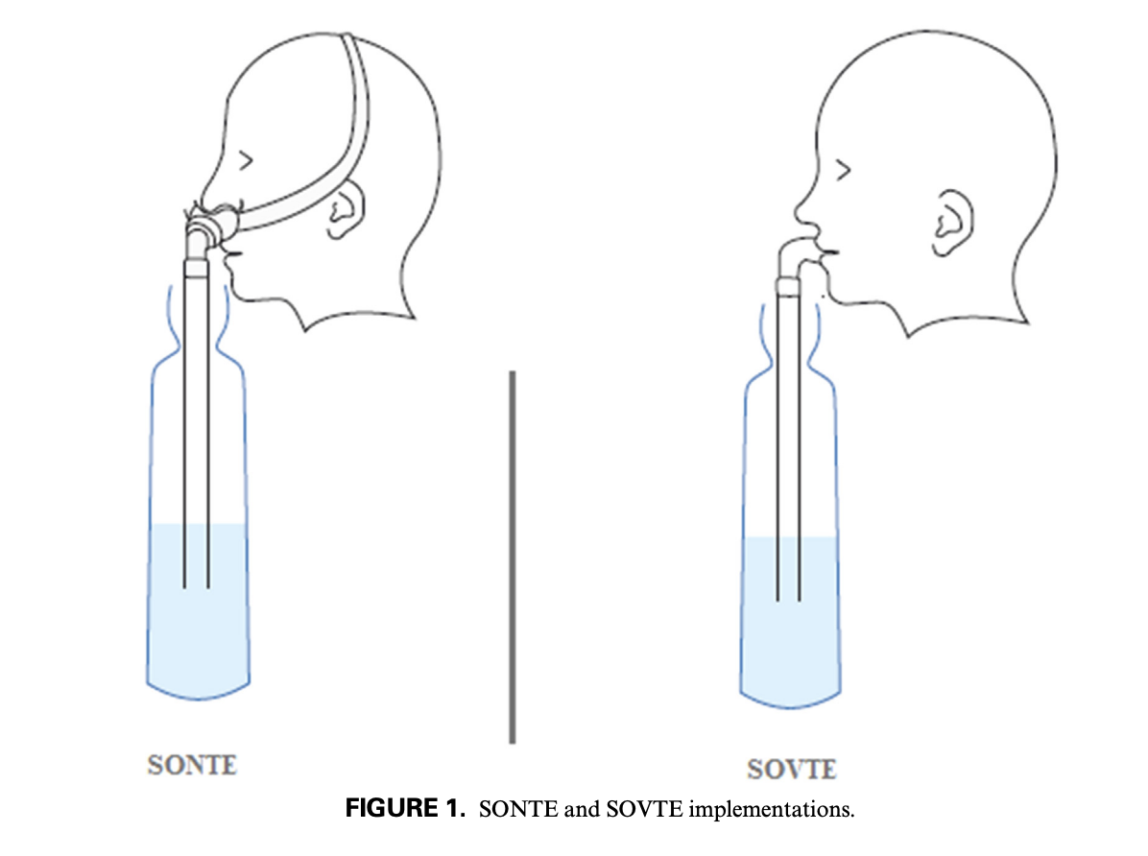
SONTE vs. SOVTE exercises (Konrot et al., 2025)
This research is relevant as SOVTs are incredibly popular in the current lexicon of voice pedagogy. However, SONTEs may be more effective because they can more directly train a significant, evidence-based way in which the first formant (among other formant/harmonic tunings) is likely lowered in actual singing: through nasalance (Konrot et al., 2025; Perna, 2008; Perna, 2020; Vampola et al., 2024 ). More research on this topic is needed, specifically regarding practical exercises singers can use to encourage adequate nasalance, with care to ensure neither too much nor too little nasalance, as both may have negative effects on the voice.
Limitations
It is important to note, though, that despite the growing body of evidence suggesting there may be benefits to the usage of nasalance in singing, the extent to which inertive versus compliant reactance directly enhances or destabilizes vocal fold oscillation in singers remains uncertain. For instance, Sundberg et al. (2013) reported that variations in F1/H2 alignment in classically trained male singers did not produce measurable changes in voice source characteristics. He concludes that “regardless of whether the first formant was slightly lower, slightly higher, or right on a partial, the properties of the voice source did not seem to be affected.” Further research is needed.
Additionally, while nasalance has become a central metric in empirical investigations of nasal acoustics, much nasalance data has been collected using nasometers designed initially for clinical speech assessment rather than for singing (Perna, 2008; 2014). These devices were optimized for conversational speech at moderate intensity levels and may not fully capture the demands of sustained phonation across wide pitch and loudness ranges (Glottal Enterprises, 2025). These nasalance measurements are also sensitive to vowel choice, SPL, mask fit, and other factors (Birch et al., 2002). For example, certain vowels may yield elevated nasalance readings independent of VPO adjustments (Perna, 2014). Additionally, facial morphology and mask fit can influence microphone separation and acoustic leakage, introducing variability that is difficult to control (Birch et al., 2002). These factors complicate direct comparisons across singers and studies.

More recent approaches estimate nasalance using airflow-based methods rather than acoustic energy alone, which may improve accuracy in distinguishing nasal airflow from oral radiation (Birch et al., 2002; Perna, 2014). However, these techniques are still subject to practical constraints in performance-based research settings, such as mask fit (Birch et al., 2002). Similarly, nasofiberscopy provides valuable visual information about velopharyngeal behavior but may alter natural singing behavior due to its invasive nature and may not always provide a clear picture (Birch et al., 2002). X-ray data is likewise not very consistent, as viewing angles of the VPO are limited (Birch et al., 2002); so Caruso might be vindicated after all. Even within the confines of speech, nasalance measurements between devices have been found to be “not interchangeable,” with significant differences in measurements between some devices (Bressmann, 2005).

These technical limitations in measuring and observing VPO and nasalance do not invalidate existing literature, but caution is needed to prevent dramatic interpretations of nasalance research. Acknowledging these limitations strengthens the interpretive framework of nasalance research and underscores the need for continued work (Birch et al, 2002).
Pedagogical Implications
The findings reviewed in this paper carry important implications for vocal pedagogy, particularly regarding how teachers regard the role of the nose in singing. Many pedagogical approaches often discourage any perceived nasal involvement, treating it as a fault to be eliminated. However, empirical evidence suggests that some nasalance is likely a normal and functional feature in professional operatic tenors (Perna, 2008). A critical pedagogical distinction must be made between hypernasality, which is typically perceptible, stylistically inappropriate, and often associated with excessive velopharyngeal opening (Jennings and Kuehn, 2008), and controlled nasalance, which may be acoustically measurable yet imperceptually “nasal” in tone color (Perna, 2008). Attempts to eliminate all nasal acoustic energy could interfere with resonance-tuning strategies that support vocal efficiency, potentially increasing strain or instability (Perna, 2014). Additionally, research has shown that expert listeners may not be able to determine whether a singer is using nasalance in the first place, casting doubt on the potential for singing teachers to misdiagnose students' perceived faults (Perna, 2008; 2014). I believe vocal instructors could benefit significantly from nasalance perceptual training to recognize faults such as hypernasality accurately.

Furthermore, the persistence of metaphor-based instruction, such as “singing into the mask” or “placing the tone forward,” highlights the need for pedagogical literacy regarding the difference between imagery and mechanism (Titze, 2008). As a result, I believe teachers should be cautious about equating these sensations with specific physiological actions. Improved pedagogical training in nasalance perception and vocal acoustics could help instructors distinguish between harmless or beneficial acoustic strategies and genuine technical faults (Perna, 2008). I believe this more nuanced understanding of nasalance allows for pedagogical flexibility. Rather than attempting to enforce strict, perception-based uniform vocal-tract positions, I think teachers should recognize that nasalance is likely one of several key variables that singers may employ to achieve efficient, healthy, and stylistically appropriate singing.
Furthermore, not only should voice teachers neccesarily consider allowing for nasalance, but the argument for specifically training nasalance (via something like an SONTE exercise) has been strengthening over the last twenty years (Konrot et al., 2025). Nasal exercises may have significant benefits for singers, improving tone quality by reducing strain, boosting formant frequencies, and contributing to the aesthetic qualities of a singer’s vocal tone (Konrot et al., 2025). Similar exercises already exist in vocal pedagogy (humming, “ng” tongue-position exercises, etc.), for which there are significant opportunities for future research to determine precisely how these exercises can assist singers (Konrot et al., 2025).
Conclusion

Collectively, my review of the nasalance literature suggests that nasalance likely plays a significant functional role in reducing instability in the singing voice, assisting vocal fold oscillation, and increasing high-frequency harmonic energy (Perna, 2014; 2020; Vampola, 2024). At the very least, research suggests that nasalance does not directly result in poor tone quality or necessarily interfere with vocal production (Perna 2008), as all of the modern studies I reviewed showed that classical tenors use nasalance to some degree during vowel phonation. However, more research is needed, particularly with female classical singers, some of whom have been found to use little or no nasalance on certain vowels as well as some basses and baritones (Birch et al., 2002; Perna, 2008). Research on nasalance in commercial music is also needed, as no such study currently exists.
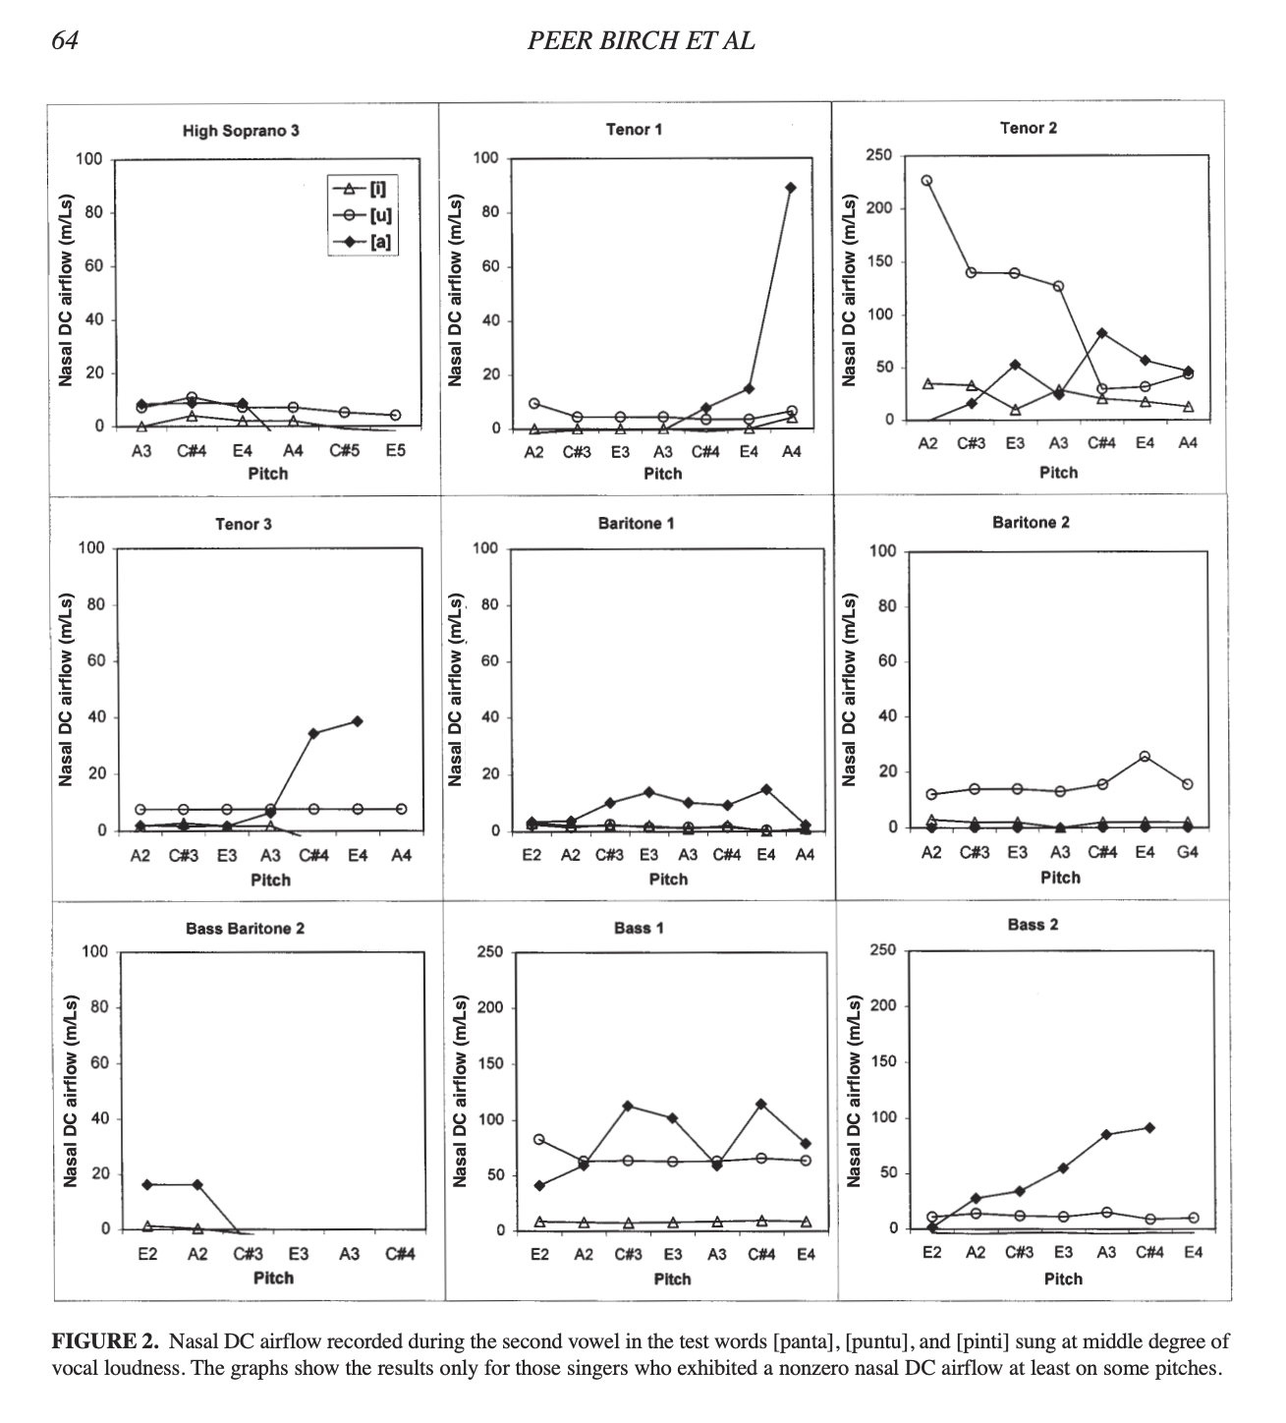
Note the lack of nasalance scores for some sopranos, basses, and baritones on certain vowels (Birch et al., 2002)
Artefact Script
Topic: Nasalance
1) Discuss why nasalance is important briefly. I will focus on CCM implications. Nasalance improves vocal economy, singer’s formant, etc.
2) Discuss the difference between “nasal tone”, nasal resonance, nasalance, twang, and forward resonance.
3) Discuss the historical debate behind nasalance
3) Show several studies measuring nasalance in classical tenors. Classical tenors use a similar vocal approach to that of many CCM styles, which is why this research is being referenced
4) Suggest exercises that singers can use to encourage nasalance.
5) Discuss limitations of nasalance research
References
Aura, M., Geneid, A., Bjørkøy, K., Rantanen, M. and Laukkanen, A.-M. (2022). A Nasoendoscopic Study of ‘Head Resonance’ and ‘Imposto’ in Classical Singing. Journal of Voice, 36(1), pp.83–90. doi:https://doi.org/10.1016/j.jvoice.2020.04.013.
Birch, P., Gümoes, B., Stavad, H., Prytz, S., Björkner, E. and Sundberg, J. (2002). Velum Behavior in Professional Classic Operatic Singing. Journal of Voice, 16(1), pp.61–71. doi:https://doi.org/10.1016/s0892-1997(02)00073-5.
Bressmann, T. (2005). Comparison of Nasalance Scores Obtained with the Nasometer, the NasalView, and the OroNasal System. The Cleft Palate-Craniofacial Journal, 42(4), pp.423–433. doi:https://doi.org/10.1597/03-029.1.
Bressmann, T., Sader, R., Whitehill, T.L., Awan, S.N., Zeilhofer, H.F. and Horch, H.H. (2000). Nasalance distance and ratio: two new measures. The Cleft palate-craniofacial journal : official publication of the American Cleft Palate-Craniofacial Association, 37(3), pp.248–56. doi:https://doi.org/10.1597/1545-1569_2000_037_0248_ndartn_2.3.co_2.
Duff, J.G. (2023). French Nasal Vowels in the Mezzo-Soprano Voice. [online] Belmont Digital Repository. Available at: https://repository.belmont.edu/music_recitals/39/ [Accessed 22 Dec. 2025].
Echternach, M., Högerle, C., Köberlein, M., Schlegel, P., Döllinger, M., Richter, B. and Kainz, M.-A. (2021). The Effect of Nasalance on Vocal Fold Oscillation Patterns During the Male Passaggio. Journal of Voice, 35(3), pp.500.e9–500.e16. doi:https://doi.org/10.1016/j.jvoice.2019.09.013.
Gill, B.P., Lee, J., Lã, F.M.B. and Sundberg, J. (2020). Spectrum Effects of a Velopharyngeal Opening in Singing. Journal of Voice, 34(3), pp.346–351. doi:https://doi.org/10.1016/j.jvoice.2018.11.014.
Glottal Enterprises (2025). Glottal. [online] Glottal.com. Available at: https://www.glottal.com/theNEMSystem.html#oro [Accessed 22 Dec. 2025].
Havel, M., Hofmann, G., Mürbe, D. and Sundberg, J. (2014). Contribution of Paranasal Sinuses to the Acoustic Properties of the Nasal Tract. Folia Phoniatrica et Logopaedica, 66(3), pp.109–114. doi:https://doi.org/10.1159/000363501.
Hoch, M. (2018). Historical Landmarks in Singing Voice Pedagogy. Voice and Speech Review, 13(1), pp.43–60. doi:https://doi.org/10.1080/23268263.2018.1527585.
Jahn, A.F. and Blitzer, A. (1996). A short history of laryngoscopy. Logoped Phoniatr Vocol, 21(3-4), pp.181–185. doi:https://doi.org/10.3109/14015439609098887.
Jennings, J.J. and Kuehn, D.P. (2008). The Effects of Frequency Range, Vowel, Dynamic Loudness Level, and Gender on Nasalance in Amateur and Classically Trained Singers. Journal of Voice, 22(1), pp.75–89. doi:https://doi.org/10.1016/j.jvoice.2006.08.017.
Konrot, A., Yılmaz, G., Bilgiç, M., Çınar, B. and Söğüt, C. (2022). Semi-occluded Nasal Tract Exercises (SONTEs): Nasal Tube in Water Exercises Using Nasal Consonants. Journal of Voice. doi:https://doi.org/10.1016/j.jvoice.2022.11.023.
Kroeger, K. (2013). William Billings’s VARIETY WITHOUT METHOD: An Experiment in Modulation.
Marafioti, P.M. (2010). Caruso’s Method of Voice Production. Dover Publications.
McCoy, S. (2008). The seduction of nasality. Journal of singing, 64(5), p.579.
Miller, R. (1993). Training Tenor Voices. Cengage Learning.
Perna, N. (2014a). Nasalance and Tenor Passaggio . Journal of Singing, Volume 70(No. 4 pp. 403-410).
Perna, N. (2014b). Nasalance and the Tenor Passaggio. Journal of singing, 70(4), pp.403–410.
Perna, N. (2020). Nasality Deconstructed. Journal of singing, 76(4), pp.429–432.
Pier Francesco Tosi (2009). Observations on the Florid Song (1723). Gregory Blankenbehler.
Pinto, C. and Hijleh, K. (2021). of Teachers of Singing Realizing the Benefits of SOVTEs: A Reflection on the Research. Journal of Singing, 77(3), pp.333–344.
Santoni, C.H. (2021). Influencing Oral-nasal Balance in Speech and Song. [online] Scholaris.ca. Available at: https://utoronto.scholaris.ca/items/099a1233-93a0-4bfd-b7d8-7101a178bb81 [Accessed 22 Dec. 2025].
Smith, C.G., Finnegan, E.M. and Karnell, M.P. (2005). Resonant Voice: Spectral and Nasendoscopic Analysis. Journal of Voice, 19(4), pp.607–622. doi:https://doi.org/10.1016/j.jvoice.2004.09.004.
Stark, J.A. (2008). Bel canto : a history of vocal pedagogy. Toronto: Univ. Of Toronto Press.
Sundberg, J., Birch, P., Gümoes, B., Stavad, H., Prytz, S. and Karle, A. (2007). Experimental Findings on the Nasal Tract Resonator in Singing. Journal of Voice, 21(2), pp.127–137. doi:https://doi.org/10.1016/j.jvoice.2005.11.005.
Sundberg, J., Lã, F.M.B. and Gill, B.P. (2013). Formant Tuning Strategies in Professional Male Opera Singers. Journal of Voice, 27(3), pp.278–288. doi:https://doi.org/10.1016/j.jvoice.2012.12.002.
Tanner, K., Roy, N., Merrill, R.M. and Power, D. (2005). Velopharyngeal Port Status During Classical Singing. Journal of Speech, Language, and Hearing Research, 48(6), pp.1311–1324. doi:https://doi.org/10.1044/1092-4388(2005/091).
Tetrazzini, L. (2017). Caruso and Tetrazzini on the Art of Singing. Createspace Independent Publishing Platform.
Titze, I. (2021). The Concept of Impedance. Journal of Singing, 77(3), pp.379–380.
Titze, I.R. (2001). Acoustic Interpretation of Resonant Voice. Journal of Voice, 15(4), pp.519–528. doi:https://doi.org/10.1016/s0892-1997(01)00052-2.
Titze, I.R. (2008). Nonlinear source–filter coupling in phonation: Theory. The Journal of the Acoustical Society of America, 123(5), pp.2733–2749. doi:https://doi.org/10.1121/1.2832337.
Titze, I.R. and Worley, A.S. (2009). Modeling source-filter interaction in belting and high-pitched operatic male singing. The Journal of the Acoustical Society of America, 126(3), pp.1530–1540. doi:https://doi.org/10.1121/1.3160296.
Tomáš Vampola, Jaromír Horáček and Anne-Maria Laukkanen (2021). Finite element modeling of the effects of velopharyngeal opening on vocal tract reactance in female voice. The Journal of the Acoustical Society of America, 150(3), pp.2154–2162. doi:https://doi.org/10.1121/10.0006370.
Tomáš Vampola, Jaromír Horáček, Vojtěch Radolf, Švec, J.G. and Anne-Maria Laukkanen (2020). Influence of nasal cavities on voice quality: Computer simulations and experiments. The Journal of the Acoustical Society of America/The journal of the Acoustical Society of America, 148(5), pp.3218–3231. doi:https://doi.org/10.1121/10.0002487.
Vampola, T., Horáček, J. and Laukkanen, A. (2024). Three Dimensional Finite Element Modeling of the Singer’s Formant Cluster Optimization by Epilaryngeal Narrowing With and Without Velopharyngeal Opening. Journal of Voice. doi:https://doi.org/10.1016/j.jvoice.2024.07.035.
Vennard, W. (1964). An Experiment to Evaluate the Importance of Nasal Resonance in Singing. Folia Phoniatrica et Logopaedica, 16(2), pp.146–153. doi:https://doi.org/10.1159/000262995.
Vennard, W. (1967). Singing : the mechanism and the technic. New York: Carl Fischer.

