Assessment Form

Module: Preparing for Professional Policing
Student Name: Paige Daves
Module Tutor (s): Kelly Andrews

Question | 1  Situation | 2  Task | 3.  Action | 4.  Result |  | Total Mark
1 | 5/5 | 2/5 | 13/15 | 4/5 |  | 24/30
2 | 5/5 | 3/5 | 10/15 | 5/5 |  | 23/30
3 | 1/5 | 1/5 | 6/15 | 2/5 |  | 10/30
 |  |  |  |  |  | Total Mark 57/90
Key
No Reference | Minimum | Satisfactory | Exceptional
0 | 0-4 | 5-10 | 11-15

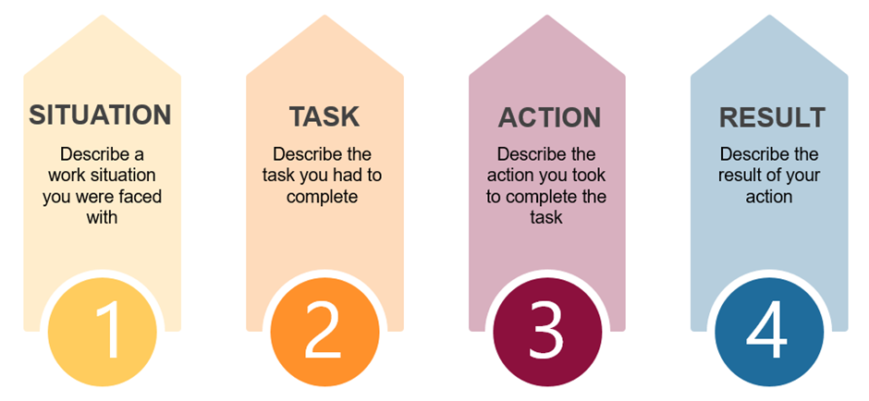

Question | Comments
1 | Situation – Working in home bargains – very popular product high demand. A customer called the store – she became angry when she found out it has sold out.  Task – needed more detail  Action – approached the person with empathy and respect – spoke to her calmly – made suggestions to resolve the problem  Result – found one in another store and she was able to go and collect it later that day – by recognising her emotional state I was able to resolve the situation –
2 | Situation – Working in home bargains – a very popular product had been advertised – but the delivery was late-  Task – I knew I had to get the product out in a quick time in an accessible place.  Actions- placed the item on the star buys session – I was going to put the product out- using past experience to do this quickly. Could have provided more detail around decision making here.  Result: Got the product out an hour after the delivery and the product sold well -  .  Good use of STAR
3 | Customers come in with different backgrounds – there can be communication or speech barriers. You must overcome this.  Needed to use I not we.  Could make the person feel insecure – could make a complaint or impact them long to term.  Needed to provide a specific situation.  Try and find a solution to the issue. Must remain respectful.  Did not use STAR here as not specific example provided.  .

.

