Lusharnia Gordon

(1905474)

Giridhar Katti

BMHP 5003

Skeletal System

26/11/2021

The Organization and Structure of the Human BodyCells, the basic building blocks of the human body, join to form tissues, which then join to form specialized structures known as organs. Organ systems are groups of organs and tissues that collaborate to accomplish a common goal. This structure is divided into several levels, each of which becomes more complex as it progresses
The Human Body's Organization and Structure Cells, the basic building blocks of the human body, combine to form tissues, which then combine to form specialized structures known as organs. Organ systems are collections of organs and tissues that work together to achieve a common goal. This structure is organized on several levels, with each level becoming more complex as it
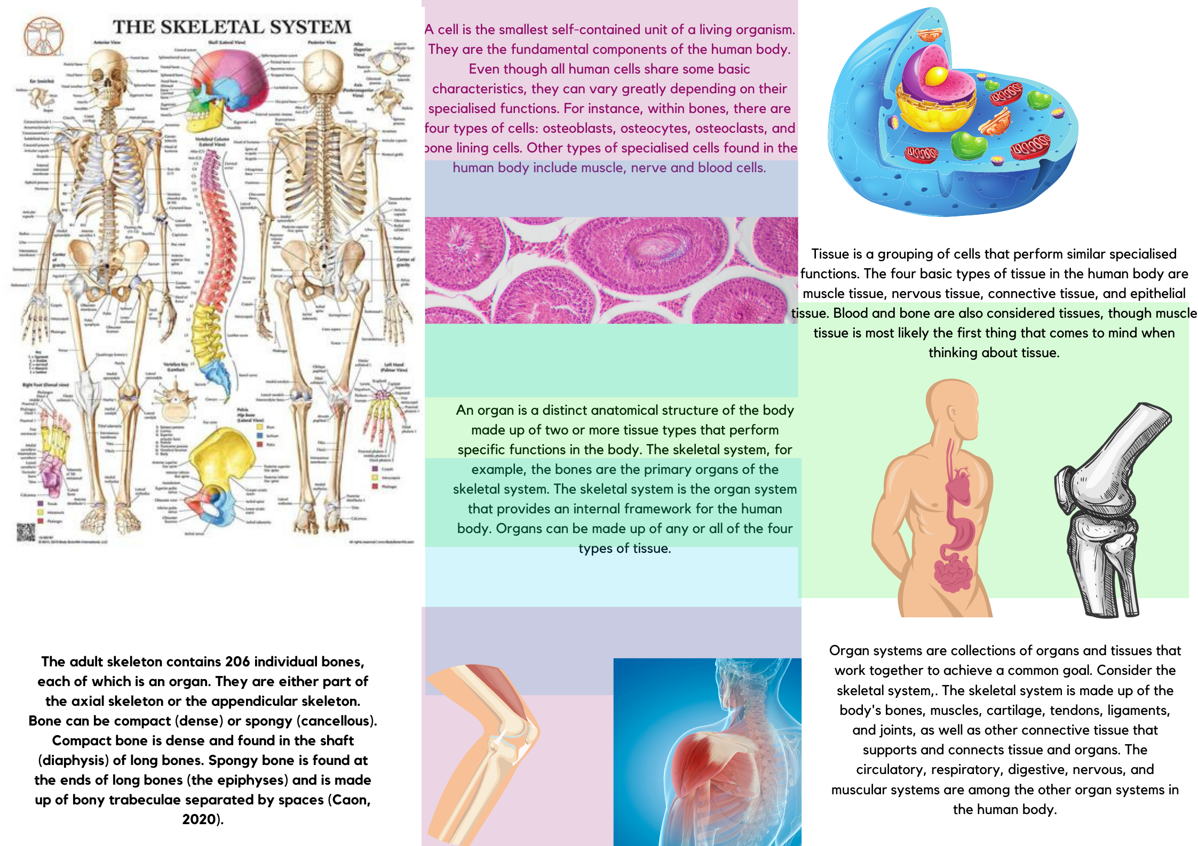
Bone is formed by specialised cells that form a sequence primarily composed of protein fibres, water, and minerals. Bone is made up of both living and non-living tissue. Blood vessels, nerves, collagen, and cells make up the living part.
Osteogenic Cells- These cells develop into osteoblasts and are found in the deep layers of the periosteum and marrow.

- Osteoblasts are bone-forming cells that mature into osteocytes.
- Osteocytes are mature bone cells responsible for monitoring and maintaining bone tissue.
- Osteoclast are cells produced from bone marrow stem cells that clear away old bone and reabsorb bone in order to keep it in shape (Waugh and Grant, 2018).

A balance of osteoblast and osteoclast activity is required to maintain normal bone function and structure. Osteoblasts are derived from fibroblasts that have collagen fibres surrounding them; calcium salts are then collected here, increasing bone size. Minerals and slats are non-living elements that are equally important for bone formation (Martin and Gormley-Fleming, 2021).

Bones, cartilage, and connective tissue comprise the skeletal system. These all work together to form certain parts of the body that perform vital functions for human life. The skeletal system can suffer from injuries such as breaking or fracturing a bone, a joint can be dislocated or sprained, and it can also be related to swimming and other sports. This system also collaborates with your muscular system to protect and move you around, to keep you upright so you don't fall to the ground while moving, and to provide you with strength.
Bone is a type of rigid connective tissue. It is made up of cells that produce an organic extracellular sequence made up of collagen fibres, ground substance, and inorganic materials in the form of mineral salts. The skeleton serves as the body's supporting framework, providing stiff levers on which muscles act to generate movement. The human skeleton is made up of various structural components such as collagen, three types of cartilage, and a variety of bone types:
- Hyaline cartilage
- Fibrocartilage
- Elastic cartilage

- Woven
- Lamellar
- Trabecular (spongy)
- Plexiform (fibrolamellar)

Osteoporosis is one example of a disorder that affects the bones. A number of variables, including your age, race, lifestyle choices, and medical conditions and medications, can raise your risk of developing osteoporosis. Some osteoporosis risks are beyond your control, such as your body type and size. Men and women with petite physical frames are at a higher risk because they may have less bone mass to draw on as they get older (MayoClinic, 2021).
Osteoporosis affects people of all ages and affects their physical, psychological, and financial well-being.
The risk factors for osteoporosis, as indicated by low bone density, and fracture overlap but are not the same. In people with secondary osteoporosis-related conditions, skeletal health should be prioritised (Siris et al., 2001).
Clinical risk factors are important but underutilised in deciding who should have BMD measurements to assess fracture risk and who should be treated.

References

Anon, 2020. Levels of Organization of the Human Organism. Available at
https://med.libretexts.org/@go/page/11097 [Accessed October 21, 2021].

Lee, P. and Vandenburgh, H., 2013. Skeletal Muscle Atrophy in Bioengineered Skeletal Muscle: A New Model System. Tissue Engineering Part A, 19(19-20), pp.2147-2155.
Mayo Clinic. 2021. Osteoporosis - Symptoms and causes. [online] Available at: <https://www.mayoclinic.org/diseases-conditions/osteoporosis/symptoms-causes/syc-20351968> [Accessed 27 November 2021].
McKinley, M., O'Loughlin, V. and Bidle, T., n.d. Anatomy & physiology.
Science Learning Hub. 2021. Body systems. [online] Available at: <https://www.sciencelearn.org.nz/resources/1885-body-systems> [Accessed 27 November 2021].
Siris, E., Miller, P., Barrett-Connor, E., Faulkner, K., Wehren, L., Abbott, T., Berger, M., Santora, A. and Sherwood, L., 2001. Identification and Fracture Outcomes of Undiagnosed Low Bone Mineral Density in Postmenopausal Women. JAMA, 286(22), p.2815.
Waugh, A., Grant, A. and Tibbitts, R., n.d. Ross & Wilson anatomy and physiology in health and illness.
Zhang, M., 2015. Computational biomechanics of the musculoskeletal system. Boca Raton: CRC Press.

