Student Name: Zoe Amber Taylor Mills
Student Number: 1801497
Course: Fine Art Studio Site & Context
Word Count: 1534
Tutors: Ryan L. Moule, Rob Jones

End of the World

This exhibit will expose humanity as plastic, behind the shield of technology, existing in an perishing environment. The present exhibition highlights existence of mankind as the end of the world; environmentally, politically and socially. Whether it be Donald Trump, social media or plastic bottles we have all become victims of humanity, including the planet. Modern hell is camouflaged with Coca Cola advertisements along with Victoria's Secret logos. Baudrillard notably recommends that the world one exists in has been replaced by a replica world, where one seeks simulated stimuli and nothing more. (Felluga 2015) Humanity has become consumers, a civilisation of greed, products of companies and the evildoers that destroy it. All these factors lead to the end of the world as one knows it, this exhibition is determined to present the reality of the present, and how close we are to the end. This exhibition will be held in the Mission Gallery in Swansea.

The exhibition begins with An Xiao’s ‘The Artist Is Kinda Present’, a parody of Marina Abramović’s The Artist is Present. Whose work was inspired by her thoughts of that stretching the length of a performance beyond expectations serves to change our approach to what time is and foster a deeper experience and a better engagement. An Xiao’s piece works in the opposite, presenting the reflection of experience but a more realistic ideal of how we live in reality now. Through a computer screen and on technology as well as social media. An Xiao works with communicating to the audience with Twitter and social media. This can represent how consumers are filled with passion for commodities, whose use has become an end in itself (Debord 2011). 95% of teens now report they have a smartphone or access to one. These intense connections result in teens engaging in a rise in further continuous online activities: 45% of teens now say they are online on a practically constant reality. (Anderson and Jiang 2018). Most people check their phone about 150 times a day or every six minutes. About 46% of people say they couldn't live without their smartphones (Newsonen 2018). This shocking statistic shows that we are at the end of the world socially as the future generation is heavily reliant to technology communication. This piece is particularly interesting as it poses a question to society as a whole, asking what went so wrong? Humanity will be reduced to online existence, cursed to manifest on the internet. To have people consistently rely on social media to live life, it shows that we are slowly becoming vegetables that are only able to live through the internet. When one becomes solely reliant on social media to communicate, this will signify the end of the world socially.

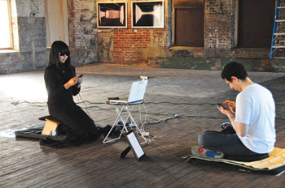
Figure 1 - An Xiao ‘The Artist is Kind Of Present’ 2010

In the center of the exhibition will be an sculpture from a series called "Vida Tóxica" (Toxic Life) which consists of fourteen sculptures created by Catalan artist Alvaro Soler Arpa with animal bones and plastic waste. "Toxic Life" evokes the struggle between nature and today's artificial toxic agents that derive from man's waste and pollutants, it highlights humanities pollution and its effect on living animals in the wildlife. The sculptures emphasize an example of the human impact of extreme plastic pollution on ecosystems and individual animals. Since the use of plastics continues to increase, so does the amount of plastics polluting the marine environment. (Robards 1995) Humanity is attracted to convenience and at this rate, unless any changes are made, the use of plastic will only continue to rise. Humans of the age of Affluence are surrounded not so much by other human beings, as they were in previous ages, but by objects (Baudrillard 1998). We have grown into a consumer society whom rely on purchasing products for pleasure rather than real life experiences. Products are epitomized by american society with its packaging, drugstores and hypermarkets (Dant 1999). These products and sense of production is glorified as a growing economy, they are seen as a status of wealth and prosperity. This is Ironic as there is at least 5.25 trillion plastic particles weighing 268,940 tons are currently floating at sea (Eriksen, Lebreton 2014). This is polluting our oceans and is polluting our planet, something that is a symbol of prosperity is the same thing that is destroying the very ground we exist on. This is included in the end of the world exhibition as it signifies the absolute destruction of the environment and the effect it has on animals and living and breathing life.

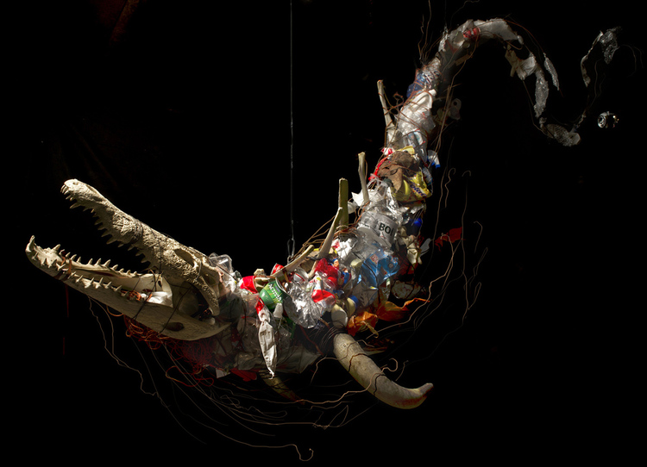
Figure 2 - Alvaro Soler Arpa ‘Toxic Life’ 2016

The next piece to further the exhibition will be Robert Cenedella’s Fin Del Mundo (End of the World). This piece is heavily inspired by “Garden of earthly delights” by Bosch, Fin Del Mundo’ gives one a shocking revelation with both present and modern disasters. This will be the main focus of the exhibition. He highlights our human dilemma and makes it so punishment will be decided in the grasp of humanity. He specifically highlights politics, making Trump the center of the artwork. With the introduction of trump becoming president of the USA, many people were in disbelief and viewed it as the end of the world as one knows it. from the excessive colours of Trump's head and hair, it all looks unhealthy and somehow poisonous in the painting. It may be representing how at the hands of modern society we are the poisoned generation, and the generation that of which will be witness to the end of the world. The work also depicts a culture obsessed with consumption, filling the piece with branding and logos it paints a wicked perception of our modern society. Expansion of consumer culture means more goods, more air travel, more waste, pollution and carbon dioxide emissions (Featherstone 2007). Presented with detailed characters, this artwork is produced within a gigantic, fatal and catastrophic assumption of the inevitable demise of humankind. Instead of giving us a mythological, magical and terrifying drop into hell filled with the likes of mystical dragons, this painting is imminent upon showing that with our own hands we make humanity's own destruction of which is a human dilemma, and our punishment will be meted out by humanity's own hands. This fits well with the exhibition as it summarizes the end of the world by modern standards, and it paints the path we are heading towards.

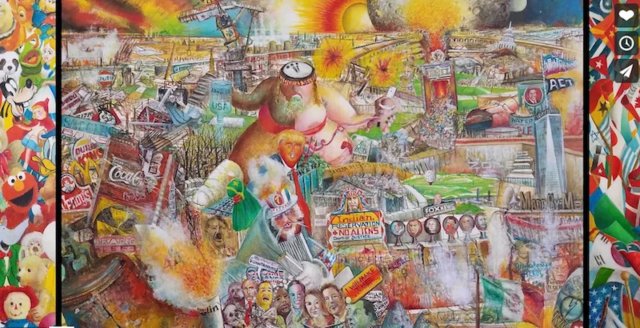
Figure 3 - Robert Cenedella ‘Fin del Mundo’ 2016

The next feature in the end of the world exhibition will be Banksy’s Seasons Greetings a piece which is prominent in present society. This artwork decides to highlight the problem of dust pollution, the image depicts a child happily facing falling snow; looking around the corner of the garage reveals the snow is actually ash from a fire. Subtle changes in the air affect not only humanity, but the plants in our ecosystem. Adjustments in the air affect the reproductive or genetic systems of plants (Stem 1977), this affects both our planet and our environment and it can negatively affect our future ecosystem. Exposure to airborne pollutants and ozone has been associated with increases in mortality and hospital admissions due to respiratory and cardiovascular disease (Brunekreef 2002). The leading causes of air pollution are power plants and cars, it is not natural and it is killing the very air life breathes. The rise in air pollution is proof that we are on our way to the end, this is as children, the people of he future, are breathing in this toxic substance. The curator has chosen this specific artwork for the exhibition as it strongly represents backlash from the decisions humanity has made to pollute the environment to also pollute themselves, this shows that life is diving at full speed into the end of the world
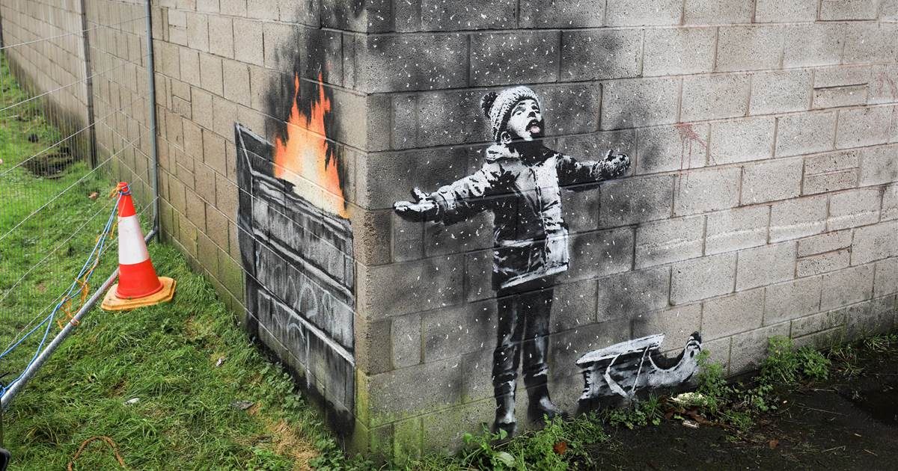
Figure 4 - Banksy ‘Seasons Greetings’ 2019

The final image of the collection will be a piece of digital art from the collection ‘Social Decay’ By Andrew Lacatusu. As titled in the collection the image is about the collective social decay in society, as touched before with An Xiao’s The artist is not present, this piece highlights how social sites like facebook will be the end of our society. Seemingly harmless social sites have been turned into large corporations, currently facebook is worth around $68.9 billion
(Bloomberg.com, 2019). This shows that these sights have turned into corporation giants, that track your information, take your money and allow no privacy. Facebook routinely tracks users, non-users and logged-out users outside its platform through Facebook Business Tools. App developers share data with Facebook through the Facebook Software Development Kit (Privacy International 2018). This is in the end of the world exhibition as it shows that the world is ending through greed in corporations and socially through the likes of social media. We are unknowingly being prevented privacy, allowing control and greed, this is leading to the end of the world as we know it. Seen from this perspective, the artwork can be observed as a mark in time, or even a prediction of what could happen in the future.
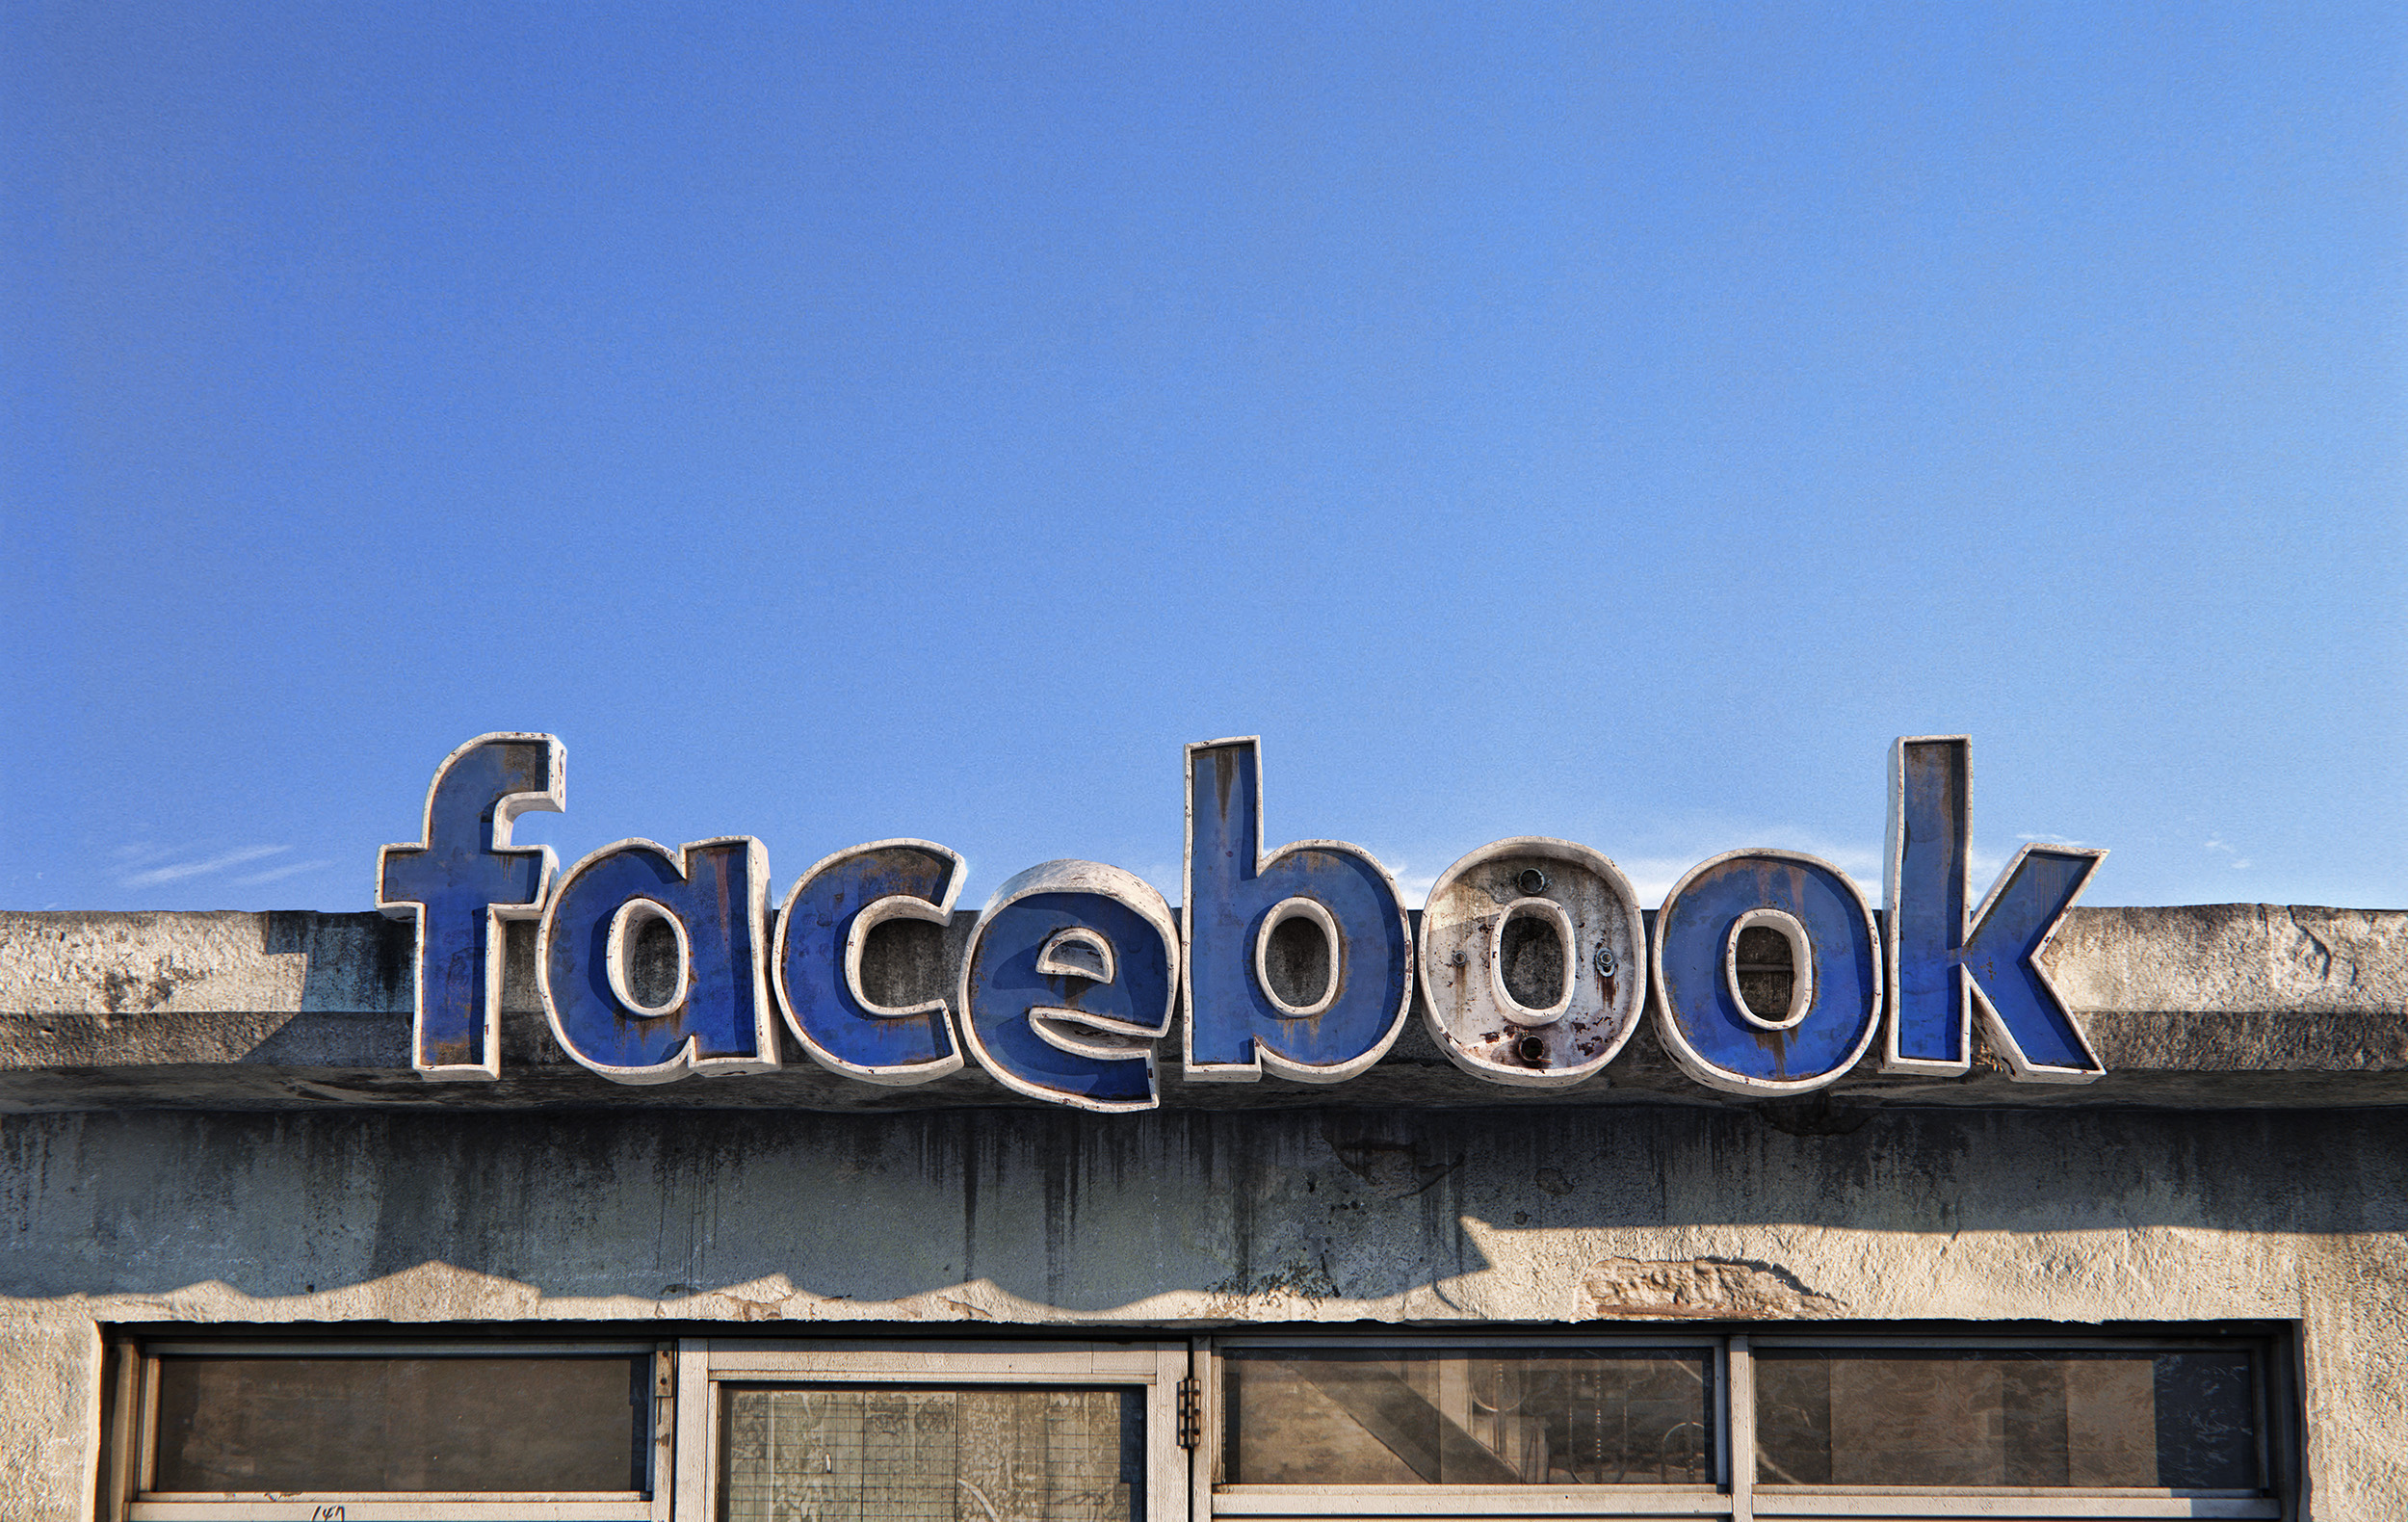
Figure 5 - Andrew Lacatusu ‘Untitled’ 2018

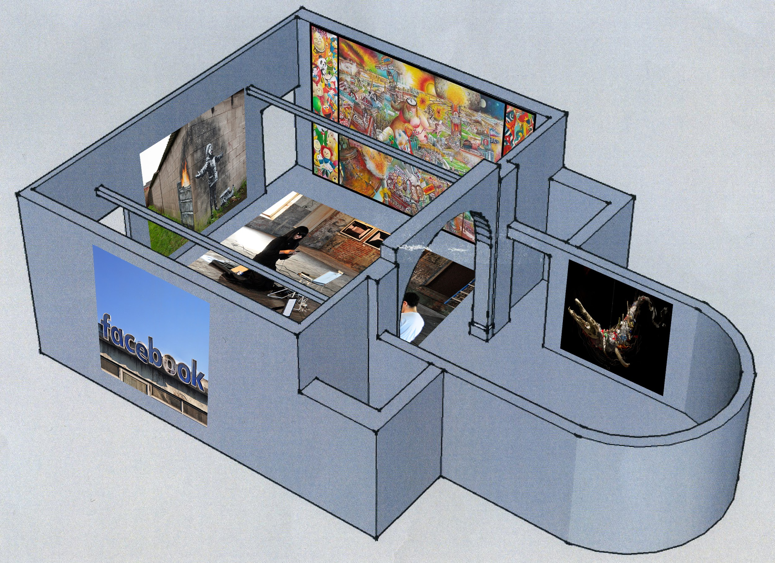
Mission Gallery Plan.

Bibliography

Felluga, D. (2015). Critical theory. Abingdon, Oxon: Routledge.

Debord, G. (2011). Comments on the society of the spectacle. London: Verso.

Anderson, M. and Jiang, J., 2018. Teens, social media & technology 2018. Pew Research Center, 31

Newsonen, S. 2019. When Did We Stop Talking to Each Other?. [Blog] Psychology Today. Available at: https://www.psychologytoday.com/gb/blog/the-path-passionate-happiness/201802/when-did-we-stop-talking-each-other [Accessed 3 May 2019]

Stern, A. (1977). Air pollution The Effects of Air Pollution. 2nd ed. Elsevier.

Robards, M., Piatt, J. and Wohl, K. (1995). Increasing frequency of plastic particles ingested by seabirds in the subarctic North Pacific. Marine Pollution Bulletin, 30(2), pp.151-157.

Baudrillard, J. (1998). The consumer society: Myths and structures. SAGE.

Dant, T. (1999). Material culture in the social world: values, activities, lifestyles. The University of Michigan: Open University Press.

Eriksen, M., Lebreton, L.C., Carson, H.S., Thiel, M., Moore, C.J., Borerro, J.C., Galgani, F., Ryan, P.G. and Reisser, J., 2014. Plastic pollution in the world's oceans: more than 5 trillion plastic pieces weighing over 250,000 tons afloat at sea. PloS one, 9(12), p.e111913.

Featherstone, M., 2007. Consumer culture and postmodernism. Sage.

Bloomberg.com. (2019). Bloomberg Billionaires Index. [online] Available at: https://www.bloomberg.com/billionaires/profiles/mark-e-zuckerberg/ [Accessed 5 May 2019].

Privacy International (2018). How Apps on Android Share Data with Facebook. [online] Privacy International. Available at: https://privacyinternational.org/sites/default/files/2018-12/How%20Apps%20on%20Android%20Share%20Data%20with%20Facebook%20-%20Privacy%20International%202018.pdf [Accessed 5 May 2019].

Brunekreef, B. and Holgate, S.T., 2002. Air pollution and health. The lancet, 360(9341), pp.1233-1242.

List of Figures

Behance.net. (2019). Behance. [online] Available at: https://www.behance.net/gallery/52646779/Social-Decay [Accessed 5 May 2019].

Instagram. (2019). Banksy on Instagram: “....Season’s greetings...”. [online] Available at: https://www.instagram.com/p/BrkqwhnlNjR/ [Accessed 5 May 2019]

Rcenedellagallery.com. (2019). Fin del Mundo (End of the World) | Oil Paintings For Sale. [online] Available at: https://www.rcenedellagallery.com/content/f%C3%ADn-del-mundo-end-world [Accessed 5 May 2019].

Saatchiart.com. (2019). [online] Available at: https://www.saatchiart.com/art/Sculpture-Animal-Marino-Toxic-Evolution/707188/2044746/view [Accessed 5 May 2019]

Pollack, B. (2019). The Social Revolution -. [online] ARTnews. Available at: http://www.artnews.com/2011/06/01/the-social-revolution/ [Accessed 5 May 2019].

